**Lesson 9 Demo 7**

**Update Deletion Policy to Protect User’s Resources**

**Objectives:** To protect a provisioned resource in the stack from deletions when the stack is deleted

**Tools required:** AWS Lab

**Prerequisites:** None

Steps to be followed:

1. Log in to your AWS lab
2. Go to CloudFormation
3. Deploy a stack using a template
4. To the template, edit the Deletion Policy to retain the specific resource
5. Delete the stack and test if the specified resource has been retained

**Step 1: Log in to your AWS lab:**

**Step 2: Go to CloudFormation**

* 1. Click on the **Create stack** button

**Step 3: Deploy a stack using a template**

**Step 4: To the template, edit the Deletion Policy to retain the specific resource**

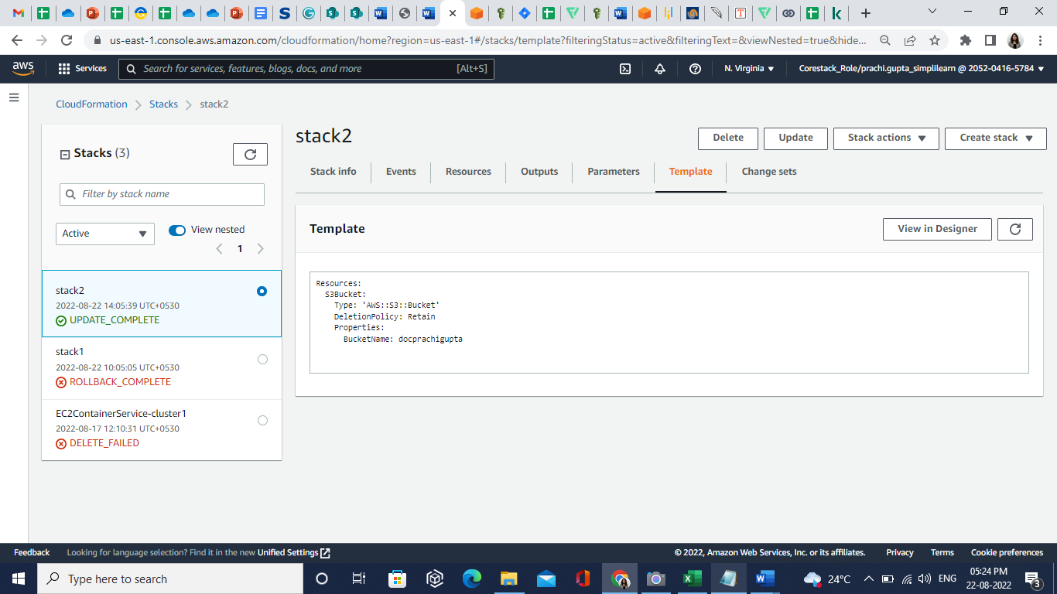

**Step 5: Delete the stack and test if the specified resource has been retained**

Hence, the stack in the specified resources is deleted.