**Lesson 9 Demo 8**

**Create an Auto Scaling Group Using a Launch Template**

**Objective:** To create an Auto Scaling group

**Tools required:** AWS account

**Prerequisites:** NA

Steps to be followed:

1. Create a Launch template
2. Create an Auto Scaling group

**Step 1: Create a Launch template**

* 1. In the EC2 dashboard, click on **Launch Template** and then click on **Create Launch**

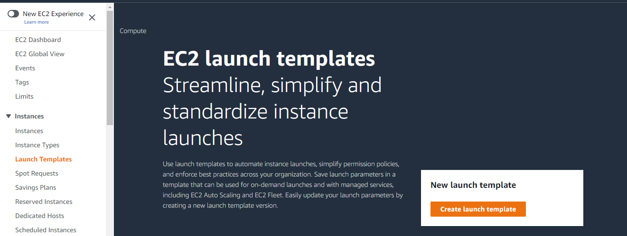**Template**

1.2 In the **Create launch template** tab, add the launch template name and description

1.3 In the **AMI** section, go to **Quick Start** and select **Amazon Linux**

1.4 Select **t2.micro** as the **Instance type** and **Create a new key pair** in the **Key pair(login)** section

1.5 In the **Network settings** tab, select the option **Select existing security group** and then select the **default Security group**

1.6 In the **Advanced details** section, under the sub-section of **User data**, add the following code:

***yum update -y***

***yum install httpd -y***

***cd /var/www/html***

***echo "WEB SERVER" > index.html***

***service httpd start***

***chkconfig httpd on***

After adding the above code, click on **Create launch template**

1.7 You will get a **launch template successfully created** message. Now, scroll down and click on **View launch templates**

**Step 2: Create an Auto Scaling Group**

* 1. Graphical user interface, application

     Description automatically generated with medium confidenceOn the left pane of the **EC2 dashboard,** click on **Auto Scaling Groups**

2.2 In the **Auto Scaling Dashboard,** click on **Create an Auto Scaling group**

2.3 In the **Create Auto Scaling group section,** add any arbitrary name for the Auto Scaling

group

2.4 In the **Launch template** section, select the template created in step 1 and then click on **Next**

2.5 In the **Choose instance launch options,** do the following:

* Select the **default VPC**
* Select all the **Availability Zones and subnets,** then click on **Next**
* Again,click on **Next**

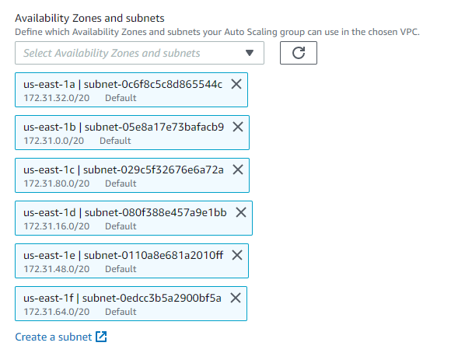

2.7 In the **Configure advanced options,** select **No load balancer**

**Note**: The users can create or attach an existing load balancer if they want.

* 1. In the **Configure group size and scaling policies,** do the following:
* Make **Desired capacity** = **9**,
* Make **Minimum capacity** = **1**
* Make **Maximum capacity = 13** thenclick on **Next**

2.9 Now skip all the sections by clicking on **Next** and then finally click on **Create Auto Scaling group**

Finally, you will see the **AutoScalingGroup1** inthe **Auto Scaling group Dashboard,** which indicates that the Auto Scaling group has been launched successfully.

