**Lesson 9 Lesson-End Project**

**Create an Alarm Using CloudWatch**

**Project agenda:** To create an alarm using CloudWatch that will allow you to watch CloudWatch metrics (CPU Utilization) with a given threshold and receive notifications when the metrics fall outside the threshold levels that you configure.

**Description:** Launch 3 virtual machine instances (Linux). Perform tasks on these VMS of your choice. Set up a dashboard with metrics showing CPU Utilization of all 3 VMS.

**Tools required:** AWS account

**Prerequisites:** None

**Expected deliverables:** CloudWatch metrics

Steps to be followed:

1. Launch 3 Linux VMs
2. Connect SSH into VMs
3. Perform Linux-related tasks on VM
4. Work with CloudWatch services
5. Select metrics for CPU utilization for all 3 VMs
6. Create an alarm and send a notification through SNS

**Step 1: Launch 3 Linux VMs**

1. In the Amazon console, search for **EC2** in the search bar:

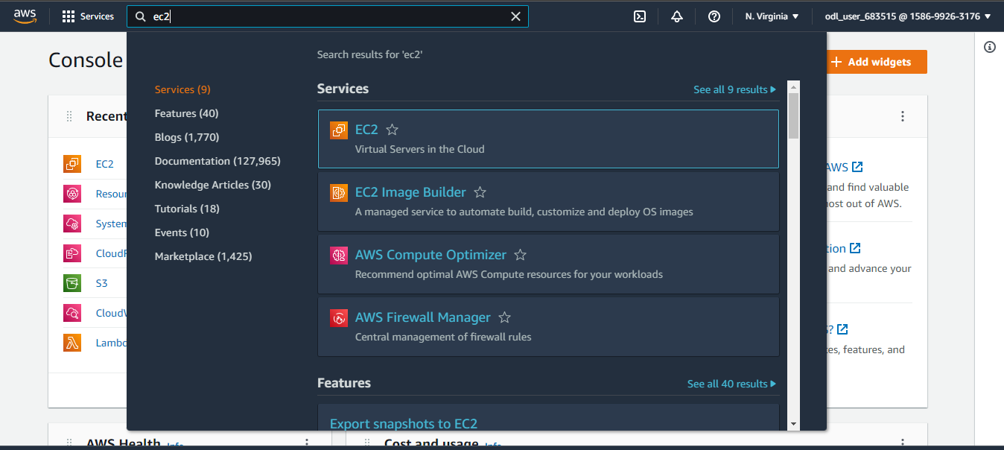

1. In the AWS EC2 console, select **Launch Instance:**

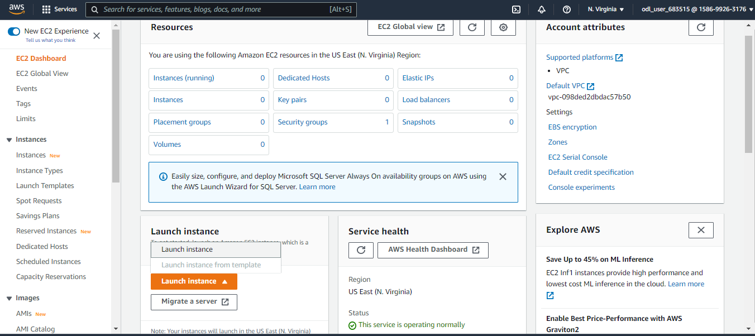

1. Add a name, select Amazon Linux Machine and t2.micro Instance type
2. Create a new keypair:

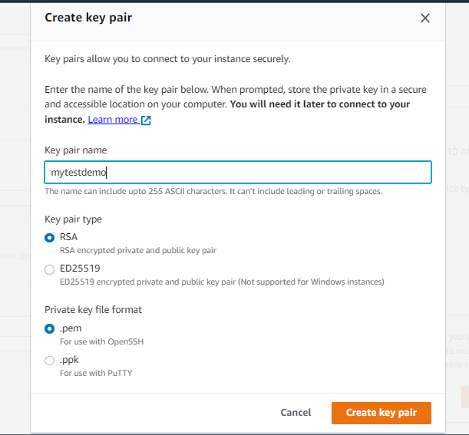

1. Click on the **Create key pair** button
2. Click on the **Launch Instance** button

1. Create 2 more instances following the same steps:

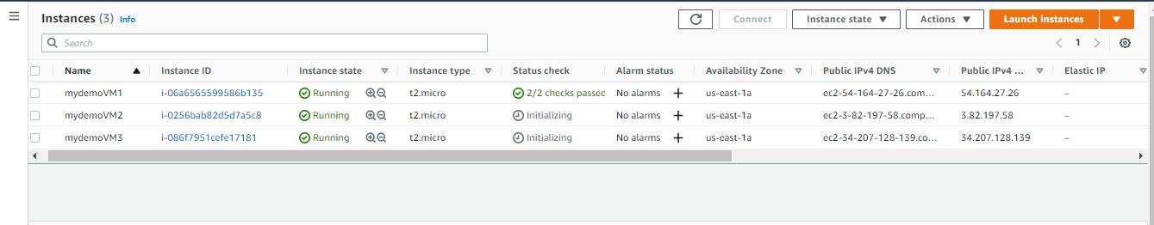

**Step 2: Connect SSH into VMs**

1. Select the Instance and click on the **Connect** option:

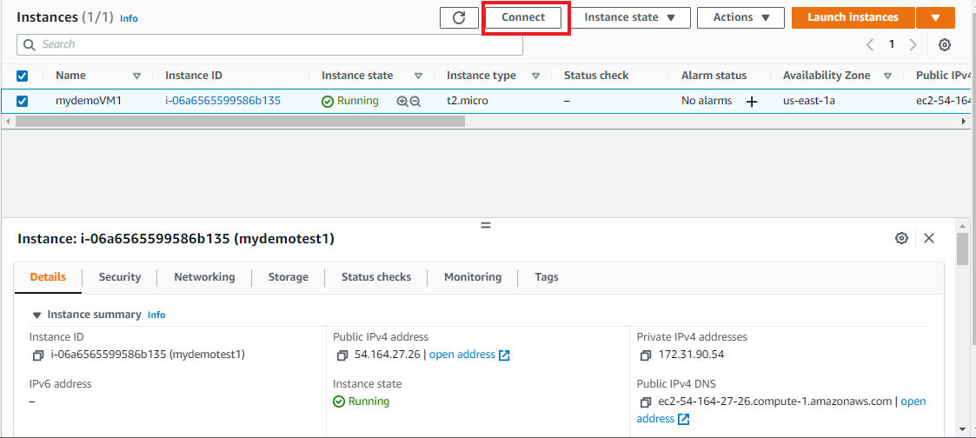

1. Click on the **Connect** button

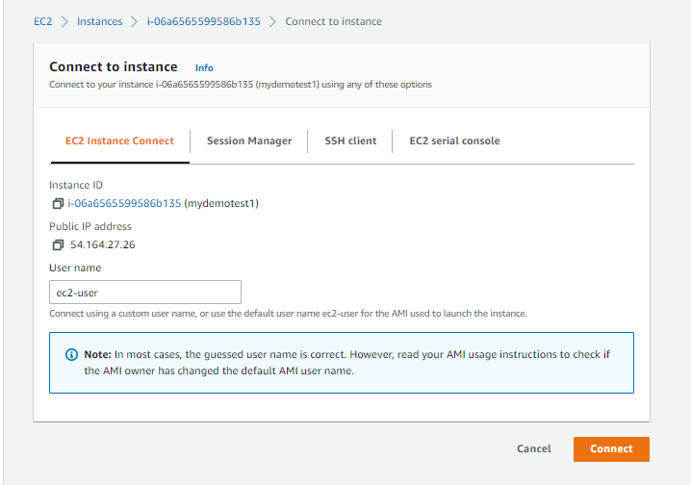

**Step 3: Perform Linux-related tasks on VM**

1. For example: Run **sudo yum install stress -y:**

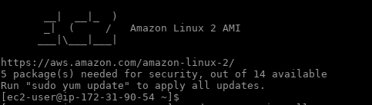



1. Connect all the 3 VMs

**Step 4: Go to the CloudWatch service**

1. Right-click on the tab and select the **Duplicate** option:

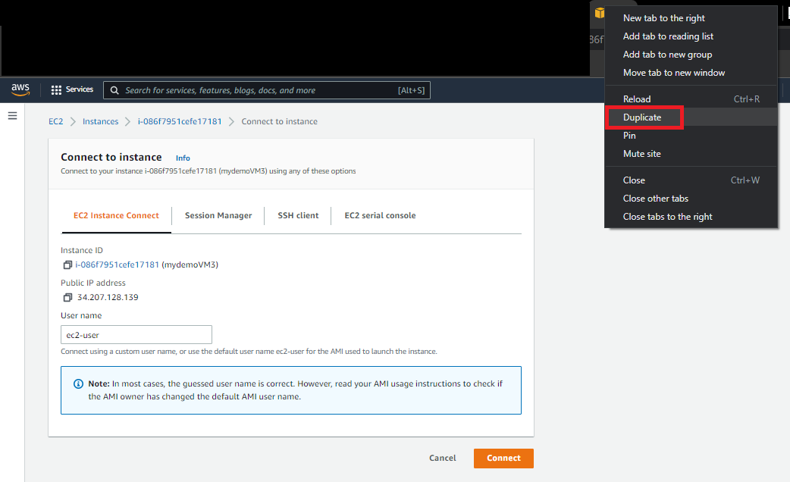

1. In the new tab, search **CloudWatch** in the search bar:

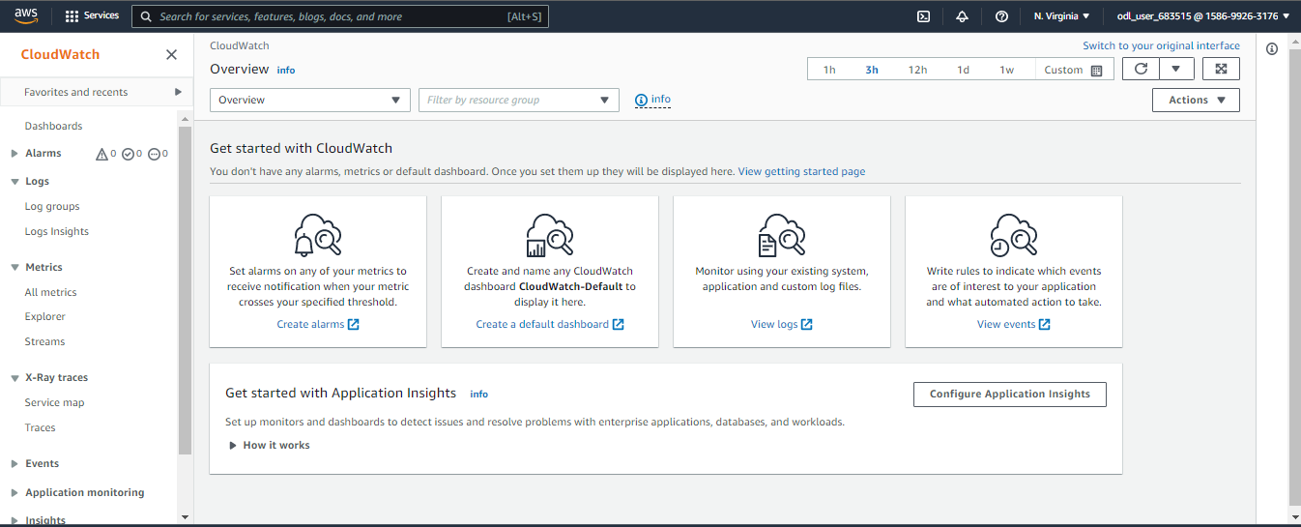

**Step 5: Select metrics for CPU utilization for all 3 VMs**

1. Click **Metrics** and select **All Metrics :**

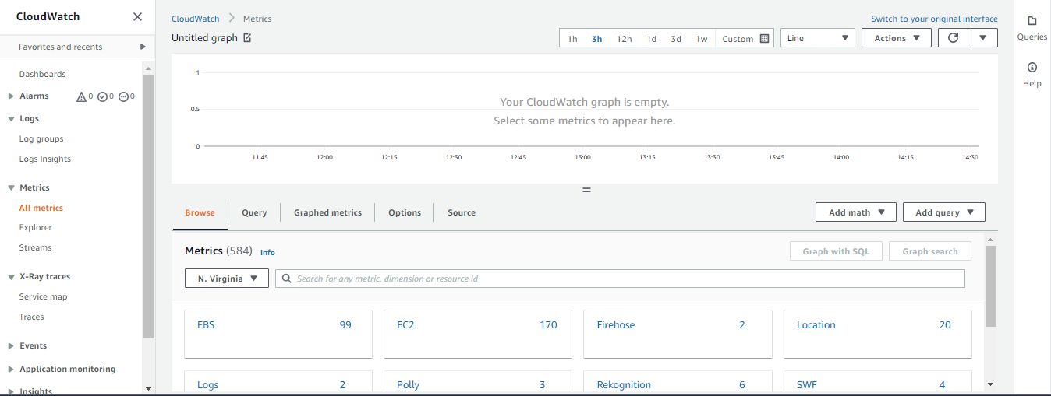

1. Select the **EC2** option

1. Select **Per-Instance Metrics** and search **CPUUtilization** in the search bar:

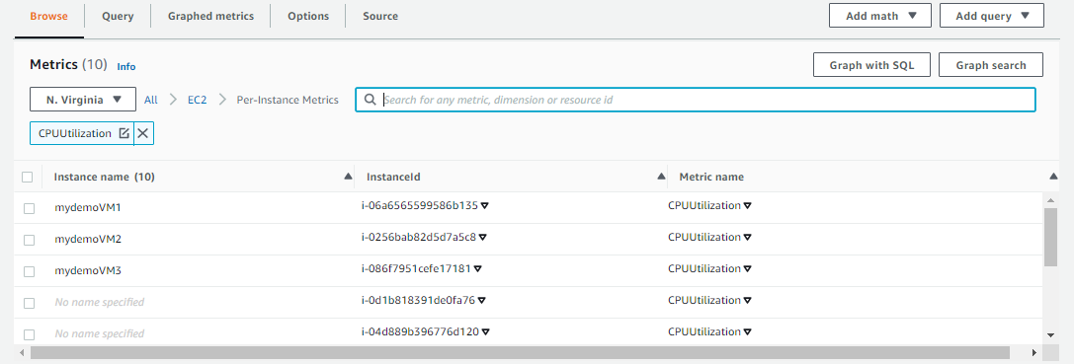

1. Select all the VMs, and click on **Actions** options, and select **Add to dashboard:**

1. Select **Create new:**

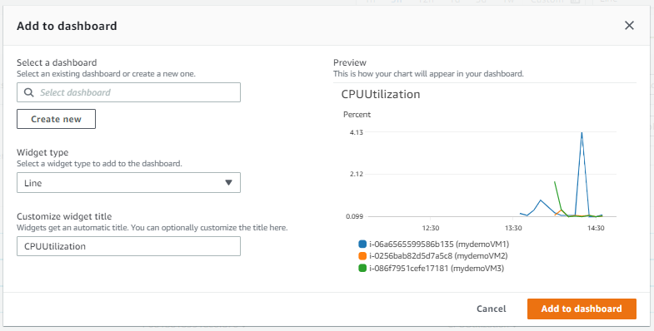

1. Give a name for the dashboard and click on **Create**
2. Click on **Add to dashboard** button

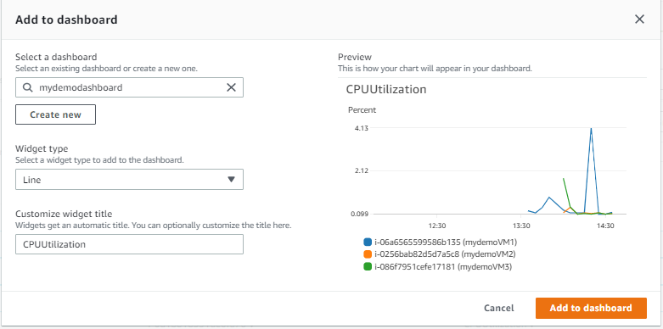

1. Click on the **Save dashboard** button:

**Step 6: Create an alarm**

1. Click **Alarms** and select **In alarm**
2. Click **Create alarm:**

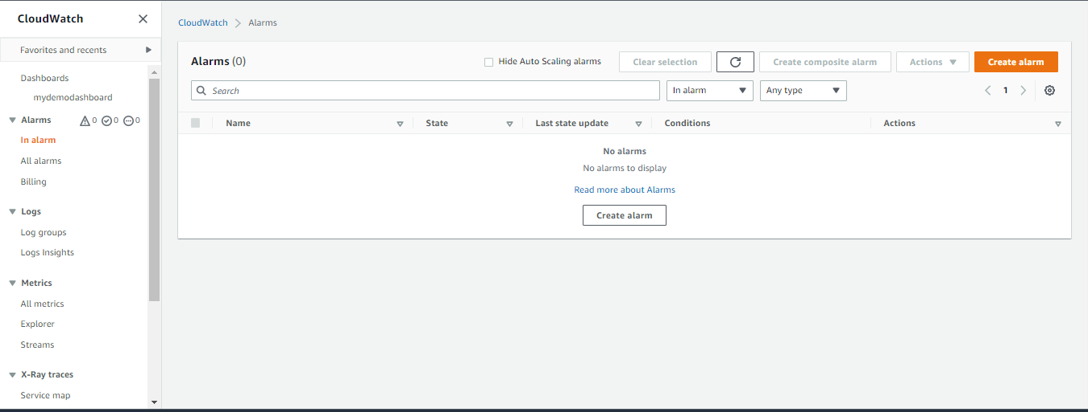

1. Click on **Select metric** then click on **Next:**

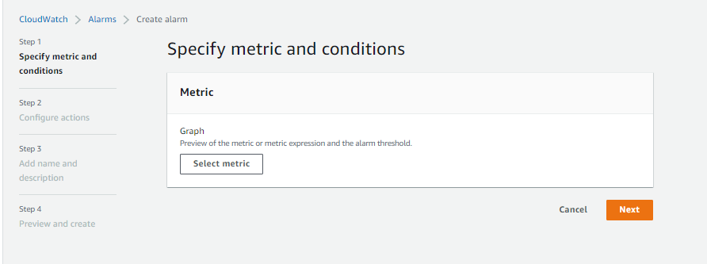

1. Click on **EC2**, select **Per-Instance Metrics**,and search **CPUUtilization** in the search bar
2. Select one metric at a time and click on **Select Metric** button:

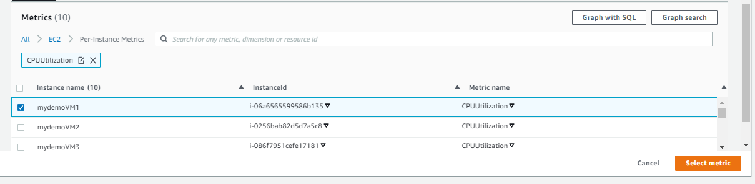

1. Give threshold value as 60 and click on **Next:**

1. Click on **Create new topic** and add an email address then click on **Create topic:**

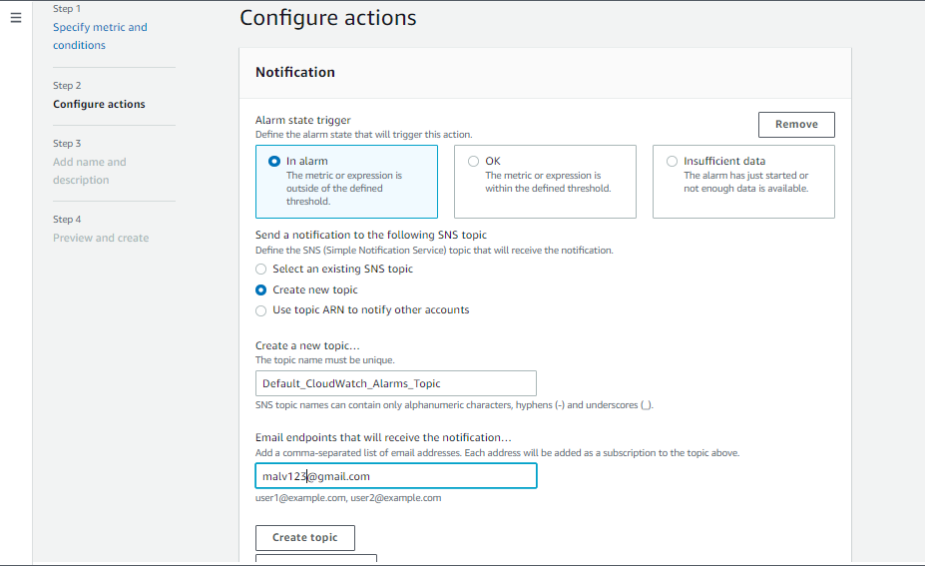

1. Add a **Name** for alarm and click on **Create alarm**

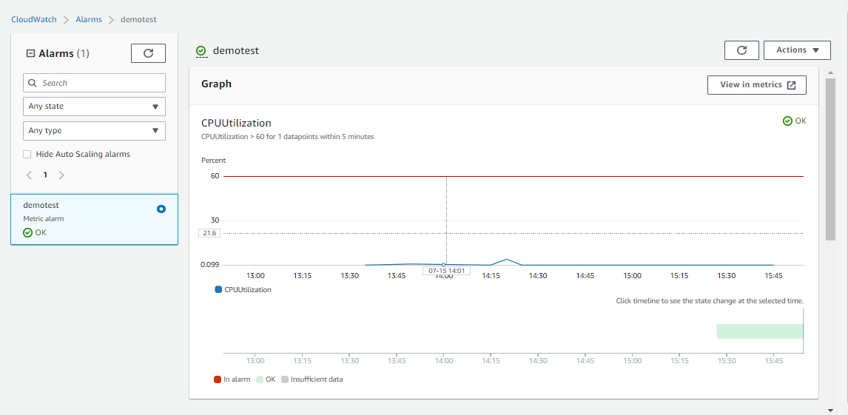

The expected result is obtained.