**Lesson 10 Demo 4**

**Dynamic Port Integration with Application Load Balancer**

**Objective:** To enable dynamic port mapping in a container

**Tools required:** AWS account

**Prerequisites:** NA

Steps to be followed:

1. Create a custom VPC and enable DNS hostname
2. Create Internet Gateway
3. Create three subnets
4. Create a Route table and attach it to three subnets
5. Create a Target group
6. Create an application load balancer
7. Create a Cluster
8. Create a Task definition
9. Run the task on the cluster

**Step 1: Create a custom VPC and enable DNS hostname**

* 1. 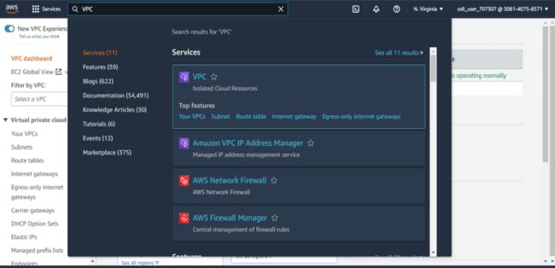In the AWS management console, search for **VPC** and then click on **Your VPC’s** from the search result

1.2 In VPC dashboard, click on **Create VPC**

1.3 In Create VPC window do the following:

* Select **VPC only**
* Enter an arbitrary name for the VPC in **Name tag**
* 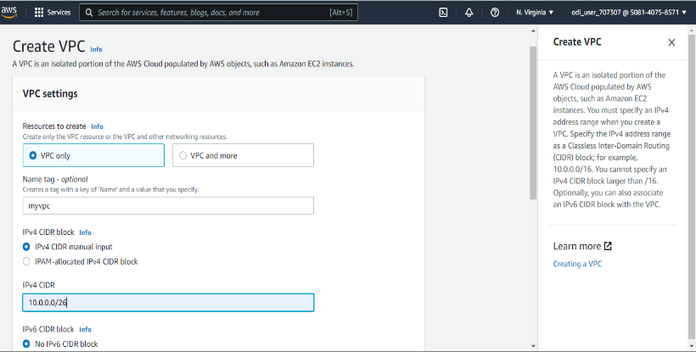Enter **10.0.0.0/26** in **IPv4 CDR**

* Click on **Create VPC**

1.4 In **VPC dashboard** click on **Actions** and select **Edit DNS hostnames**

1.5 Click on **Enable** in **DNS hostnames,** then click on **Save changes**

**Step 2 Create Internet Gateway**

2.1 Now go back to your **VPC dashboard** and click on **Create Internet gateway**

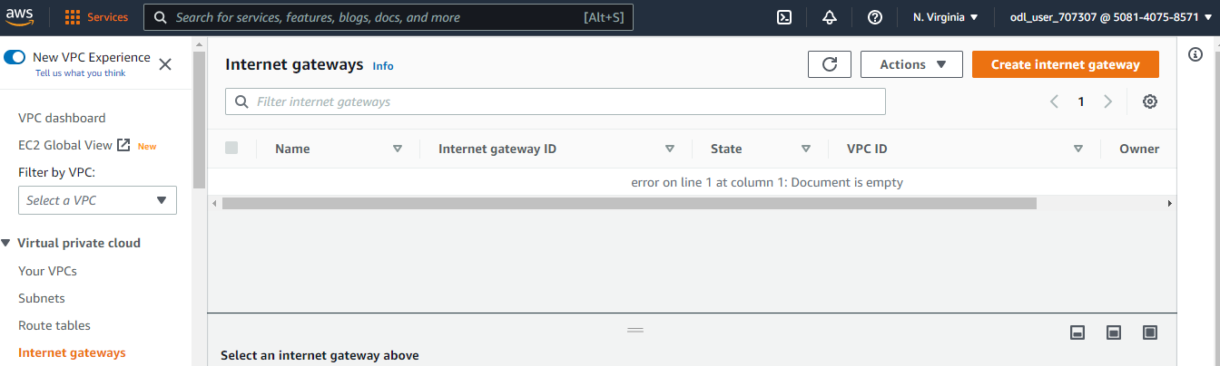

2.3 Enter an arbitrary name for the **Internet gateway** in the **Name tag**,then click on **Create**

**internet gateway**

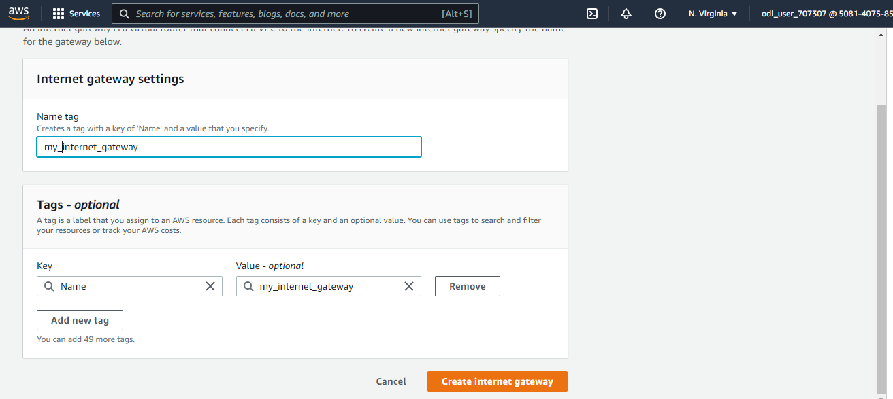

2.4 In the **Internet gateways dashboard** click on **Attach to a VPC**

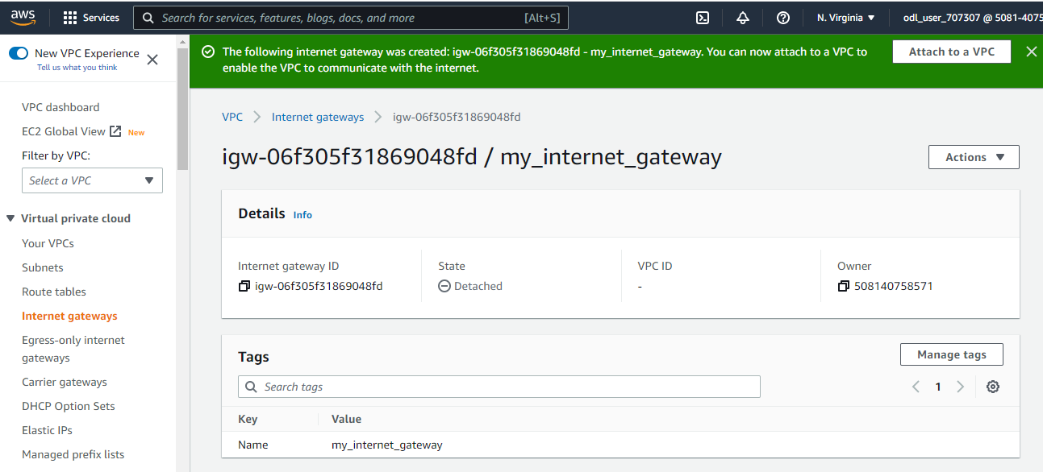

2.5 In the **Available VPCs**, select the VPC created in step 1, then click on **Attach internet**

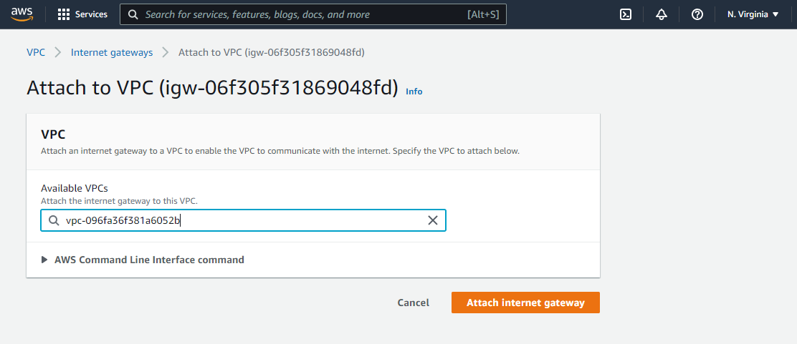**gateway**

**Step 3 Create three subnets**

3.1 Click on **Subnets**

3.2 In the **VPC ID**, enter the VPC created in step 1

3.3 In the Subnet settings section, do the following:

* Create a subnet in the **us-east-1a** zone and enter **10.0.0.0/28** in **IPv4 CIDR block**
* Create a subnet in the **us-east-1b** zone and enter **10.0.0.16/28** in **IPv4 CIDR block**
* Create a subnet in the **us-east-1c** zone and enter **10.0.0.32/28** in **IPv4 CIDR block**
* 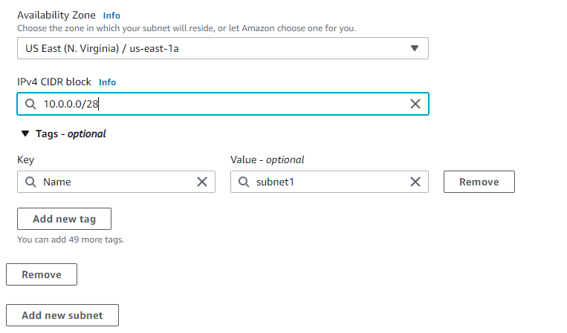Click on **Create subnet**

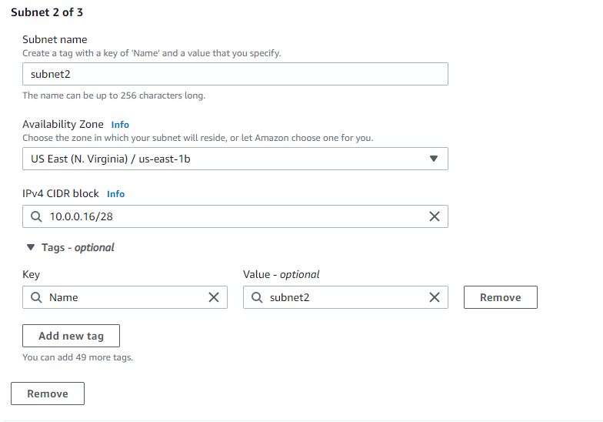

3.4 In the Subnets dashboards, click on **Actions**, then select **Edit subnet settings**

Click on **Enable auto-assign public IPv4 address**

**Step 4 Create a Route table and attach it to three subnets**

4.1 Go to route table dashboard click on **Create route table**

4.2 In the create route table window, do the following:

Enter an arbitrary name for the route table

Add the VPC created in step 1 in the VPC section

Click on **Create route table**

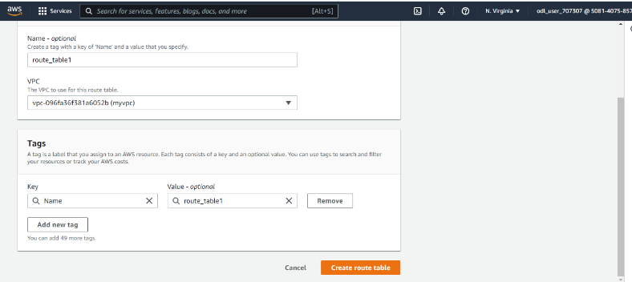

4.3 In the route table dashboard select the route table go to **Actions** tab and then click on

**Edit routes**

4.4 In the Edit routes window, do the following:

Select **Internet Gateway** from the drop down

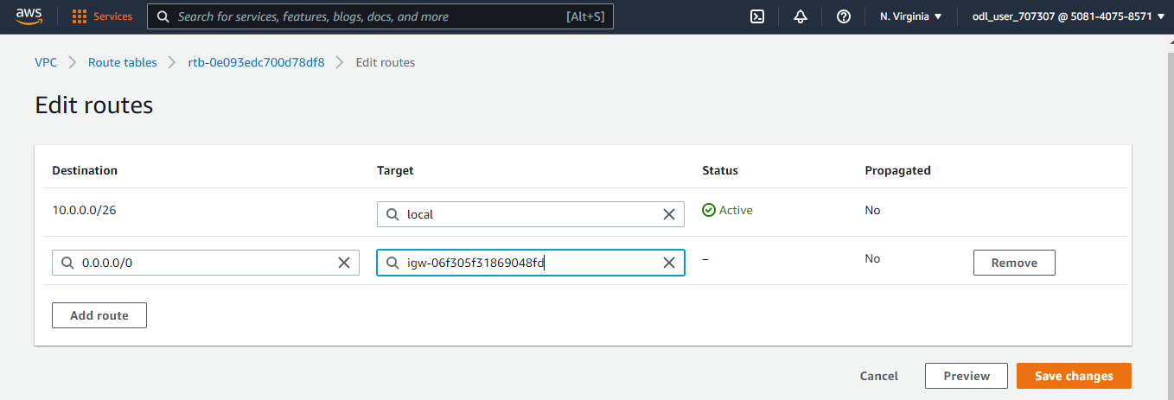 Click on **Save changes**

4.5 In the route table dashboard select the route table go to **Actions** tab and then click on

**Edit subnet association**

* Select all the three subnets and click on **Save association**

**Step 5: Create a Target group**

5.1 In the **Choose target type** section select **Instances**

5.2 In the **Target group name** section give a **name** of your choice to the target group and

then select the VPC created in step 1

5.3 Now click on **Next**

5.4 After clicking on Next the Target group will be successfully created

**Step 6: Create an application load balancer**

6.1 On the left pane of the **EC2 dashboard** click on **Load Balancer**

6.2 In the **Load Balancer Dashboard** click on **Create Load Balancer.** In the **Load balancer types** select **Application Load Balancer**

**

* 1. In the **Load balancer name** add any **name** of your choice and then in **Network mappings**

select the VPC created in step 1

6.5 In the **Security Group** section select the **default security group**

6.6 Add the target group created in step 5 to your **Default action**

Click on **Create load balance**

* Now, click on **View load balancer:**

**Step 7: Create a cluster**

* 1. In the AWS management console search for **ECS** and then click on **Elastic Container**

**Service:**

* 1. In the ECS dashboard click on **Clusters:**

7.3 Click on **Create Cluster:**

7.4 In the **Select cluster template** section select **EC2 Linux + Networking**:

7.5 In the **Configure cluster** section:

* In **Cluster name** enter any arbitrary name for the cluster
* Click on **Create**

7.6 In the **Launch Status** click on **View Cluster:**

**Step 8: Create a task definition**

8.1 In the ECS dashboard click on **Task Definitions.** Click on **Create new Task Definition**:

8.3 In **Select launch type compatibility** select **EC2**.

8.4 In the **Configure task and container** **definition** do the following:

* Add an arbitrary name for the Task Definition in the **Task definition name**
* In **Task memory (MiB)** enter 512 and 1024 in **Task CPU(Units)**
* Click on Add Container

8.5 In the Add container console do the following:

* Give an arbitrary name to the container in the **Container name**
* Graphical user interface, application

  Description automatically generatedEnter **nginx:latest** inthe **Image**

8.6 Set the **Hard limit** as **128**

8.7 Enter **Host port** as **0** and **Container port** as **80**,then click on **Add**

8.7 Click on **Create** in **Configure task and container** **definition** console:

**Step 9: Run a task from that task definition on the cluster**

9.1 In the **Task Definition** dashboard click on **Actions** and select **Run Task:**

9.2 In the Run Task console do the following:

* Select **EC2** as **Launch type**
* Enter an arbitrary name for the **Task Group**

In the **Load balancer name** select the load balancer created in step 5, then click on **Add to load balancer**

In **Production listener port** select **80:HTTP**

In **Target group name** select the target group created in step 4

* 1. Graphical user interface, text, application, email

     Description automatically generatedClick on **Run Task:**

9.4 From the **Clusters** dashboard open the task definition created in step 8:

Hence, you have successfully ran a task by enabling dynamic port mapping in a container