Surveillance Robot based on Image Processing
Prof. Ravindra V. Asundi Anjini Ratish P Darshan Sindhe D Nagaraj K Rajeshwar N S

Electronics and Communication Engineering, BMS Institute of Technology and Management, Bengaluru, India

Abstract— This project attempts to provide surveillance to a particular area with the help of a chained robot which will roam the entire given area with randomness. The module uses image processing techniques to observe the environment and notifies the control station. Three main aspects of the project are to maunder in a given area with randomness, observe changes in the environment through captured images and provide parking surveillance.
The robot is equipped with ultrasonic sensors and proximity sensors for self guidance purpose. Once the robot is powered, its autonomy nature will guide towards the randomness. Camera module is used to capture images of environment and detects changes. It notifies the control station if necessary changes have been detected. Parking surveillance system is another feature which will identify the number plate of the vehicle approaching to the parking lobby and verifies for wrong parking in a parking spot.

Keywords - Surveillance, Image Processing, Background Subtraction, Motion Detection

Introduction
The importance of surveillance robots is increasing as security is top priority in today’s unpredictable society. With the advance in technology, we are able to build more robust robots to handle hazardous situations and save several lives. Introducing image processing into surveillance robot can result in effective method to handle and inform hazardous situations to the control station.
The main purpose of the robot we are making is to provide visual information to a selected area and provide surveillance to that particular area. Hence the main feature of our robot is an onboard video camera. Also the robot must be compact and self contained in the sense it mst have an onboard battery pack and wireless interface to the human controller.
This project attempts to address the need for a self-contained security system. Currently, security systems require many costly components and a complicated installation process. Two basic types of systems are currently available. The first is a wired system. One drawback is that installation of a wired system can take a lot of time and money. Another drawback is that it is a permanent part of the home. If the owner moves, the security system must stay. The second type of system is a wireless one. The components for this are also costly. Wireless systems are more mobile, but they require batteries which must be changed every so often.

- HARDWARE
- Raspberry pi
Raspberry pi 3 Model B is used which delivers 6 times the processing capacity than its previous version. It is stated that this Pi board has an upgraded Broadcom BCM2837 ARMCortex-A53 1.2GHz processor. This board also has an increased memory of 1Gbyte LPDDR2-900 RAM. The Pi Board boots from Micro SD card which runs a version of Linux operating system. The Raspberry Pi board takes power from Micro USB socket of 5 Volts, 2 Amperes. The Board itself has a 10/100 BaseT Ethernet socket and 4 numbers USB 2.0 connector. The board has 40-pin 2x20 strip expansion header of which each pin spaced 2.54mm. This 40-pin provides 27 GPIO for connecting input output devices as well as +3.3, +5 Volts and GND supply lines. The board also has 15-pin MIPI Camera Serial Interface for interfacing Raspberry Pi camera module.
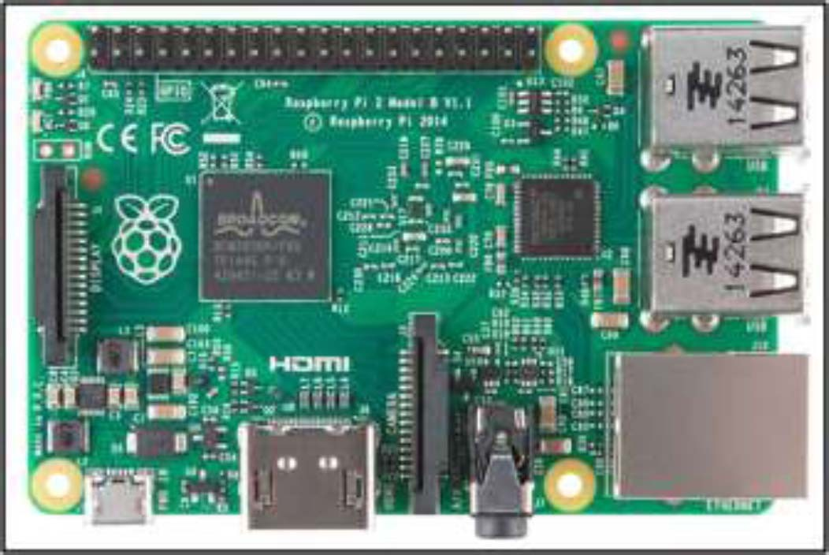

FIG1- Raspberry pi 3 -B

- Robot

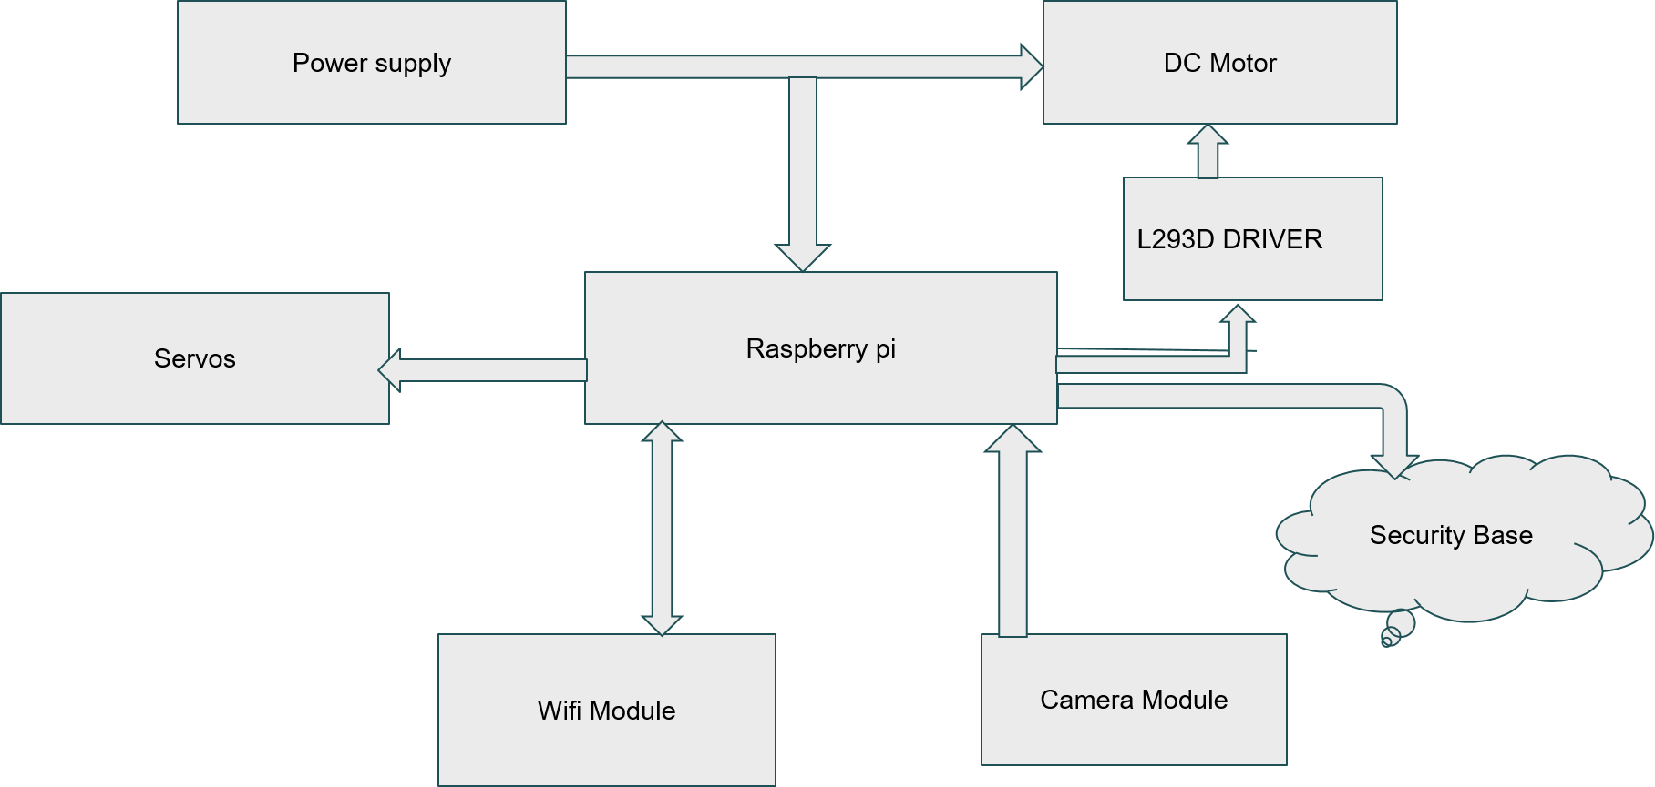
FIG 2- Robot Hardware

Fig. 2 shows the architecture of robot hardware. The robot is built using mechanical and electrical components. The main controlling unit of the system is Raspberry Pi. Power supply circuit is designed to provide power to Pi board and motor driver IC (L293D). Two dc motors are used to control the forward, backward, left and right movement of robot. Camera module is used to take picture frames for video. Tilt motion of camera is controlled using servomotors to provide the wide capturing area.

- Motor Driver Circuit

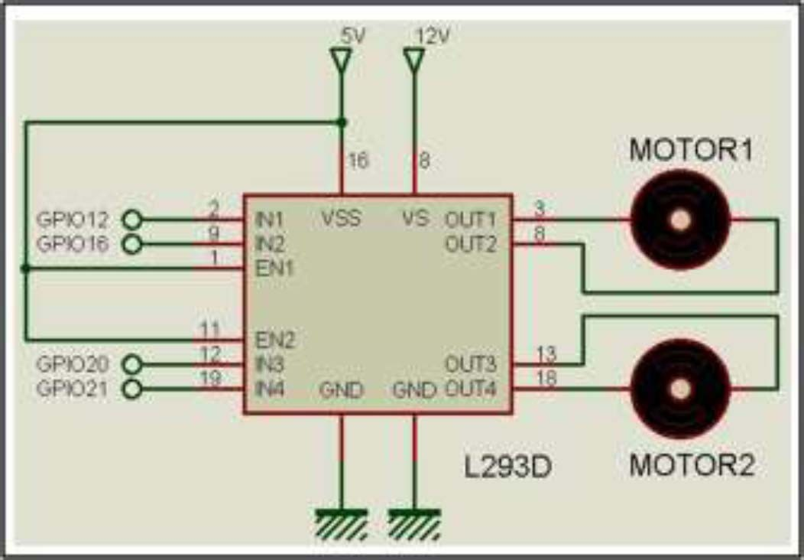

FIG 3- Motor Driver Circuit

Motor driver IC allows DC motor to run in either clockwise or anticlockwise direction. L293D works on H-Bridge principle. There are two H-Bridges in IC. In Fig. 5 there are two Enable pins which are connected to logic 1. There are two supply
pins; VSS which is connected to +5 volts and VS which is connected to +12 volts. The higher voltage +12 volt provides current to DC motor. There are four input pins, each of two pins control a single DC motor. By changing the logic level on two pins like “0 and 1” or “1 and 0” the motor rotation direction has been controlled.

- SOFTWARE

A . For Embedding Code in Raspberry Pi
For the coding of Raspberry Pi, Python language is used. Python language is easy-to-learn since it has a small set of keywords and clearly defined syntax. The diverse set of libraries for Python is portable and compatible with almost all operating systems like Windows, UNIX, and Macintosh. Its programming is 4 times shorter than languages likes JAVA. There is no need to declare any type of arguments or variables. It uses simple functions and variables without defining classes.

B. Open CV
OpenCV (Open Source Computer Vision Library) is an open source computer vision and machine learning software library. OpenCV was built to provide a common infrastructure for computer vision applications and to accelerate the use of machine perception in the commercial products. Being a BSD-licensed product, OpenCV makes it easy for businesses to utilize and modify the code
C. SSH
Secure Shell (SSH) is a cryptographic network protocol for operating network services securely over an unsecured network. Used to remotely login the pi from the Laptop or mobile.

- METHODOLOGY
- Motion Detection
Background subtraction (BS) is a common and widely used technique for generating a foreground mask (namely, a binary image containing the pixels belonging to moving objects in the scene) by using static cameras. As the name suggests, BS calculates the foreground mask performing a subtraction between the current frame and a background model, containing the static part of the scene or, more in general, everything that can be considered as background given the characteristics of the observed scene.
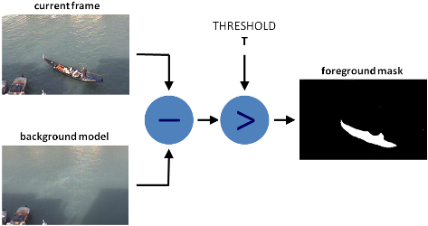
FIG 4 – Background Subtraction
Background modelling consists of two main steps:
- Background Initialization;

- Background Update.
In the first step, an initial model of the background is computed, while in the second step that model is updated in order to adapt to possible changes in the scene.

- Character Recognition
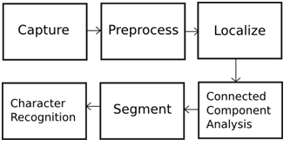
- Object Tracking

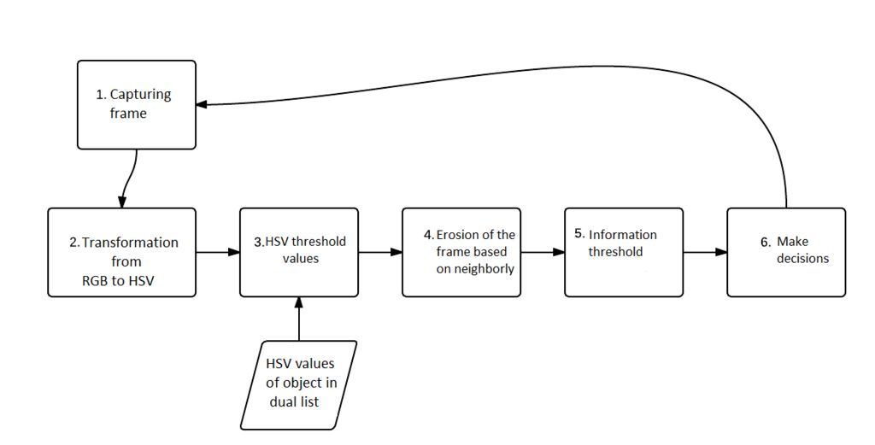

First it was necessary to capture (or receive) the image or, specifically the frame containing the image (frame). The size is 160x120 pixels. The frame at large (eg. 640 pixels wide and 480 pixels high), caused slowdowns in the recognition process when the image was transmitted remotely. The system default is RGB color, this color system is represented in the webcam frame obtained through the basic colors: red (Red), Green (Green) and blue (Blue). These colors are represented on a pixel by pixel dimensional vector, for example, the color red is represented 0com values (0, 255, 0), respectively represented for each channel.
After the captured image, the conversion from RGB color system to the color HSV (hue, saturation, and value) was undertaken, since this model describes similar to the recognition by the human eye colors. Since the RGB (red, green and

blue) system has the colors based on combinations of the primary colors (red, green and blue) and the HSV system defines colors as their color, sparkle and shine (hue, saturation, and value), facilitating the extraction of information. In diagram the step 2 shows the conversion from RGB to HSV, using the "cvtColor" native OpenCV, which converts the input image from an input color system to another function.
With the image in HSV model, it was necessary to find the correct values of HSV minimum and maximum color of the object that will be followed. To save these values, were made two vectors with minimal HSV and HSV maximum color object as values: minimum Hue (42) Minimum saturation (62) Minimum brightness (63) Maximum Hue (92) Maximum Saturation (255) Maximum Brightness (235). So the next step to generate a binary image, the relevant information may be limited only in the context of these values. These values are needed to limit the color pattern of the object. A function of comparing the pixel values with the standard values of the inserted vector was used. The result was a binary image providing only one value for each pixel.
Having made the segmentation, resulting in the binary image, it is noted that noise are still present in the frame. These noises are elements that hinder the segmentation (including obtaining the actual size) of the object. To fix (or attempt to fix) this problem, it was necessary to apply a morphological transformation through operators in the frame, so that the pixels were removed that did not meet the desired standard. For this, the morphological operator EROSION, who performed a "clean" in the frame, reducing noise contained in it was used.
Then it was used to "Moments" function, which calculates the moments of positive contour (white) using an integration of all pixels present in the contour. This feature is only possible in a frame already binarized and without noise, so that the size of the contour of the object is not changed by stray pixels in the frame, which hinder and cause redundancy in information.
moments = cv2.moments (imgErode, True)
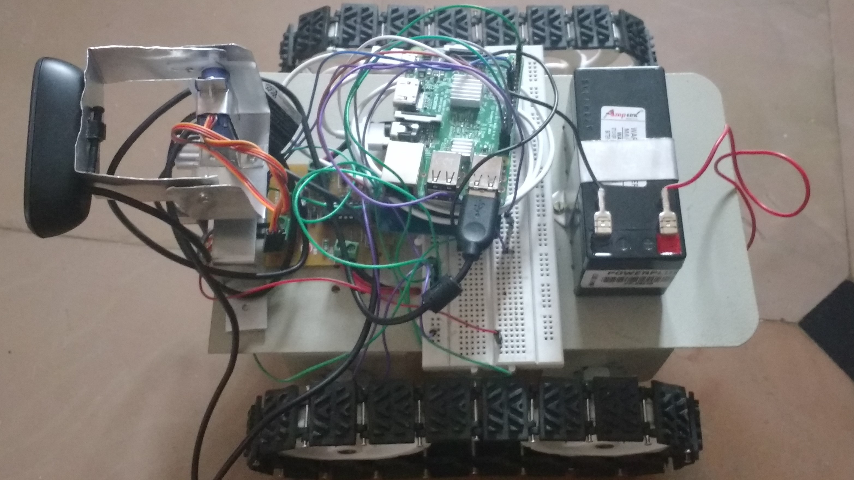
FIG 5- ROBOT

- FUTURE SCOPE

- Robot can be designed to walk on uneven surfaces and stairs.

- Artificial intelligence can be included in the robot.

- Robot can be connected to the cloud and share data between similar robots on surveillance.

- CONCLUSION

This system can be effectively made use in military application, offices and also as a home security system required by the user. It also provides a wide opportunity for various extensions according to the user requirements. Since it carries a given network with it, it can be accessed from wherever the user can manage within a given radius and if the user runs out of range his partner can take up the controls using the portable device software.

It provides real time video streaming for reconnaissance and surveillance operations. By taking the action against received data, any desired surveillance operation can be done.

Although it’s not a finished product in some ways, it can be used as a prototype to develop better, more effective machines(eg: equipped with GSM, Intelligence, cloud etc.) which provide higher security sensitive levels, greater range and more secure body.

- REFERENCES

- Elgammal, Ahmed, David Harwood, and Larry Davis. "Non-parametric model for background subtraction." Computer Vision—ECCV 2000 (2000): 751-767.

- Huang, Shih-Chia. "An advanced motion detection algorithm with video quality analysis for video surveillance systems." IEEE transactions on circuits and systems for video technology 21.1 (2011): 1-14.

- JacobGoldberger, SamRoweis, and RuslanSalakhutdinovGeoffHinton. "Neighbourhood components analysis." NIPS’04 (2004).

- Soucy, Pascal, and Guy W. Mineau. "A simple KNN algorithm for text categorization." Data Mining, 2001. ICDM 2001, Proceedings IEEE International Conference on. IEEE, 2001.

- Du, Shan, et al. "Automatic license plate recognition (ALPR): A state-of-the-art review." IEEE Transactions on Circuits and Systems for Video Technology 23.2 (2013): 311-325.

- Park, Myoungkuk, et al. "Performance Guarantee of an Approximate Dynamic Programming Policy for Robotic Surveillance." IEEE Transactions on Automation Science and Engineering 13.2 (2016): 564-578.

- Yadav, Sanjana, and Archana Singh. "An image matching and object recognition system using webcam robot." Parallel, Distributed and Grid Computing (PDGC), 2016 Fourth International Conference on. IEEE, 2016.

