**Rajesh Document for testing after updating**

* Symposium can be assigned to reviewers from “Bulk Assign Reviewer(s)”. Same as other Papers.
* Manual Assign Reviewers also available. Same as other Papers
* Symposium paper is submitted with:
  + Requested Symposium Type (Requested Presentation Type)
  + Symposium Title
  + Symposium Abstract
  + Chairs and Co-Chairs details
  + Presenter Details + Presentation Title.
  + Themes
  + Custom Fields.
* Reviewer will we assigned to the Submission with all information provided in the symposium.
* Blind Review:
  + Blind Review will be moved from General Setting to each Paper Settings (Abstract, Full Paper, Posters, Presentations, Symposium). For each submission type we can decide if it is enabling or not.
  + Under Symposium Settings > Review will have two sub-options. If Enable Review = YES:
    - Chair and Co-Chair Blind Review (YES, NO). If is yes, no names of Chairs/Co-Chairs should be shown to reviewers
    - Presenters Blind Review (YES, NO). If is yes, no names of presenters should be shown to reviewers
* Automatic Assign Reviews not available for Symposium as this stage.
* The rating for the symposium is one rating for the whole symposium, like our current abstract review. So, in this case, the symposium is accepted.
* Accepted Symposium, and bulk Accept is the same as other paper. Email template based with the Presentation Type must be created.
* Once Symposium is Accepted, individual abstracts will be generated to each presenter, with status = Not Submitted.
* Review page:
  + Will contain the same design of our current Review page, but also will contain the following sections.
    - Paper Details (Symposium details): Title, Themes, Custom Fields
    - Chair/Co-chair section will show if it is not blind review = NO
    - Presenters section will show if it is not blind review = NO
  + Symposium Abstract will show all information show on the template, but we will hide or show Chair and presenters according with settings.
  + All other current functionality will remind the same.
* Reports:
  + Download Review Score Report as other papers
  + Download Submissions Report as other papers (with and without files)
  + Under Reports.

**Review Symposium papers when Abstracts are CREATED after submitting the Symposium.**

Authors Submit a Symposium, and automatically the paper abstracts are generated for each presenter with status = Not Submitted.

A transactional email will be sent to presenters how to log in and how to submit the abstract that has been crated automatically from the Symposium submission.

To review only symposium abstracts and assign reviewers we will add a new checkbox under Limit section of submission. – Filter by Symposium Abstracts = YES/NO

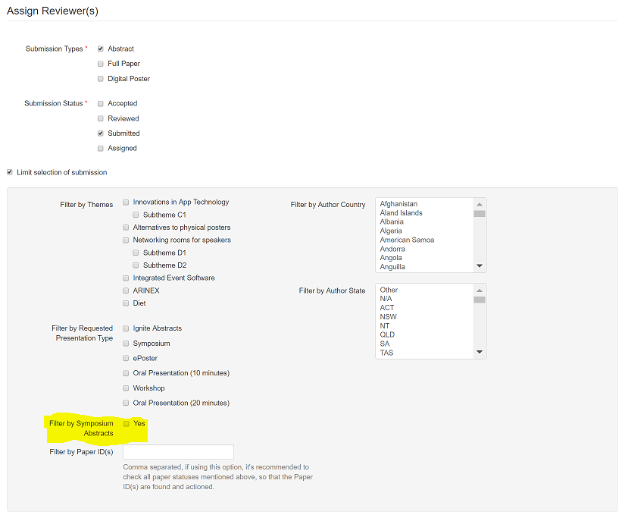

By default, the option will be disable and if we assign Abstracts to reviewers without filter by symposium abstracts, only individual abstracts will be assigned.

To assign abstracts that belong to a Symposium will need to filter by symposium abstracts.

The Assign Review options will remind the same:

* Randomly Assign Reviewers
* Assign Matching papers to Selected Reviewers
* Distribute Matching papers amongst Selected Reviews

However, when we are filtering by Symposium abstracts, all the group of abstracts that belongs to a symposium will be assigned to the Assigned Reviewers selected.

So, we are going to assign Symposium submission to be reviewed along to all abstract submitted.

Example:



In the Review page will appear a new tab called: Symposium Abstracts to differentiate between Abstracts (normal submissions) and Symposium (symposium submissions)

Under Symposium Abstracts tab, we will list the symposiums allocated to the reviewer and once they open the symposium it will show all the symposium information with different tabs for each abstract to review.

The reason that we are going to have a new Symposium Abstract tab is because the Symposium can be reviewed two times:

* Review Symposium without abstracts. -> Accept Symposium and Abstracts are generated
* Review Symposium with Abstracts - > Accept Symposium based with the average scored provide in each individual abstract.

Example:

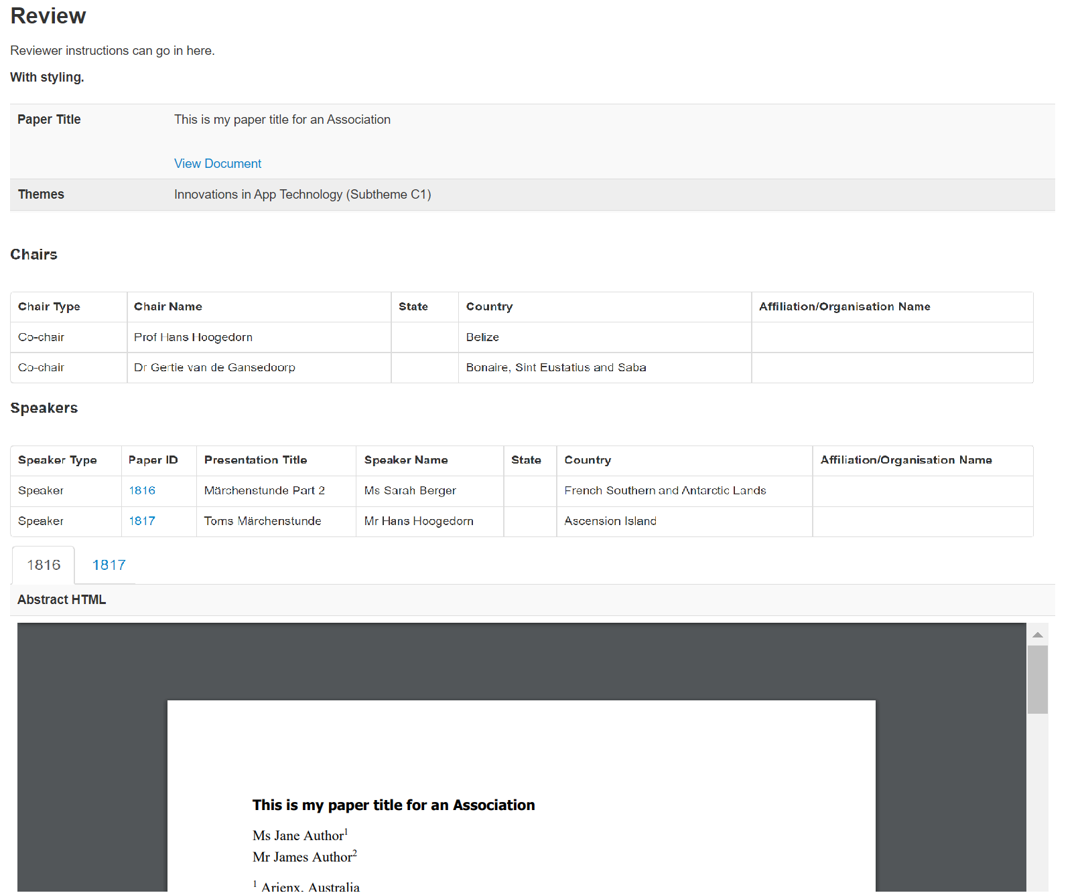

In each tab we will have the score questions that belongs to each abstract.

The average score of the review symposium abstract is the average of all abstracts. This average it will show under Symposium Abstract – Complete Review.

Reports:

* Download Review Score Report as other papers
* Download Submissions Report as other papers (with and without files)
* Under Reports.

**Flow Chart**

