1. 1. Predefined Variables available on design pattern editor (Select 2) → **Target CI type , Computer_system**

2. What is contained in the Extension Section --> Shared Library

3. ITOM capabilities (Select 3) ---> **Realize fast time to value, Enable service impact analysis, Extend discovery throughout IT**

4.

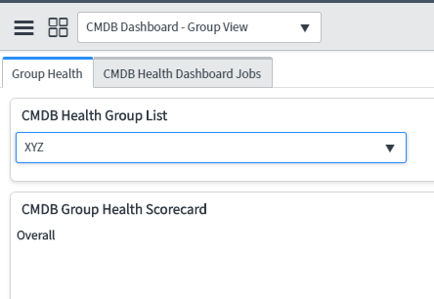

What is XYZ ? -🡪 CMDB Group of type Health

5. How to measure relationship health 🡪 Relationship Staleness, Orphan Relationship, Duplicate Relationship

6. Document example of Datasource Precedence

7. Discovery dashboard errors– possible recommended 🡪 Action on ALL, Action on Selected

8. For a set of duplicate CIs, the CI which we need to keep in CMDB 🡪 Master CI

9. ITOM Packaging (Select 3) → **Standard, Professional, Enterprise**, Corporate

10. 10000 to 1000 IP address example from ebook → **Shazzam Batch Size**

11. ECC Queue: Output→ **Probe**, input→ **Sensor**

12. During SNP Discovery, Log shows “ Active, Couldn’t classify” error → **Redefine or create classifier**

13. vCenter technique for event capturing → Vcenter Event Collector Extension

14. Quick discovery requires → **IP Address, MID Server**

15. Yellow color on MID Server version indicates 🡪 ServiceNow is on Kingston Patch 3 and MID server is on Kingston Patch 1

16. A Device record __→ Provides link to CI

17. Discovery Schedule Manager provided option (Select 2) -> Discovered Device, Unidentified IPs

18. Define ECC queue fields Topic, name, Source and Queue (Match the definitions) →match the defn

19. Device has both SNMP and SSH port open but during first discovery SSH failed and SNMP succeed, What kind Affinity will be saved for future **→ IP Service Affinity**

20. SNMP Uses which credentials -> read community string

21. Which extends Discovery → **Probes and Sensor, classifier and pattern**

1. To Start Debug mode in Infrastructure Select ( 2 options) → **hostname, IP Address**
2. Use different credential from default admin → **Change User**
3. Parse variables operation provides option → **delimiter and position**
4. Merge Table option → **First table, Second table, target table**
5. If you have to parse 2 variables what should be the strategy → **Use 2 steps**
6. What is valid syntax in variable $Table**_**.var  fill out the valid option “ _”? (3 option) → **[*],  [ ], [3],** [X]
7. $process_details[1].install_dir → what is type of variable “process_details”? → **table**
8. How will you define Patter → **A set of step contains operation**
9. Horizontal discovery Process Design Entry point selection**?** Options - ALL, TCP
10. If you want to Discover an application which is communicating to some other application, using patterns, How will discover that? -> Select Target Port and IP as the Find Process Strategy
11. CMDB Health KPI match the KPIs with their definition
12. What is the strategy used in Identification? Whether the CI exists or a new CI is discovered
13. What is best practice while using pattern operations using variables-> Target query to variables
14. One storage device based question was there -> ans in DAS, NAS, SAN, MAN
15. CMDB Health KPI match the KPIs with their definition ->

Ans

Correctness – orphan, staleness, duplicate

Completeness – Required, recommended

Compliance – Audit

Classification – No such CMDB Health KPI

1. Tracked config files – ans files tracked as CI, compare changes
2. One screenshot based example was there on reconciliation and data precedence[Alteris & Snow Discovery]

And -> name did not changes it is as windows 1.

1. One question on deduplication tasks
2. Temprory varriables available in discovery pattern -> computer_system, process
3. One question was on “” – ans constant value
4. $name_details[1].exec_info+”-”+$process.excecutable dir select correct option? -> Ans WMIQuery operation