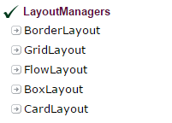

BorderLayout (LayoutManagers):

LayoutManagers:
The LayoutManagers are used to arrange components in a particular manner. LayoutManager is an interface that is implemented by all the classes of layout managers. There are following classes that represents the layout managers:
- java.awt.BorderLayout
- java.awt.FlowLayout
- java.awt.GridLayout
- java.awt.CardLayout
- java.awt.GridBagLayout
- javax.swing.BoxLayout
- javax.swing.GroupLayout
- javax.swing.ScrollPaneLayout
- javax.swing.SpringLayout etc.

BorderLayout:
The BorderLayout is used to arrange the components in five regions: north, south, east, west and center. Each region (area) may contain one component only. It is the default layout of frame or window. The BorderLayout provides five constants for each region:
- public static final int NORTH
- public static final int SOUTH
- public static final int EAST
- public static final int WEST
- public static final int CENTER

Constructors of BorderLayout class:
- BorderLayout(): creates a border layout but with no gaps between the components.
- JBorderLayout(int hgap, int vgap): creates a border layout with the given horizontal and vertical gaps between the components.

Example of BorderLayout class:
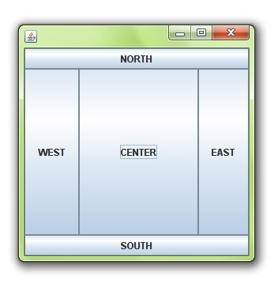

import java.awt.*;
import javax.swing.*;

public class Border {
JFrame f;
Border(){
f=new JFrame();

JButton b1=new JButton("NORTH");;
JButton b2=new JButton("SOUTH");;
JButton b3=new JButton("EAST");;
JButton b4=new JButton("WEST");;
JButton b5=new JButton("CENTER");;

f.add(b1,BorderLayout.NORTH);
f.add(b2,BorderLayout.SOUTH);
f.add(b3,BorderLayout.EAST);
f.add(b4,BorderLayout.WEST);
f.add(b5,BorderLayout.CENTER);

f.setSize(300,300);
f.setVisible(true);
}
public static void main(String[] args) {
new Border();
}
}

GridLayout
The GridLayout is used to arrange the components in rectangular grid. One component is displayed in each rectangle.

Constructors of GridLayout class:
- GridLayout(): creates a grid layout with one column per component in a row.
- GridLayout(int rows, int columns): creates a grid layout with the given rows and columns but no gaps between the components.
- GridLayout(int rows, int columns, int hgap, int vgap): creates a grid layout with the given rows and columns alongwith given horizontal and vertical gaps.

Example of GridLayout class:
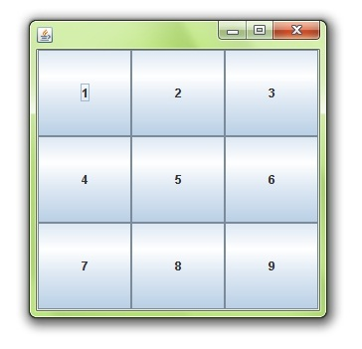
import java.awt.*;
import javax.swing.*;

public class MyGridLayout{
JFrame f;
MyGridLayout(){
f=new JFrame();

JButton b1=new JButton("1");
JButton b2=new JButton("2");
JButton b3=new JButton("3");
JButton b4=new JButton("4");
JButton b5=new JButton("5");
JButton b6=new JButton("6");
JButton b7=new JButton("7");
JButton b8=new JButton("8");
JButton b9=new JButton("9");

f.add(b1);f.add(b2);f.add(b3);f.add(b4);f.add(b5);
f.add(b6);f.add(b7);f.add(b8);f.add(b9);

f.setLayout(new GridLayout(3,3));
//setting grid layout of 3 rows and 3 columns

f.setSize(300,300);
f.setVisible(true);
}
public static void main(String[] args) {
new MyGridLayout();
}
}

FlowLayout
The FlowLayout is used to arrange the components in a line, one after another (in a flow). It is the default layout of applet or panel.

Fields of FlowLayout class:
- public static final int LEFT
- public static final int RIGHT
- public static final int CENTER
- public static final int LEADING
- public static final int TRAILING

Constructors of FlowLayout class:
- FlowLayout(): creates a flow layout with centered alignment and a default 5 unit horizontal and vertical gap.
- FlowLayout(int align): creates a flow layout with the given alignment and a default 5 unit horizontal and vertical gap.
- FlowLayout(int align, int hgap, int vgap): creates a flow layout with the given alignment and the given horizontal and vertical gap.

Example of FlowLayout class:
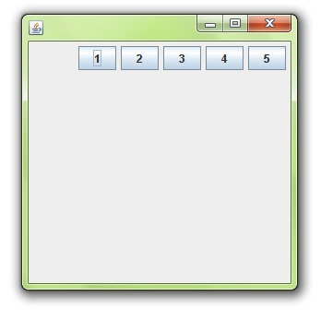
import java.awt.*;
import javax.swing.*;

public class MyFlowLayout{
JFrame f;
MyFlowLayout(){
f=new JFrame();

JButton b1=new JButton("1");
JButton b2=new JButton("2");
JButton b3=new JButton("3");
JButton b4=new JButton("4");
JButton b5=new JButton("5");

f.add(b1);f.add(b2);f.add(b3);f.add(b4);f.add(b5);

f.setLayout(new FlowLayout(FlowLayout.RIGHT));
//setting flow layout of right alignment

f.setSize(300,300);
f.setVisible(true);
}
public static void main(String[] args) {
new MyFlowLayout();
}
}

BoxLayout class:
The BoxLayout is used to arrange the components either vertically or horizontally. For this purpose, BoxLayout provides four constants. They are as follows:

Note: BoxLayout class is found in javax.swing package.

Fields of BoxLayout class:
- public static final int X_AXIS
- public static final int Y_AXIS
- public static final int LINE_AXIS
- public static final int PAGE_AXIS

Constructor of BoxLayout class:
- BoxLayout(Container c, int axis): creates a box layout that arranges the components with the given axis.

Example of BoxLayout class with Y-AXIS:
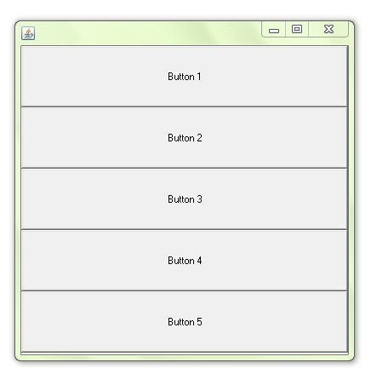
import java.awt.*;
import javax.swing.*;

public class BoxLayoutExample1 extends Frame {
Button buttons[];

public BoxLayoutExample1 () {
buttons = new Button [5];

for (int i = 0;i<5;i++) {
buttons[i] = new Button ("Button " + (i + 1));
add (buttons[i]);
}

setLayout (new BoxLayout (this, BoxLayout.Y_AXIS));
setSize(400,400);
setVisible(true);
}

public static void main(String args[]){
BoxLayoutExample1 b=new BoxLayoutExample1();
}
}

Example of BoxLayout class with X-AXIS:
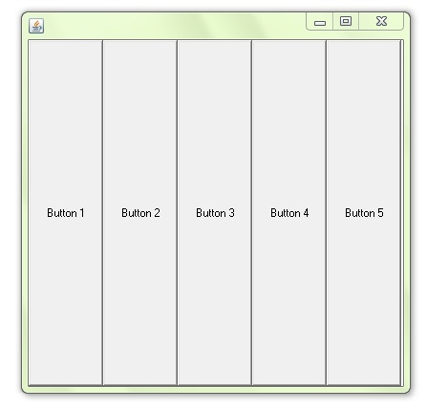
import java.awt.*;
import javax.swing.*;

public class BoxLayoutExample2 extends Frame {
Button buttons[];

public BoxLayoutExample2() {
buttons = new Button [5];

for (int i = 0;i<5;i++) {
buttons[i] = new Button ("Button " + (i + 1));
add (buttons[i]);
}

setLayout (new BoxLayout(this, BoxLayout.X_AXIS));
setSize(400,400);
setVisible(true);
}

public static void main(String args[]){
BoxLayoutExample2 b=new BoxLayoutExample2();
}
}

CardLayout class
The CardLayout class manages the components in such a manner that only one component is visible at a time. It treats each component as a card that is why it is known as CardLayout.

Constructors of CardLayout class:
- CardLayout(): creates a card layout with zero horizontal and vertical gap.
- CardLayout(int hgap, int vgap): creates a card layout with the given horizontal and vertical gap.

Commonly used methods of CardLayout class:
- public void next(Container parent): is used to flip to the next card of the given container.
- public void previous(Container parent): is used to flip to the previous card of the given container.
- public void first(Container parent): is used to flip to the first card of the given container.
- public void last(Container parent): is used to flip to the last card of the given container.
- public void show(Container parent, String name): is used to flip to the specified card with the given name.

Example of CardLayout class:
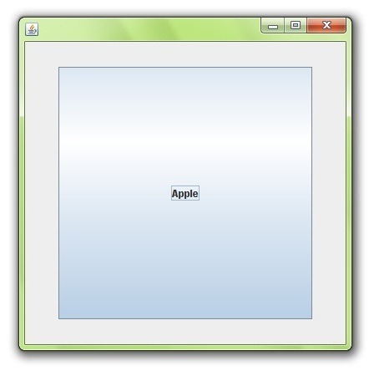

import java.awt.*;
import java.awt.event.*;

import javax.swing.*;

public class CardLayoutExample extends JFrame implements ActionListener{
CardLayout card;
JButton b1,b2,b3;
Container c;
CardLayoutExample(){

c=getContentPane();
card=new CardLayout(40,30);
//create CardLayout object with 40 hor space and 30 ver space
c.setLayout(card);

b1=new JButton("Apple");
b2=new JButton("Boy");
b3=new JButton("Cat");
b1.addActionListener(this);
b2.addActionListener(this);
b3.addActionListener(this);

c.add("a",b1);c.add("b",b2);c.add("c",b3);

}
public void actionPerformed(ActionEvent e) {
card.next(c);
}

public static void main(String[] args) {
CardLayoutExample cl=new CardLayoutExample();
cl.setSize(400,400);
cl.setVisible(true);
cl.setDefaultCloseOperation(EXIT_ON_CLOSE);
}

