Creating the CNAB HELLOWORLD:

Created a folder name CNAB_WS

Prerequisites:
a)Duffle installed in your machine and set it as Globally or keep Duffle file in place where you execute the commands.

STEPS::::::::
1) To Create the Duffle Folder struture use the below command
→ duffle create helloworld

the above command create the following folder structure:
CNAB_WS
→ helloworld
a)CNAB
app
run
Dockerfile
b)duffle.json
The Screenshot looks like this::::

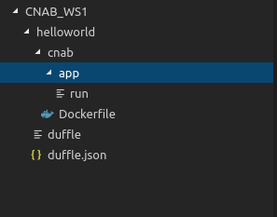

The Dockerfile looks like this below screenshot (Invocation Image)

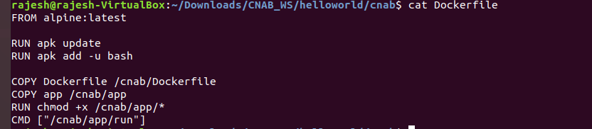

The run file looks file below screenshot
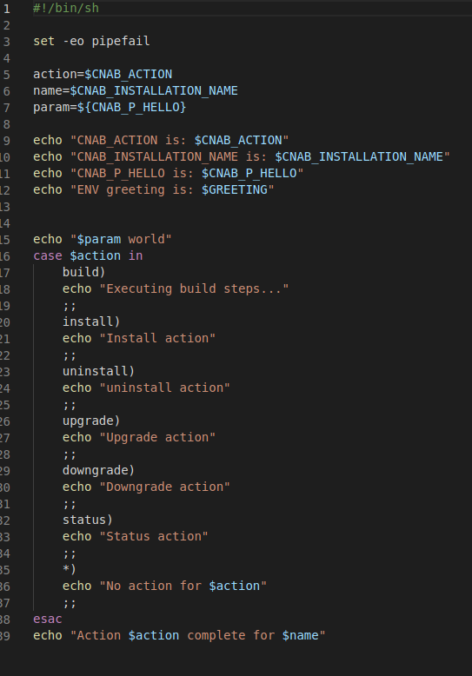

Creating the duffle.json:
The screetshot looks like below:::

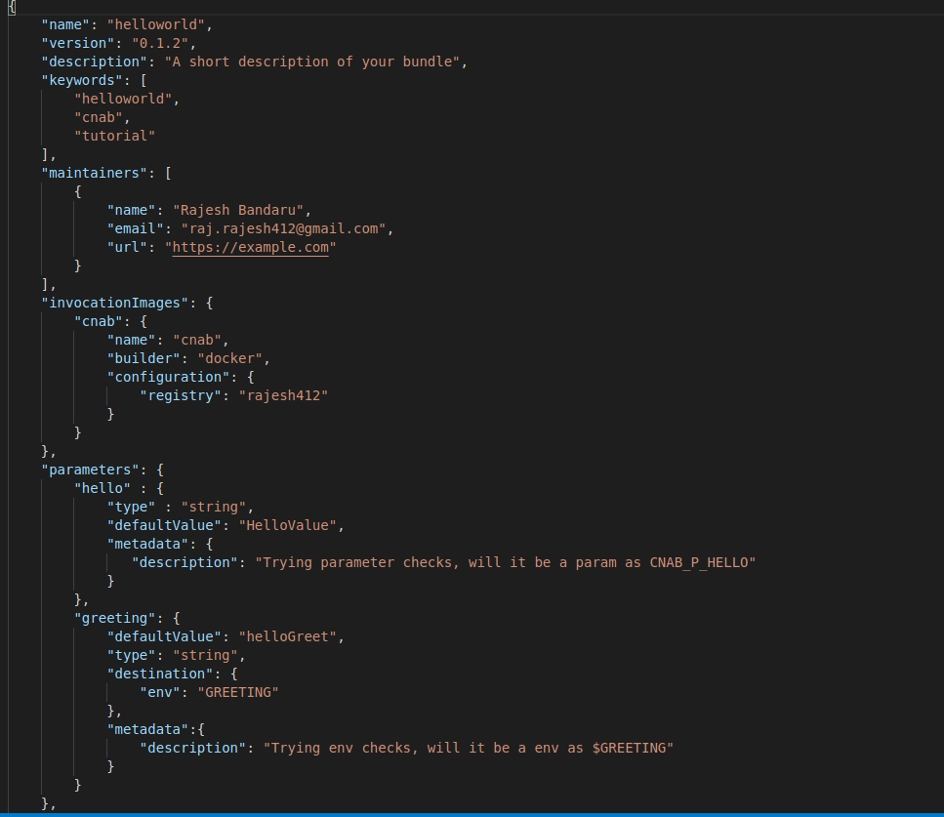

To Build an Image:

Duffle build .
Ubuntu: sudo ./duffle build .

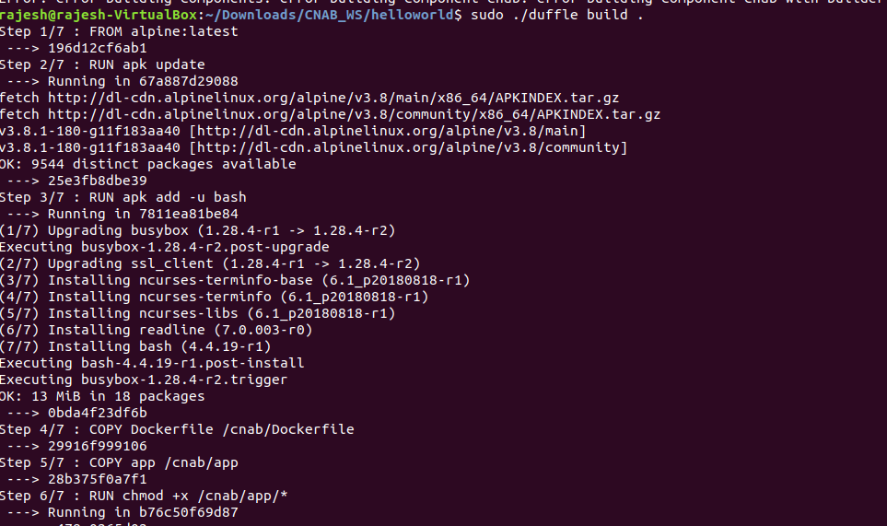

Creation of invocation image:

Inspect bundle list:::
sudo ./duffle bundle list

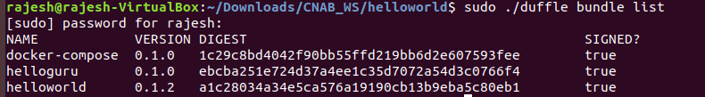
To run the Bundle:
duffle install helloworld
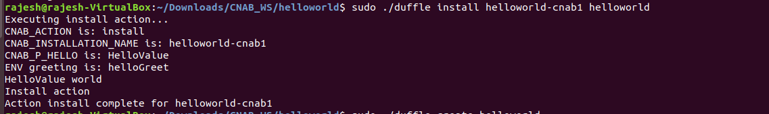

To see the status of duffle:
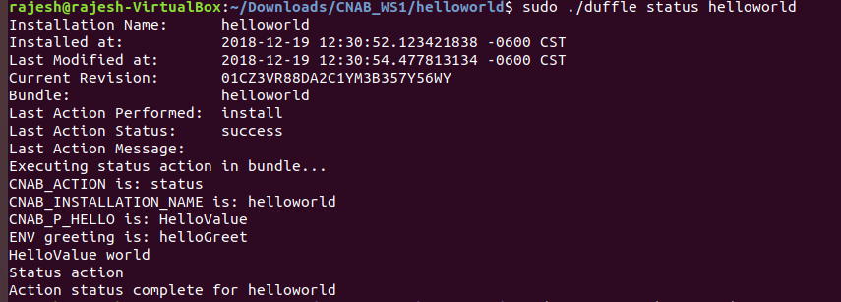

To uninstall action:
