Concerns:

1. Unable to execute any of the custom phases before installation.

Install lifecycle phase is the default first phase.

Workaround is to call other custom phases in the install phase to execute them just before the install phase.



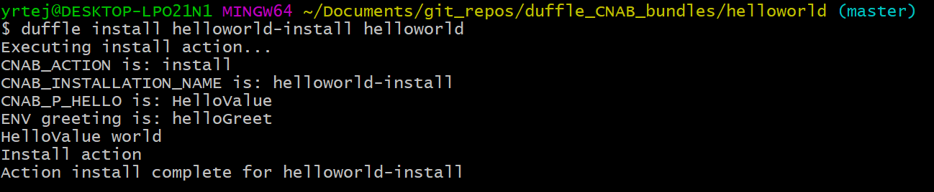

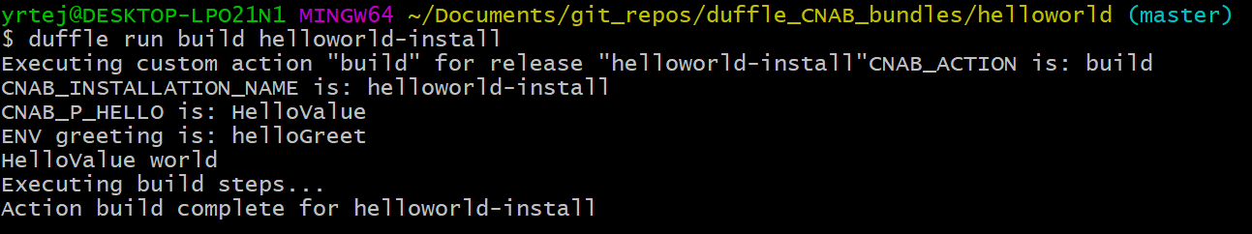

1. Unable to delete claims that are created with an error. There is no force deletions of claims.

Workaround is to delete that claim in ~/.duffle/claims

