1. **Create the Directory Structure**

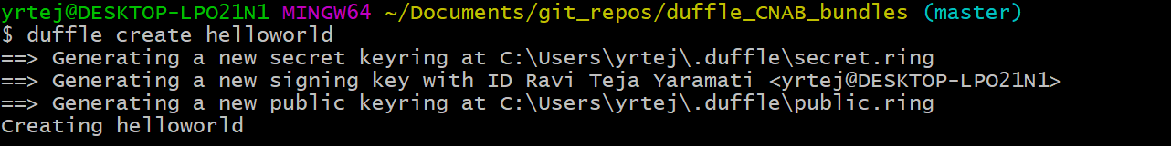

1. **The cnab/ directory**

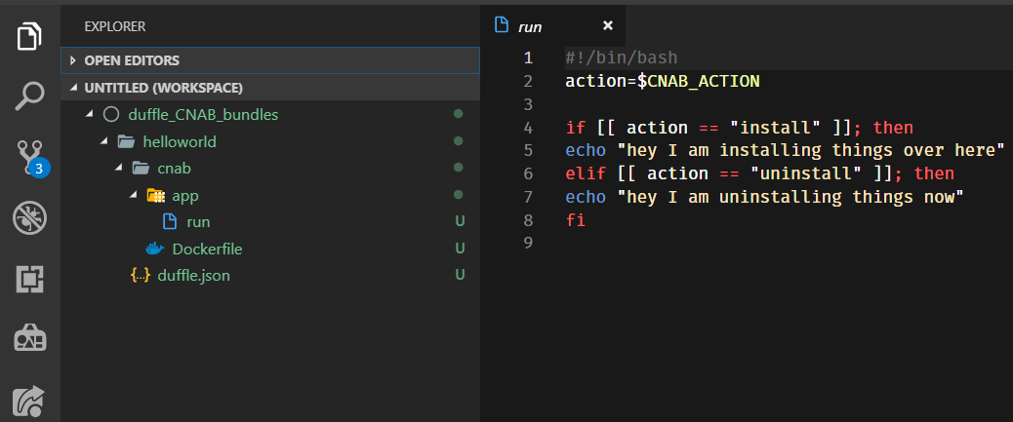

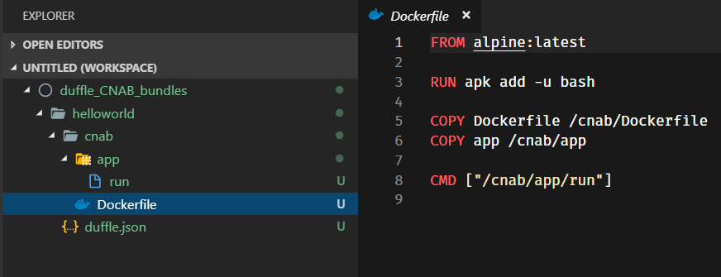

1. **Modifying the run file to reqirements:**

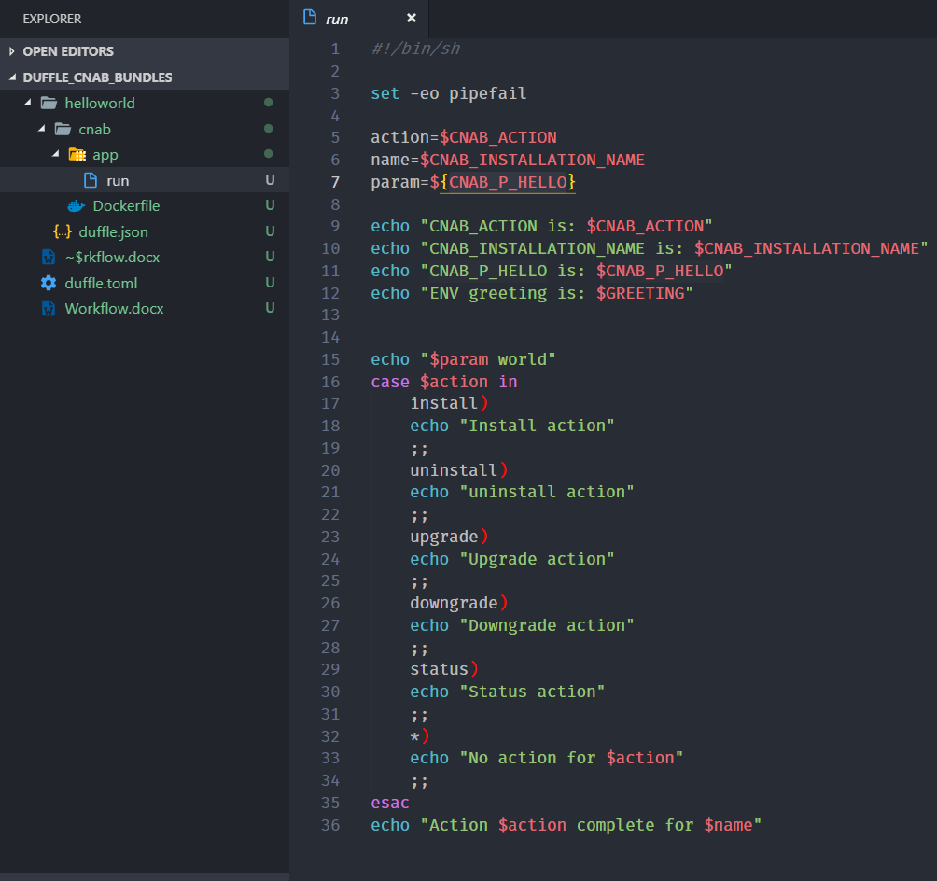

1. **Defining the Invocation Image**

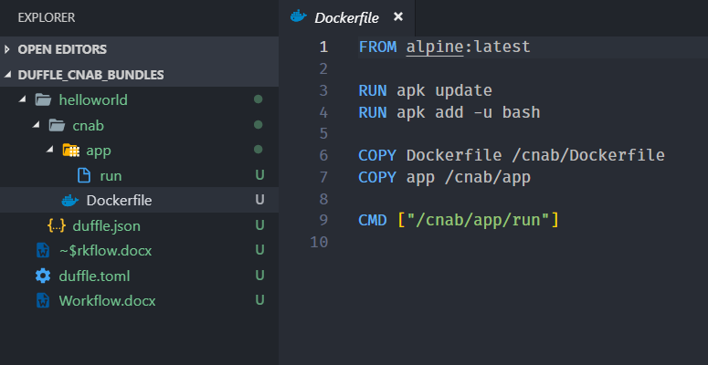

1. **Duffle.json:**

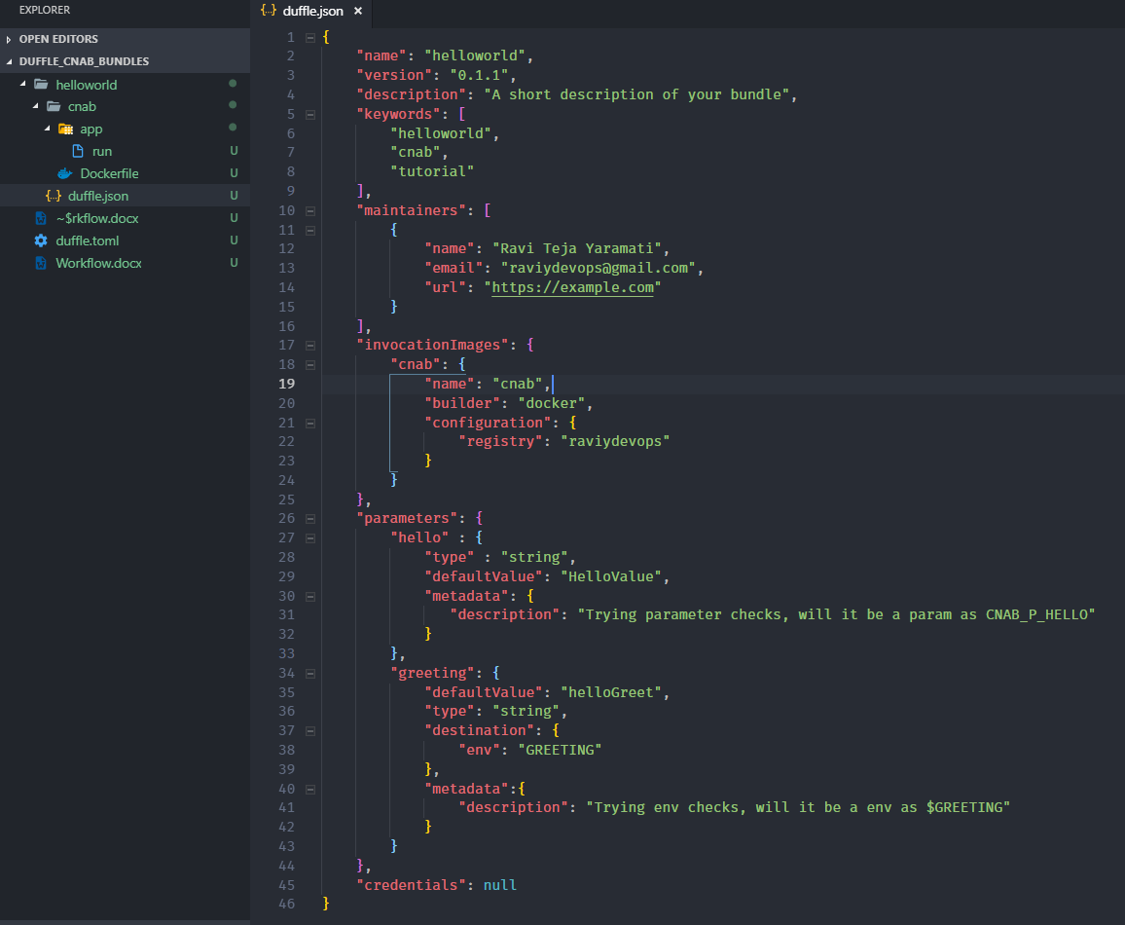

1. **Building the bundle**

## 

Invocation image created and bundle got created. Also we can find the bundle created in ~/.duffle/bundles/ directory.

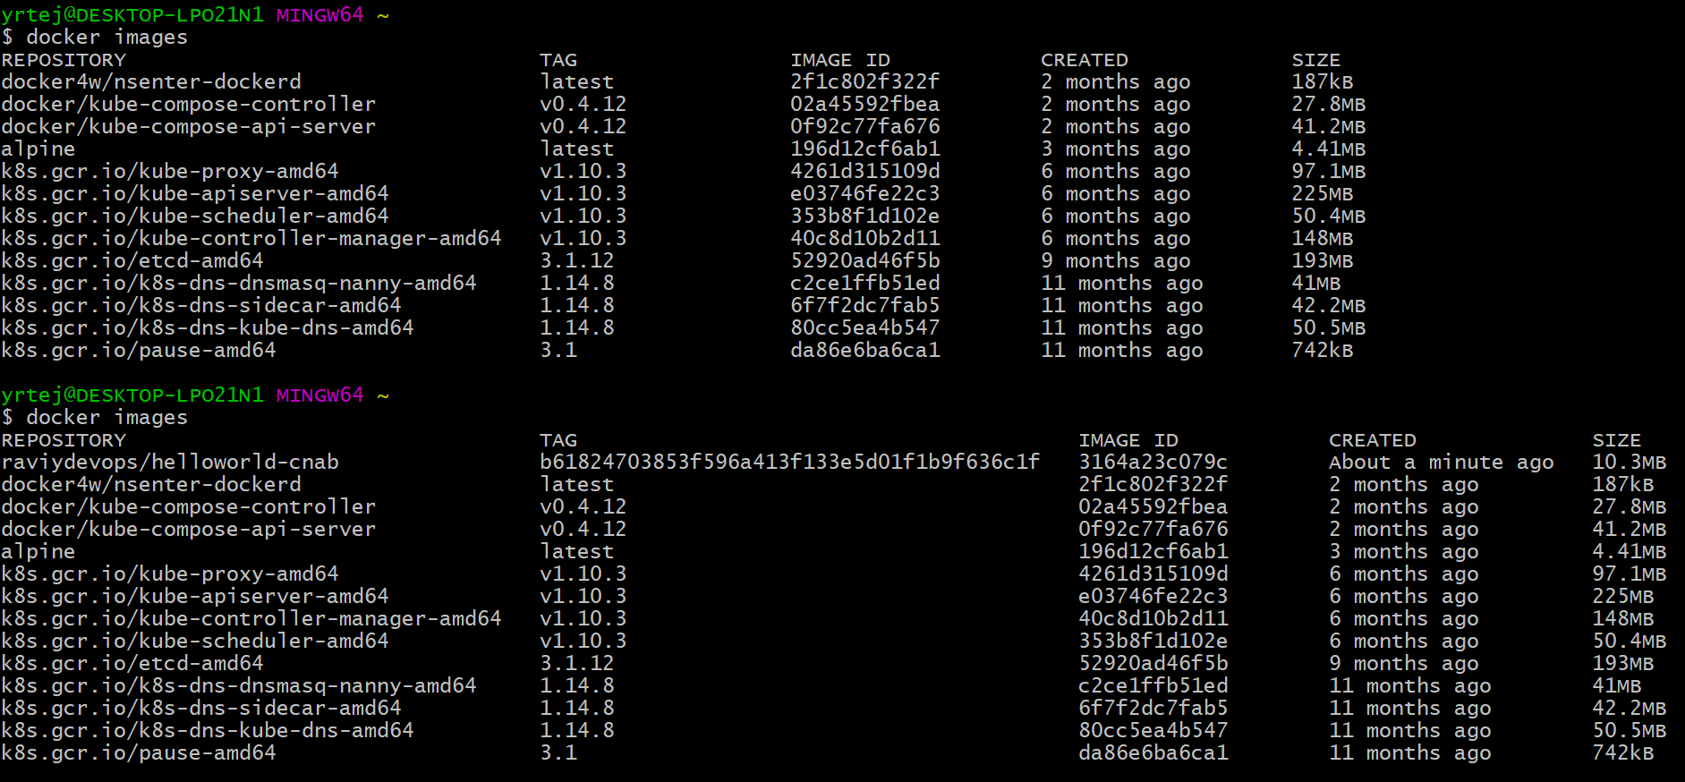

List of bundles:



Inspecting the bundle (low level info of the bundle):

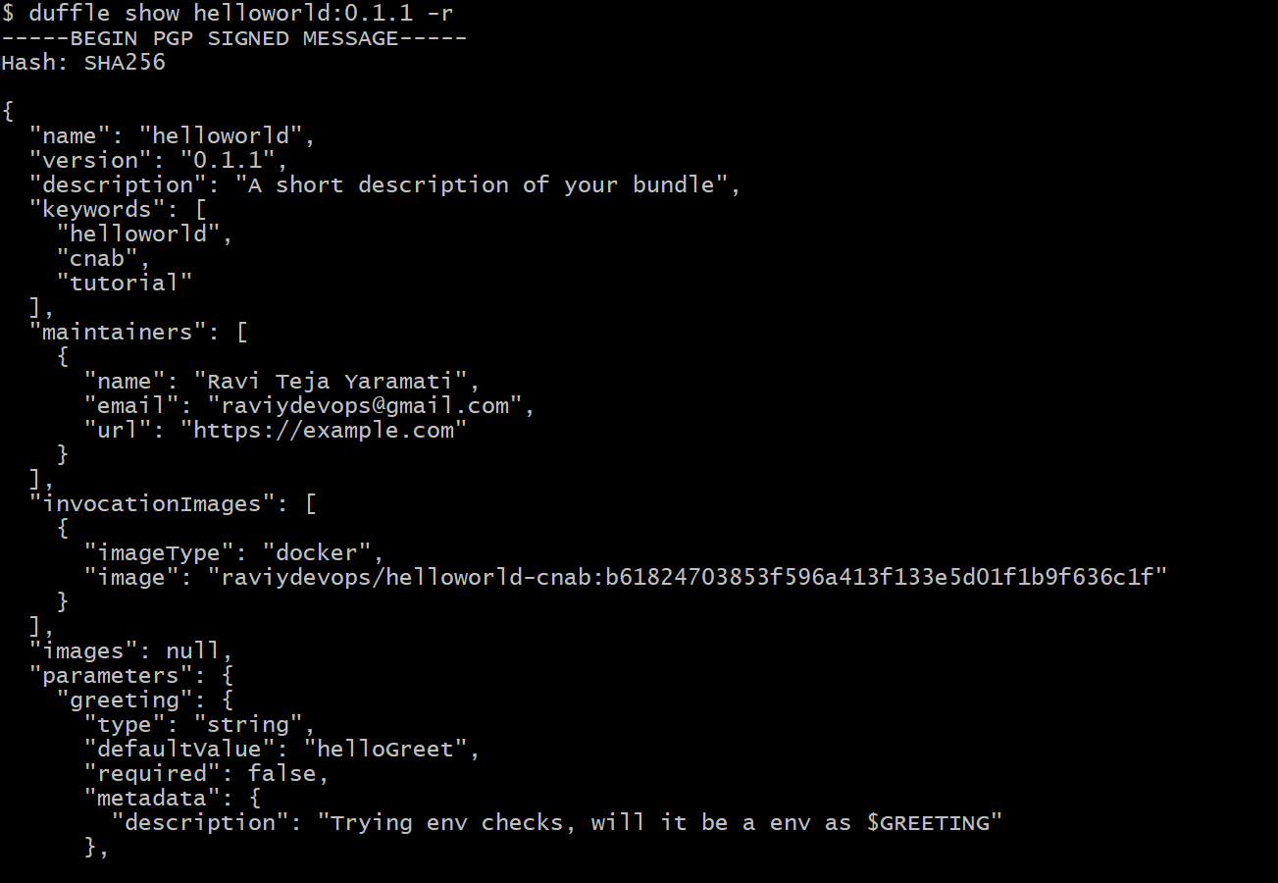

1. **Running the bundle:**

duffle install NAME BUNDLE

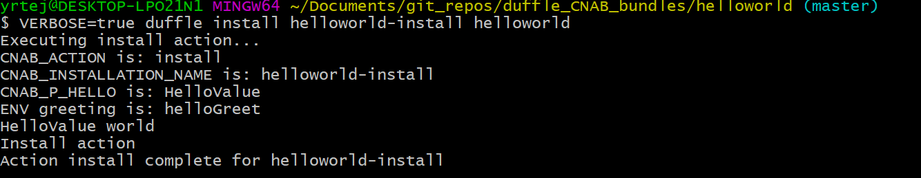

Checking the status of the bundle installation:

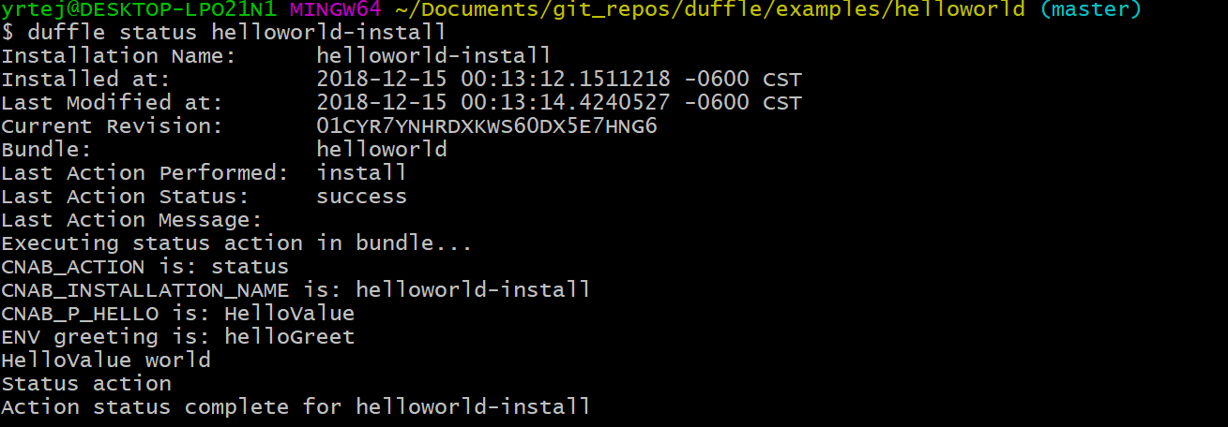

Executing uninstall action:

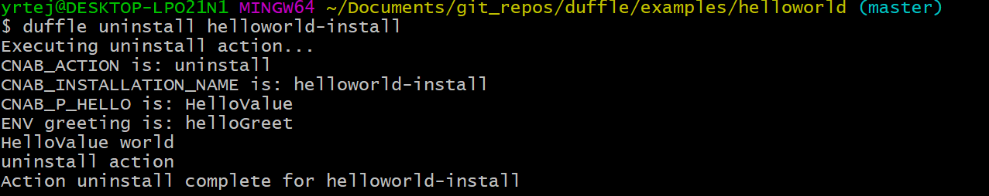



1. **Trying a different custom action:**

Modifying the run script by adding a build phase:

Modifying duffle.json to include actions:build :

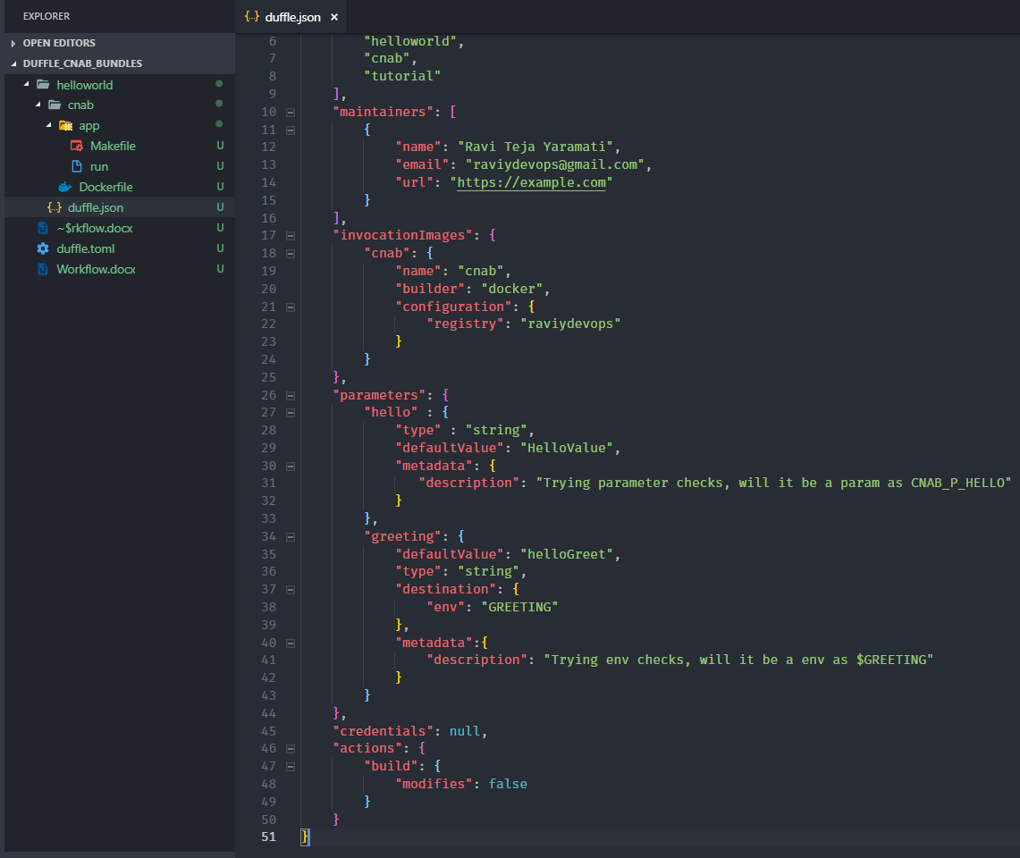

Modifying run script:

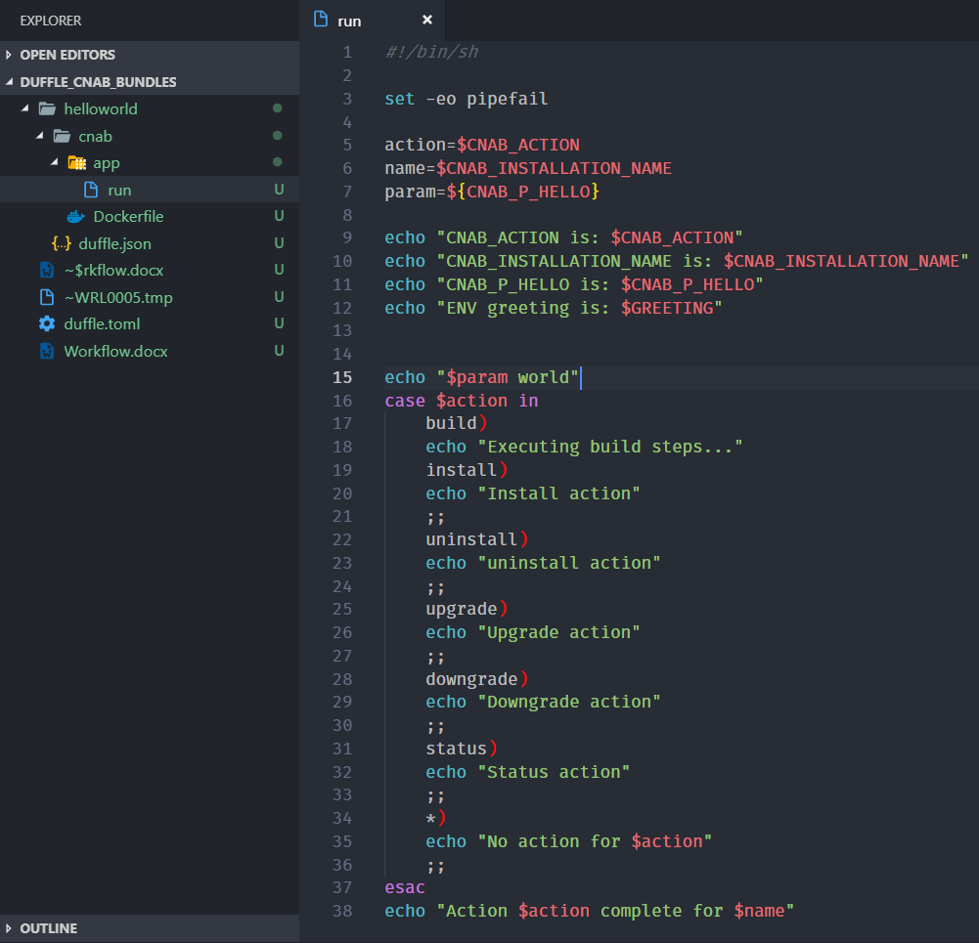

Building the bundle:

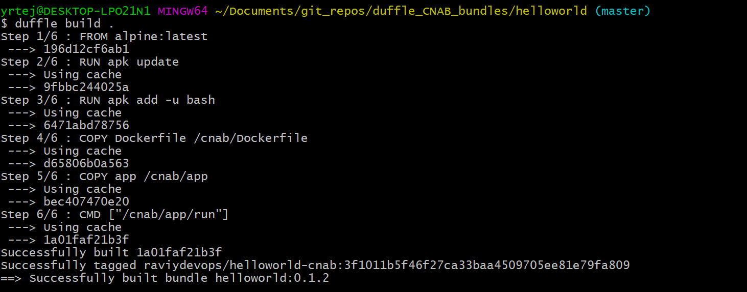

Installing the bundle:

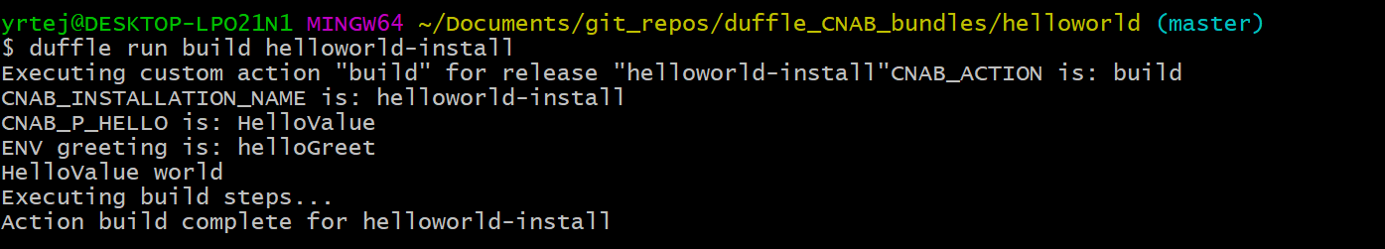

This won’t work:



Custom lifecycles can be executed using duffle run command:

