1. **Create the Directory Structure**



1. **Creating the invocation Image:**

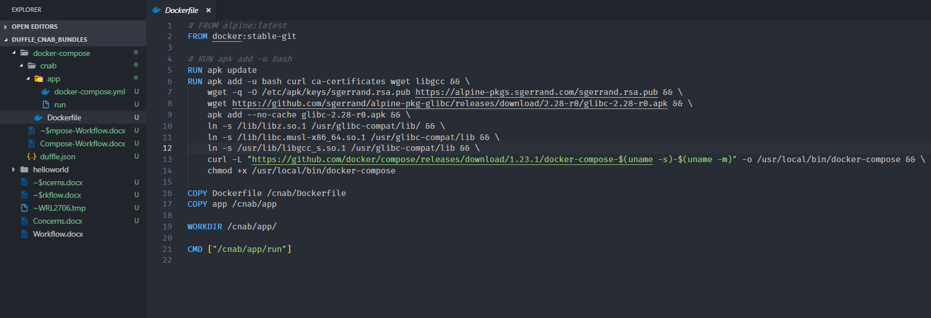

1. **Creating the docker-compose.yml:**

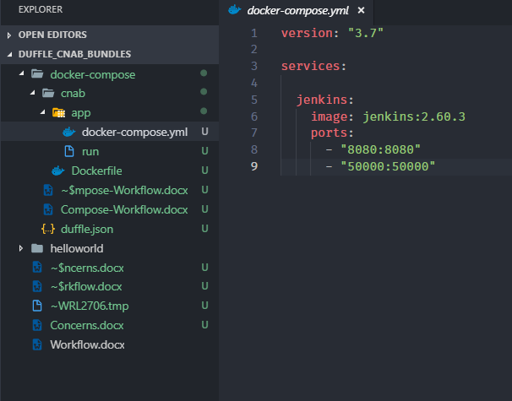

1. **Modifying the run file**

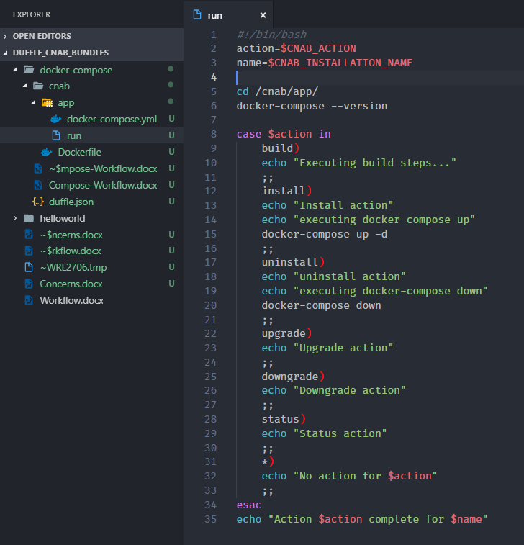

1. **Modifying the duffle.json file:**

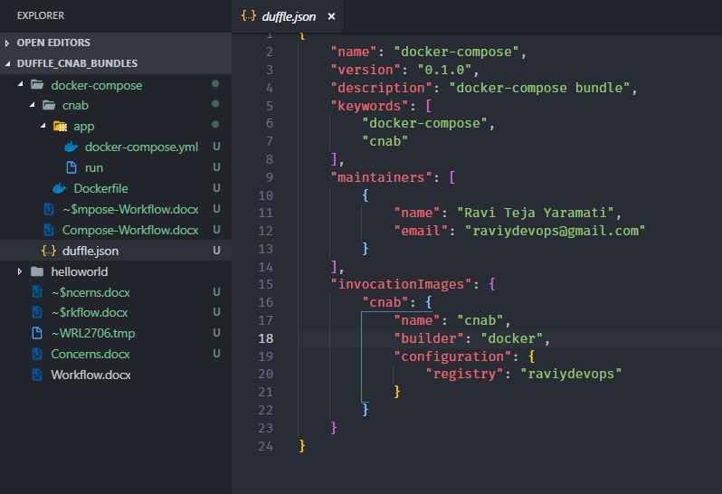

1. **Building the bundle:**

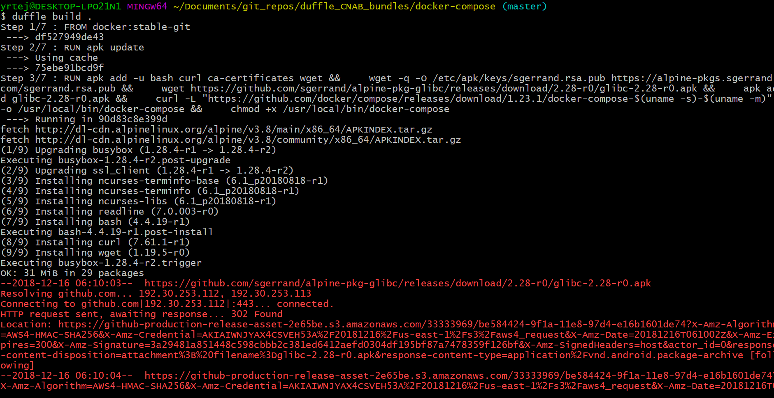

1. **Installing the bundle:**

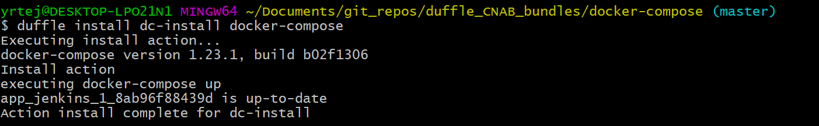

1. **Localhost:8080**

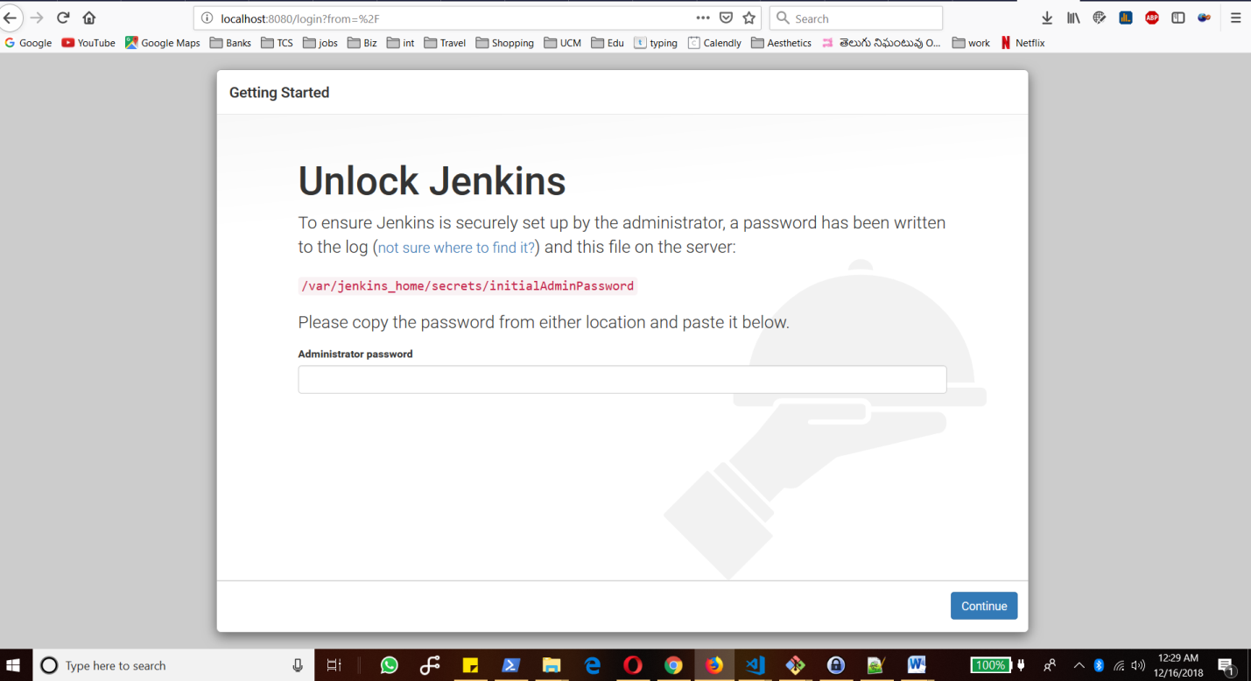

1. **Listing bundles**

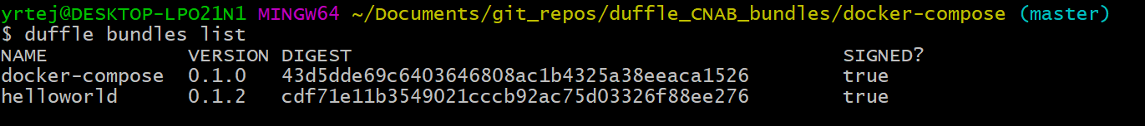

1. **Uninstalling the bundle install**

