Scenario-1:
HandleErrorData:
Source has bad data, write bad data into one sink and good data into another sink.

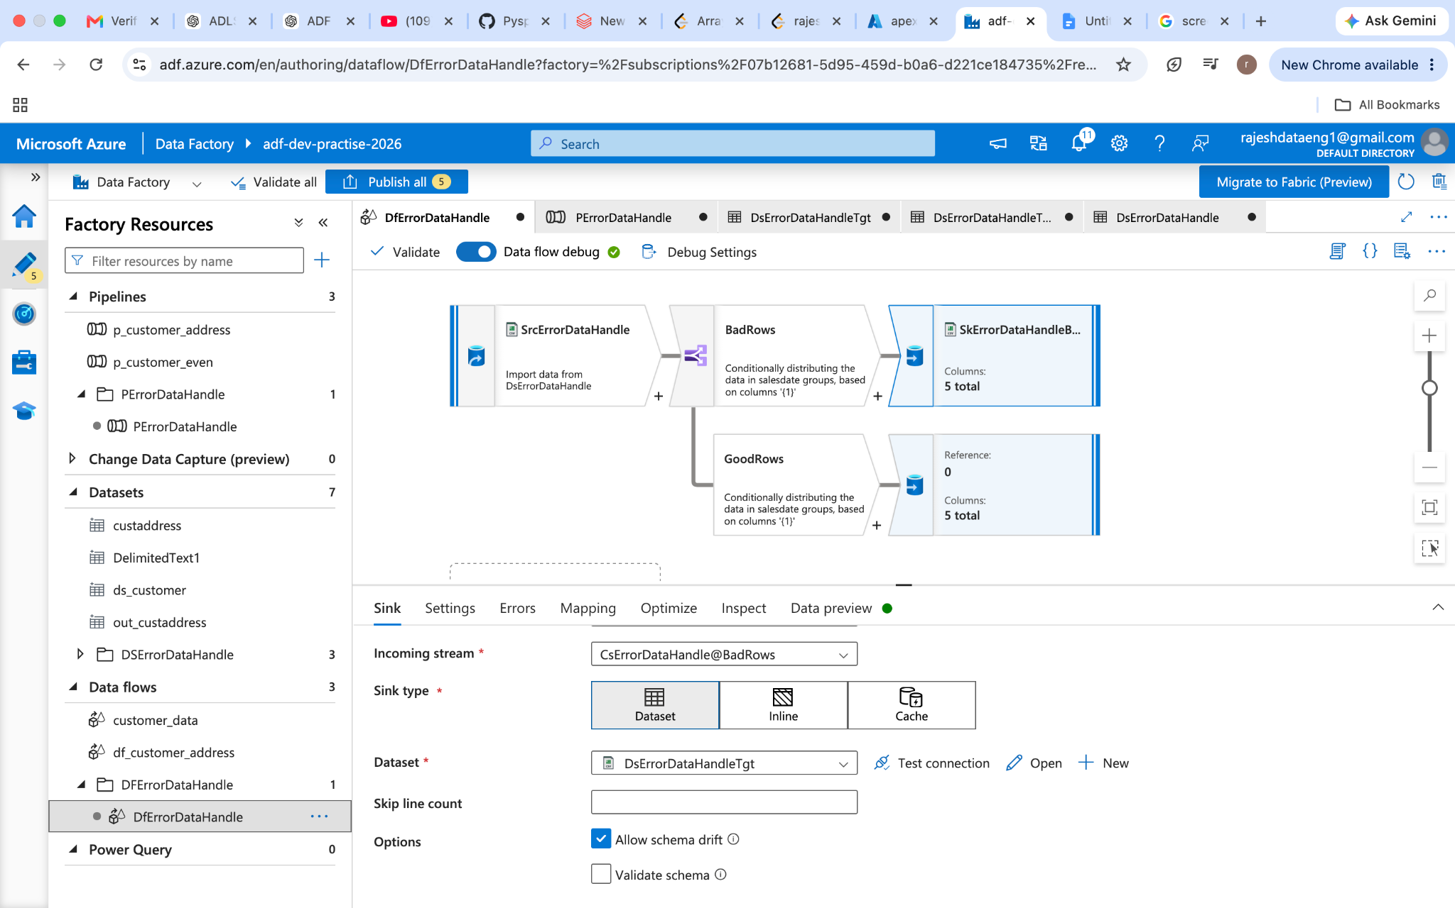

conditional_Split transform to split the data.
Baddata
GoodData.

Scenario-2: GetMultipleFileNames from source and write into sink.
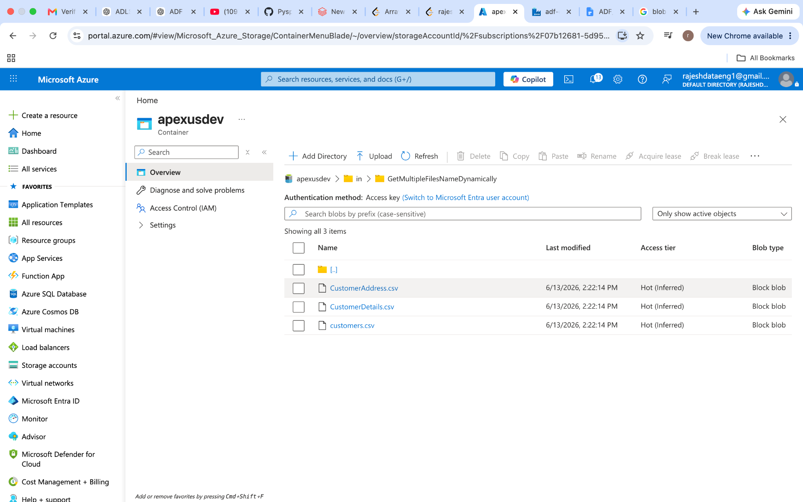

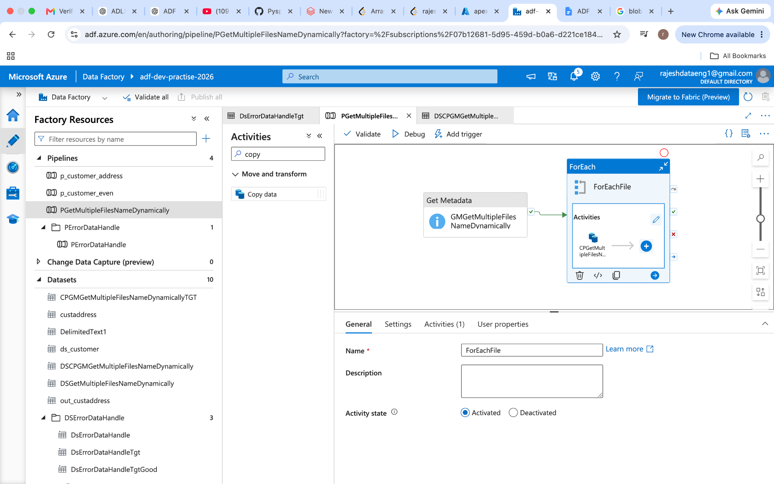

Scenario-3: Multiple files load into multiple tables:
Same as scenario -2:
In the Sink select the DB and define a parameter for the file and dynamically assign a value from Foreach activity (@item.name).
To create a table have an option Autocreate
If the table is already created it will map to those columns.

Scenario-4: copy all files from one adls account folder to another.
Same as scenario -2.

Scenario-5:
Incrementally copying files from the adls folder.
Using copy activity we can do it. How the incremental works here is.
Start time End time.
@adddays(utcnow(), -2) utcnow()
In the last two days whatever new files come those will be processed.

Let us if pipeline start or schedule to run at 6PM utc every day then
start time will be 2026-06-01 06:00:00
End time will be 2026-06-02 06:00:00 Whatever the files come in between these time frames only those files will be processed.

Here there is a catch for any reason one skipped or stopped that particular day of processing will be skipped. A better production approach is using a watermark timestamp field.

Scenario-6: Incremental copy using watermark timestamp field.
I am creating a watermarktable to hold the till the date run timestamp.
New value will get from the loading table has max(timestamp).
In the first load watermarkvalue is 1900-01-01 00:00:00
Table has max date has 2026-06-01 10:10:10
Now the query will be

Select * from table timestamp > 1900-01-01 00:00:00 and <= 2026-06-01 10:10:10
Once load is completed creating a stored proc and updating the watermark value as 2026-06-01 10:10:10 and in the next run new watermark value will get from the table itself as max(timestamp) as 2026-06-02 10:10:10.

Lookup one → old watermark
Lookup two → new watermark.

Copy activity get the data from table and write into table/ADLS.
Stored proc to update the timestamp to the water mark table.

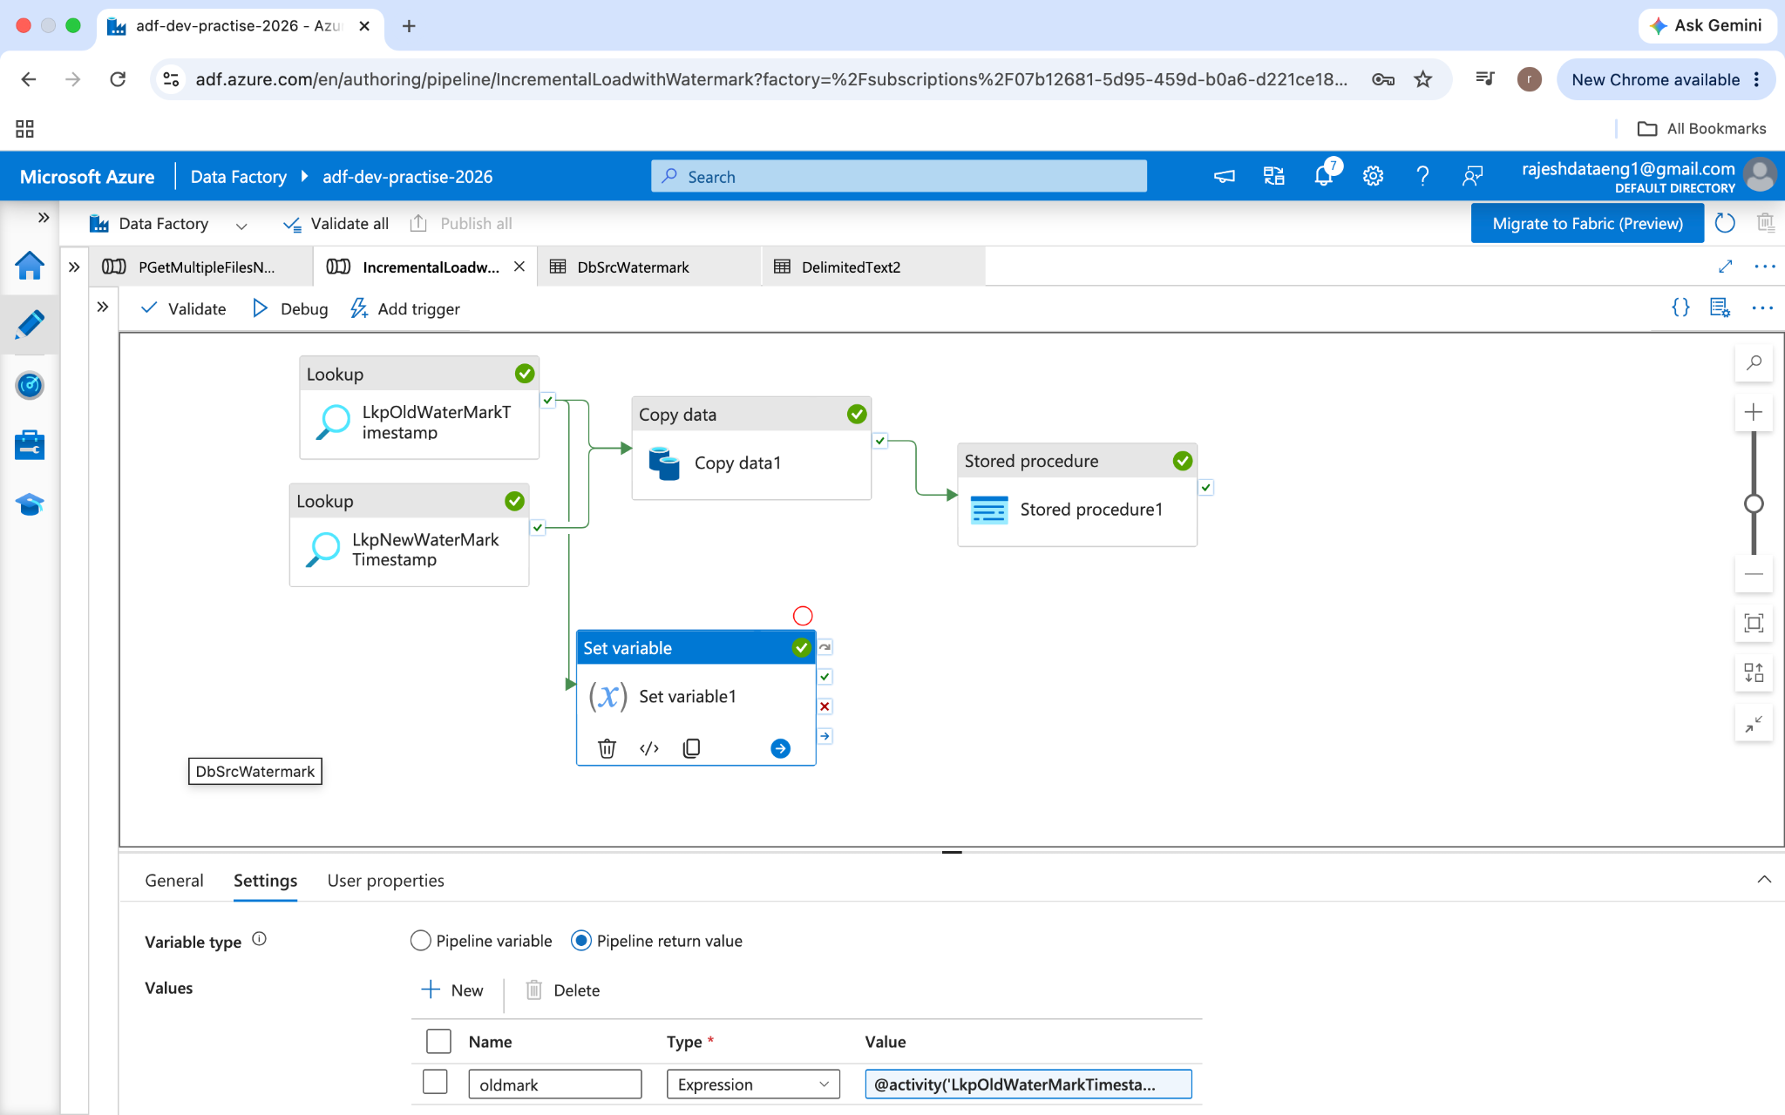

Scenario-7:
Delete files older than 30 days:
GetMetadata activity
End date @adddays(utcnow(), -31)

Foreach activity – to iterate all the files.
Delete activity to delete the file.
Enable logging to know what all the files delete in logs.

Scenario-8:
Remove duplicate:
Let say I have data as
1 A US
2 B US
1 C US
3 D US
Here 1 is duplicated with two different values. If we go by employee ID to find the duplicate.
Source1 → Union transformation → aggregate → sort → sink
Here 1 is duplicate but which row should be considered as original value and other to be considered has duplicate value.
Access pattern is the option
Select last$$ then 1 C US will be consider has original value
first$$ then 1 A US will be considered has original value.

Scenario-9:
Generate a sequence after a source file sequence.
Let say a file has employee data and has the sequence and the second file just has the employee data without sequence now needed to generate a sequence start from the first file end onwards.

source(with employee ID) → derived a dummy column to group data → aggregate
Get max(ID) → join (maxID + second source) → define a sequence generated → derived column(maxID + seq ID (start from 1)).
Since source 1 is already used, create a branch out of it to reuse the same data and union both data → write into sink.

Scenario-10:
Running total.
Data:
ID,Item,quantity
1,laptop,2
2,mobile,5
3,COD,9
4,Deck,4

Output:
1,laptop,2,2
4,deck,4,6
2,mobile,5,11
3,cod,9,20

Source → window transformation → sink
Window: order by quantity
sum(quantity)
Scenario-11:
SCD-Type1:
Source1 has 2 records
Source2 has 5 records, two are old records and three are new records.

Source → alter transformation → sink
Alter transformation we do upsert (it has insert, delete, update, upsert).
Sink→ setting → upsert (it has allow insert, allow, delete, allow update and allow upsert).

Scenario-12:
Get file count:
Getmetadata activity → set variable (take the output of get metadata activity as array) and length of it.
Getmetadata activity → for loop → set variable count.

Scenario-13:
SCD type2:
Source and target both are SQL in the scenario.
Source1 (new data) → select(new column names) → lookup(src1 + src2) → conditional split(
source2(target table) → select(new column names)

Based on primary keys or hashmap) to find insert data and update data.
Split1 insert data → service column(set flag here) → select columns → sink

Split2 update → both tables columns not null and all fields check not equal condition
→ derived column to assign 0 and select → alter row (update only) → sink

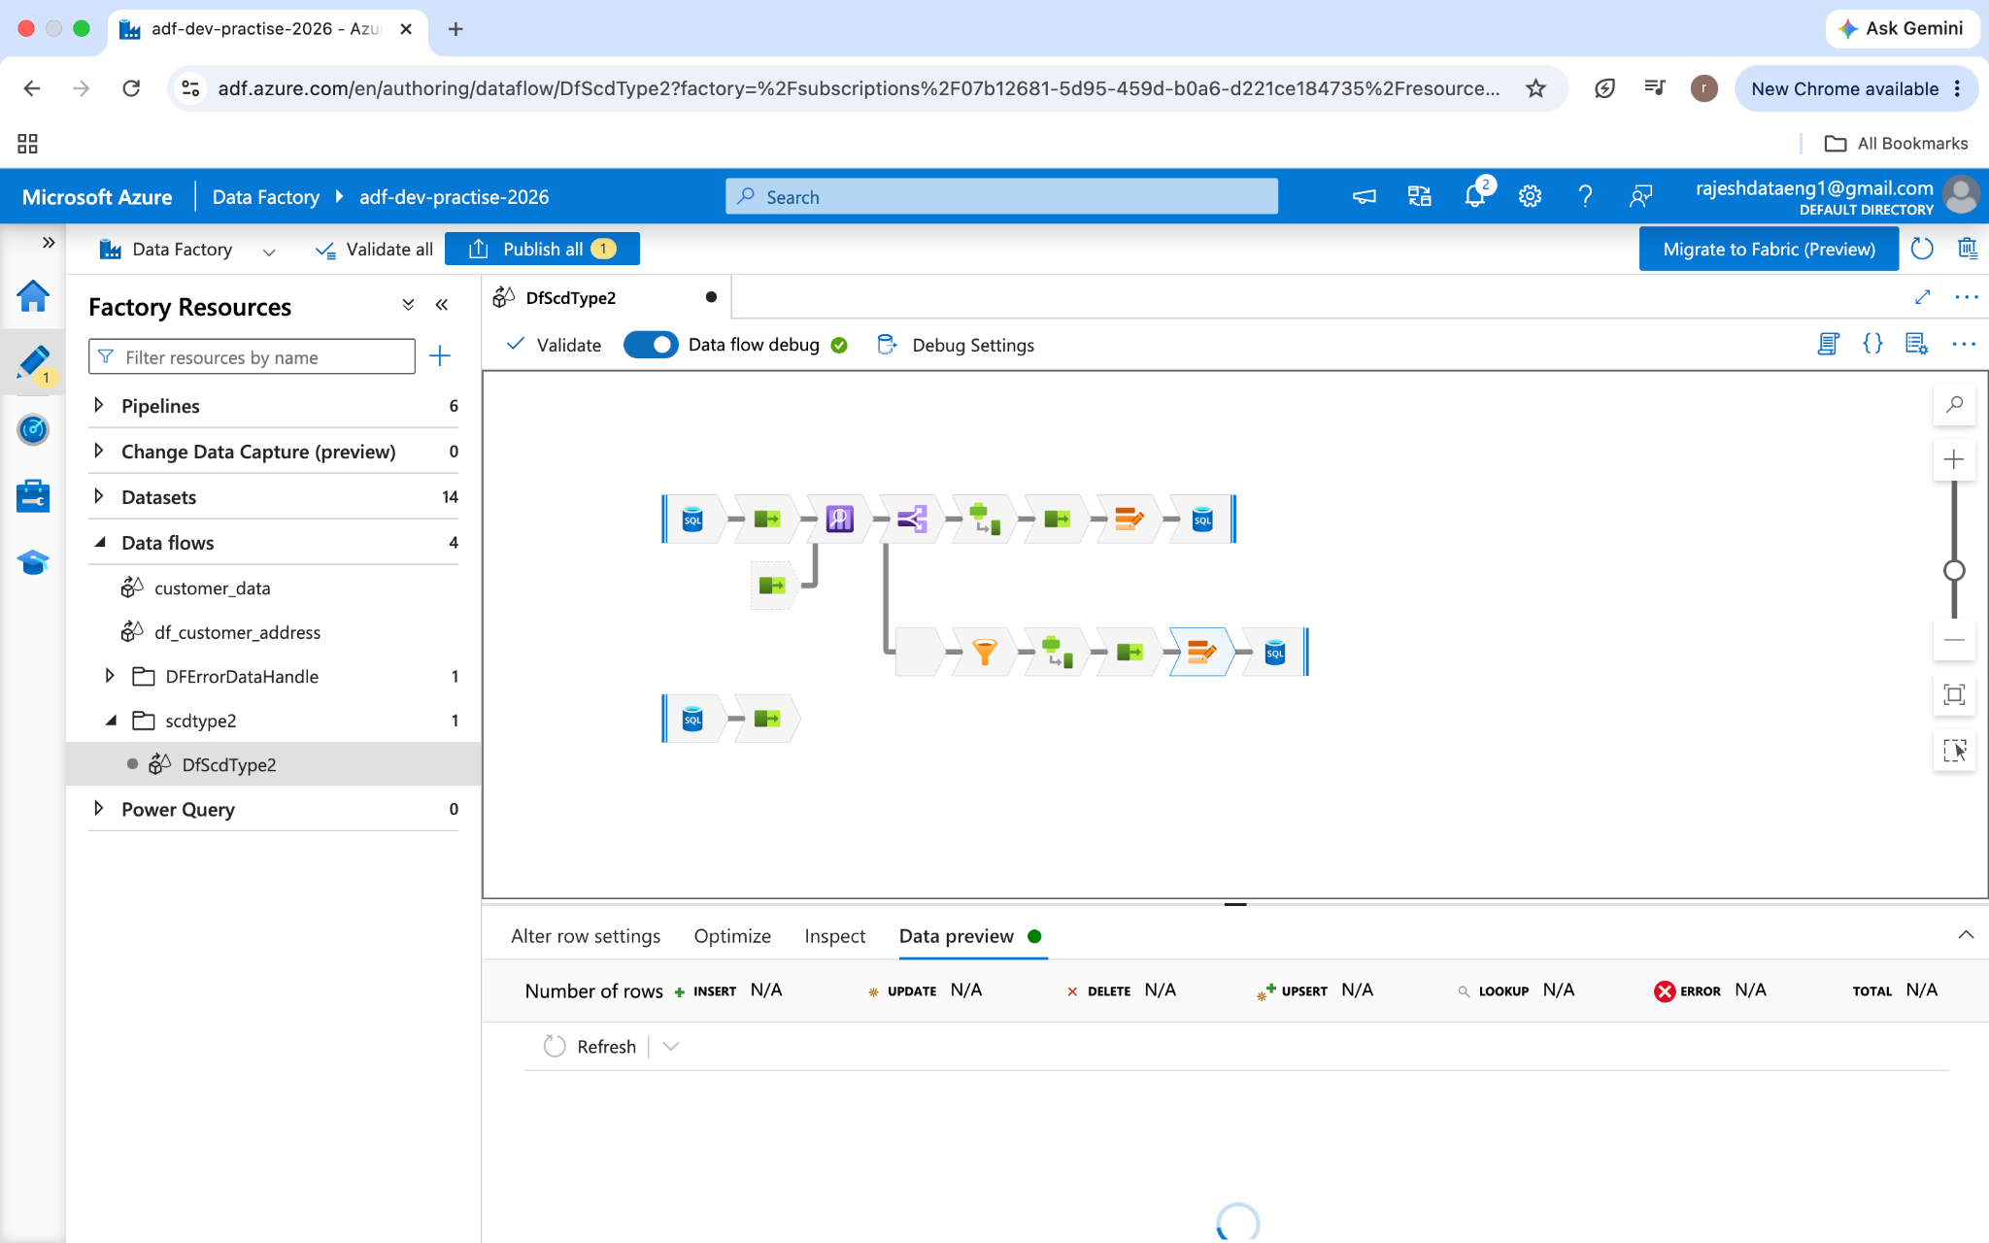

Scenario-14:
I have a stored procedure as input parameter and return an output.
Create procedure employee_count
@gender varchar(10),
@empcount int output
as
Begin
Select @empcount = count(emp) from employee where gener = @gender
End

In adf if we use this in stored procedure activity and pass a value as ‘Male’
Then stored procedure activity will fail because the procedure is expecting two input parameters. Activity doesn’t know it is input parameter or output parameter.

Lookup activity will handle this.
Query:
Declare @emptotal int
Execute employee_count ‘male’, @emptotal output
Select @emptotal as emptotal

Scenario-15: send an email alert when the pipeline is failed.
Ex: pipeline as success or fail tag
Activity → web activity → logic apps
When a logic app receives an HTTP request then send an email about failure.
Logic app HTTP post url paste it in the web activity.

Scenario-16:
If any activity fails run another activity
Or any activity failed to send an email (using web activity).

Activity success or failure other activity triggered
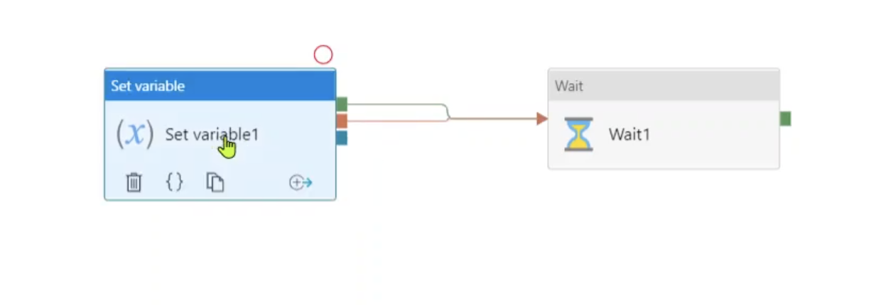

Both activities are successful then triggered.
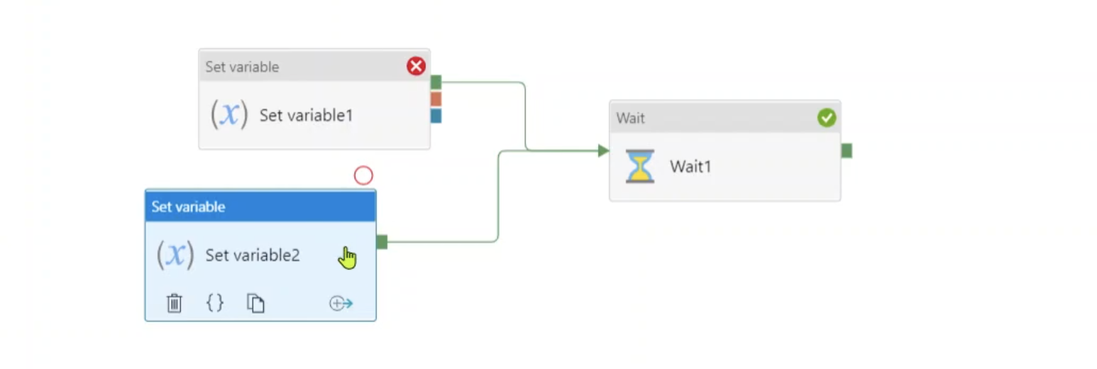
This not recommended approach if any of the failures then triggered other activity and this is not or condition it is going to be and if all three failed then only activity will be triggered.
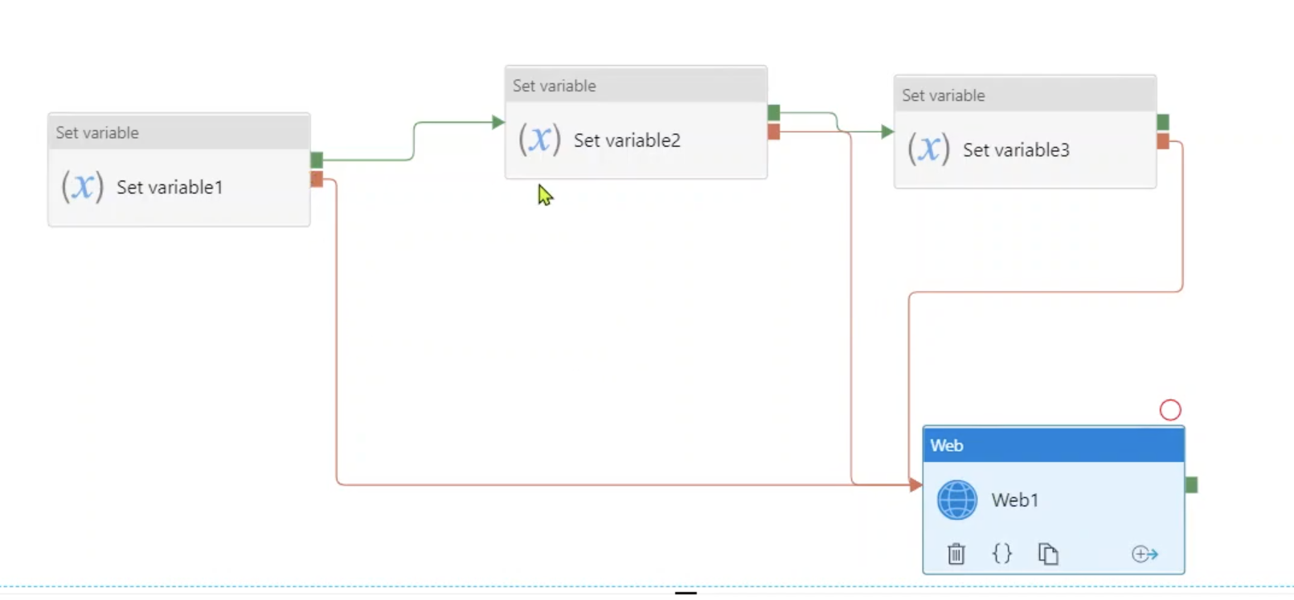

Not recommended approach.

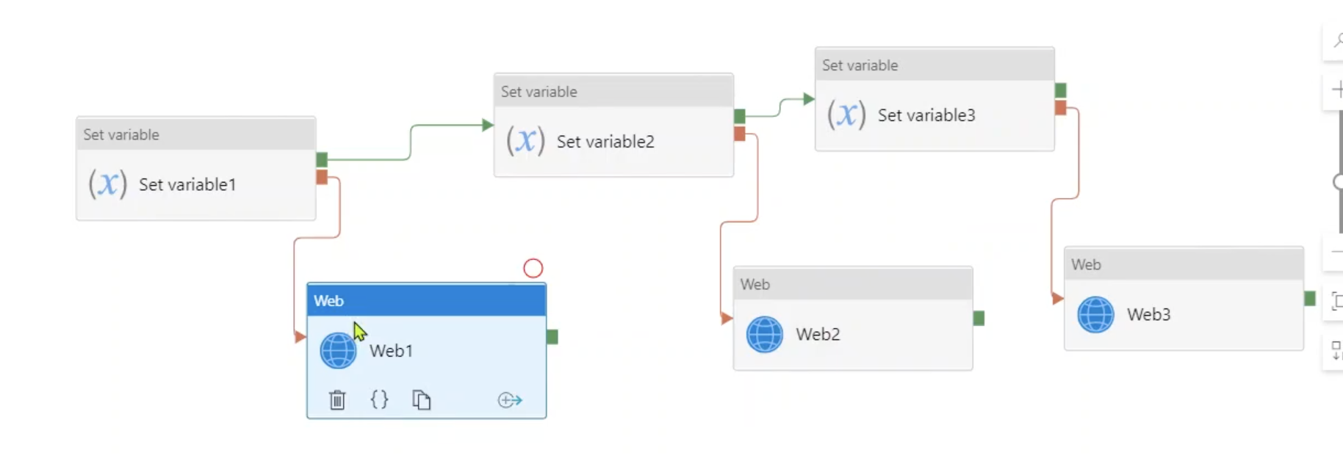

Recommended approach :
First failed, other two skipped, last skipped trigger email.
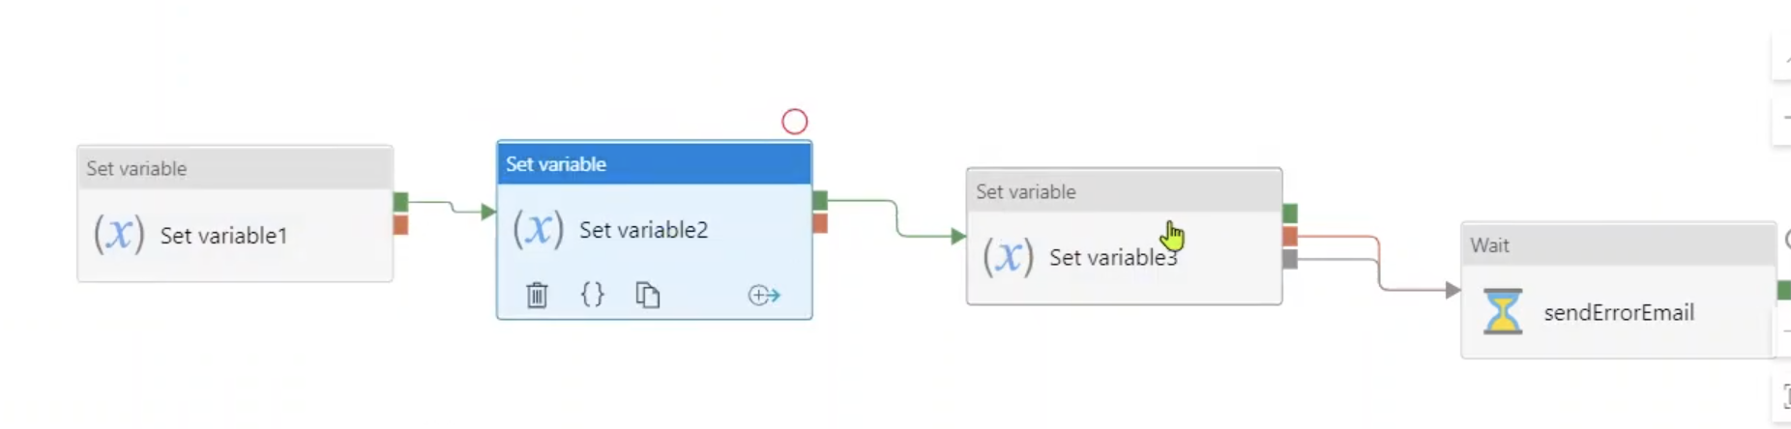
Not recommended approach.
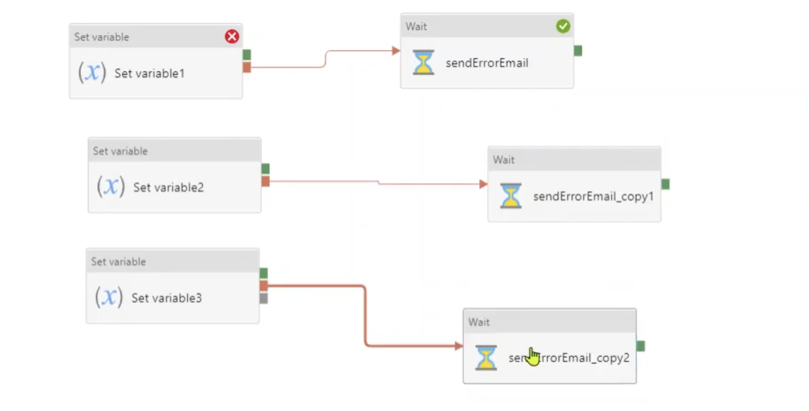

Parallel execution recommended approach.

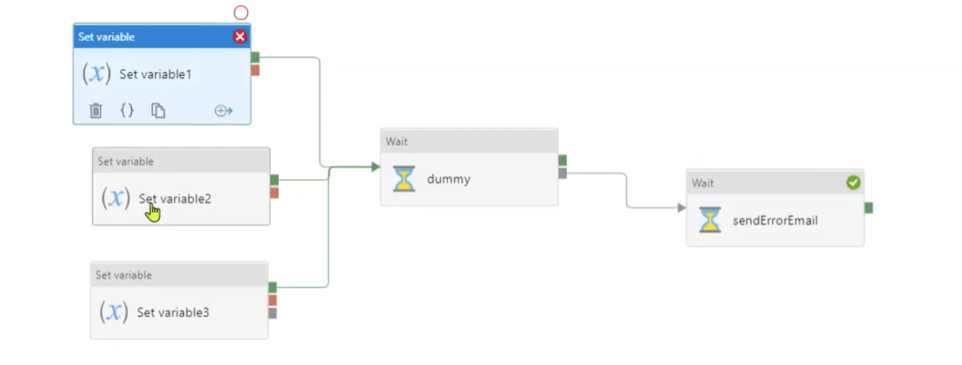

Scenario-17:
How to capture an error message of any pipeline activity is failed.
If the pipeline activities are in series, END of the pipeline is skipped/error to connect a new variable activity and capture the error message.

If pipeline activities are in parallel then add a dummy activity connect all the parallel activities to the dummy activity and skip add to the activity.

Scenario-18:

How to run a pipeline from one adf to another adf.
Web activity (mention the Rest api url) and provide the access to the ADF from IAM.

Scenario-19:
Query from lookup table.
Direct Select query can be done but direct create, delete and update can’t be done.
In order to do that use a declarative sentence and execute it.
Declare @sql nvcarchar(1000)
Set @sql = ‘create table employee’
Exec sp_executesql @sql

Scenario-20:
Run a pipeline from logic apps.
In logic apps we have option called Actions
And select create pipeline to trigger it.

If the pipeline requires any input parameters to be passed from logic apps, pass them in the json format with the exact parameter name.

Scenario-21:
Deployment will be done using the ARM template (Azure Devops CI/CD).

Scenario-22:
Partition source data by columns and store in hierarchy path:
In sink we have an options as
- Use current partitioning
- Single partition
- Set partitioning → select this and select partition field so data will be partitioned and create a folder with that partition value.

Scenario-23:
Validate schema in ADF:
- Employee.csv has 10 fields
We will get a file on a daily basis and want to validate each time before processing it.

Same file name store in another csv file with only column names (employeeref.csv)
Use get metadata activity for employees.csv → field list( select structure).
Another metadata activity foremployeeref.csv →same
Use if activity compare it both matches inside if activity -> true → use copy
Else → false no activity.

