OS Config Drift Automation – Service Workflow
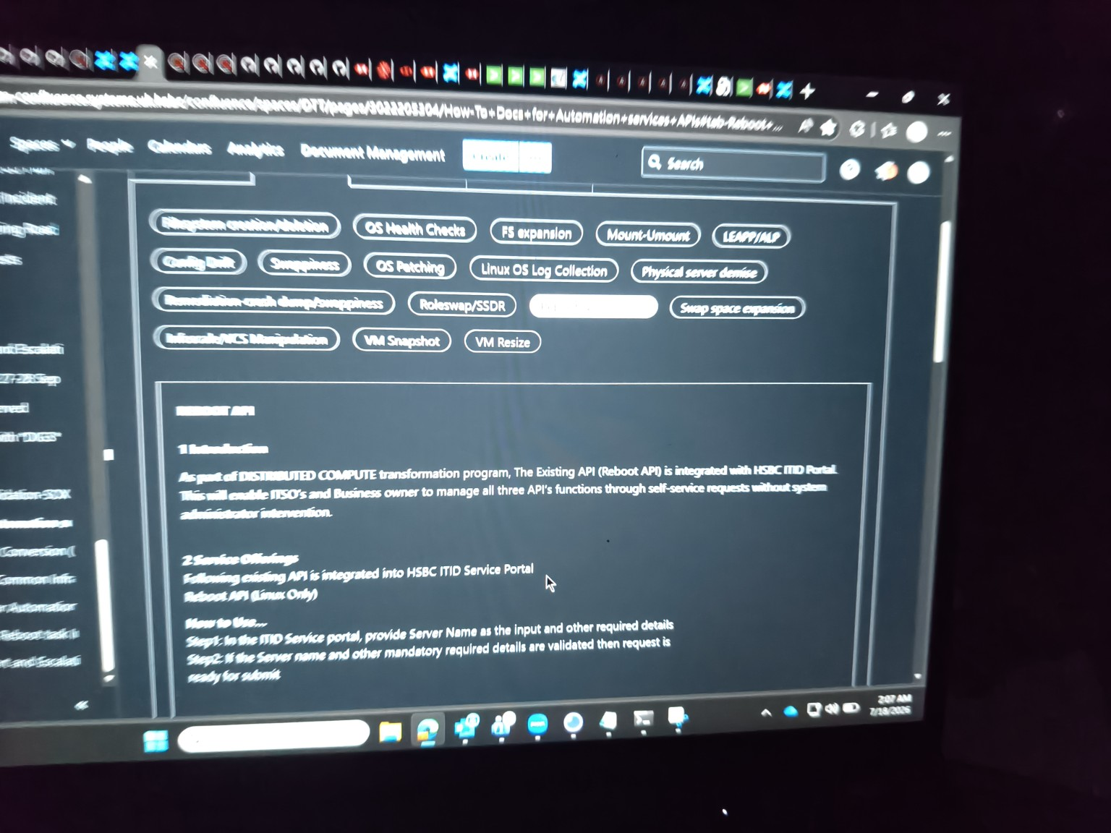
Figure 1: ITID Service Portal – OS Config Drift Automation Interface

1. Introduction
As part of the Distributed Compute Transformation Program, the OS Config Drift Automation service is integrated with the HSBC ITID Service Portal. The solution enables ITSOs and Business Owners to detect, analyze, and remediate operating system configuration drift through a standardized self-service automation workflow.

2. Objective
- Automate operating system configuration drift detection.
- Reduce manual intervention by system administrators.
- Ensure server configurations remain compliant with baseline standards.
- Provide centralized visibility into drift status.
- Enable controlled remediation through the ITID Service Portal.

3. Scope
The automation workflow supports Linux-based infrastructure managed through the HSBC ITID Service Portal and integrates with backend automation and compliance tools.

4. Service Components
- OS Config Drift Detection
- Configuration Baseline Validation
- Drift Analysis
- Automated Remediation
- Execution Logging
- Compliance Reporting
- Audit Tracking

5. High-Level Architecture
User / ITSO / Business Owner → ITID Service Portal → Validation Layer → Drift Detection Engine → Compliance Baseline Repository → Remediation Automation → Target Linux Server → Status & Audit Logs

6. End-to-End Workflow
- User logs in to the HSBC ITID Service Portal.
- User selects the OS Config Drift service.
- Server name and required parameters are provided.
- Portal validates mandatory input fields.
- Request is submitted for processing.
- Drift Detection Engine compares current server configuration against approved baselines.
- Drift report is generated.
- If remediation is approved, automation workflows are executed.
- Configuration changes are applied to the target server.
- Execution status, logs, and audit records are updated in the portal.

7. Drift Detection Workflow
- Collect current OS configuration details.
- Retrieve approved baseline configuration.
- Compare package versions, services, kernel parameters, and system settings.
- Identify deviations from baseline.
- Generate drift severity classification.
- Store findings for audit and reporting.

8. Remediation Workflow
- Review detected drift items.
- Validate remediation eligibility.
- Trigger automation workflow.
- Apply configuration corrections.
- Verify post-remediation compliance.
- Update final execution status.

9. Validation Checks
- Server name validation
- Operating system eligibility
- User authorization verification
- Baseline availability check
- Change window validation (if applicable)
- Duplicate request prevention

10. Logging and Audit Tracking
- Request submission timestamp
- Drift detection results
- Remediation execution logs
- Success/Failure status
- Error details
- User and approval information
- Compliance audit records

11. Benefits of OS Config Drift Automation
- Improved configuration compliance
- Reduced operational effort
- Faster remediation of drift issues
- Enhanced audit readiness
- Standardized server management
- Increased infrastructure stability

12. Conclusion
The OS Config Drift Automation workflow provides a centralized and automated mechanism for detecting and remediating configuration drift across Linux infrastructure. By integrating the service with the HSBC ITID Service Portal, organizations can improve compliance, reduce manual effort, strengthen governance, and maintain consistent operating system configurations across their server environment.

