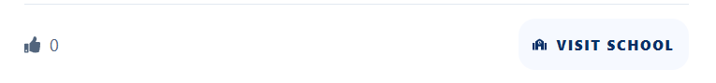
This like btn is not working properly , everyone should be able to like this , logged in and non logged in use, make plan for this
howu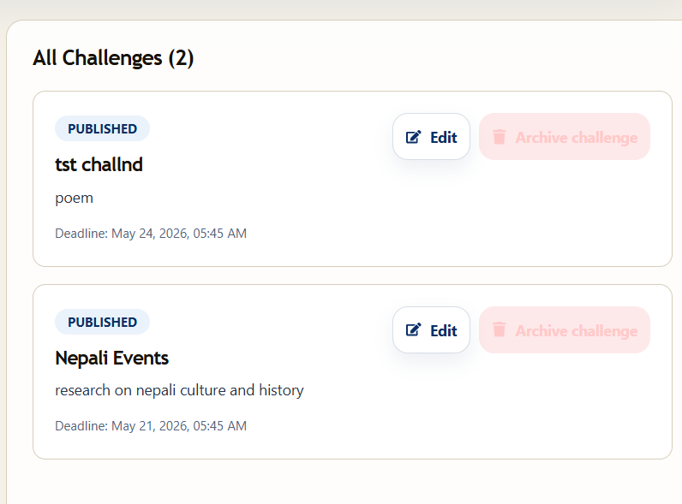

ui for delete and since this is super admin, this is research for student and they are sending either essay or poem or other so what I want is super admin will choose what student will send and student will not get chance to select if it Is selected from admin, go give option for admin,
in school admin notification, this is flikiring , notification is blinking I don’t know why, analyse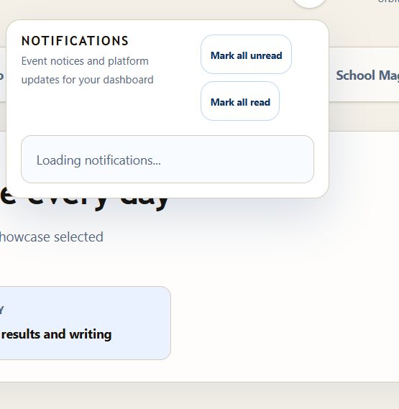
problem in add student , specially bulk add and also , when I click on add student I don’t know if it is slow or not opening. Examine that , and when I refresh than it is opening ,
okay the event school section must be connecete with students as well, like if I update the team, in student section, it is not showing like , I created for 10 team and it must be updated at real time like how many student are added and all,
notification must be real time and when school create the event then student didn’t get is in real time, notification must be real time everywhere,
I create capacity but I mean capacity is not updated at real time , if it is school event than we should not write school in internal event, and it is there and the happen when I open through student and open view event
notification to student is not real time, there shouldn’t be any mistake in notification
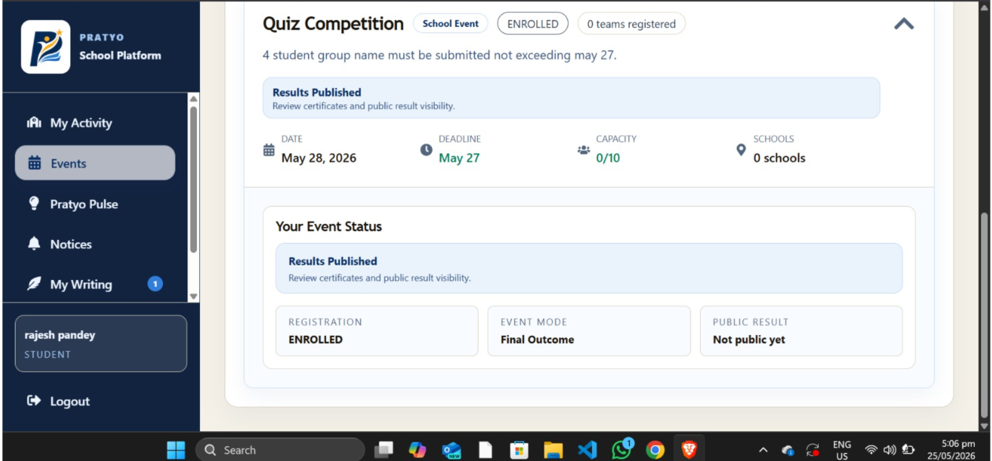

if you watch here, there is capacity problem, school no need to as as it is school event , the result has been published but still there is not public yet option, what is that, if published then there should be option for , view certificate, and at left there I think we should add my certificate option, where only certificate are shown with the name of particular event ,
whenever I send any event I need to refresh, how good is that, what is appropriate way, ??what can be done here ,

