|  |  |  |  |  |
| --- | --- | --- | --- | --- |
|  |  | | | |
|  | |  | | |
| Project: | | SMS | | |
| Team No.: | | 6 | | |
| Class: | | CSE 3310; Fall 2019 | | |
| Module: | | Unified Modeling Language (UML) | | |
| Deliverable: | | UML Document – Increment I delivery | | |
| Version: | | [1.0] | Date: | [09/26/2019] |

Contributors:

Shameen Shetty

Rajesh Rayamajhi

Sudarshan Tiwari

Kritan Duwal

Revision History

| Version number | Date | Originator | Reason for change | High level description of changes |
| --- | --- | --- | --- | --- |
| 1.0 | 09/26/2019 | Team 6 | Initial draft |  |
|  |  |  |  |  |
|  |  |  |  |  |
|  |  |  |  |  |

TABLE OF CONTENTS

1. Introduction and Project Overview 3

2. Project Context Diagram 4

3. UML Diagram 5

3.1 UML Diagram: system 5

3.2 UML Diagram: “Registration and Login” 5

3.3 UML Diagram: “Setup” 5

3.4 UML Diagram: “Service Categories” 5

3.5 UML Diagram: “Vendor Addition” 5

3.6 UML Diagram: “Place Service Request” 5

3.7 UML Diagram: “Accept Service Request” 5

3.8 UML Diagram: “Service Request Change or Cancellation” 5

3.9 UML Diagram: “Review and Rating” 5

3.10 UML Diagram: “Payments” 5

3.11 UML Diagram: “Order History” 5

3.12 UML Diagram: “Search” 5

# 1. Introduction and Project Overview

Develop an android application to help users initiate “service request” for their home or small business. This will help users (i.e. customers that require service) to be put in contact with service providers. The product will make money by collecting commission from each service request fulfilled by the service provider.

-extracted from CSE 3310 Term Project Fall 2019. Dr. Khalili

# 2. Project Context Diagram

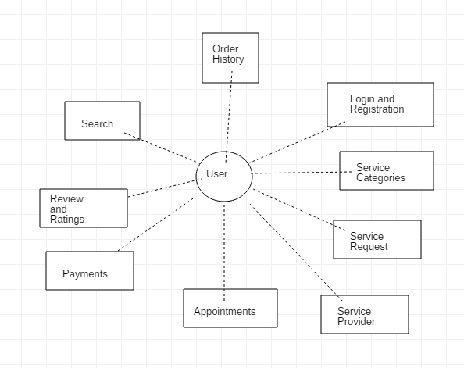

# 3. UML Diagram

## 3.1 UML: Class Diagram: system

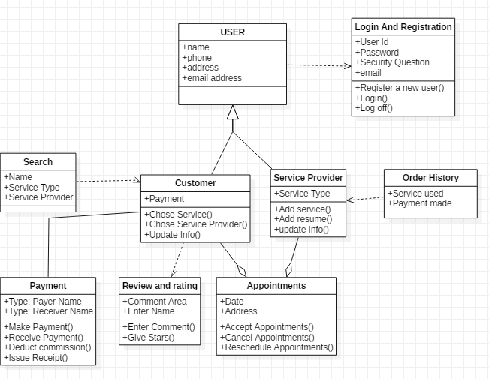

## 

## 3.2 UML: Class Diagram: “Registration and Login”

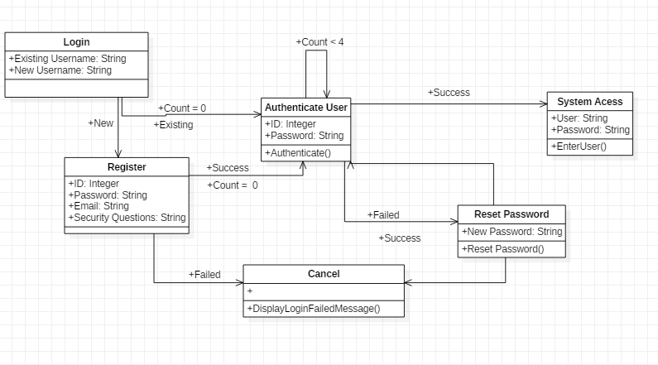

## 

## 3.3 UML: Class Diagram: “Setup”

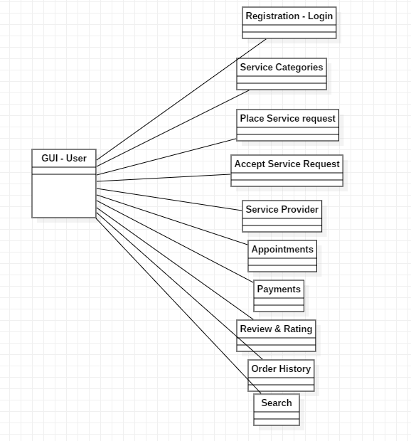

## 3.4 UML: Activity Diagram: “Service Categories”

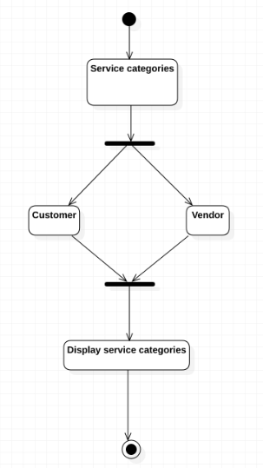

## 3.5 UML: Activity Diagram: “Vendor Addition”

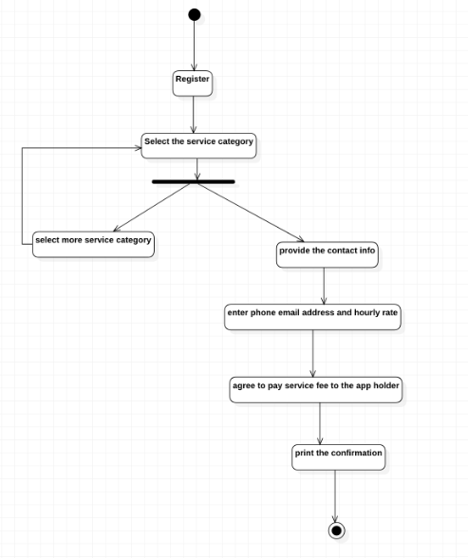

## 3.6 UML: Activity Diagram: “Place Service Request”

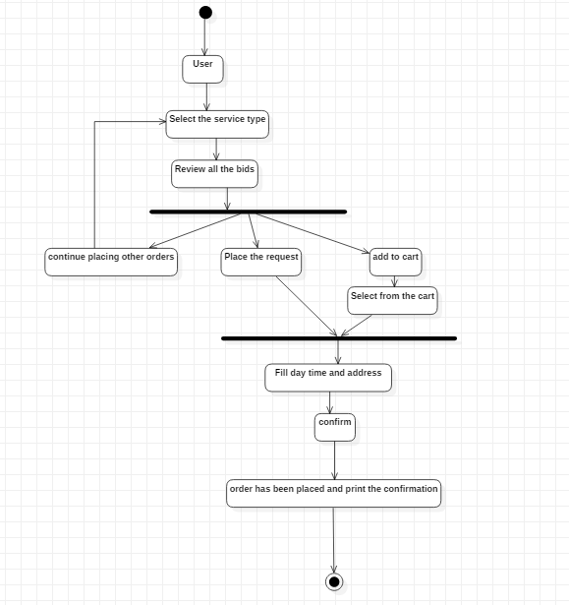

## 

## 3.7 UML: Activity Diagram: “Accept Service Request”

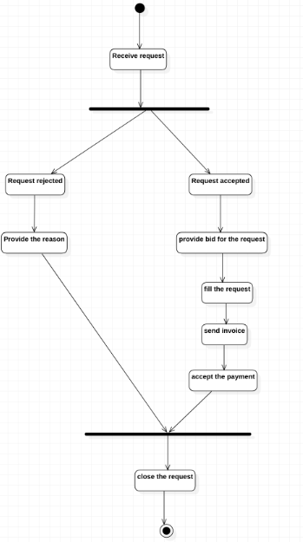

## 3.8 UML: Class Diagram: “Service Request Change or Cancellation”

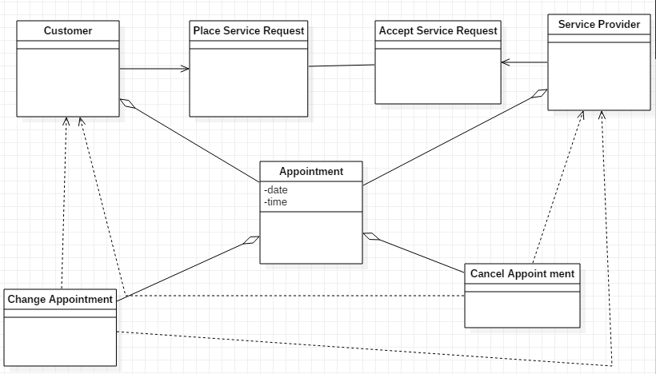

## 3.9 UML: Class Diagram: “Review and Rating”

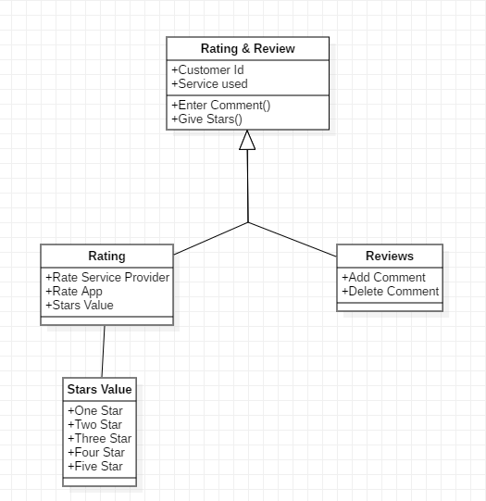

## 3.10 UML: Activity Diagram: “Payments”

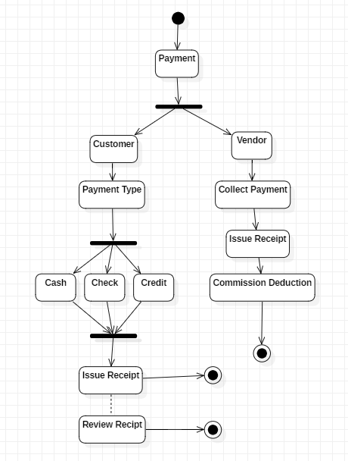

## 3.11 UML: Class Diagram: “Order History”

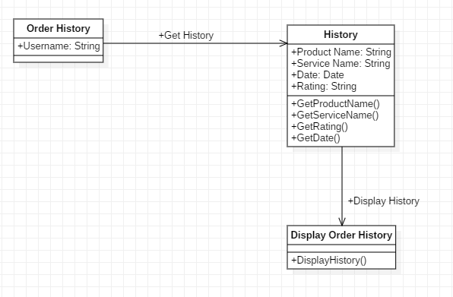

## 3.12 UML: Class Diagram: “Search”

