|  |  |  |  |  |
| --- | --- | --- | --- | --- |
|  |  | | | |
|  | |  | | |
| Project: | | SERVICE MANAGEMENT SYSTEM (SMS) | | |
| Team No.: | | 6 | | |
| Class: | | CSE 3310; Fall 2019 | | |
| Module: | | System Requirements Analysis (SRA) | | |
| Deliverable: | | SRA Document | | |
| **Version:** | | **[1.1]** | **Date:** | **[12/03/2019]** |

Contributors:

Shameen Shetty

Rajesh Rayamajhi

Sudarshan Tiwari

Kritan Duwal

**Revision History**

|  |  |  |  |  |
| --- | --- | --- | --- | --- |
| ***Version number*** | ***Date*** | ***Originator*** | ***Reason for change*** | ***High level description of changes*** |
| 1.0 | 10/29/2019 | Team 6 | Initial draft |  |
| 1.1 | 12/03/2019 | Team 6 | Review | Reviewing the documents after app development and making necessary changes in the document like addition and removal of features. |
|  |  |  |  |  |
|  |  |  |  |  |

TABLE OF CONTENTS

**1. Introduction and Project Overview 3**

**2. Objectives 4**

2.1 BUSINESS Objectives 4

2.2 SYSTEM Objectives 5

**3. Project Context Diagram 6**

**4. Systems Requirements 7**

4.1 “Login and Registration” Requirements 7

4.2 “Service Categories” Requirements 7

4.3 “Service request” Requirements 7

4.4 “Appointments” Requirements 7

4.5 “Accept Service Request” Requirements 7

4.6 “review and rating” Requirements 7

4.7 “payments” Requirements 7

4.8 “order history” Requirements 7

4.9 “search” Requirements 7

**5. Software Processes and UML Diagrams 8**

5.1 Hardware and Infrastructure 8

5.2 UML Diagrams 8

5.3 Test Plan 8

5.4 Screen Shots 8

**6. Assumptions and Constraints 9**

6.1 ASSUMPTIONS 9

6.2 CONSTRAINTS 9

6.3 Out of Scope material 9

**7. Delivery and Schedule 10**

**8. Stakeholder Approval Form 11**

**Appendix: 12**

# 1. Introduction and Project Overview

Develop an android application to help users initiate “service request” for their home or small business. This will help users (i.e. customers that require service) to be put in contact with service providers. You will make money by collecting commission from each service request fulfilled by the service provider. The categories of services (displayed graphically by an icon) can be expanded to cover more service areas in the future. Initially the listed services should be supported. The system should minimally include the following components:

1. Login & Registration: Customers (i.e. Service Requesters) can optionally register and login to the system. They can also order place a Service Request (SR) without registration and login. If they choose to register and login, they could get points, can review Service Providers quality of Service, could get discounts, and receive helpful tips and updates. To register, they must provide full name, email, and phone number.
2. Setup: Setup control fields such as: Sounds **on**/off, receive commission **yes**/no, use points toward a service yes/**no**. feel free to include other parameters. The Bold charters will be the default.
3. Service Categories: The following areas of service should be presented in the app. For each category of service area below (i.e. similar to Uber fro rides):
   * Appliances
   * Electrical
   * Plumbing
   * Home Cleaning
   * Tutoring
   * Packaging and Moving
   * Computer Repair
   * Home Repair and Painting
   * Pest Control
4. Register to become an approved vendor for one or more of the above service categories (i.e. Service Provider). You must provide contact info including phone, address and email. You can optionally provide sample rates (e.g. how much to fix something, or per hour of labor). You must also agree to pay a small portion of money received (e.g. 20%) as fee to the app holder
5. Place a Service Request (by Customers): Select a Service category and place an order solicitation for bid by the service providers. Finalize your selection after reviewing all bids.
6. Cancellation and Change: Allow customers to cancel or change service dates. You can specify in setup that you lose points if you cancel within the last x (e.g. 24) hours
7. Accept a Service Request (by service provider)): Provide bids for Requested services to customers
8. Payments: Handle money paid by the customers, received by the service provider. You, the owner of app, will receive a commission (e.g. 20%) of the service fee.
9. Review and Rating (by customers): Use Stars (one to five stars) to rate the service received, and allow to enter for a short comment to help future users
10. Order History: Display the history of service requested for a given customer.
11. Search: Ability to search for a service provider by address, name, star rating, etc.

# 2. Objectives

## 2.1 BUSINESS Objectives

The following is a list of business objectives:

**Objective 1**: Login and Registration - If user already registered, login. If password is forgotten, reset and e-mail new password. If User ID forgotten, request a new registration. If new user, Register the user by collecting the following personal information:

Last name, middle name {optional}, first name

Phone number; E-mail address

Select a “User Id” & “Password”

**Objective 2**: Service Categories - This component will allow entry of the support service categories. The application must initially support the following categories (additional categories is optional):

* + Appliances
  + Electrical
  + Plumbing
  + Home Cleaning
  + Tutoring
  + Packaging and Moving
  + Computer Repair
  + Home Repair and Painting
  + Pest Control

**Objective 3**: Service Request – This component will allow the user to choose from different types of services. The services will be displayed according to Service Name, Service Type, Rating, Location etc. The user then can further filter the data according to certain fields (e.g. No service with a rating below 2 stars). This component will also allow the registered vendor to accept or decline a service request received from the user. The vendors can provide the bid for the requests.

**Objective 4:** Service provider – A user who wants to sell their services can use this functionality to become an approved vendor by providing their details (Location, contact number, service being provided, sample rates, etc).

**Objective 5:** Appointments – Once the request has been accepted, the user can provide a date, time and location and they can change it or cancel it. The vendor can choose to accept the appointment date and location, or they can request for a different date or location.

**Objective 6**: Payments – Once the request has been fulfilled, the user will pay the agreed upon rates to the service providers/vendors, in either cash or credit depending on the vendor.

**Objective 7:** Review and Ratings – This component will allow the user to rate and review the quality of the service provided by the vendor. The Rating system will go from a minimum of 1 star to a maximum of 5 stars. The user can also leave a comment further detailing the review.

**Objective 8:** Search – The user can search for a particular type of service being provided. The search results will be displayed according to the Name of the vendor, the Rating it has, the Type of service it provides, etc. They can also filter the search query according to the fields (e.g. No service below a certain rating). And further sort the data in ascending or descending order.

**Objective 9:** Order History – This component will fetch the past orders from a database that have been made by the user and display all the details of the order – the rating the user provided, the location and date it took place, the amount that was paid, etc.

## 2.2 SYSTEM Objectives

The following is a list of system objectives:

**Objective 1**: System will be an android application for mobile platform.

**Objective 2**: Firebase Database will be used as the database.

**Objective 3:** PayPal Payment processor will be used to verify the payments.

**Objective 4:** App will be able to send simple notifications.

# 3. Project Context Diagram

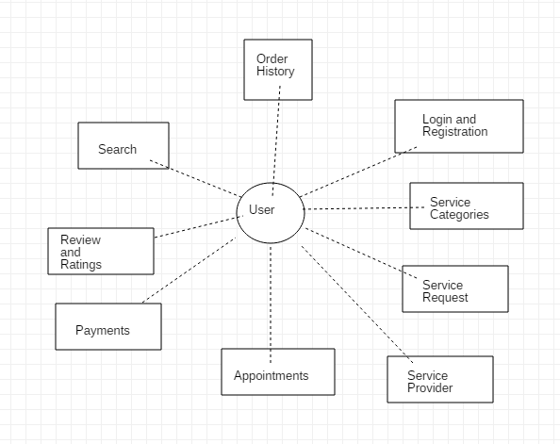

# 4. Systems Requirements

## 4.1 “Login and Registration” Requirements

|  |  |
| --- | --- |
| **Requirement Title:** | Login and Registration |
| **Sequence No:** | 001 |
| **Short description:** | Login an existing user or register a new user. |
| **Description:** | Existing users can log in to the application by entering their Username and password.  New users must register before accessing the application. The following information will be collected:   * Name (First, Last name) * Email address * Select an ID (at least 8 characters long, alphanumeric, wild characters not allowed) * Select a security question   User can press:   * Submit * Use cancel or exit using the system buttons. |
| **Pre-Conditions**: | * Application must be loaded already * Duplicate registration is not allowed |
| **Post Conditions:** | * All “Saved” changes will be kept permanently |
| **Other attributes:** | * None |

|  |  |
| --- | --- |
| **Requirement Title:** | Login and Registration |
| **Sequence No:** | 002 |
| **Short description:** | Register a new user |
| **Description:** | New users must register before accessing the application. The following information will be collected:   * Name (First, Last name) * Email address * Select an ID (at least 8 characters long, alphanumeric, wild characters not allowed) * Select a security question   User can press:   * Submit * Exit screen (or close) using the host |
| **Pre-Conditions**: | * Application must be loaded already * Duplicate registration is not allowed |
| **Post Conditions:** | * All “Saved” changes will be kept permanently |
| **Other attributes:** | * None |

|  |  |
| --- | --- |
| **Requirement Title:** | Login and Registration |
| **Sequence No:** | 003 |
| **Short description:** | Checks if user is an existing user. |
| **Description:** | Existing users can log in to the application by entering their Username and password. Authenticate User will check if that username and password combination is stored in the database.  If it is a success (both username and password are correct):   * Allow user system access   If it is a failure (either one or both fields entered are wrong):   * Display message “Login Failed” * Increase count by 1 up to a maximum of 4 * If count exceeds max limit, lock the user from trying to login and request they try again in a few minutes or reset their password |
| **Pre-Conditions**: | * Application must be loaded already * Duplicate registration is not allowed * Cannot exceed 4 failed login attempts |
| **Post Conditions:** | * All “Saved” changes will be kept permanently |
| **Other attributes:** | * None |

|  |  |
| --- | --- |
| **Requirement Title:** | Login and Registration |
| **Sequence No:** | 004 |
| **Short description:** | Resets the password for an existing user to a new password that they chose. |
| **Description:** | An existing user can choose to change their password or if an existing user fails to login after 4 attempts, they are requested to change their password.  New users must register before accessing the application. The following information will be collected:   * Name (First, Last name) * Email address * Select an ID (at least 8 characters long, alphanumeric, wild characters not allowed) * Select a security question   User can press:   * Submit * Exit screen (or close) using the system buttons |
| **Pre-Conditions**: | * Application must be loaded already * Duplicate registration is not allowed * Cannot exceed 4 failed login attempts |
| **Post Conditions:** | * All “Saved” changes will be kept permanently |
| **Other attributes:** | * None |

|  |  |
| --- | --- |
| **Requirement Title:** | Login and Registration |
| **Sequence No:** | 005 |
| **Short description:** | Cancel |
| **Description:** | If a user is entering their credentials or making a new account, and decide not to submit, they can press the exit by pressing the cancel button on the host device. |
| **Pre-Conditions**: | * Application must be loaded already |
| **Post Conditions:** | * None |
| **Other attributes:** | * None |

|  |  |
| --- | --- |
| **Requirement Title:** | Login and Registration |
| **Sequence No:** | 006 |
| **Short description:** | System Access |
| **Description:** | Existing users can log in to the application by entering their Username and password. After the correct combination has been entered and verified by Authenticate User, if it matches the records in the database – the user will be allowed System Access. |
| **Pre-Conditions**: | * Application must be loaded already * Duplicate registration is not allowed |
| **Post Conditions:** | * All “Saved” changes will be kept permanently |
| **Other attributes:** | * None |

## 4.2 “Service Categories” Requirements

|  |  |
| --- | --- |
| **Requirement Title:** | Service Categories |
| **Sequence No:** | 001 |
| **Short description:** | Display all available service categories. |
| **Description:** | The user will be able to select any one option from the list of service categories. The following categories will be displayed:   * Appliances * Electrical * Plumbing * Home Cleaning * Tutoring * Packaging and Moving * Computer Repair * Home Repair * Pest Control |
| **Pre-Conditions**: | * Application must be loaded * User might be logged in |
| **Post Conditions:** | * User will be shown a service request screen where they will fill in further information about specific requests. General information will include address, phone number, and email. |
| **Other attributes:** | * None |

## 4.3 “Service request” Requirements

|  |  |
| --- | --- |
| **Requirement Title:** | Service Request |
| **Sequence No:** | 001 |
| **Short description:** | Select service type |
| **Description:** | A registered user should select the service type from the list of available services. After selection of a service required, the user should fill up a service request form where the user will be asked the following information:   * Name * Email * Contact No. * Address * Problem Description   User can press:   * Send Request * Cancel using the host device |
| **Pre-Conditions**: | * Application must be loaded already * User must log in * User must know what kind of service they want * User must provide factual information |
| **Post Conditions:** | * User must be able to place a service request |
| **Other attributes:** | * None |

|  |  |
| --- | --- |
| **Requirement Title:** | Service Request |
| **Sequence No:** | 002 |
| **Short description:** | Continuing place other orders |
| **Description:** | A registered user should be able to continue placing the orders if they need more than one services. If more than one service is requested, it will be added to the cart. They will again select the service and review all the bids provided by the vendor. They will select the best vendor that will provide the best bid for their service. The following information will be provided to the user:   * List of available services   User can press:   * Cancel Request * Select serviceView Bids |
| **Pre-Conditions**: | * Application screen must be already in select service type * User must know what kind of service they want * User must have more than one service * User must provide factual information |
| **Post Conditions:** | * User should be able to cancel previously made request and bid will be available in cart |
| **Other attributes:** | * None |

|  |  |
| --- | --- |
| **Requirement Title:** | Service Request |
| **Sequence No:** | 003 |
| **Short description:** | Cart |
| **Description:** | A registered user can see the list of service requests made and the information of the request. It includes the following information on each service request made:   * Name * Email * Contact No. * Address * Problem Description   They can either cancel or view bids for the particular request made.User can press:   * Cancel Request * View all bids |
| **Pre-Conditions**: | * Application screen must be in service categories. |
| **Post Conditions:** | * List of selected service type and bid will be available in cart |
| **Other attributes:** | * None |

|  |  |
| --- | --- |
| **Requirement Title:** | Service Request |
| **Sequence No:** | 004 |
| **Short description:** | Check out |
| **Description:** | A registered user can check out for the service request after they are done reviewing the bids made from the vendor.The user will review the total cost they have to pay for a particular service and the total time for completion of the job and choose the most favorable bid made. The user will be able to either accept or decline the bid by pressing the buttons.  User can press:   * Accept * Decline |
| **Pre-Conditions**: | * Application screen must be loaded already in-service categories. * Duplicate confirmation is not allowed. * There must be at least one bid made by the vendor to checkout a service. |
| **Post Conditions:** | * User can schedule the date of service and make payments |
| **Other attributes:** | * None |

## 4.4 “Appointments” Requirements

|  |  |
| --- | --- |
| **Requirement Title:** | Appointment |
| **Sequence No:** | 001 |
| **Short description:** | Confirm Appointment |
| **Description:** | * After choosing a favorable vendor the user should be able to schedule an appointment for the service. The user should choose a working day. The user will be provided a detailed calendar from where they can schedule an appointment. |
| **Pre-Conditions**: | * Application must be loaded * Vendor must have provided a bid to the service request |
| **Post Conditions:** | * User should be able to make a payment to confirm the appointment |
| **Other attributes:** | * None |

|  |  |
| --- | --- |
| **Requirement Title:** | Appointment |
| **Sequence No:** | 002 |
| **Short description:** | Cancel Appointment |
| **Description:** | The user will be able to cancel any saved appointments. The user will be able to see the list of appointments with different vendors for different types of service and cancel among any for any kind of reason. The user can see list of appointments where each list will display the following details of the service appointment.   * Service Provider Name * Service Provider Contact * Service Category * Bid amount * Client Problem * Date of Appointment   The user will be able to press the following buttons for particular activity:   * Change appointment * Cancel appointment |
| **Pre-Conditions**: | * Application must be loaded * User must have a saved appointment * The appointment must not have passed the current time and date |
| **Post Conditions:** | * Saved appointment will be terminated * User will be able to see the remaining appointments and the vendor will be able to see the cancelation activity on his list. |
| **Other attributes:** | * None |

|  |  |
| --- | --- |
| **Requirement Title:** | Appointment |
| **Sequence No:** | 003 |
| **Short description:** | Change Appointment |
| **Description:** | The user will be able to change the date for any saved appointments. The user will be able to see the list of appointments with different vendors for different types of service and make necessary change for any appointment scheduled. The user can see list of appointments where each list will display the following details of the service appointment.   * Service Provider Name * Service Provider Contact * Service Category * Bid amount * Client Problem * Date of Appointment |
| **Pre-Conditions**: | * Application must be loaded * User must have a saved appointment * The appointment must not have passed the current time and date |
| **Post Conditions:** | * Saved appointment will be changed * User will be able to choose a new date for the service from the scroll view calendar provided * Order History will be updated to display the changes |
| **Other attributes:** | * None |

## 4.5 “Accept Service Request” Requirements

|  |  |
| --- | --- |
| **Requirement Title:** | Accept Service Request |
| **Sequence No:** | 001 |
| **Short description:** | Place a bid |
| **Description:** | An authorized vendor can see the list of available requests and accept the request based on their terms and conditions. They will be able to perform the following operations:   * Can provide bid for the requests * Decline the request   The vendor will have to accept a particular service request and place a bid for that request. The vendor will bid the total amount they will charge and the time they will take for providing the service. |
| **Pre-Conditions**: | * An application must be loaded in registered vendor mode * Service Requests should be made by the customers. |
| **Post Conditions:** | * Bid must be provided which will be visible to the customers. |
| **Other attributes:** | * None |

|  |  |
| --- | --- |
| **Requirement Title:** | Accept Service Request |
| **Sequence No:** | 002 |
| **Short description:** | Accept Request |
| **Description:** | An authorized vendor can see the list of available requests and accept the request based on their terms and conditions. The vendor will have to accept a particular service request and place a bid for that request. The vendor will bid the total amount they will charge and the time they will take for providing the service. They will then accept the service after providing the required information i.e. the total amount for the service and the total time it takes. |
| **Pre-Conditions**: | * An application must be loaded in registered vendor mode * Service Requests should be made by the customers. |
| **Post Conditions:** | * The customer will be notified about the acceptance of bid and will be able to review the appointment. |
| **Other attributes:** | * None |

|  |  |
| --- | --- |
| **Requirement Title:** | Accept Service Request |
| **Sequence No:** | 003 |
| **Short description:** | Decline requests |
| **Description:** | An authorized vendor decline the requests if they cannot fulfill the requirements provided by the users. The vendor will press the decline button to decline the request. |
| **Pre-Conditions**: | * An application must be loaded in registered vendor mode * Service Requests should be made by the customers. |
| **Post Conditions:** | * Customer won't be notified if the request has been declined but the vendor shouldnt see the same request again. |
| **Other attributes:** | * None |

## 4.6 “review and rating” Requirements

|  |  |
| --- | --- |
| **Requirement Title:** | Review and Ratings |
| **Sequence No:** | 001 |
| **Short description:** | Enter Review or Comment |
| **Description:** | The customer who has utilized certain service and if desires to give feedback regarding the service provider or the quality of service provided enters a Review or a Comment. They can either criticize the service provided or appreciate it. This section has a word limitation of 1000 words. |
| **Pre-Conditions**: | * The user must have utilized the service that they want to comment over. * The user cannot review a service provider who hasn’t provided them the service. |
| **Post Conditions:** | * The review made will be public. * Other registered users can add comments over the review provided |
| **Other attributes:** | * None |

|  |  |
| --- | --- |
| **Requirement Title:** | Reviews and ratings |
| **Sequence No:** | 002 |
| **Short description:** | Give Ratings (Stars) |
| **Description:** | The customer who has utilized certain service and if desires to give feedback regarding the service provider or the quality of service provided gives stars. The user can click on star at any position out of 5 stars. The position of the star is the rating provided by the user to the service. The most satisfied user gives 5 stars while the least satisfied user gives 1 star. |
| **Pre-Conditions**: | * The user must have utilized the service that they want to rate. * The user cannot rate a service provider who hasn’t provided them the service. |
| **Post Conditions:** | * The ratings provided will be public. * If the user changes the number of stars provided it should change the ratings accordingly. |
| **Other attributes:** | * There is no decimal value for rating and zero-star rating. |

## 4.7 “payments” Requirements

|  |  |
| --- | --- |
| **Requirement Title:** | Payments |
| **Sequence No:** | 001 |
| **Short description:** | Select Payment Type |
| **Description:** | A registered user who has chosen a specific service, reviewed all the bids and wants to make a payment for the service selected to the vendor that will be providing the service will make the payment after scheduling an appointment by any methods available. The following information will be provided to the user.   * List of payment methods available for payment   User can check an option for the dropdown menu:   * Cash or Cheque * Credit or Debit |
| **Pre-Conditions**: | * User must have chosen a service type, day, time and the address and confirm the selection. |
| **Post Conditions:** | * New application screen must pop-up upon the selection of the payment type. * The user can come back to switch the selection method. |
| **Other attributes:** | * 20% of the payment amount will be retrieved for the developers. |

|  |  |
| --- | --- |
| **Requirement Title:** | Payments |
| **Sequence No:** | 002 |
| **Short description:** | Cash or Cheque Payment Option |
| **Description:** | A registered user who chooses to make a payment on cash for the service they have selected and agreed to make payment according to the provided bid by different vendors. The user will be asked to make a confirmation to make a payment on cash or cheque on the date of service before the work begins. User can press confirm button that makes an agreement to make a payment on cash or cheque. |
| **Pre-Conditions**: | * User must have chosen cash or cheque option from the drop down menu. |
| **Post Conditions:** | * The vendor should be notified about the way in which the vendor is getting paid. |
| **Other attributes:** | * None |

|  |  |
| --- | --- |
| **Requirement Title:** | Payments |
| **Sequence No:** | 003 |
| **Short description:** | Card Payment Option |
| **Description:** | A registered user or a guest user who chooses to make a payment electronically using their card information choose the card payment option. The user is required to enter their:   * Card number * The expiration dates * Card security CVV number   Or the user can make a payment by scanning the card using the host device camera.  The information provided in the card are verified by Paypal integration.  User can press:   * Confirm payment to make the payment * Cancel or exit using the host device button. |
| **Pre-Conditions**: | * User must have chosen card option out of all payment options available |
| **Post Conditions:** | * After entering the card information, the information is to be verified if it fulfilled the required information format. * Upon entering correct information and confirmation an application screen with a message for successful scheduling of services. |
| **Other attributes:** | None |

## 4.8 “order history” Requirements

|  |  |
| --- | --- |
| **Requirement Title:** | Order History |
| **Sequence No:** | 001 |
| **Short description:** | Sends a request to fetch the order history of all previously made orders. |
| **Description:** | The User will be able to access the order history on their profile. They will be able to see the service category they used, the vendor and other details of the service used.  They will press the button on the slide navigation bar and under their profile can see the order history.  User can press:   * Order History button |
| **Pre-Conditions**: | * The user must be logged in to view their order history * The user can view only their own order history. |
| **Post Conditions:** | * None |
| **Other attributes:** | * Must be a registered user to view order history |

## 4.9 “search” Requirements

|  |  |
| --- | --- |
| **Requirement Title:** | Search |
| **Sequence No:** | 001 |
| **Short description:** | App user can use the search functionality to find all the different services being provided. |
| **Description:** | Executes a query that has been entered by a user. The query can be sorting the services according to its:   * Service Name * Service Rating (The rating the service has, which is out of 5 stars with 1 star being the lowest rating possible) * Service Type   User can press:   * Search (to enter their search query) * Exit search (or close) |
| **Pre-Conditions**: | * None |
| **Post Conditions:** | * None |
| **Other attributes:** | * None |

|  |  |
| --- | --- |
| **Requirement Title:** | Search |
| **Sequence No:** | 002 |
| **Short description:** | Will fetch the data of the different services currently being offered. |
| **Description:** | Finds the services that are being offered and fetches the data of each service. The following information is fetched:   * Service Name * Service Rating (The rating the service has, which is out of 5 stars with 1 star being the lowest rating possible) * Service Type |
| **Pre-Conditions**: | * None |
| **Post Conditions:** | * None |
| **Other attributes:** | * None |

|  |  |
| --- | --- |
| **Requirement Title:** | Search |
| **Sequence No:** | 003 |
| **Short description:** | ‘Search Query Failed’ screen will be displayed if the search query inputted by the user did not execute. |
| **Description:** | The search query inputted by the user finds the services that are being offered and fetches the data of each service. If the query does not execute properly (for example, a particular service does not exist) then the Search Failed display will pop-up which will provide a description of the failed query (for example, “Search Failed: Service does not exist”. |
| **Pre-Conditions**: | * None |
| **Post Conditions:** | * None |
| **Other attributes:** | * None |

|  |  |
| --- | --- |
| **Requirement Title:** | Search |
| **Sequence No:** | 004 |
| **Short description:** | Once a successful search query has been executed, and the data has been fetched, the results of the search will be displayed in a Search Display screen |
| **Description:** | Displays the results of the query that has been entered by a user.  The following information is fetched:   * Service Name * Service Rating (The rating the service has, which is out of 5 stars with 1 star being the lowest rating possible) * Service Type   The user can further order the data by arranging it in ascending or descending order for any particular columns (e.g. Sort the displayed data according to its Rating, in ascending order)  User can press:   * Exit search (or close) |
| **Pre-Conditions**: | * None |
| **Post Conditions:** | * None |
| **Other attributes:** | * None |

# 5. Software Processes and UML Diagrams

## 5.1 Hardware and Infrastructure

Minimum OS version is Android 4.4 KitKat.

## 5.2 UML Diagrams

## 3.1 UML: Class Diagram: system

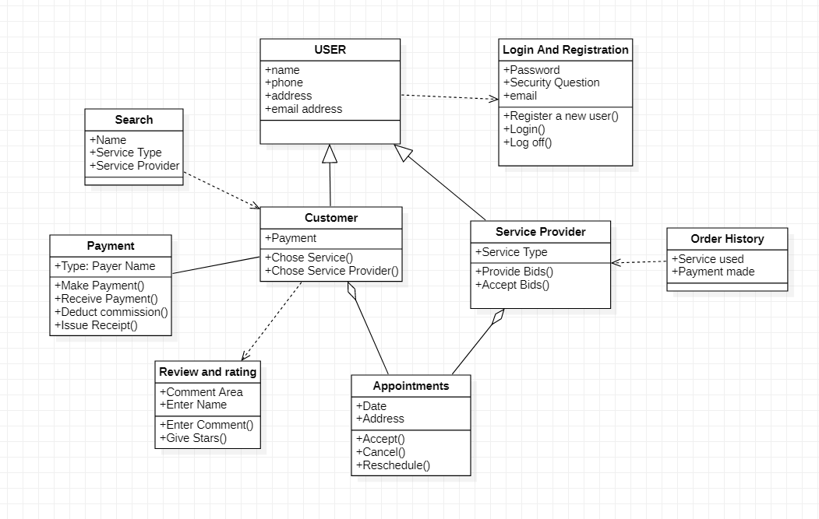

## 3.2 UML: Class Diagram: “Registration and Login”

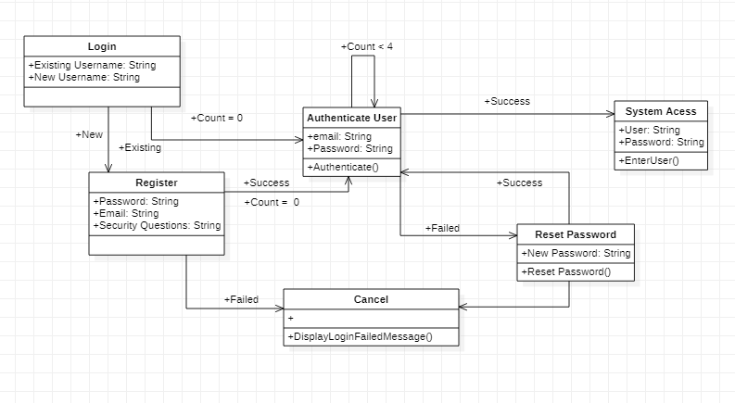

## 

## 3.3 UML: Class Diagram: “Setup”

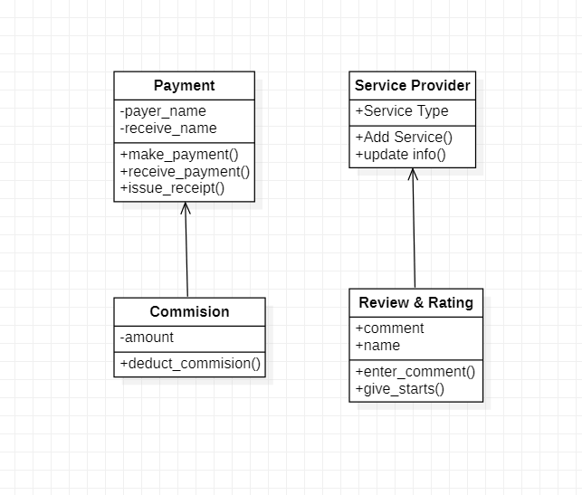

## 3.4 UML: Activity Diagram: “Service Categories”

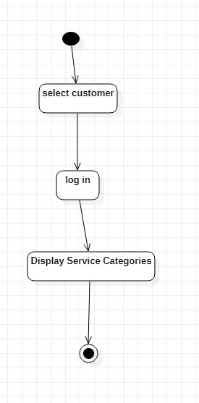

## 3.5 UML: Activity Diagram: “Vendor Addition”

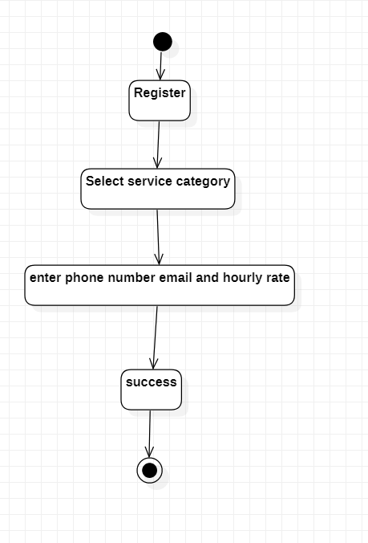

## 3.6 UML: Activity Diagram: “Place Service Request”

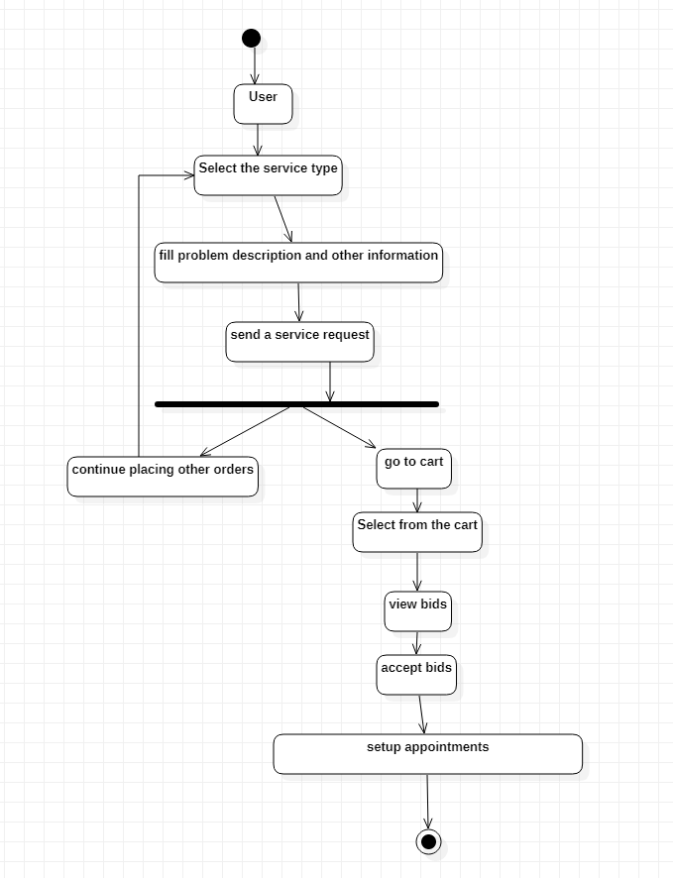

## 3.7 UML: Activity Diagram: “Accept Service Request”

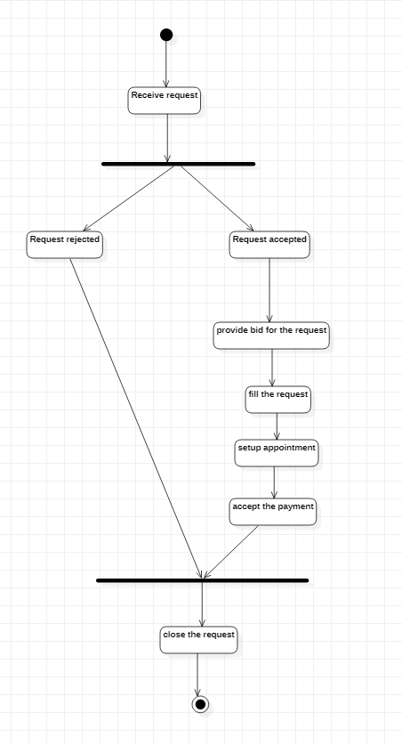

## 3.8 UML: Class Diagram: “Service Request Change or Cancellation”

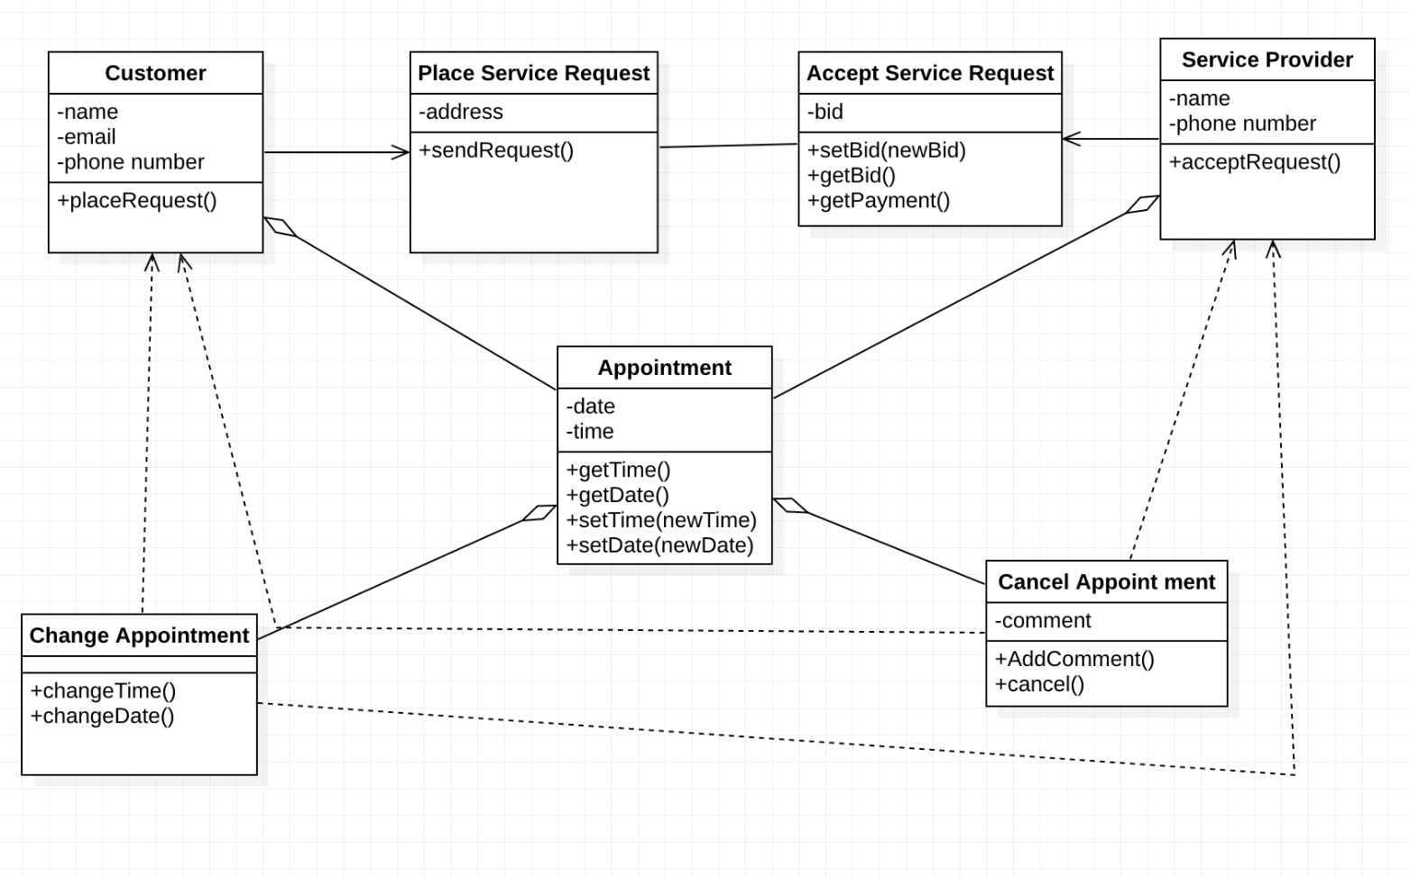

## 3.9 UML: Class Diagram: “Review and Rating”

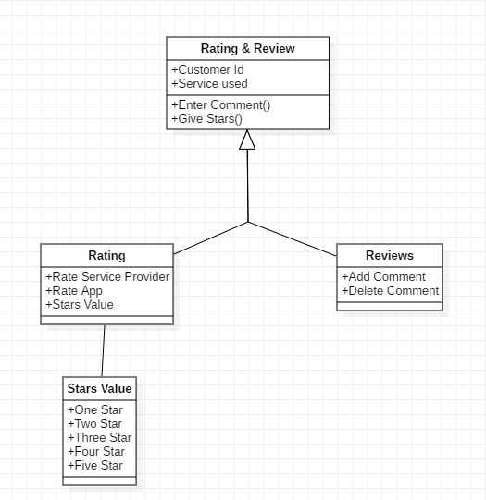

## 3.10 UML: Activity Diagram: “Payments”

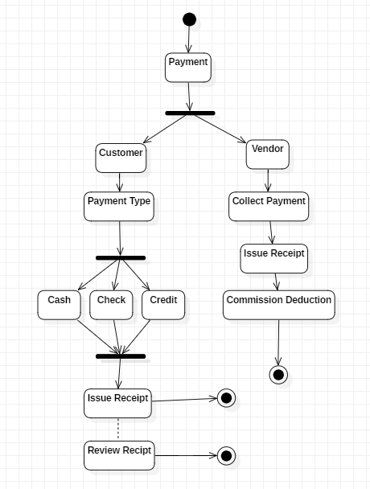

## 3.11 UML: Class Diagram: “Order History”

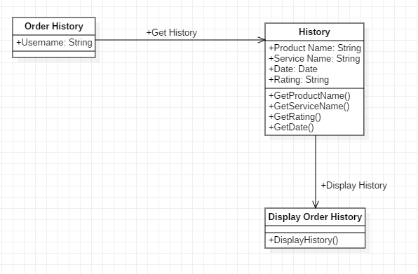

## 3.12 UML: Class Diagram: “Search”

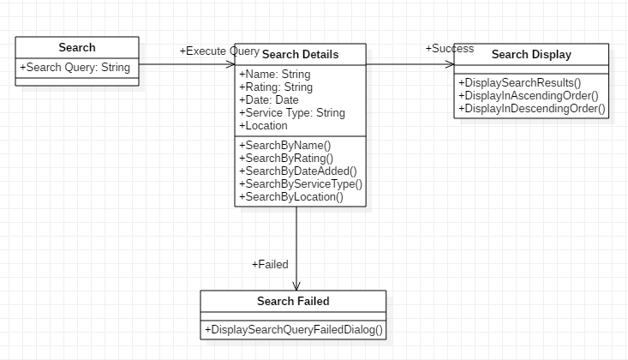

## 5.3 Test Plan

A Test Plan will be provided at a later stage.

## 5.4 Screen Shots

No screen shots available at this time.

# 6. Assumptions and Constraints

## 6.1 ASSUMPTIONS

The following is a list of assumptions:

* Only people older than 18 can use this product
* Vendors are providing correct information and not misleading the user
* The user will not provide fake information

## 6.2 CONSTRAINTS

The following is a list of constraints:

* Team lacks android development skills
* App needs to be downloaded on a device

## 6.3 Out of Scope material

The following is a list of “out of scope” material:

* Post Project maintenance is not covered
* Code implements material written by other sources
* App Security is not guaranteed.

# 7. Delivery and Schedule

{List all tasks/milestones from start of the project to the end with specific dates for both Anticipated Start & End Dates

|  |  |  |  |  |
| --- | --- | --- | --- | --- |
| Task/Milestone Description | Anticipated Start Date | Anticipated End Date | Status | Comments |
| Prepare UML diagrams | 9/5/2019 | 9/26/2019 | Complete | UML diagram delivered  Increment 1 Deliverable |
| SRA document (Includes project objectives, Requirements and UML diagrams) | 9/27/2019 | 10/29/2019 | Complete | SRA document delivered  Increment 2 Deliverable |
| Design: Design big picture, define format, navigation and functionality to include | 09/27/2019 | 10/29/2019 | Complete | Design thought out on paper |
| Implementation: Home screen design | 10/29/2019 | 11/02/2019 | Complete |  |
| Implementation: Login and registration | 10/29/2019 | 11/05/2019 | Complete |  |
| Implementation: Service Categories | 10/29/2019 | 11/05/2019 | Complete |  |
| Implementation:  Service Request | 10/29/2019 | 11/05/2019 | Complete |  |
| Implementation: Service provider | 10/29/2019 | 11/07/2019 | Complete |  |
| Implementation:  Appointments | 10/29/2019 | 11/07/2019 | Complete |  |
| Implementation:  Payments | 10/29/2019 | 11/07/2019 | Complete |  |
| Implementation:  Review and Ratings | 10/29/2019 | 11/09/2019 | Partially Completed |  |
| Implementation:  Search | 10/29/2019 | 11/09/2019 | Partially Completed |  |
| Implementation:  Order History | 10/29/2019 | 11/09/2019 | Complete |  |
| Test case design | 10/25/2019 | 11/14/2019 | Complete | Increment 3 Deliverable |
| External Documentation (i.e. User Manual) | 11/15/2019 | 11/28/2019 | Complete |  |
| Project presentation | 11/19/2019 | 11/28/2019 | Complete |  |
| Final Milestone: project delivery |  | 11/28/2019 | Complete | Increment 4 Deliverable |

# 8. Stakeholder Approval Form

|  |  |  |  |
| --- | --- | --- | --- |
| Stakeholder Name | Stakeholder Role | Stakeholder Comments | Stakeholder Approval Signature and Date |
| Bahram Khalili | Development Mgr |  |  |
| Akshit Singhal | Project Assistant |  |  |
| Rajesh Rayamajhi | Developer |  |  |
| Shameen Shetty | Developer |  |  |
| Sudarshan Tiwari | Developer |  |  |
| Kritan Duwal | Developer |  |  |

# Appendix:

None