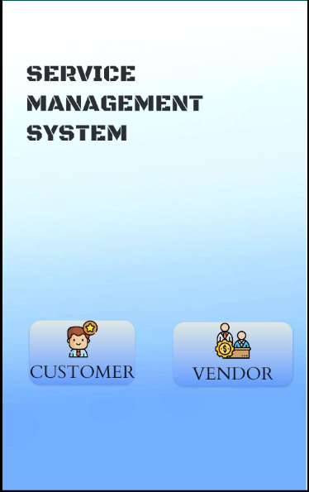

**Figure 1: SMS Home Screen**

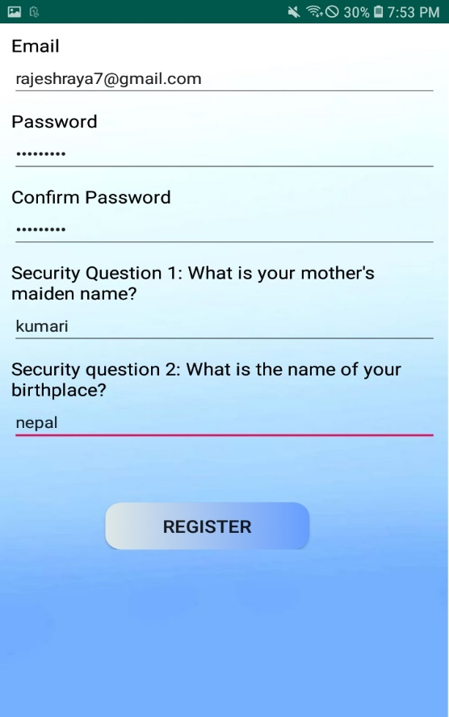

**Figure 2: User Registration**

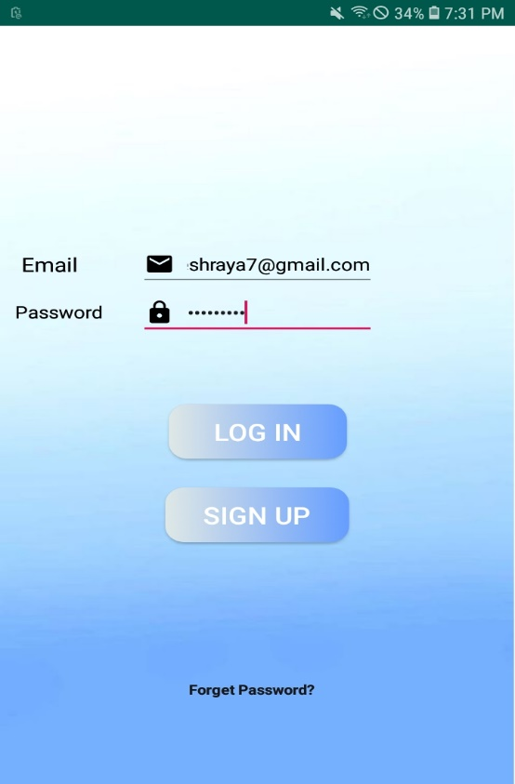

**Figure 3: User Login**

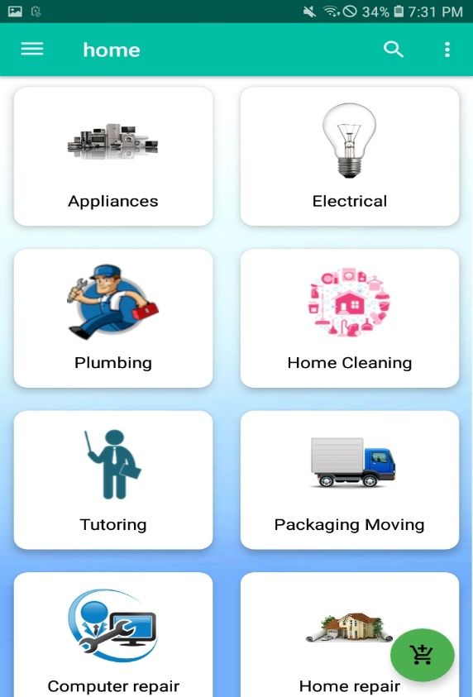

**Figure 4: User Home Screen**

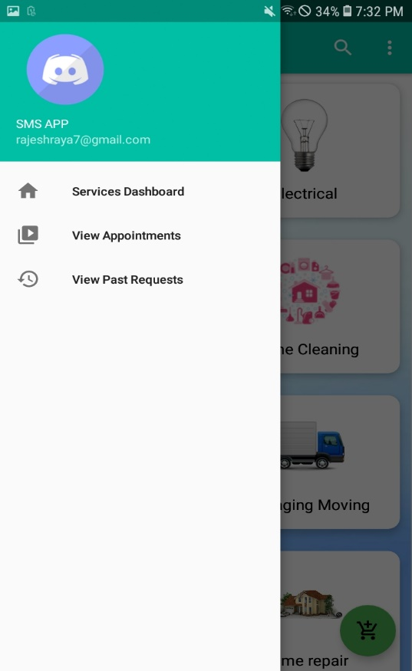

**Figure 5: User Side navigation bar**

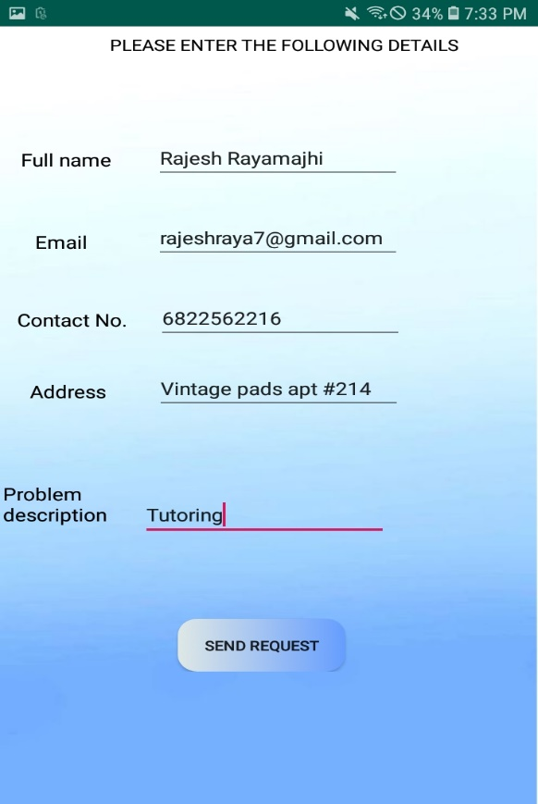

**Figure 6: User Service Request Form**

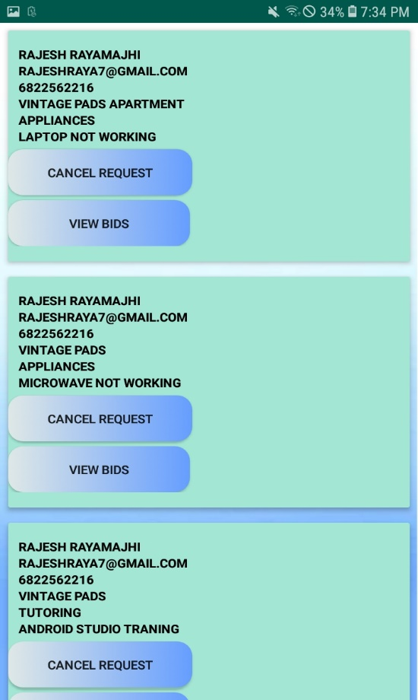

**Figure 7: Service Requests List**

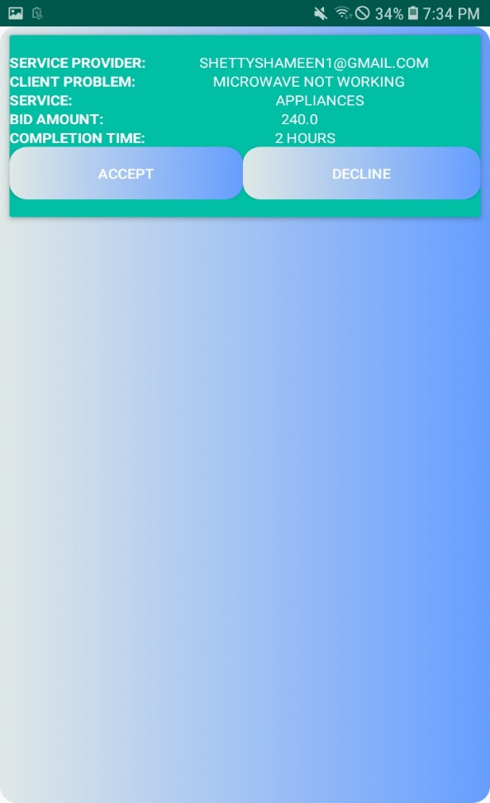

**Figure 8: Vender Bids list**

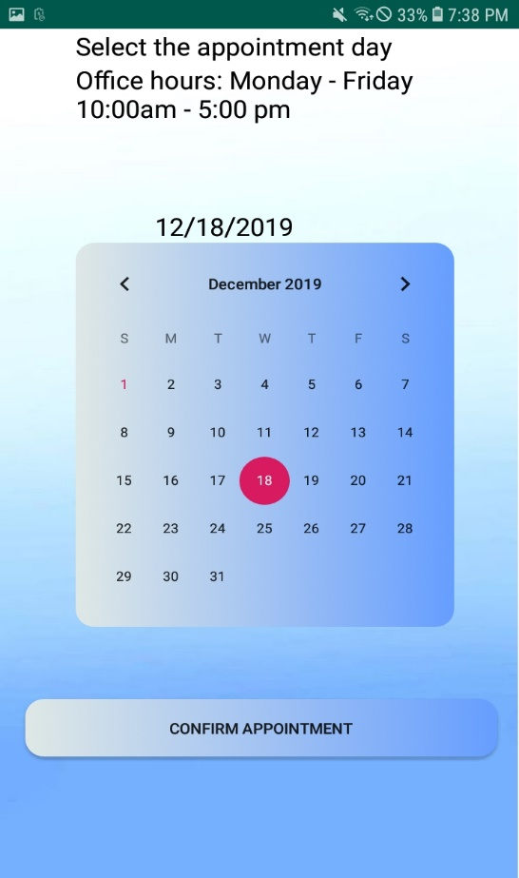

**Figure 9: Appointment Schedule after review of bids**

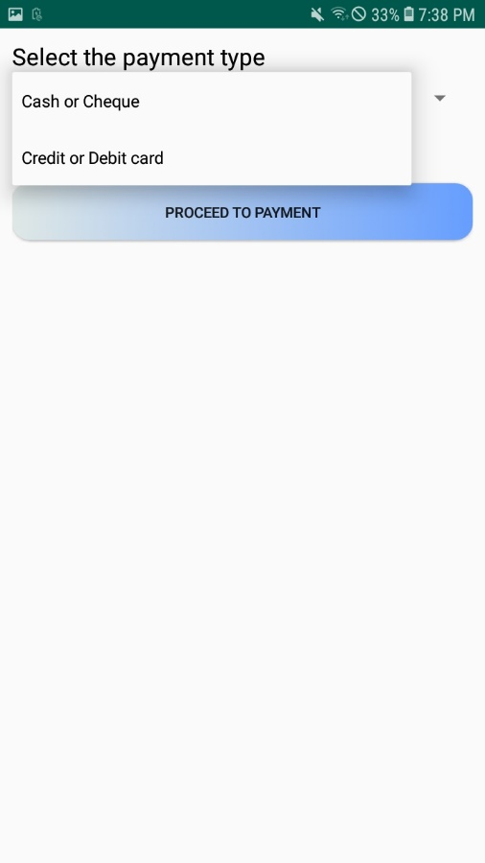

**Figure 10: Payment after appointment schedule**

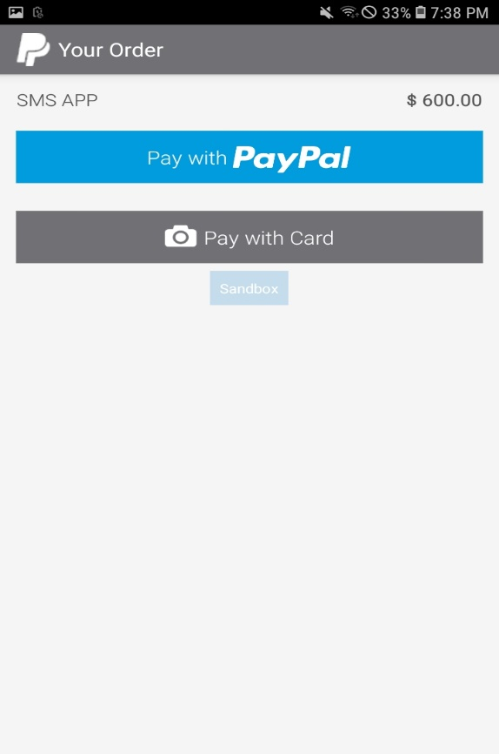

**Figure 11: Electronic Payment using PayPal integration**

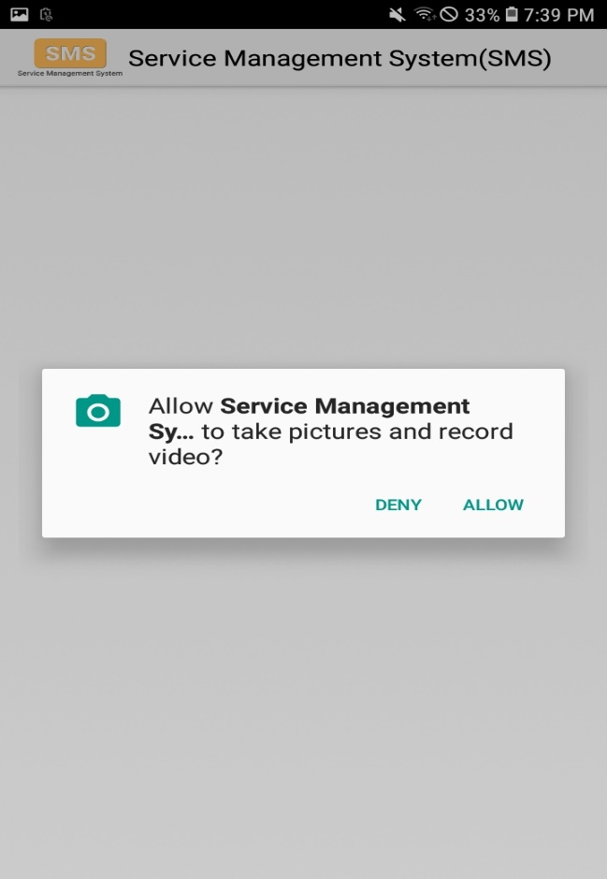

**Figure 12: Request to allow using camera for card scan**

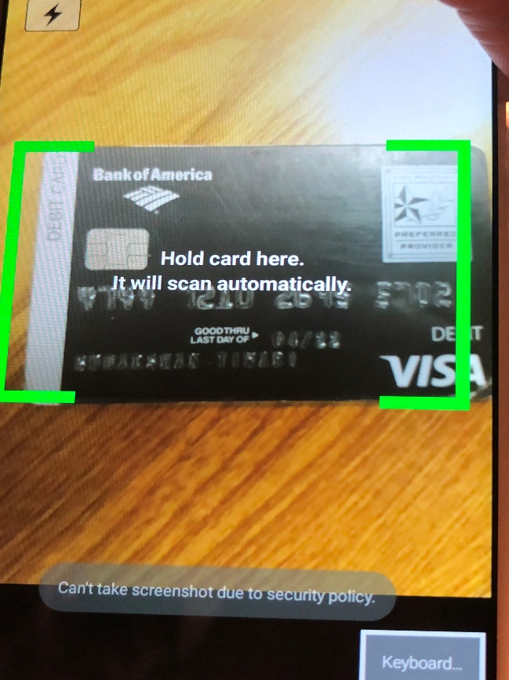

**Figure 13: Card scan for payment**

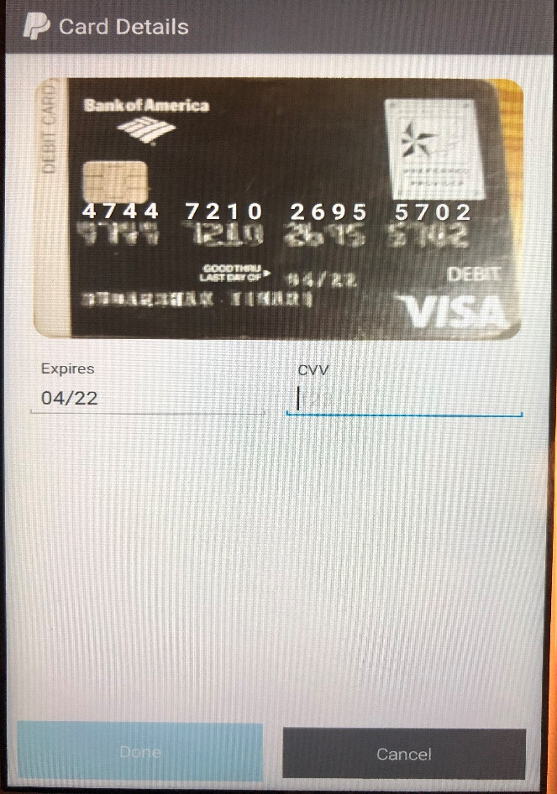

**Figure 14: Security Verification for payment**

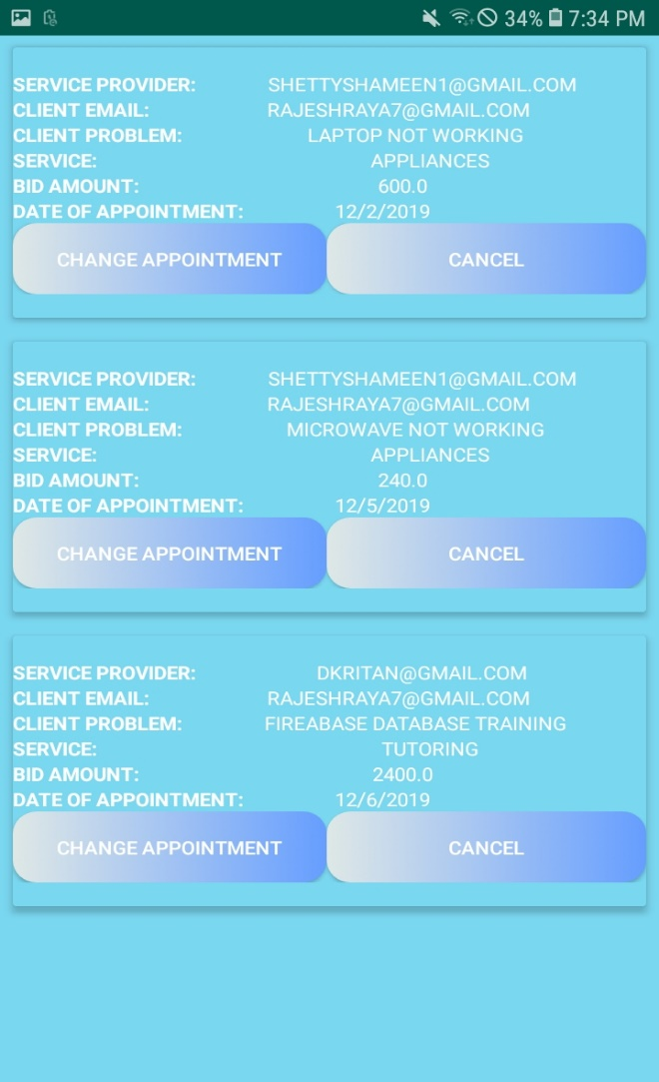

**Figure 15: Change and cancel appointment**

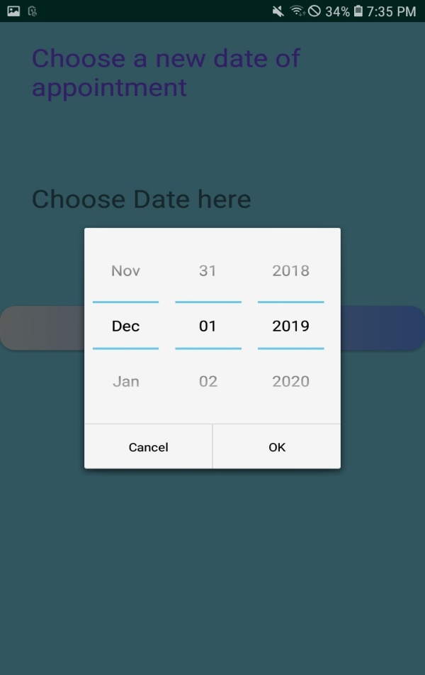

**Figure 16: Change date to change appointment**

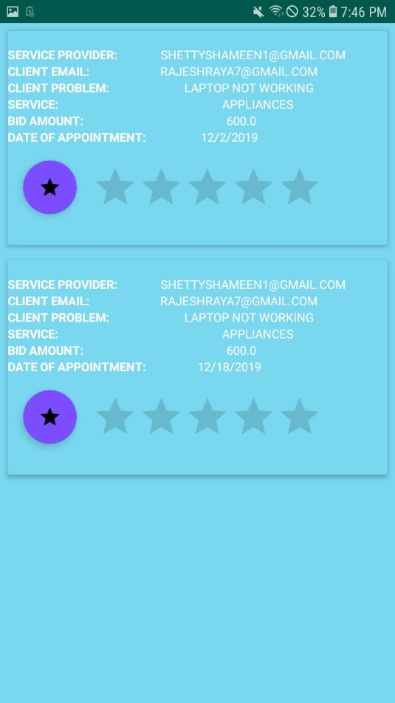

**Figure 17: Order History**

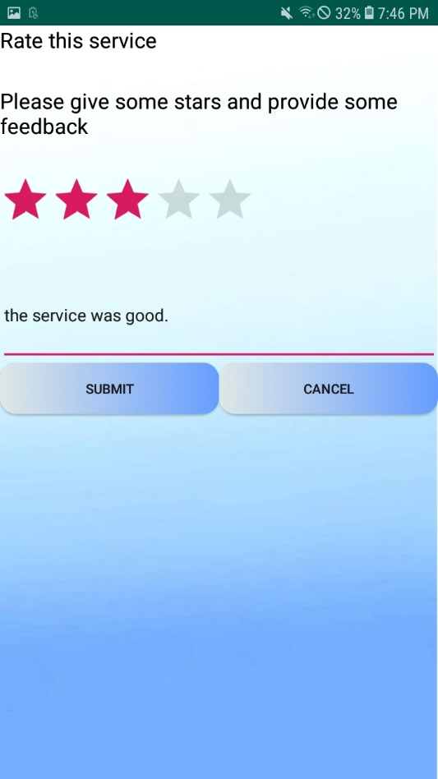

**Figure 18: Rating the vendor**

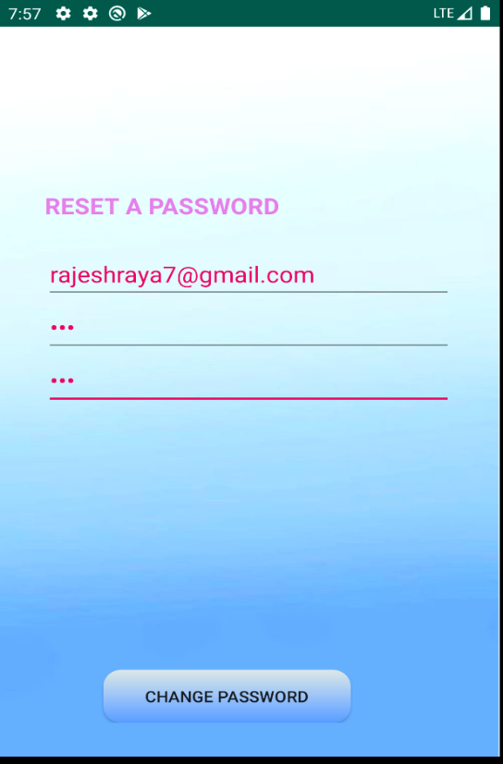

**Figure 19: User Reset password**

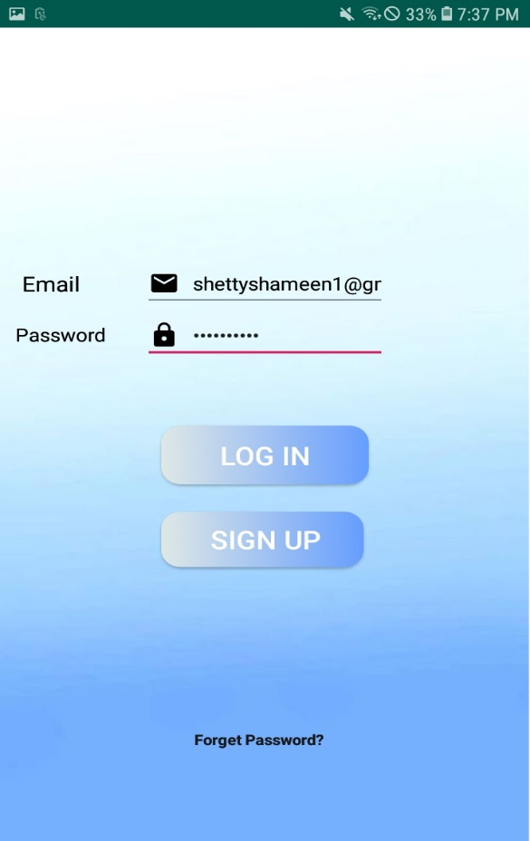

**Figure 20: Vendor Login and Registration**

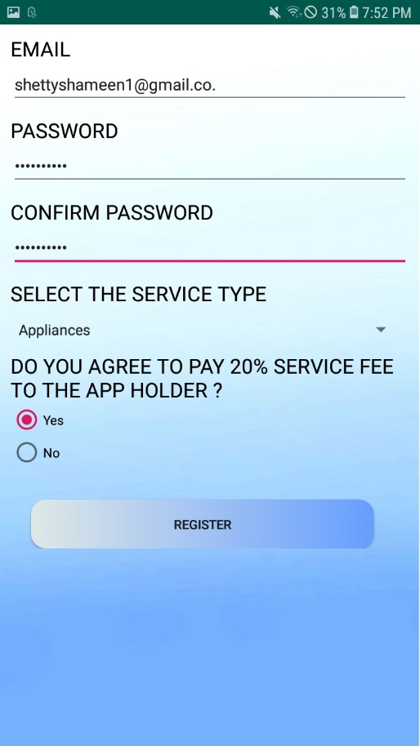

**Figure 21: Vendor Registration**

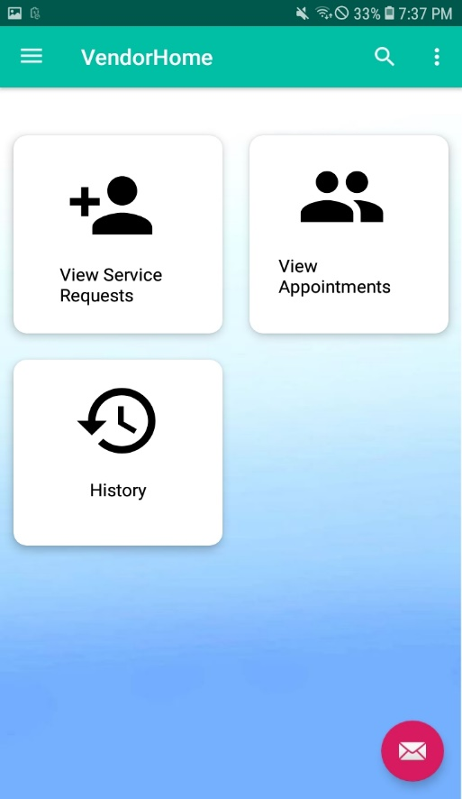

**Figure 22: Vendor Home Screen**

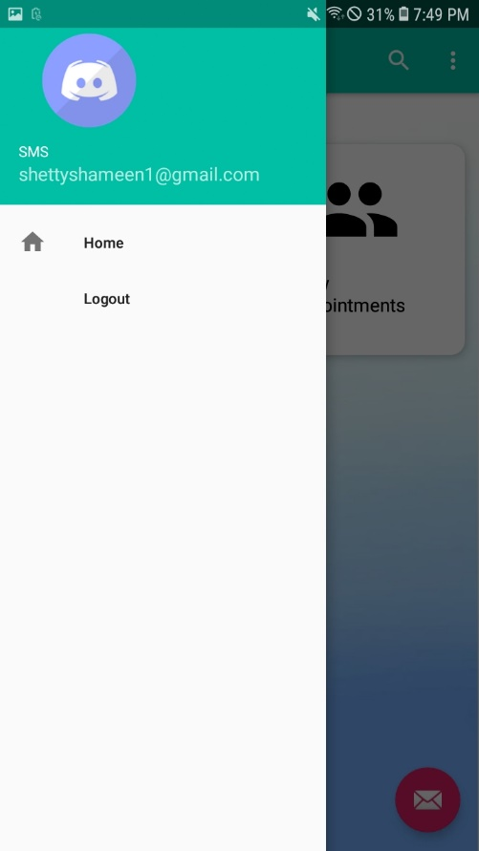

**Figure 23: Vendor Slide navigation bar**

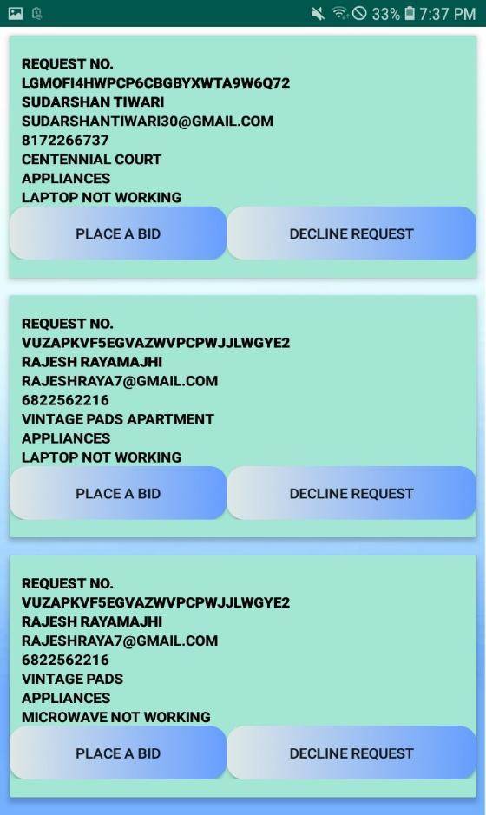

**Figure 24: View Service Request**

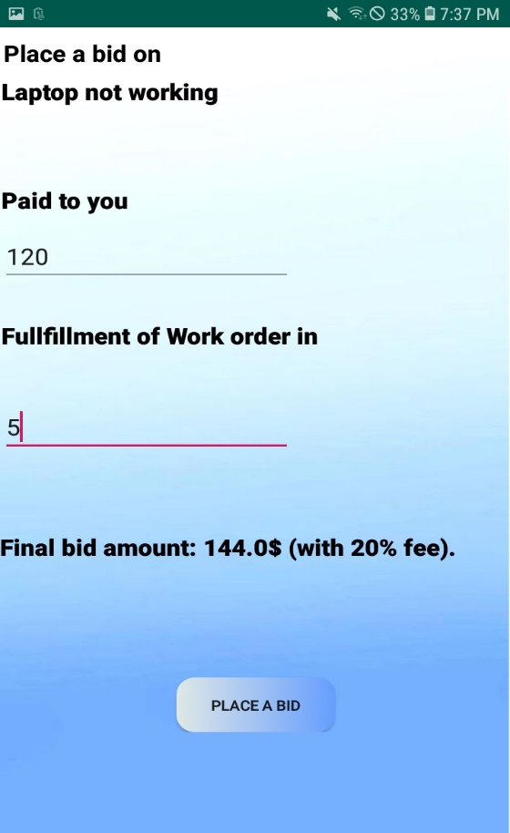

**Figure 25: Place a bid for a request**

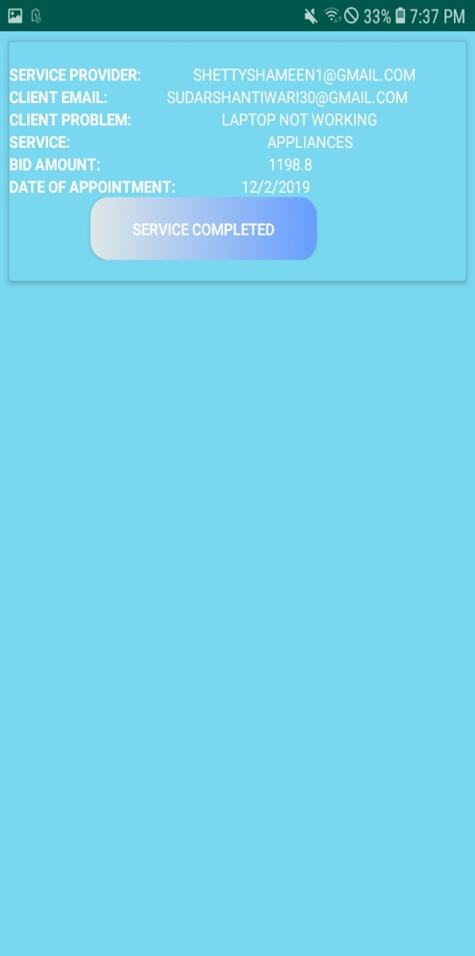

**Figure 26: Service Completion Confirmation**

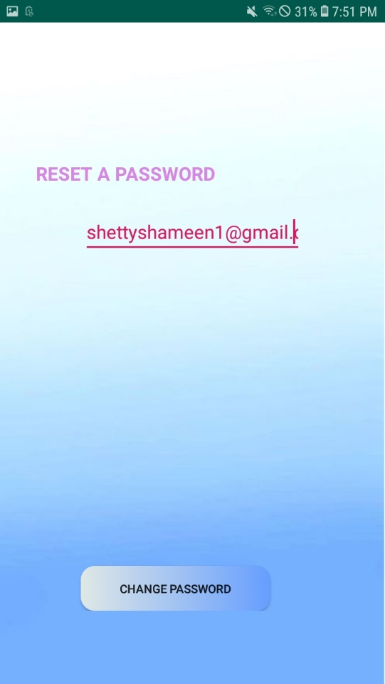

**Figure 27: Vendor password reset screen**