Part 1 Data Base setup

Screenshots

1)Created the database

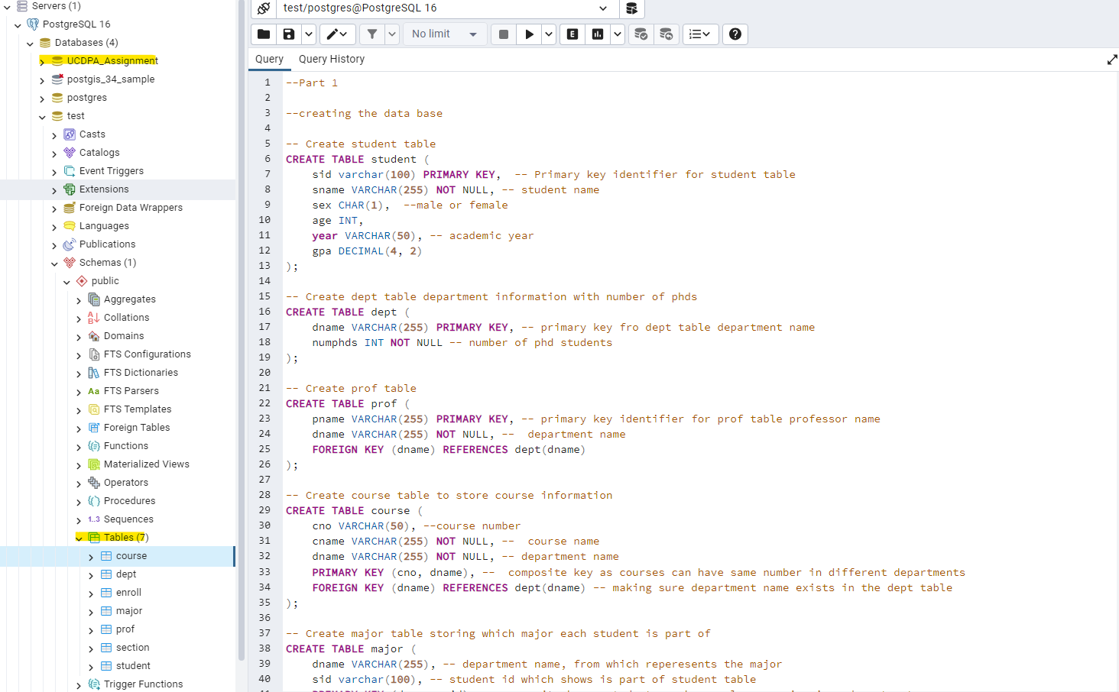
2) Verifying if the data is being copied with example data table

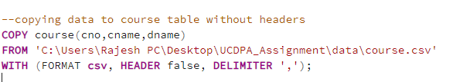

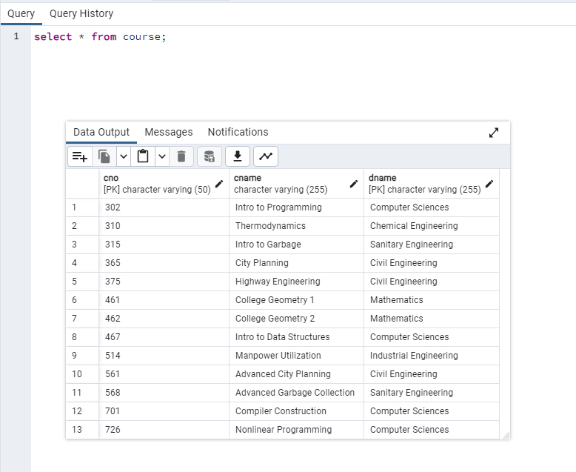
3) Relationship between the tables with the attributes

In order to model the academic organization, a number of links between attributes are constructed using main and foreign keys. Each student is individually identified by the sid property of the student table, which is connected to the enroll and major tables, which show the students' course enrollments and declared majors, respectively. The dname of the dept (department) table links to the major, prof, and course tables, providing a unique identity for academic departments and indicating which department offers which major, who teaches there, and what courses are offered. The combination of the course number (cno) and the dname in the course table refers to particular sections inside the section table, denoting various courses or programs. Students can access the exact class sections they are enrolled in by connecting the section table to the enroll table.

4) Entity Relationship diagram extracted from Postgresql

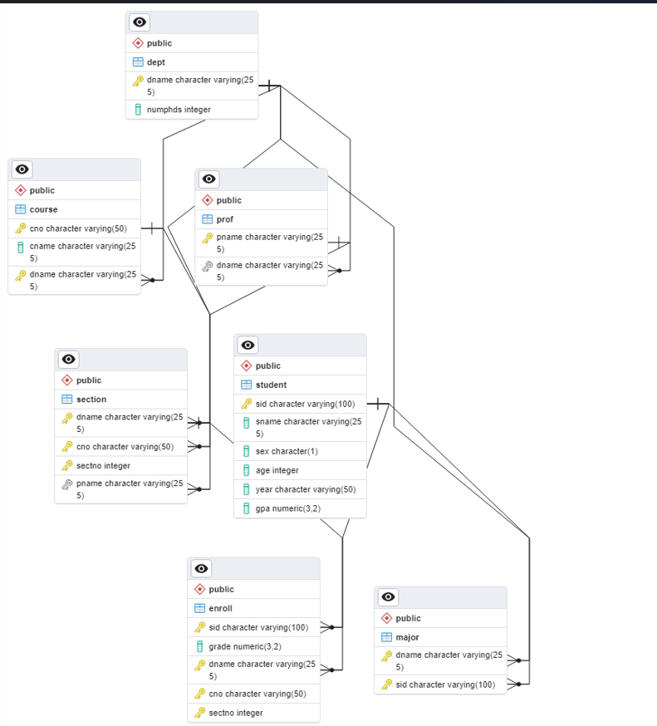

Section 2 Screenshots of the queries with the outputs in the order of the questions
1)

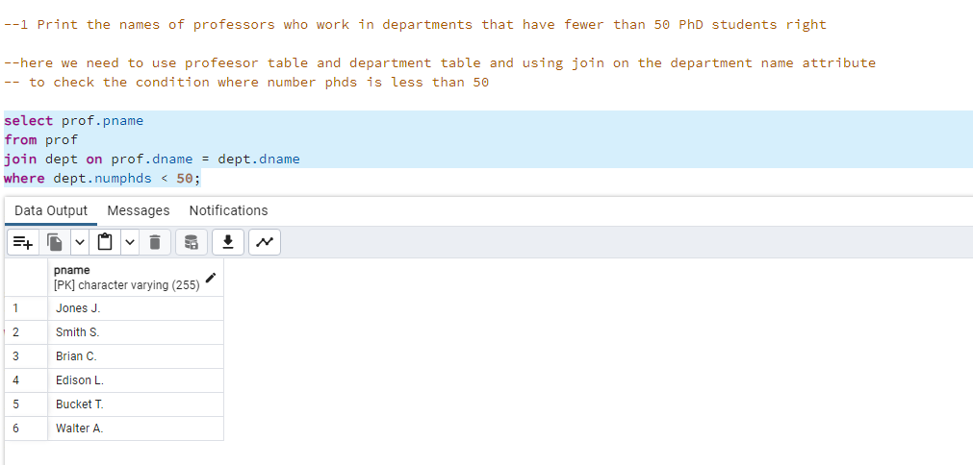
2)

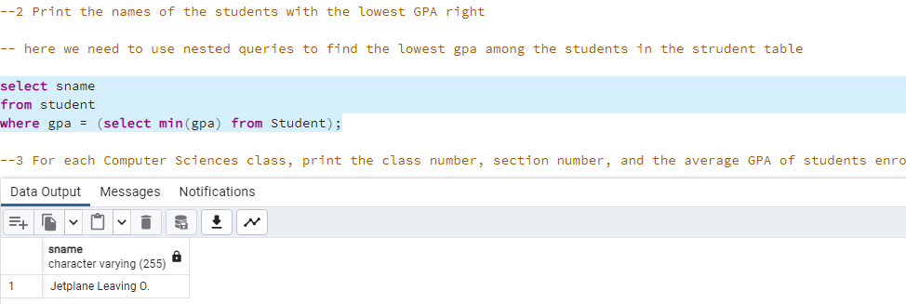
3)

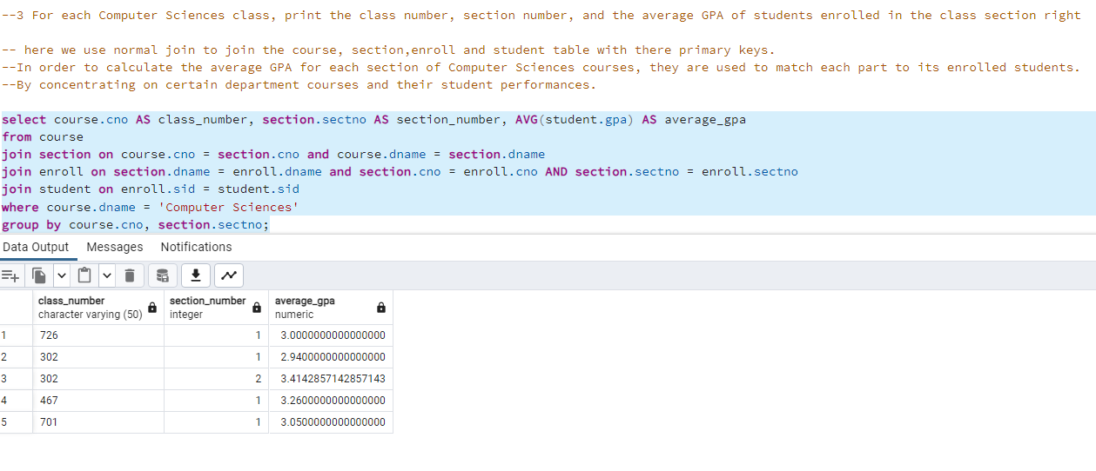

4)

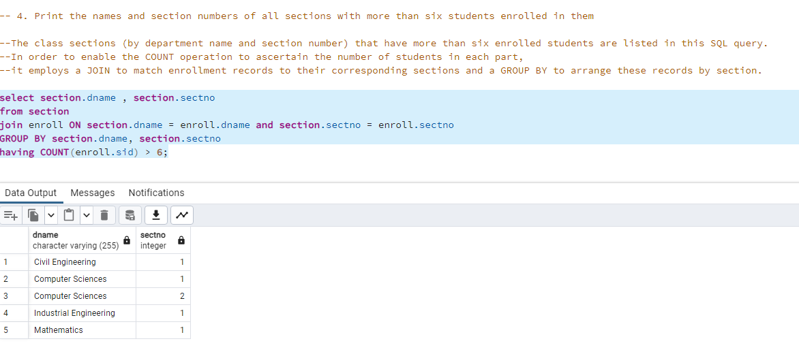

5)
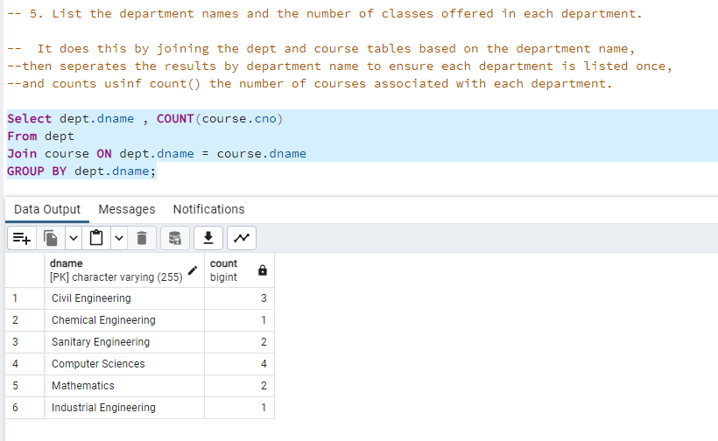

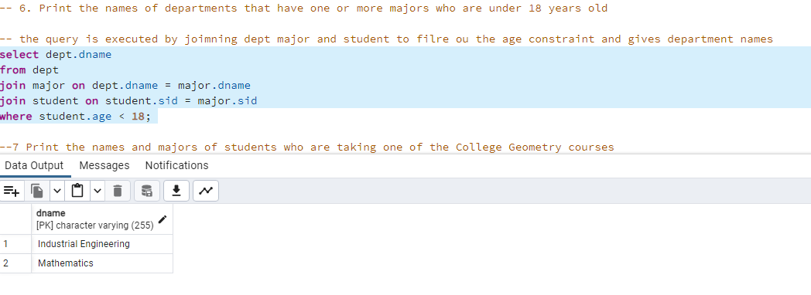
6)

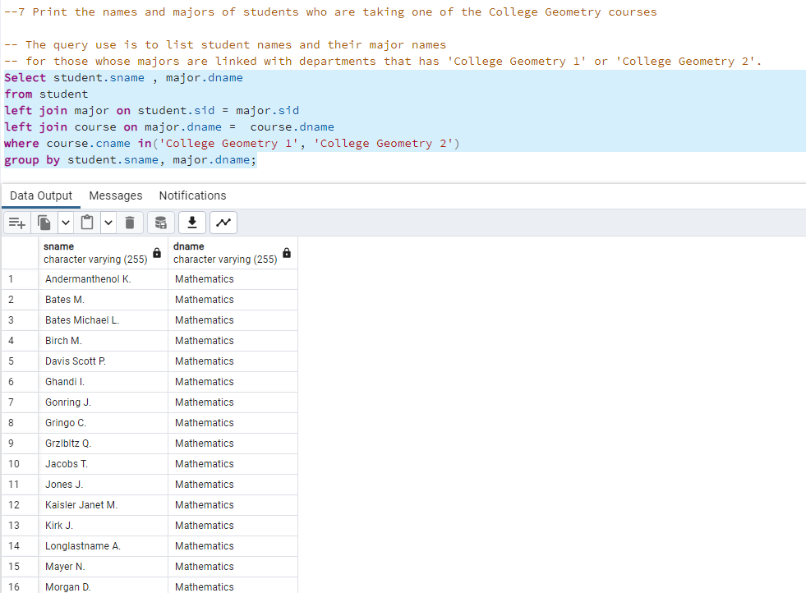
7)

8)
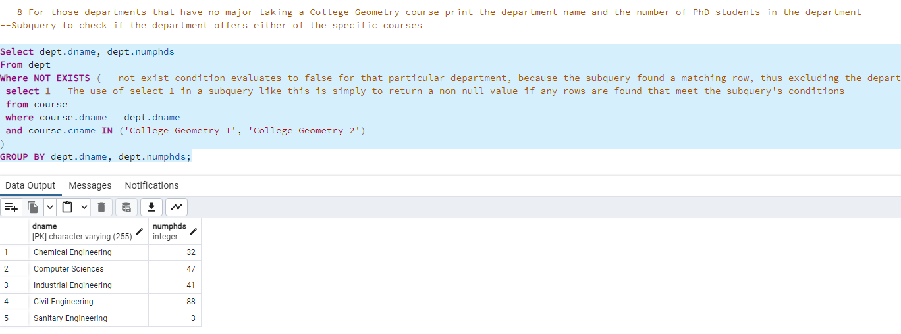
9)

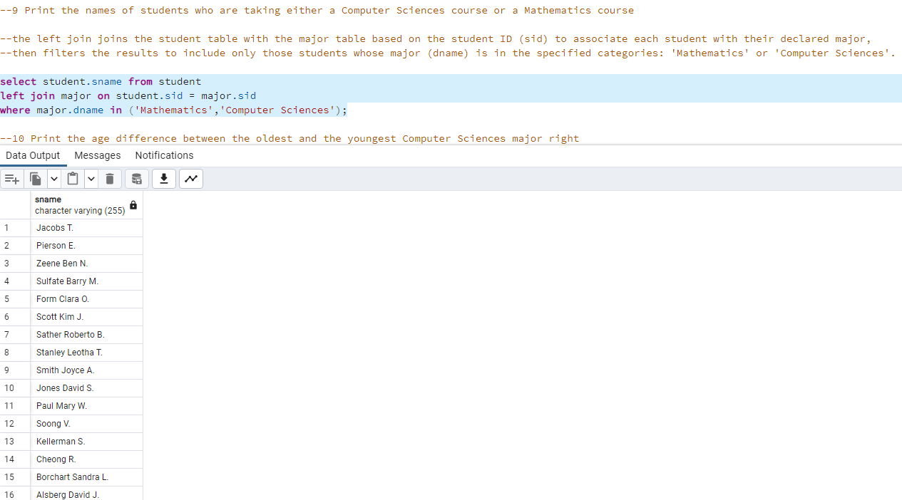

10)
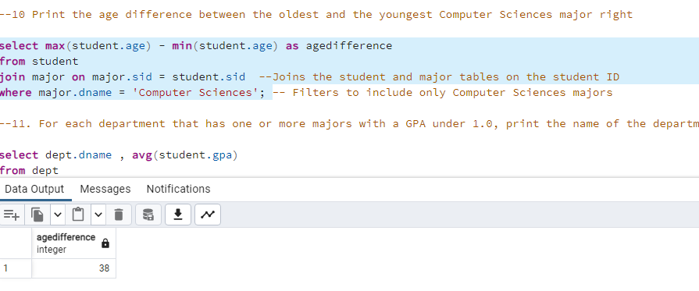

11)

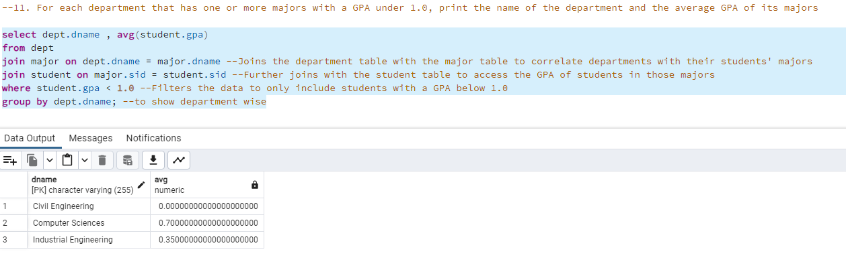
12)

