**HTML**

1. **<hr>**
2. **<center>**
3. **<br>**
4. **<pre>**
5. **<p align="left">Left Aligned</p>**
6. **<p align="center">Center Aligned</p>**
7. **<p align="right">Right Aligned</p>**
8. **Id=demo -> head inside < style >#demo{}**
9. **Class=demo -> head inside <style> .demo{}**
10. **<p class="borderStyle colorStyle" > -> .borderstyle .colorStyle**
11. **Rtl**
12. **Ltl**
13. **<a href=**[**www.fsf.com**](http://www.fsf.com)**> fsf </a>**

|  |  |  |
| --- | --- | --- |
| **Attribute** | **Options** | **Function** |
| [**align**](https://www.tutorialspoint.com/html/html_align_attribute.htm) | right, left, center | Horizontally aligns tags |
| [**bgcolor**](https://www.tutorialspoint.com/html/html_bgcolor_attribute.htm) | numeric, hexadecimal, RGB values | Places a background color behind an element |
| [**id**](https://www.tutorialspoint.com/html/html_id_attribute.htm) | User Defined | Names an element for use with Cascading Style Sheets. |
| [**class**](https://www.tutorialspoint.com/html/html_class_attribute.htm) | User Defined | Classifies an element for use with Cascading Style Sheets. |
| [**width**](https://www.tutorialspoint.com/html/html_width_attribute.htm) | Numeric Value | Specifies the width of tables, images, or table cells. |
| [**height**](https://www.tutorialspoint.com/html/html_height_attribute.htm) | Numeric Value | Specifies the height of tables, images, or table cells. |
| [**title**](https://www.tutorialspoint.com/html/html_global_title_attribute.htm) | User Defined | A text to display in a tool tip. |

1. <ul>

<li>Item 1</li>

<li>Item 2</li>

</ul>

<p> This is a paragraph following an unordered list. </p>

* Item 1
* Item 2

This is a paragraph following an unordered list.

1. **<em>**
2. **<Strong>**
3. This is a paragraph with **emphasized**text.
4. **<p> visit <a href=””>here</a>**
5. visit  [here](https://www.tutorialspoint.com/).
6. <p>This is a <span style="color: blue;">blue</span> text within a paragraph. </p>
7. This is a blue text within a paragraph.
8. <p> Here's an image: <img src="\html\images\test.png" alt="Example Image"> </p>
9. <p> H<sub>2</sub>O is the chemical formula for water. 2<sup>3</sup> equals 8.</p>
10. <p> The book <cite>War and Peace </cite> is a classic novel. </p>
11. The book War and Peace is a classic novel.
12. <p style="font-size: 20px; color: green;">This paragraph has inline styles.</p>
13. <font size =”-1,+1”>hello</font size>
14. <font face=”fjhjabhfa”>
15. <font color=”red”>

|  |  |  |  |  |
| --- | --- | --- | --- | --- |
| **HTML Block Elements** | | | | |
| [**<address>**](https://www.tutorialspoint.com/html/html_address_tag.htm) | [**<article>**](https://www.tutorialspoint.com/html/html_article_tag.htm) | [**<aside>**](https://www.tutorialspoint.com/html/html_aside_tag.htm) | [**<blockquote>**](https://www.tutorialspoint.com/html/html_blockquote_tag.htm) | [**<canvas>**](https://www.tutorialspoint.com/html/html_canvas_tag.htm) |
| [**<dd>**](https://www.tutorialspoint.com/html/html_dd_tag.htm) | [**<div>**](https://www.tutorialspoint.com/html/html_div_tag.htm) | [**<dl>**](https://www.tutorialspoint.com/html/html_dl_tag.htm) | [**<dt>**](https://www.tutorialspoint.com/html/html_dt_tag.htm) | [**<fieldset>**](https://www.tutorialspoint.com/html/html_fieldset_tag.htm) |
| [**<figcaption>**](https://www.tutorialspoint.com/html/html_figcaption_tag.htm) | [**<figure>**](https://www.tutorialspoint.com/html/html_figure_tag.htm) | [**<footer>**](https://www.tutorialspoint.com/html/html_footer_tag.htm) | [**<form>**](https://www.tutorialspoint.com/html/html_form_tag.htm) | [**<h1> - <h6>**](https://www.tutorialspoint.com/html/html_hn_tag.htm) |
| [**<header>**](https://www.tutorialspoint.com/html/html_header_tag.htm) | [**<hr>**](https://www.tutorialspoint.com/html/html_hr_tag.htm) | [**<li>**](https://www.tutorialspoint.com/html/html_li_tag.htm) | [**<main>**](https://www.tutorialspoint.com/html/html_main_tag.htm) | [**<nav>**](https://www.tutorialspoint.com/html/html_nav_tag.htm) |
| [**<noscript>**](https://www.tutorialspoint.com/html/html_noscript_tag.htm) | [**<ol>**](https://www.tutorialspoint.com/html/html_ol_tag.htm) | [**<p>**](https://www.tutorialspoint.com/html/html_p_tag.htm) | [**<pre>**](https://www.tutorialspoint.com/html/html_pre_tag.htm) | [**<section>**](https://www.tutorialspoint.com/html/html_section_tag.htm) |
| [**<table>**](https://www.tutorialspoint.com/html/html_table_tag.htm) | [**<tfoot>**](https://www.tutorialspoint.com/html/html_tfoot_tag.htm) | [**<ul>**](https://www.tutorialspoint.com/html/html_ul_tag.htm) | [**<video>**](https://www.tutorialspoint.com/html/html_video_tag.htm) |  |



|  |  |  |  |  |
| --- | --- | --- | --- | --- |
| **HTML Inline Elements** | | | | |
| [**<a>**](https://www.tutorialspoint.com/html/html_a_tag.htm) | [**<abbr>**](https://www.tutorialspoint.com/html/html_abbr_tag.htm) | [**<acronym>**](https://www.tutorialspoint.com/html/html_acronym_tag.htm) | [**<b>**](https://www.tutorialspoint.com/html/html_b_tag.htm) | [**<bdo>**](https://www.tutorialspoint.com/html/html_bdo_tag.htm) |
| [**<big>**](https://www.tutorialspoint.com/html/html_big_tag.htm) | [**<br>**](https://www.tutorialspoint.com/html/html_br_tag.htm) | [**<button>**](https://www.tutorialspoint.com/html/html_button_tag.htm) | [**<cite>**](https://www.tutorialspoint.com/html/html_cite_tag.htm) | [**<code>**](https://www.tutorialspoint.com/html/html_code_tag.htm) |
| [**<dfn>**](https://www.tutorialspoint.com/html/html_dfn_tag.htm) | [**<em>**](https://www.tutorialspoint.com/html/html_em_tag.htm) | [**<i>**](https://www.tutorialspoint.com/html/html_i_tag.htm) | [**<img>**](https://www.tutorialspoint.com/html/html_img_tag.htm) | [**<input>**](https://www.tutorialspoint.com/html/html_input_tag.htm) |
| [**<kbd>**](https://www.tutorialspoint.com/html/html_kbd_tag.htm) | [**<label>**](https://www.tutorialspoint.com/html/html_label_tag.htm) | [**<map>**](https://www.tutorialspoint.com/html/html_map_tag.htm) | [**<object>**](https://www.tutorialspoint.com/html/html_object_tag.htm) | [**<output>**](https://www.tutorialspoint.com/html/html_output_tag.htm) |
| [**<q>**](https://www.tutorialspoint.com/html/html_q_tag.htm) | [**<samp>**](https://www.tutorialspoint.com/html/html_samp_tag.htm) | [**<script>**](https://www.tutorialspoint.com/html/html_script_tag.htm) | [**<select>**](https://www.tutorialspoint.com/html/html_select_tag.htm) | [**<small>**](https://www.tutorialspoint.com/html/html_small_tag.htm) |
| [**<span>**](https://www.tutorialspoint.com/html/html_span_tag.htm) | [**<strong>**](https://www.tutorialspoint.com/html/html_strong_tag.htm) | [**<sub >**](https://www.tutorialspoint.com/html/html_sub_tag.htm) | [**<sup>**](https://www.tutorialspoint.com/html/html_sup_tag.htm) | [**<textarea>**](https://www.tutorialspoint.com/html/html_textarea_tag.htm) |
| [**<time>**](https://www.tutorialspoint.com/html/html_time_tag.htm) | [**<tt>**](https://www.tutorialspoint.com/html/html_tt_tag.htm) | [**<var>**](https://www.tutorialspoint.com/html/html_var_tag.htm) |  |  |

1. <div style=”color:red;”> block line element
2. <p> This is <span style="color:red">red</span></p> block line element
3. <link rel="stylesheet" type="text/css" href="/html/style.css"> External css
4. **Formatting tags**
5. 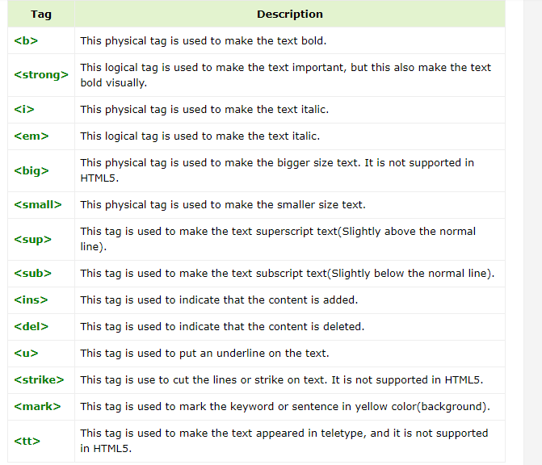
6. 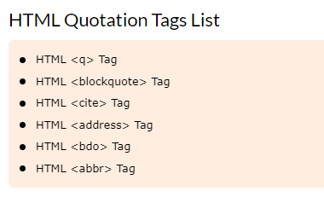
7. <img src="/html/images/test.png" alt="Test Image" border="3" align="right" />