1. **Log Analysis**

I found three error in the attached file 1) ERROR o.s.i.handler.LoggingHandler org.springframework.web.client.HttpClientErrorException: 401 Unauthorized

2) ERROR c.f.figo.gateway.FigoErrorHandler An error occurred while communicating with Figo, reason: FigoError{code=40001

3) ERROR o.a.c.c.C.[.[.[.[dispatcherServlet] Servlet.service() for servlet [dispatcherServlet] in context with path [] threw exception [Request processing failed; nested exception is com.finreach.figo.gateway.FigoClientException: An error occurred

1. **Automation Task - Project Summary:**

**Tools & Framework used:** Eclipse IDE, Cucumber Framework, Selenium, Maven

**Programming Language:** Java 8

**Framework Understanding:**

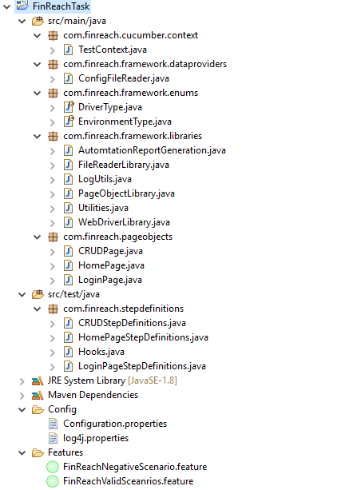

This framework uses Selenium WebDriver-Cucumber-Junit-Maven with Page Object Model.

* WebDriverLibrary and all PageObjectLibrary initialization happens inside TestContext.java class
* ConfigFileReader.java class initialize the **Configuration.properties** file.

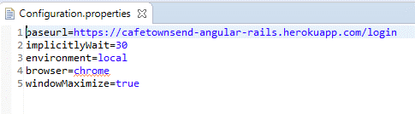

* DriverType.java & EnvironmentType.java Enums have constant on driver type (local or remote) and environment type
* FileReaderLibrary.java class is singleton class initialize ConfigFileReader.java class
* PageObjectLibrary.java initialize all page objects of the frameworks
* WebDriverLibrary.java class initialize the driver and other driver related behaviour
* LogUtils.java & Utilities.java are framework utility classes
* Hooks.java class helps in before and after scenario actions
* All page objects are inside “**com.finreach.pageobjects**” package
* Test cases are inside cucumber feature file. I have created two separate feature files considering the given scenarios. TestRunner files generate at the run time. Location to find both feature files after execution is **\target\generated-test-sources\cucumber\**.
* **Parallel01IT.java** and **Parallel02IT.java** are the TestRunner classes.

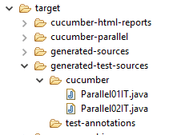

* For parallel execution I have used **cucumber-jvm-parallel-pugin**

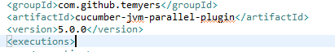

* For logging, I have used Log4j library. Log file are generated inside “logs” folder

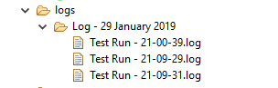

* For reporting I have used masterthought report, which can be obtained after execution in “**target\cucumber-html-reports\overview-features.html**”. 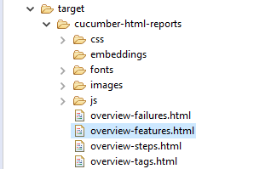
* “**overview-features.html**” is the html report of the features.

**Feature File:**

* Cucumber feature files “**FinReachValidSceanrios.feature**” & “**FinReachNegativeScenario.feature**” has all three stories scenario.

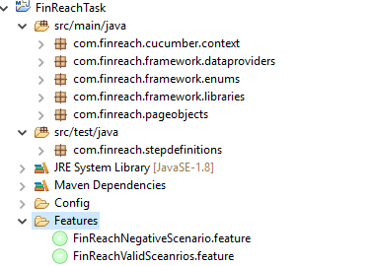

**Step Definition Files (Glue Code):**

* Feature files glue code are inside “**com.finreach.stepdefinitions**” package

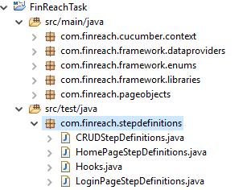

# How to Execute Test:

### Option#1:

* Clone the project or download to local machine from https://github.com/rajesha2016/FinReachTask.git
* Open command prompt or terminal
* Go to project workspace



* Type “**mvn clean install**”



* After execution, use get success message

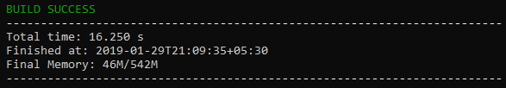

### Option#2:

* Clone the project https://github.com/rajesha2016/FinReachTask.git to IDE
* Go to individual Feature file
* Right click on the file: click on Run as >> Cucumber feature file

# Report:

* Framework should generate clear and concise report after automation script execution.
* I have used “**masterthought**” to generate html report
* After execution, two json report generate for each feature file.

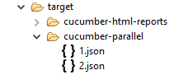

* “**masterthought**” merge this two json report and generate nice html report. Java code for merging this two json files is inside “AutomtationReportGeneration.java”

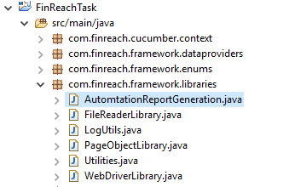

* Complete report looks like below. User can view report specific to Features, Tags, Steps and Failures. User can find the report “**target\cucumber-html-reports\overview-features.html**”.

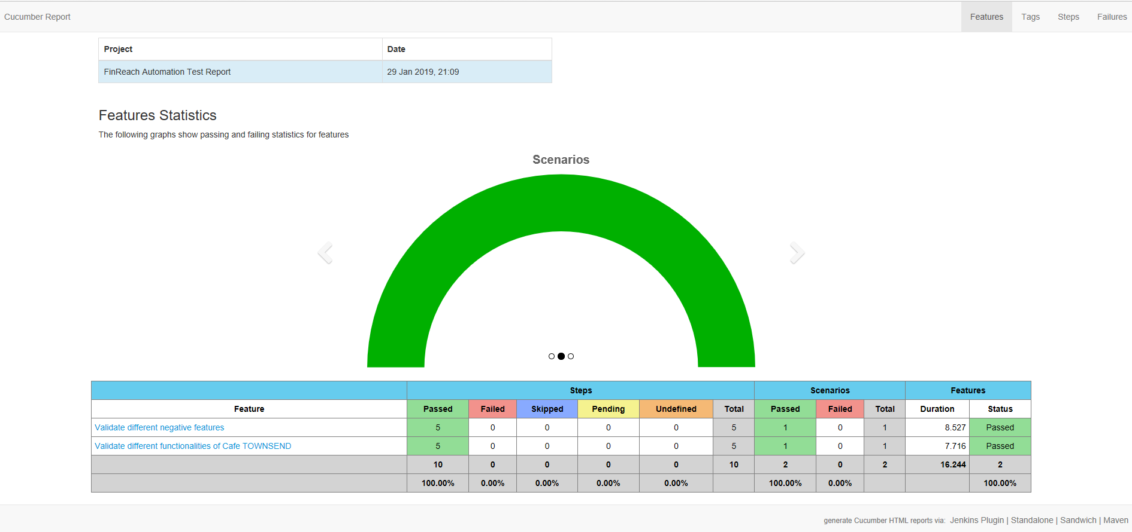

* Report specific to feature file

