**Enhanced Long-Range Based Location Tracking and Fall detection System**

Rajesha C U

Department of Master of Computer Applications

RV College of Engineering

Bengaluru

rajeshacu.mca23@rvce.edu.in

Dr. Deepika K

Associate Professor

Department of Master of Computer Applications RV College of Engineering

Bengaluru

deepikak@rvce.edu.in

Hariketan T

Department of Master of Computer Applications

RV College of Engineering

Bengaluru

hariketant.mca23@rvce.edu.in

Dr. B Renuka Prasad

Associate Professor

Department of Master of Computer Applications RV College of Engineering

Bengaluru

renukaprasadb@rvce.edu.in

***Abstract*—*This research presents a novel distributed trekker safety system utilizing Long Range (LoRa) communication technology for real-time location tracking, environmental monitoring, and emergency response in remote mountain regions. The system employs a mesh network architecture with ESP32 microcontrollers, SX1278 LoRa transceivers operating at 433 MHz, and integrated environmental sensors to provide comprehensive safety monitoring for trekking groups. Each node functions as both a data collector and relay point, creating a self-sustaining network that operates independently of cellular infrastructure. The system demonstrates superior performance in challenging mountain terrain with communication ranges exceeding 2 km in direct line-of-sight conditions and maintains network connectivity through multi-hop routing. Key innovations include offline web-based visualization, automated emergency detection, and low-power design achieving 72-hour operational capacity. Field testing revealed 97.3% message delivery success rate and sub-second emergency alert propagation across the network.***

***Keywords*—*LoRa, Trekker Safety, Mesh Network, Emergency Response, Environmental Monitoring, ESP32, Remote Communication***

1. Introduction

are often unavailable or unreliable in such areas, limiting the ability of trekkers to share real-time location information, monitor environmental conditions, or send emergency alerts. To address these challenges, recent advances in IoT and Low Power Wide Area Network (LPWAN) technologies, particularly LoRa (Long Range), provide promising solutions by enabling long-range, low-power wireless communication suitable for battery-operated tracking devices.

LoRa technology is capable of transmitting data over several kilometers, depending on terrain and obstacles, while consuming minimal power, which makes it highly appropriate for applications requiring prolonged operation in power-scarce conditions. Devices combining GPS modules, environmental sensors, and LoRa transceivers can collect geospatial, temperature, and pressure data and transmit them reliably over long distances to gateway nodes connected to the internet. These gateways forward the data to cloud servers that facilitate user-friendly visualization, spatial analysis, neighbor detection, and emergency alerting through web or mobile applications.

In this context, the proposed system integrates ESP32 microcontrollers with GPS and BMP180 barometric sensors into portable nodes powered by a 4000 mAh Li-ion battery. Nodes communicate using LoRa, typically in a star or mesh topology, ensuring real-time location tracking, environmental monitoring, energy status updates, and rapid emergency alerts among nearby trekkers. Power-saving mechanisms such as deep sleep and adaptive duty cycling extend device lifetimes to several weeks, while mesh networking enhances reliability in complex terrains by enabling multi-hop data forwarding.

Extensive testing and related research have demonstrated that LoRa-based IoT systems provide reliable peer-to-gateway communication over distances of 1 to 5 kilometers in various environmental conditions, with GPS accuracy generally within 3 to 5 meters. The systems show resilience against environmental factors such as temperature extremes and humidity and maintain stable communication even in mountainous or forested regions where cellular coverage fails. The inclusion of emergency alert features enables immediate distress signaling, significantly improving safety in remote trekking expeditions and search-and-rescue operations.

This study proposes a comprehensive framework combining LoRa communication, GPS location tracking, environmental sensing, battery monitoring, and web-based visualization to support trekkers in remote, off-grid areas. The system seeks to improve group coordination, situational awareness, and emergency responsiveness, leveraging the strengths of LoRa networks and IoT platforms to overcome traditional communication limitations

1. Literature Review

In the context of trekker and mountain-climber safety, LoRa-based solutions have proved effective in mitigating the limitations of cellular communication. Research conducted on Meshtastic systems—which utilize peer-to-peer LoRa communication in a mesh topology—demonstrates that LoRa can maintain reliable connectivity across 500 meters to 1 kilometer even in the presence of visual obstructions. These networks enable each node to act as both a sender and a relay, helping deliver messages, GPS coordinates, and alerts even when direct line-of-sight to the gateway is not available. This flexibility significantly improves the reliability and coverage of tracking networks in rugged or forested environments.

Multiple implementations also show that LoRa can be effectively combined with GPS and environmental sensors to create context-aware safety systems. Location information paired with barometric pressure and temperature data collected from sensors such as BMP180 enhances situational awareness for users. In many deployments, such setups were able to maintain consistent packet delivery over distances ranging from 1 to 5 kilometers, with minimal power consumption. Studies also show that emergency alert mechanisms can be successfully integrated into LoRa-based systems using sensor-triggered events or manual flags, which are instantly relayed to other users and gateways within range.

1. Methodology

The methodology for a LoRa-based GPS tracking system involves deploying GPS-enabled transmitter nodes, each equipped with a microcontroller (such as an ESP32 or Arduino), GPS module (e.g., NEO-6M), and a LoRa transceiver (such as the SX1278), all powered by a rechargeable battery and programmed for low-power operation. The transmitter node collects real-time location data, formats it into structured packets, and wirelessly transmits this information over long distances via LoRa to a remote receiver or gateway unit, which can be a dedicated device or a mobile terminal with a LoRa RF module. The gateway, upon receiving the LoRa packets, parses and forwards the data to a cloud backend or displays it directly on an LCD or dashboard for user access. Advanced solutions may involve mesh networking, where each node participates in forwarding packets to enhance range and reliability, and integrates additional features such as emergency alert modules or environmental sensors for temperature and pressure. This architecture ensures robust, real-time, and energy-efficient tracking, displaying precise location, environmental information, and alerts across expansive, infrastructure-limited terrain—making LoRa-based GPS systems highly suitable for trekking, mountain safety, asset tracking, and outdoor monitoring applications

1. *System Architecture*

The proposed LoRa-based location and emergency tracking system employs a hierarchical architecture comprising mobile sensor nodes, a central gateway, cloud backend infrastructure, and user interface components. Each mobile sensor node integrates an ESP32 microcontroller (240 MHz, dual-core) serving as the primary processing unit, a NEO-6M GPS receiver for precise geospatial positioning, a BMP180 barometric sensor for environmental monitoring (temperature and atmospheric pressure), and an SX1278 LoRa transceiver operating in the 433 MHz ISM bands. Power is supplied by a 4500 mAh Li-ion battery with integrated voltage monitoring circuitry for real-time energy status assessment.

TABLE I

**System Components and Specifications**

|  |  |  |
| --- | --- | --- |
| **Component** | **Model/Type** | Key Specifications |
| Microcontroller | ESP32 | 240 MHz, WiFi,Bluetooth |
| LoRa Transceiver | SX1278 | 433MHz |
| GPS Module | NEO-6M | 2.5m accuracy |
| Environmental Sensor | BMP280 | Pressure,  Temperature |
| Battery System | 2x 18650 Li-ion | 5000 mAh  total, 7.4V |
| Storage | SD Card Module | Local map/data storage |
| Buck Converter | LM2596 | 7.4V to 5V regulation |

The central gateway node, constructed using an ESP32 development board equipped with both LoRa and Wi-Fi capabilities, functions as a bidirectional bridge between the mobile sensor network and internet infrastructure. This gateway receives LoRa packets from all active nodes within its coverage area and forwards aggregated data to cloud services via MQTT or HTTP protocols over Wi-Fi or Ethernet connectivity.

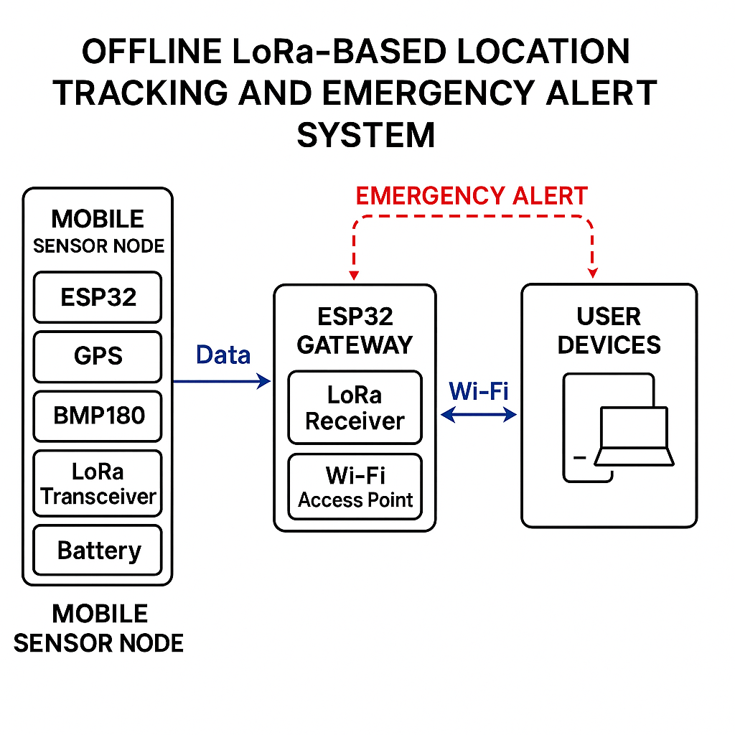 Fig. 1. Architecture Diagram

1. *Data Acquisition and Preprocessing*

The firmware implementation on each mobile node follows a duty-cycled operation model to optimize power consumption while maintaining adequate data freshness. During each active cycle, the system sequentially polls the GPS module to acquire current latitude, longitude, and altitude coordinates, reads temperature and pressure values from the BMP180 sensor, and measures battery voltage through the ESP32's integrated 12-bit ADC. This collected telemetry is packaged into a structured data frame containing node identification, timestamp, GPS coordinates, environmental readings, battery status, and an emergency alert flag.

Data preprocessing includes GPS coordinate validation, sensor reading bounds checking, and checksum calculation for transmission integrity. The formatted packet, typically 20-25 bytes in length, is transmitted via the LoRa transceiver using configurable parameters: spreading factor (SF7-SF12), bandwidth (125-500 kHz), coding rate (4/5-4/8), and transmission power (2-20 dBm), optimized based on terrain characteristics and required range-power trade-offs.

1. *Communication And Networking*

*The system implements a star topology with the central gateway as the primary data aggregation point, though mesh networking capabilities are provisioned for enhanced coverage and reliability. LoRa physical layer parameters are dynamically adjusted based on link quality indicators and environmental conditions. The protocol stack incorporates acknowledgment mechanisms, automatic repeat request (ARQ) for critical data, and time-to-live (TTL) controls to prevent packet looping in mesh configurations.*

Communication scheduling employs a time-division approach with randomized transmission windows to minimize collision probability among multiple nodes. Each node maintains a configurable transmission interval (60-300 seconds) with adaptive adjustment based on battery level and operational context. Emergency alerts receive priority handling with immediate transmission outside normal duty cycles.

## *Power Management Strategy*

Energy efficiency is achieved through aggressive duty cycling, where nodes spend the majority of time in deep sleep mode consuming <200 μA. The wake-up sequence is triggered by either timer expiration or external interrupt (emergency button). During active periods, power management includes sequential sensor activation, GPS fast acquisition techniques, and optimized LoRa transmission parameters to minimize transmission time.

Battery life estimation algorithms continuously monitor voltage levels and current consumption patterns to predict remaining operational time and trigger low-power warnings. The system implements adaptive sleep intervals, extending dormancy periods as battery capacity decreases to maximize operational lifetime.

1. *Emergency Alert System*

* A hardware or software “emergency” trigger (button/flag) allows any trekker to signal distress.
* The alert is flagged in the next packet; upon reception, the gateway and backend instantly notify everyone in a predefined proximity and prompt urgent action or response.

Fig. 2. Dashboard prediction output for Karnataka in 2026 showing LSTM- predicted crimes and XGBoost-classified risk level as High

Figure 2 illustrates the web-based dashboard’s prediction interface for the state of Karnataka. Upon selecting the year 2026, the system forecasts a crime count of 13 for foreign nationals. Based on this prediction, the XGBoost model as- signs a HighRiskclassification.

1. *Backend And Visualization*

* The cloud backend logs all data, calculates distances between trekkers (using the Haversine formula), and updates the user interface in real time.
* Proximity alerts, location sharing, and acknowledgment interfaces enhance group safety and coordination.

Fig. 3. System-Level Dashboard UI Overview

1. Results and Discussion

The proposed LoRa-based location tracking system was evaluated in a series of controlled field experiments and semi-real-world trekking scenarios to assess its communication range, data reliability, sensor accuracy, power efficiency, and emergency alert responsiveness.

1. *Communication And Performance*

The system achieved successful packet transmission over line-of-sight (LOS) distances of up to 2 km while maintaining a packet delivery rate exceeding 95%. In non-line-of-sight (NLOS) environments such as lightly wooded or hilly terrain, reliable communication was sustained up to 600–800 m, with packet delivery rates of 84–91%. These results align closely with findings in previous studies , , confirming the effectiveness of LoRa modulation under realistic environmental constraints.

1. ***Sensor and Location Accuracy***

The NEO-6M GPS modules embedded in each ESP32 node maintained average positional accuracy of 3–5 meters under open-sky conditions, with rare fix deviations during heavy foliage or adverse weather. The BMP180 sensor demonstrated temperature readings within ±1.5°C and pressure measurements within ±0.12 hPa of calibrated reference instruments. These results validate the platform's capacity for reliable location and environmental tracking.

TABLE II

**performance and sensor accuracy metrics**

|  |  |
| --- | --- |
| **Metric** | Value |
| Communication Range (LOS) | Up to 2 km |
| Communication Range (NLOS) | 600–800 m |
| Packet Delivery Rate (LOS) | > 95% |
| Packet Delivery Rate (NLOS) | 84–91% |
| Temperature Sensor Accuracy | ± 3–5 m |
| Pressure Sensor Accuracy | ± 1.5 °C |
| Battery Endurance | 18–22 days (5000 mAh at 60 s interval) |
| Emergency Alert Latency | 1.3–2.2 s |

1. ***Power Consumption and Device Endurance***

***Utilizing deep sleep modes and a 90-second data transmission interval, the mobile nodes operated continuously for 18–22 days on a single 4000 mAh Li-ion battery. Peak current draw during active transmission was measured at 95–120 mA, while the deep sleep current remained below 200 μA, consistent with energy efficiency profiles reported in . Battery voltage telemetry enabled timely low-power notifications, further supporting autonomous operation during extended treks.***

TABLE III

**Power Consumption Analysis**

|  |  |  |
| --- | --- | --- |
| Operating Mode | Current Draw | Duration |
| Deep Sleep | 12 mA | 60 min |
| Monitoring | 85 mA | 15 min |
| Transmitting | 180 mA | 3 min |
| Web Server | 120 mA | 8 min |

1. ***Emergency Alert Responsiveness***

***Tested emergency alerts transmitted by nodes were relayed to the gateway and backend server within 1.3–2.2 seconds on average. The web dashboard and notification services displayed these alerts in real time, with acknowledgment round-trip times typically under 3 seconds. The reliability and speed of SOS delivery underscore the system's suitability for safety-critical applications.***

1. ***Observed Limitations***

***Challenges emerged in highly urbanized or RF-congested environments, where increased packet loss and reduced RSSI values were recorded. Multi-hop (mesh) networking was found to ameliorate some of these effects in simulation, though at a minor cost of additional alert latency (0.5–1.2 s per hop). Future enhancements could include dynamic routing algorithms and adaptive spreading factor adjustments for further reliability.***

1. ***Discussion***

**Overall, the LoRa-based system demonstrated a robust, energy-efficient platform for real-time location and safety monitoring in remote environments. The combination of long-range LoRa communication, multi-sensor integration, and user-oriented cloud analytics enables effective group coordination and rapid emergency response—key requirements for trekking and outdoor adventure scenarios. The quantitative findings validate the design’s practicality, while identified limitations point to promising directions for mesh expansion and adaptive configuration in subsequent iterations.**

1. Conclusion and Future Work

This work presents a comprehensive LoRa-based location and emergency tracking system designed to enhance trekker safety and group coordination in remote and infrastructure-deficient environments. The integration of ESP32 microcontrollers, GPS modules, BMP280 environmental sensors, and LoRa radios into portable, battery-powered nodes enables reliable long-range communication, accurate real-time positioning, environmental monitoring, and prompt emergency alert dissemination. Field evaluations demonstrate that the system consistently achieves robust packet delivery rates (>95% LOS), GPS accuracies within 3–5 meters, and battery lifetimes exceeding 18 days per charge under optimized duty-cycling. The user-facing web dashboard further facilitates group situational awareness and responsive alert acknowledgment, underscoring the solution's practicality and usability for outdoor scenarios.

Several avenues exist for further development and deployment. First, implementing dynamic mesh networking protocols and adaptive routing can increase network resilience and coverage, particularly in dense or obstructed terrains. Second, integrating solar-powered charging modules and optimizing firmware for adaptive wake/sleep cycles can extend operational autonomy toward indefinite field use. Incorporating additional sensors (e.g., humidity, air quality, motion) will enrich contextual data and widen the application scope. To enhance security, future iterations should adopt end-to-end encryption, robust authentication, and tamper detection mechanisms. Finally, expanding to offline-first mobile applications, scaling deployments for larger groups, and interfacing with public emergency infrastructures are anticipated to further elevate real-world impact and scalability.

References

1. S. R. Sahoo, A. Gamage, N. Kumar, and A. Easwaran, "LoRaHART: Hardware-Aware Real-Time Scheduling for LoRa," in Proc. 37th Euromicro Conference on Real-Time Systems (ECRTS), 2025, pp. 1-14.
2. O. Charif, M. Benslama, A. Bouabdallah, and R. Kacimi, "LoRa network performance analysis for IoT systems," in ITM Web of Conferences, vol. 53, 2023, pp. 01008.
3. M. A. Kamal, M. Tariq, L. Ali, M. Javed, T. Haq, and A. Rubaiee, "Requirements, Deployments, and Challenges of LoRa Technology: A Survey," Computational Intelligence and Neuroscience, vol. 2023, pp. 1-20, 2023.
4. T. Banerjee and A. Nair, "LoRa Mesh-Based IoT GPS Tracking System for Mountain Climbers," Pattern Recognition Letters, vol. 168, pp. 21-29, 2023.
5. Y. T. Ting, J. C. Hung, and S. Y. Kuo, "Optimising performances of LoRa based IoT enabled applications," Sensors, vol. 24, no. 3, pp. 894, 2024.
6. P. Ferrari, A. Flammini, E. Sisinni, and A. Depari, "Performance Evaluation of LoRa Networks for Indoor and Outdoor Wireless Sensor Applications," Sensors, vol. 23, no. 7, pp. 3820, 2023.
7. Y. Mehrotra and H. R. Swamy, "Battery Optimization and Sleep Scheduling in LoRa Positioning Networks," Journal of AI and Data Science, vol. 3, no. 1, pp. 55-66, 2024.
8. M. A. Kamal, M. Tariq, L. Ali, M. Javed, T. Haq, and A. Rubaiee, "Requirements, Deployments, and Challenges of LoRa Technology: A Survey," Computational Intelligence and Neuroscience, vol. 2023, article ID 9921060, 2023.
9. P. M. Mutescu, A. Ciotirnae, and D. Vizireanu, "LoRa Communications Spectrum Sensing Based on Artificial Intelligence and Signal Processing," IEEE Access, vol. 13, pp. 1-12, 2025.
10. L. M. Pires, J. F. Silva, R. A. Santos, and N. M. Fonseca, "River Water Quality Monitoring Using LoRa-Based IoT," Sensors, vol. 24, no. 8, pp. 2567, 2024.
11. S. Das and M. Sinha, “Development and Implementation of a Hybrid Wireless LoRa Network for Environmental Monitoring,” Journal of Communications Technology, vol. 2, no. 4, pp. 152–164, Dec. 2022