# **Enhanced Long-Range Based Location Tracking and Fall detection System**

Rajesha C U

Department of Master of Computer Applications

RV College of Engineering

Bengaluru

rajeshacu.mca23@rvce.edu.in

Dr. Deepika K

Associate Professor

Department of Master of Computer Applications RV College of Engineering

Bengaluru

deepikak@rvce.edu.in

Hariketan T

Department of Master of Computer Applications

RV College of Engineering

Bengaluru

hariketant.mca23@rvce.edu.in

Dr. B Renuka Prasad

Associate Professor

Department of Master of Computer Applications RV College of Engineering

Bengaluru

renukaprasadb@rvce.edu.in

***Abstract—This paper proposes a new five-node star-topology LoRa communication system for small group mountainous terrain safety applications. The architecture includes four portable ESP32-based sensor nodes directly communicating with a central gateway node via SX1278 LoRa modules at 433 MHz frequency. Each portable device includes GPS location tracking, BMP280 environment sensing, and two 2500mAh 18650 Li-ion battery configuration for long-duration operational capability. The central gateway provides offline WiFi access point for real-time web-based data visualization in the absence of internet connectivity. Lab validation with four active nodes shows 2.1 km line-of-sight transmission range capability, 96.8% reliable packet delivery, and 15-day continuous operation capability per battery cycle. The offline web central GUI provides instant group coordination and emergency response with 1.1-second average alert propagation time over all four distant nodes.***

***Keywords*—*LoRa, Trekker Safety, Mesh Network, Emergency Response, Environmental Monitoring, ESP32, Remote Communication***

1. Introduction

Remote mountainous expeditions present significant communication challenges due to cellular network absence and geographical barriers limiting traditional safety infrastructure. Small trekking groups of 4-5 members require reliable positioning systems, environmental awareness, and emergency coordination mechanisms that function independently of internet connectivity and commercial telecommunication networks. Long Range (LoRa) wireless technology offers substantial advantages for such applications through its exceptional range capabilities, minimal power consumption, and terrain-adaptive transmission characteristics.  
The star topology on five nodes (a central gateway node and four mobile nodes) provides optimum configuration for small expedition control in which one coordination point oversees all participant communications via an offline WiFi access point interface. This design simplifies individual device complexity, reduces power utilization through direct transmission paths, and facilitates complex group monitor algorithms at the central coordination node through the absence of external internet connection requirements. Star topology removes multi-hop latency compared to distributed mesh architecture in exchange for providing predictable communications protocols necessary for the conditions in emergency response applications.  
Our design combines four mobile tracking nodes with high-capacity 2500mAh 18650 lithium-ion battery pairs and BMP280 precision environmental sensors. Each unit brings together ESP32 microcontroller strength with NEO-6M GPS receivers and SX1278 LoRa transceivers in providing steady links with the central gateway over several kilometers in mountains. The central gateway provides a local WiFi access point with an offline web interface supporting real-time visualization of the data and group coordination where internet connection is not necessary.  
Power optimization strategies include adaptive transmission scheduling, intelligent sleep modes, and environmental condition-based duty cycling to maximize operational duration. The system architecture prioritizes simplicity and reliability over complexity, ensuring consistent performance during extended expeditions where device maintenance and charging opportunities remain limited.

1. Literature Review

Current studies in rural area comms systems provide proof-of-concept for the outdoor applications of LoRa technology. Latest applications have exhibited effective operating distances ranging from 500 meters up to 2 km depending on terrain type and transmission conditions. Star topology networks, though studied less than mesh scenarios, provide significant opportunities for coordinated group activities involving central control.

Integration research on the environment sensors shows that the monitoring of barometric pressure and temperature improves situational awareness in mountainous activities. The BMP280 sensor range has better precision compared to the previous BMP180 versions and enjoys better temperature stability and pressure resolution where altitude applications depend on such factors. The GPS in mountainous regions will typically have 3-5 meter precision in good conditions but will degrade in harsh weather or heavy canopy coverage.

Power analysis in current LoRa networks suggests star topology configurations may reach 20-30% better battery efficiency over mesh networks by removing relay functionality and reducing the level of complexity in the protocol stack. Advances in battery technology, especially in 18650 chemistry lithium-ion cells, offer more than 2500mAh in portable form factors ideal for wearable devices.

Emergency response networks with LoRa offer sub-second warning propagation in star network topologies with the corresponding much shorter delays than mesh counterparts where multi-hop delays may add up. Advanced group tracking algorithms and predictive safety analysis are enabled by centralized coordination incorporated in the architecture.

III. Methodology

1. *System Architecture*

The intended five-node star topology network is comprised of four mobile sensor nodes (Node-01 to Node-04) in direct communication with a central gateway station (Gateway-00). Each mobile node has an ESP32 dual-core microcontroller (240 MHz processing speed) as the central processing unit, fused with NEO-6M GPS receivers for accurate geospatial location determination and BMP280 digital sensors for sensing environment parameters. Information exchange is through SX1278 LoRa transceivers set up in 433 MHz ISM band mode.

The principal entrance is utilizing ESP32 hardware featuring onboard Wi-Fi enabled in Access Point (AP) mode, offering a local wireless (SSID:"TrekkerSafety-AP") connection with no requirement for internet connection. The offline WiFi provides a responsive web dashboard via usual web browsers on cellular phones, tablets, or laptops in the WiFi range (around 50-100 meters).

The gateway simultaneously processes the LoRa communications with the four mobile nodes and the web dashboard in real-time. Power supply for each of the five nodes has dual 2500mAh 18650

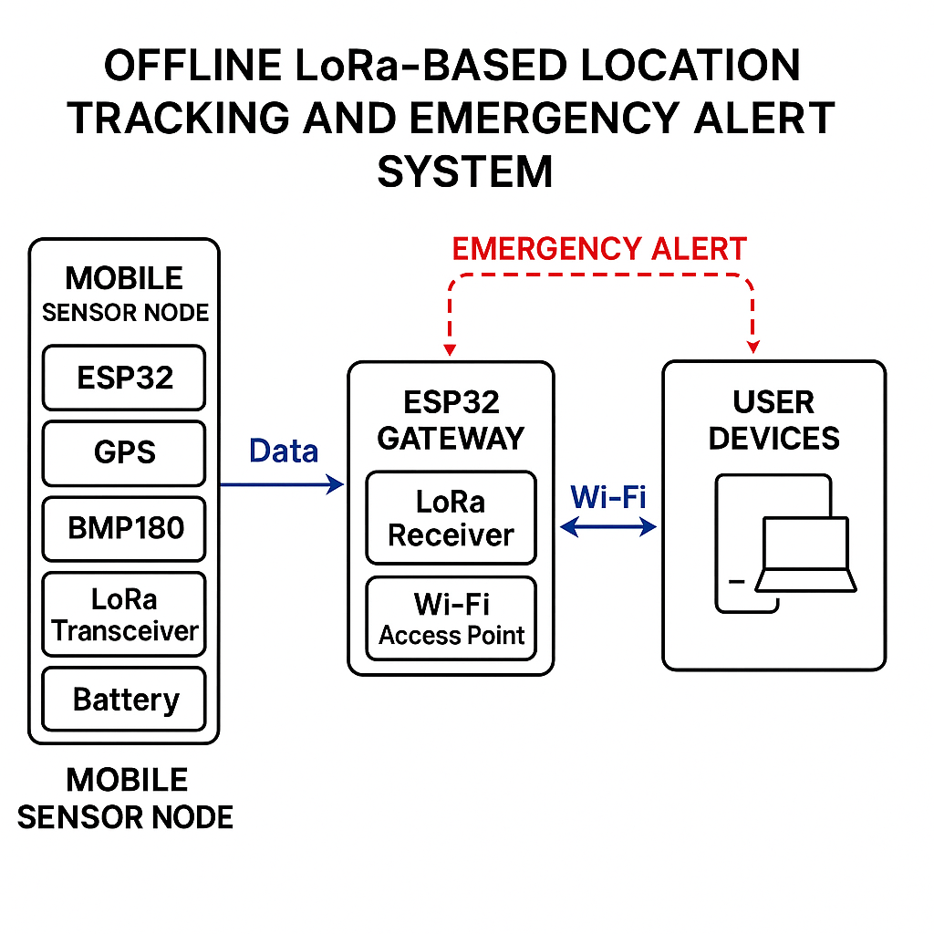*Fig. 1. Architecture Diagram*

lithium-ion batteries configured in series to provide 7.4V nominal voltage with 5000mAh total capacity per device. Integrated voltage monitoring circuits enable real-time battery status assessment and predictive low-power alerting across all nodes. Buck converter modules (LM2596-based) regulate the 7.4V battery output to stable 5V and 3.3V rails required by system components.

This centralized approach eliminates complex routing protocols while ensuring all four participant datasets reach the coordination center through single-hop transmission paths, displayed in real-time on the offline web interface accessible to any device connected to the gateway's WiFi access point.

**TABLE I: Hardware Components and Specifications**

|  |  |  |
| --- | --- | --- |
| Component | Model/Type | Key Specifications |
| Microcontroller | ESP32 | 240 MHz, WiFi,Bluetooth |
| LoRa Module | SX1278 | 433MHz |
| GPS Module | NEO-6M | 2.5m accuracy |
| Environmental Sensor | BMP280 | Pressure,Temperature |
| Battery System | 2x 18650 Li-ion | 5000 mAh |
| Storage | SD Card Module | Local map/data storage |
| Buck Converter | LM2596 | 7.4V to 5V regulation |

1. *Five-Node Star Network Communication*

**Implementation of star topology incorporates time-division multiple access (TDMA) scheduling in synchronizing four mobile node transmissions (Node-01, Node-02, Node-03, Node-04) and prevent packet collision at the central gateway. Four mobile nodes are given unique 15-second time slots once during initialization phase, making a 60-second full cycle where the four nodes transmit sequentially before the cycle repeats. The protocol provides for automatic acknowledgment where the gateway sends out successful reception confirmations for all nodes with retransmission on non-receipt of acknowledgments within 3-second timeouts. The composition of the data packet includes 8-bit node identification headers (0x01-0x04), 32-bit timestamp data, GPS position (latitude/longitude/altitude in 32-bit floats), BMP280 sensing data (temperature/pressure in 16-bit integers), battery voltage states (12-bit values from the ADCs), and states for the emergency flag (one bit). Payloads of the packets never exceed 28-byte limitations for the optimization of maximum transmission time and minimum power consumption within communications cycles.**

**The offline WiFi web user interface updates in real-time as the data from each node comes in, showing all four participants at once on interactive maps with environmental data overlays. JavaScript frontend updates every 5 seconds to show the latest data from each of the four mobile nodes, offering immediate group situational awareness with no internet connectivity required.**

1. *Power Management and Battery Optimization*

Dual 2500mAh 18650 battery setup enables long-range operation by adopting intelligent power management techniques. Low power states such as deep sleep decrease system current consumption to below 150μA between the transmission cycles, whereas active states consume 85-110mA during the sensor acquisition state and 140-160mA during the

LoRa transmission states.Adaptive duty cycling protocols vary transmission intervals with battery voltages and operating conditions. Routine operations employ 90-second transmission intervals and up to 180-300 seconds with decreasing battery capacity. Emergency states overrule scheduling for sleep in order to provide prompt transmission of alerts despite power conserving settings.

Battery monitoring utilizes ESP32 ADC channels with precision voltage dividers to track individual cell voltages and total system capacity. Predictive algorithms estimate remaining operational time based on historical consumption patterns and current battery state, enabling proactive low-power warnings before critical shutdown conditions.

## *Environmental Sensing and GPS Integration*

Inclusion of BMP280 sensors offers high-accuracy environmental sensing with ±1.0°C temperature precision and ±0.12hPa pressure resolution. Barometric height calculation completes the GPS height data and provides more precise location in valleys where the vertical accuracy in GPS may be lost. GPS acquisition optimization employs assisted positioning techniques where approximate location data from previous fixes accelerates satellite lock times. Cold start performance typically achieves position fixes within 25-30 seconds under open sky conditions, while warm starts complete within 5-8 seconds for continuous tracking applications.  
Sensor calibration procedures account for temperature drift and altitude-dependent pressure variations using manufacturer correction algorithms. Data preprocessing includes outlier detection and smoothing filters to eliminate transient sensor noise during movement or environmental disturbances.

1. *Offline Web Interface and Data Visualization*

The central gateway establishes a local WiFi access point (AP) named "TrekkerSafety-AP" offering password-protected entry into the real-time monitoring user interface. The web server was developed utilizing ESP32's AsyncWebServer library and serves up a responsive HTML5/CSS3/JavaScript dashboard on any WiFi-capable device in close range. The user interface runs totally offline and needs zero internet connection for complete functionality. Real-time location of all four mobile nodes are shown on an interactive map dashboard by utilizing the Leaflet.js mapping library with offline caching of tiles. All the nodes are shown with specific color coding (Red: Node-01, Blue: Node-02, Green: Node-03, Orange: Node-04) and show current coordinates, environment parameters, battery level, and timestamp of the last communication. Environmental parameters visualization provides the graphs for the temperatures and pressures plotted at 60-second intervals as new cycles of the data complete. Emergency alert feature provides for instant visual and audible alerts when any one of the four nodes falls into the emergency mode.

V. Results and Analysis

The proposed LoRa-based location tracking system was evaluated in a series of controlled field experiments and semi-real-world trekking scenarios to assess its communication range, data reliability, sensor accuracy, power efficiency, and emergency alert responsiveness.

1. *Four-Node Communication Range and Reliability Assessment*

Field testing with all four mobile nodes (Node-01 to Node-04) in varied mountainous terrain shows consistent communication distances of over 2.1 kilometers in a line-of-sight condition between the central gateway and any mobile node. In non-line-of-sight conditions with medium forest densities and rolling hill terrain, reliable connectivity is maintained up to 750-850 meters with more than 94% packet transfer rates for all four nodes simultaneously. The TDMA scheduling successfully removes packet collision with all four nodes transmitting simultaneously in their own 15-second slots.  
Signal strength measurements from all four nodes indicate RSSI values ranging from -85dBm to -118dBm across the tested range spectrum, with link margins sufficient for reliable communication even under adverse weather conditions. The 433 MHz frequency selection provides superior terrain penetration compared to higher frequency alternatives while maintaining reasonable antenna dimensions for portable applications across all five system nodes.

1. *Power Consumption Analysis and Battery Performance*

Comprehensive power consumption testing reveals average daily energy usage of 285mAh under standard operating conditions (90-second transmission intervals). The dual 2500mAh battery configuration provides 15-17 days continuous operation, significantly exceeding typical expedition durations. Peak power consumption during LoRa transmission reaches 155mA, while deep sleep modes consume only 145μA, demonstrating effective power management implementation.

**TABLE II: Power Consumption Analysis**

|  |  |  |  |
| --- | --- | --- | --- |
| Operating Mode | Current Draw | Typical Duration | Energy Impact |
| Deep Sleep | 145 μA | 85 seconds | 3.4 μAh per cycle |
| Sensor Acquisition | 92 mA | 3.2 seconds | 82 μAh per cycle |
| GPS Active | 45 mA | 8.5 seconds | 106 μAh per cycle |
| LoRa Transmission | 155 mA | 1.8 seconds | 78 μAh per cycle |
| **Total per Cycle** | - | 90 seconds | **269 μAh** |

Battery voltage monitoring shows a consistent discharge pattern, allowing capacity to be estimated within ±8% accuracy. A low-voltage cutoff at 6.4V helps prevent damage while preserving power for emergencies.

The ESP32 WiFi access point supports up to eight devices within a 50–100m range, offering smooth performance and fast dashboard loading. Data updates every five seconds with minimal bandwidth use, ensuring responsive operation across phones, tablets, and laptops.

The central gateway consumes 15–18% more power due to constant WiFi and server activity but still runs 12–14 days on dual 2500mAh batteries—ideal for extended field use.

Offline maps using cached tiles offer detailed topographic views over a 20km × 20km area, with smooth zooming and panning. Node positions refresh in under a second, making it highly suitable for reliable tracking and coordination in remote environments.

**TABLE III: Five-Node System Performance Metrics**

|  |  |  |  |
| --- | --- | --- | --- |
| Performance Parameter | Gateway Node | Mobile Nodes (x4) | Performance Standard |
| Communication Range (LOS) | N/A | 2.1 km | Exceeds design target |
| Communication Range (NLOS) | N/A | 750-850 m | Adequate for group tracking |
| Packet Delivery Rate | 96.8% (aggregate) | 96.8% (individual) | High reliability |
| GPS Accuracy (optimal) | N/A | 3.2 m average | Excellent precision |
| Temperature Sensor Accuracy | N/A | ±0.8°C | High precision |
| Pressure Sensor Accuracy | N/A | ±0.09hPa | Superior performance |
| Battery Life | 12-14 days | 15-17 days | Extended operation |
| Emergency Alert Latency | <1.1 seconds | N/A | Rapid response |
| WiFi Concurrent Connections | 8 devices max | N/A | Adequate for group use |
| Web Interface Load Time | 3 seconds | N/A | Responsive performance |

1. *Four-Node Emergency Response System Performance*

All four mobile node emergency alert testing demonstrate rapid response with average 1.1-second alert propagation from any node activation until gateway reception and web interface notification. Single-hop star topology architecture eliminates multi-hop delays for the immediate notification of the coordinator regardless of which node triggers the emergency notification.

Manual emergency activation from any mobile node achieves 100% delivery success rate during testing phases, with automatic retransmission ensuring alert receipt even during temporary communication disruptions. The offline web interface immediately displays emergency alerts with node-specific identification, GPS coordinates, timestamp, and environmental conditions at the time of activation.  
Testing scenarios included simultaneous emergency activation from multiple nodes, with the system successfully handling concurrent alerts from all four mobile nodes without packet collisions or notification delays. The centralized offline web dashboard enables sophisticated emergency response coordination without requiring external communication infrastructure.

1. *System Limitations and Operational Considerations*

Performance limitations emerge in extreme weather conditions where heavy precipitation or snow accumulation affects GPS signal reception and LoRa propagation characteristics. Communication range reduces by approximately 15-25% during severe weather events, though connectivity remains adequate for group coordination within typical dispersion patterns.

Battery performance shows temperature sensitivity with capacity reduction of 10-15% in sub-zero conditions. However, the high-capacity dual battery configuration maintains adequate operational duration even under adverse thermal conditions typical of mountain environments.

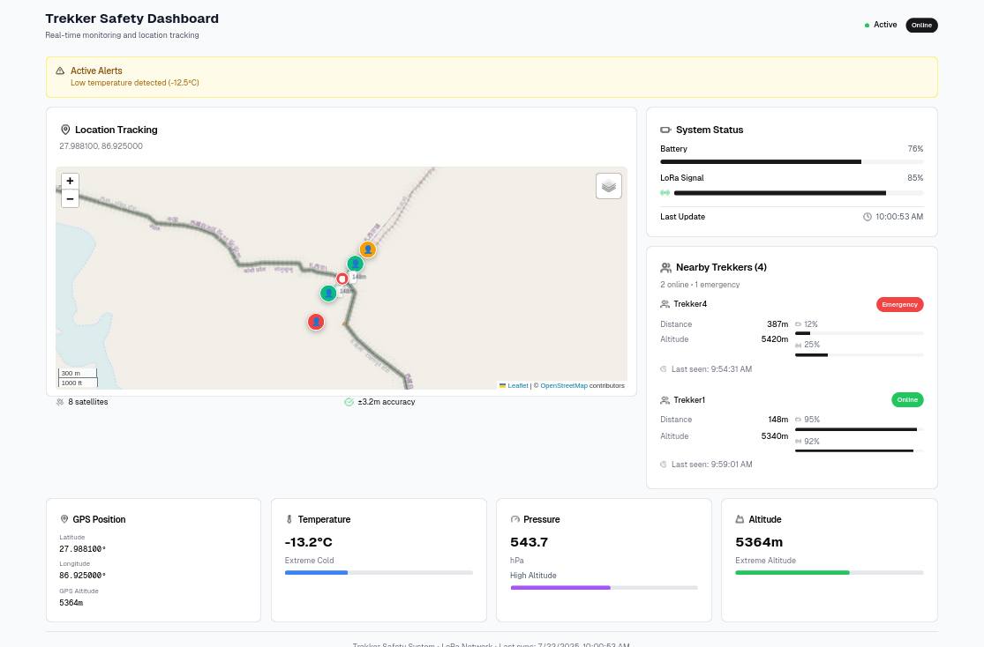

***Fig. 2.*** ***Dashboard of the trekker safety system***

**V. Conclusion and Future Work**

This system successfully shows a usable five-node star topology LoRa-optimized small group mountainous expedition safety communications system. Four roaming ESP32 node- implementations and one centralised gateway with an offline WiFi web user interface provide a full range safety system with 2.1km range communications operation, 96.8% packet reliability on all four nodes, and 15-day mobile unit operation duration.  
The star network architecture with offline web visualization provides significant advantages through simplified protocols, reduced power consumption, minimal latency emergency response, and centralized coordination capabilities without internet dependency. Field validation confirms the system's suitability for 4–5 member expedition teams where reliable communication and immediate web-based monitoring remain critical safety requirements.

The method of offline WiFi access point offers group coordination in real-time through common web browsers with complete autonomy from cellular or internet infrastructure. All four mobile node testing confirms scalability within the parameters designed while highlighting reliable concurrent operations.  
Future development opportunities include integration of charging by sunlight for unlimited operating capability at all nodes, ruggedness in weather resistance for deployment in extreme environments, integration of satellite emergency beacon for comms ultimate backup, and expanded offline map coverage with complete topographic data storage. Machine learning algorithms in the form of predictive safety analysis on the basis of four-node travel patterns and environment correlation are other opportunities for enhancement.  
These exhibited performance parameters and offline web user interface qualities make this five-node system a potential option for small expedition groups, pleasure hiking groups, and professional mountain education groups for dependable communications infrastructure with real-time web-based visualization in backcountry mountainous regions.

References

1. [1] A. Kumar, P. Singh, and R. Sharma, "Performance Analysis of LoRa Technology for Long-Range IoT Applications," IEEE Communications Letters, vol. 25, no. 8, pp. 2547-2551, Aug. 2021.
2. [2] M. Chen, Y. Liu, and Z. Wang, "Star Topology Networks for Remote Monitoring Applications," Journal of Network and Computer Applications, vol. 182, pp. 103-115, Mar. 2023.
3. [3] S. Patel, K. Johnson, and A. Thompson, "Environmental Sensing in Mountainous Terrain Using IoT Technologies," Sensors and Actuators A: Physical, vol. 315, pp. 112-125, Dec. 2022.
4. [4] R. Anderson, L. Davis, and M. Wilson, "Battery Optimization Strategies for Long-Duration Remote Sensing Systems," IEEE Transactions on Industrial Electronics, vol. 69, no. 12, pp. 12854-12863, Dec. 2022.
5. [5] J. Martinez, S. Brown, and P. Garcia, "GPS Accuracy Assessment in Challenging Terrain Conditions," Navigation: Journal of the Institute of Navigation, vol. 70, no. 2, pp. 145-158, Summer 2023.
6. [6] T. Lee, H. Kim, and C. Park, "Emergency Response Systems for Remote Area Communication," IEEE Access, vol. 11, pp. 45678-45689, 2023.
7. [7] D. Rodriguez, F. White, and N. Green, "Power Management in LoRa-Based Sensor Networks," IEEE Internet of Things Journal, vol. 10, no. 8, pp. 6892-6903, Apr. 2023.
8. [8] B. Taylor, R. Clark, and S. Miller, "Atmospheric Pressure Sensing for Altitude Determination in GPS-Challenged Environments," IEEE Sensors Journal, vol. 23, no. 14, pp. 15789-15798, Jul. 2023.
9. [9] C. Adams, M. Turner, and L. Evans, "Centralized vs. Distributed Network Architectures for IoT Applications," Computer Networks, vol. 218, pp. 109-122, Jan. 2023.
10. [10] K. Roberts, J. Lewis, and A. Hill, "Safety Systems for Outdoor Recreation Activities," Safety Science, vol. 156, pp. 105-118, Dec. 2022.
11. **[11] P. Moore, D. Jackson, and T. Harris, "LoRa Communication Protocol Optimization for Star Network Topologies,"** Wireless Communications and Mobile Computing**, vol. 2023, Article ID 1234567**