A project report

On

Topic-Chat

Computer science & engineering

Submitted

By

N. Sri Devi (13A91A05A4) SK. Salman (13A91A05B6)

S. Rajesh (14A95A0525) B. Jayanth (13A91A0574)



Aditya engineering college

(Approved by AICTE, affiliated to JNTUK & NBA accredited)

Department of computer science & engineering

**ABSTRACT**

This project is aimed at developing an application based system, which manages the activity of “Students chatting on different topics of subjects”. This system will manage the database and maintain a list of Students groups that have registered on this site.

**INDEX**

**Table of Contents**

1. **INTRODUCTION**
   1. INTRODUCTION TO PROJECT
   2. PURPOSE OF PROJECT
2. **SYSTEM ANALYSIS**
   1. INTRODUCTION
   2. ANALYSIS MODEL
   3. SYSTEM REQUIREMENTS SPECIFICATIONS
   4. INPUT AND OUTPUT
3. **SOFTWARE REQUIREMENTS SPECIFICATION**
   1. FUNCTIONAL REQUIREMENTS
   2. PERFORMANCE REQUIREMENTS
4. **SELECTED SOFTWARE**
   1. GCM
   2. PHP
   3. MYSQL SERVER
   4. ANDROID
5. **SYSTEM DESIGN**
   1. E-R DIAGRAMS
   2. DATA DICTIONARY
   3. UML DIAGRAMS
6. **OUTPUT SCREENS**
7. **TESTING AND IMPLEMENTATION**
   1. UNIT TESTING
8. **CONCLUSION**

**1. INTRODUCTION**

**1.1 INTRODUCTION TO PROJECT:**

The aim of this project is to develop a chat application using client server architecture which relies on GCM programming provided by the android.

* 1. **PURPOSE OF PROJECT :**

The purpose of this project is to manage the activity of “Students chatting on different topics of subjects”. This system will manage the database and maintain a list of Students groups that have registered on this site.

**2. SYSTEM ANALYSIS**

**2.1 INTRODUCTION:**

After analyzing the requirements of the task to be performed, the next step is to analyze the problem and understand its context. The first activity in the phase is studying existing system and other is to understand the requirements and domain of the new system. Both the activities are equally important, but the first activity serves as a basis of giving the functional specifications and then successful design of proposed system.

**2.2 ANALYSIS MODEL:**

This document play a vital role in the development of life cycle (SDLC) as it describes the complete requirement of the system.

**SPIRAL MODEL** was defined by Barry Boehm in his 1988 article, a spiral model of software development and enhancement. This model was not first model to discuss iterative development, but it was first model to discuss why the iteration models.

As originally envisioned, the iterations were typically 6 months to 2 years long. Each phase starts with design goal and ends with a client reviewing the progress thus far. Analysis and engineering efforts are applied at each phase of project, with an eye towards the end goal of project.

**The following diagram show how a spiral model acts like:**

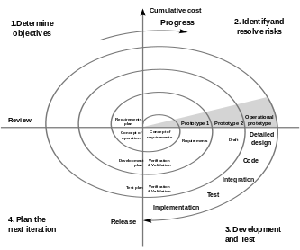

**2.3 SYSTEM REQUIREMENTS SPECIFICATIONS:**

**HARDWARE REQUIREMENTS:**

* PIV 2.8 GHZ processor and above
* RAM 512 MB and above
* HDD 40 GB and above

**SOFTWARE REQUIREMENTS:**

* WINDOWS OS(XP/200/7/8/10)
* Android Studio 1.2 and higher
* PHP server(WAMP/XAMP)
* MYSQL Server

**2.4 INPUT AND OUTPUT:**

The following are the some inputs and outputs of project.

**INPUTS:**

* Admin enter the credentials.
* Admin adds the topics.
* Admin adds the messages for each topic.
* Student has registered first he/she will enter registration details.
* Student enters credentials.
* Student access the topics and sends messages to related topics.

**OUTPUTS:**

* Admin will get his home page.
* Admin can see the student chats.
* Admin can send the push notifications to students.
* Student can send messages to topics.

**3. SOFTWARE REQUIREMENTS SPECIFICATION:**

**3.1 INTRODUCTION:**

**Purpose:** The main purpose of preparing of this document is to give a general

Insight into the analysis and requirements of the existing system or situation and determining the operating characteristics of the system.

**3.2 FUNCTIONAL REQUIREMENTS:**

**Output Design:**

Outputs from the computer systems are required primarily to communicate the results of processing to users. They also used to provide a permanent copy of the results for later consultation.

**Input Design:**

Input design is the part of overall system design. The main objective during the input design is given below:

* To produce a cost-effective method of input.
* To achieve the highest possible level of accuracy.
* To ensure that the input is acceptable and understood by user.

**Error avoidance:**

At this stage care is to be taken to ensure that input data remains accurate from the stage at which it is recorded up to the stage in which the data accepted by the system. This can be achieved only by means of careful control each time the data is handled.

**Error detection:**

Even though every effort is make to avoid the occurrence of errors, still a small proportion of errors is always likely to occur, these types of errors can be discovered by using validations to check the input data

**3.3 PERFORMANCE REQUIREMENTS:**

Performance is measured in terms of the output provided by the application

Requirement specification plays an important part in the analysis of a system. Only when the requirements specifications are properly given, it is possible to design a system, which will fit into required environment.

The requirements specifications for every system can be broadly stated as given below:

* The system should able to interface with the existing system.
* The system should be accurate.
* The system should be better than the existing system.

**4.** **SELECTED SOFTWARE:**

* 1. **GCM(Google Cloud Messaging ):**

[Google Cloud Messaging](https://developers.google.com/cloud-messaging/) allows you send lightweight messages from the backend server to all the devices whenever there is new data available. This saves lot of user’s battery by avoiding poll request to server for new data. Using GCM you can build powerful multi-platform (iOS, Android & Web) apps like topic chat, news feed, cloud storage and lot more. On top of everything, GCM is completely free and there are no limitations.

Below is the pictorial representation of the overall architecture:

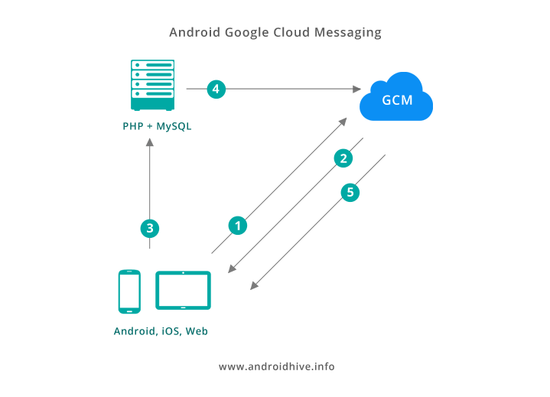

**1**. First the app connects to GCM server and register itself.

**2**. Upon successful registration, GCM issues gcm **registration token** to device. This registration token uniquely identifies each device.

**3**. The device sends the registration token to our server to store it in **MySQL**.

**4**. Whenever app server wants to send push notification, it sends a request to GCM server sending the **push message** along with the **registration token**.

**5**. GCM server identifies the device using the registration token and initiates the push message.

**6**. The device receives the **push messages** and further action takes place.

* 1. **PHP (Hyper Text Preprocessor)**:

The PHP Hypertext Preprocessor (PHP) is a programming language that allows web developers to create dynamic content that interacts with databases. PHP is basically used for developing web based software applications. This tutorial helps you to build your base with PHP.

PHP started out as a small open source project that evolved as more and more people found out how useful it was. Rasmus Lerdorf unleashed the first version of PHP way back in 1994.

* It is integrated with a number of popular databases, including MySQL, PostgreSQL, Oracle, Sybase, Informix, and Microsoft SQL Server.
* All PHP code must be included inside one of the three special markup tags are recognized by the PHP Parser. A most common tag is the <?php...?>
* Five important characteristics make PHP's practical nature possible Simplicity, Efficiency, Security, Flexibility, Familiarity
* Php supports object oriented concepts like class, objects, polymorphism, inheritance, dynamic binding etc….
  1. **MYSQL SERVER**:

MySQL is the most popular Open Source Relational SQL database management system. MySQL is one of the best RDBMS being used for developing web-based software applications.

MySQL is a fast, easy-to-use RDBMS being used for many small and big businesses. MySQL is developed, marketed, and supported by MySQL AB, which is a Swedish company. MySQL is becoming so popular because of many good reasons:

* MySQL works on many operating systems and with many languages including PHP, PERL, C, C++, JAVA, etc
* MySQL works very quickly and works well even with large data sets.
* MySQL is very friendly to PHP, the most appreciated language for web development.
* MySQL is released under an open-source license. So you have nothing to pay to use it.
  1. **ANDROID**:

Android is a software stack for mobile devices that includes an operating system, middleware and key applications .Android is a software platform and operating system for mobile devices based on the Linux operating system and developed by Google and the Open Handset Alliance. It allows developers to write managed code in a Java-like language that utilizes Google-developed Java libraries, but does not support programs developed in native code.

**FEATURES:**

**1.** **Application Framework:**

It is used to write applications for Android. Unlike other embedded mobile environments, Android applications are all equal, for instance, an applications which come with the phone are no different than those that any developer writes.

**2. Dalvik Virtual Machine:**

It is extremely low-memory based virtual machine, which was designed especially for Android to run on embedded systems and work well in low power situations. It is also tuned to theCPU attributes. The Dalvik VM creates a specialfile format (.DEX) that is created through build time post processing. Conversion between Java classes and .DEX format is done by included “dx” tool.

**3. Integrated Browser:**

Google made a right choice on choosing WebKit as open source web browser. They added a two pass layout and frame flattening. Two pass layout loads a page without waiting for blocking elements, such as external CSS or external JavaScript and after a while renders again with all resources downloaded to the device.

**4 .Optimized Graphics:**

As Android has 2D graphics library and 3D graphics based on OpenGLES 1.0, possibly we will see great applications like Google Earth and spectacular games like Second Life, which come on Linux version. At this moment, the shooting legendary 3D game Doom was presented using Android on the mobile phone.

**5. SQLite:**

Extremely small (< 500kb) relational database management system, is integrated in Android. It is based on function calls and single file, where all definitions, tables and data are stored. This simple design is more than suitable for a platform such as Android.

**7. Data Storage:**

SQLite is used for structured data storage .SQLite is a powerful and light weight relational database engine available to all applications.

**8. Connectivity:**

Android supports a wide variety of connectivity technologies including GSM, CDMA, Bluetooth, EDGE, EVDO, 3G and Wi-Fi.

**9. Messaging:**

SMS, MMS, and XMPP are available forms of messaging including threaded text messaging.

**10. Java Virtual Machine:**

Software written in Java can be compiled into Dalvik byte codes and executed in the Dalvik virtual machine, which is a specialized VM implementation designed for mobile device use, although not technically a standard Java Virtual Machine.

**5.** **SYSTEM DESIGN:**

**5.1 ER-DIAGRAMS:**

An entity relationship diagram (ERD) shows the relationships of entity sets stored in a database. An entity in this context is a component of data. In other words, ER diagrams illustrate the logical structure of databases.

At first glance an entity relationship diagram looks very much like a [flowchart](https://www.smartdraw.com/flowchart/). It is the specialized symbols, and the meanings of those symbols, that make it unique.

**ER-Diagram for topic-chat:**

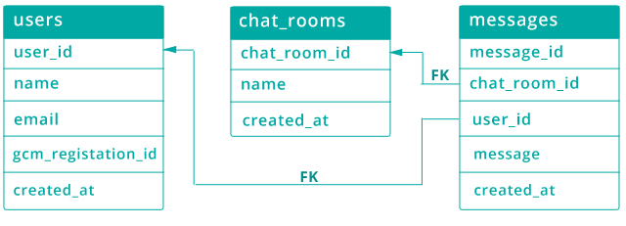

**5.2 DATA DICTIONARY:**

After carefully understanding the requirements of the client the entire data storage requirements are divided into tables. The below tables are Normalized to avoid any anomalies during the course of data entry.

Table: **chat_rooms**

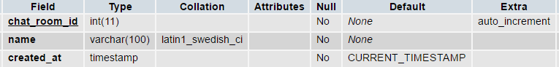

Table: **messages**

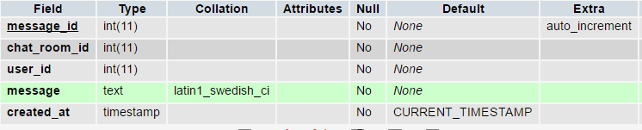

Table**: users**

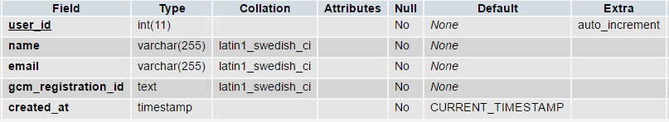

**6.3 UML DIAGRAMS:**

SYSTEM NAME

Use case 1

:

:

Use case 2

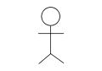

**USE CASE FOR LOGIN PROCESS**



Admin Database

**Over view use case diagram:**

System

Registration



Login



Add Topics

Student

Send notification

Admin

Send message

**Admin use case diagram:**

Login

System



Logout

Send messages

Send Notifications

Add Topics

**Student use case diagram:**



Logout

Send Messages

View Messages

Login

Registration

System

Student

**7. OUTPUT SCREENS:**

**7.1 SERVER OUTPUT SCREENS:**

**ADMIN LOGIN PAGE**:

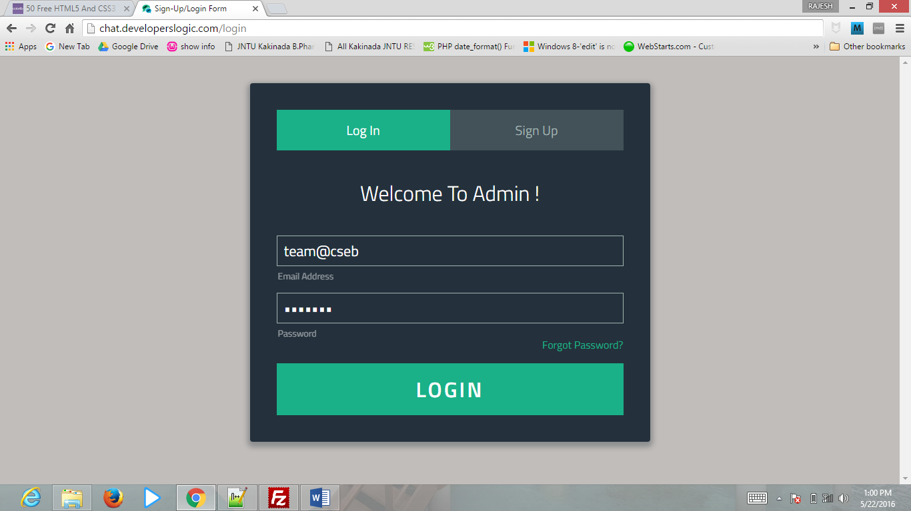

ADMIN START PAGE:

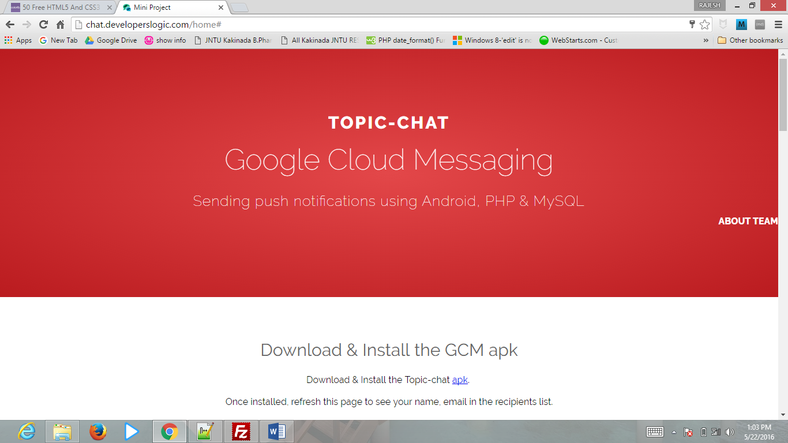

ADMIN VIEW AND SEND MESSAGES:

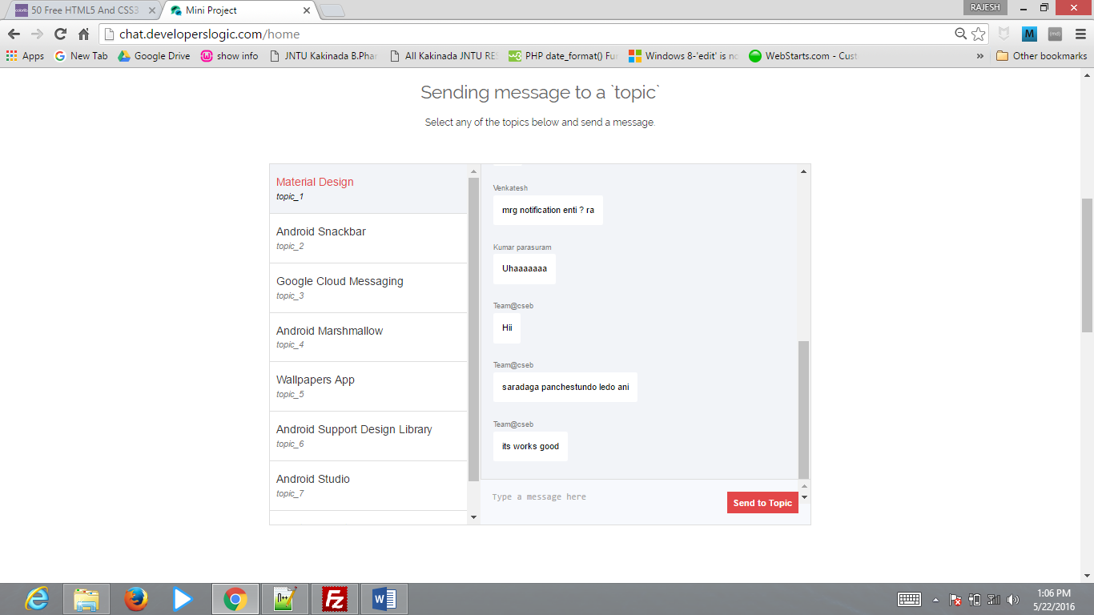

ADMIN SEND NOTIFICATIONS TO STUDENT:

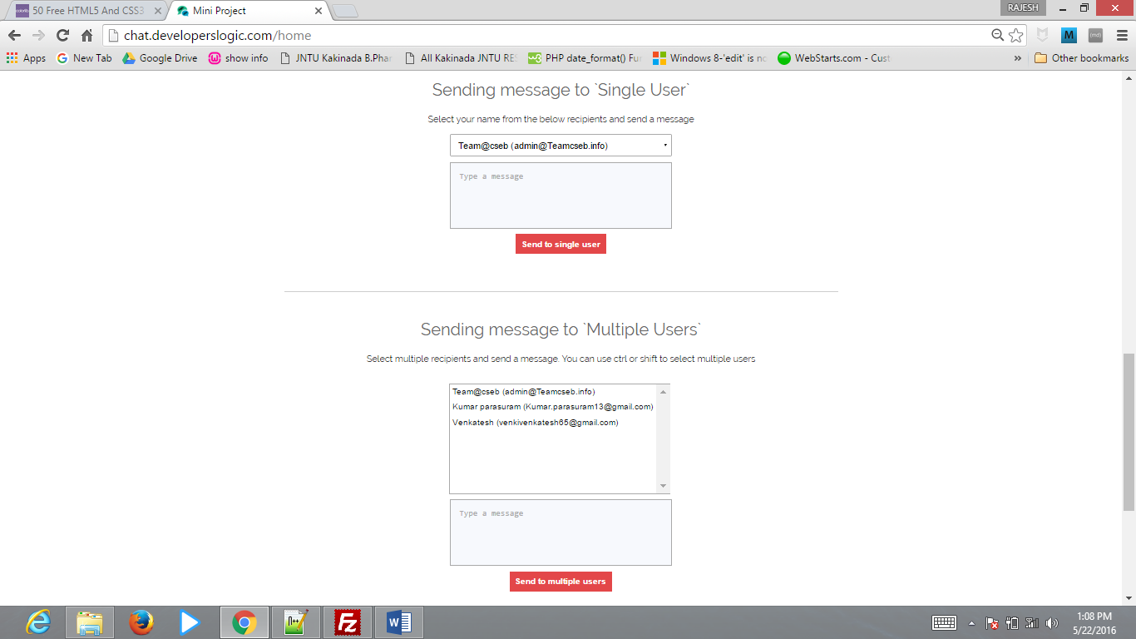

**7.2 CLIENT OUTPUT SCREENS:**

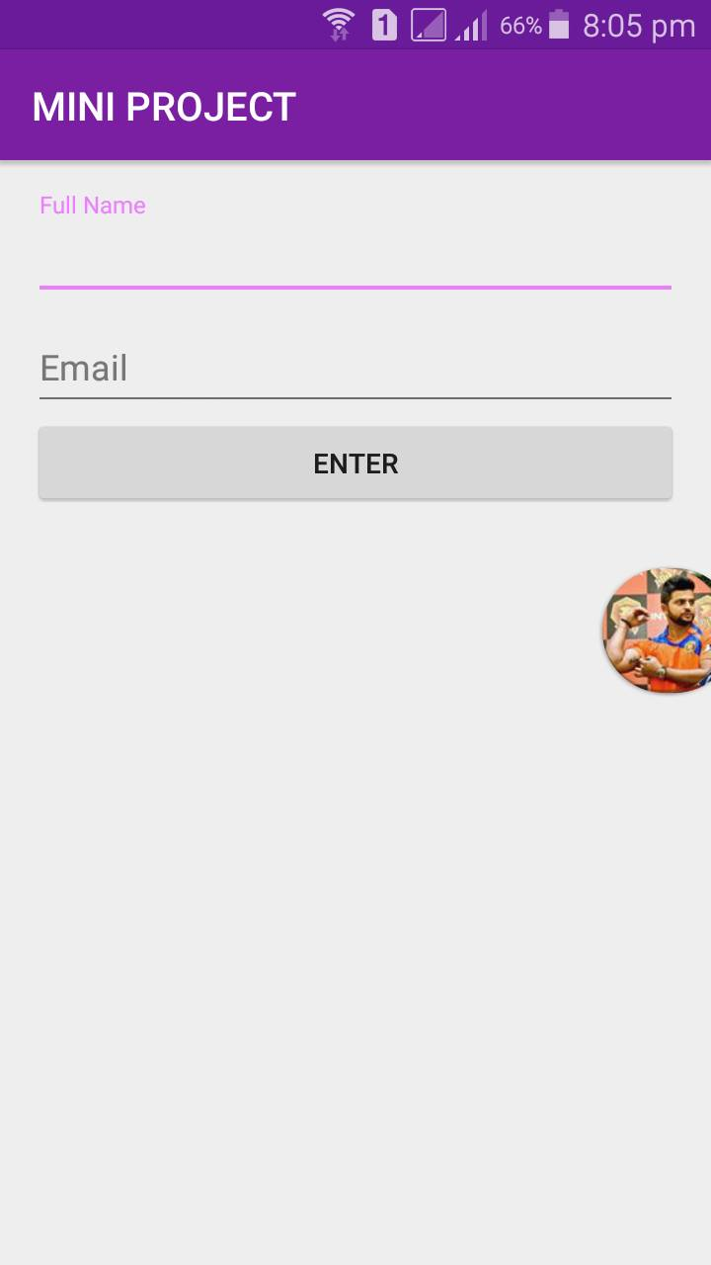

CLIENT TOPICS VIEW:

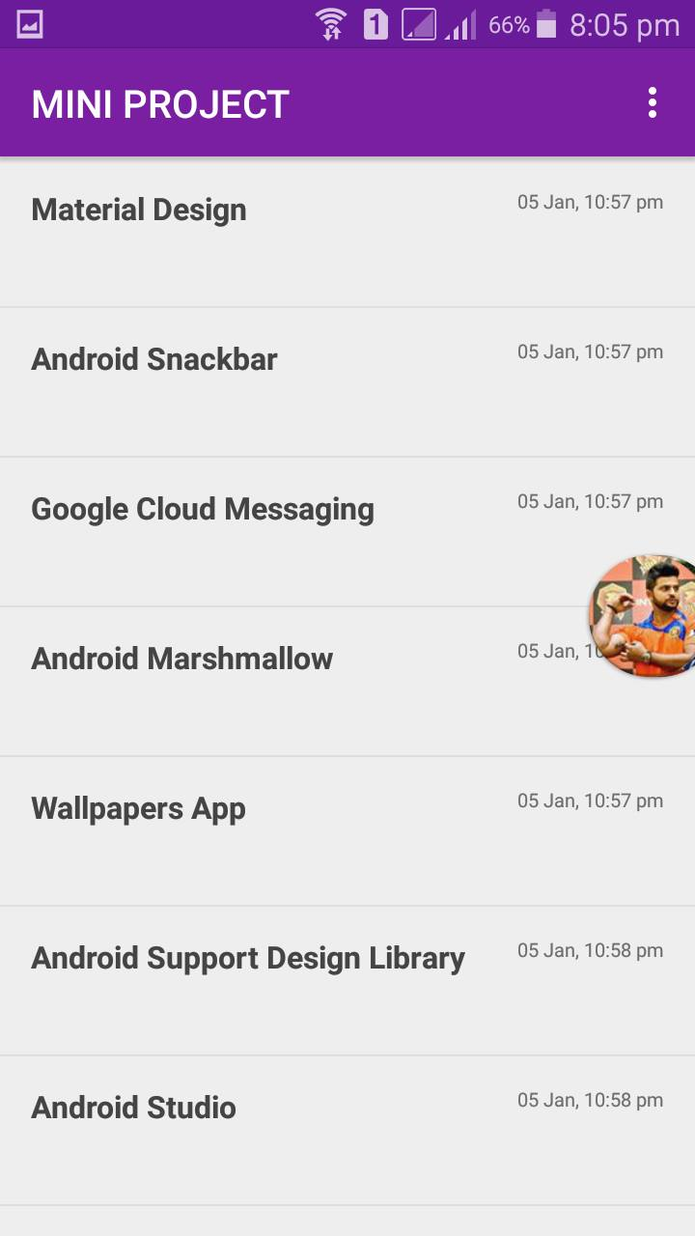

CLIENT MESSAGES VIEW:

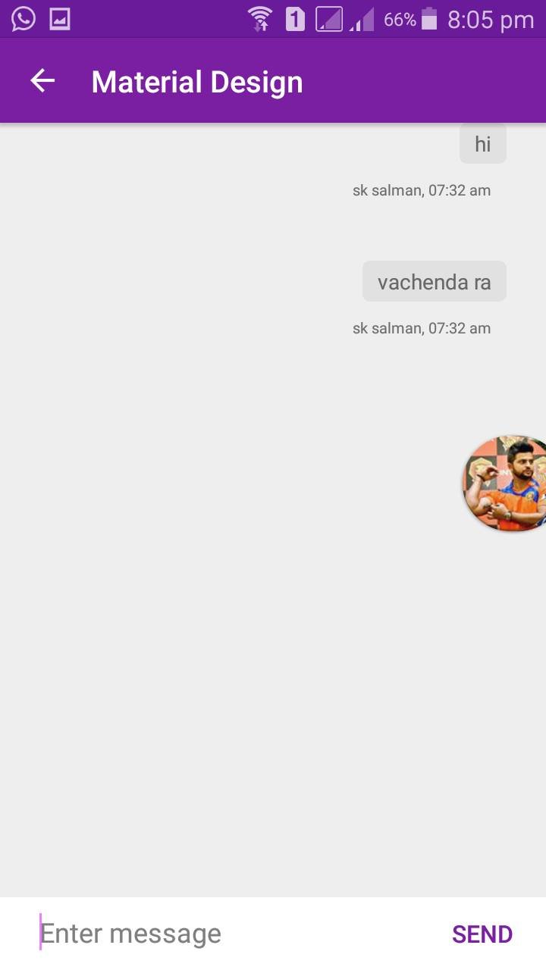

**7. TESTING AND IMPLEMENTATION:  
 7.1 INTRODUCTION:**

Software testing is a critical element of software quality assurance and represents the ultimate review of specification, design and coding. In fact, testing is the one step in the software engineering process that could be viewed as destructive rather the constructive.

ACCEPTANCE TESTING

UNIT TESTING

SYSTEM TESTING

SUB-SYSTEM TESTING

MODULE TESTING

Component testing

Integration testing

User testing

**UNIT TESTING:**

Unit testing focuses verification effort on the smallest unit of software design,the module. the unit testing we have is white box oriented and some modules the steps are conducted in parallel.

**CONCLUSION**

It has been great pleasure for me to work on this exciting and challenging project.

This project proved good for me as it provided practical knowledge of not only programming in php and android and gcm, but also about all handling procedure related with “project title”. It also provides knowledge about the latest technology that will be great demand in future. This will provide better opportunities and guidance in future in developing projects independently.