Student Name : Rajeshwaren AK
Register No. :710023104012
Subject : Web Technology
Academic Year / Semester :3rd Year
Date of Submission : 09-February 2026
College : Anna University Regional Campus Coimbatore,
Tamil Nadu

Aim
To design and develop a responsive web-based Lost & Found Item Management Portal that allows users to report lost or found items, browse listings, view item details, and facilitate communication between finders and owners — all using only client-side technologies (HTML, CSS, JavaScript) with localStorage for persistence.
Objectives
- Create a user-friendly interface for reporting lost and found items.
- Display separate listings for lost and found items with search-friendly layout.
- Allow users to view detailed information of any reported item.
- Simulate data persistence using browser localStorage so newly reported items appear in listings.
- Demonstrate responsive design using pure CSS (Grid + Flexbox).
- Provide clear navigation and professional look suitable for college campus use.
- Document the complete development process for academic submission.
Software Requirements
Development Tools / Environment
- Operating System : Windows 11 / macOS / Linux
- Code Editor : Visual Studio Code
- Browser : Google Chrome / Microsoft Edge (for testing & debugging)
- Version Control : Git + GitHub (for version tracking & hosting)
Technologies Used
- Frontend : HTML5, CSS3, JavaScript (Vanilla)
- Styling : Pure CSS (Flexbox + CSS Grid, no Bootstrap/Tailwind)
- Data Storage : JavaScript array + browser localStorage (client-side persistence)
- Hosting (optional) : GitHub Pages / Netlify (static deployment)
- Libraries : None (100% vanilla implementation)
Hardware Requirements: Any standard laptop/desktop with 4GB+ RAM and modern browser

System Architecture / Website Structure
Folder Structure
lost-found-portal/
├── index.html → Home page with recent previews
├── lost.html → Lost items listing
├── found.html → Found items listing
├── report.html → Form to report new lost/found item
├── details.html → Single item detail view
├── about.html → Project documentation & credits
│
├── css/
│ └── style.css → All custom styles (pure CSS)
│
├── js/
│ ├── data.js → Sample static items array + helpers
│ └── script.js → Shared logic (filtering, merging localStorage, utilities)
│
├── images/
│ └── items/ → Placeholder images for sample items
│
└── README.md
High-Level Architecture
User → Browser (HTML + CSS + JS)
↓
Static Files (GitHub Pages / Netlify)
↓
JavaScript
├── Static sample data (data.js)
└── Dynamic user reports (localStorage)
↓
Render dynamic listings & details
Procedure / Methodology
- Planning
  - Identified real-world problem: lost items in college campus
  - Listed required pages and features
  - Decided to keep it static + localStorage for academic demo
- Design
  - Created responsive layout using CSS Grid for cards
  - Designed consistent navbar with checkbox hamburger for mobile
  - Planned card-based UI for items (image + title + location + date)
- Development
  - Created HTML structure for all pages
  - Wrote pure CSS (no framework) for styling and responsiveness
  - Implemented static sample data in data.js
  - Added form handling in report.html with localStorage save
  - Created merge logic in script.js so user reports appear in listings
  - Made details.html read item by ID from combined data
- Testing
  - Tested in Chrome, Edge, Firefox
  - Checked mobile responsiveness (hamburger menu, grid layout)
  - Verified that new reports appear in correct tab (lost/found)
  - Cleared localStorage to simulate fresh start
- Deployment
  - Pushed to GitHub repository
  - Enabled GitHub Pages for live demo
- 8. Modules / Pages Description
Page | Purpose | Key Features
index.html | Home / Landing page | Intro + Recent 3 lost + 3 found previews
lost.html | Displays all lost items | Card grid, “Report Lost” button
found.html | Displays all found items | Card grid, “Report Found” button
report.html | Form to report new lost or found item | Radio (lost/found), validation, localStorage save
details.html | Shows full details of one item | Image, description, contact, back button
about.html | Project documentation & credits | Aim, technologies, advantages, developer info
Code Snippets
A. Sample data (data.js)
JavaScript
const items = [
{ id: 1, type: "lost", title: "Black Earbuds", ... },
// more sample items
];
B. Merge logic – script.js (key part)
JavaScript
function getAllItemsIncludingUserSubmitted() {
let all = [...items];
const stored = localStorage.getItem('lostFoundItems');
if (stored) all = [...all, ...JSON.parse(stored)];
all.sort((a,b) => new Date(b.date) - new Date(a.date));
return all;
}

function getItemsByType(type) {
return getAllItemsIncludingUserSubmitted().filter(i => i.type === type);
}
C. Report form save (report.html)
JavaScript
const newItem = { id: 'user-'+Date.now(), type: formData.get('type'), ... };
let reports = JSON.parse(localStorage.getItem('lostFoundItems') || '[]');
reports.push(newItem);
localStorage.setItem('lostFoundItems', JSON.stringify(reports));
D. Card rendering example (lost.html / found.html)
JavaScript
grid.innerHTML = items.map(item => `
<div class="card">
<img src="${item.image || 'placeholder'}">
<span class="badge ${item.type === 'lost' ? 'badge-lost' : 'badge-found'}">${item.type.toUpperCase()}</span>
<h3>${item.title}</h3>
...
</div>
`).join('');
10. Output Screenshots
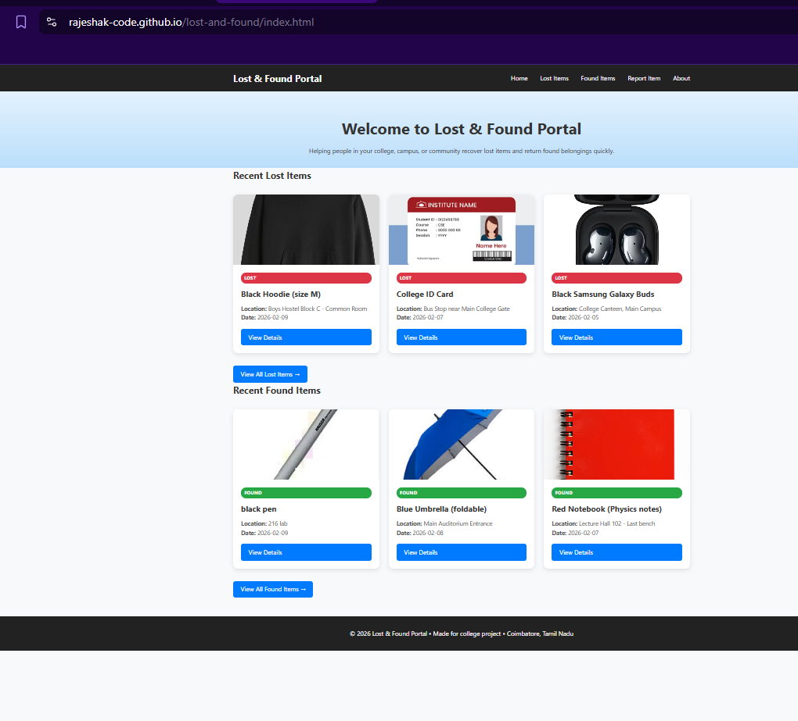
Home
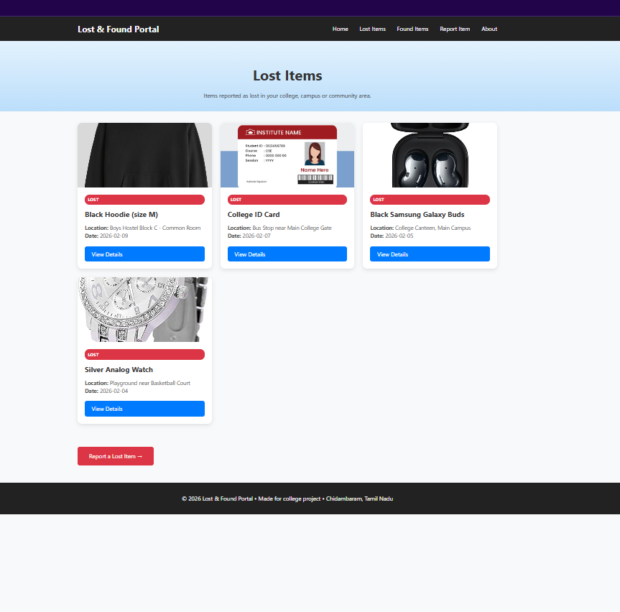
Lost
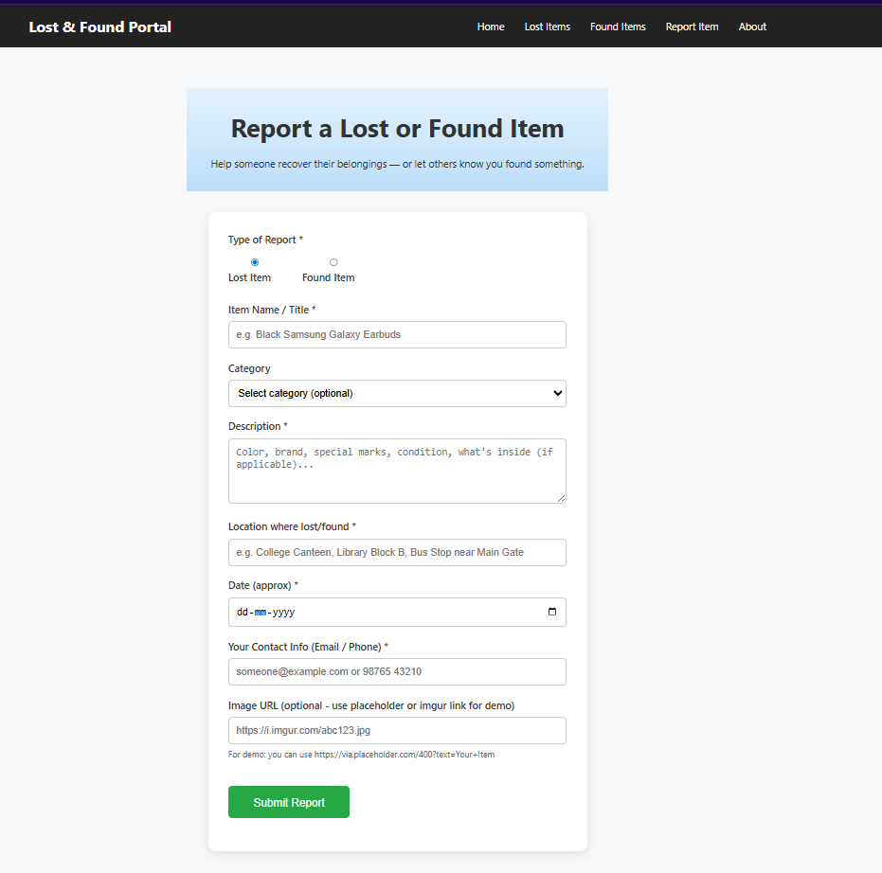
Report
Future Scope
- Integrate real backend database (Supabase / Firebase / MongoDB)
- Add user authentication (login/signup)
- Support actual image upload (to Supabase Storage / Cloudinary)
- Implement real-time updates (new reports appear without refresh)
- Add search bar, category filter, date range filter
- Email notification to contact person when item is reported
- Admin panel to mark items as “Recovered” or delete spam
- Mobile app version using same backend
Conclusion
- The Lost & Found Portal successfully demonstrates how modern web technologies (HTML5, CSS3 Grid/Flexbox, JavaScript, localStorage) can be used to build a practical, responsive, and user-friendly application without any backend server.
- The project achieves its aim of providing a centralized platform for reporting and viewing lost & found items in a college environment. By combining static sample data with dynamic user-submitted reports (via localStorage), it gives a realistic demo experience while remaining lightweight and free to host.
- This project helped in understanding client-side development, responsive design principles, DOM manipulation, form handling, and data persistence in the browser — key skills in Web Technology.

