SMART GARDENING SYSTEM USING IOT

MADE BY

RAJESH D BORATE

# ABSTRACT :

Garden maintenance has been evolving over the years. It’s gone from being a manual-based operation to an almost completely automated operation. We would like to discuss the objects that work in an integrated environment, which could take automation to the next level. Internet of Things (IoT) will be the main focus and will be referred to as "the solution".

Every garden has life cycle stages such as soil cultivation, planting, fertilizing and pest control, irrigation, and harvesting. We will not identify all the automation opportunities at every life cycle stage, but will present, at a conceptual level, how various entities can work together in the context of IoT.

**Devices:** IoT is all about IP enabled devices. The equipment used in soil cultivation, planting and other operations may not be internet ready, yet. They need to be prepared for getting connected to the internet.

**Information models:** For each device, we need to decide on the data to be exchanged between them. An information model is to be developed with attributes and functions for each device.

**Device orchestration:** Since the solution is an integrated one, devices need to be managed in such a way that they can either be plugged in and out, the configurations managed, their availability tracked, and so on.

**Data collection:** Each device is programmed to send the necessary data to a central unit that is the cloud storage. For example, a weather sensor (probably multiple sensors) can send information like air and soil temperature, humidity, pressure, wind, rainfall, solar, dew point temperature, and so on.

**Central processing:** This unit is the heart of the solution that collects data from the various connected devices. The central unit collects data and is 'intelligent' enough to act on the data based on the pre- configured rules. The actions can be in terms of commands and notifications sent back to connected devices and inform the user connected to the device and hence inform the user on which crop or plant can be grown in that particular soil type.

# INTRODUCTION :

IOT (internet of things) is an upcoming technology that makes use of internet to control /monitor electronic /mechanical devices, automobiles and other physical devices connected to the internet. IOT gives user the ability to control more than digital things easily through a comfortable GUI over the internet. Our researchers focus on the use of IOT for home/industry automation and monitoring various physical parameters over the internet. This internet of things projects have been proposed on existing system improvements and new innovative solutions to different problems. Internet of things is a technology which encounters remote monitoring and controlling of devices which being connected to it wirelessly, here the concepts of wireless sensors networks and Ethernet protocols are made of use. Internet of Things(IoT) is advancement in technology where in it makes use of Wireless sensor networks nanotechnology and Miniaturization. IoT is all about many physical devices interacting with each other. Internet of things will provide seamless connectivity between the things in virtual world with real world thereby ensures anytime, anywhere, anything. IoT will help the user to approach various applications in a smarter way which might be a smart home, smart agriculture, smart industries or enterprise. The user can check the status of any resources in the network and take necessary measures passing commands controlling the devices which happen across the web server making use of Ethernet protocols. The aim of this is to develop a smart gardening /plantation system that records

various parameters related to plants and provide. This system consists of a distributed wireless network of soil moisture, temperature and ultrasonic sensor. The experiment required sensors, Raspberry pi 3 and pipe to supply water from tank controlled by a gate. Moisture sensor was installed near the roots and daylight sensor was installed further away to clearly detect the sunbeam. These sensors send their data to the raspberry pi to analyse. Main purpose of this project is to save the water and to increase the production of trees and plants in the garden by monitoring the growth of plants we designed a system to automatically sprinkle accurate amount of water by detecting soil moisture, daylight intensity and water level. Each type of plant needs different soil moisture for smooth growth. Hence the soil moisture is a key variable that can be used to determine the quantity of water needed. Besides, the availability of the amount of daylight is also very crucial for a tree.

# Smart Gardening App (SGA):

SGA is based on NODE MCU and smart phone device using internet. The main objective of the smart plantation is to provide comfortable, a convenient user interface by sensing and controlling plant environment. This figure shows the system architecture of SGA which consists of NODE MCU, Temperature sensor, Humidity sensor, pump, LDR sensor, Relay circuit, Android application.

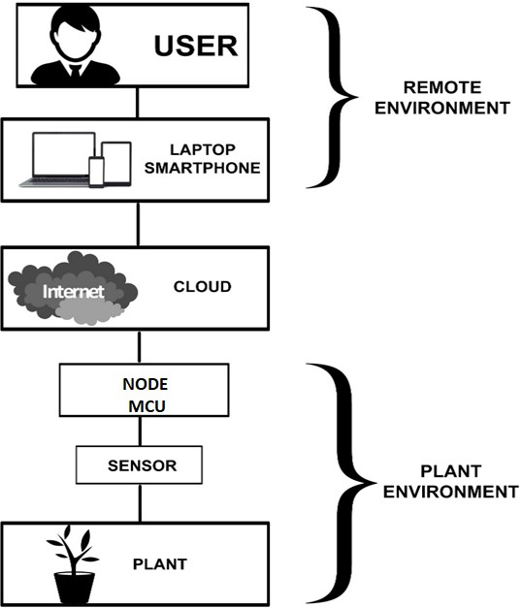

# EXPLANATION :

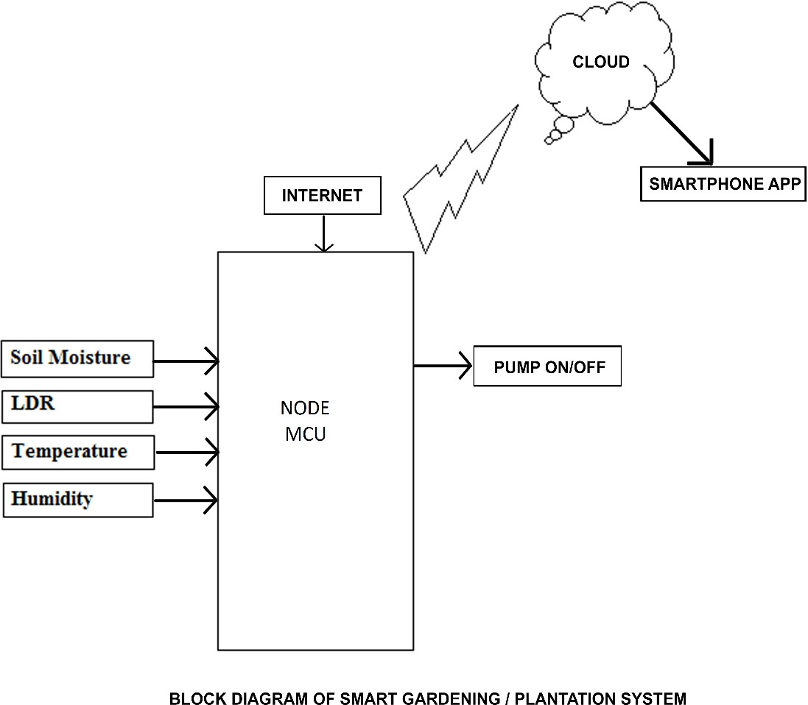

Based on various analog readings from above mentioned sensors, we transfer all this data to our respective cloud based platform through the NODE MCU. Later on, by doing various processing on the data obtained from the cloud on our respective client web page/app we can obtain the regular updates and growth trends for our plant. By using this system, we can never overwater or underwater our plant because of the controlled water pump through soil moisture sensor. Also, we can see what all plants we can grow in the soil available to us by putting our sensors, along with our the global location. Moreover by collecting some proper data set, we can perform some sophisticated machine learning algorithm that could greatly automate all our tasks and manage everything effectively.

# COMPONENT USED: SENSORS:

A **sensor** is a device that measures a physical quantity and converts it into a 'signal' which can be read by an observer or by an instrument. We have used the following sensors in our system.

# Soil moisture sensor :-

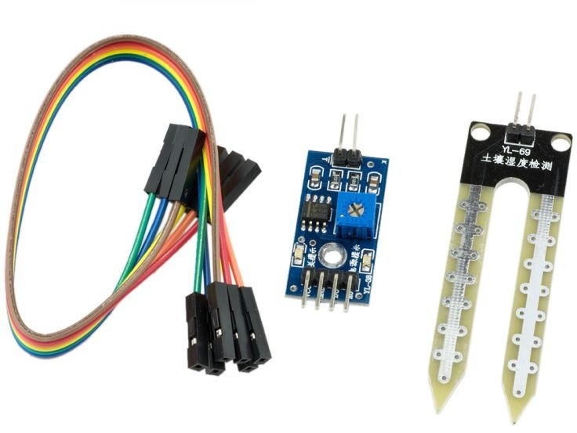This sensor can be used to test the moisture of soil, when the soil is having water shortage, the module output is at high level, else the output is at low level. By using this sensor one can automatically water the flower plant, or any other plants requiring automatic watering technique. Module triple output mode, digital output is simple, analog output more accurate, serial output with exact readings.

Soil moisture sensors measure the water content in soil. A soil moisture probe is made up of multiple soil moisture sensors. One common type of soil moisture sensors in commercial use is a Frequency domain sensor such as a capacitance sensor. Soil moisture content may be determined via its effect on dielectric constant by measuring the capacitance between two electrodes implanted in the soil. This sensors are mostly used in Agriculture and Landscape irrigation.

# LDR (Light Dependent Resistor) :-

When LDR subjected to light energy, a Photoconductive light sensor will change its physical property. Photo Resistor is a common type of photoconductive device. Photo resistor is a semiconductor device that uses light energy to control the flow of electrons and therefore the flow of current in it. The most common type of photoconductive cell is a Light Dependent Resistor or LDR. As the name implies, a Light Dependent Resistor is a semiconductor device that changes its electrical resistance depending on the presence of light. A Light Dependent Resistor changes its electrical resistance from a high value of several thousand Ohms in the dark to only a few hundreds of Ohms when light is incident on it by creating electron – hole pairs in the material. The most common material used to make a Light Dependent Resistor is Cadmium Sulphide (CdS). Other materials like Lead Sulphide (PbS), Indium Antimonide (InSb) or Lead Selenide (PbSe) can also be used as the semiconductor substrate. Cadmium Sulphide is used in Photo resistors that are sensitive to near infrared and visible light. The reason it is used is because of its close resemblance of its spectral response curve to that of the human eye. It can be controlled by a simple, light source like a flash light.

Cadmium Sulphide is deposited as a thread pattern on an insulator in the shape of a zigzag line as shown below.

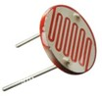

The reason for zigzag path is to increase dark resistance and therefore decrease the dark current. This cell is encapsulated in a glass to protect the substrate from contamination. The symbol of photo resistor is shown below.

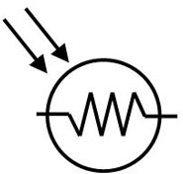

A Light Dependent Resistor is generally connected in series with a resistor with a single DC voltage supply across it. The connection is shown below.

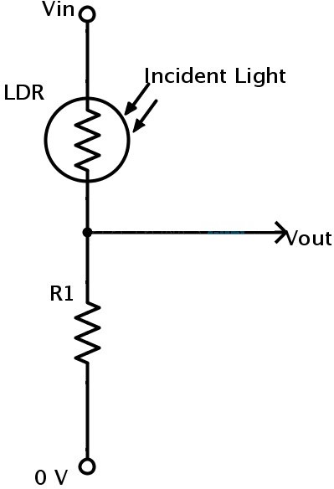

The advantage of this connection is the appearance of different voltages at their junction for different intensities of light. This connection is an example of a Voltage Divider Network or Potential Divider. The reason is because the resistive value of the light dependent resistor RLDR will determine the amount of voltage drop across the series resistor R1. The current in a series connection is same and as the resistance of the light dependent resistor changes due to the light intensity, the output voltage will be determined by using the voltage divider formula. The output voltage,

VOUT = VIN * (R1 / (RLDR + R1 ))

In the absence of light, the resistance of a light dependent resistor is as high as 10 M Ω. In the presence of sunlight, the resistance of a light dependent resistor will fall to 100 Ω. The variation of the resistance of a light dependent resistor over different intensities of light is shown in the below curve. Light Sensitive Switch are commonly in Light Dependent Resistor.

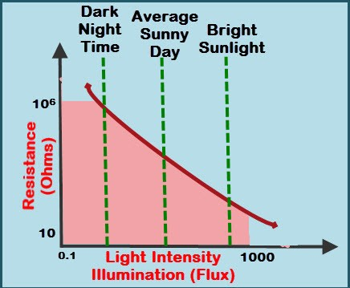

# Temperature and Humidity sensor (DHT 11) :-

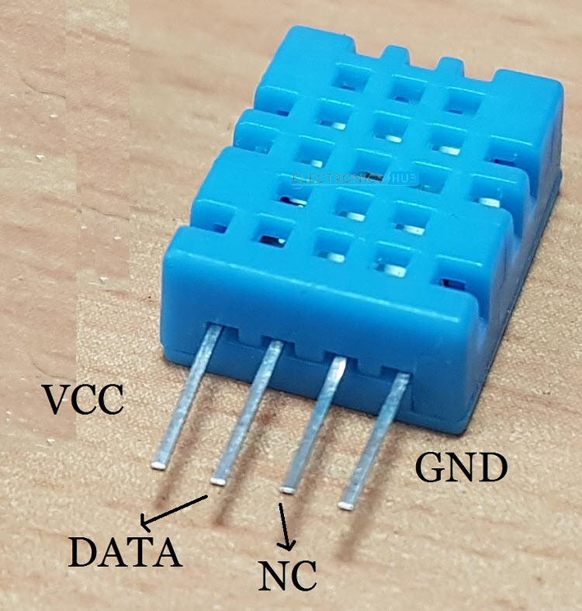

DHT11 is a Humidity and Temperature Sensor, which generates calibrated digital output.

A humidity sensor senses, measures and regularly reports the relative humidity in the air. It measures both moisture and air temperature. Relative humidity, expressed as a percent, is the ratio of actual moisture in the air to the highest amount of moisture air at that temperature can hold. The warmer the air is, the more moisture it can hold, so relative humidity changes with fluctuations in temperature.

Humidity sensors detect the relative humidity of the immediate environments in which they are placed. They measure both the moisture and temperature in the air and express relative humidity as a percentage of the ratio of moisture in the air to the maximum amount that can be held in the air at the current temperature. As air becomes hotter, it holds more moisture, so the relative humidity changes with the temperature.

Most humidity sensors use capacitive measurement to determine the amount of moisture in the air. This type of measurement relies on two electrical conductors with a non- conductive polymer film laying between them to create an electrical field between them. Moisture from the air collects on the film and causes changes in the voltage levels between the two plates. This change is then converted into a digital measurement of the air relative humidity after taking the air temperature into account.

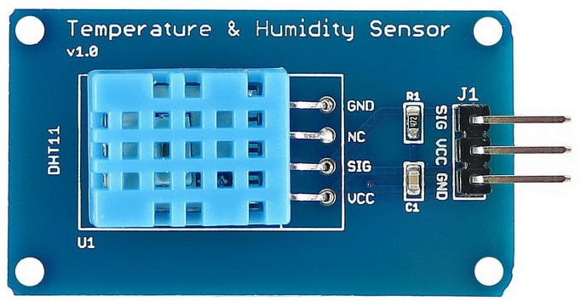

Temperature Sensor consists of 3 main components. A resistive type humidity sensor, an NTC (negative temperature coefficient) thermistor (to measure the temperature) and an 8-bit microcontroller, which converts the analog signals from both the sensors and sends out single digital signal.

* ULTRASONIC SENSOR:

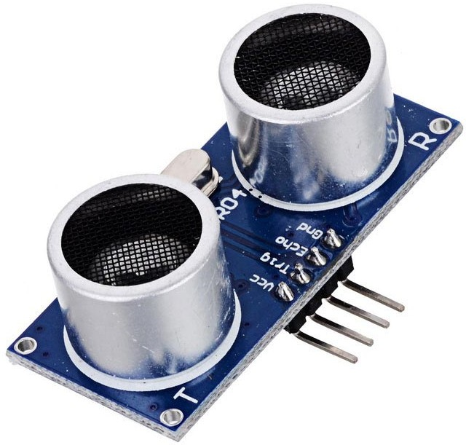

An Ultrasonic sensor is a device that can measure the distance to an object by using sound waves. Sonar uses the propagation of sound to detect object. It measures distance by sending out a sound wave at a specific frequency and listening for that sound wave to bounce back. By recording the elapsed time between the sound wave being generated and the sound wave bouncing back, it is possible to calculate the distance between the sonar sensor and the object.

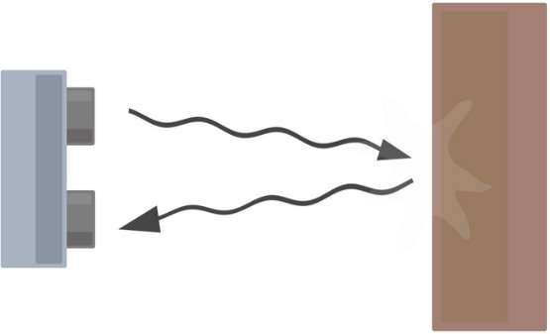

***BASIC ULTRASONIC SENSOR OPERATION***

Since it is known that sound travels through air at about 344 m/s (1129 ft/s), you can take the time for the sound wave to return and multiply it by 344 meters (or 1129 feet) to find the total round-trip distance of the sound wave. Round-trip means that the sound wave traveled 2 times the distance to the object before it was detected by the sensor; it includes the 'trip' from the sonar sensor to the object AND the 'trip' from the object to the Ultrasonic sensor (after the sound wave bounced off the object). To find the distance to the object, simply divide the round-trip distance in half.



But note that the accuracy of the ultrasonic sensor can be affected by temperature and humidity of the air it is being used. It is important to understand that some objects might not be detected by ultrasonic sensors. This is because some objects are shaped or positioned in such a way that the sound wave bounces off the object, but are deflected away from the Ultrasonic sensor. It is also possible for the object to be too small to reflect enough of the sound wave back to the sensor to be detected. Other objects can absorb the sound wave all together (cloth, carpeting, etc), which means that there is no way for the sensor to detect them accurately.

* NODE MCU:

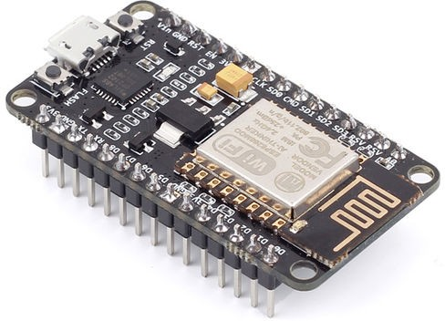

NodeMCU is an open source IoT platform. Open-source. NODE MCU is Interactive, Programmable, Simple, Smart, WI-FI enabled and is off low cost.

The Development Kit based on ESP8266, integates GPIO, PWM, IIC, 1-Wire and ADC all in one board. The ESP8266 was developed by the Shangai-based company Espressif Systems, an IC manufacturer focused on the development of RF chips, particularly Wi-Fi. There are several modules in the market that use the ESP8266 chip, they are named ESP-NN, where NN is a number 01, 02,…..12, sometimes followed by a letter. The pin layout of NODE MCU is shown below. These modules typically carry the ESP8266 SoC, flash memory, a crystal, and in most cases, an onboard antenna.

# PIN LAYOUT OF NODE MCU:

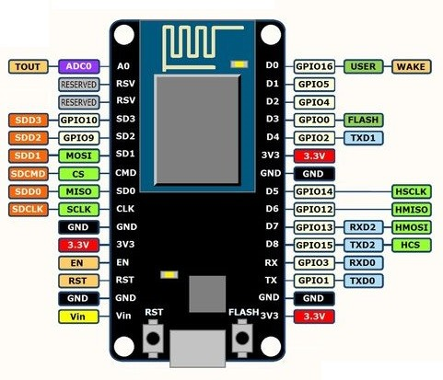

**CIRCUIT DIAGRAM :**

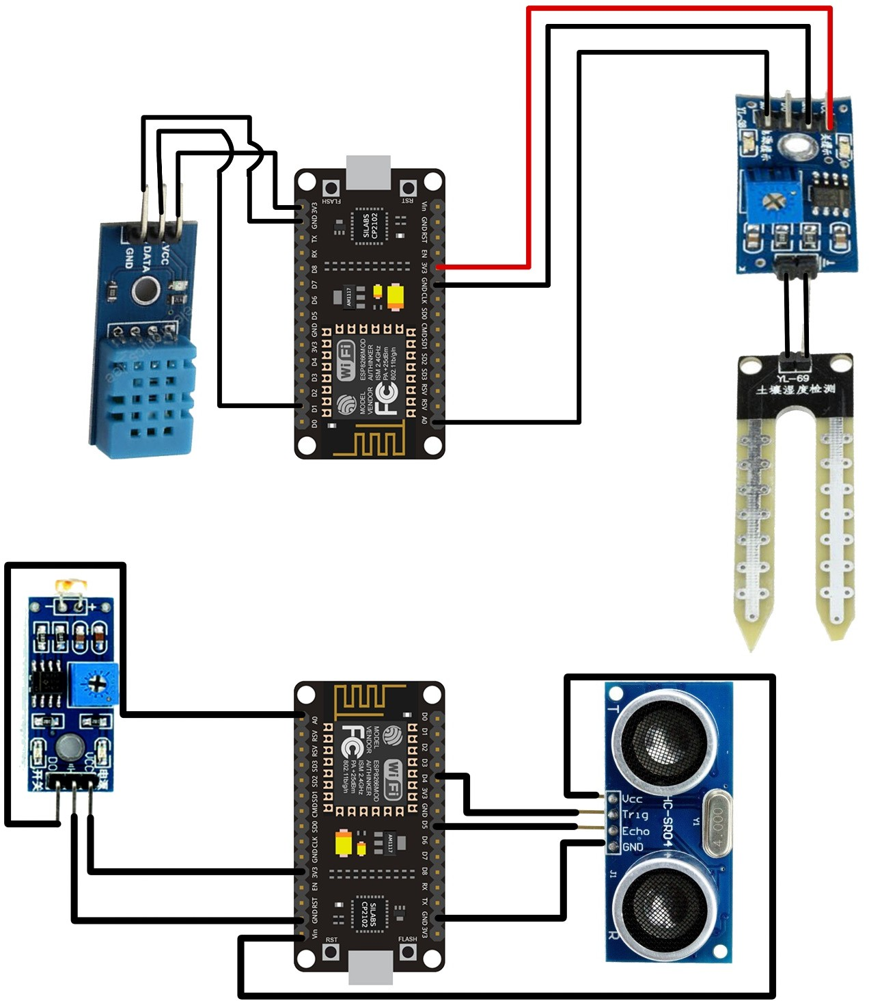

* **APPLICTION :**

Nowadays world’s automatic systems are more preferred than manual system, so by kipping that into our mind our system is very much easy to control, convinient device. Our device is able to supply water whenever the dryness value goes below the threshold value. And also our system is able to give temperature near-arround the plant. If we have putted our plant in darkness so this plant will required sunlight, our system is will give notification immidiatly that “ this plqnt required sunlight, so put it somewhere else where sunlight is sufficient for the plant ”. Also we have ultrasonic sensor to get the information about the water remainig into the tank. When water level goes below the certain value, then also our system will send notification to the user.

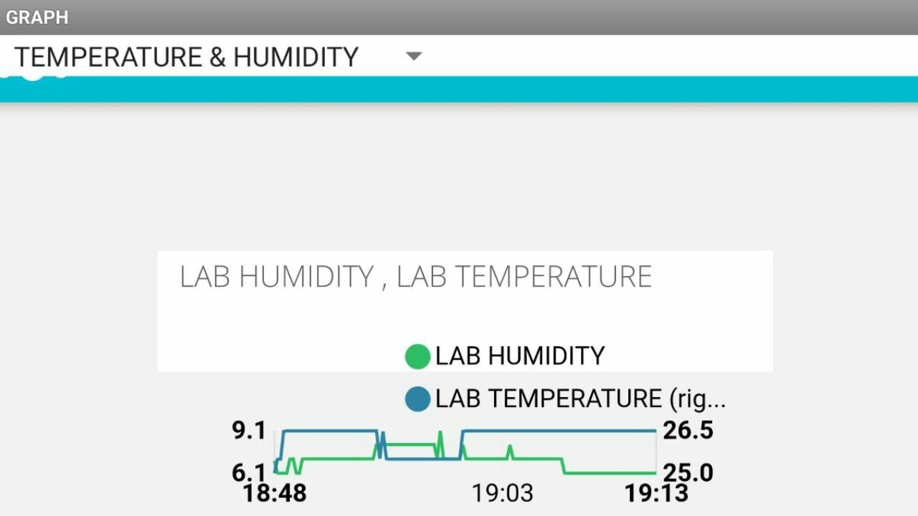

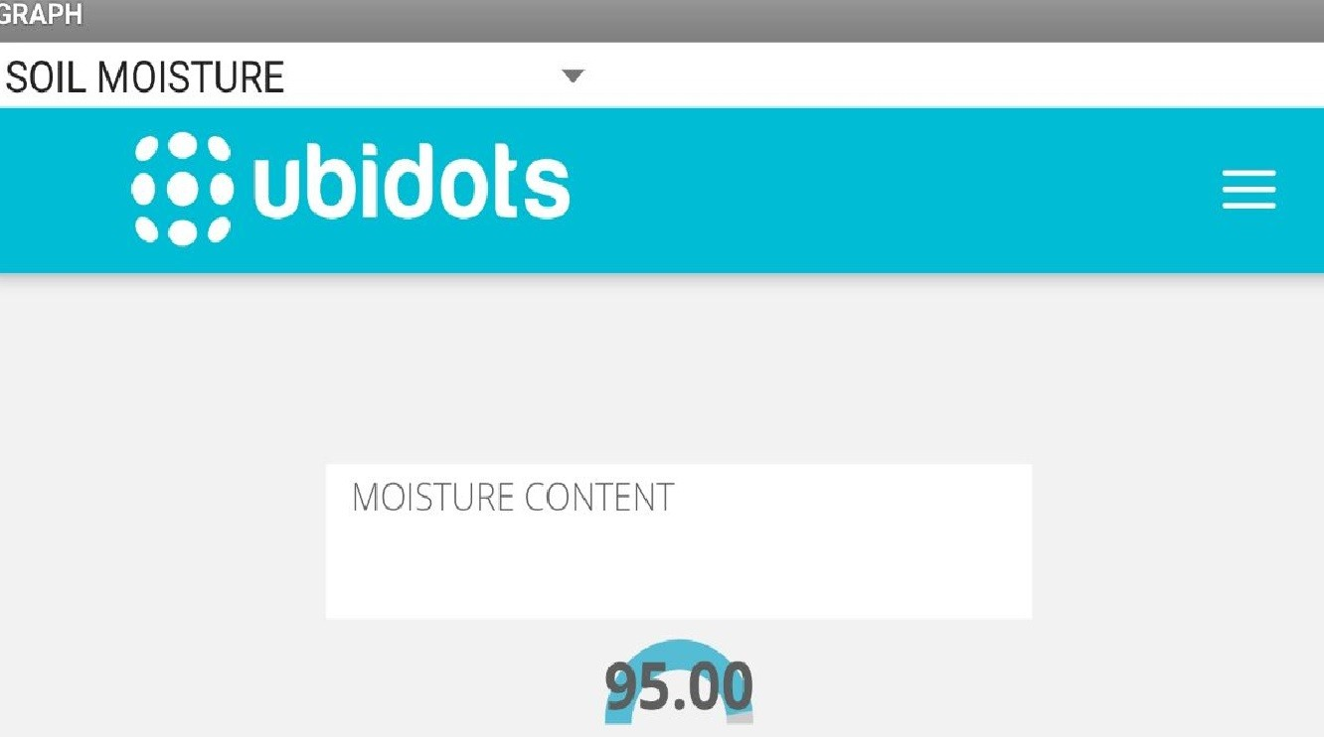

# FUTURE ASPECTS:

* + We can modify our system which contain the database of most of the plants near-arround us, then this system will ask to user, which plant user wants in the garden. And this system will give all required information for healthy growth of the plants.
  + Also we can modify our system, with boat which will throw the seeds in 180’ and by using the ultrasonic sensor, it will sens the distance of the seeds and again it will repeat the process.
  + We can aslo modify our system by adding GPS to our system. And it will give perfect information about the plants and seeds, which seeds or plants are perfect place for it. According to the GPS location this system will give information about the temperature, soil, and air content at that location.

# CONCLUSION:

The smart plantation using Internet of Things has been experimentally proven to work satisfactorily by connecting simple appliances to it and the appliances were successfully controlled remotely through internet. The designed system not only monitors the sensor data, like temperature, light, motion sensors, but also actuates a process according to the requirement, for example switching on the light when it gets dark. It also stores the sensor parameters in the cloud (Gmail) in a timely manner. This will help the user to analyze the condition of various parameters in the home anytime anywhere. Such a system can easily be made and it is not very costly. With the improvement of sensor technology, the system will become more efficient and useful. For instance, a more accurate weather forecast can help better decision making in supplying water and reducing water wastage. Using this system, one can save manpower, water to improve production and ultimately increase profit. The automated irrigation system is feasible and cost effective for optimizing water resources for agricultural production. The system would provide feedback control system which will monitor and control all the activities of plant growth and irrigation system efficiently.

# REFERENCES:

* WEBSITES :
* <http://ieeexplore.ieee.org/document/7016780/>
* https://en.wikipedia.org/wiki/Sensor
* [https://www.electronicshub.org/dht11-humidity-sensor-](http://www.electronicshub.org/dht11-humidity-sensor-) arduino/
* <http://www.electronic-tutorials.ws/io/io_4.html>
* https://en.wikipedia.org/wiki/Relay
* BOOKS/JOURNALS:

➢

[https://www.ijirset.com/upload/2017/iccstar/20_O010.p](http://www.ijirset.com/upload/2017/iccstar/20_O010.p) df

* <http://airccse.org/journal/ijasa/papers/3315ijasa02.pdf>