INTRODUCTION
TO
THE PROJECT

INTRODOCTION

This project is carried out as per the user requirements keeping in mind the modern requirements of the competition.

The name of the project is “Extended File System Reader Writer”.

Following are the steps involved for making a successful Portal.

1. Scope of the system is studied deeply.

2. Requirement gathering is done using various methods available
Software engineering.

3. Analysis reports of the requirements that are gathered by different
Method is carried for the project.

4. On the basis of the indents send by the user and requirements is
Gathered for the system.

5. Based on the requirement analysis, a study of the system is done
To prepare Functional Decomposition Diagram (FDD), Data Flow
Diagram (DFD), and an Entity Relationship Diagram (ERD).
This tools help in pictorial representation of the flow of the
system.

6. The Project incorporates excellent GUI features. It is made to be
Menu driven so that it becomes convenient for the end user who
May not be a computer literate. It consists of screens and reports.

7. The project covers all-important aspects of the exiting system and
Ensures computerized working of the system. It also introduces
Certain features that alleviate the current loopholes in the system.

9. There is the effective reduction in errors, strong hold on the system,
There is an improved accuracy and consistency of data is maintained.
Project ensures better security of the confidential data.

Salient Features

- Latest Technology
- Modular
- Integrated
- Easy to customize
- Secured
- Easy to run

NEED FOR SYSTEM

The existing system was based on the traditional and manual way of working. In the entire procedure there is a lot of work manually done.

All this work most of the times may have chances of more mistakes. In case of any mistakes, rectification has to be done and the whole rectification process becomes unnecessarily cumbersome.

- An analysis of problem with existing system determined that it was essential to take exam through computerization.

- New system (this system) will save time.

- As the existing System includes more manual work, it leads to repetition and redundancy of work.

- Information is not available to the management, being a manual system daily reports to be generated acquire a lot of time.

- As we required to reboot to switch OS ,it adds some overheads.

\

STUDY OF EXISTING SYSTEM

Existing system

The existing system is a manual system and function in the following way

- To copy the file stored on Linux operating system, one can need to reboot the OS and enter into the Linux environment.

- Copy the file into some secondary device.

- Again reboot the machine to switch the OS

- Several reboots are required to copy other files

LIMITATIONS OF THE EXISTING SYSTEM

As the existing system was based on the traditional and manual way of working, this system was not able to handle the proper memory management.

In the entire procedure there is a lot of work is being done manually since no surety of 100% success.

As the existing System includes more manual work, it leads to repetition and redundancy of work.

Existing system adds some burdens on the machines.

It add some delay in the work as rebooting time can be added in it.

It degrades performance of the work, hence throughput of the system.

REQUIREMENT ANALYSIS

REQUIREMENT DETERMINATION TECHNIQUES

Systems are developed in dynamic environment and to overcome any system problem, the developer should have a sound knowledge about the system. The system should be studied in depth and to study the system you need to collect facts. Facts expressed in quantitative form can be termed as data. Success of any requirement investigation depends upon availability of accurate and reliable data. These depend on the appropriateness of the method chosen for data collection. The specific methods used for collecting data are called Fact-Finding Techniques.

As this proposed system is directly interact with the operating system component requirement of the this system based on the following:

Sound knowledge of the File System:
As we are interacting with the FS then the knowledge of the targeted FS is must.

Knowledge of OS:
Since we are interacting with the File System through the OS system calls efficient and proper use of them required.

RISKASSEMENT

Risk: Risk is an untoward incident, which may occur during the life cycle of the system under development.

The following risk can occur during the development of the system
- Risk associated with the overall size of the software to be built. Project risk is directly proportional to the product size.

- Delivery Deadlines should also be kept in mind.

- Risk associated with the customer not accepting the product delivered

- Lack of mechanism used for controlling changes to customer requirements that impact the software.

- Technology not meeting the expectation.

- Software under development being corrupted.

- Hard disk being corrupted.

- Any other natural calamities, risks.

USER REQUIREMENTS

The basic requirements were to get rid of the existing system, which was full of manual intervention with no use of computer technology. The user requirements for the proposed system are as follows:

- The System should have authorized and authenticated login.

- User friendly and easy to use.

- Should display various error messages if incorrect is entered and guide on the same.

- The system should be able to keep the details of the Candidates.

- The system should keep the OS in consistent state.

- The system should be able to maintain the database of the Candidates.

- Provide an Ease to use User Manual.

- The System should be able to generate various kinds of

- The should transfer the file from one environment to another without of any change.

- The offline system should no go in inconsistent state.

STUDY OF PROPOSED SYSTEM

Objectives of the proposed system

- To fully automate the system, so that the data should be stored in
the data system and it should generate information.

- Increasing the accuracy of information is one more objective of
the system.

- To introduce the data system and enforce integrity and retrieve
the information needed.

- The new system should interpret the data read from Linux partition.
- The proposed system should not affect the integrity of the other system (Linux) installed on the PC and from which we are transferring the data.
- To generate various reports quickly and accurately.

- It should also synchronize and saturate the differences between two system. i.e. For line break Linux uses ‘ln’ while windows uses ‘lrln’ mechanism which should avoided.
- Minimization of input, leading to less error being committed by the user.

- Proper usage of standard coding techniques thus making it easier for maintenance of the system.

SCOPE OF THE SYSTEM

The purpose of the system is make information available to the user whenever he required. It aims at allowing using the system to the user with little or no previous background in using computers. Many features offered by it. The main features of the system are follows:
Copy the Files not directories:
This proposed system can be able to transfer the files but not directories. Since directories can have large structures in it.

Commands implemented :

Ls : list files
This command can work as that of the command on the Linux.
It caches all the Files and Folders from current working directories. It display all those files and Folder from current directory.

Cp : Copy Files
- This can search the files in file chache of the current directory.
- If that file doesn’t present it generate appropriate exception.
- If the file is present then it reads the inode associated with it and retrieves all the data blocks associated with that inode ,stores it into buffer .
- Then it creates the File at standard location on Windows and copy all the buffer.
- Before copying it interprets the differences between File System difference between these two different OS and try to remove it.
- Finally it renames that newly created file as its name in Linux environment.

Cd: Change Directory
It works similar as that of the “chdir” command on Linux or “cd” command on Windows.
- It first take two argument one is command and other is absolute path of directory.
- It first searches for the presence of that file in current working directory.
- If that file doesn’t present it generate appropriate exception.
- If that particular file is a file and not a directory then also it generates exception. Since we can not treat it as a directory.
- If the file is present then it reads the inode associated with it and retrieves all the data blocks associated with that inode ,stores it into buffer .

- The data of this directory is nothing but a directory structure of the other files and directories present in the particular directory.
- Extract the directory structure of its child.

Exit: Exit from the program
This command will exit from this system.

FEASIBILITY STUDY

The project feasibility is the likelihood that the system will be useful to the organization. It provides an overview of the complex business requirement or opportunity and determines if feasible solutions exist before full life-cycle resources are committed. The main objective of the feasibility study is to test the technical, operation and economic feasibility of the system under development. Once scope has been identified, it is reasonable to ask: ”Can we build software to meet this scope? Is the project feasible?” Putnam and Myers address this issue when they write:

…Not everything imaginable is feasible, not even in software, evanescent as it may appear to outsiders. On the contrary, software feasibility has four solid dimensions: Technical- Is a project technically feasible? Is it within the state of art? Can defects be reduced to a level matching the applicant’s needs? Finance- is it financially feasible? Can development be completed at a cost the software organization, its client, or the market can afford? Social- Will the project’s time-to-market beat the competition? Resources- does the organization have the resources needed to succeed?

Operation Feasibility

The management approves the project, as there was no such existing system for order processing and maintaining the various details. It was a solely manual system, so there was encouragement from the management side. The proposed system will improve the efficiency of the system. The system will speed up the process of transaction and data sharing between these two completely different system.

1.Technical Feasibility

- The hardware and software required for the system will be made available at the time of implementation of the system.
- The system has technical capacity to hold data required to use the new system and can be used to get the best out of the system.
- The system also gives guarantee of accuracy, reliability, ease of access and data security.
- It also requires the expertise’s it the File System domain since any wrong operation may cause the system crash.

2.Economical Feasibility

This means to check whether the system is economically feasible or not.
This system has following points:
- The user can produce report on demand of the management, which helps them to make important decisions. So the system saves time and money.

3.Time Feasibility

The proposed portal built by this project is the need if this type of organization and this project is time feasible as per requirement.

OPERATING ENVIRONMENT

OPERATING ENVIRONMENT:

The software requirement can produce at the culmination of the analysis task. The function and performance allocated to software as part of system engineering are refined by established a complete information description, a detailed functional description, a representation of system behavior, an indication of performance and design constrain, appropriate validation criteria, and information pertinent to requirements.

This project requires the following Hardware and Software in order to execute them. They are as given below.

Environment | Requirement
Hardware | Pentium based server with minimum 128 MB RAM and 10 GB Hard Disk
Software Required | - Visual C++ 6.0 and above  - Microsoft MSDN library  - VMWare GSX Server or later  - Device Driver Kit 2003
Network | LAN

SOFTWARE CONFIGURATION

- Operating System : Red Hat Linux,WinXP
- Programming Language : Win32 SDK and C.
- Antivirus : Norton Antivirus
- Office Package : MS Office 2000
- Debugging Tools : Windbg

ADVANTAGES OF PROPOSED SYSTEM

- Time is tremendously saved in transferring data .

- Huge amount of money and work is saved.

- Workload is reduced.

- Prompt validation checks.

- Enhanced Security.

- It reduces the reboots of the system.

- It can be done parallely with our current work.

SYSTEM ANALYSIS

CONVENTIONS USED FOR A DATA FLOW DIAGRAM

Introduction

Data flow diagrams can be used to provide a clear representation of any business function. The technique starts with an overall picture of the business and continues by analysing each of the functional areas of interest. This analysis can be carried out to precisely the level of detail required. The technique exploits a method called top-down expansion to conduct the analysis in a targeted way.

There are only four symbols that are used in the drawing of business process diagrams (data flow diagrams).

PROCESS

ENTITY

DATA FLOW

REPEATED ENTITY

CONVENTIONS FOR ENTITY RELATIONSHIP DIAGRAM

EXTERNAL ENTITY AS SOURCE OR DESTINATION

REPEATING EXTERNAL ENTITY AS SOURCE OR DESTINATION

RELATIONSHIP

ONE TO ONE  RELATIONSHIP | 1 1
ONE TO MANY RELATIONSHIP | 1 M
MANY TO MANY  RELATIONSHIP | M M

TESTING PROCEDURES AND
IMPLEMENTATION
PHASE

TESTING

INTRODUCTION

Software testing is a critical element of software quality assurance and represents the ultimate review of specification, design and coding. In fact testing is the one step in the software engineering process that could be viewed as destructive rather than constructive.
A strategy for software testing integrates software test case design methods into a well-planned series of steps that result in the successful construction of software. Testing is the set of activities that can be planned n advance and conducted systematically. The underlying motivation of program testing is to affirm software quality with methods that can economically and effectively applied to both large and small scale systems.

STRATEGIC APPROACH TO SOFTWARE TESTING

The software engineering process can be viewed as a spiral. Initially, system engineering defines the role of software and leads to software requirement analysis where the information domain, functions, behavior, performance, constraints and validation criteria for software are established. Moving inward along the spiral, we come to design and finally to coding. TO develop computer software we spiral in along streamlines that decreases the level of abstraction on each turn.
A strategy for software testing may also be viewed in the context of the spiral. Unit testing begins at the vertex of the spiral and concentrates on each unit of the software as implemented in source code. Testing progresses by moving outward along the spiral to integration testing, where the focus is on the design and the construction of the software architecture. Taking another turn on outward on the spiral we encounter validation testing where requirements established as part of software requirements analysis are validated against the software that has been constructed. Finally we arrive at system testing, where the software and other system elements are tested as a whole.

UNIT TESTING

Unit testing focuses verification effort on the smallest of software design, the module. The unit testing we have used white-box oriented and for some modules the steps are conducted in parallel.

WHITE BOX TESTING

This type of testing ensures that
All independent paths have been exercised at least once
All logical decisions have been executed on their true false sides.
All loops are executed at their boundaries and within their operational bounds.
All internal data structures have been exercised to assure their validity.
To follow the concept of white box testing we have tested each form we have created independently to verify that
Data flow is correct.
All conditions are exercised to check their validity.
All loops are executed n their boundaries.

CONDITIONAL TESTING

In this part of the testing each of the conditions were tested to both true and false aspects. And all the resulting paths were tested. So that each path that may be generate on particular condition is traced to uncover any possible errors.

DATA FLOW TESTING

This type of testing selects the paths of the program according to location of definition and use of variables. This kind of testing was used only when some local variables were declared. The definition-use chain method was used in this type of testing. These were particularly useful in nested statements.

LOOP TESTING

In this type of testing all the loops are tested to all the limits possible. The following exercise was adopted for all loops:
All the loops were tested at their limits just above them and just below them.
All the loops were skipped at least once.
For nested loops test the inner most loop first and then work onwards.
For concatenated loops the values of dependent loops were set with the help of connected loop.
Unstructured loops were resolved nested loops or concatenated loops and tested as above.

INTEGRATION TESTING

Integration testing is a systematic technique for constructing the program structure while conducting tests to uncover errors associated with interfacing.
Incremental integration is the antithesis of the big-bang approach. The program is constructed and tested in small segments where errors are easier to isolate and correct.
Coding and
Unit Testing
Integration Testing

INTEGRATION APPROACH

We have used combined approach for integrating different part of software. The Top-Down strategy has been used for upper level modules and Bottom-Up strategy has been used for sub-ordinate levels.
Example: Login and homepage modules were integrated first in Top-Down strategy manner. Then the new entry module was created, and this newly created module after through testing was integrated to the system. As new modules were created, they were added slowly and steadily to the system.
So program was an entity from the very beginning, through incomplete (due to Top-Down strategy) and modules were added as they were ready thus reducing the need for drivers stubs (due to Bottom-Up strategy).
Each time a thoroughly tested module was added to the system, the regression testing was performed to confirm that newly added module have created any unwanted changes.

New Test Cases
Software under Testing
Output
Existing Test Cases

Comparator

Results of Testing

GUI TESTING

GUI testing is done to ensure uniform look and feel of the user interface components across the application. All the major elements of the graphical interface such as Window’s mouse operations etc were validated during GUI testing. Table summarizes examples of the tests that were performed to validate the GUI.

TESTING OF CLIENT/SERVER ARCHITECTURE

Client/Server architecture represents a significant challenge for software testers. The distributed nature of Client/Server environments, the performance issues associated with transaction processing, the potential presence of number of different hardware platform, the complexities of network communication, the need to service multiple clients from a centralized database, and the coordination requirements imposed on the server all combine to make testing of Client/Server architecture and the software that reside within them considerably more difficult than stand-alone applications.

VALIDATION TESTING

Validation testing success when software functions in a manner that can be reasonably expected by the customer software validation is achieved through a series of Back-Box tests that demonstrate conformity with the requirements. These testes are conducted to ensure that all functional requirements are satisfied. All performance requirements are achieved.

BLACK BOX TESTING

Black Box testing focuses on the functional requirements of the software. We have used black-box testing while integrating various parts of the modules as a validation testing tool.
Black Box testing helps to find errors such as:
Incorrect on missing functions.
Interface errors.
Errors in data structures.
Initialization and termination errors.

PERFORMANCE AND ACCEPTANCE TESTING

A few perspective users of the software were called and the system was tested in consultation with the users as per the user requirement. To ensure that the software performs as intended by the user, such test data was used that ensures that the results were as intended by the user. Performance testing is designed to test the runtime performance of software within the context of an integrated system. For true performance testing all system elements should be fully integrated.

SYSTEM TESTING

System testing is actually a series of different tests whose primary purpose is to fully exercise the computer-based system as a whole. Although each test has a different purpose, all work should verify that system elements have been properly integrated and performs allocated functions. The aim of system testing is to ensure that the system as a whole gives intended results.
System testing also safety testing which attempts to verify that protection mechanisms built into a system will, in fact protect it from improper penetration.

SECURITY TESTING

Security testing attempts to verify that protection mechanisms built into a system will, in fact, protect it from improper penetration during security testing, the tester plays the role of individual who desire to penetrate. The CGLRC software has undergone security testing as it uses passwords and only after verification allows entering in the system.

SYSTEM
IMPLEMENTATION

IMPLEMENTATION OF SYSTEM

System Implementation includes following steps:

- Study of the extended File System

- Study of how ext2FS is stored on disk

- Study of ext2FS data structures.

- Constructing algorithms for accessing data from disk.

- Study of Programming Language.

Study of the extended File System

Layouts of an Ext2 partition and of an Ext2 block group

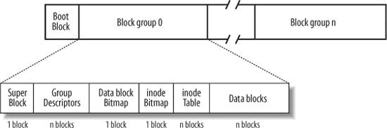

The first block in each Ext2 partition is never managed by the Ext2 filesystem, because it is reserved for the partition boot sector. The rest of the Ext2 partition is split into block groups , each of which has the layout shown in Following Figure. As you will notice from the figure, some data structures must fit in exactly one block, while others may require more than one block. All the block groups in the filesystem have the same size and are stored sequentially, thus the kernel can derive the location of a block group in a disk simply from its integer index.

Block groups reduce file fragmentation, because the kernel tries to keep the data blocks belonging to a file in the same block group, if possible. Each block in a block group contains one of the following pieces of information:

A copy of the filesystem's superblock
A copy of the group of block group descriptors
A data block bitmap
An inode bitmap
A table of inodes
A chunk of data that belongs to a file; i.e., data blocks

If a block does not contain any meaningful information, it is said to be free.
As you can see from Following Figure, both the superblock and the group descriptors are duplicated in each block group. Only the superblock and the group descriptors included in block group 0 are used by the kernel, while the remaining superblocks and group descriptors are left unchanged; in fact, the kernel doesn't even look at them. When the e2fsck program executes a consistency check on the filesystem status, it refers to the superblock and the group descriptors stored in block group 0, and then copies them into all other block groups. If data corruption occurs and the main superblock or the main group descriptors in block group 0 become invalid, the system administrator can instruct e2fsck to refer to the old copies of the superblock and the group descriptors stored in a block groups other than the first. Usually, the redundant copies store enough information to allow e2fsck to bring the Ext2 partition back to a consistent state.
How many block groups are there? Well, that depends both on the partition size and the block size. The main constraint is that the block bitmap, which is used to identify the blocks that are used and free inside a group, must be stored in a single block. Therefore, in each block group, there can be at most 8xb blocks, where b is the block size in bytes. Thus, the total number of block groups is roughly s/(8xb), where s is the partition size in blocks.

For example, let's consider a 32-GB Ext2 partition with a 4-KB block size. In this case, each 4-KB block bitmap describes 32K data blocks that is, 128 MB. Therefore, at most 256 block groups are needed. Clearly, the smaller the block size, the larger the number of block groups.

Study of ext2FS data structures.

1 Superblock
An Ext2 disk superblock is stored in an ext2_super_block structure, whose fields are listed in Table 1.[*] The _ _u8, _ _u16, and _ _u32 data types denote unsigned numbers of length 8, 16, and 32 bits respectively, while the _ _s8, _ _s16, _ _s32 data types denote signed numbers of length 8, 16, and 32 bits. To explicitly specify the order in which the bytes of a word or double-word are stored on disk, the kernel also makes use of the _ _le16, _ _le32, _ _be16, and _ _be32 data types; the former two types denote the little-endian ordering for words and double-words (the least significant byte is stored at the highest address), respectively, while the latter two types denote the big-endian ordering (the most significant byte is stored at the highest address).
[*] To ensure compatibility between the Ext2 and Ext3 filesystems, the ext2_super_block data structure includes some Ext3-specific fields, which are not shown in Table 1.

Table 1. The fields of the Ext2 superblock
Type | Field | Description
_ _le32 | s_inodes_count | Total number of inodes
_ _le32 | s_blocks_count | Filesystem size in blocks
_ _le32 | s_r_blocks_count | Number of reserved blocks
_ _le32 | s_free_blocks_count | Free blocks counter
_ _le32 | s_free_inodes_count | Free inodes counter
_ _le32 | s_first_data_block | Number of first useful block (always 1)
_ _le32 | s_log_block_size | Block size
_ _le32 | s_log_frag_size | Fragment size
_ _le32 | s_blocks_per_group | Number of blocks per group
_ _le32 | s_frags_per_group | Number of fragments per group
_ _le32 | s_inodes_per_group | Number of inodes per group
_ _le32 | s_mtime | Time of last mount operation
_ _le32 | s_wtime | Time of last write operation
_ _le16 | s_mnt_count | Mount operations counter
_ _le16 | s_max_mnt_count | Number of mount operations before check
_ _le16 | s_magic | Magic signature
_ _le16 | s_state | Status flag
_ _le16 | s_errors | Behavior when detecting errors
_ _le16 | s_minor_rev_level | Minor revision level
_ _le32 | s_lastcheck | Time of last check
_ _le32 | s_checkinterval | Time between checks
_ _le32 | s_creator_os | OS where filesystem was created
_ _le32 | s_rev_level | Revision level of the filesystem
_ _le16 | s_def_resuid | Default UID for reserved blocks
_ _le16 | s_def_resgid | Default user group ID for reserved blocks
_ _le32 | s_first_ino | Number of first nonreserved inode
_ _le16 | s_inode_size | Size of on-disk inode structure
_ _le16 | s_block_group_nr | Block group number of this superblock
_ _le32 | s_feature_compat | Compatible features bitmap
_ _le32 | s_feature_incompat | Incompatible features bitmap
_ _le32 | s_feature_ro_compat | Read-only compatible features bitmap
_ _u8 [16] | s_uuid | 128-bit filesystem identifier
char [16] | s_volume_name | Volume name
char [64] | s_last_mounted | Pathname of last mount point
_ _le32 | s_algorithm_usage_bitmap | Used for compression
_ _u8 | s_prealloc_blocks | Number of blocks to preallocate
_ _u8 | s_prealloc_dir_blocks | Number of blocks to preallocate for directories
_ _u16 | s_padding1 | Alignment to word
_ _u32 [204] | s_reserved | Nulls to pad out 1,024 bytes

The s_inodes_count field stores the number of inodes, while the s_blocks_count field stores the number of blocks in the Ext2 filesystem.
The s_log_block_size field expresses the block size as a power of 2, using 1,024 bytes as the unit. Thus, 0 denotes 1,024-byte blocks, 1 denotes 2,048-byte blocks, and so on. The s_log_frag_size field is currently equal to s_log_block_size, because block fragmentation is not yet implemented.
The s_blocks_per_group, s_frags_per_group, and s_inodes_per_group fields store the number of blocks, fragments, and inodes in each block group, respectively.
Some disk blocks are reserved to the superuser (or to some other user or group of users selected by the s_def_resuid and s_def_resgid fields). These blocks allow the system administrator to continue to use the filesystem even when no more free blocks are available for normal users.
The s_mnt_count, s_max_mnt_count, s_lastcheck, and s_checkinterval fields set up the Ext2 filesystem to be checked automatically at boot time. These fields cause e2fsck to run after a predefined number of mount operations has been performed, or when a predefined amount of time has elapsed since the last consistency check. (Both kinds of checks can be used together.) The consistency check is also enforced at boot time if the filesystem has not been cleanly unmounted (for instance, after a system crash) or when the kernel discovers some errors in it. The s_state field stores the value 0 if the filesystem is mounted or was not cleanly unmounted, 1 if it was cleanly unmounted, and 2 if it contains errors.

2. Group Descriptor and Bitmap
Each block group has its own group descriptor, an ext2_group_desc structure whose fields are illustrated in Table 2.

Table 2. The fields of the Ext2 group descriptor
Type | Field | Description
_ _le32 | bg_block_bitmap | Block number of block bitmap
_ _le32 | bg_inode_bitmap | Block number of inode bitmap
_ _le32 | bg_inode_table | Block number of first inode table block
_ _le16 | bg_free_blocks_count | Number of free blocks in the group
_ _le16 | bg_free_inodes_count | Number of free inodes in the group
_ _le16 | bg_used_dirs_count | Number of directories in the group
_ _le16 | bg_pad | Alignment to word
_ _le32 [3] | bg_reserved | Nulls to pad out 24 bytes

The bg_free_blocks_count, bg_free_inodes_count, and bg_used_dirs_count fields are used when allocating new inodes and data blocks. These fields determine the most suitable block in which to allocate each data structure. The bitmaps are sequences of bits, where the value 0 specifies that the corresponding inode or data block is free and the value 1 specifies that it is used. Because each bitmap must be stored inside a single block and because the block size can be 1,024, 2,048, or 4,096 bytes, a single bitmap describes the state of 8,192, 16,384, or 32,768 blocks.

3. Inode Table
The inode table consists of a series of consecutive blocks, each of which contains a predefined number of inodes. The block number of the first block of the inode table is stored in the bg_inode_table field of the group descriptor.
All inodes have the same size: 128 bytes. A 1,024-byte block contains 8 inodes, while a 4,096-byte block contains 32 inodes. To figure out how many blocks are occupied by the inode table, divide the total number of inodes in a group (stored in the s_inodes_per_group field of the superblock) by the number of inodes per block.
Each Ext2 inode is an ext2_inode structure whose fields are illustrated in Table 3.

Table 3. The fields of an Ext2 disk inode
Type | Field | Description
_ _le16 | i_mode | File type and access rights
_ _le16 | i_uid | Owner identifier
_ _le32 | i_size | File length in bytes
_ _le32 | i_atime | Time of last file access
_ _le32 | i_ctime | Time that inode last changed
_ _le32 | i_mtime | Time that file contents last changed
_ _le32 | i_dtime | Time of file deletion
_ _le16 | i_gid | User group identifier
_ _le16 | i_links_count | Hard links counter
_ _le32 | i_blocks | Number of data blocks of the file
_ _le32 | i_flags | File flags
Union | osd1 | Specific operating system information
_ _le32 [EXT2_N_BLOCKS] | i_block | Pointers to data blocks
_ _le32 | i_generation | File version (used when the file is accessed by a  network filesystem)
_ _le32 | i_file_acl | File access control list
_ _le32 | i_dir_acl | Directory access control list
_ _le32 | i_faddr | Fragment address
Union | osd2 | Specific operating system information

Many fields related to POSIX specifications are similar to the corresponding fields of the VFS's inode object. The remaining ones refer to the Ext2-specific implementation and deal mostly with block allocation.
In particular, the i_size field stores the effective length of the file in bytes, while the i_blocks field stores the number of data blocks (in units of 512 bytes) that have been allocated to the file.
The values of i_size and i_blocks are not necessarily related. Because a file is always stored in an integer number of blocks, a nonempty file receives at least one data block (since fragmentation is not yet implemented) and i_size may be smaller than 512 x i_blocks. On the other hand, a file may contain holes. In that case, i_size may be greater than 512 x i_blocks.
The i_block field is an array of EXT2_N_BLOCKS (usually 15) pointers to blocks used to identify the data blocks allocated to the file .
The 32 bits reserved for the i_size field limit the file size to 4 GB. Actually, the highest-order bit of the i_size field is not used, so the maximum file size is limited to 2 GB. However, the Ext2 filesystem includes a "dirty trick" that allows larger files on systems that sport a 64-bit processor such as AMD's Opteron or IBM's PowerPC G5. Essentially, the i_dir_acl field of the inode, which is not used for regular files, represents a 32-bit extension of the i_size field. Therefore, the file size is stored in the inode as a 64-bit integer. The 64-bit version of the Ext2 filesystem is somewhat compatible with the 32-bit version because an Ext2 filesystem created on a 64-bit architecture may be mounted on a 32-bit architecture, and vice versa. On a 32-bit architecture, a large file cannot be accessed, unless opening the file with the O_LARGEFILE flag set
Recall that the VFS model requires each file to have a different inode number. In Ext2, there is no need to store on disk a mapping between an inode number and the corresponding block number because the latter value can be derived from the block group number and the relative position inside the inode table. For example, suppose that each block group contains 4,096 inodes and that we want to know the address on disk of inode 13,021. In this case, the inode belongs to the third block group and its disk address is stored in the 733rd entry of the corresponding inode table. As you can see, the inode number is just a key used by the Ext2 routines to retrieve the proper inode descriptor on disk quickly.

4. Extended Attributes of an Inode
The Ext2 inode format is a kind of straitjacket for filesystem designers. The length of an inode must be a power of 2 to avoid internal fragmentation in the blocks that store the inode table. Actually, most of the 128 characters of an Ext2 inode are currently packed with information, and there is little room left for additional fields. On the other hand, expanding the inode length to 256 would be quite wasteful, besides introducing compatibility problems between Ext2 filesystems that use different inode lengths.
Extended attributes have been introduced to overcome the above limitation. These attributes are stored on a disk block allocated outside of any inode. The i_file_acl field of an inode points to the block containing the extended attributes . Different inodes that have the same set of extended attributes may share the same block.
Each extended attribute has a name and a value. Both of them are encoded as variable length arrays of characters, as specified by the ext2_xattr_entry descriptor. Figure 2 shows the layout in Ext2 of the extended attributes inside a block. Each attribute is split in two parts: the ext2_xattr_entry descriptor together with the name of the attribute are placed at the beginning of the block, while the value of the attribute is placed at the end of the block. The entries at the beginning of the block are ordered according to the attribute names, while the positions of the values are fixed, because they are determined by the allocation order of the attributes.

Figure 2. Layout of a block containing extended attributes
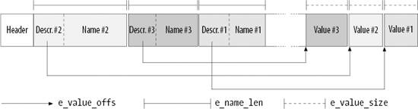

5. How Various File Types Use Disk Blocks
The different types of files recognized by Ext2 (regular files, pipes, etc.) use data blocks in different ways. Some files store no data and therefore need no data blocks at all. This section discusses the storage requirements for each type, which are listed in Table 4.

Table 4. Ext2 file types
File_type | Description
0 | Unknown
1 | Regular file
2 | Directory
3 | Character device
4 | Block device
5 | Named pipe
6 | Socket
7 | Symbolic link

5.1. Regular file
Regular files are the most common case and receive almost all the attention in this chapter. But a regular file needs data blocks only when it starts to have data. When first created, a regular file is empty and needs no data blocks; it can also be emptied by the truncate( ) or open( ) system calls. Both situations are common; for instance, when you issue a shell command that includes the string >filename, the shell creates an empty file or truncates an existing one.

5.2. Directory
Ext2 implements directories as a special kind of file whose data blocks store filenames together with the corresponding inode numbers. In particular, such data blocks contain structures of type ext2_dir_entry_2. The fields of that structure are shown in Table 5. The structure has a variable length, because the last name field is a variable length array of up to EXT2_NAME_LEN characters (usually 255). Moreover, for reasons of efficiency, the length of a directory entry is always a multiple of 4 and, therefore, null characters (\0) are added for padding at the end of the filename, if necessary. The name_len field stores the actual filename length (see Figure 3).

Table 5. The fields of an Ext2 directory entry
Type | Field | Description
_ _le32 | inode | Inode number
_ _le16 | rec_len | Directory entry length
_ _u8 | name_len | Filename length
_ _u8 | file_type | File type
char [EXT2_NAME_LEN] | name | Filename

The file_type field stores a value that specifies the file type ( Table 4). The rec_len field may be interpreted as a pointer to the next valid directory entry: it is the offset to be added to the starting address of the directory entry to get the starting address of the next valid directory entry. To delete a directory entry, it is sufficient to set its inode field to 0 and suitably increment the value of the rec_len field of the previous valid entry. Read the rec_len field of Figure 3; we'll see that the oldfile entry was deleted because the rec_len field of usr is set to 12+16 (the lengths of the usr and oldfile entries).

Figure 3. An example of the Ext2 directory
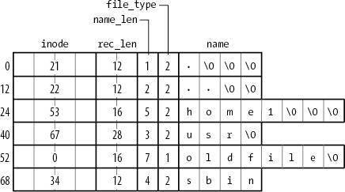

5.3. Symbolic link
As stated before, if the pathname of a symbolic link has up to 60 characters, it is stored in the i_block field of the inode, which consists of an array of 15 4-byte integers; no data block is therefore required. If the pathname is longer than 60 characters, however, a single data block is required.

5.4. Device file, pipe, and socket
No data blocks are required for these kinds of files. All the necessary information is stored in the inode.

SYSTEM DESIGN

Super Block information Of the Linux:

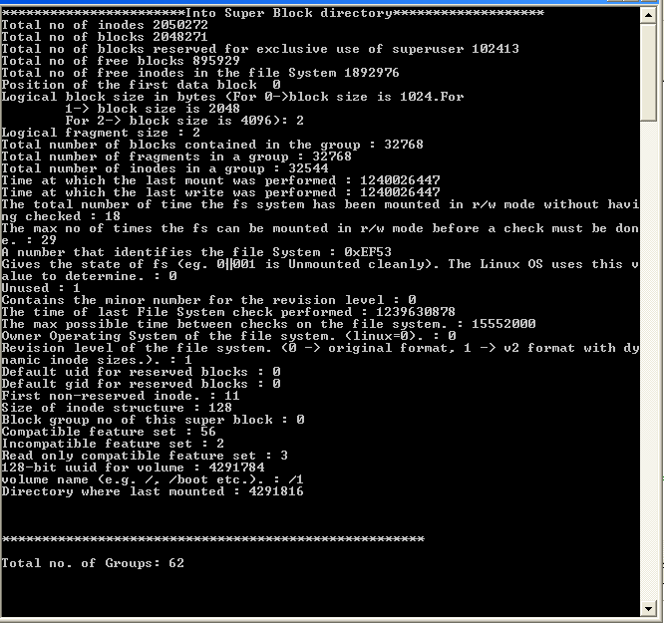

Group Descriptor information Of the Linux:

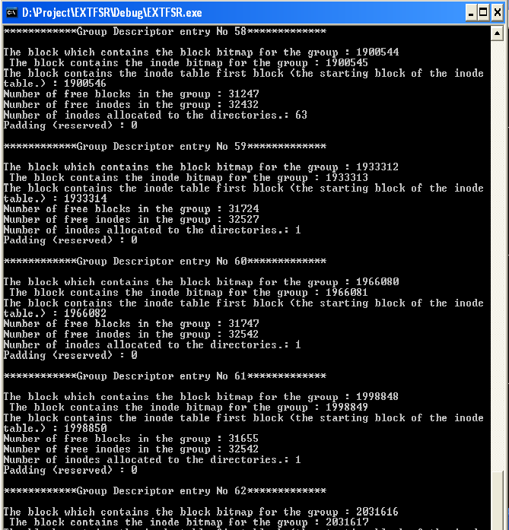

“/” table information Of the Linux:

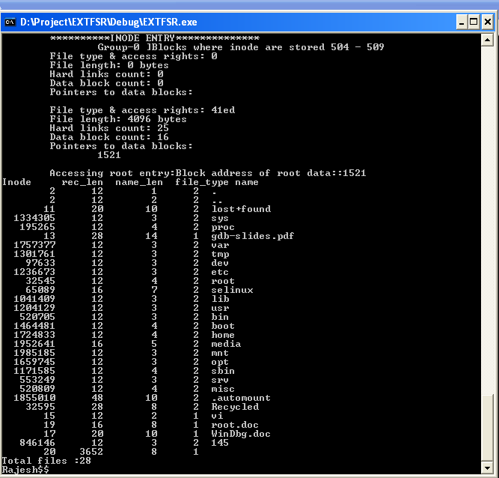

Free Inode Bitmap for Block Group Of the Linux:

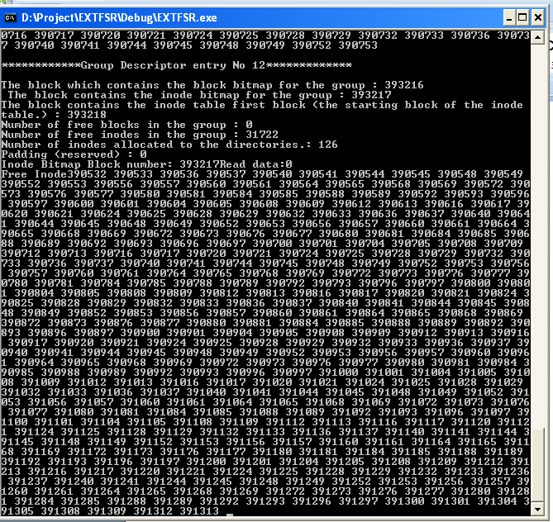

Change Directory and LS Command:

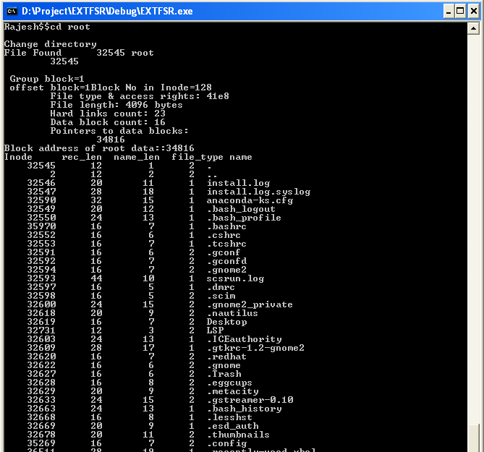
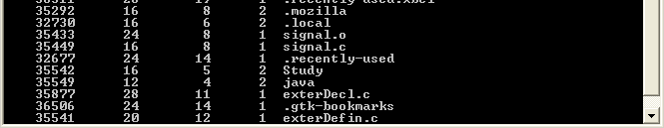

IMPORTANT
ALGORITHMS IMPLEMENTATION

Finding On disk INODE using Inode number

When we have an inode numbers then we can find the position of the Inode stored on Disk space .That address is calculated by following algorithm.

Algorithm Inode_Addr
Input :
- Inode Number,(inodeno)
- Inodes per Group ,( inode_per_group)
- Inode Size ,(inode_size)
- Block Size,(block_size)
- Inode Block Number for Group (inode_block)

Output : Disk Address of the Inode

{
__int64 address;// 64 bit variable
DWORD groupno= inodeno / inode_per_group;//From Super Block

DWORD inode_offset= inodeno % inode_per_group;//This will give the inode // number within that block for particular inode considering starting inode as ‘1’.

DWORD block_offset= (inode_offset * inode_size) / block_size;
address=((inode_block[groupno]+block_offset)*block_size);
// inode_block[groupno] it will give us the block number from where // the memory blocks for inodes stored.

DWORD inode_in_memory_offset=(inode_offset*inode_size)%block_size;
//This will give us the starting position of the inode we are expecting // from the block in which this inode is stored

address=address+ inode_in_memory_offset;//exact position of input // inode

return address;
}

Reading On disk Directory Structure

Algorithm Directory_entries
Input : Directory path

Output : Link List for Files and directories present in directory
{
convert path to its disk inode number ;
if(inode not belonging to directory)
{
return error;
}
get memory disk address for inode; //Algorithm Inode_Addr
read the disk inode present at disk memory address;
read the data block belonging to file inode into buffer;
while(all data blocks not read)
{
restore values from buffer to the appropriate position in Directory structure;
add directory structure to link list;
}
return link list;

}

DATA STRUCTURES

LOCAL DATA STRUCTURES

struct EXT2_DIR_ENTRY
{

DWORD inode; /* Inode number */

WORD rec_len; /* Directory entry length */

BYTE name_len; /* Name length */

BYTE file_type;/* Type of the file*/

char name[EXT2_NAME_LEN]; /* File name */

} ;

This data structure is used to read the file or directory entry stored at data block of any directory. Generally the data block of any file contains the entries for its descendent i.e. files and directories present in it.

struct TRAVEL_DIR
{

DWORD inode; /* Inode number */

char name[EXT2_NAME_LEN]; /* File name */

BYTE file_type;

struct TRAVEL_DIR * next;

};

This structure is used to keep track of the path traveled by the user i.e. If user goes to “root” directory from “ / ” , then this link list contains two entries one is for “/” along with its disk inode number. Name indicates the File Name.

Head of this Link List will be always “ / ”.

GLOBAL DATA STRUCTURES
struct EXT2_GROUP_DESC

{

DWORD bg_block_bitmap;

DWORD bg_inode_bitmap;

DWORD bg_inode_table;

WORD bg_free_blocks_count;

WORD bg_free_inodes_count;

WORD bg_used_dirs_count;

WORD bg_pad;

DWORD bg_reserved[3];

} ;
This structure is used to read group descriptor entries stored on the disk. Generally second or third block of extended file system is used to store this information. This mechanism simplify the memory management of the operating system. It also reduce the seek time since memory is divided into group of Blocks (generally 32768 blocks per group)

struct EXT2_INODE

{

WORD i_mode; /* File mode */

WORD i_uid; /* Low 16 bits of Owner Uid */

DWORD i_size; /* Size in bytes */

DWORD i_atime; /* Access time */

DWORD i_ctime; /* Creation time */

DWORD i_mtime; /* Modification time */

DWORD i_dtime; /* Deletion Time */

WORD i_gid; /* Low 16 bits of Group Id */

WORD i_links_count; /* Links count */

DWORD i_blocks; /* Blocks count */

DWORD i_flags; /* File flags */

DWORD osd1; /* OS dependent 1 */

DWORD i_block[EXT2_N_BLOCKS];//* Pointers to blocks */

DWORD i_generation; /* File version (for NFS) */

DWORD i_file_acl; /* File ACL */

DWORD i_dir_acl; /* Directory ACL */

DWORD i_faddr; /* Fragment address */

BYTE l_i_frag; /* Fragment number */

BYTE l_i_fsize; /* Fragment size */

WORD i_pad1;

WORD l_i_uid_high; /* these 2 fields */

WORD l_i_gid_high; /* were reserved */

DWORD l_i_reserved2;

};
This structure is for storing on disk inode information. The time related values i.e. creation, updating times of file. Each file stored in Linux must have an disk inode associated with it. This is an one of the important data structure in File System.
This contains the information of the data blocks allocated to that particular file.

FUTURE ENHANCEMENT

FUTURE ENAHANCEMENTS

- This project is mainly aimed to transfer data from Linux to Windows ,but vice versa is not done.
In Future this feature like to be added.

- Like to provide Graphical User Interface (GUI) .

- Like to make more User friendly.

- Like to provide a facility of transferring directories (Currently only File Transfer is possible).

- Like to provide large number of command support. Like mkdir, rmdir, chmod etc..

- Unhandled problem while transferring files. (Like few differences in interpretation of files by different OS. i.e As we seen there were problems while opening a file in Windows which is created in Linux Domain.)

REFERENCES

BOOK REFERENCE

UNDERSTANDING THE LINUX KERNEL 2.4 by

DANIEL BOVET & MACRO CESATI

THE DESIGN OF THE UNIX OPERATING SYSTEM by
MAURICE BACH

SOFTWARE TOOLS REFERENCE

MSDN 2008 DOCUMANTATION

GROUP REFERENCE

GEEP LINUX email- geek_linux@yahoogroups.com

SEARCH ENGEEN

Google.com

