# Abstract

The aim of this visualization is to visualize 1930 Salt March path by Mahatma Gandhi and the content analysis of his speeches during the march in British India. This task is achieved by employing numerical and other data (speeches, places visited, halts, crowds along the march). This project proposes a retelling of the momentous event in a data-centric narrative, to communicate and highlight the significance and rich historical context of the Salt March in 1930 [1].

# Introduction

Salt March by Gandhi in British India is often referred as a stepping stone for Indian Independence [2]. The performed visualizations are user-centric, two different visualizations are included in the final model, one is the geospatial path of the Salt March including crowd strength along the way and the other one is, an interactive content analysis of Gandhi speeches used in addressing the people in different places during the march along with full speech text.

# Data

The data for this project is collected from multiple sources, mainly from Gandhi Literature by Sevagram Ashram, Government of India [3] and the arcGis [4] [5].

**Datatype**: This collected dataset consists of both Numerical and categorical data. Data includes information of the Day, Date, Time, Place, Geo-coordinates, Crowd count and speeches.

# Tasks

* To visualize historic Salt March geospatially on a map with the number of crowd participating at each location during the march
* To visualize content analysis of Gandhi speeches and highlight the most influential words in the speech

# Approach

## Visualization-1: Geospatial Map of Salt March

### Visual encoding channels:

**Position**: Position is a primary attribute in visualizing a geospatial map. For this visualization the data position is mapped using latitudes and longitudes of the Salt March path.

**Mark**: Circular shape dots are used to point the places. A path is drawn based on the density of the crowd data. Legends are used to indicate start point and end point.

**Size**: Width of the path joining each location (node) is varied based on the crowd participation data.

**Color**: Different colors are been used, to depict a place (dot) “yellow color” is used, crowd joining the path is shown in light brown, start flag and end flags are given in red and green respectively.

**Orientation**: Orientation is shown on the map direction connecting each place and crowd movement (density).

### Tools & Technologies used:

‘R’ language [6] with libraries ggplot and ggrepel.

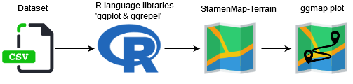

### Method

Figure.1 shows the implementation flow, Firstly, the geospatial data of Salt march is plotted using longitude and latitude on the ggplot[x] and mapped the path using function geom_path() of the ggplot2 library, this creates a visualization of the Salt March path. The cities data was used to point each city that the Gandhi’s followers visited using function geom_point() of the ggplot2 library with labeling the city name. To visualize same on the India map, geo-coordinates between Gujarat and Maharashtra states where the event occurred are collected from OpenStreetMaps [X] and plotted on StamenMap[X] using ggmap[X]

## Visualization-2: Content analysis of Gandhi speeches

### Visual encoding channels:

**Position**: Each speech represented by a grey rectangle (height corresponding to the length of the speech, counted in words) arranged in a grid of such rectangles

**Mark**: Nine groups of words are searched and indexed in each of these speeches, with a thin line representing them

**Size**: The height of each rectangle is decided based on the length of the speech corresponding to the word count

**Brightness**: Brightness is varied based the user actions (onClick)

**Color**: A unique color code is mapped between button and each word on the grid

### Tools and Technologies used:

D3.js and Lodash.js

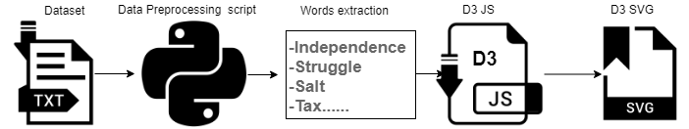

### Method

The collected dataset consisted of raw speeches of Gandhi with date and publication reference. Firstly, a python script is written to pre-process the data in which all special character are eliminated and removed stop words using Stanford NLP [3] and logic is scripted to collect the most influential words used during the march. This preprocessed data is fed on D3 JS and a SVG is drawn, on each word click, it highlights all instances of that word across all the speeches. This reveals the gist of each speech visually, looking at the multitude of issues Gandhi talked about. The click also overlays text that tells the user how many times the clicked on word was used in all the speeches, and in that particular speech. Also it highlights on the full speech section to give the exact context when and why that word was spoken in his speeches.

# References

|  |  |  |
| --- | --- | --- |
| [1] |  | Kenneth Pletcher, Salt March, Encyclopædia Britannica, inc, https://www.britannica.com/event/Salt-March (Accessed on 04-04-2019). |
| [2] |  | Weber, Thomas. Gandhian nonviolence and the Salt March [online]. Social Alternatives, Vol. 21, No. 2, Autumn 2002: 46-51. https://search.informit.com.au/documentSummary;dn=200206750;res=IELAPA, ISSN: 0155-0306. [Accessed on 06 Apr 19]. |
| [3] |  | Gandhi Literature: Collected Works of Mahatma Gandhi, Volume 48, <http://www.gandhiashramsevagram.org/gandhi-literature/collected-works-of-mahatma-gandhi-volume-1-to-98.php> [Accessed on 06 Apr 19]. |

[4] The Dandi March, <https://www.arcgis.com/home/item.html?id=b948453224aa4449984cdcca1400261e#overview> [Accessed on 06 Apr 19].

[5] 11] Dataset, http://keyaar.in/salt/DandiMarch-Data-CSVFiles.zip [Accessed on 06 Apr 19].