SWYNEX – Task 2

Exploratory Data Analysis Report
Dataset: Cleaned HR Employee Dataset from Task 1

1. Objective
The objective is to explore the cleaned dataset, calculate descriptive statistics, identify patterns and anomalies, create visualizations, and communicate useful insights.

2. Dataset Overview
The analysis uses 500 cleaned employee records and 15 original analytical fields from Task 1. An AttritionFlag and AgeGroup were created only as analysis helpers.
The dataset is a controlled demonstration sample. Findings describe this sample only and should not be interpreted as actual workforce statistics.

3. Important Statistics
Metric | Value
Total employees | 500.0
Attrition cases | 67.0
Employees retained | 433.0
Overall attrition rate (%) | 13.4
Average age | 36.46
Average monthly income | 6643.35
Median monthly income | 6514.0
Average years at company | 6.28
Average job satisfaction | 2.57
Average work-life balance | 2.5

4. Key Analyses

Attrition
67 of 500 employees are classified as attrition cases, giving an overall rate of 13.4%.

Overtime
Attrition is 22.4% among overtime employees versus 9.5% among non-overtime employees.

Department
Human Resources has the highest department-level attrition rate at 25.0%.

Job Role
Human Resources has the highest observed job-role attrition rate at 37.5%; the group is relatively small, so this percentage needs caution.

Age
The highest age-group attrition rate is observed for 26-35 at 16.3%.

Tenure
Average tenure is 5.33 years for attrition cases and 6.42 years for non-attrition cases.

Income
Median monthly income is 6,469 for attrition cases and 6,514 for non-attrition cases, indicating little separation by income alone.

Work-Life Balance
Work-life balance level 4 has 8.8% attrition compared with 16.1% at level 2 in this sample.

5. Charts
01 Attrition Distribution
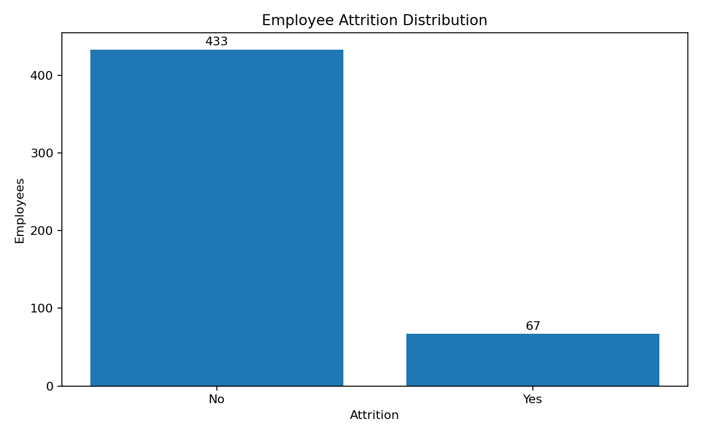
02 Overtime Attrition
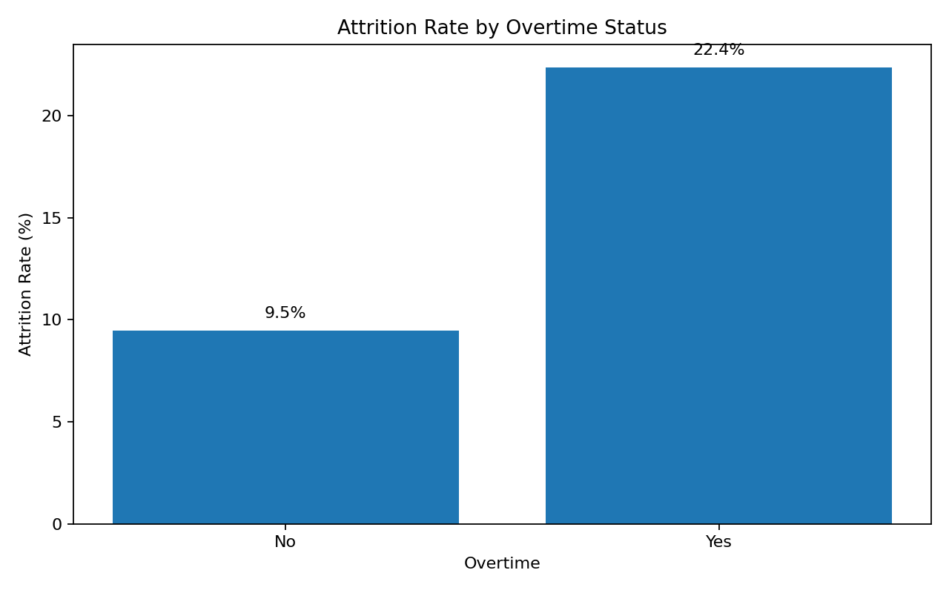
03 Department Attrition
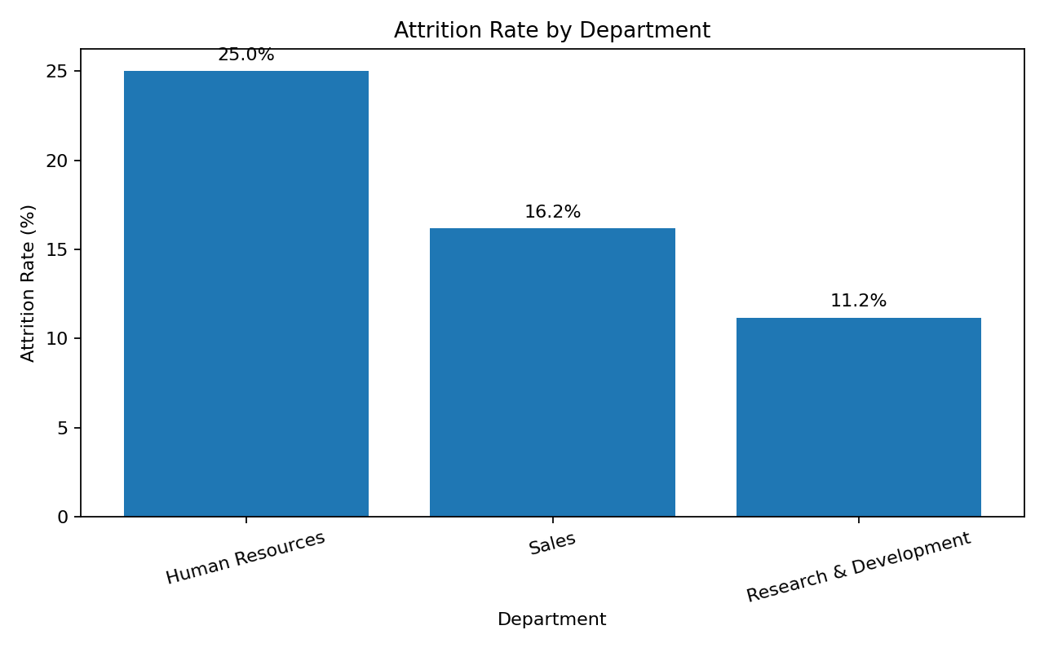
04 Jobrole Attrition
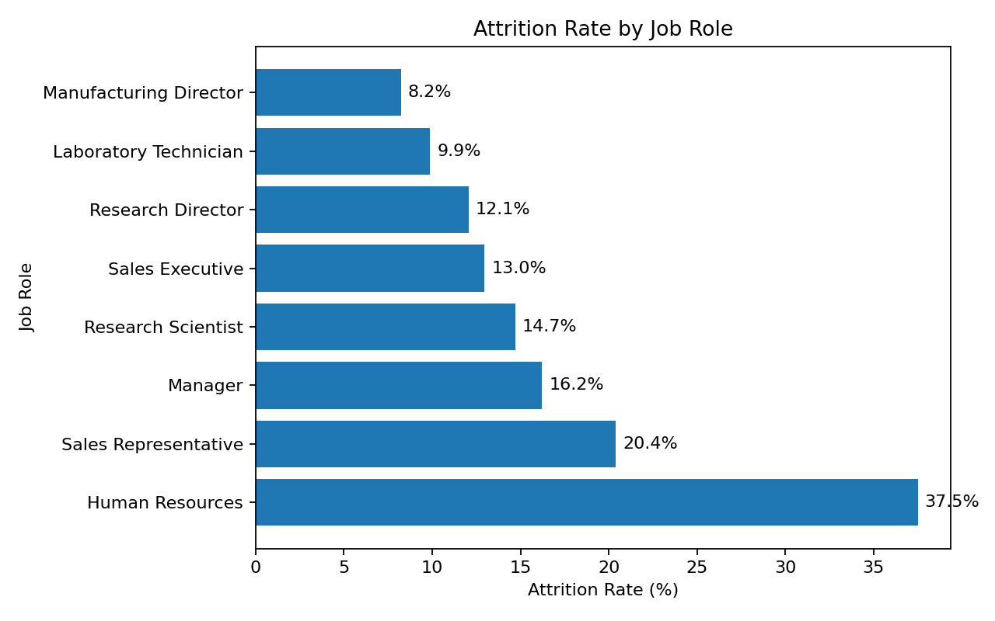
05 Agegroup Attrition
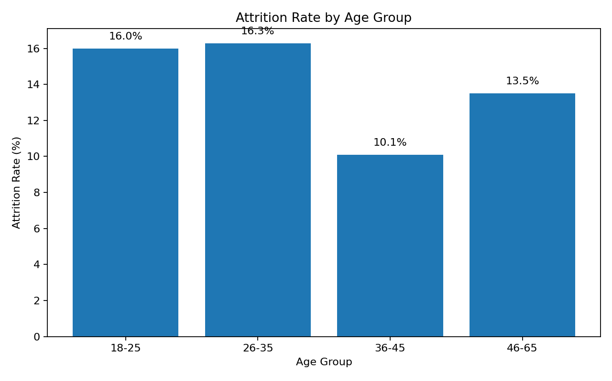
06 Income Distribution
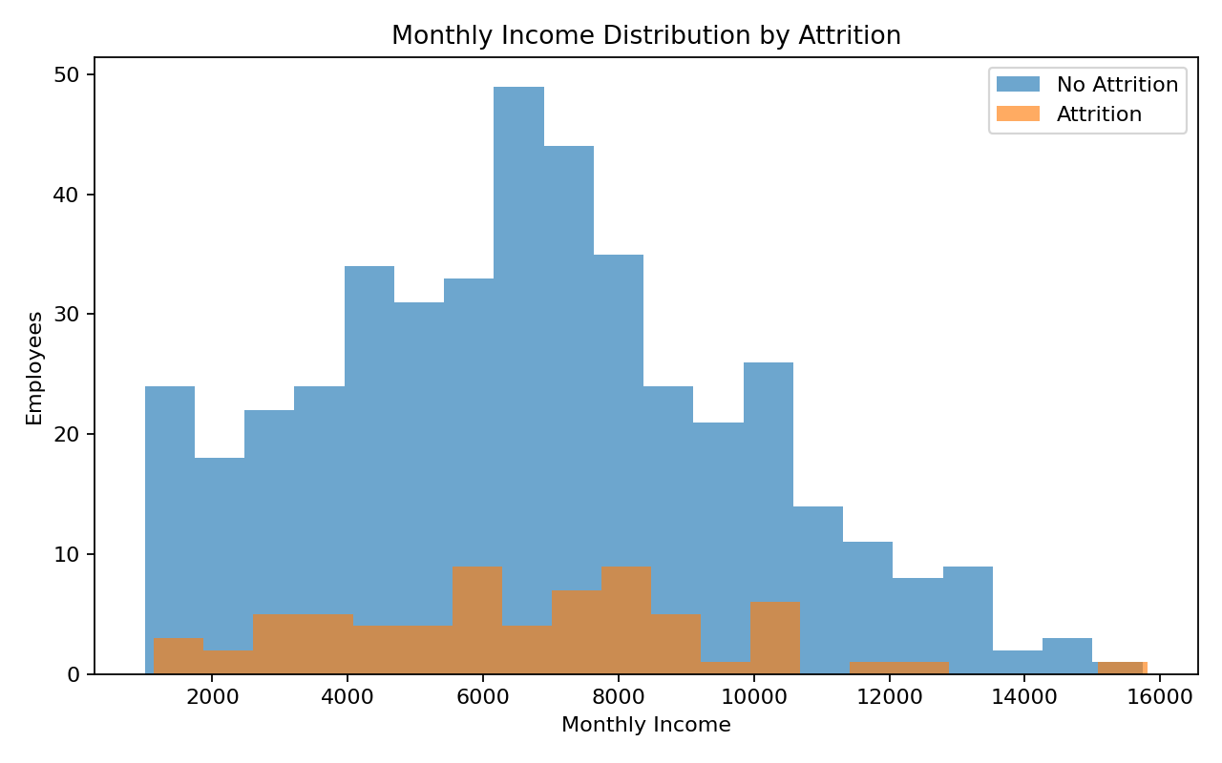
07 Tenure Attrition
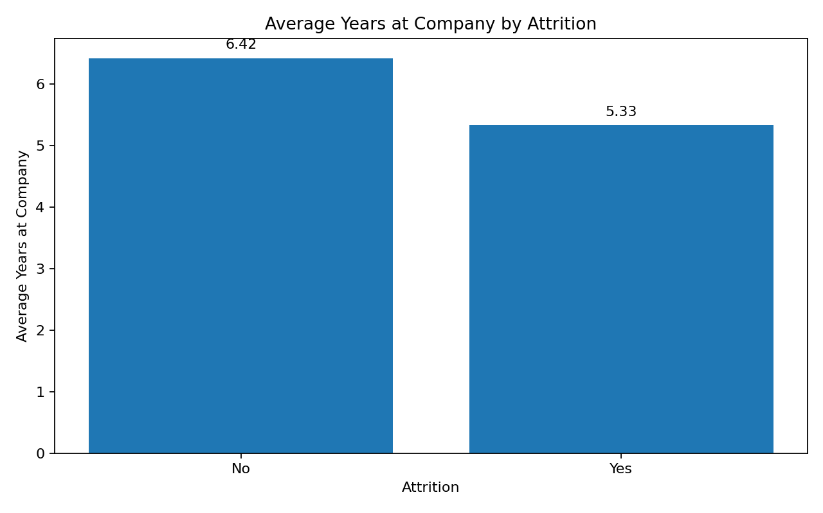

6. Conclusion
The EDA indicates that overtime status, department, job role, age group, tenure and work-life balance provide useful segmentation variables for further investigation. Income shows comparatively little separation in this sample. EDA identifies associations rather than causation, so the findings should be validated with larger samples and statistical or predictive methods.

