## Question 1

Title: Counting Combinations

Description: A counting problem involving combinations of items.

Difficulty: Medium

Question:

A restaurant offers 3 types of appetizers (soup, salad, breadsticks), 4 main courses (pasta, chicken, fish, steak), and 2 desserts (ice cream, cake). How many different three-course meals are possible?

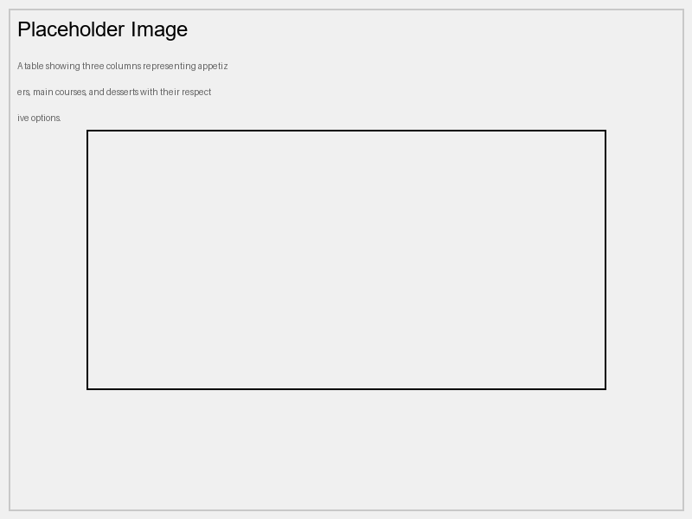

Options:

* 12
* 9
* 24
* 72

Correct Answer: 24

Explanation:

To find the total number of different three-course meals, multiply the number of choices for each course: $3 \times 4 \times 2 = 24$

Curriculum Info:

Subject: Mathematics

Unit: Combinatorics

Topic: Counting Principles

Marks: 5