## Question 1

Title: Geometry and Volume

Description: Calculating dimensions based on volume and arrangement.

Difficulty: Medium

Question:

A box contains 8 identical cubes arranged in a $2 \times 2 \times 2$ formation. If each cube has a side length of 3 centimeters, what are the dimensions of the box?

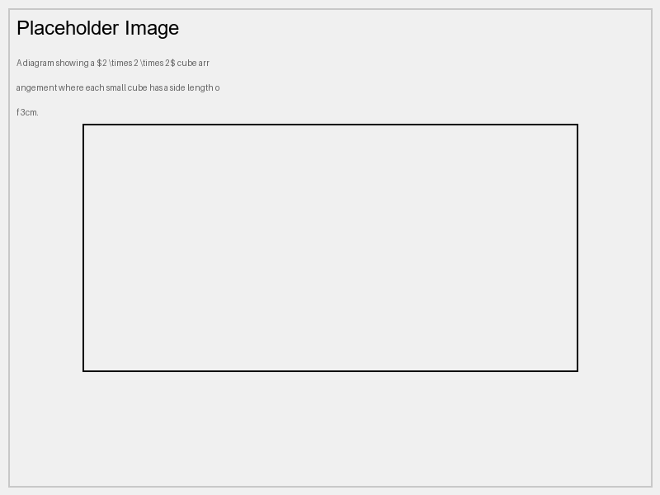

Options:

* 3 cm x 3 cm x 3 cm
* 6 cm x 6 cm x 6 cm
* 3 cm x 6 cm x 6 cm
* 6 cm x 6 cm x 3 cm

Correct Answer: 6 cm x 6 cm x 6 cm

Explanation:

Since there are 2 cubes along each dimension, and each cube has a side length of 3 cm, the total length along each dimension of the box is $2 \times 3 = 6$ cm. Therefore, the dimensions of the box are 6 cm x 6 cm x 6 cm.

Curriculum Info:

Subject: Mathematics

Unit: Geometry

Topic: Volume and Dimensions

Marks: 5