**Big data lab c1**

RAJESH CR

1NT19IS125

CREATING AND USING DATABASE:

> use rajesh

switched to db rajesh

> db

rajesh

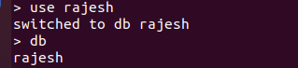

USING INSERT ONE

> db.rajesh.insertOne({"name":"rajesh","dept":"ISE"})

{

"acknowledged" : true,

"insertedId" : ObjectId("6254f2d8dc4617d4215e3a16")

}

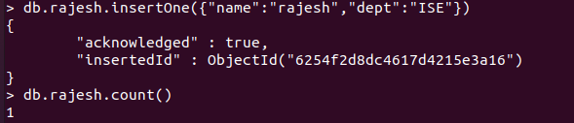

USING INSERT MANY:

> db.rajesh.insertMany([ {"name":"john","dept":"ISE"},{"name":"Issac","dept":"ISE"},{"name":"Rajput","dept":"ISE"},{"name":"naresh","dept":"ISE"}])

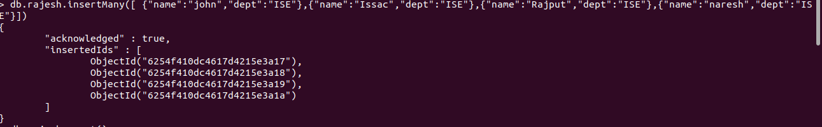

USING COUNT:

>db.rajesh.count()



USING FIND:

> db.rajesh.find()

{ "_id" : ObjectId("6254f2d8dc4617d4215e3a16"), "name" : "rajesh", "dept" : "ISE" }

{ "_id" : ObjectId("6254f410dc4617d4215e3a17"), "name" : "john", "dept" : "ISE" }

{ "_id" : ObjectId("6254f410dc4617d4215e3a18"), "name" : "Issac", "dept" : "ISE" }

{ "_id" : ObjectId("6254f410dc4617d4215e3a19"), "name" : "Rajput", "dept" : "ISE" }

{ "_id" : ObjectId("6254f410dc4617d4215e3a1a"), "name" : "naresh", "dept" : "ISE" }

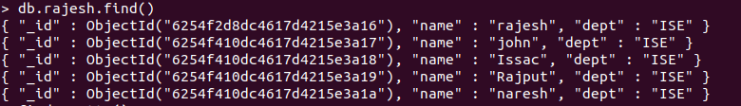

USING FIND.PRETTY():

> db.rajesh.find().pretty()

{

"_id" : ObjectId("6254f2d8dc4617d4215e3a16"),

"name" : "rajesh",

"dept" : "ISE"

}

{

"_id" : ObjectId("6254f410dc4617d4215e3a17"),

"name" : "john",

"dept" : "ISE"

}

{

"_id" : ObjectId("6254f410dc4617d4215e3a18"),

"name" : "Issac",

"dept" : "ISE"

}

{

"_id" : ObjectId("6254f410dc4617d4215e3a19"),

"name" : "Rajput",

"dept" : "ISE"

}

{

"_id" : ObjectId("6254f410dc4617d4215e3a1a"),

"name" : "naresh",

"dept" : "ISE"

}

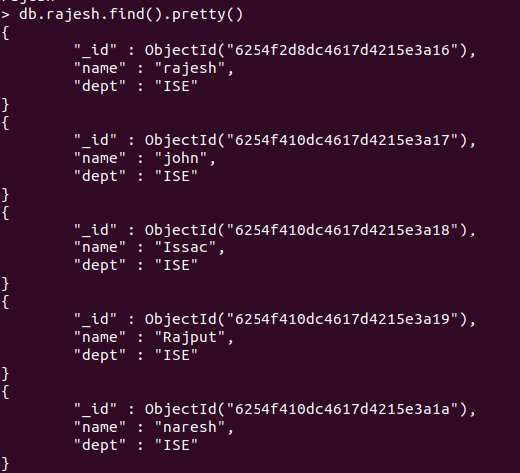

USING UPDATE ONE:

db.rajesh.updateOne({"name":"john"},{ $set: {"dept":"CSE"}})

{ "acknowledged" : true, "matchedCount" : 1, "modifiedCount" : 1 }



USING UPDATE MANY:

db.rajesh.updateMany({},{ $set:{"college":"NMIT"}})

{ "acknowledged" : true, "matchedCount" : 5, "modifiedCount" : 5 }



DELETE ONE:

> db.rajesh.deleteOne({"name":"john"})



John got deleted

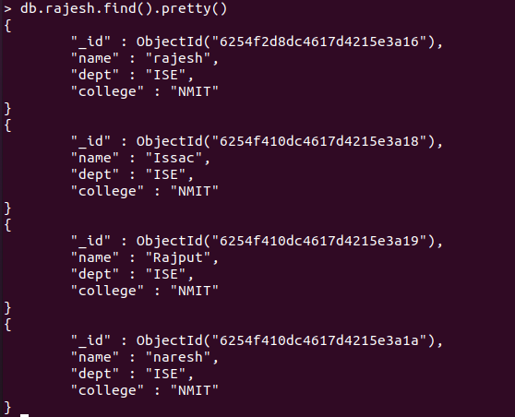

DELETE MANY:

> db.rajesh.deleteMany({"dept":"ISE"})

{ "acknowledged" : true, "deletedCount" : 4 }

> db.rajesh.count()

0



REPLACE ONE:

db.rajesh.replaceOne(

... ... {"name" : "naresh"}, {"name" : "Sai", "dept" : "ISE", "college" : "NMIT"})



USING UNSET:

db.rajesh.updateMany({}, { $unset: { "dept": "CSE" } })



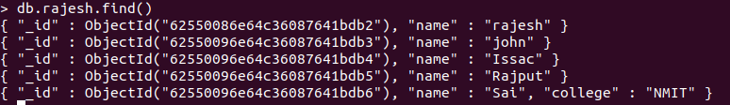

USING OR:

db.rajesh.find({$or: [{dept: "EEE"},{dept:"civil"}]}).pretty()

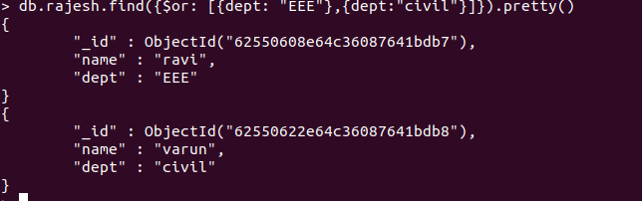

USING AND:

db.rajesh.find({$and: [{dept: "ISE"},{college: "NMIT"}]}).pretty()

