Practical No. 1
Study of Networking

Aim :- To study the IP address.

Circuit Diagram :-
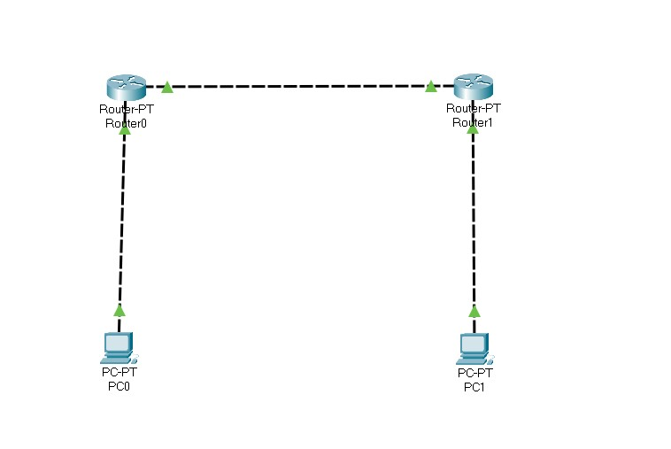

Program :-
Router 0 > cli :- enable configure terminal interface fastethernet 0/0 ip address 10.0.0.1 255.0.0.0 no shutdown
exit interface fastethernet 0/1 ip address 20.0.0.1 255.0.0.0 no shutdown
exit

Router 1 > cli :- enable configure terminal interface fastethernet 0/0 ip address 40.0.0.1 255.0.0.0 no shutdown
exit
interface fastethernet 0/1 ip address 20.0.0.2 255.0.0.0 no shutdown
exit

Pc 0 > Desktop > Ip configuration :- ipv4 : 10.0.0.2 subnet mask : 255.0.0.0
Default gateway: 10.0.0.1

Pc 1 > Desktop > Ip configuration :-
ipv4 : 40.0.0.2
subnet mask : 255.0.0.0
Default gateway: 40.0.0.1

Output :-
PC0 :-
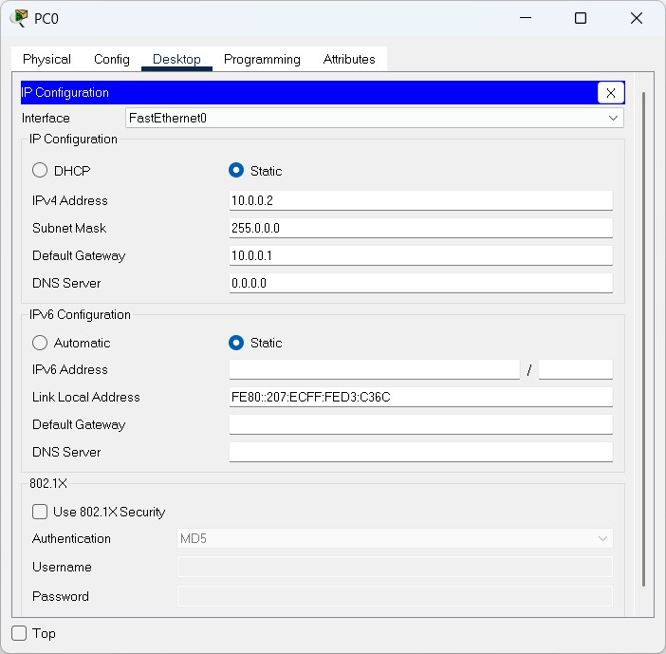

PC1:-
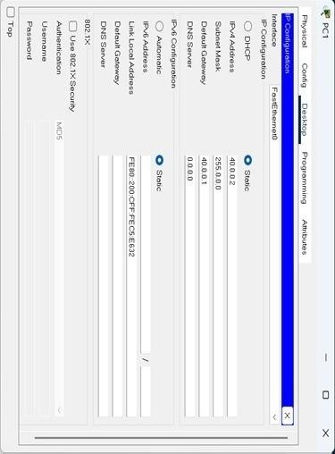
Conclusion :- The program was executed successfully

Practical No. 2
Study of Network Layer

a) Static Routing

Aim :- To study Static routing.

Circuit Diagram :-
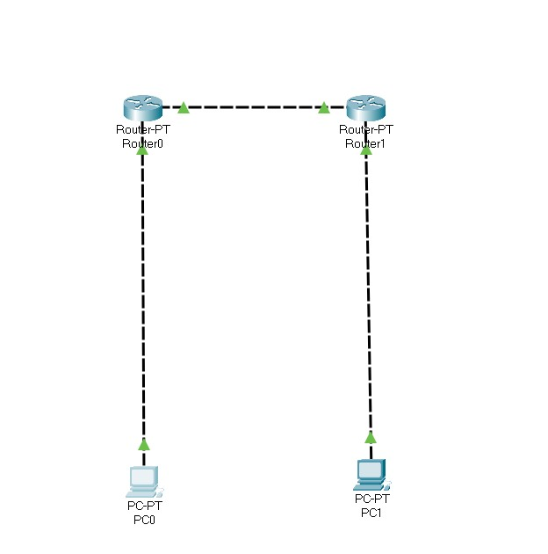

Program :-
Router 0 > cli :- enable configure terminal interface fastethernet 0/0 ip address 10.0.0.1 255.0.0.0 no shutdown
exit interface fastethernet 0/1 ip address 20.0.0.1 255.0.0.0 no shutdown
exit ip route 40.0.0.0 255.0.0.0 20.0.0.2

Router 1 > cli :- enable configure terminal interface fastethernet 0/0 ip address 40.0.0.1 255.0.0.0 no shutdown
exit
interface fastethernet 0/1 ip address 20.0.0.2 255.0.0.0 no shutdown
exit ip route 10.0.0.0 255.0.0.0 20.0.0.1

Pc 0 > Desktop > Ip configuration :-
ipv4 : 10.0.0.2
subnet mask : 255.0.0.0
Default gateway: 10.0.0.1

Pc 1 > Desktop > Ip configuration :-
ipv4 : 40.0.0.2
subnet mask : 255.0.0.0
Default gateway: 40.0.0.1

Output :-
PC0 :-
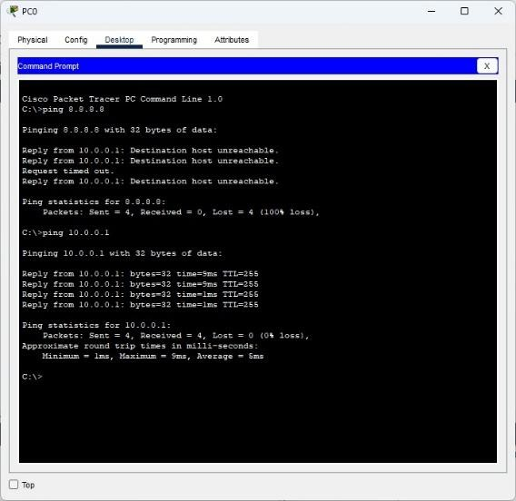

PC1 :-
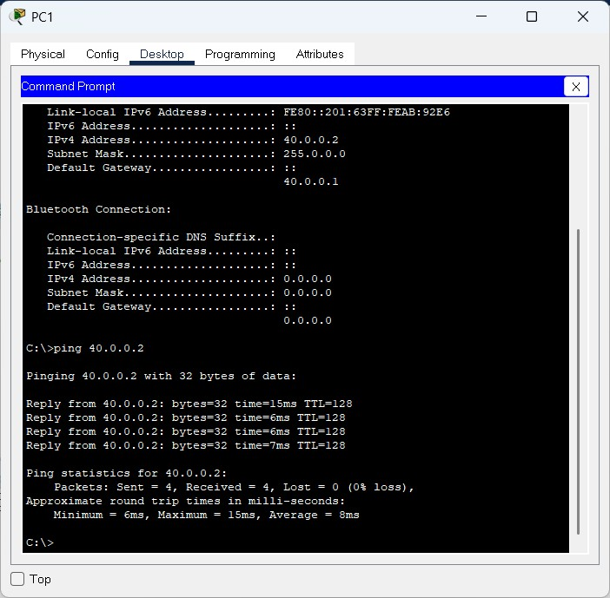

Conclusion :- The program was executed successfully.

b) RIP Routing

Aim :- To study RIP routing.

Circuit Diagram :-
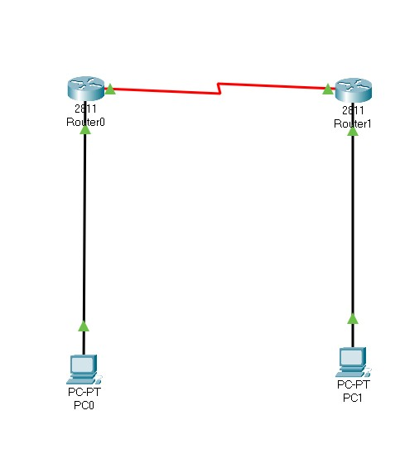

Program :-
Router 0 > cli :- enable configure terminal interface fastethernet 0/0 ip address 10.0.0.1 255.0.0.0 no shutdown
exit interface fastethernet 0/1 ip address 20.0.0.1 255.0.0.0 no shutdown
exit router rip version 2 network 10.0.0.0 network 20.0.0.0 exit

Router 1 > cli :- enable configure terminal interface fastethernet 0/0 ip address 40.0.0.1 255.0.0.0 no shutdown
exit interface fastethernet 0/1 ip address 20.0.0.2 255.0.0.0 no shutdown
exit router rip version 2 network 40.0.0.0 network 20.0.0.0 exit

Pc 0 > Desktop > Ip configuration :- ipv4 : 10.0.0.2 subnet mask : 255.0.0.0
Default gateway: 10.0.0.1

Pc 1 > Desktop > Ip configuration :- ipv4 : 40.0.0.2
subnet mask : 255.0.0.0
Default gateway: 40.0.0.1

Output :-

PC0:-
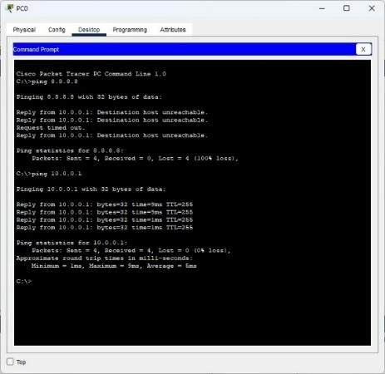

PC1:
-

Conclusion :- The program was executed successfully.

c) OSPF Routing

Aim :- To study OSPF routing.

Circuit Diagram :-
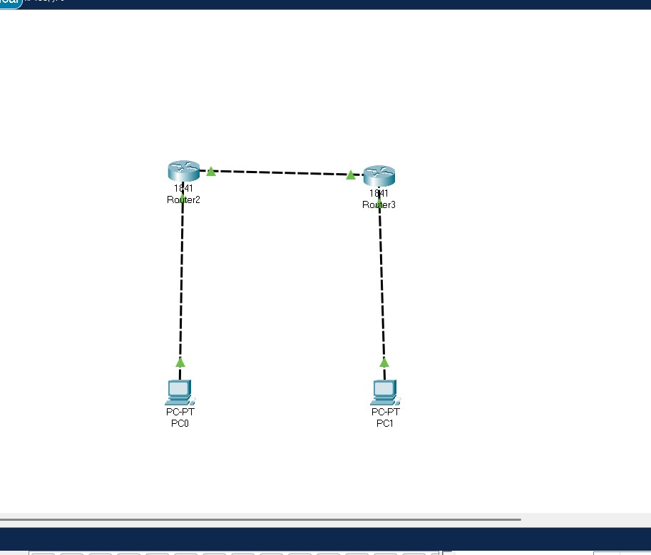

Program :-
Router 0 > cli :- enable configure terminal interface fastethernet 0/0 ip address 10.0.0.1 255.0.0.0 no shutdown
exit interface fastethernet 0/1 ip address 20.0.0.1 255.0.0.0 no shutdown
exit router ospf 1 network 10.0.0.0 0.255.255.255 area 0 network 20.0.0.0 0.255.255.255 area 0 exit

Router 1 > cli :- enable configure terminal interface fastethernet 0/0 ip address 40.0.0.1 255.0.0.0 no shutdown
exit interface fastethernet 0/1 ip address 20.0.0.2 255.0.0.0 no shutdown
exit router ospf 2 network 40.0.0.0 0.255.255.255 area 0 network 20.0.0.0 0.255.255.255 area 0 exit

Pc 0 > Desktop > Ip configuration :- ipv4 : 10.0.0.2
subnet mask : 255.0.0.0
Default gateway: 10.0.0.1

Pc 1 > Desktop > Ip configuration :- ipv4 : 40.0.0.2
subnet mask : 255.0.0.0
Default gateway: 40.0.0.1

Output :-

PC0:-

PC1:-

Conclusion :- The program was executed successfully.

Practical No. 3
Study of Application Layer

a) DHCP
Aim :- To study DHCP.
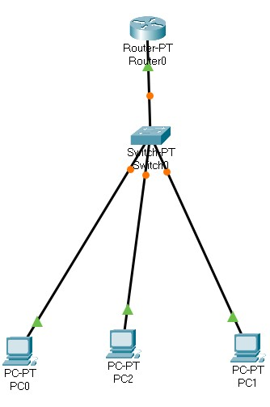

Circuit Diagram :
-

Program :-
Router 0 > cli :- enable configure terminal interface fastethernet 0/0 ip address 10.0.0.1 255.0.0.0 no shutdown
exit ip dhcp pool syit network 10.0.0.0 255.0.0.0 default-router 10.0.0.1 ip dhcp excluded-address 10.0.0.2 10.0.0.1 ip dhcp pool syit network 10.0.0.0 255.0.0.0 default-router 10.0.0.1 ip dhcp excluded-address 10.0.0.2 10.0.0.13
exit
Output:-
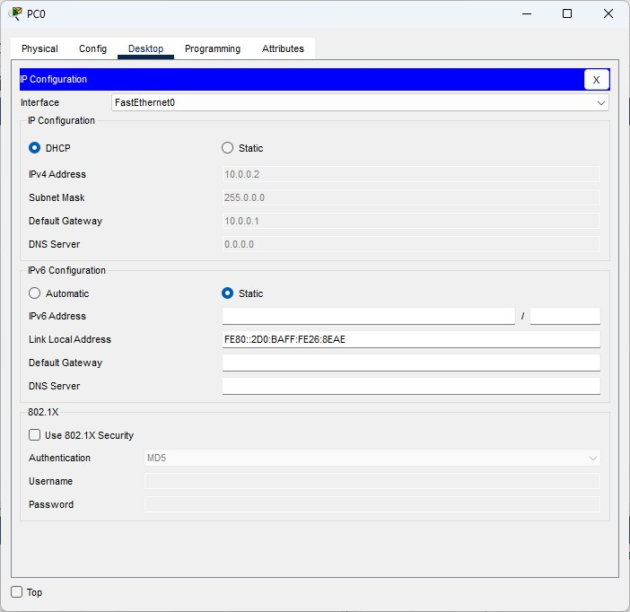
Pc
0

Pc1
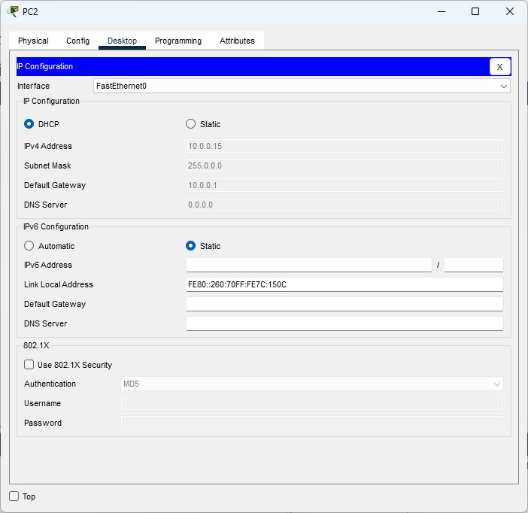

Conclusion :- The program was executed successfully.

b) DNS

Aim :- To study DNS.

Circuit Diagram :-
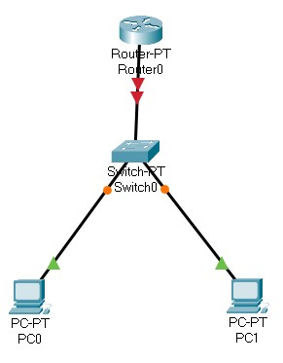

Program :-
Router 0 > cli :- enable configure terminal interface fastethernet 0/0 ip address 10.0.0.1 255.0.0.0 no shutdown
exit ip dhcp pool syit network 10.0.0.0 255.0.0.0 default-router 10.0.0.1 dns-server 8.8.8.8 exit ip host www.syit.com 10.0.0.1 exit

Pc 0 > Desktop > Ip configuration :- ipv4 : 10.0.0.2
subnet mask : 255.0.0.0
Default gateway: 10.0.0.1

Pc 1 > Desktop > Ip configuration :- ipv4 : 10.0.0.3
subnet mask : 255.0.0.0
Default gateway: 10.0.0.1

Output:-
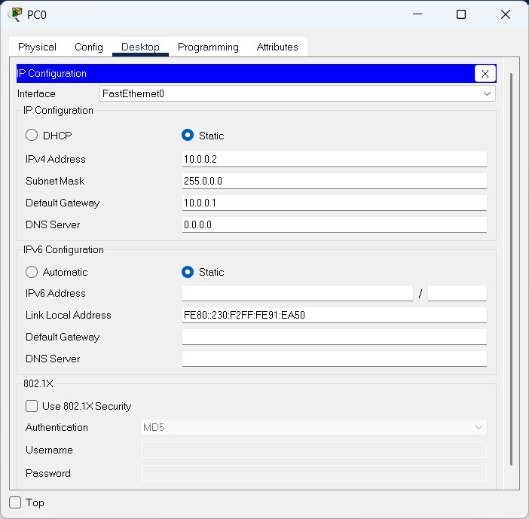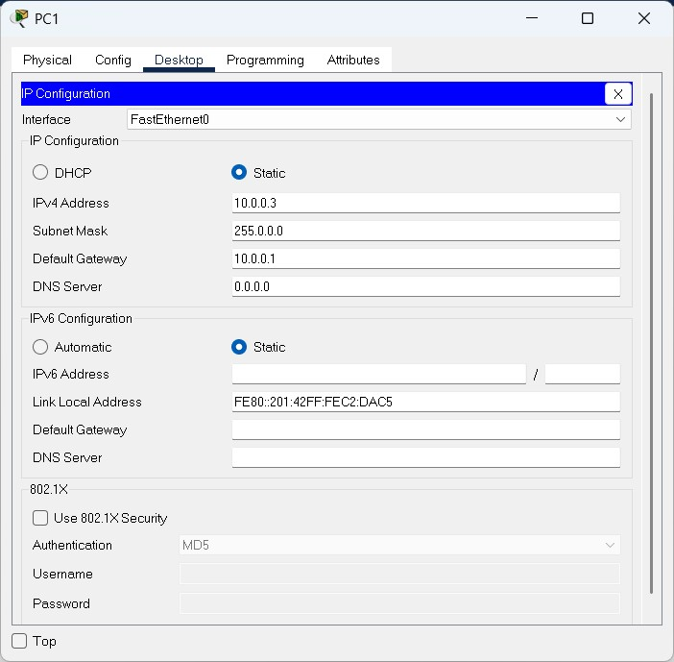
PC0

PC1

Conclusion:-The program executed Successfully

c) FTP

Aim :- To study FTP.
Diagram:
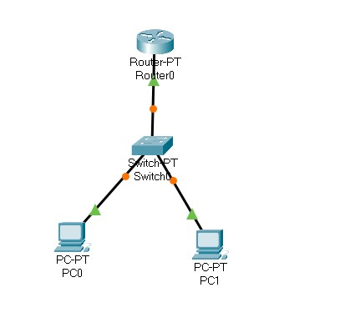

Program :-
Router 0 > cli :- enable configure terminal interface fastethernet 0/0 ip address 10.0.0.1 255.0.0.0 no shutdown
exit ip ftp username bscit ip ftp password syit ip ftp server enable exit

Pc 0 > Desktop > Ip configuration :- ipv4 : 10.0.0.2 subnet mask : 255.0.0.0
Default gateway: 10.0.0.1

Pc 1 > Desktop > Ip configuration :- ipv4 : 10.0.0.3
subnet mask : 255.0.0.0
Default gateway: 10.0.0.1

Pc 0 > Desktop > Text Editor :-
This is from PC0

Pc 0 > Desktop > Command Prompt :-
ftp 10.0.0.1 username : bscit password : syit put testfile.txt

Pc 1 > Desktop > Command Prompt :-
ftp 10.0.0.1
username : bscit password : syit get testfile.txt Output:-
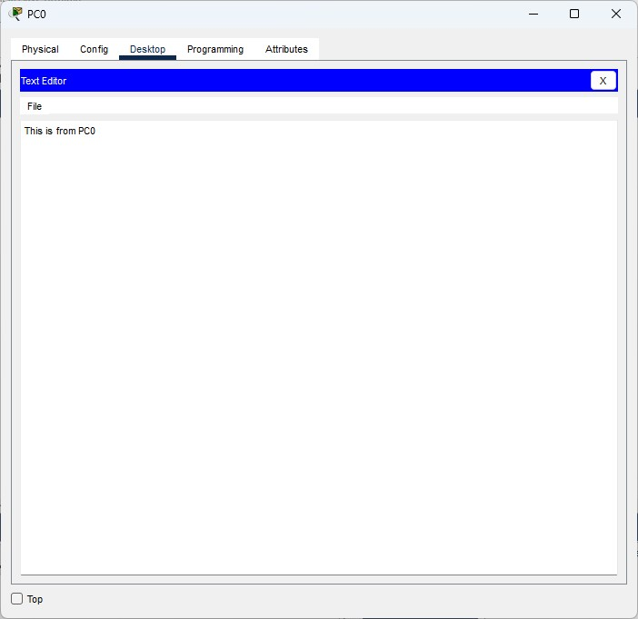

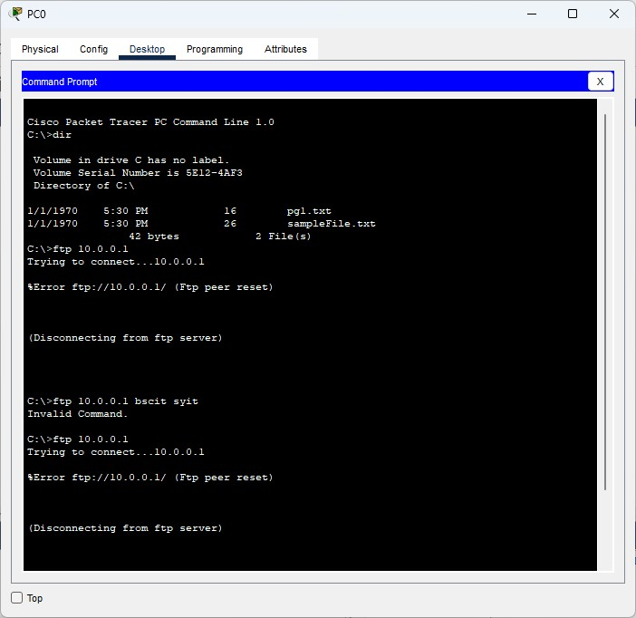

Conclusion:-The program executed Successfully

d) HTTP

Aim :- To study HTTP.

Circuit Diagram:-
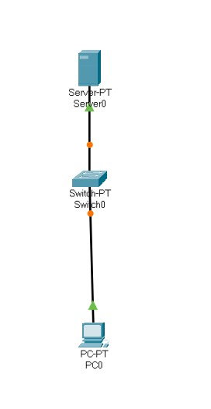
Program :- Server 0 > Desktop > Ip configuration :- ipv4 : 10.0.0.2 subnet mask : 255.0.0.0
Default gateway: 0.0.0.0

Server 0 > Services > HTTP :-
HTTP : on
HTTPS : on

Server 0 > Services > TFTP :- service: off

Server 0 > Services > HTTP > index.html > Edit :-
<html>
<head>
<title>SYIT</title>
</head>
<body>
<h1>I am SYIT</h1>
</body>
</html>

Pc 0 > Desktop > Ip Configuration :- ipv4 : 10.0.0.3 subnet mask : 255.0.0.0
Default gateway: 10.0.0.2
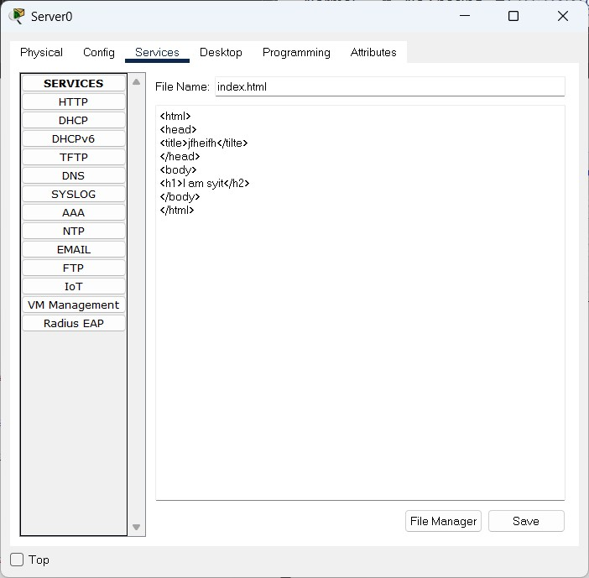

Output:
-

Conclusion:-The program executed Successfully.

e) TELNET

Aim :- To study TELNET.
Circuit diagram:-

Program :-
Router 0 > cli :- enable configure terminal interface fastethernet 0/0 ip address 10.0.0.1 255.0.0.0 no shutdown
exit line vty 0 10 password syit login transport input telnet exit exit

Pc 0 > Desktop > Ip configuration :- ipv4 : 10.0.0.2 subnet mask : 255.0.0.0
Default gateway: 10.0.0.1

Pc 1 > Desktop > Ip configuration :- ipv4 : 10.0.0.3
subnet mask : 255.0.0.0
Default gateway: 10.0.0.1

Output:-
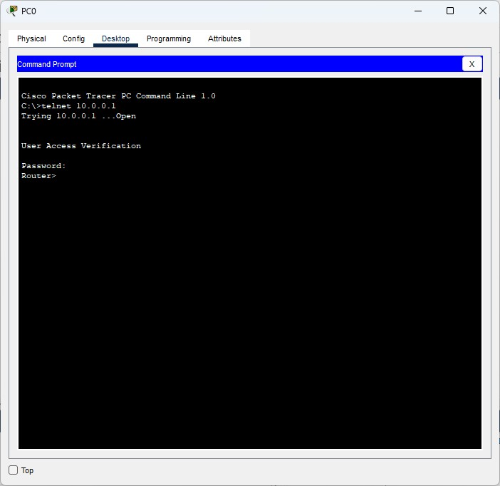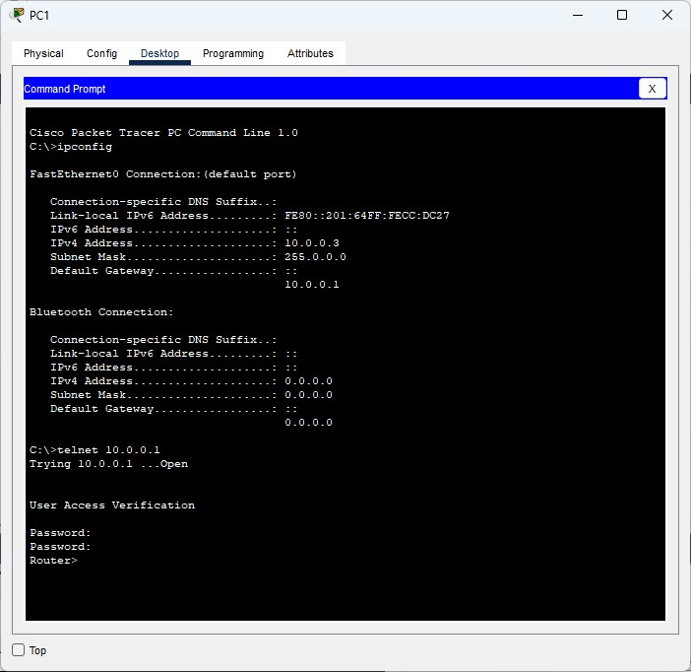

Conclusion:-The program executed Successfully.

