HR Analytics: Employee Attrition
Insights and Predictive Modelling

Academic Internship Project Report

Author: Rajesh Lakkappa Harapanahalli
Programme: Data Analytics with AI
Dataset: IBM HR Analytics Employee Attrition & Performance (Fictional)

1. Abstract
IMPORTANT: The dataset used throughout this project is entirely fictional. It was synthesised by IBM data scientists for illustrative purposes only. It does not represent real IBM employees, real IBM HR decisions, or any actual organisation. All findings refer exclusively to this fictional dataset.
This project presents an end-to-end data analytics and predictive modelling workflow applied to a fictional employee dataset. The dataset contains 1,470 employee records with 31 attributes. The recorded attrition rate in the fictional dataset is 16.1% (237 of 1,470 employees). The project covers data preprocessing, exploratory data analysis, binary classification modelling, model evaluation, and interactive dashboard development. Four classification models were trained and compared. Logistic Regression was selected as the primary model based on its superior recall (0.6596), F1-score (0.4627), and ROC-AUC (0.8042) on a held-out test set. An interactive Streamlit dashboard presents the findings to an HR audience. All analytical conclusions are limited to this fictional dataset.

2. Introduction
Employee attrition — the voluntary or involuntary departure of employees from an organisation — represents a significant operational and financial challenge. Recruitment, onboarding, and training costs, combined with the loss of institutional knowledge, make attrition one of the most studied problems in human resource management.
This project demonstrates how data analytics and machine learning can be applied to explore patterns in a fictional HR dataset and build a classification model to identify records associated with attrition. The workflow follows a standard data science process: data acquisition, preprocessing, exploratory analysis, feature engineering, model training, evaluation, and dashboard development.

3. Problem Statement
The analytical problem is framed as: given a fictional employee record with 30 demographic and workplace-related attributes, can a classification model predict whether the record has an attrition value of Yes (left) or No (stayed)? The target variable is binary: Attrition = Yes (positive class) or No (negative class). The minority class (Yes) represents approximately 16.1% of records, creating a class imbalance that must be addressed during modelling.

4. Project Objectives
- Analyse attrition patterns across departments, job roles, and employee characteristics
- Examine relationships between workplace factors and recorded attrition
- Perform reproducible data preprocessing without modifying the raw dataset
- Conduct exploratory data analysis to answer nine defined analytical questions
- Engineer features and build scikit-learn pipelines for classification
- Train and compare four classification models using consistent evaluation
- Evaluate models using metrics appropriate for imbalanced binary classification
- Build an interactive Streamlit dashboard communicating findings to an HR audience
- Document all findings, limitations, and responsible-use guidance

5. Scope of the Project
This project covers: dataset inspection and quality assessment; data preprocessing and encoding; univariate and bivariate exploratory analysis; binary classification using Logistic Regression, Decision Tree, Random Forest, and a Dummy baseline; model evaluation on a stratified held-out test set; and dashboard development using Streamlit and Plotly.
Out of scope: real-time HR systems, causal inference, longitudinal analysis, deployment to production infrastructure, natural language processing of free-text fields, or analysis of any real employee data.

6. Dataset Description and Source
The dataset used is the IBM HR Analytics Employee Attrition and Performance dataset, available on Kaggle. It was synthesised by IBM data scientists and contains entirely fictional employee records. It has no connection to real IBM employment data.
Property | Value
Name | IBM HR Analytics Employee Attrition & Performance
Source | Kaggle — pavansubhasht/ibm-hr-analytics-attrition-dataset
URL | https://www.kaggle.com/datasets/pavansubhasht/ibm-hr-analytics-attrition-dataset
Format | CSV
Nature | FICTIONAL / SYNTHESISED — not real employee data
Raw dimensions | 1,470 rows x 35 columns
Processed dimensions | 1,470 rows x 31 columns
Target variable | Attrition (Yes=1, No=0)
Problem type | Binary classification
Attrition = Yes | 237 (16.1%)
Attrition = No | 1233 (83.9%)
Imbalance ratio | 5.2 : 1 (No : Yes)

7. Technologies Used
Library / Tool | Purpose
Python 3.14 | Programming language
pandas 2.3 | Data manipulation and analysis
NumPy 2.3 | Numerical computing
Matplotlib 3.10 | Static visualisation
Seaborn 0.13 | Statistical data visualisation
scikit-learn 1.8 | Machine learning pipelines and models
joblib | Model persistence
Streamlit 1.52 | Interactive web dashboard
Plotly 7.1 | Interactive charts in dashboard
python-docx 1.2 | Word document generation
Jupyter Notebook | Interactive analysis and submission notebook
pathlib | Portable cross-platform file paths

8. Methodology
The project follows the CRISP-DM (Cross-Industry Standard Process for Data Mining) framework adapted to an academic context:
Step | Activity
Step 1 | Project Setup, Business Understanding, and Dataset Inspection
Step 2 | Data Preprocessing and Exploratory Data Analysis
Step 3 | Predictive Modelling and Model Evaluation
Step 4 | Interactive Dashboard Development
Step 5 | Documentation and Submission Preparation

9. Data Preprocessing
The raw dataset was inspected before any transformations. The original file was never modified. All transformations were applied to an in-memory copy and saved to data/processed/hr_attrition_clean.csv.
Preprocessing steps applied:
Step | Result
Missing values check | No missing values found (0 in all 35 columns)
Duplicate row check | No duplicate rows found (0 duplicates)
Drop EmployeeCount | Constant column (value = 1 for all rows) — zero information
Drop Over18 | Constant column (value = Y for all rows) — zero information
Drop StandardHours | Constant column (value = 80 for all rows) — zero information
Drop EmployeeNumber | Unique row identifier — data leakage risk if used as feature
Encode Attrition | Yes -> 1, No -> 0 (target variable for scikit-learn)
Encode OverTime | Yes -> 1, No -> 0 (binary feature)
Year consistency check | YearsAtCompany <= TotalWorkingYears: OK; all 4 checks passed
Output shape | 1,470 rows x 31 columns

10. Exploratory Data Analysis
All findings below are associations in the fictional dataset. No causal relationships are claimed. Rates use the correct denominator (attrited count / total in group), not raw counts.

10.1 Overall Attrition Rate
Of 1,470 fictional employee records, 237 have Attrition = Yes, giving an overall rate of 16.1%. The No:Yes imbalance ratio is 5.2:1. This imbalance must be accounted for in model evaluation.
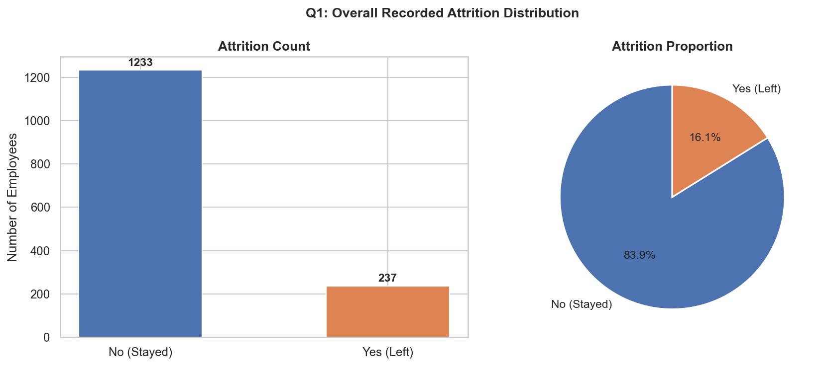
Figure 1: Overall attrition distribution in the fictional dataset

10.2 Attrition by Department
Department | Attrition Rate
Sales | 92 of 446 (20.6%)
Human Resources | 12 of 63 (19.0%)
Research & Development | 133 of 961 (13.8%)

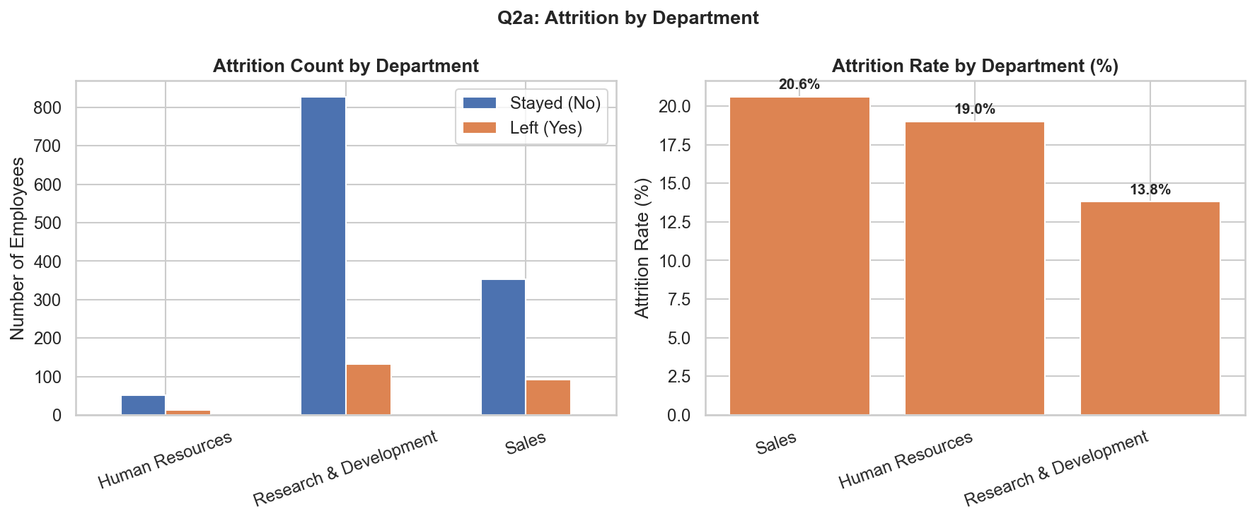
Figure 2: Attrition count and rate by department

10.3 Attrition by Job Role
Job Role | Attrition Rate
Sales Representative | 33 of 83 (39.8%)
Laboratory Technician | 62 of 259 (23.9%)
Human Resources | 12 of 52 (23.1%)
Sales Executive | 57 of 326 (17.5%)
Research Scientist | 47 of 292 (16.1%)
Healthcare Representative | 9 of 131 (6.9%)
Manufacturing Director | 10 of 145 (6.9%)
Manager | 5 of 102 (4.9%)
Research Director | 2 of 80 (2.5%)

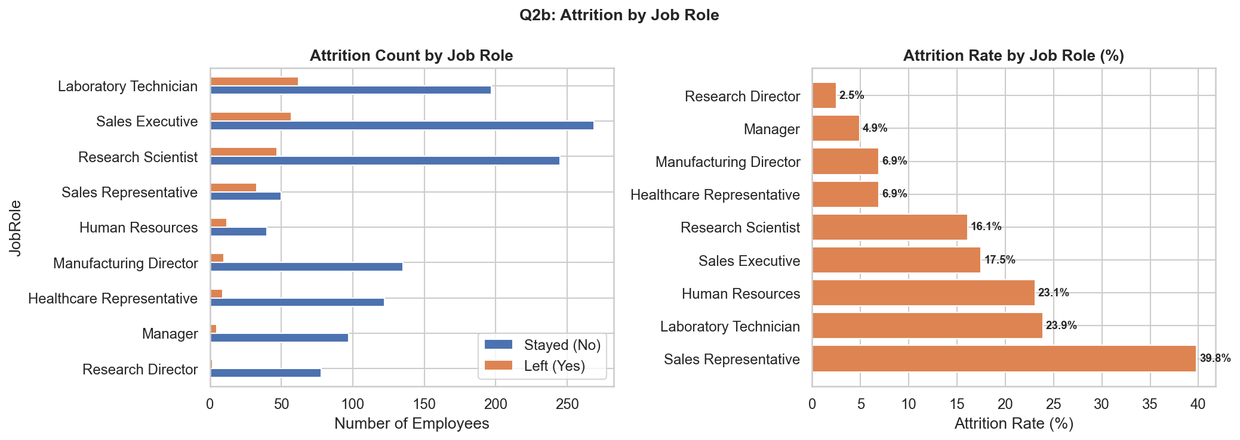
Figure 3: Attrition rate by job role

10.4 Overtime Analysis
Employees with OverTime = Yes recorded a 30.5% attrition rate compared to 10.4% for those without overtime — approximately 3 times higher. This is the strongest single linear association with attrition (Pearson r = +0.25). This is an association, not a causal relationship. Overtime may reflect demanding roles or understaffing rather than directly causing departure.
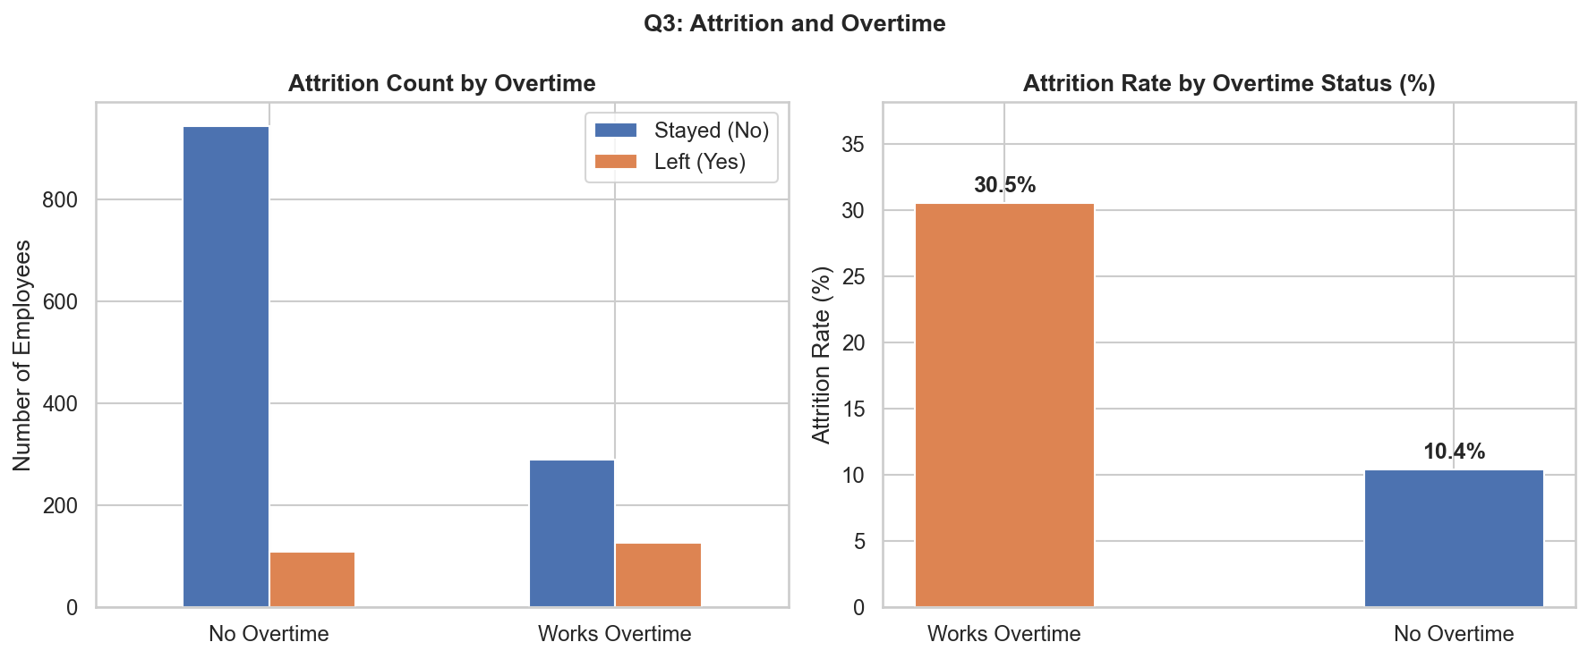
Figure 4: Attrition rate by overtime status

10.5 Job Satisfaction
Lower satisfaction levels are associated with higher recorded attrition: Level 1 (Low) = 22.8%, Level 2 (Medium) = 16.4%, Level 3 (High) = 16.5%, Level 4 (Very High) = 11.3%. The gradient is clearest at the extremes.
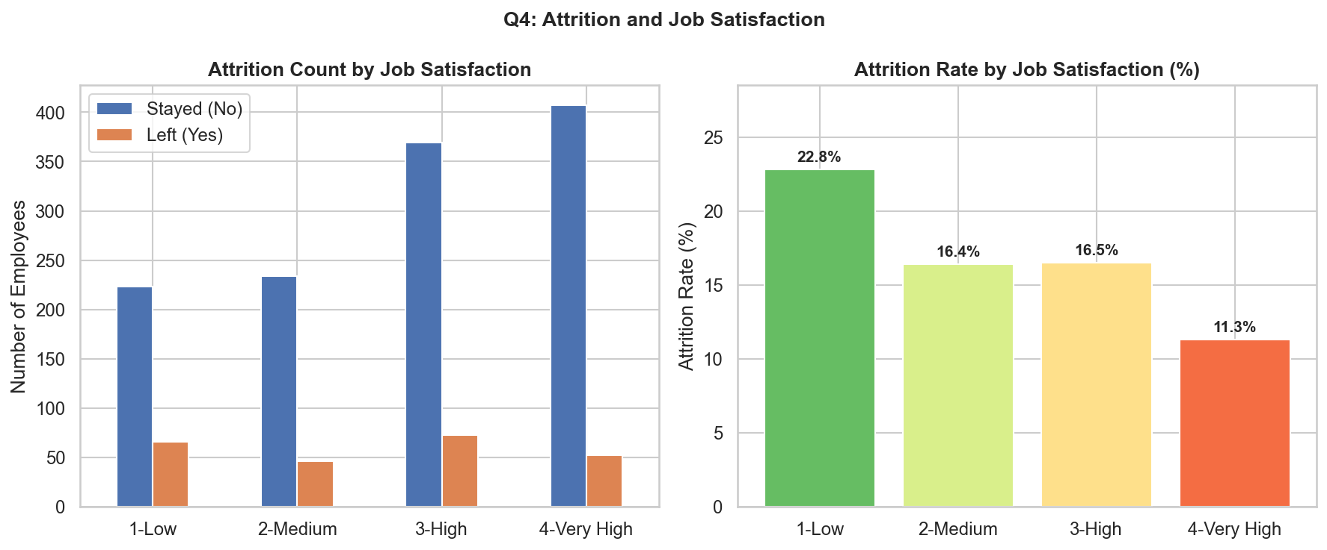
Figure 5: Attrition rate by job satisfaction level

10.6 Tenure
Employees with shorter tenure show higher recorded attrition. Median tenure of leavers: 3 years; stayers: 6 years. The 0-2 year band recorded a 28.9% rate, declining to 6.7% for the 11-20 year band.
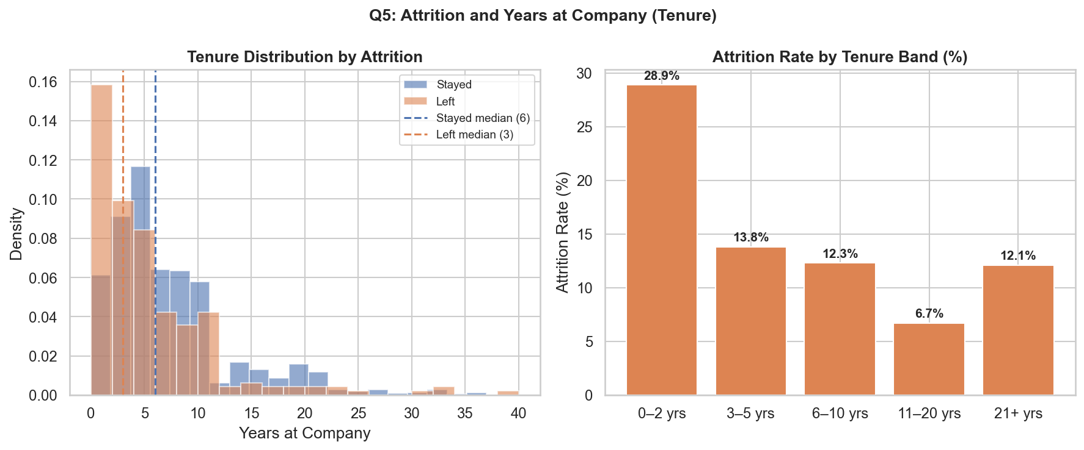
Figure 6: Tenure distribution and attrition rate by tenure band

10.7 Monthly Income
Employees who left had a lower median monthly income (3,202) than those who stayed (5,204). Distribution overlap is substantial, indicating income alone is not a clean separator.
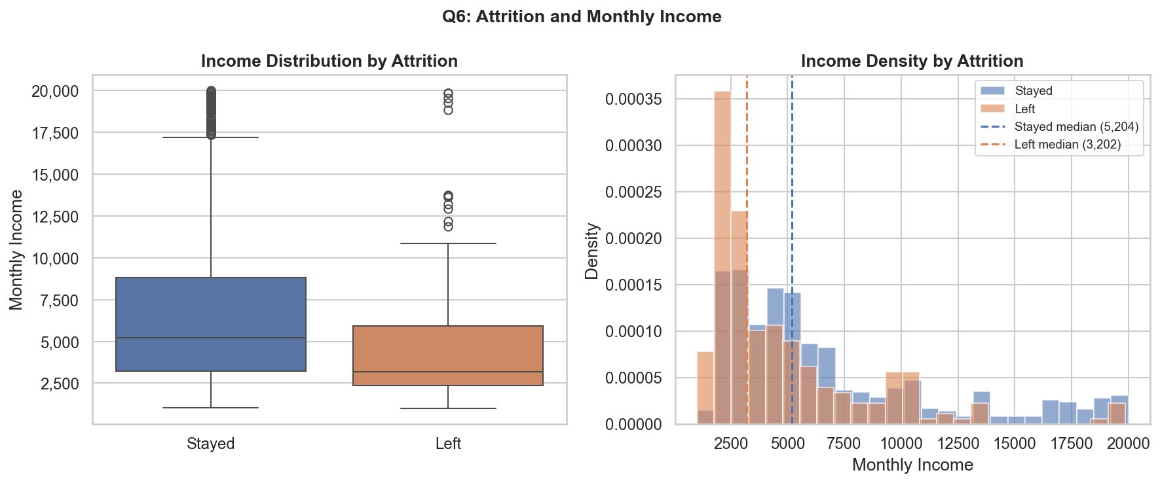
Figure 7: Monthly income distribution by attrition

10.8 Age
The 18-25 age band recorded the highest attrition rate (35.8%). Rates generally decline with age, reaching 9.2% for the 36-45 band. Median age of leavers: 32; stayers: 36.
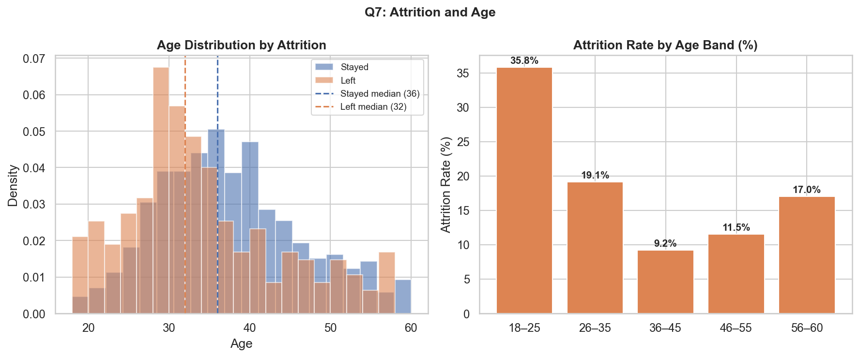
Figure 8: Age distribution by attrition

10.9 Correlation Heatmap
The strongest linear correlation with Attrition is OverTime (+0.25), followed by JobLevel (-0.17), TotalWorkingYears (-0.17), Age (-0.16), and MonthlyIncome (-0.16). Most correlations are modest, suggesting non-linear models may capture additional signal.
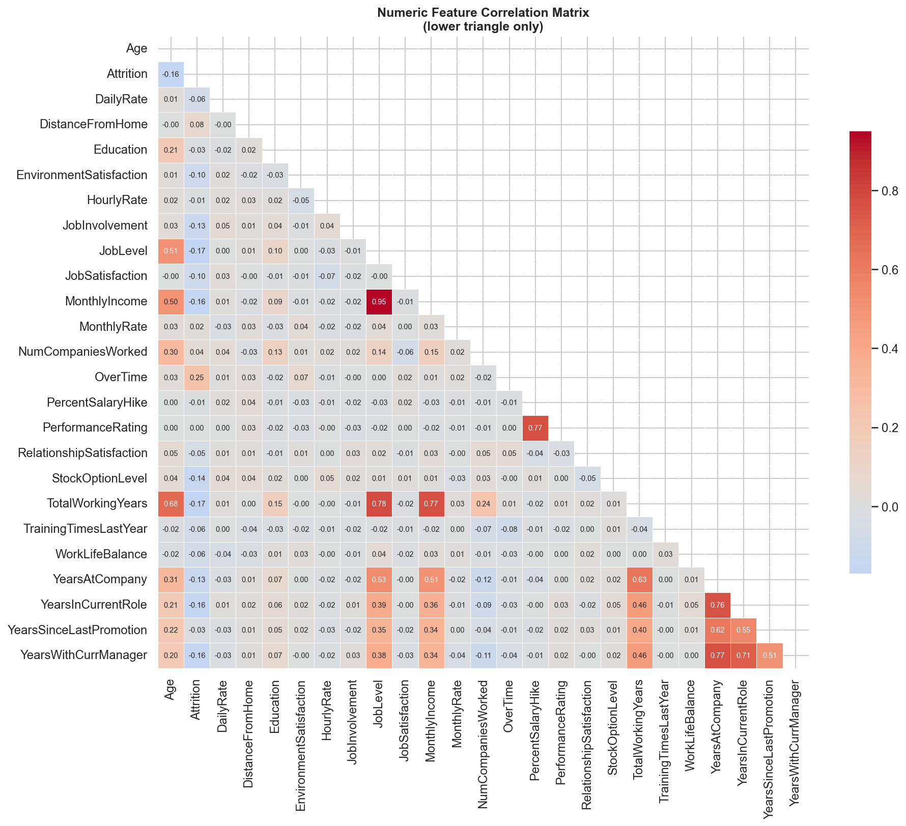
Figure 9: Pearson correlation matrix for numeric features

11. Predictive Modelling

11.1 Feature Preparation
Features: all 30 columns except the target Attrition. Categorical features (6): BusinessTravel, Department, EducationField, Gender, JobRole, MaritalStatus. Numerical features (24): all remaining numeric columns. A scikit-learn Pipeline with ColumnTransformer applies median imputation and StandardScaler to numerical features, and most-frequent imputation with OneHotEncoder (drop=first) to categorical features. The pipeline is fitted exclusively on training data to prevent data leakage.

11.2 Train/Test Split
The dataset was split 80% training / 20% test using stratified sampling (random_state=42) to preserve the 16.1% positive class ratio in both sets. Training set: 1,176 rows (190 positives). Test set: 294 rows (47 positives). The test set was locked after splitting and not used for any fitting, tuning, or feature selection.

11.3 Models Trained
Model | Key Settings | Notes
Dummy Baseline | strategy=most_frequent | Predicts No for every record — floor benchmark
Logistic Regression | class_weight=balanced, max_iter=1000, solver=lbfgs | Linear model — interpretable
Decision Tree | class_weight=balanced, max_depth=6, min_samples_leaf=10 | Non-linear, single tree
Random Forest | n_estimators=200, class_weight=balanced_subsample, max_depth=10 | Ensemble of 200 trees

12. Model Evaluation
All models were evaluated on the same locked test set (294 rows). Accuracy alone is a misleading metric with 5.2:1 class imbalance — the Dummy Baseline achieves 84% accuracy while catching zero actual leavers. Recall for the positive class (Attrition=Yes) is the primary selection criterion.
Model | Accuracy | Precision | Recall | F1 | ROC-AUC
Dummy Baseline | 0.8401 | 0.0000 | 0.0000 | 0.0000 | 0.5000
Logistic Regression | 0.7551 | 0.3563 | 0.6596 | 0.4627 | 0.8042
Decision Tree | 0.7279 | 0.3103 | 0.5745 | 0.4030 | 0.6815
Random Forest | 0.8299 | 0.4483 | 0.2766 | 0.3421 | 0.7775

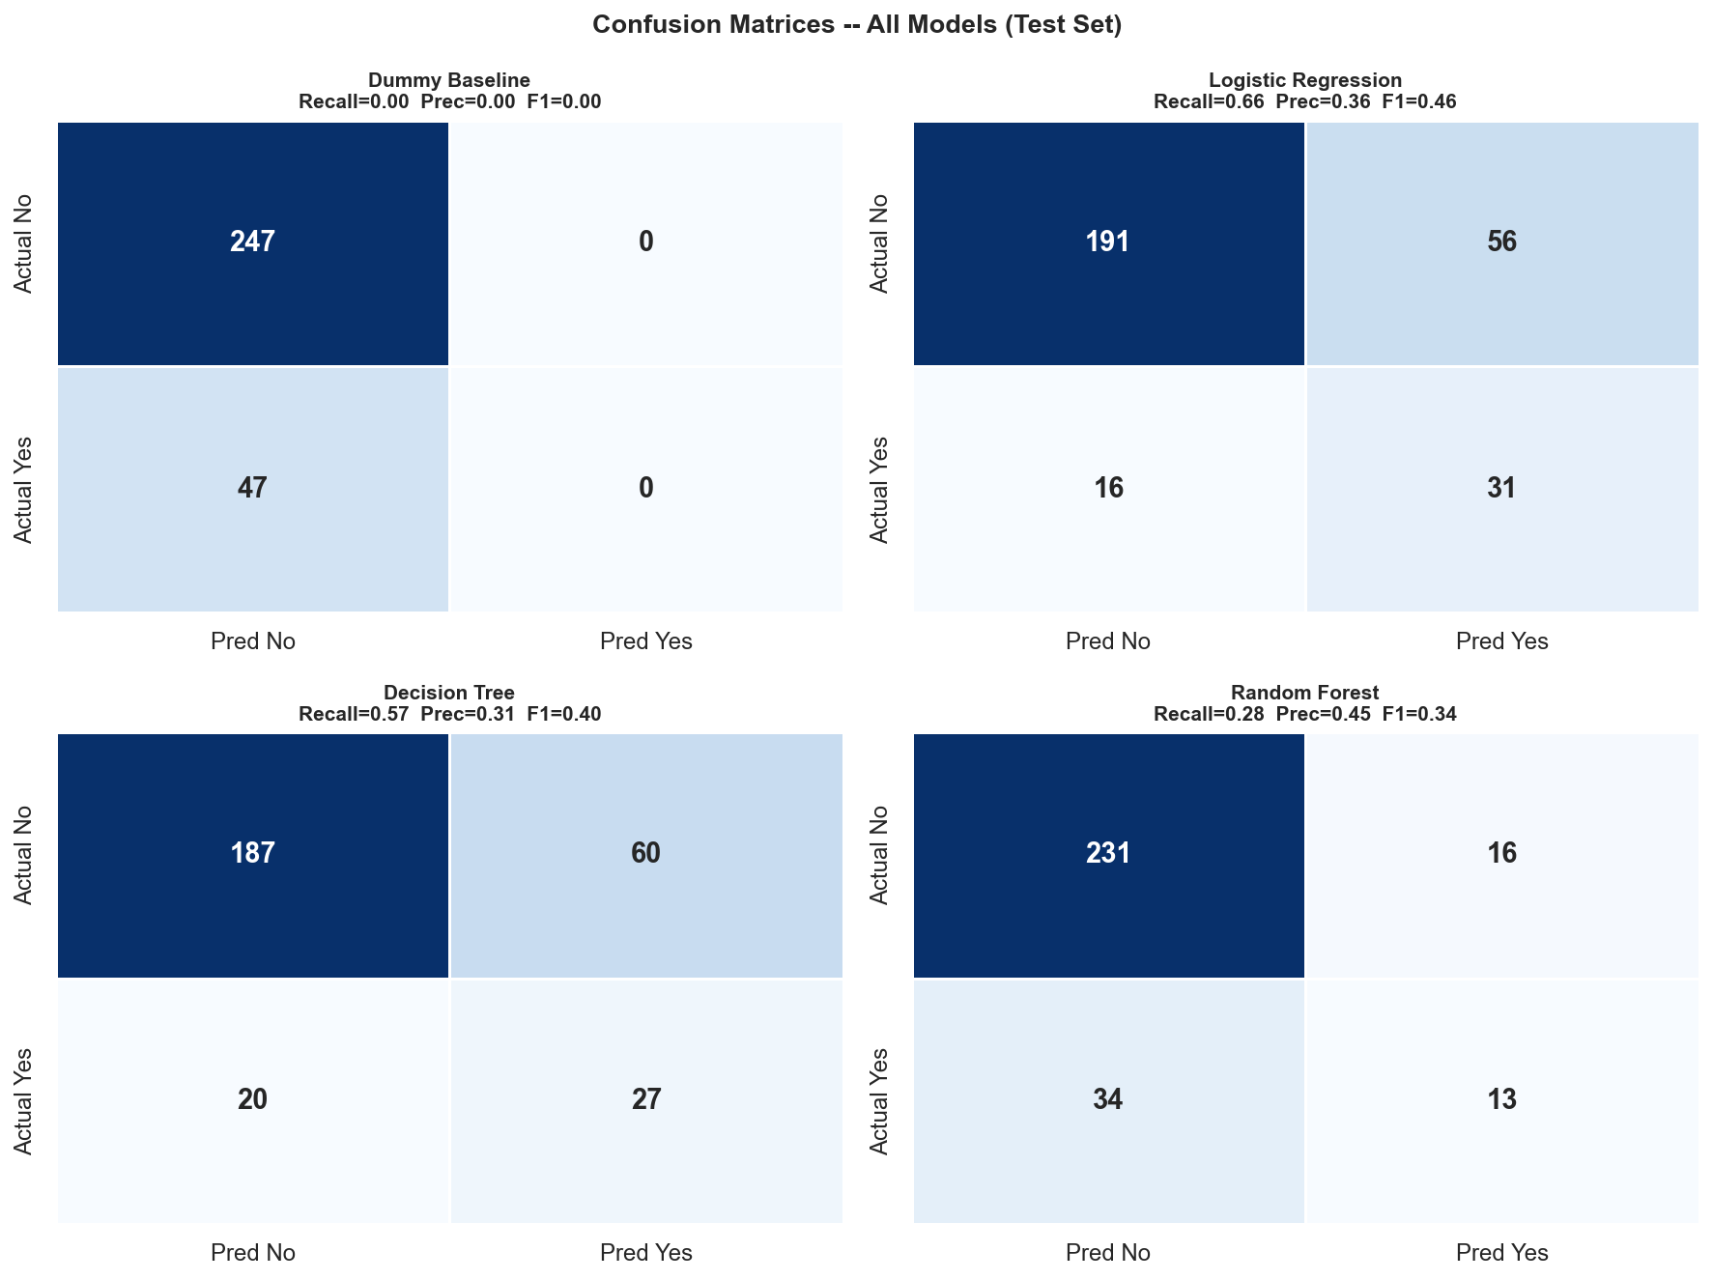
Figure 10: Confusion matrices for all four models (test set)
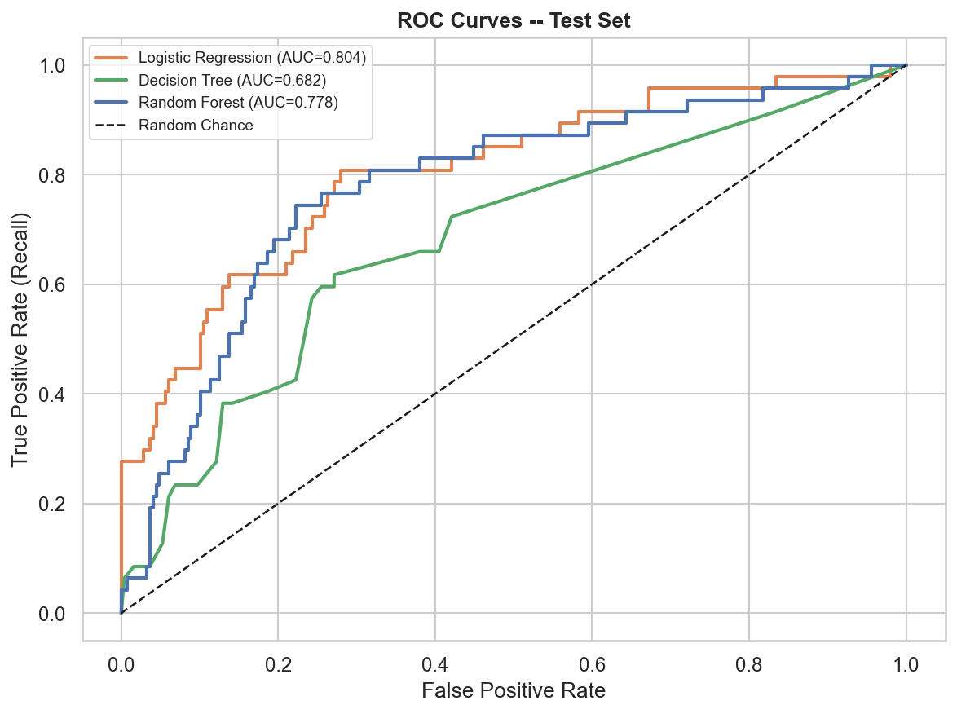
Figure 11: ROC curves for Logistic Regression, Decision Tree, and Random Forest
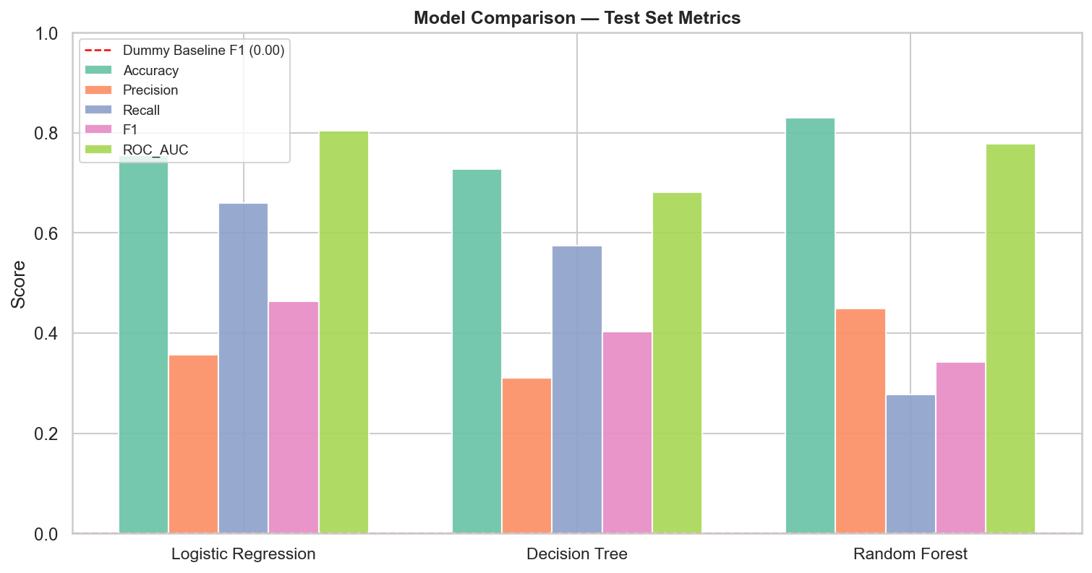
Figure 12: Model comparison — all metrics on the test set

12.1 Selected Model: Logistic Regression
Logistic Regression was selected based on the highest F1-score (0.4627), highest Recall (0.6596), and highest ROC-AUC (0.8042) among the three non-dummy models. It also shows the most stable cross-validation performance (CV F1 std = 0.029).
Confusion matrix (test set): True Positives = 31, True Negatives = 191, False Positives = 56, False Negatives = 16. The model caught 31 of 47 actual leavers in the test set (66.0%).

12.2 Feature Importance
The top features by Logistic Regression coefficient magnitude include: BusinessTravel_Travel_Frequently (+1.60), JobRole_Laboratory Technician (+1.57), JobRole_Sales Representative (+1.26), OverTime (+0.75), and MaritalStatus_Single (+0.87). Negative coefficients include: JobRole_Research Director (-1.12) and TotalWorkingYears (-0.62).
These are statistical associations in the fictional dataset. They do not establish causal relationships and must not be used to justify employment decisions.
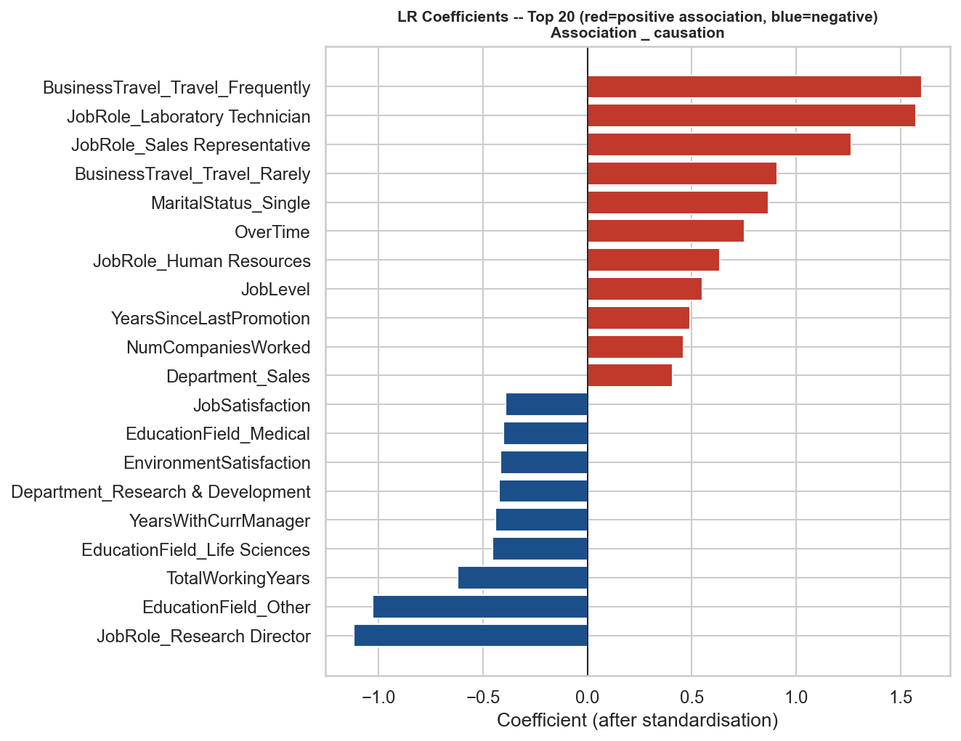
Figure 13: Logistic Regression top 20 coefficients (after standardisation)

13. Dashboard Design and Implementation
An interactive Streamlit dashboard (app.py) presents the analytical findings to an HR audience through four pages:
Page | Contents
Executive Overview | KPI cards, attrition pie chart, department and role summaries
Attrition Analysis | Breakdown by department, job role, overtime, satisfaction, tenure, income, age, travel
Model Performance | Comparison table, confusion matrix, ROC curve, metric definitions
Insights & Recommendations | Eight evidence-based findings with observations, evidence, interpretation, actions, and limitations

Sidebar filters (Department, Job Role, Overtime, Business Travel) update descriptive charts and metrics dynamically. Model evaluation results always reflect the fixed Step 3 test set — filters do not retrain or re-evaluate the model.
Launch command: streamlit run app.py (from the project root)

14. Key Findings
All findings are from the fictional dataset and describe associations only.
Finding | Value
Overall attrition rate | 16.1% (237 of 1,470)
Department — highest rate | Sales: 20.6%
Job role — highest rate | Sales Representative: 39.8%
Overtime association | OT=Yes: 30.5% vs OT=No: 10.4% (~3x higher)
Job satisfaction | Level 1 (Low): 22.8% vs Level 4 (Very High): 11.3%
Early tenure risk | 0-2 year band: 28.9% attrition rate
Median tenure difference | Leavers: 3 yrs, Stayers: 6 yrs
Median income difference | Leavers: 3,202, Stayers: 5,204
Strongest linear predictor | OverTime (Pearson r = +0.25)
Best model (F1) | Logistic Regression: F1=0.4627, Recall=0.6596, AUC=0.8042

15. Business Recommendations
The following observations are grounded in patterns found in the fictional dataset. They are framed as potential areas for investigation, not validated HR policies. All recommendations are for aggregate, voluntary, and supportive initiatives only.
- Overtime workload: Investigate whether overtime is concentrated in specific roles or departments. Review workload distribution as part of a voluntary wellbeing programme.
- Early tenure support: The 0-2 year group shows the highest recorded attrition rate (28.9%). A structured onboarding and early-career support programme may be worth exploring.
- Job satisfaction monitoring: Regular anonymous satisfaction surveys could help identify at-risk groups. Voluntary engagement programmes may support lower-satisfaction employees.
- Role-specific review: Sales Representative and Laboratory Technician roles show elevated attrition rates. Investigating role-specific workloads, career progression, or compensation may be appropriate.
- Compensation benchmarking: Lower median incomes are associated with higher attrition. Compensation benchmarking for junior roles could be a component of a broader retention review.
- Business travel: Frequent travellers show a 24.9% attrition rate vs 8.0% for non-travellers. Reviewing whether travel requirements in certain roles can be reduced may be worthwhile.

16. Limitations
- Fictional data — all findings apply only to this synthesised dataset and cannot be generalised.
- Association is not causation — no finding establishes a causal relationship.
- Moderate model performance — F1=0.46, Recall=0.66 are useful but not high-confidence.
- Class imbalance — the 5.2:1 No:Yes ratio means small changes in predictions can noticeably shift metrics.
- No temporal data — this is a cross-sectional snapshot; trends over time cannot be observed.
- Self-reported fields — satisfaction and involvement scores may reflect survey conditions rather than long-term experience.
- PerformanceRating has very low variance — only values 3 and 4 present out of a 1-4 scale.
- No hyperparameter tuning — default/lightly tuned models; tuning could improve results.

17. Ethical Considerations
Predictive models applied to HR data raise significant ethical concerns even when built on fictional data. The following principles must govern any real-world application of similar techniques:
- Prohibited uses: Predictions must not be used to dismiss, demote, deny promotions, or otherwise disadvantage individual employees. Any such use would constitute an inappropriate application of a statistical model.
- Bias and fairness: Models trained on historical HR data may reflect and amplify existing organisational biases related to gender, age, marital status, or role type. A real-world deployment would require a thorough bias and fairness audit and compliance with employment law.
- Human oversight: Any HR system using predictive models must include human review of all individual-level decisions. Automated employment decisions based on model outputs alone are not appropriate.
- Data protection: Real employee data is personal data subject to GDPR, PDPA, and similar regulations. Appropriate consent, data minimisation, and security controls must be in place.
- Transparency: Employees should be informed if predictive analytics are used in HR processes that affect them.

18. Conclusion
This project successfully demonstrated an end-to-end data analytics and machine learning workflow on a fictional HR dataset. The dataset of 1,470 records with a 16.1% recorded attrition rate was processed, analysed, and used to train four classification models. Logistic Regression was selected as the primary model, achieving a test-set F1-score of 0.4627, Recall of 0.6596, and ROC-AUC of 0.8042.
The most notable patterns observed in the fictional data were: a strong association between overtime and attrition; higher attrition in early-tenure employees; lower median income among employees who left; and role-specific variation with Sales Representative recording the highest rate at 39.8%. An interactive Streamlit dashboard presents these findings for an HR audience.
All findings are limited to the fictional dataset. No conclusions should be drawn about real organisations, and the model must not be used for any real employment decision without full revalidation on real, ethically governed data.

19. References
1. IBM. (n.d.). IBM HR Analytics Employee Attrition & Performance [Fictional dataset]. Kaggle. https://www.kaggle.com/datasets/pavansubhasht/ibm-hr-analytics-attrition-dataset
2. Pedregosa, F., et al. (2011). Scikit-learn: Machine learning in Python. Journal of Machine Learning Research, 12, 2825-2830. https://scikit-learn.org
3. McKinney, W. (2010). Data structures for statistical computing in Python. Proceedings of the 9th Python in Science Conference, 51-56. https://pandas.pydata.org
4. Harris, C. R., et al. (2020). Array programming with NumPy. Nature, 585, 357-362. https://numpy.org
5. Hunter, J. D. (2007). Matplotlib: A 2D graphics environment. Computing in Science & Engineering, 9(3), 90-95. https://matplotlib.org
6. Waskom, M. (2021). Seaborn: Statistical data visualisation. Journal of Open Source Software, 6(60), 3021. https://seaborn.pydata.org
7. Streamlit Inc. (2024). Streamlit: The fastest way to build data apps (Version 1.52). https://streamlit.io
8. Plotly Technologies Inc. (2024). Plotly Python graphing library (Version 7.1). https://plotly.com/python/
9. Chapman, P., et al. (2000). CRISP-DM 1.0: Step-by-step data mining guide. SPSS Inc.

