(1) Create Investor :

(a) JSON String
{
"name":"Amit",
"email":"amitjaiswal4@gmail.com",
"mobileNumber":"9871031177",
"residentialStatus":"NRI",
"permanentAddress" :
{
"line1" : "One",
"line2":"Two",
"pincode":"226022",
"city":"Lucknow",
"state":"UP",
"country":"India"
},
"correspondenceAddress" :
{
"line1" : "One",
"line2":"Two",
"pincode":"226022",
"city":"Lucknow",
"state":"UP",
"country":"kjk"
},
"overseasAddress" :
{
"line1" : "One",
"line2":"Two",
"pincode":"226022",
"city":"Lucknow",
"state":"UP",
"country":"America"
}
}

(b) Execution snapshot in POSTMAN

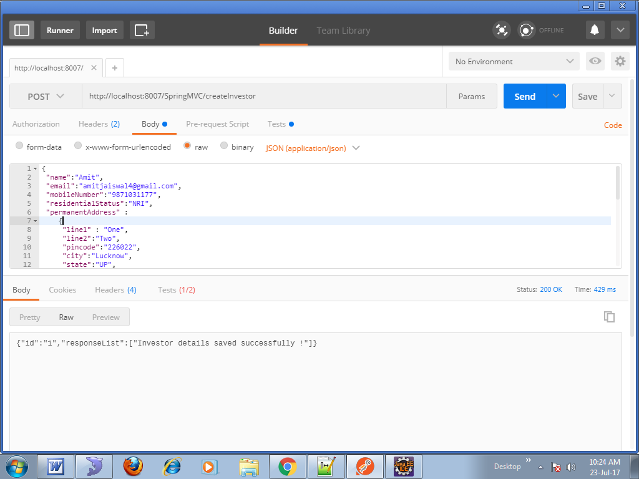

(c) DB table snapshot
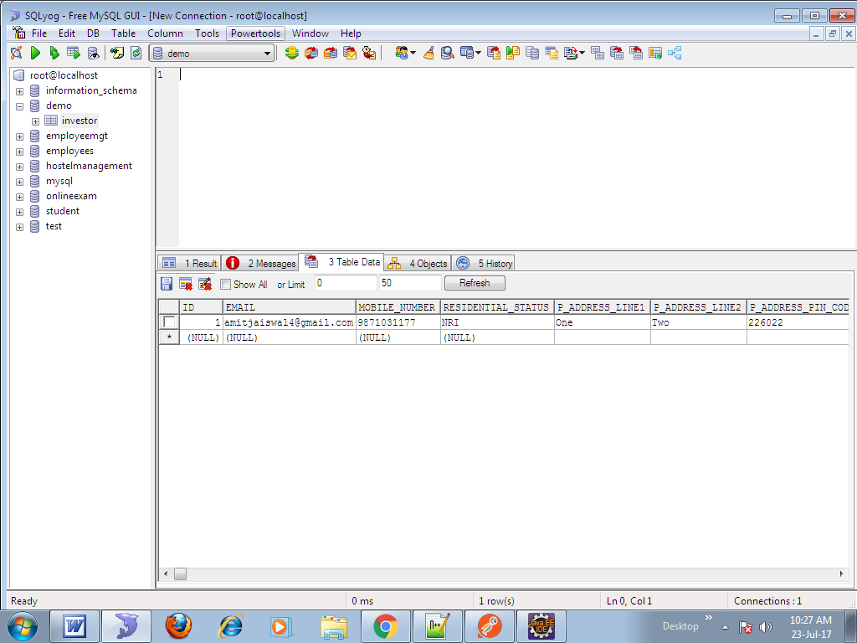

(2) Update Investor :
Eg: name and email
(a) JSON String
{
"id":1,
"name":"Rajesh",
"email":"rajeshjaiswal4@gmail.com",
"mobileNumber":"9871031177",
"residentialStatus":"NRI",
"permanentAddress" :
{
"line1" : "One",
"line2":"Two",
"pincode":"226022",
"city":"Lucknow",
"state":"UP",
"country":"India"
},
"correspondenceAddress" :
{
"line1" : "One",
"line2":"Two",
"pincode":"226022",
"city":"Lucknow",
"state":"UP",
"country":"kjk"
},
"overseasAddress" :
{
"line1" : "One",
"line2":"Two",
"pincode":"226022",
"city":"Lucknow",
"state":"UP",
"country":"America"
}
}

(b) Execution snapshot in POSTMAN

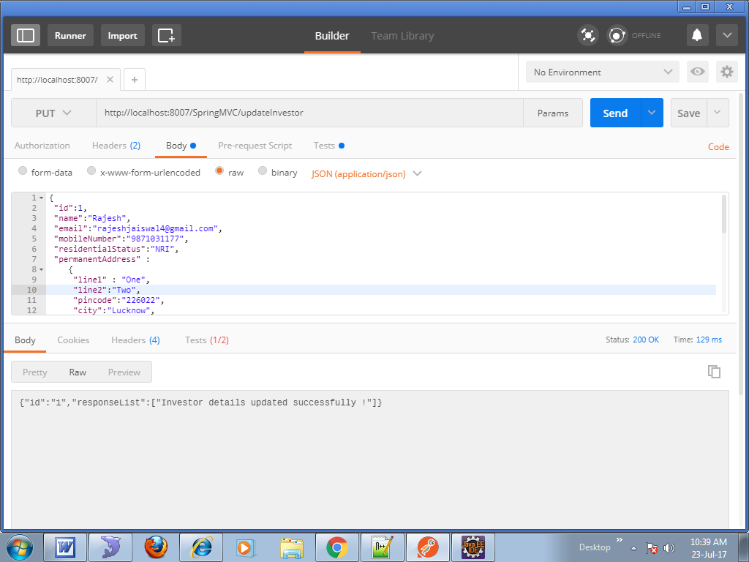

(c) DB table snapshot

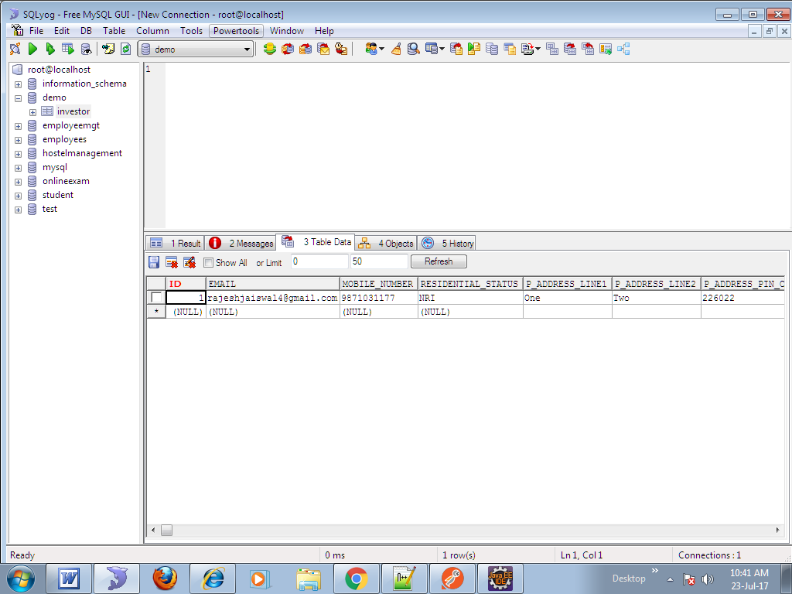
(3) Validations
(a) JSON String
{
"name":"",
"email":"rajeshjaiswal4@gmail.com",
"mobileNumber":"9871031177",
"residentialStatus":"NRI",
"permanentAddress" :
{
"line1" : "One",
"line2":"Two",
"pincode":"226022",
"city":"Lucknow",
"state":"UP",
"country":"India"
},
"correspondenceAddress" :
{
"line1" : "One",
"line2":"Two",
"pincode":"226022",
"city":"Lucknow",
"state":"UP",
"country":"kjk"
},
"overseasAddress" :
{
"line1" : "One",
"line2":"Two",
"pincode":"226022",
"city":"Lucknow",
"state":"UP",
"country":"America"
}
}

(b) Execution snapshot in POSTMAN
