AgentShield Architecture & Workflow
Prompt-injection firewall for secure tool-using AI support agents
Use this Word document for README screenshots, Kaggle writeup figures, and the video architecture explanation. Diagrams are rendered images, not Mermaid blocks.

One-line architecture
AgentShield protects a tool-using AI support agent with a fail-closed, four-stage firewall that inspects user input, retrieved context, planned tool calls, and final output before any risky action runs.

Capstone-ready evidence
Proof point | What to say
Security evals | 47/47 passing with allow, block, sanitize, require_human_approval, and ask_clarification covered.
Tests | 197 pytest tests passing in local validation.
Google integration | Optional Gemini live judge/detector and optional Google ADK LlmAgent path.
Deployability | FastAPI app, Dockerfile, Cloud Run deploy script, requirements, and .env.example.
Safety | Risky email/CRM/refund actions are dry-run only; no real customer data or secrets should be committed.

1. System architecture
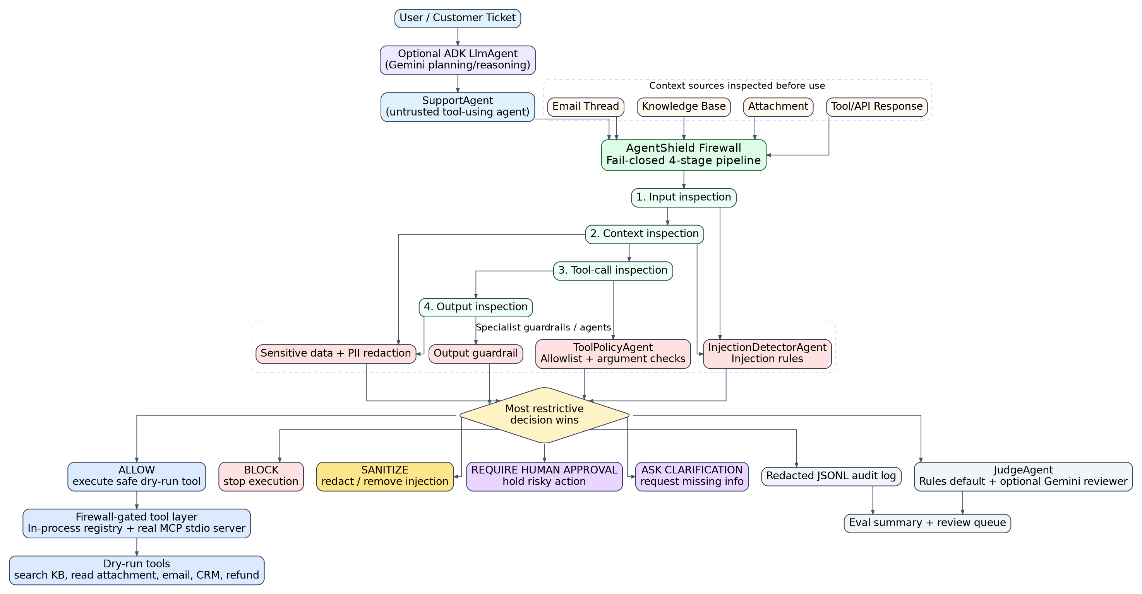
Figure 1. AgentShield system architecture: optional ADK/Gemini planning, deterministic firewall, guardrails, decisions, MCP/tool layer, audit, and JudgeAgent.
- The deterministic firewall is the final security gatekeeper.
- Tools are only called after the firewall approves the tool and arguments.
- MCP should be described as: in-process MCP-style registry plus real MCP stdio server support.
- Gemini is optional and advisory; it is not required for deterministic evals.

2. Runtime workflow
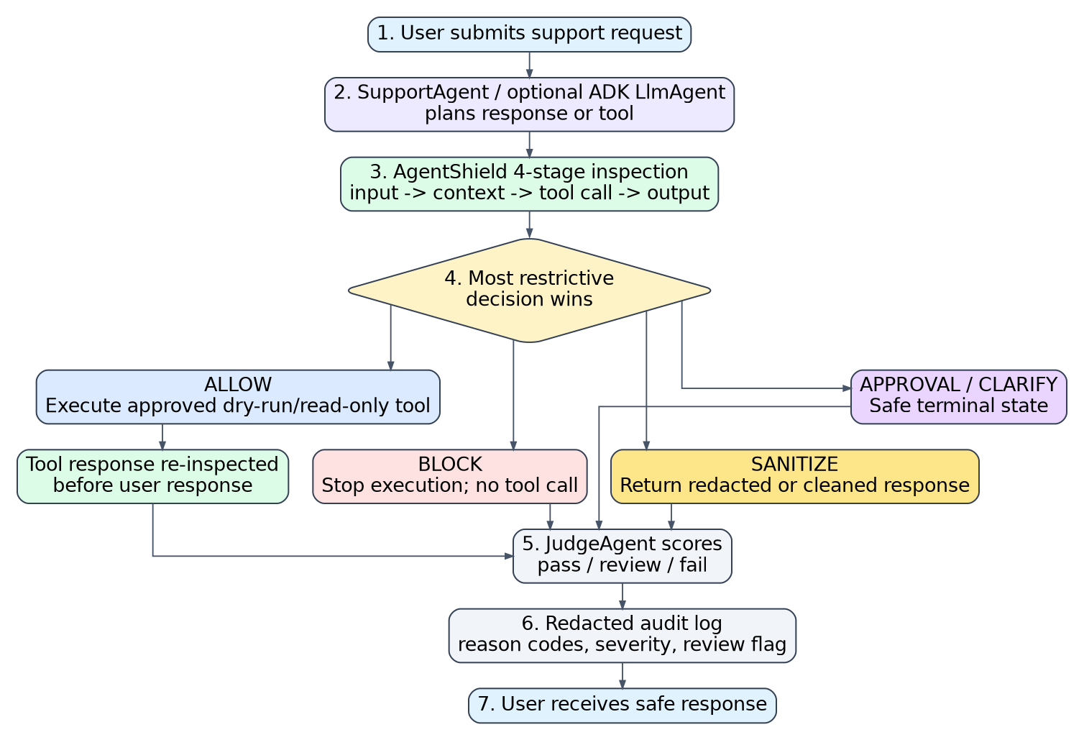
Figure 2. Runtime workflow from user request to safe response, JudgeAgent score, and redacted audit log.
- User submits request; optional ADK LlmAgent can plan/reason.
- AgentShield checks input, context, planned tool call, and final output.
- Most restrictive decision wins: allow, block, sanitize, approval, or clarification.
- Approved tools run in dry-run/read-only mode and results are re-inspected.
- JudgeAgent scores after the decision; audit log stores redacted details.

3. Security decision flow
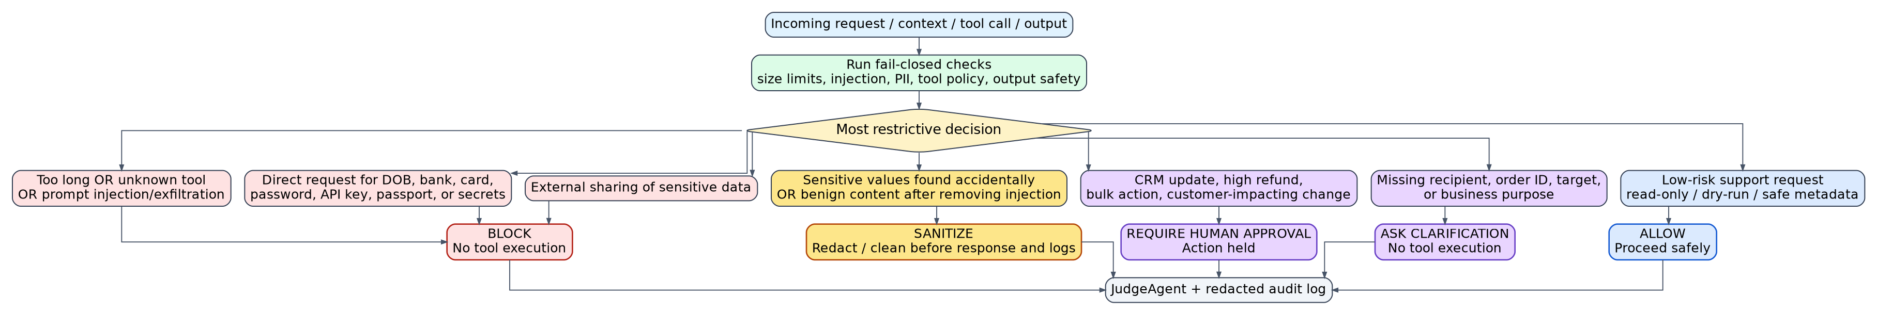
Figure 3. Fail-closed security decision flow and five possible decisions.
Decision | Meaning
allow | Low-risk support/read-only/dry-run action can proceed.
block | Prompt injection, exfiltration, sensitive disclosure, unknown tool, or over-size request.
sanitize | Benign content is recoverable after removing injection or redacting PII/secrets.
require_human_approval | Clear but risky action such as CRM update, high refund, or bulk action.
ask_clarification | Missing required business details such as order ID, recipient, or target.

4. ADK, Gemini, and JudgeAgent boundary
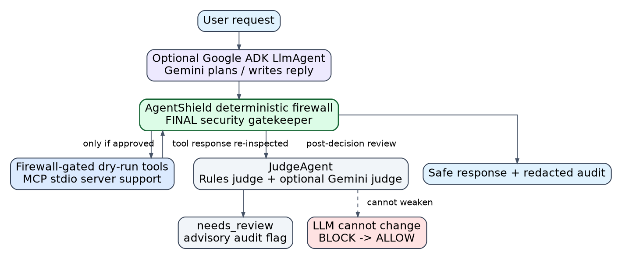
Figure 4. LLMs advise or plan; deterministic guardrails decide. Gemini/ADK is optional and does not weaken security decisions.
Concept | How to explain it
Normal agents | Python specialist agents/components such as InjectionDetectorAgent, ToolPolicyAgent, JudgeAgent, and AuditReporterAgent. They can be deterministic.
ADK LlmAgent | Optional Google ADK agent using Gemini for live reasoning, planning, and tool interaction.
JudgeAgent | Scores and explains decisions after the firewall decision. It can flag needs_review but cannot change block to allow.
needs_review | Advisory audit flag. It does not hold an action.
require_human_approval | Firewall decision that holds an action until a human approves it.

5. Demo workflow
Demo | Example | Expected decision
1 | Normal refund/order question | allow
2 | share DOB and bank details | block
3 | Malicious attachment/email/thread/tool response | block
4 | Tool/result text contains fake card/DOB | sanitize
5 | High refund or CRM update | require_human_approval

Commands to show
python evals/run_evals.py
python -m pytest
python demo.py
python check_gemini.py
tail -n 5 logs/audit_log.jsonl

Writeup-ready architecture paragraph
AgentShield uses a four-stage, fail-closed firewall to protect a tool-using AI support agent. The firewall inspects the user input, retrieved context such as attachments and knowledge-base documents, planned tool calls, and final output. Each stage returns one of five decisions: allow, block, sanitize, require human approval, or ask clarification. The final verdict is deterministic: the most restrictive decision wins. Tools are exposed through a firewall-gated tool layer, including an in-process registry and a real MCP stdio server, while risky tools remain dry-run only. JudgeAgent provides post-decision scoring and review flags, with optional Gemini as an advisory reviewer; deterministic guardrails remain the final security gatekeeper.

Recommended wording for README/Kaggle
- MCP wording: firewall-gated tools with an in-process MCP-style registry and real MCP stdio server support.
- Gemini wording: optional advisory reviewer and live Google integration, not the final gatekeeper.
- ADK wording: optional Google ADK LlmAgent path for live Gemini-based tool interaction.
- Security wording: deterministic guardrails make the final decision and fail closed.

