1. Load data and create Spark data frame

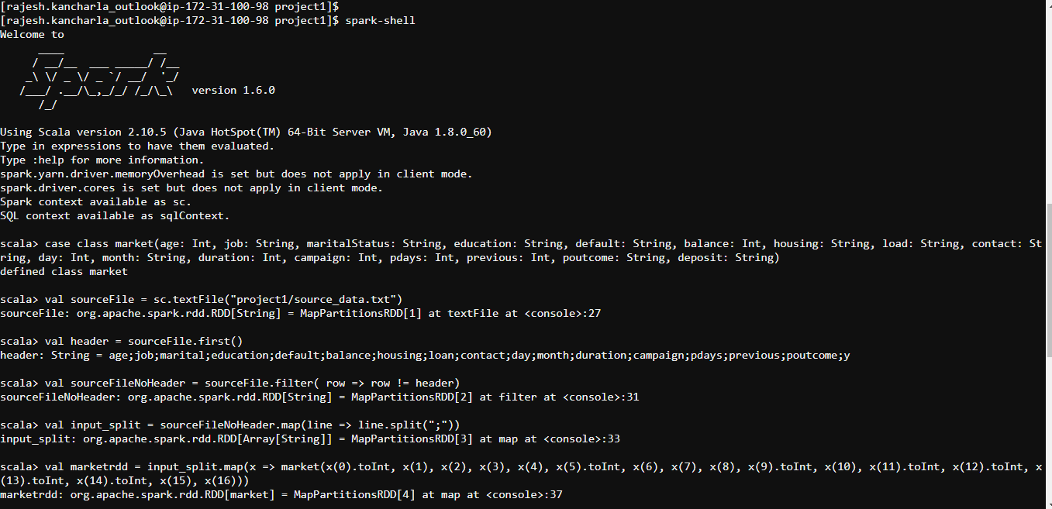

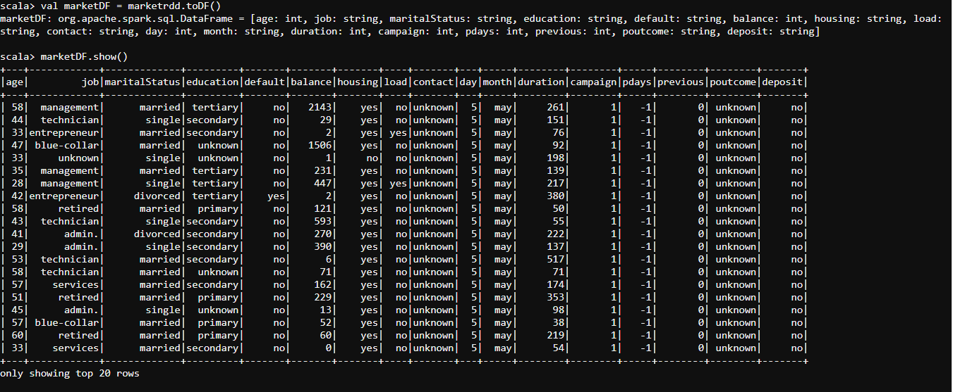

2. Give marketing success rate. (No. of people subscribed / total no. of entries)

2a Give marketing failure rate

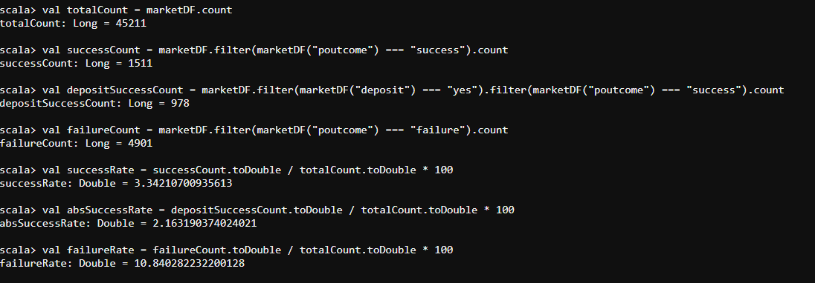

3. Maximum, Mean, and Minimum age of average targeted customer

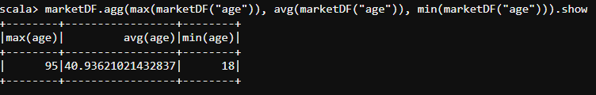

4. Check quality of customers by checking average balance, median balance of customers

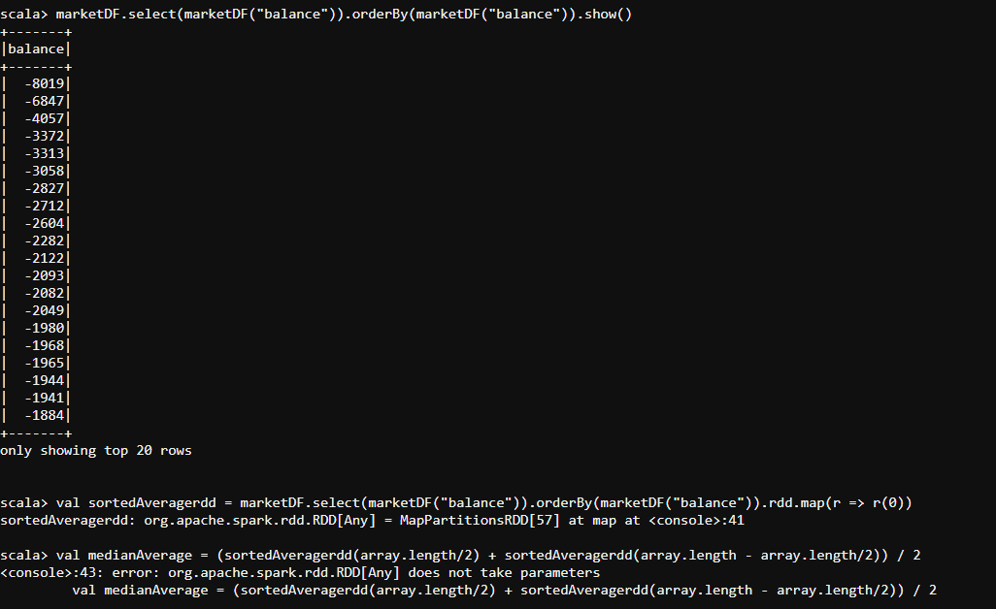

5. Check if age matters in marketing subscription for deposit

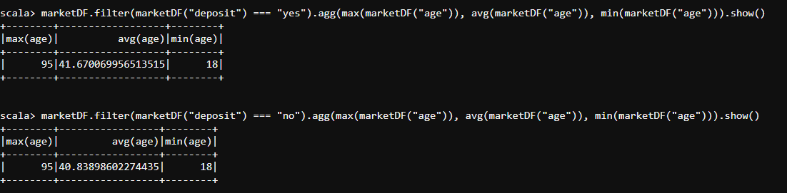

there is no impact on age with market deposit. The max, average, min ages are the same when deposit is yes / no.

6. Check if marital status mattered for subscription to deposit.

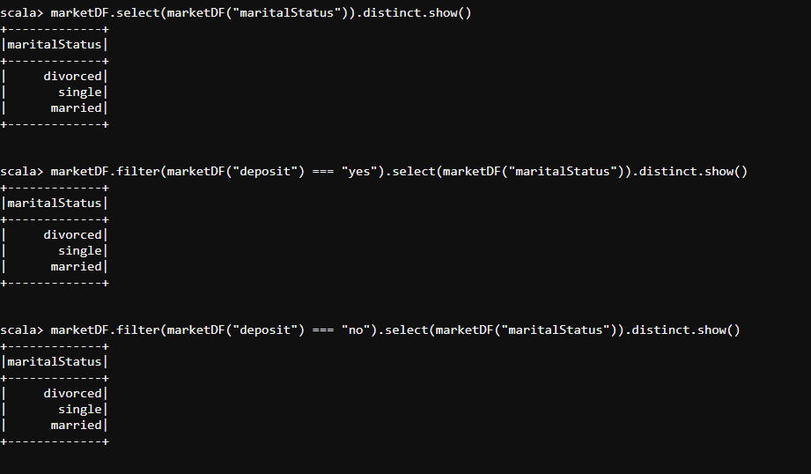

there is no impact on maritalStatus with market deposit. The maritalStatus values are the same when deposit is yes / no.

7. Check if age and marital status together mattered for subscription to deposit scheme

Same as 5 and 6, no impact.

8. Do feature engineering for column—age and find right age effect on campaign

