Popular Exercises
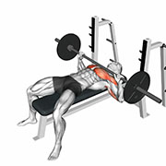  Bench Press (Barbell)  Chest | 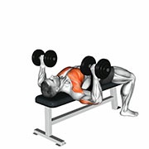  Bench Press (Dumbbell)  Chest | 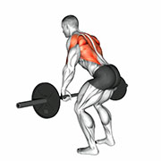  Bent Over Row (Barbell)  Upper Back
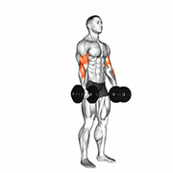  Bicep Curl (Dumbbell)  Biceps | 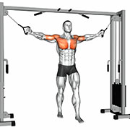  Cable Fly Crossovers  Chest | 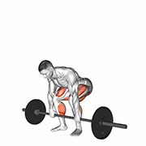  Deadlift (Barbell)  Glutes
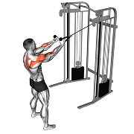  Face Pull  Shoulders | 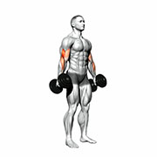  Hammer Curl (Dumbbell)  Biceps | 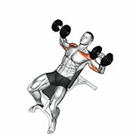  Incline Bench Press (Dumbbell)  Chest
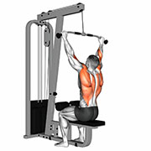  Lat Pulldown (Cable)  Lats | 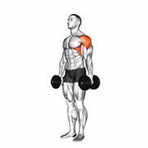  Lateral Raise (Dumbbell)  Shoulders | 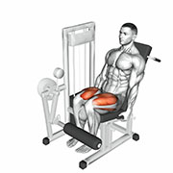  Leg Extension (Machine)  Quadriceps
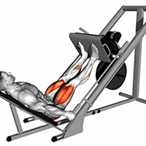  Leg Press (Machine)  Quadriceps | 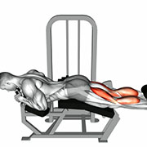  Lying Leg Curl (Machine)  Hamstrings | 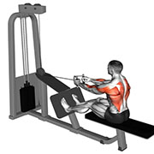  Seated Cable Row - V Grip (Cable)  Upper Back
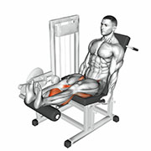  Seated Leg Curl (Machine)  Hamstrings | 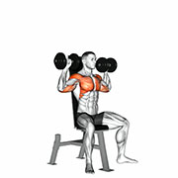  Shoulder Press (Dumbbell)  Shoulders | 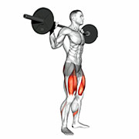  Squat (Barbell)  Quadriceps
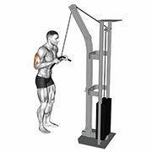  Triceps Pushdown  Triceps | 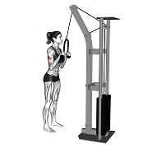  Triceps Rope Pushdown  Triceps

All Exercises
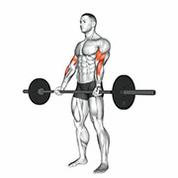  21s Bicep Curl  Biceps | 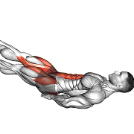  Ab Scissors  Abdominals | 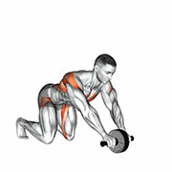  Ab Wheel Abdominals - Aerobics  Cardio
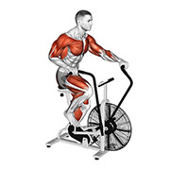  Air Bike  Cardio | 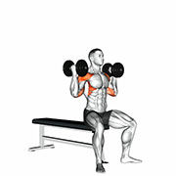  Arnold Press (Dumbbell)  Shoulders | 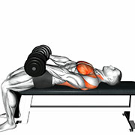  Around The World  Chest
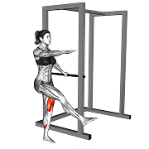  Assisted Pistol Squats  Quadriceps | 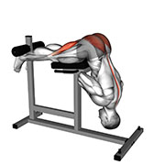  Back Extension (Hyperextension)  Lower Back | 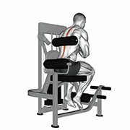  Back Extension (Machine)  Lower Back
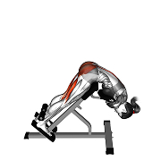  Back Extension (Weighted Hyperextension)  Lower Back | 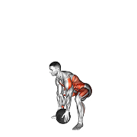  Ball Slams  Full Body | 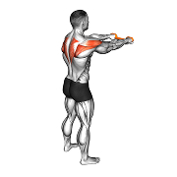  Band Pullaparts  Shoulders
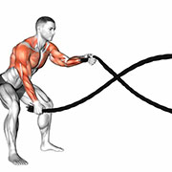  Battle Ropes  Cardio | 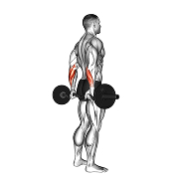  Behind the Back Bicep Wrist Curl (Barbell)  Forearms | 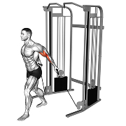  Behind the Back Curl (Cable)  Biceps
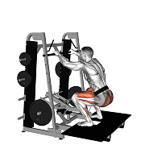  Belt Squat (Machine)  Quadriceps | 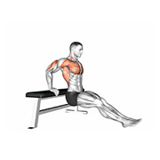  Bench Dip  Triceps |   Bench Press (Barbell)  Chest
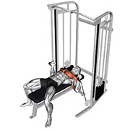  Bench Press (Cable)  Chest |   Bench Press (Dumbbell)  Chest | 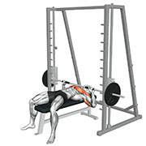  Bench Press (Smith Machine)  Chest
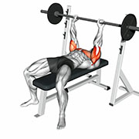  Bench Press - Close Grip (Barbell)  Triceps | 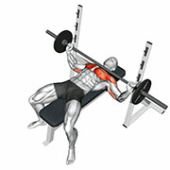  Bench Press - Wide Grip (Barbell)  Chest | 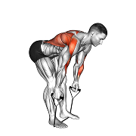  Bent Over Row (Band)  Upper Back
  Bent Over Row (Barbell)  Upper Back | 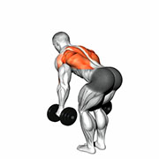  Bent Over Row (Dumbbell)  Upper Back |   Bicep Curl (Barbell)  Biceps
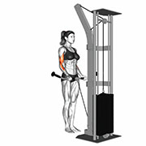  Bicep Curl (Cable)  Biceps |   Bicep Curl (Dumbbell)  Biceps | 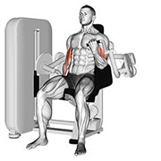  Bicep Curl (Machine)  Biceps
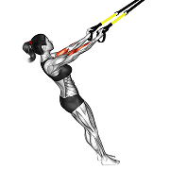  Bicep Curl (Suspension)  Biceps | 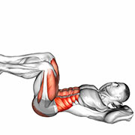  Bicycle Crunch  Abdominals | 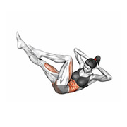  Bicycle Crunch Raised Legs  Abdominals
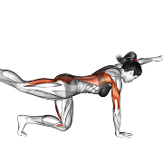  Bird Dog  Glutes | 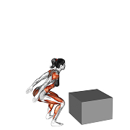  Box Jump  Quadriceps | 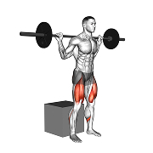  Box Squat (Barbell)  Quadriceps
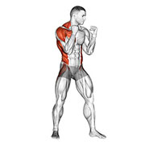  Boxing  Cardio | 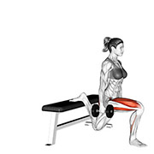  Bulgarian Split Squat  Quadriceps | 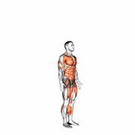  Burpee  Full Body
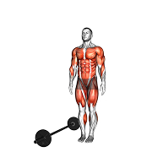  Burpee Over the Bar  Full Body | 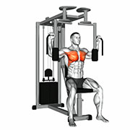  Butterfly (Pec Deck)  Chest | 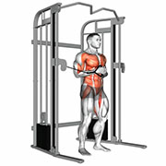  Cable Core Palloff Press  Abdominals
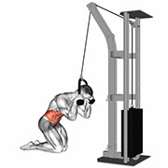  Cable Crunch  Abdominals |   Cable Fly Crossovers  Chest | 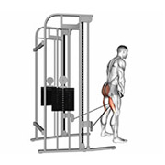  Cable Pull Through  Glutes
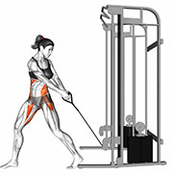  Cable Twist (Down to up)  Abdominals | 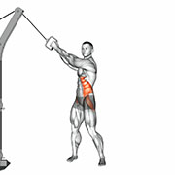  Cable Twist (Up to down)  Abdominals | 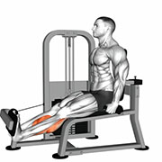  Calf Extension (Machine)  Calves
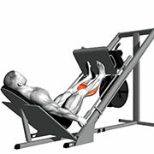  Calf Press (Machine)  Calves | 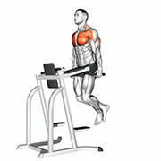  Chest Dip  Chest | 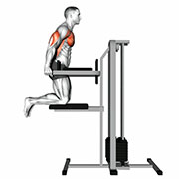  Chest Dip (Assisted)  Chest
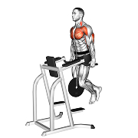  Chest Dip (Weighted)  Chest | 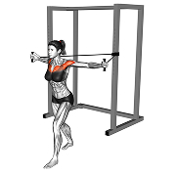  Chest Fly (Band)  Chest | 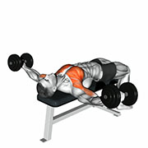  Chest Fly (Dumbbell)  Chest
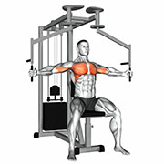  Chest Fly (Machine)  Chest | 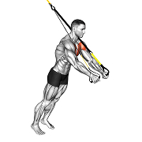  Chest Fly (Suspension)  Chest | 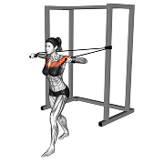  Chest Press (Band)  Chest
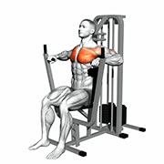  Chest Press (Machine)  Chest | 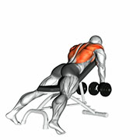  Chest Supported Incline Row (Dumbbell)  Upper Back | 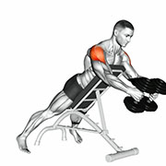  Chest Supported Reverse Fly (Dumbbell)  Shoulders
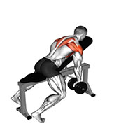  Chest Supported Y Raise (Dumbbell)  Shoulders | 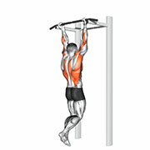  Chin Up  Lats | 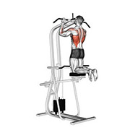  Chin Up (Assisted)  Lats
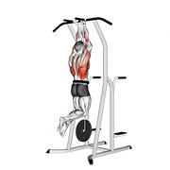  Chin Up (Weighted)  Lats | 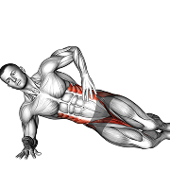  Clamshell  Glutes | 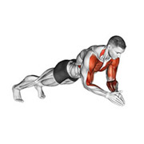  Clap Push Ups  Chest
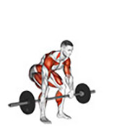  Clean  Full Body | 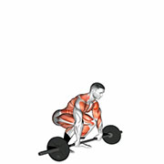  Clean and Jerk  Full Body |   Clean and Press  Full Body
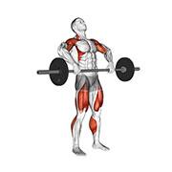  Clean Pull  Full Body | 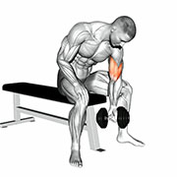  Concentration Curl  Biceps | 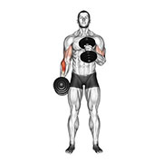  Cross Body Hammer Curl  Biceps
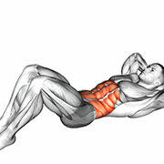  Crunch  Abdominals | 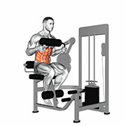  Crunch (Machine)  Abdominals | 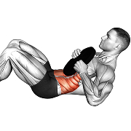  Crunch (Weighted)  Abdominals
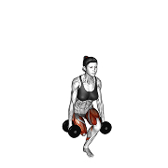  Curtsy Lunge (Dumbbell)  Quadriceps | 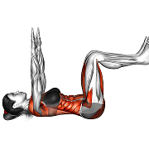  Dead Bug  Abdominals | 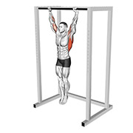  Dead Hang  Upper Back
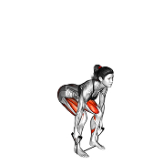  Deadlift (Band)  Glutes |   Deadlift (Barbell)  Glutes | 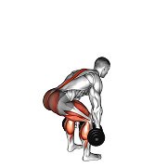  Deadlift (Dumbbell)  Glutes
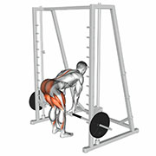  Deadlift (Smith Machine)  Glutes | 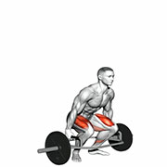  Deadlift (Trap bar)  Glutes | 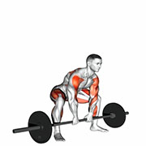  Deadlift High Pull  Full Body
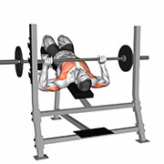  Decline Bench Press (Barbell)  Chest | 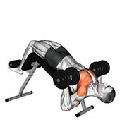  Decline Bench Press (Dumbbell)  Chest | 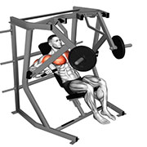  Decline Bench Press (Machine)  Chest
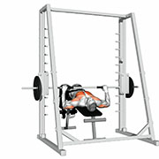  Decline Bench Press (Smith Machine)  Chest | 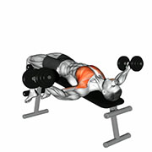  Decline Chest Fly (Dumbbell)  Chest | 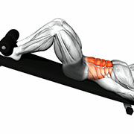  Decline Crunch  Abdominals
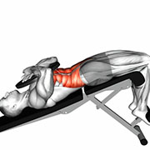  Decline Crunch (Weighted)  Abdominals | 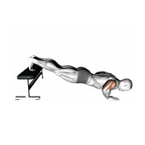  Decline Push Up  Chest | 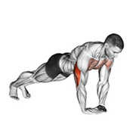  Diamond Push Up  Triceps
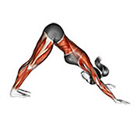  Downward Dog  Full Body | 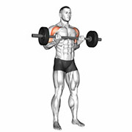  Drag Curl  Biceps | 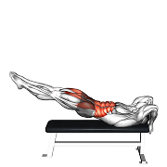  Dragon Flag  Abdominals
  Dragonfly  Abdominals | 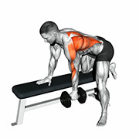  Dumbbell Row  Lats | 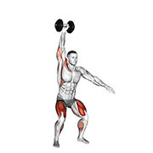  Dumbbell Snatch  Full Body
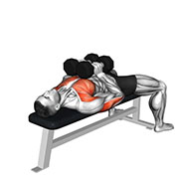  Dumbbell Squeeze Press  Chest | 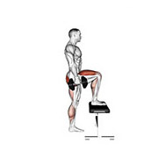  Dumbbell Step Up  Quadriceps | 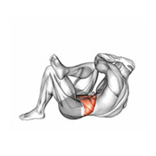  Elbow to Knee  Abdominals
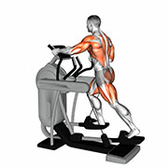  Elliptical Trainer  Cardio | 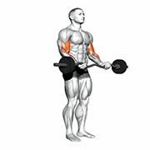  EZ Bar Biceps Curl  Biceps |   Face Pull  Shoulders
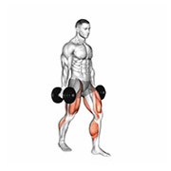  Farmers Walk  Full Body | 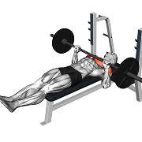  Feet Up Bench Press (Barbell)  Chest | 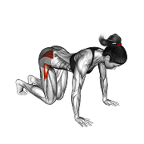  Fire Hydrants  Glutes
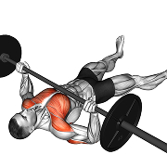  Floor Press (Barbell)  Chest | 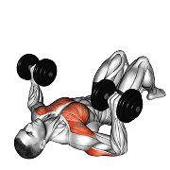  Floor Press (Dumbbell)  Chest | 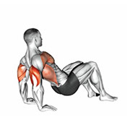  Floor Triceps Dip  Triceps
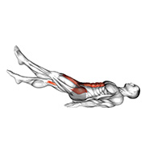  Flutter Kicks  Abdominals | 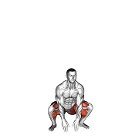  Frog Jumps  Quadriceps | 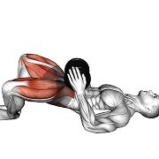  Frog Pumps (Dumbbell)  Glutes
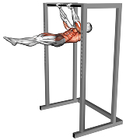  Front Lever Hold  Full Body |   Front Lever Raise  Full Body | 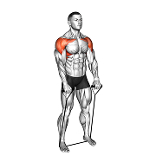  Front Raise (Band)  Shoulders
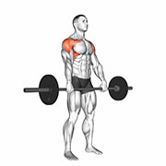  Front Raise (Barbell)  Shoulders | 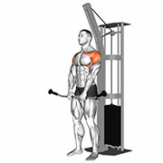  Front Raise (Cable)  Shoulders | 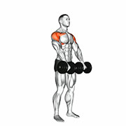  Front Raise (Dumbbell)  Shoulders
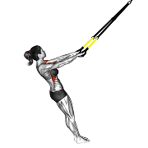  Front Raise (Suspension)  Shoulders | 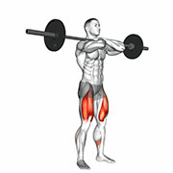  Front Squat  Quadriceps |   Full Squat  Quadriceps
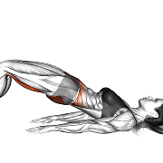  Glute Bridge  Glutes | 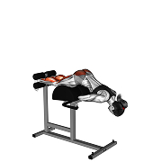  Glute Ham Raise  Hamstrings | 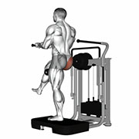  Glute Kickback (Machine)  Glutes
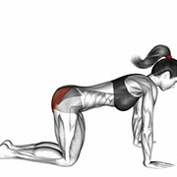  Glute Kickback on Floor  Glutes | 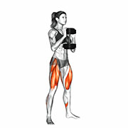  Goblet Squat  Quadriceps | 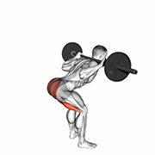  Good Morning (Barbell)  Hamstrings
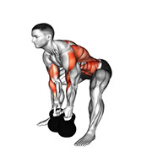  Gorilla Row (Kettlebell)  Upper Back | 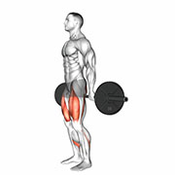  Hack Squat  Quadriceps | 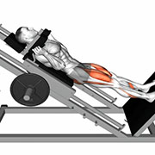  Hack Squat (Machine)  Quadriceps
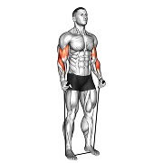  Hammer Curl (Band)  Biceps | 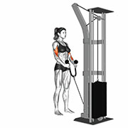  Hammer Curl (Cable)  Biceps |   Hammer Curl (Dumbbell)  Biceps
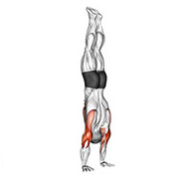  Handstand Hold  Full Body | 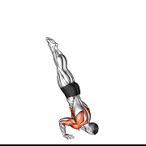  Handstand Push Up  Shoulders | 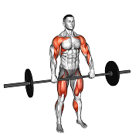  Hang Clean  Full Body
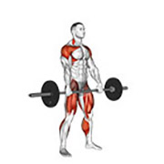  Hang Snatch  Full Body | 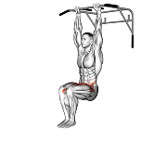  Hanging Knee Raise  Abdominals | 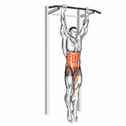  Hanging Leg Raise  Abdominals
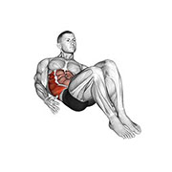  Heel Taps  Abdominals |   Hex Press (Dumbbell)  Chest | 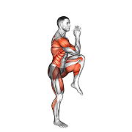  High Knee Skips  Full Body
  High Knees  Full Body | 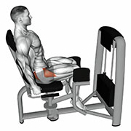  Hip Abduction (Machine)  Abductors | 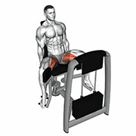  Hip Adduction (Machine)  Adductors
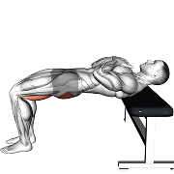  Hip Thrust  Glutes | 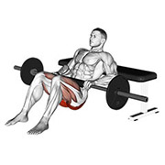  Hip Thrust (Barbell)  Glutes | 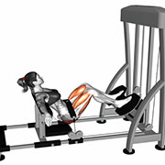  Hip Thrust (Machine)  Glutes
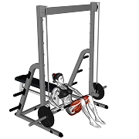  Hip Thrust (Smith Machine)  Glutes | 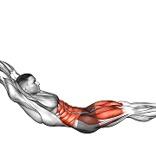  Hollow Rock  Abdominals | 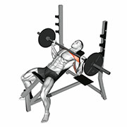  Incline Bench Press (Barbell)  Chest
  Incline Bench Press (Dumbbell)  Chest | 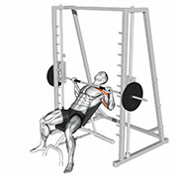  Incline Bench Press (Smith Machine)  Chest | 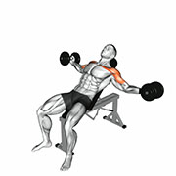  Incline Chest Fly (Dumbbell)  Chest
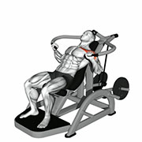  Incline Chest Press (Machine)  Chest | 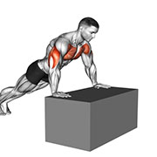  Incline Push Ups  Chest | 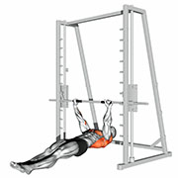  Inverted Row  Upper Back
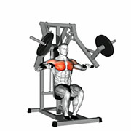  Iso-Lateral Chest Press (Machine)  Chest | 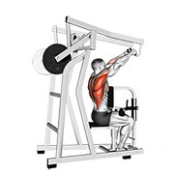  Iso-Lateral High Row (Machine)  Lats | 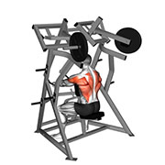  Iso-Lateral Low Row  Upper Back
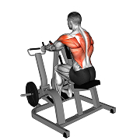  Iso-Lateral Row (Machine)  Upper Back | 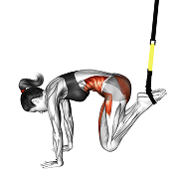  Jack Knife (Suspension)  Abdominals | 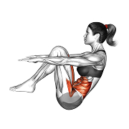  Jackknife Sit Up  Abdominals
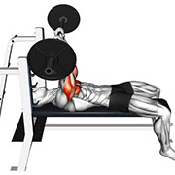  JM Press (Barbell)  Triceps | 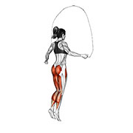  Jump Rope  Cardio | 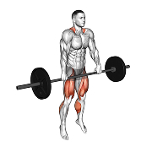  Jump Shrug  Full Body
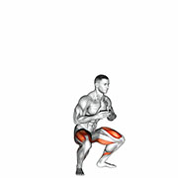  Jump Squat  Quadriceps | 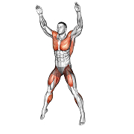  Jumping Jack  Full Body | 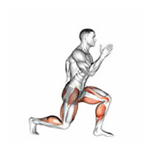  Jumping Lunge  Quadriceps
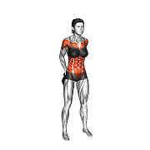  Kettlebell Around the World  Shoulders | 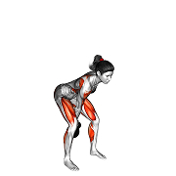  Kettlebell Clean  Full Body | 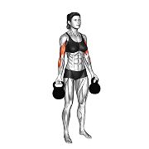  Kettlebell Curl  Biceps
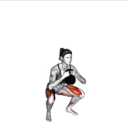  Kettlebell Goblet Squat  Quadriceps | 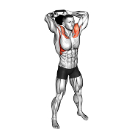  Kettlebell Halo  Shoulders | 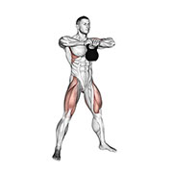  Kettlebell High Pull  Full Body
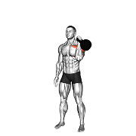  Kettlebell Shoulder Press  Shoulders | 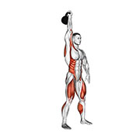  Kettlebell Snatch  Full Body | 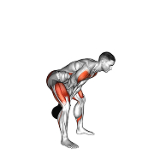  Kettlebell Swing  Full Body
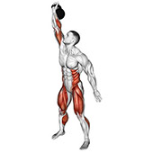  Kettlebell Turkish Get Up  Full Body | 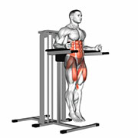  Knee Raise Parallel Bars  Abdominals | 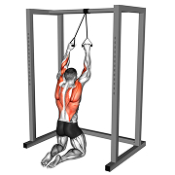  Kneeling Pulldown (band)  Lats
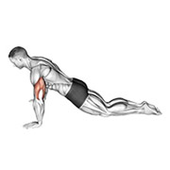  Kneeling Push Up  Chest | 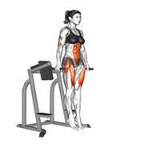  L-Sit Hold  Abdominals | 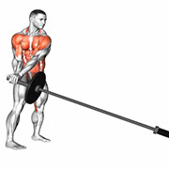  Landmine 180  Abdominals
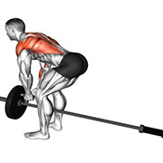  Landmine Row  Upper Back | 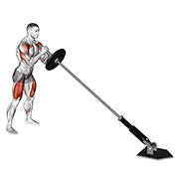  Landmine Squat and Press  Full Body | 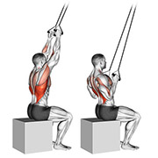  Lat Pulldown (Band)  Lats
  Lat Pulldown (Cable)  Lats | 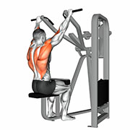  Lat Pulldown (Machine)  Lats | 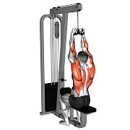  Lat Pulldown - Close Grip (Cable)  Lats
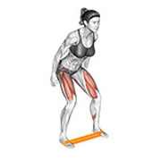  Lateral Band Walks  Glutes | 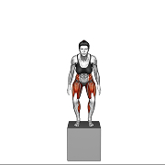  Lateral Box Jump  Quadriceps | 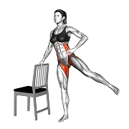  Lateral Leg Raises  Glutes
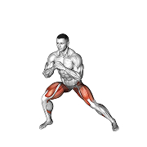  Lateral Lunge  Quadriceps | 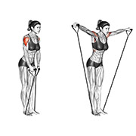  Lateral Raise (Band)  Shoulders | 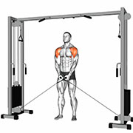  Lateral Raise (Cable)  Shoulders
  Lateral Raise (Dumbbell)  Shoulders | 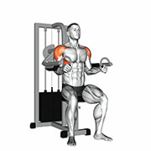  Lateral Raise (Machine)  Shoulders | 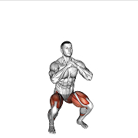  Lateral Squat  Quadriceps
  Leg Extension (Machine)  Quadriceps |   Leg Press (Machine)  Quadriceps | 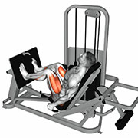  Leg Press Horizontal (Machine)  Quadriceps
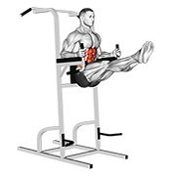  Leg Raise Parallel Bars  Abdominals | 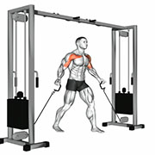  Low Cable Fly Crossovers  Chest | 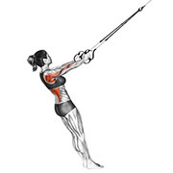  Low Row (Suspension)  Upper Back
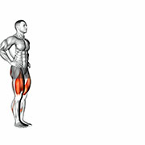  Lunge  Quadriceps | 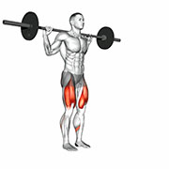  Lunge (Barbell)  Quadriceps | 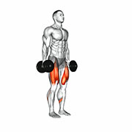  Lunge (Dumbbell)  Quadriceps
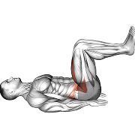  Lying Knee Raise  Abdominals |   Lying Leg Curl (Machine)  Hamstrings | 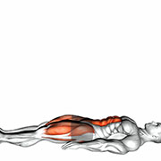  Lying Leg Raise  Abdominals
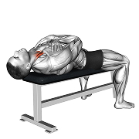  Lying Neck Curls  Neck | 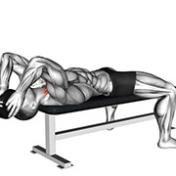  Lying Neck Curls (Weighted)  Neck | 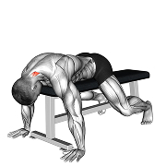  Lying Neck Extension  Neck
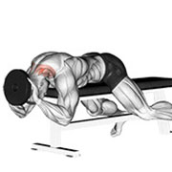  Lying Neck Extension (Weighted)  Neck | 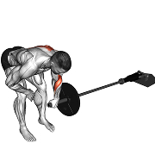  Meadows Rows (Barbell)  Upper Back | 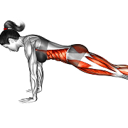  Mountain Climber  Full Body
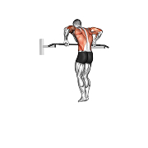  Muscle Up  Full Body | 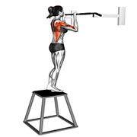  Negative Pull Up  Lats | 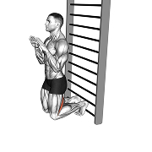  Nordic Hamstrings Curls  Hamstrings
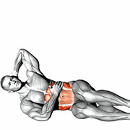  Oblique Crunch  Abdominals | 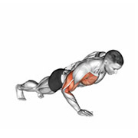  One Arm Push Up  Chest | 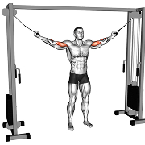  Overhead Curl (Cable)  Biceps
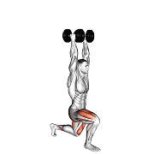  Overhead Dumbbell Lunge  Quadriceps | 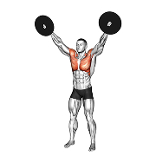  Overhead Plate Raise  Shoulders | 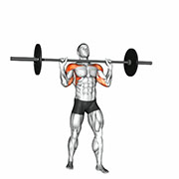  Overhead Press (Barbell)  Shoulders
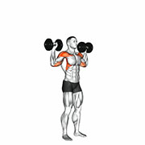  Overhead Press (Dumbbell)  Shoulders | 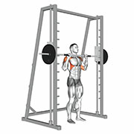  Overhead Press (Smith Machine)  Shoulders | 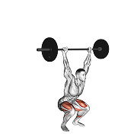  Overhead Squat  Full Body
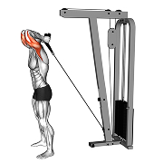  Overhead Triceps Extension (Cable)  Triceps | 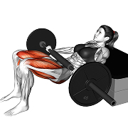  Partial Glute Bridge (Barbell)  Glutes | 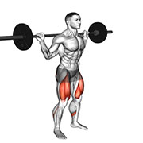  Pause Squat (Barbell)  Quadriceps
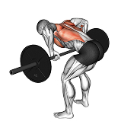  Pendlay Row (Barbell)  Upper Back | 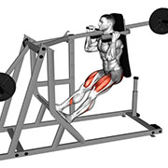  Pendulum Squat (Machine)  Quadriceps | 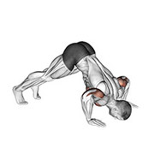  Pike Pushup  Shoulders
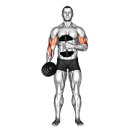  Pinwheel Curl (Dumbbell)  Biceps | 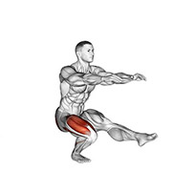  Pistol Squat  Quadriceps | 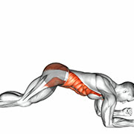  Plank  Abdominals
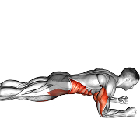  Plank Pushup  Chest | 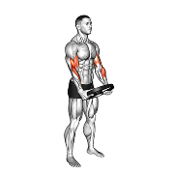  Plate Curl  Biceps | 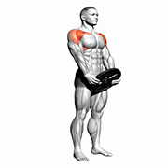  Plate Front Raise  Shoulders
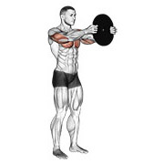  Plate Press  Chest | 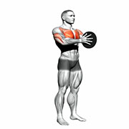  Plate Squeeze (Svend Press)  Chest | 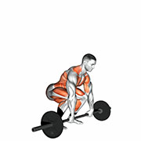  Power Clean  Full Body
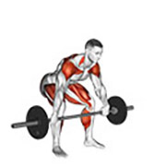  Power Snatch  Full Body | 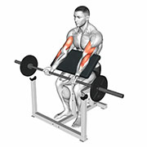  Preacher Curl (Barbell)  Biceps | 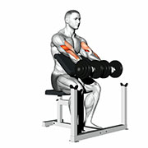  Preacher Curl (Dumbbell)  Biceps
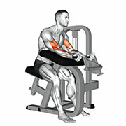  Preacher Curl (Machine)  Biceps | 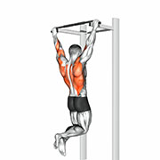  Pull Up  Lats | 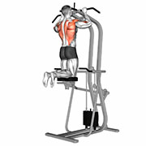  Pull Up (Assisted)  Lats
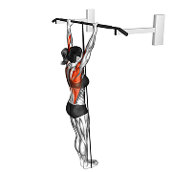  Pull Up (Band)  Lats | 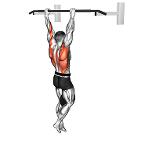  Pull Up (Weighted)  Lats | 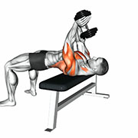  Pullover (Dumbbell)  Lats
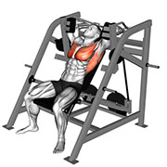  Pullover (Machine)  Lats | 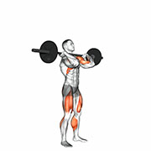  Push Press  Shoulders | 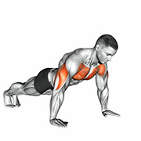  Push Up  Chest
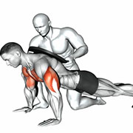  Push Up (Weighted)  Chest | 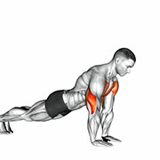  Push Up - Close Grip  Chest | 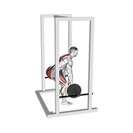  Rack Pull  Upper Back
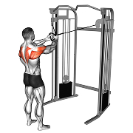  Rear Delt Reverse Fly (Cable)  Shoulders | 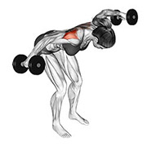  Rear Delt Reverse Fly (Dumbbell)  Shoulders | 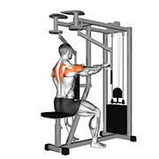  Rear Delt Reverse Fly (Machine)  Shoulders
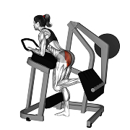  Rear Kick (Machine)  Glutes | 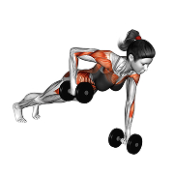  Renegade Row (Dumbbell)  Upper Back | 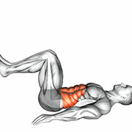  Reverse Crunch  Abdominals
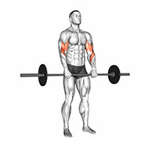  Reverse Curl (Barbell)  Biceps | 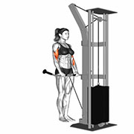  Reverse Curl (Cable)  Biceps | 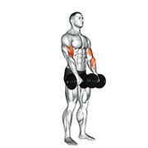  Reverse Curl (Dumbbell)  Biceps
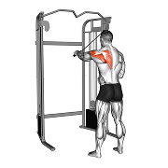  Reverse Fly Single Arm (Cable)  Shoulders | 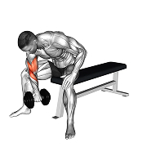  Reverse Grip Concentration Curl  Biceps | 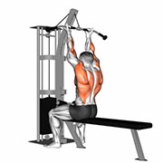  Reverse Grip Lat Pulldown (Cable)  Lats
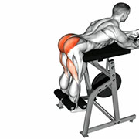  Reverse Hyperextension  Glutes | 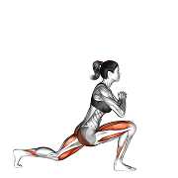  Reverse Lunge  Quadriceps | 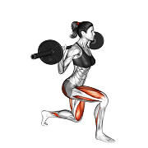  Reverse Lunge (Barbell)  Quadriceps
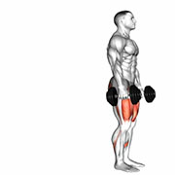  Reverse Lunge (Dumbbell)  Quadriceps | 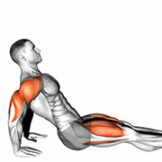  Reverse Plank  Abdominals | 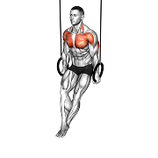  Ring Dips  Chest
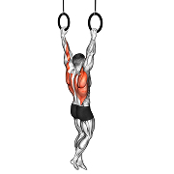  Ring Pull Up  Lats | 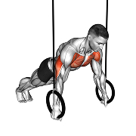  Ring Push Up  Chest | 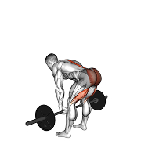  Romanian Deadlift (Barbell)  Hamstrings
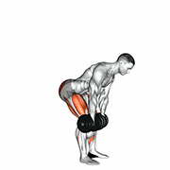  Romanian Deadlift (Dumbbell)  Hamstrings | 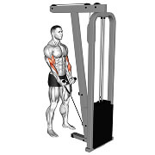  Rope Cable Curl  Biceps | 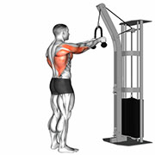  Rope Straight Arm Pulldown  Lats
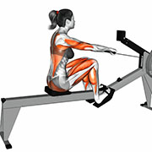  Rowing Machine  Cardio | 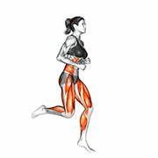  Running  Cardio | 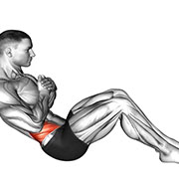  Russian Twist (Bodyweight)  Abdominals
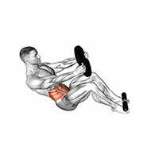  Russian Twist (Weighted)  Abdominals | 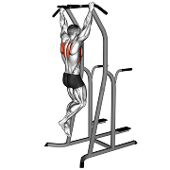  Scapular Pull Ups  Upper Back | 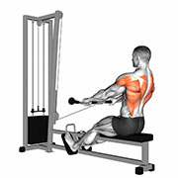  Seated Cable Row - Bar Grip  Upper Back
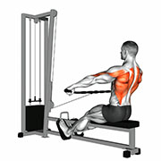  Seated Cable Row - Bar Wide Grip  Upper Back |   Seated Cable Row - V Grip (Cable)  Upper Back | 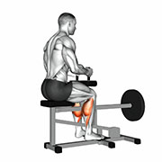  Seated Calf Raise  Calves
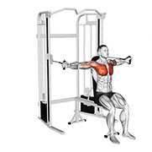  Seated Chest Flys (Cable)  Chest | 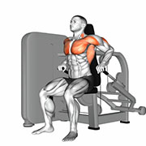  Seated Dip Machine  Triceps | 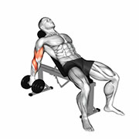  Seated Incline Curl (Dumbbell)  Biceps
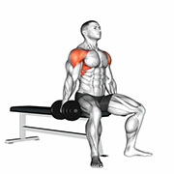  Seated Lateral Raise (Dumbbell)  Shoulders |   Seated Leg Curl (Machine)  Hamstrings | 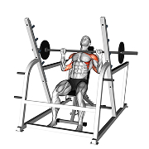  Seated Overhead Press (Barbell)  Shoulders
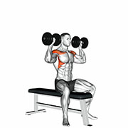  Seated Overhead Press (Dumbbell)  Shoulders | 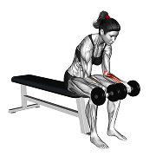  Seated Palms Up Wrist Curl  Forearms | 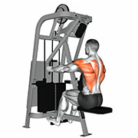  Seated Row (Machine)  Upper Back
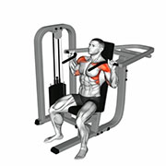  Seated Shoulder Press (Machine)  Shoulders | 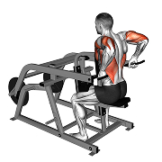  Seated Triceps Press  Triceps | 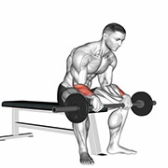  Seated Wrist Extension (Barbell)  Forearms
  Shoulder Press (Dumbbell)  Shoulders | 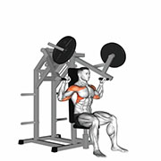  Shoulder Press (Machine Plates)  Shoulders | 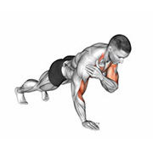  Shoulder Taps  Shoulders
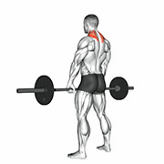  Shrug (Barbell)  Traps | 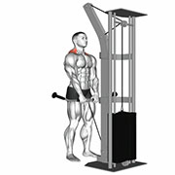  Shrug (Cable)  Traps | 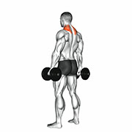  Shrug (Dumbbell)  Traps
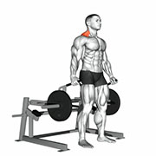  Shrug (Machine)  Traps | 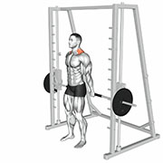  Shrug (Smith Machine)  Traps | 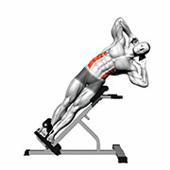  Side Bend  Abdominals
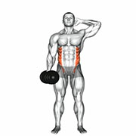  Side Bend (Dumbbell)  Abdominals | 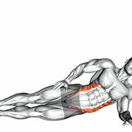  Side Plank  Abdominals | 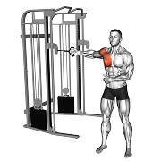  Single Arm Cable Crossover  Chest
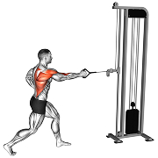  Single Arm Cable Row  Upper Back | 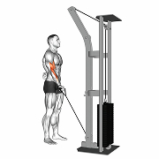  Single Arm Curl (Cable)  Biceps | 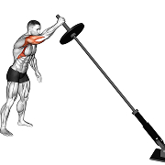  Single Arm Landmine Press (Barbell)  Shoulders
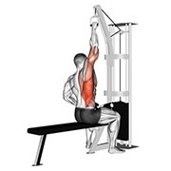  Single Arm Lat Pulldown  Lats | 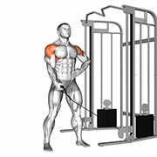  Single Arm Lateral Raise (Cable)  Shoulders | 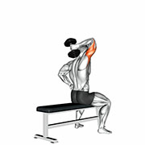  Single Arm Tricep Extension (Dumbbell)  Triceps
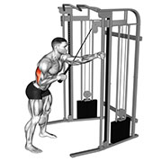  Single Arm Triceps Pushdown (Cable)  Triceps | 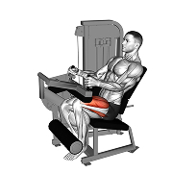  Single Leg Extensions  Quadriceps | 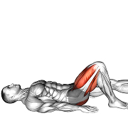  Single Leg Glute Bridge  Glutes
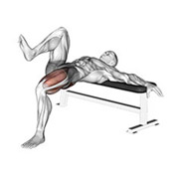  Single Leg Hip Thrust  Glutes | 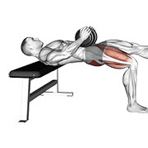  Single Leg Hip Thrust (Dumbbell)  Glutes | 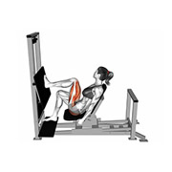  Single Leg Press (Machine)  Quadriceps
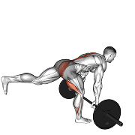  Single Leg Romanian Deadlift (Barbell)  Hamstrings | 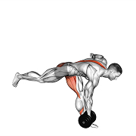  Single Leg Romanian Deadlift (Dumbbell)  Hamstrings | 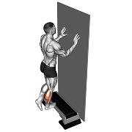  Single Leg Standing Calf Raise  Calves
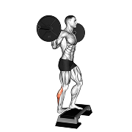  Single Leg Standing Calf Raise (Barbell)  Calves | 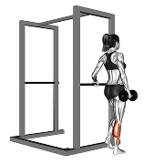  Single Leg Standing Calf Raise (Dumbbell)  Calves | 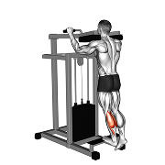  Single Leg Standing Calf Raise (Machine)  Calves
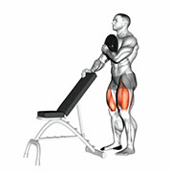  Sissy Squat (Weighted)  Quadriceps | 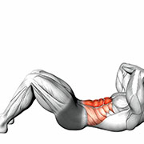  Sit Up  Abdominals | 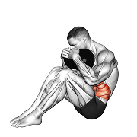  Sit Up (Weighted)  Abdominals
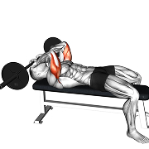  Skullcrusher (Barbell)  Triceps | 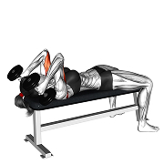  Skullcrusher (Dumbbell)  Triceps | 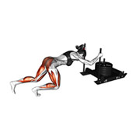  Sled Push  Full Body
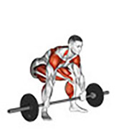  Snatch  Full Body | 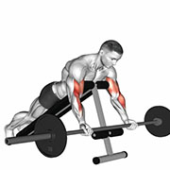  Spider Curl (Barbell)  Biceps | 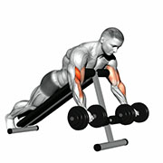  Spider Curl (Dumbbell)  Biceps
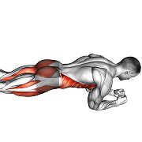  Spiderman  Abdominals | 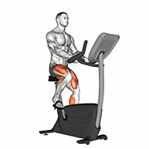  Spinning  Cardio | 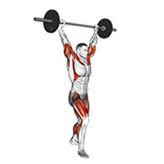  Split Jerk  Full Body
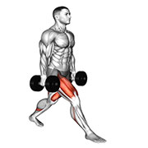  Split Squat (Dumbbell)  Quadriceps | 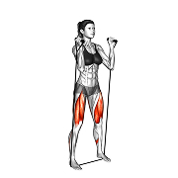  Squat (Band)  Quadriceps |   Squat (Barbell)  Quadriceps
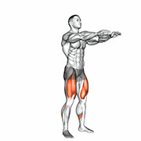  Squat (Bodyweight)  Quadriceps | 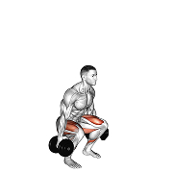  Squat (Dumbbell)  Quadriceps | 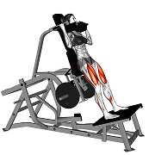  Squat (Machine)  Quadriceps
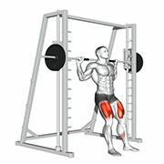  Squat (Smith Machine)  Quadriceps | 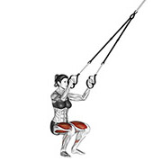  Squat (Suspension)  Quadriceps | 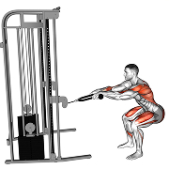  Squat Row  Full Body
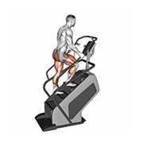  Stair Machine (Floors)  Cardio |   Stair Machine (Steps)  Cardio | 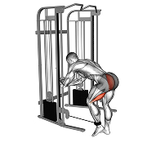  Standing Cable Glute Kickbacks  Glutes
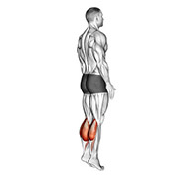  Standing Calf Raise  Calves | 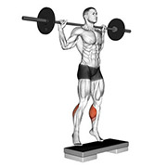  Standing Calf Raise (Barbell)  Calves | 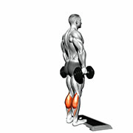  Standing Calf Raise (Dumbbell)  Calves
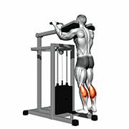  Standing Calf Raise (Machine)  Calves | 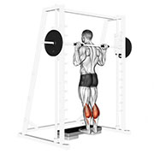  Standing Calf Raise (Smith)  Calves | 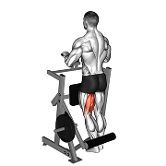  Standing Leg Curls  Hamstrings
  Standing Military Press (Barbell)  Shoulders | 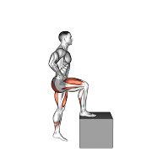  Step Up  Quadriceps | 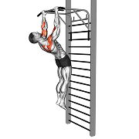  Sternum Pull up (Gironda)  Lats
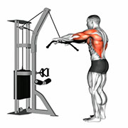  Straight Arm Lat Pulldown (Cable)  Lats | 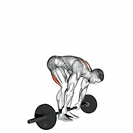  Straight Leg Deadlift  Hamstrings | 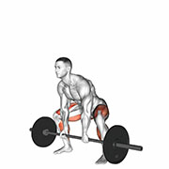  Sumo Deadlift  Glutes
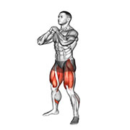  Sumo Squat  Quadriceps | 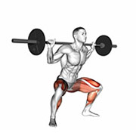  Sumo Squat (Barbell)  Quadriceps | 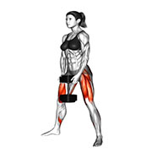  Sumo Squat (Dumbbell)  Quadriceps
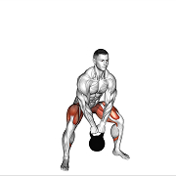  Sumo Squat (Kettlebell)  Quadriceps | 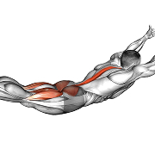  Superman  Lower Back | 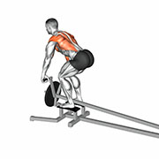  T Bar Row  Upper Back
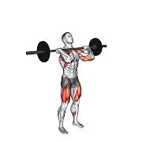  Thruster (Barbell)  Full Body | 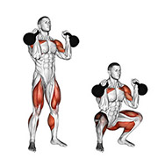  Thruster (Kettlebell)  Full Body | 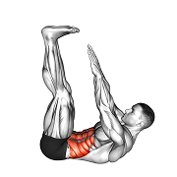  Toe Touch  Abdominals
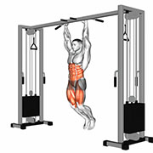  Toes to Bar  Abdominals | 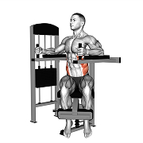  Torso Rotation  Abdominals | 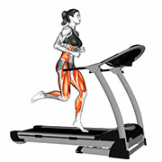  Treadmill  Cardio
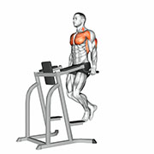  Triceps Dip  Triceps | 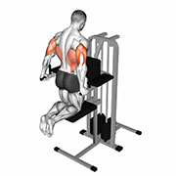  Triceps Dip (Assisted)  Triceps |   Triceps Dip (Weighted)  Triceps
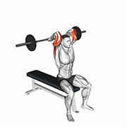  Triceps Extension (Barbell)  Triceps | 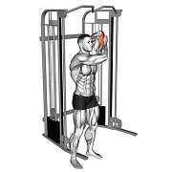  Triceps Extension (Cable)  Triceps | 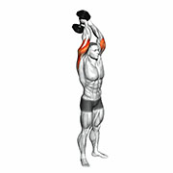  Triceps Extension (Dumbbell)  Triceps
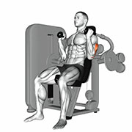  Triceps Extension (Machine)  Triceps | 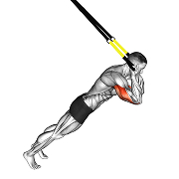  Triceps Extension (Suspension)  Triceps | 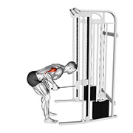  Triceps Kickback (Cable)  Triceps
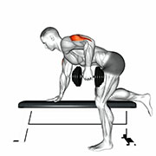  Triceps Kickback (Dumbbell)  Triceps | 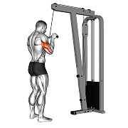  Triceps Pressdown  Triceps |   Triceps Pushdown  Triceps
  Triceps Rope Pushdown  Triceps | 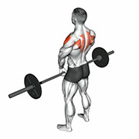  Upright Row (Barbell)  Shoulders | 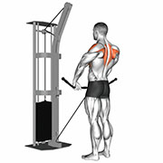  Upright Row (Cable)  Shoulders
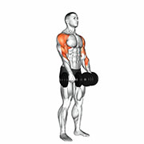  Upright Row (Dumbbell)  Shoulders | 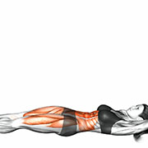  V Up  Abdominals | 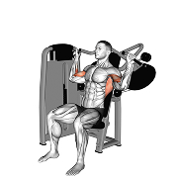  Vertical Traction (Machine)  Lats
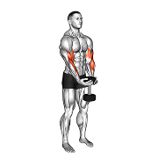  Waiter Curl (Dumbbell)  Biceps |   Walking Lunge  Quadriceps | 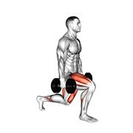  Walking Lunge (Dumbbell)  Quadriceps
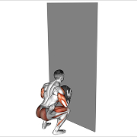  Wall Ball  Full Body | 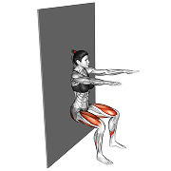  Wall Sit  Quadriceps | 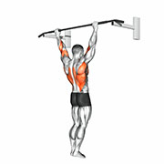  Wide Pull Up  Lats
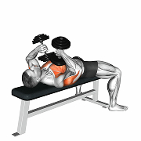  Wide-Elbow Triceps Press (Dumbbell)  Triceps | 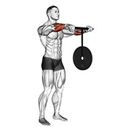  Wrist Roller  Forearms | 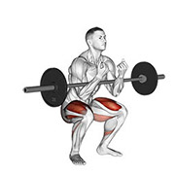  Zercher Squat  Quadriceps
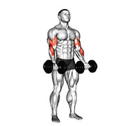
Zottman Curl (Dumbbell)
Biceps

