1Rajesh Kumar Kaushal and 2Naveen Kumar

1,2Chitkara University Institute of Engineering and Technology, Chitkara University, Punjab, India [rajesh.kaushal@chitkara.edu.in](mailto:rajesh.kaushal@chitkara.edu.in), [naveen.sharma@chitkara.edu.in](mailto:naveen.sharma@chitkara.edu.in)* (corresponding author)

[1]

Convergence of Blockchain and Internet of Things Using Hyperledger Fabric

*Abstract*— Internet of Things (IoT) is becoming increasingly significant and has the ability to benefit society. It offers several benefits such as interconnectivity, ubiquity, data generation, automation, real time monitoring, predictive analysis and resource optimization. It can be used in a variety of settings, such as buildings, businesses, healthcare, agriculture, and transportation, among others. Its widespread use makes it a flexible and potent technology. Due to its potential to revolutionize healthcare delivery, improve patient outcomes, increase operational efficiency, and lower costs, the IOT is crucial for the healthcare industry. While IoT-based healthcare solutions have numerous advantages, there are also a number of problems and difficulties that must be properly resolved in order for them to be successfully implemented and used. The primary concern is security and privacy. Integration of blockchain and IOT can be highly useful in various healthcare industry by addressing critical issues related to security, trust, data integrity, and automation. The primary objective of this study is to demonstrate how IOT based healthcare sensors can communicate with blockchain networks to make the whole healthcare eco-system highly secure and efficient. Initially, effective blockchain framework and RPM (Remote Patient Monitoring) sensors were identified. This study deployed Hyperledger fabric framework to implement the RPM system. Thereafter, two experiments were conducted and it is found that there was no packet loss when RPM transactions were sent to blockchain network at the speed of 2 transactions per minutes but the system encounter with packet loss at 5 transactions per minute.

*Index Terms*— Blockchain, Hyperledger Fabric, Blockchain Framework, Remote Patient Monitoring

# introduction

Internet of Things (IoT) describes how various gadgets are connected to the internet. These gadgets are known as smart devices and helps to gather and exchange data with one another and store information on either a centralized system or on a cloud platform. Because of its uniqueness and specific qualities, the Internet of Things (IoT) is becoming increasingly significant and has the ability to benefit society [1]. It offers several benefits such as interconnectivity, ubiquity, data generation, automation, real time monitoring, predictive analysis and resource optimization. Almost every element of

our life could be affected by IoT. It can be used in a variety of settings, such as buildings, businesses, healthcare, agriculture, and transportation, among others. Its widespread use makes it a flexible and potent technology [2][3].

Due to its potential to revolutionize healthcare delivery, improve patient outcomes, increase operational efficiency, and lower costs, the Internet of Things (IoT) is crucial for the healthcare industry. Patients' vital signs and health data can be continuously monitored with the use of IoT devices like wearable fitness trackers and medical sensors. The ability to monitor patients remotely is made possible by the real-time data that may be sent to healthcare professionals [4]. As it can assist in detecting and addressing health issues early on, it is particularly beneficial for patients with chronic diseases, the elderly, or those recovering from surgery.

IoT devices have the ability to provide warnings and messages in response to abnormalities in patient data or predefined thresholds. Alerts concerning critical circumstances can be sent to healthcare professionals, enabling them to act quickly and give timely medical care and thus perhaps saving lives. IoT-generated data can give healthcare practitioners a more thorough understanding of a patient's health over time, allowing them to customize treatment regimens and treatments. Better patient outcomes and more effective treatments may result from this personalized strategy [5].

IoT can help cut costs by streamlining healthcare processes, increasing treatment effectiveness, and reducing hospital readmissions through early intervention [6][7]. Additionally, it can facilitate the transition from reactive to proactive healthcare, which over time may prove to be more cost-effective . While IoT-based healthcare solutions have numerous advantages, there are also a number of problems and difficulties that must be properly resolved in order for them to be successfully implemented and used. The primary concern is security and privacy. Cyberattacks may target IoT devices. There are serious hazards to patient safety and privacy when medical devices are tampered with or when patient data is accessed without authorization.

Moreover, patients might not always be entirely aware of the extent to which IoT devices gather, use, and share their health data. To safeguard patient privacy, it is critical to give clear, transparent information and get informed permission.

Integration of blockchain and IOT can be highly useful in various healthcare industry by addressing critical issues related to security, trust, data integrity, and automation [8][9]. A tamper-resistant and immutable ledger can be created by IoT devices by simply recording data onto the blockchain. Unauthorized parties find it very challenging to change or remove data once it has been put to the blockchain. To safeguard data during transmission between IoT devices and the blockchain and avoid eavesdropping, blockchain networks use powerful encryption algorithms. Blockchain makes it possible to validate data using cryptographic hashes.

IoT devices can store data along with cryptographic signatures and thus enabling validity and integrity of the data. Data history, including where and when it was created, is preserved on the blockchain. This ensures transparency and auditability. Blockchain eliminates the need for middlemen or centralized authorities to validate and trust data. This can boost efficiency and cut expenses for IoT applications. It is clear that there are several issues when IOT is used alone for healthcare solution but amalgamation of IOT and blockchain can efficiently resolve all these issues [10]. The primary objective of this study is to demonstrate how IOT based healthcare sensors can communicate with blockchain networks to make the whole healthcare eco-system highly secure. Normal systems and blockchain based IOT system are different as blockchain systems are decentralized, more secure and immutable.

# related work

Blockchain technology has the potential to significantly improve the security and functionality of IoT-based healthcare solutions. In order to securely store healthcare data produced by IoT devices, blockchain offers a tamper-proof and immutable ledger. When data is stored on the blockchain, it cannot be changed or removed without consensus and thus preserving the integrity of the data. Through the use of smart contracts on the blockchain, IoT devices may communicate directly with one another and carry out preset tasks without the need for middlemen, making the entire ecosystem very secure. In order to comply with data privacy laws, users and patients can control and monitor who has access to their IoT-generated personal or health data.

Several attempts has been made in the past to offer blockchain and IOT based healthcare solutions. In order to enhance security, interoperability, data management, and patient privacy, blockchain-based healthcare solutions are being investigated and put into practice across many facets of the healthcare sector. Some of these facets are listed below.

1. Drug traceability and authentication
2. Clinical trials and research data sharing
3. IOT based medication adherence and prescription verification
4. Healthcare supply chain management
5. IOT based wireless sensor deployment for health monitoring

Even after wide exploration of blockchain and IOT based healthcare applications, still there is one crucial area which is untouched and unaddressed and needs immediate attention. This area is integration of IOT based remote patient monitoring (RPM) with blockchain networks. The efficiency, security, and privacy of remote patient monitoring in healthcare could all be improved by blockchain technology. For the purpose of monitoring and care management, RPM entails the use of linked devices and digital health technology to gather and communicate patient data from a distance to healthcare providers.

The biggest challenge while integrating blockchain with IOT is to carefully choose which blockchain framework is to be used for the underlying solution. There are several blockchain frameworks and each has its own pros and cons. These frameworks are Ethereum, Hyperledger fabric, Quorum, Hyperledger Sawtooth, R3 corda and Parity. The Ethereum blockchain serves as a decentralized platform for creating and implementing smart contracts and decentralized applications (DApps). Quorum is a blockchain platform with an enterprise focus created for use cases requiring high performance, security, and privacy. While it is built on the Ethereum source, it is modified to satisfy the unique requirements of businesses and financial institutions. An open-source blockchain technology called Hyperledger Sawtooth was created as part of the Hyperledger project of the Linux Foundation. Its objective is to offer an adaptable and modular platform for developing distributed ledger applications and blockchain networks. R3 Corda is an open-source blockchain platform made for companies, especially those in the corporate and financial services industries. Its main goal is to make peer-to-peer transactions and contracts between users of a network secure, confidential, and effective. To promote the Ethereum ecosystem and blockchain development in general, Parity Ethereum aims to provide dependable, high-performance blockchain infrastructure and tools.

Due to several similar blockchain frameworks it is important to compare their performance before choosing one of them. Table 1 illustrates the comparison of these frameworks.

Table 1. Blockchain framework performance comparison

|  |  |  |  |  |  |  |  |  |
| --- | --- | --- | --- | --- | --- | --- | --- | --- |
| Ref. | 1 | 2 | 3 | 4 | 5 | 6 | 7 | Outcome |
| [11] | Tick outline | Tick outline | Close outline | Close outline | Close outline | Close outline | Close outline | Hyperledger Outshined |
| [12] | Tick outline | Tick outline | Close outline | Close outline | Close outline | Close outline | Close outline | Hyperledger Outshined |
| [13] | Tick outline | Tick outline | Close outline | Close outline | Close outline | Close outline | Close outline | Hyperledger Outshined |
| [14] | Tick outline | Tick outline | Close outline | Close outline | Tick outline | Close outline | Tick outline | Corda outperformed in latency and fabric in throughput |
| [15] | Close outline | Tick outline | Tick outline | Close outline | Close outline | Close outline | Close outline | Hyperledger Outshined |
| [16] | Close outline | Tick outline | Tick outline | Tick outline | Close outline | Close outline | Close outline | Hyperledger Outshined |
| [17] | Tick outline | Tick outline | Close outline | Close outline | Close outline | Close outline | Close outline | Hyperledger Outshined |
| [18] | Tick outline | Tick outline | Close outline | Close outline | Close outline | Tick outline | Close outline | Hyperledger Outshined |

Note: 1 as Ethereum, 2 as Fabric, 3 as Hyperledger Sawtooth, 4 as Hyperledger Iroha, 5 as R3 Corda, 6 as Parity and 7 as Quorum.

# methodology

To demonstrate the way to implement the blockchain and IOT based healthcare solution for remote patient monitoring, a hyperledger fabric scenario has been designed along with a careful selection of necessary components. The figure 1 illustrates this stepwise approach to implement the proposed solution.

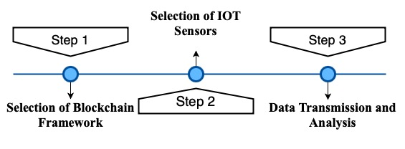

Figure 1. Stepwise approach to implement the solution.

Table 1 suggests that Hyperledger fabric is a blockchain framework which outperforms in terms of performance as compared to other frameworks. As a result of this, Hyperledger fabric is preferred in this study to implement the RPM solution. Thereafter IOT sensors were investigated and to mimic the real patient monitoring system this study is using MAX30100 pulse monitoring and DS18B20 body temperature monitoring sensors only. At last data transmission and analysis was conducted. In this study different data packets at fixed time intervals were sent from the IOT device to blockchain network and then blockchain ledger was investigated to compute the number of packets lost.

# implementation

During the implementation phase, a blockchain scenario was designed which have multiple organizations and peers. The scenario is depicted in the figure 2.

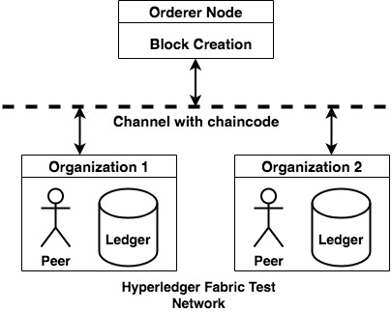

Figure 2. Blockchain network scenario to receive patient data

Linux was used to implement the scenario in Figure 2. Many dependencies, including Docker, Node.js, and chaincode definitions, are needed for the deployment of the scenario shown in Figure 2. Depending on your exact use case, network requirements, and desired programming language, the implementation method could be different.

Additionally, selecting underlying ledger technology, like couchDB or levelDB, is advised throughout implementation. Using couchDB has the benefit of enabling the issuance of queries similar to those in SQL (Structured Query Language). Tables 2 and 3, respectively, provide examples of the dependencies needed to implement the fabric and IOT-based RPM solutions.

Table 2. Dependencies for hyperledger fabric based solution

|  |  |  |
| --- | --- | --- |
| Software | Version | Purpose |
| Docker | 20.10.12 | For containerization |
| cURL | 7.71.1 | To download utilities using http |
| Ubuntu OS | 20.04 | Open source Operating system |
| NPM | 7.24.0 | To manage package versioning and download third party packages |
| Programming Language (Node.js) | 16.10.0 | A Framework of javaScript required for writing smart contracts |
| Fabric | 2.3.1 | Blockchain Framework |

The hyperledger fabric is responsible for managing both the blockchain ledger, which preserves an entire transaction history, and the global state database, which simply stores the most recent transactions. The sensors and microcontroller are required for an Internet of Things setup.

Table 3. Dependencies for IOT based healthcare solution

|  |  |  |
| --- | --- | --- |
| Sr. No. | Sensor and Microcontroller | Specifications |
| 1 | Microcontroller | Node MCU |
| 2 | Body Temperature Sensor | DS18B20 sensor, temperature range –55oC to +125oC, Input voltage 3 volt to 5.5 volt |
| 3 | Pulse Oximetry Sensor | MAX30100 sensor, measure blood oxygen level in percentage, Input voltage 3 volt to 5.5 volt |

The complete flow of communications between blockchain network and IOT based RPM system is depicted in the figure 3.

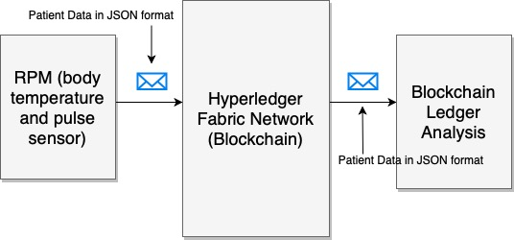

Figure 3. Communication flow

The communication initiates from the IOT system which may be located anywhere. The patient data is first transformed into a Javascript Object Notation (JSON) which is a widely used data format to share information in a client server environment. The blockchain network first authenticates the sender and then stores the transaction on the ledger.

# results

The analysis was conducted by transmitting packets and the investigating the blockchain ledger. The primary emphasis to implement and conduct the test is to evaluate how RPM systems can be integrated with blockchain and to monitor its efficiency in terms of packet lost.

The experiment was conducted for varying time durations such as 30, 60, 90, 120 and 150 minutes respectively and packet transmission rate was set to 2 packets per minute. The proposed RPM system continuously reads the patient vitals for 30 second and then stores the mean values in a JSON format and then send it to the blockchain network. The JSON packet looks like as follows.

{

PatientID: 1101,

PatientName: xyz,

Temp: 34,

Pulse: 89,

MachineID: RPM131

}

This is a trivial JSON packet to demonstrate the working of the proposed system and in a real time such packets may be more complex. A total of 60 packets were transmitted within 30 minutes of duration. The success rate is depicted in the figure 3.

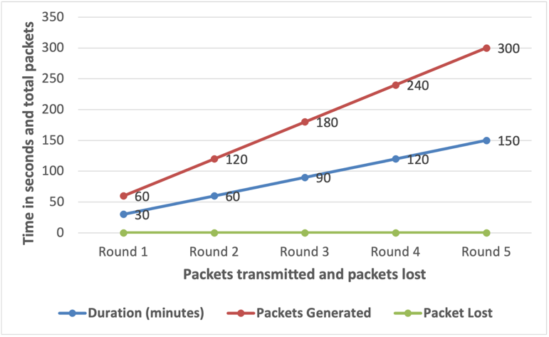

Figure 4. Efficiency of the proposed system at 2 Tx per minute

It is evident from the figure 4 that there was no packet lost during the entire communication and the proposed system performed efficiently.

Thereafter another experiment was conducted with different transaction rate. In the second experiment, the transmission rate was set to 5 transactions per minute. This indicates that the RPM system was transmitting every packet after 20 seconds to the blockchain network. This experiment was also conducted for similar time durations but the only difference is this time the transaction rate was different. The JSON packet format was also identical. The results are depicted in the figure 5. It is evident from the figure 5 that after changing the transmission rate few packets were lost.

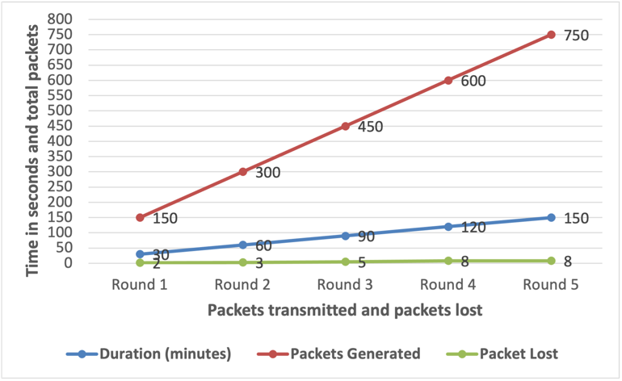

Figure 5. Efficiency of the proposed system at 5 Tx per minute

The figure 5 shows a minor packet loss such as 2 packets were lost during the round 1 and then 3, 5, 8 and 8 packets were lost during round 2, round 3, round 4 and round 5 respectively.

# conclusion

This study describes a methodical approach to implementing an IOT-based RPM system with blockchain to remotely monitor patients' health while maintaining confidentiality and privacy. In this study, huge number of packets are generated which are cryptographically stored and almost impossible to tamper. This study has not implemented any encryption method but still data is encrypted before being stored on the ledger due to inherent features of Hyperledger fabric blockchain framework. This study also claims that it is difficult to monitor the reason for packet loss as there are multiple possibilities such as poor internet connectivity, issues with IOT system (microcontroller and sensors) or the issues with the blockchain network. Future studies may attempt to find ways to identify which side of the network is causing problems. Moreover, in future artificial intelligence can deployed along with blockchain and IOT to enable the overall system to make decisions automatically. This amalgamation may offer highly intelligent RPM devices.

# REFERENCES

[1] A. Rejeb et al., ‘The Internet of Things (IoT) in healthcare: Taking stock and moving forward’, Internet of Things, p. 100721, 2023.

[2] A. Belfiore, C. Cuccurullo, and M. Aria, ‘IoT in healthcare: A scientometric analysis’, Technological Forecasting and Social Change, vol. 184, p. 122001, 2022.

[3] Y. Asiri, H. T. Halawani, A. D. Algarni, and A. A. Alanazi, ‘IoT enabled healthcare environment using intelligent deep learning enabled skin lesion diagnosis model’, Alexandria Engineering Journal, vol. 78, pp. 35–44, 2023.

[4] Q Fan, C - Zhang, Y Xie - L. Zhu, Y. Zhou and X. Liu, "Enabling efficient and secure health data sharing for Healthcare IoT systems" - Future Generation Computer Systems, Vol. 149, pp 304–316, 2023.

[5] D. Verma - "Internet of things in nano integrated wearable biosensor devices for healthcare applications", Biosensors and Bioelectronics, Vol. 11, pp 100153, 2022.

[6] K. Kasat, D. L. Rani, B. Khan, A. J, M. K. Kirubakaran, and P. Malathi, ‘A novel security framework for healthcare data through IOT sensors’, Measurement: Sensors, vol. 24, p. 100535, 2022.

[7] P. Kaur, ‘Internet of things (IoT) and big data analytics (BDA) in healthcare’, in Digital Transformation in Healthcare in Post-Covid-19 Times, M. D. Lytras, A. A. Housawi, and B. S. Alsaywid, Eds. Academic Press, 2023, pp. 45–57.

[8] A. Tomar, N. Gupta, D. Rani, and S. Tripathi, ‘Blockchain-assisted authenticated key agreement scheme for IoT-based healthcare system’, Internet of Things, vol. 23, p. 100849, 2023.

[9] E. M. Adere, ‘Blockchain in healthcare and IoT: A systematic literature review’, Array, vol. 14, p. 100139, 2022.

[10] A. I. Taloba et al., ‘A blockchain-based hybrid platform for multimedia data processing in IoT-Healthcare’, Alexandria Engineering Journal, vol. 65, pp. 263–274, 2023.

[11] S. Pongnumkul et. al., 'Performance-analysis of private. blockchain-platforms in varying workloads:' in *2017 26th International Conference on Computer Communication and Networks (ICCCN)*, 2017, pp. 1–6.

[12] Y. Hao, Y. Li, X. Dong, L. Fang, and P. Chen, “Performance analysis of consensus algorithm in private blockchain,” in *2018 IEEE Intelligent Vehicles Symposium (IV)*, 2018, pp. 280–285.

[13] M Dabbagh et. al., 'Performance-analysis of blockchain platforms, Empirical evaluation of hyperledger fabric and ethereum' in *2020 IEEE 2nd International Conference on Artificial Intelligence in Engineering and Technology (IICAIET)*, 2020, pp. 1–6.

[14] A. A. Monrat, O. Schelén, and K. Andersson, “Performance evaluation of permissioned blockchain platforms,” in *2020 IEEE Asia-Pacific Conference on Computer Science and Data Engineering (CSDE)*, 2020, pp. 1–8.

[15] O. Mendsaikhan, H. Hasegawa, Y. Yamaguchi, and H. Shimada, “Identification of cybersecurity specific content using the Doc2Vec language model,” in *2019 IEEE 43rd annual computer software and applications conference (COMPSAC)*, 2019, vol. 1, pp. 396–401.

[16] A. Woznica and M. Kedziora, “Performance and scalability evaluation of a permissioned Blockchain based on the Hyperledger Fabric, Sawtooth and Iroha,” *Comput. Sci. Inf. Syst.*, vol. 19, no. 2, pp. 659–678, 2022.

[17] P. M. Abhishek, D. G. Narayan, H. Altaf, and P. Somashekar, “Performance Evaluation of Ethereum and Hyperledger Fabric Blockchain Platforms,” in *2022 13th International Conference on Computing Communication and Networking Technologies (ICCCNT)*, 2022, pp. 1–5.

[18] Y. Liu, K. Qian, K. Wang, and L. He, “BCmaster: A Compatible Framework for Comprehensively Analyzing and Monitoring Blockchain Systems in IoT,” *IEEE Internet Things J.*, vol. 9, no. 22, pp. 22529–22546, 2022.

1.