**Software Requirements**

**Document (SRD)**

**Revision History**

|  |  |  |  |
| --- | --- | --- | --- |
| **Author** | **Date** | **Version** | **Description** |
| John Dougherty  Michael Ekaireb  Shanghai team | June 5 2012 | 0.9 | **Initial revision** |
|  |  |  |  |
|  |  |  |  |
|  |  |  |  |

**Table of Contents**

1.1 Resource Requirements 4

Hardware 4

1.2 Verification Requirements Note: to be moved to the SRD 4

Verification Requirements 4

1.3 Quality Requirements 6

Quality Requirements 6

Control system documentation, distribution, access, and use 6

1.4 Maintainability Requirements 7

1.5 Key Scenarios 7

Pertinent Types 11

Mailbox Classification 11

Device Classification 11

Type Classification 11

Create Session 12

Open Session 13

Close Session 14

Login 15

Logoff 17

Device Management 18

Create Device 18

Delete Device 19

Stat Device 21

Notification Management 22

Get Notification Headers 23

Post Notification 28

Delete Notification 30

Update Notification 32

Expunge 34

## Resource Requirements

-

|  |  |  |  |
| --- | --- | --- | --- |
|  | Hardware |  |  |
|  | The enterprise services must run on RedHat Enterprise. |  |  |
|  | The data server shall store at least 2 TB of current log files. |  |  |
|  | The data server shall support data backups. |  |  |
|  | The data server shall support a minimum of two (2) years data archive. |  |  |

## Verification Requirements Note: to be moved to the SRD

- specifies tests to be done during development, test data, test documentation to be delivered.

|  |  |  |  |
| --- | --- | --- | --- |
|  | Verification Requirements |  |  |
|  | All activities(messages) between VTS and Agent shall be logged called system logs |  |  |
|  | All activities(messages) between VTS and Ventilator should be logged, called app logs |  |  |
|  | All logs, including system logs and app logs, shall be stored locally. Agent shall transfer these logs to server when the network is available. |  |  |
|  | The system log and app log shall contain full information of the activity(message), while the BLOB part can be stored as a separated file and referenced in the log file |  |  |
|  | There shall be a MiM "man-in-the-middle" between VTS and Agent, responsible for reproducing the communication for both VTS and Agent. |  |  |
|  | MiM shall work as a bi-direction mock object where the data source is from the logs of previous communication. |  |  |
|  | MiM shall play back the logs and send the corresponding content to the other side. |  |  |
|  | When MiM is talking with Agent, it shall take the VTS system logs and BLOB files as input and provide the right response to the Agent so that it looks like the Agent is talking to the VTS. |  |  |
|  | For testing purpose, logs shall be modifiable via script language, like Lua, to simulate the different cases. |  |  |
|  | The log format shall include:   * Sender id/Module id * Session id(GUID)/Device id * User id * Action id * Date/time * Level * Message type (string, json, …) * Message |  |  |
|  | VTS shall log all communication activities with Vent. |  |  |
|  | VTS shall log all communication activities with Agent. |  |  |
|  | VTS shall interact with Agent without requiring the Ventilator. |  |  |
|  | Agent shall log all communication activities with VTS. |  |  |
|  | Agent shall interact with Server. |  |  |
|  | Server shall log all communication activities with Agent. |  |  |
|  | Server shall log all communication activities with Database. |  |  |
|  | Log server shall collect and store logs from VTS, Agent, app server and database. |  |  |
|  | Logs shall be queried and viewed via browser. |  |  |
|  | Queried logs shall be filtered, sorted and paged. |  |  |
|  | Queried logs shall be exported into CSV file or Excel file. |  |  |
|  | Logs shall be tracked by session, user and device. |  |  |
|  | Log server shall monitor the system status by analyzing the logs. |  |  |

## Quality Requirements

|  |  |  |  |
| --- | --- | --- | --- |
|  | Quality Requirements |  |  |
|  | The system shall conform to the Covidien IS quality control process. |  |  |
|  | The system shall be validated to ensure accuracy, reliability, consistent intended performance, and the ability to discern invalid or altered records. |  |  |
|  | The ability to generate accurate and complete copies of records in both human readable and electronic form is required. |  |  |
|  | Records must be protected to enable accurate and ready retrieval throughout the records retention period. |  |  |
|  | Control system documentation, distribution, access, and use |  |  |
|  | Provide revision and change control procedures to maintain an audit trail that documents time-sequenced development and modification of systems documentation. |  |  |
|  | The system shall maintain the uniqueness of identification codes and passwords. |  |  |
|  | The system shall ensure that identification codes and passwords are periodically checked, recalled, or revised. |  |  |
|  | The system shall follow loss management procedures to electronically de-authorize lost or compromised passwords |  |  |
|  | The system shall use transaction safeguards to prevent unauthorized use. |  |  |
|  | The system shall detect attempts at unauthorized use. |  |  |
|  | The system shall report attempts at unauthorized use. |  |  |
|  | Documents shall be approved in Agile. |  |  |
|  | The system handoffs between executable shall use design by contract methodology. |  |  |

## Maintainability Requirements

|  |  |  |  |
| --- | --- | --- | --- |
|  | **Maintainability** |  |  |
|  | The system shall have 70% unit test coverage. |  |  |
|  | The system shall use pattern based designs. |  |  |
|  | The source code shall be documented. |  |  |
|  | The system shall have an E/R diagram for the database. |  |  |
|  | The system shall have a systems architecture document capturing the overall system design. |  |  |
|  | The system shall use static code analysis to catch and prevent coding errors. |  |  |

## Key Scenarios

These are the connection scenarios worked out between RMS and the Netspective



Below are the key agent workflows for Sprint two. Agent internals

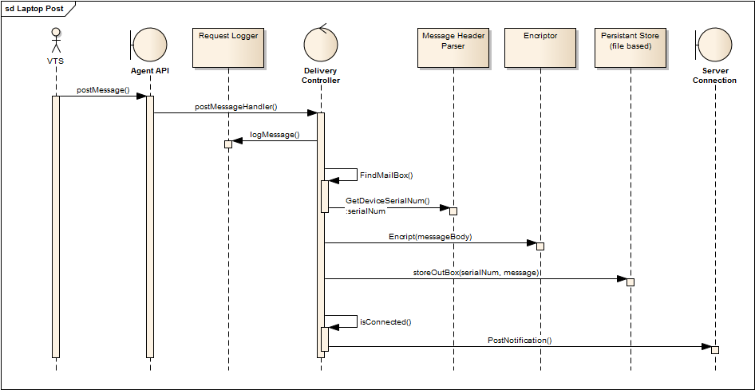

Here is the system Post Notification. The laptop agent design is based on iMAP communication mailboxes. We add a message logger the intent of the logger is to be able to completely reproduce the calls to the application so that they can be run in as a mock object to exercise the service.

The messages will be stored in a ‘mailbox’ for the device. The name of the mailbox is the device+serial number of the device. Here outgoing posts are placed in the out box, while any incoming messages will be placed into the inbox. Conceptually the mail boxes will be set up like this:

..\PB480-321324d1\inBox

..\PB480-321324d1\outBox

The body of the message will be encrypted using public-private key encryption.

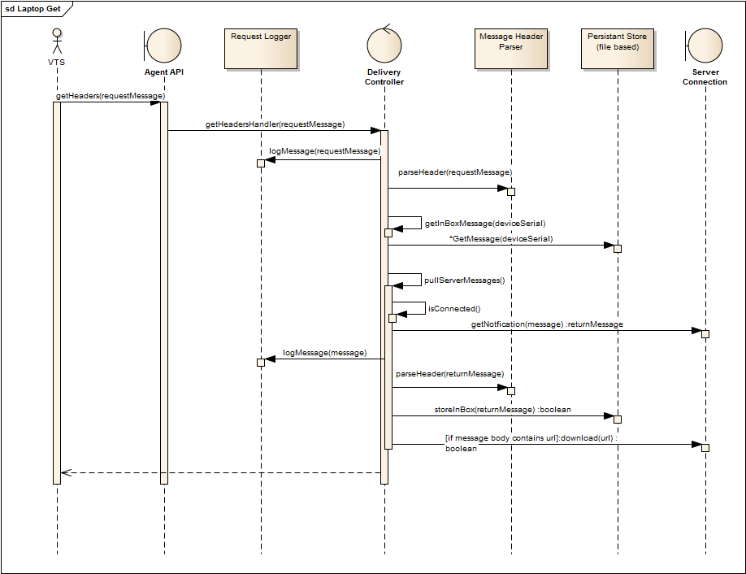

## Pertinent Types

We are using GUIDs globally unique identifiers for managing message keys.

<pertinent_type>7a85f0c9-531e-4754-ad68-04c77ed63657/86fd6b83-219a-4482-8813-191c477ccd7e</pertinent_type>

{Device Classification}/{Type Classification}

{Type Classification}

|  |  |  |
| --- | --- | --- |
| Mailbox Classification | | |
| Name | GUID | Description |
| DEVICE_INBOX | 34caa93b-6ed3-4a93-9be7-4e31eb4b22d5 | Device specific notifications coming from server. |
| DEVICE_OUTBOX | 3bd775ad-7250-42ff-adf4-188e0b691bff | Device specific notifications to be forwarded to server. |
| SYSTEM_INBOX | b20af193-6353-4cf5-95cc-e79b84d88907 | Service specific messages. |

|  |  |  |
| --- | --- | --- |
| Device Classification | | |
| Name | GUID | Description |
| PB980_VENTILATOR | 7a85f0c9-531e-4754-ad68-04c77ed63657 | Device Type = VENTILATOR  Make=PB  Model=PB980 |
| PB840_VENTILATOR | a7a65225-ef2d-48e9-89c8-6975dd7dc054 | Device Type = VENTILATOR  Make=PB  Model=PB840 |

|  |  |  |
| --- | --- | --- |
| Type Classification | | |
| Name | GUID | Description |
| DEVICE_SOFTWARE | 24637560-edb3-4961-b17d-14e74f74457c | Device software. |
| DEVICE_INFO | 532ffdda-6f38-41da-9a40-cb0801e6695f | Device identifying information. |
| DEVICE_FIRMWARE | a582e8a9-282a-4f49-93d1-f11547826a91 |  |

The communication interface between the Agent and its clients will be managed by the following communication contract worked out in collaboration with many team members. We agree not to make unilateral changes to this interface contract between our systems.

A session_guid id is generated by the laptop agent when the client requests a session. It is used by the laptop agent to distinguish between multiple application sessions and to assigns state to an application.

### Create Session

**Call:**

<?xml version="1.0" encoding="utf-8"?>

<message schema_version="3644767c-2632-411a-9416-44f8a7dee08e">

<request type='createsession' xaction_guid='0f16a851-a043-498d-a857-77ee5c59499c' />

</message>

**Response:**

On success, a new session GUID is returned.

<?xml version="1.0" encoding="utf-8"?>

<message schema_version="3644767c-2632-411a-9416-44f8a7dee08e" session_guid='bd86a4a2-a894-4be5-b0e4-8b9b24ba6ed3'>

<response type='param' xaction_guid='0f16a851-a043-498d-a857-77ee5c59499c' >

<params>

**<param name='session'>bd86a4a2-a894-4be5-b0e4-8b9b24ba6ed3</param>**

</params>

</response>

</message>

On failure, an error response is returned with an indication of reason.

<?xml version="1.0" encoding="utf-8"?>

<message schema_version="3644767c-2632-411a-9416-44f8a7dee08e" session_guid='bd86a4a2-a894-4be5-b0e4-8b9b24ba6ed3' >

<response type='bad' xaction_guid='0f16a851-a043-498d-a857-77ee5c59499c'>

<params>

**<param name='reason'>Error:???????</param>**

</params>

</response>

</message>

### Open Session

**Call:**

<?xml version="1.0" encoding="utf-8"?>

<message schema_version="3644767c-2632-411a-9416-44f8a7dee08e">

<request type='opensession' xaction_guid='9650e555-810d-487b-94bf-da8d2f0e334e'>

<params>

**<param name='session'>bd86a4a2-a894-4be5-b0e4-8b9b24ba6ed3</param>**

</params>

</request>

</message>

**Response:**

On success, a confirmation message indicating that a session has been opened.

<?xml version="1.0" encoding="utf-8"?>

<message schema_version="3644767c-2632-411a-9416-44f8a7dee08e" session_guid='bd86a4a2-a894-4be5-b0e4-8b9b24ba6ed3' >

<response type='ok' xaction_guid='9650e555-810d-487b-94bf-da8d2f0e334e'/>

</message>

On failure, an error response is returned with an indication of reason.

<?xml version="1.0" encoding="utf-8"?>

<message schema_version="3644767c-2632-411a-9416-44f8a7dee08e" session_guid='bd86a4a2-a894-4be5-b0e4-8b9b24ba6ed3' >

<response type='bad' xaction_guid='0f16a851-a043-498d-a857-77ee5c59499c'>

<params>

**<param name='reason'>Error:???????</param>**

</params>

</response>

</message>

### Close Session

**Call:**

<?xml version="1.0" encoding="utf-8"?>

<message schema_version="3644767c-2632-411a-9416-44f8a7dee08e" session_guid='bd86a4a2-a894-4be5-b0e4-8b9b24ba6ed3'>

<request type='closesession' xaction_guid='9650e555-810d-487b-94bf-da8d2f0e334e'/>

</message>

**Response:**

On success, a confirmation message indicating that the session is closed.

<?xml version="1.0" encoding="utf-8"?>

<message schema_version="3644767c-2632-411a-9416-44f8a7dee08e">

<response type='ok' xaction_guid='9650e555-810d-487b-94bf-da8d2f0e334e'/>

</message>

On failure, an error response is returned with an indication of reason.

<?xml version="1.0" encoding="utf-8"?>

<message schema_version="3644767c-2632-411a-9416-44f8a7dee08e" session_guid='bd86a4a2-a894-4be5-b0e4-8b9b24ba6ed3' >

<response type='bad' xaction_guid='0f16a851-a043-498d-a857-77ee5c59499c'>

<params>

**<param name='reason'>Error:???????</param>**

</params>

</response>

</message>

### Login

The Login command is used to identify and authenticate a user, associating him/her to a session.

**Call:**

<?xml version="1.0" encoding="utf-8"?>

<message schema_version="3644767c-2632-411a-9416-44f8a7dee08e" session_guid='bd86a4a2-a894-4be5-b0e4-8b9b24ba6ed3'>

<request type='login' xaction_guid='e1c38f30-50a0-4ccf-a74a-c7ec11b54544'>

<params>

**<param name='username'>michael.ekaireb</param>**

**<param name='password'>P@ssw0rd1</param>**

</params>

</request>

</message>

**Response:**

On success, a confirmation message indicating that the user has successfully logged in and is in the authenticated state.

<?xml version="1.0" encoding="utf-8"?>

<message schema_version="3644767c-2632-411a-9416-44f8a7dee08e" session_guid='bd86a4a2-a894-4be5-b0e4-8b9b24ba6ed3'>

<response type='ok' xaction_guid='e1c38f30-50a0-4ccf-a74a-c7ec11b54544'/>

</message>

On failure, an error response is returned with an indication of reason.

<?xml version="1.0" encoding="utf-8"?>

<message schema_version="3644767c-2632-411a-9416-44f8a7dee08e" session_guid='bd86a4a2-a894-4be5-b0e4-8b9b24ba6ed3' >

<response type='bad' xaction_guid='0f16a851-a043-498d-a857-77ee5c59499c'>

<params>

**<param name='reason'>Error:???????</param>**

</params>

</response>

</message>

### 

### Logoff

The Logoff command informs the server that a user is no longer associated with a given session.

**Call:**

<?xml version="1.0" encoding="utf-8"?>

<message schema_version="3644767c-2632-411a-9416-44f8a7dee08e" session_guid='bd86a4a2-a894-4be5-b0e4-8b9b24ba6ed3'>

<request type='logoff' xaction_guid='23b2320b-6378-4013-80fb-a05ffe199e9c'/>

</message>

**Response:**

On success, a confirmation that logoff completed, user is no longer associated.

<?xml version="1.0" encoding="utf-8"?>

<message schema_version="3644767c-2632-411a-9416-44f8a7dee08e" session_guid='bd86a4a2-a894-4be5-b0e4-8b9b24ba6ed3'>

<response type='ok' xaction_guid='23b2320b-6378-4013-80fb-a05ffe199e9c'/>

</message>

On failure, an error response is returned with an indication of reason.

<?xml version="1.0" encoding="utf-8"?>

<message schema_version="3644767c-2632-411a-9416-44f8a7dee08e" session_guid='bd86a4a2-a894-4be5-b0e4-8b9b24ba6ed3' >

<response type='bad' xaction_guid='0f16a851-a043-498d-a857-77ee5c59499c'>

<params>

**<param name='reason'>Error:???????</param>**

</params>

</response>

</message>

## Device Management

### Create Device

The Create Device command is used to create a device node, allowing the agent to know about the existence of a given device.

**Call:**

<?xml version="1.0" encoding="utf-8"?>

<message schema_version="3644767c-2632-411a-9416-44f8a7dee08e" session_guid='bd86a4a2-a894-4be5-b0e4-8b9b24ba6ed3'>

<request type='createdevice' xaction_guid='55c26878-90fb-4a4a-aa1f-3a689310771e'>

<params>

**<param name='device_uri'>{7a85f0c9-531e-4754-ad68-04c77ed63657}/{840 34567453}</param>**

</params>

</request>

</message>

**Response:**

On success, a confirmation that the device was created.

<?xml version="1.0" encoding="utf-8"?>

<message schema_version="3644767c-2632-411a-9416-44f8a7dee08e" session_guid='bd86a4a2-a894-4be5-b0e4-8b9b24ba6ed3'>

<response type='ok' xaction_guid='55c26878-90fb-4a4a-aa1f-3a689310771e'/>

</message>

On failure, an error response is returned with an indication of reason.

<?xml version="1.0" encoding="utf-8"?>

<message schema_version="3644767c-2632-411a-9416-44f8a7dee08e" session_guid='bd86a4a2-a894-4be5-b0e4-8b9b24ba6ed3' >

<response type='bad' xaction_guid='0f16a851-a043-498d-a857-77ee5c59499c'>

<params>

**<param name='reason'>Error:???????</param>**

</params>

</response>

</message>

### Delete Device

The Delete Device command is used to remove a device node, allowing the agent to forget about the existence of a given device.

**Call:**

<?xml version="1.0" encoding="utf-8"?>

<message schema_version="3644767c-2632-411a-9416-44f8a7dee08e" session_guid='bd86a4a2-a894-4be5-b0e4-8b9b24ba6ed3'>

<request type='deletedevice' xaction_guid='55c26878-90fb-4a4a-aa1f-3a689310771e'>

<params>

**<param name='device_uri'>{7a85f0c9-531e-4754-ad68-04c77ed63657}/{840 34567453}</param>**

</params>

</request>

</message>

**Response:**

On success, a confirmation that the device was deleted.

<?xml version="1.0" encoding="utf-8"?>

<message schema_version="3644767c-2632-411a-9416-44f8a7dee08e" session_guid='bd86a4a2-a894-4be5-b0e4-8b9b24ba6ed3'>

<response type='ok' xaction_guid='55c26878-90fb-4a4a-aa1f-3a689310771e'/>

</message>

On failure, an error response is returned with an indication of reason.

<?xml version="1.0" encoding="utf-8"?>

<message schema_version="3644767c-2632-411a-9416-44f8a7dee08e" session_guid='bd86a4a2-a894-4be5-b0e4-8b9b24ba6ed3' >

<response type='bad' xaction_guid='0f16a851-a043-498d-a857-77ee5c59499c'>

<params>

**<param name='reason'>Error:???????</param>**

</params>

</response>

</message>

### Stat Device

The Stat Device command is used to test the assertion that a device is known by the laptop agent.

**Call:**

<?xml version="1.0" encoding="utf-8"?>

<message schema_version="3644767c-2632-411a-9416-44f8a7dee08e" session_guid='bd86a4a2-a894-4be5-b0e4-8b9b24ba6ed3'>

<request type='statdevice' xaction_guid='55c26878-90fb-4a4a-aa1f-3a689310771e'>

<params>

<param name='device_uri'>{7a85f0c9-531e-4754-ad68-04c77ed63657}/{840 34567453}</param>

</params>

</request>

</message>

**Response:**

On success, confirmation that a device is known to system.

<?xml version="1.0" encoding="utf-8"?>

<message schema_version="3644767c-2632-411a-9416-44f8a7dee08e" session_guid='bd86a4a2-a894-4be5-b0e4-8b9b24ba6ed3'>

<response type='ok' xaction_guid='55c26878-90fb-4a4a-aa1f-3a689310771e'/>

</message>

On failure, an error response is returned with an indication of reason.

<?xml version="1.0" encoding="utf-8"?>

<message schema_version="3644767c-2632-411a-9416-44f8a7dee08e" session_guid='bd86a4a2-a894-4be5-b0e4-8b9b24ba6ed3' >

<response type='bad' xaction_guid='0f16a851-a043-498d-a857-77ee5c59499c'>

<params>

**<param name='reason'>Error:???????</param>**

</params>

</response>

</message>

## Notification Management

|  |  |
| --- | --- |
|  |  |

### Get Notification Headers

**Call:**

<?xml version="1.0" encoding="utf-8"?>

<message schema_version="3644767c-2632-411a-9416-44f8a7dee08e" session_guid='bd86a4a2-a894-4be5-b0e4-8b9b24ba6ed3'>

<request type='getheaders'

xaction_guid='55c26878-90fb-4a4a-aa1f-3a689310771e'

>

<params>

<param name='mailbox'>34caa93b-6ed3-4a93-9be7-4e31eb4b22d5</param>

<param name='device_uri'>{bc108d24-1cd7-403f-8dd4-e8e0ad816a20}/{840 34567453}</param>

</params>

</request>

</message>

**Response:**

On success, a list of notifications that is available for a given device_uri.

<?xml version="1.0" encoding="utf-8"?>

<message schema_version="3644767c-2632-411a-9416-44f8a7dee08e" session_guid='bd86a4a2-a894-4be5-b0e4-8b9b24ba6ed3'>

<response type='headers'

xaction_guid='55c26878-90fb-4a4a-aa1f-3a689310771e'>

<headers>

<notification oid='344aa359-f0ba-4f5a-b6d2-790bfd1ad95e'>

<header notification_type='command' notification_action='set'>

<pertinent_type>7a85f0c9-531e-4754-ad68-04c77ed63657/86fd6b83-219a-4482-8813-191c477ccd7e</pertinent_type>

<pertinent_identifier>840 351545678</pertinent_identifier>

<notification_id>344aa359-f0ba-4f5a-b6d2-790bfd1ad95e</notification_id>

</header>

</notification>

<notification oid='344aa359-f0ba-4f5a-b6d2-790bfd1ad95e'>

<header notification_type='command' notification_action='get'>

<pertinent_type>7a85f0c9-531e-4754-ad68-04c77ed63657/ac2b174e-f6f7-45ed-997c-35c71f74ef5b</pertinent_type>

<pertinent_identifier>840 351545678</pertinent_identifier>

<notification_id>344aa359-f0ba-4f5a-b6d2-790bfd1ad95e</notification_id>

</header>

</notification>

</headers>

</response>

</message>

On failure, an error response is returned with an indication of reason.

<?xml version="1.0" encoding="utf-8"?>

<message schema_version="3644767c-2632-411a-9416-44f8a7dee08e" session_guid='bd86a4a2-a894-4be5-b0e4-8b9b24ba6ed3' >

<response type='bad' xaction_guid='0f16a851-a043-498d-a857-77ee5c59499c'>

<params>

**<param name='reason'>Error:???????</param>**

</params>

</response>

</message>

Get Notification

**Call:**

<?xml version="1.0" encoding="utf-8"?>

<message schema_version="3644767c-2632-411a-9416-44f8a7dee08e" session_guid='bd86a4a2-a894-4be5-b0e4-8b9b24ba6ed3'>

<request type='getnotification' xaction_guid='55c26878-90fb-4a4a-aa1f-3a689310771e'

>

<params>

<param name='notification_oid'>bc108d24-1cd7-403f-8dd4-e8e0ad816a20</param>

</params>

</request>

</message>

**Response:**

On success, a notification with both body and header. The body element is base64 encoded.

<?xml version="1.0" encoding="utf-8"?>

<message schema_version="3644767c-2632-411a-9416-44f8a7dee08e" session_guid='bd86a4a2-a894-4be5-b0e4-8b9b24ba6ed3' >

<response type='notifications'

xaction_guid='55c26878-90fb-4a4a-aa1f-3a689310771e'>

<notifications>

<notification oid='344aa359-f0ba-4f5a-b6d2-790bfd1ad95e'>

<header notification_type='command' notification_action='set'>

<pertinent_type>ddf96625-cb25-49c2-a59b-07da0f48d46c/86fd6b83-219a-4482-8813-191c477ccd7e</pertinent_type>

<pertinent_identifier>840 351545678</pertinent_identifier>

<notification_id>344aa359-f0ba-4f5a-b6d2-790bfd1ad95e</notification_id>

</header>

<body />

</notification>

</notifications>

</response>

</message>

On failure, an error response is returned with an indication of reason.

<?xml version="1.0" encoding="utf-8"?>

<message schema_version="3644767c-2632-411a-9416-44f8a7dee08e" session_guid='bd86a4a2-a894-4be5-b0e4-8b9b24ba6ed3' >

<response type='bad' xaction_guid='0f16a851-a043-498d-a857-77ee5c59499c'>

<params>

**<param name='reason'>Error:???????</param>**

</params>

</response>

</message>

### Post Notification

**Call:**

The body element is base64 encoded.

<?xml version="1.0" encoding="utf-8"?>

<message schema_version="3644767c-2632-411a-9416-44f8a7dee08e" session_guid='bd86a4a2-a894-4be5-b0e4-8b9b24ba6ed3' >

<request type='postnotification'

xaction_guid='55c26878-90fb-4a4a-aa1f-3a689310771e'>

<params>

**<param name='mailbox'>34caa93b-6ed3-4a93-9be7-4e31eb4b22d5</param>**

**<notification>**

**<header notification_type='command' notification_action='set'>**

**<pertinent_type>7a85f0c9-531e-4754-ad68-04c77ed63657/86fd6b83-219a-4482-8813-191c477ccd7e</pertinent_type>**

**<pertinent_identifier>840 351545678</pertinent_identifier>**

**<notification_id>344aa359-f0ba-4f5a-b6d2-790bfd1ad95e</notification_id>**

**</header>**

**<body />**

**</notification>**

</params>

</request>

</message>

**Response:**

On success, the OID of the notification is returned.

<?xml version="1.0" encoding="utf-8"?>

<message schema_version="3644767c-2632-411a-9416-44f8a7dee08e" session_guid='bd86a4a2-a894-4be5-b0e4-8b9b24ba6ed3'>

<response type='param' xaction_guid='0f16a851-a043-498d-a857-77ee5c59499c' >

<params>

**<param name='**notification_oid**'>bd86a4a2-a894-4be5-b0e4-8b9b24ba6ed3</param>**

</params>

</response>

</message>

On failure, an error response is returned with an indication of reason.

<?xml version="1.0" encoding="utf-8"?>

<message schema_version="3644767c-2632-411a-9416-44f8a7dee08e" session_guid='bd86a4a2-a894-4be5-b0e4-8b9b24ba6ed3' >

<response type='bad' xaction_guid='0f16a851-a043-498d-a857-77ee5c59499c'>

<params>

**<param name='reason'>Error:???????</param>**

</params>

</response>

</message>

### Delete Notification

Mark a notification deleted.

**Call:**

<?xml version="1.0" encoding="utf-8"?>

<message schema_version="3644767c-2632-411a-9416-44f8a7dee08e" session_guid='bd86a4a2-a894-4be5-b0e4-8b9b24ba6ed3'>

<request type='deletenotification' xaction_guid='55c26878-90fb-4a4a-aa1f-3a689310771e'

>

<params>

<param name='notification_oid'>bc108d24-1cd7-403f-8dd4-e8e0ad816a20</param>

</params>

</request>

</message>

**Response:**

On success, a confirmation that the notification was deleted.

<?xml version="1.0" encoding="utf-8"?>

<message schema_version="3644767c-2632-411a-9416-44f8a7dee08e" session_guid='bd86a4a2-a894-4be5-b0e4-8b9b24ba6ed3'>

<response type='ok' xaction_guid='55c26878-90fb-4a4a-aa1f-3a689310771e'/>

</message>

On failure, an error response is returned with an indication of reason.

<?xml version="1.0" encoding="utf-8"?>

<message schema_version="3644767c-2632-411a-9416-44f8a7dee08e" session_guid='bd86a4a2-a894-4be5-b0e4-8b9b24ba6ed3' >

<response type='bad' xaction_guid='0f16a851-a043-498d-a857-77ee5c59499c'>

<params>

**<param name='reason'>Error:???????</param>**

</params>

</response>

</message>

### Update Notification

**Call:**

<?xml version="1.0" encoding="utf-8"?>

<message schema_version="3644767c-2632-411a-9416-44f8a7dee08e" session_guid='bd86a4a2-a894-4be5-b0e4-8b9b24ba6ed3' >

<request type='updatenotification'

xaction_guid='55c26878-90fb-4a4a-aa1f-3a689310771e'>

<params>

<notification oid='344aa359-f0ba-4f5a-b6d2-790bfd1ad95e'>

<header notification_type='command' notification_action='set'>

<pertinent_type>ddf96625-cb25-49c2-a59b-07da0f48d46c/86fd6b83-219a-4482-8813-191c477ccd7e</pertinent_type>

<pertinent_identifier>840 351545678</pertinent_identifier>

<notification_id>344aa359-f0ba-4f5a-b6d2-790bfd1ad95e</notification_id>

</header>

<body />

</notification>

</params>

</request>

</message>

**Response:**

On success, confirmation that a notification has been updated.

<?xml version="1.0" encoding="utf-8"?>

<message schema_version="3644767c-2632-411a-9416-44f8a7dee08e" session_guid='bd86a4a2-a894-4be5-b0e4-8b9b24ba6ed3'>

<response type='ok' xaction_guid='55c26878-90fb-4a4a-aa1f-3a689310771e'/>

</message>

On failure, an error response is returned with an indication of reason.

<?xml version="1.0" encoding="utf-8"?>

<message schema_version="3644767c-2632-411a-9416-44f8a7dee08e" session_guid='bd86a4a2-a894-4be5-b0e4-8b9b24ba6ed3' >

<response type='bad' xaction_guid='0f16a851-a043-498d-a857-77ee5c59499c'>

<params>

**<param name='reason'>Error:???????</param>**

</params>

</response>

</message>

### Expunge

**Call:**

Remove a single notification marked for deletion.

<?xml version="1.0" encoding="utf-8"?>

<message schema_version="3644767c-2632-411a-9416-44f8a7dee08e" session_guid='bd86a4a2-a894-4be5-b0e4-8b9b24ba6ed3'>

<request type='expunge' xaction_guid='55c26878-90fb-4a4a-aa1f-3a689310771e'

>

<params>

<param name='notification_oid'>bc108d24-1cd7-403f-8dd4-e8e0ad816a20</param>

</params>

</request>

</message>

Remove notifications marked deletion from system.

<?xml version="1.0" encoding="utf-8"?>

<message schema_version="3644767c-2632-411a-9416-44f8a7dee08e" session_guid='bd86a4a2-a894-4be5-b0e4-8b9b24ba6ed3'>

<request type='expunge' xaction_guid='55c26878-90fb-4a4a-aa1f-3a689310771e' />

</message>

**Response:**

On success, a confirmation that the notification was undeleted is returned.

<?xml version="1.0" encoding="utf-8"?>

<message schema_version="3644767c-2632-411a-9416-44f8a7dee08e" session_guid='bd86a4a2-a894-4be5-b0e4-8b9b24ba6ed3'>

<response type='ok' xaction_guid='55c26878-90fb-4a4a-aa1f-3a689310771e'/>

</message>

On failure, an error response is returned with an indication of reason.

<?xml version="1.0" encoding="utf-8"?>

<message schema_version="3644767c-2632-411a-9416-44f8a7dee08e" session_guid='bd86a4a2-a894-4be5-b0e4-8b9b24ba6ed3' >

<response type='bad' xaction_guid='0f16a851-a043-498d-a857-77ee5c59499c'>

<params>

**<param name='reason'>Error:???????</param>**

</params>

</response>

</message>