# Description and Value Proposition

Today’s service model supports only small percentage of the US population, and does not provide regular access to the overall deployed fleet (current penetration is at roughly 20%). The balance of service performed on PB vents is done by 3rd parties, and biomedical engineering.

Additionally, today’s service model is inefficient. Typically, the service department will receive calls with very little information, and which only provides hints at possible sources of a problem. As a result, service personnel won’t really know source of the issue until a CSE is actually physically in front of a given device. Many times the CSE will have guessed at the root-cause based on an inaccurate or incomplete problem description, and may have taken the incorrect part(s) on the customer visit which may necessitate a return visit.

The challenge is to grow the service revenue base while increasing efficiencies of CSE’s.

This can be achieved by providing a software based solution which drives additional revenues by enticing customers to commit to service contracts based on a more complete service offering and improved efficiencies, and which facilitates the sales of options and features to existing customers.

## Customer Benefits

Customers will be enticed to commit service contracts if it can be demonstrated that the solution can improve Hospital productivity, and provide for a safer patient environment.

The product will support improved Hospital productivity by reducing ventilator down-times by allowing biomedical service technicians to:

* Closely monitor the operational state of the devices under their responsibility, and maintain a better state of preparedness.
* Access a Smart-Help capability which provides cues and indications relating to device failures with suggested courses of action.
* Access to training and additional information resources to assist with diagnosing device service issues.
* Pull in Covidien Service personnel to participate in live diagnostic sessions.
* Manage and apply device software upgrades without requiring onsite Service Staff.
* Facilitate Software Option purchases and installation on demand.

The product will support a safer patient environment and outcomes by allowing biomedical service technicians to:

* Receive smart notifications directly from devices indicating performance degradation or malfunction.
* Remotely interrogate service related operational information from devices.
* Proactively schedule devices for repairs
* Maintain accurate records of device configurations
* Maintain accurate records of device related service activities

## Covidien Benefits

Beyond additional revenue, a Remote Ventilator Service Solution will benefit internal Covidien Customers such as Service, Marketing, Sales, Regulatory, and Development by:

* Provide feedback relating to Customer User Interface Usage Statistics, Device configuration information, and other parameters which would provide a valuable feedback mechanism to Marketing on UI design, software feature value, as well as identify customers where additional training on the use of the product is required.
* Provide up to date information pertaining to Software Events, and other significant device logs which will help in the identification of post-launch issues, and shorten the discover-fix-deploy timeline.
* Reduces costs by minimizing the number of onsite visits to support software upgrades
* Facilitate the identification of the needed components required when needing to make an onsite visits.
* Drives service revenues by providing incentive to maintain a current service contract,
* Facilitates post market sales of new features by lowering the barrier for software upgrade sales and delivery of new feature option enablement directly to the device.
* Enable different business models such as “pay per use” which lowers barriers to new revenue.

# System Composition and Approach

The system would be comprised of ventilator devices equipped for wireless (or wired) connectivity and remote servicing capabilities, Ambulatory Service Application(s), Stationary Service Application(s), and a number of Hospital deployed Server software components, an Enterprise Device Management Server, and a back-end Service/Customer Zone web-portal.

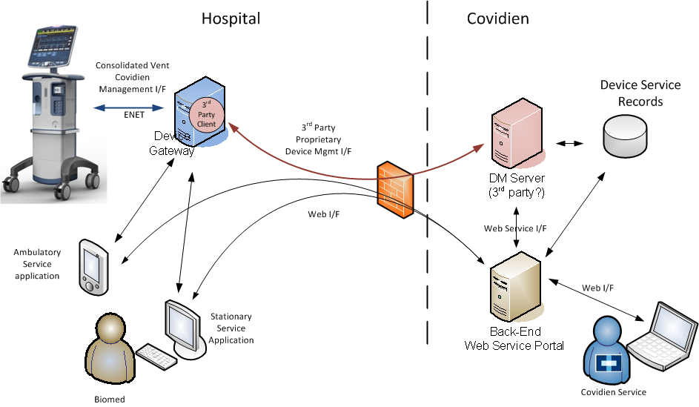

## Ventilator Support

The Ventilator should initially support existing serial interfaces, but eventually be modified to support a more fully developed and robust interface which consolidates the DCI, Service, and other interfaces into a single Covidien device management Interface.

## Stationary Service Application

The stationary Service application will be released to coincide with the post-launch release of Viking software (new interface definition), and would deploy on laptops and desktop workstations.

The Workstation solution will provide biomedical technicians with the ability to track the state of devices actively deployed on patients as well as instantly access historical service related information about the devices under their responsibility.

Additionally, the Service Workstation would support deployment as a replacement for the VTS 2000 software implementation for small/limited deployments as well as an administrative console.

The presentation of the GUI would be optimized for display of a global view of multiple device’s information on a larger display. This application would be favorable for deployment on laptops as stand-alone solutions, and service department workstations.

In addition to the information described above, the Workstation application would provide the following specialized capabilities for System Administrators and Group Supervisors based on login credentials and assigned privileges:

System Administrators:

* User administration
  + Role assignment tied to login credentials on the Hospital network
  + User creation/deletion
* System Configuration
  + Global Ambulatory application defaults
  + Alert notifications (audible and visible notifications)
  + Alternative device Alarm/notification delivery (SMS, email)
  + Hospital Information System integration configuration
  + Database selection and definition
  + Shift definitions
  + Employee Profile definition

Supervisory Staff

* Report Creation
* Shift scheduling
* Association of Device to Biomedical Technician

## Ambulatory Service Application

The ambulatory software aspect of the Remote Ventilation Service Monitoring solution will be designed for deployment on a mobile computing platform, and the GUI presentation optimized for space constrained touch displays.

The Ambulatory Service application should be multipurpose in that it will allow technicians to track the devices actively deployed on patients as well as instantly access historical service related information about the devices under their responsibility.

The application will allow on-shift service technicians to receive alerts and notifications from devices under their supervision while the device is deployed on patients. These alerts and notifications will pertain to changes in device operational state (Vent InOp, etc...), status (Battery Level, etc..), and errors.

Additionally, the ambulatory application would provide the Bio-medical technician the ability interrogate a device (whether actively ventilating a patient or in service-mode) for the operational related parameters related to the following:

* Detailed Device Parameters pertaining to the device’s Software, Hardware configuration, and associated version information
* Operational status of the Ventilator as a whole as well as the significant constituent components such as the compressor, batteries, gas sources, etc…
* Allows the user to interrogate the device’s diagnostic log and display error identifiers/diagnostic codes, a description of the issue, related test (SST, EST) step (if applicable), Additional information, and suggested courses of action.

The User interface for the Ambulatory Service application would support a summary view of all the devices of interest to the user based on their login credentials. The summary view will identify all devices viewable by the user, the device’s connection status, as well as an indication of the current state and status of the device. Selecting the device would provide a device summary view where all key data for the device is readily viewable. The UI of the application will facilitate interrogation of a device’s diagnostic and alarm logs, as well as historical data regarding the device’s smart alerts, and errors.

## Device Gateway

A key aspect of any deployment involves the Covidien Device Gateway. This system is comprised of multiple service stacks which would be used to facilitate Remote Ventilation Service (RVS), Remote Ventilation Monitoring, and other device related Analytics applications that might be developed in the furture. The Gateway services will deploy on server platforms (hardware and O/S), and will support virtualization technologies such as VMWare and Citrix.

The architecture pursued will be developed to provide open, standards-based interfaces for connecting to and communicating with a wide variety of devices, and should provide an evolutionary implementation path.

The server components of the system will be developed according to principles of Service Oriented Architecture, with their emphasis on decomposition of application capabilities into business services that are loosely coupled and easily accessible through interfaces based on web standards, and provide an ideal set of guidelines for designing a technical approach for Remote Service as well as other areas of application.

The architecture will focus on Service stacks which separate areas of concern. The set of concerns are focused on making applications and information widely accessible and easily integrated.

The Service stacks are related to Device integration, Data integration, Systems Integration, Application Services as well as infrastructure Services as depicted below:

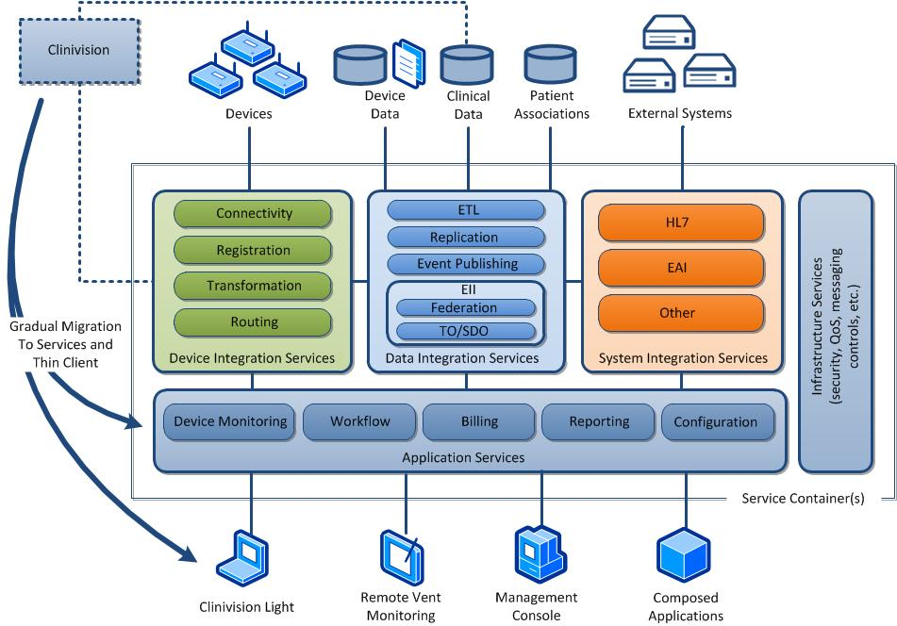

## Device Management Server

The Device Management (DM) server is a component that will either be deployed within Covidien’s network, or made available as a cloud based service, and be exposed to the Device Gateway via secured communications interfaces.

This server will act as a software and license key repository, as well as provide a means for scheduling service transactions with devices located at different hospital customer sites.

The Covidien DM server will interact with the Covidien Gateway installed at customer sites for the communication with devices within the hospital network.

## Customer Zone Web Portal

The Back-End Service Web Portal provides a browser based interface which allows Covidien Service personnel as well as hospital personnel access to view the details of the devices under their responsibility. The view presented and abilities enabled will be scoped according to the user’s role as determined by their login credentials. The portal will allow Covidien Service personnel to schedule management jobs, to remotely access information regarding specified devices, and schedule devices for upgrade. The portal will allow customer Biomedical Technicians and Supervisory staff to view the status of their fleets, access service transaction records, schedule software updates, as well as purchase and install software features. This system would also allow home care-givers the opportunity to manage their devices, and interact with Covidien’s Service personnel in a meaningful way.

# Deployment Models

The system should be developed with the concept of being deployed as an enterprise grade solution with multiple workstations and ambulatory applications connected via a network to the Supporting Software Service components deployed on enterprise grade server hardware.

However, a key aspect of the system (depending on licensing), is that it will also support deployment of the Workstation application as well as the supporting Software Services onto a single hardware system such as a laptop such that it could provide a complete self-contained servicing solution for smaller customer deployments, and could fill the role of the of the VTS 2000 software system post launch.

In this way, the system would operate much like the Single-Workstation deployment in Clinivision where the Single-Workstation has all the software services and databasing technologies deployed on a single system, it allows for configuration and administration of the system, and also allows for charting of patient related data.

The system would initially be developed as a turn-key solution for deployment on existing IT infrastructure, but would also eventually be made available as a Cloud based solution to facilitate service monitoring of home healthcare ventilation devices such as the PB540, PB560, etc…

As a home-care solution, remote service monitoring capabilities would allow the Covidien develop and offer a remote monitoring solution/service to Home care-givers. This form of remote monitoring, is similar to the “OnStar” product, offers patients and family members a sense of medical security while living with a ventilator in the home.

The solution would provide support for both wired and wireless connectivity, and would deploy on readily available hardware platforms such as desktops, laptops, tablets, or other personal computing devices.

The installation of the Remote Ventilator Service Application product will be with minimal effort for customers and will comply with all security standards currently enforced in hospital environments. This allows for easier IT adoption and will not require a lengthy project plan or many resources to implement. The product usage will be intuitive and will not require customers to attend formal training to configure and use the product.

# Project Phasing

The development of the Remote Service and Software update solution should be developed and released in phases as alluded to earlier in the document.

## Phase 1 - Initial deployment at time of Viking Launch

The approach taken for remote service of the Viking Ventilator must take into consideration support for existing 840 ventilators as well as the launch time window of Viking. The initial launch solution must provide support for upgrading the ventilator software as well as validation testing of the ventilator directly via a laptop as implemented by the Breathlabs VTS 2000 software with some additional modifications.

The existing 840 solution interoperates with the VTS 2000 software via a serial interface which is becoming increasing difficult to find supported in late model laptops and computing platforms. Additional USB to Serial adapters will also be phased out over time. As such, the current interfaces on the ventilator should be maintained, but should be migrated to communicate via USB transport directly.

To facilitate remote service, The VTS 2000 software would need to be refactored to include support for the notion of logging into a remote secure FTP server for retrieval of a ventilator software image from a designated customer folder, should only support update of those ventilator devices as specified by the Service organization, and should only operate on authorized software versions. The solution should capture a log of evidence which contains the start time, the finish time, and the update status for each device updated. Additionally, the package should capture relevant service logs available via the current service interface implementation. All status and service logs should be pushed back to the secure FTP server once the update and device update log creation have been accomplished.

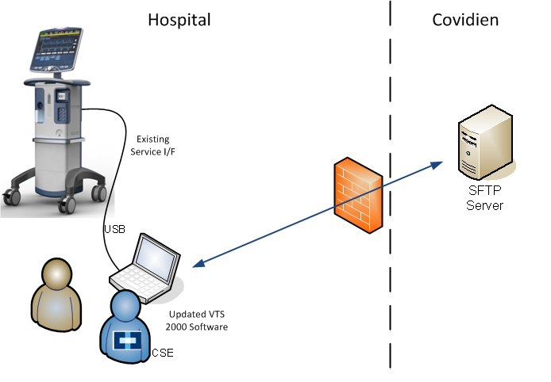

### Work Breakdown

Ventilator related work:

* Integrate USB stack onto Viking, and map serial interface to new stack
* Support acquisition of additional log information.

VTS work:

* Amend implementation to support SFTP login & Image download
* Move the existing serial I/F implementation from Serial to USB
* Support querying and creation of log file information during update process

Server work:

* Identify, prototype and test Secure FTP server solution
* Deploy SFTP server in Covidien network
* Software development of log-file consolidation and storage.

Resource requirement: 2 Developers & 1 Software Test

Duration: ???

## Phase 2

The second phase of the remote service should:

* Commence as soon as possible,
* Focus on deployment in the first year after Viking launch,
* Deploy a re-developed device management interface on the Ventilator
* Address an initial deployment of the remote servicing system as a laptop deployable solution.
* Only require enough device integration services to allow connection to the Vent.
* Back-End Service Portal functionality is limited to interrogation of transaction logs and limited data-mining.
* Be architected to support the large scale deployments in support of the next phase of product Beta testing.

There are existing software entities on the GUI and BD boards within the ventilator whose job it is to terminate an existing Service interface for support of software downloads and testing required for validation of the device. These software modules should be modified and extended to terminate a refactored service management interface to the device.

In addition to the existing Service interface, that the DCI, and Wave form interfaces be also consolidated to this new messaging protocol.

The interface should also support the notion of sending alerts to the appropriate service in the network pertaining to device alarms or smart prompts as they are generated in the device. While all patient alarms are clinical in nature, there will a classification of alarms and alerts which may pertain to the proper functioning of the device and warrant notification of service personnel. The alert information should contain all pertinent information relating to the Alert identification, Alert urgency/priority, problem analysis information, condition remedying information, System Response, and the alarm reset criteria.

Commands and alert support on this new Covidien Device Management Protocol (CDMP) will continue to be supported based on the operational state of the device. All commands that would otherwise be operational while the ventilator is in service mode may not be allowable while the device is in-use on a patient. For example, the ventilator should negatively acknowledge commands to perform a software updates, tests, etc… while in use on a patient, but should honor requests to retrieve patient related data, settings, alarm logs, etc… Conversely, commands that would be honored while in use on a patient may not be applicable while the device is in service-mode (e.g. request for patient related parameters). Finally, there will be a classification of data that should be available regardless of the state of the device such as device alarm logs, status information relating to batteries, etc... Work is needed to identify all the information elements that will be supported post-launch, and the device state in which the requested operation and associated data element will be supported.

The information communicated on this new interface should be supported via a centralized and controlled interface point to the device which supports a standardized approach for encoding/decoding, authentication, encryption, and processing of requests from external entities. In this manner, all communication with the device is performed in a common, secure, and consistent manner. This interface should be given a comprehensive name such as the Covidien Device Management Protocol (CDMP).

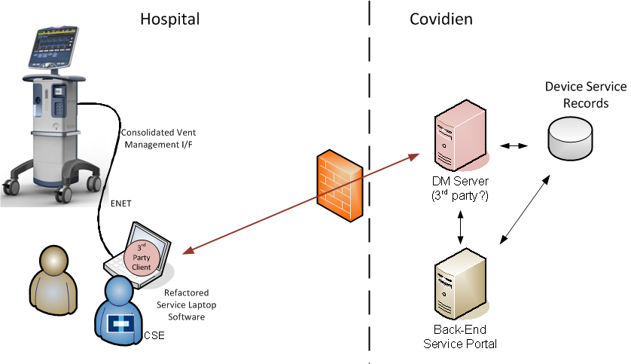

Ventilator work breakdown

* Development of new Interface Specification (in progress)
* Creation/adaptation of existing interfaces in Ventilator
* Client development on GUI… either:
  + Modify existing Service mgmt Code (existing software entities) to include support for DCI, Waveform, and sending of Alarm and other GUI alerts.
  + Develop new front-end, and create hooks to existing software.

Workstation application work breakdown (deployed on laptop)

* Develop initial framework and User interface.
* Engage in VOC input
* Develop basic administration and configuration modules
* Re-develop the VTS 2000 validation modules
* Re-develop 840 software update module
* Formally design, develop, and verify integration of client to gateway service elements.

3rd Party DM Server Work breakdown (deployed in Cloud or on Covidien infrastructure)

* Identify and evaluate competitors
* Develop early prototype with likely solution partner(s)
* Execute legal agreements
* Perform interoperability testing with vendor.
* Validation testing

Service Web Portal (professional services or contract engagement?)

* Define usecases and system requirements
* Define User Interface for Customer – Zones
* Define DM server <-> web interactions

Connectivity (gateway) Service Development

* Implement DCS Service interfacing components
* Integration of 3rd party management client

## Phase 3

The 3rd phase of development would look to deploy a more fully developed server based solution as depicted in the diagram below:

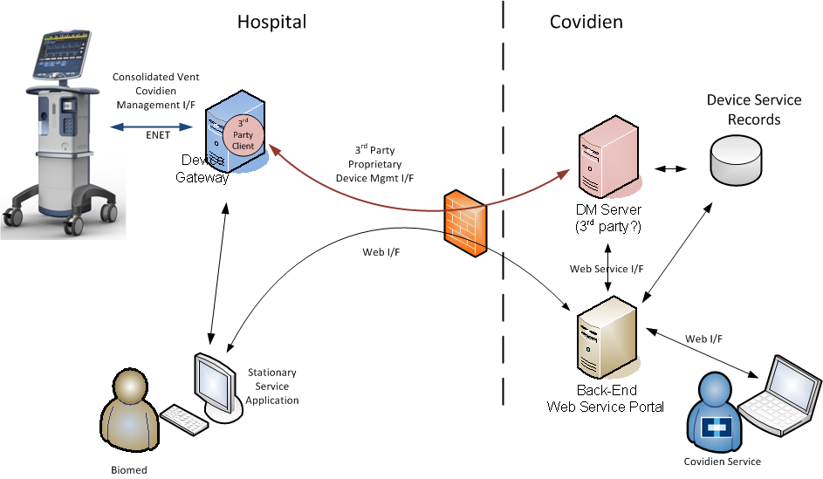

This phase of development would focus on the following:

* Deployment of an initial version of the Stationary Service Application for:
  + Service Alert monitoring
  + Device Service history review
  + Software feature purchase
  + Software update
* Layering in functionality in the Ventilator to support more than one server.
* Modifying the Covidien Management I/F to support additional data elements.
* More fully developing the Back-End Service Portal for:
  + Support of Customer Zones
  + Device job scheduling.
  + Improved Data Mining
* Preliminary version of the ambulatory application for Beta testing purposes.

# Business Objectives and Risks

Commercial (revenue-generating) Objectives

* Provide value to the Puritan Bennett ventilator line by providing capabilities that can either be bundled with ventilators or sold separately, and in either case increasing sales for ventilators, ventilator service contracts, and optional software features.
* Developing external interfaces into the Viking platform in support of RVS enables support for development of additional Viking-paired software solutions in the future.
* Enabling new Sales models (Pay per Use).

# Key Functional Objectives

* Provide Customer’s service personnel a system which provides them instant access to detailed information regarding the status of devices, and proactively handle device emergencies.
* Provide Customer’s service personnel the ability to assess the status, and update the capabilities of their fleets on demand
* Provide Covidien with crucial information for use by regulatory, marketing, sales, and development to accurately track customer fleet configurations, and option deployments, upgrade status, feature usage, and software events, etc…

# Covidien Business Initiatives Match

* The RVM system is developed collaboratively with the Viking development team to insure that open external interfaces are developed in the Viking platform.
* Additionally, it positions Viking for participation in the interoperability initiatives being requested by our most important customers like Kaiser and others.
* The system can help with the Destination 174 initiative by readily extending to support Covidien’s monitoring products.

# Risks / Issues

* Specification and implementation of any support required in the Viking platform must be accomplished without impact to the Viking schedule.
* Software solutions are something of a new business model to Covidien and therefore will require investment of resources to properly execute and market. Pairing with the Viking product mitigates this to some degree, but sales and marketing will still require attention in order to effectively launch an RVS system into the market.
* Deployment of software solutions is relatively new to Covidien, and there are limited existing resources which are knowledgeable about IT-centric deployments.
* There is limited software service support experience within Covidien, and would require the hiring of additional knowledgeable resources for 2nd and 3rd tier support.

# Data Sources Required

* Ventilator service log data
* Ventilator Alarm and Alert information
* Authentication/Authorization data (i.e. user authentication/authorization)

# Specific Functional Capabilities (high level requirements)

* Support display of selected ventilator service data directly from the ventilator.
* Support display of selected ventilator operational data directly from the ventilator.
* Support display of service related alarms and alerts.
* Support a wide variety of display devices.
* Support mobility scenarios (e.g. wireless connectivity and handheld devices)
* Support authentication/authorization of users
* Leverage built-in capabilities of the Viking platform.

# Appendix A – Device Management Interface Choices

There are a number choices for a device management interface which will satisfy any encoding/decoding, authentication, encryption requirements from a device gateway to the device. The options are:

* Proprietary XML based approach
* SNMPv3
* XMPP with XML streams,

A fairly simple XML approach could be used for communication with the ventilator, but it would require the ad-hoc creation of a series of commands as well as organization of data to be managed within the device into some sort of schema. This approach would also require the implementation an encryption approach (SSL or TSL), as well as some ad-hoc authentication scheme. Also, while initially a more straight forward approach, it may not be as good long term solution when compared to some of the predefined options which exist.

Simple Network Management Protocol (SNMP) is a good option to consider, and is an "Internet-standard protocol for managing devices on IP networks. It consists of a set of standards for network management, including an application layer protocol, a database schema, and a set of data objects. SNMP exposes management data in the form of variables on the managed systems, which describe the system configuration. These variables can then be queried (and sometimes set) by managing applications.

There are multiple versions of the SNMP standard with the latest version being SNMPv3. This latest version of the standard primarily added security and remote configuration enhancements to the protocol.

The Extensible Messaging and Presence Protocol (XMPP, RFC’s 2779, 3920, 3921) is also a viable approach as it supports XML streams over Transport Layer Security (TLS) and Simple Authentication and Security Layer (SASL). XMPP is an open protocol optimized for instant messaging but is extensible and robust enough for arbitrary messaging use in modern medical device platforms. XMPP was defined to help with (a) presence management, (b) direct message exchange, and (c) querying for arbitrary data. Use of XMPP can eliminate polling for messages and alarm states; facilitates two way data exchange without firewall and network path issues; can pass binary or text data; and knows when devices or servers are on or offline.This interface definition would be able to support the Remote Ventilator Monitoring and Remote Ventilator Servicing solutions either by direct connection to the Hospital Network, or wirelessly via a WiFi adapter.