**PB980 ESS Software Design Document**

Release: 2.0.0.0

Date: 1/4/2015

Author: Amarnath Chitumalla

Contents

1. Introduction 3

1.1. Purpose 3

1.2. Definitions of Terms 3

2. Overview 4

3. Class/ Collaboration Diagram: 4

3.1. High Level Class diagram 4

4. Sequence Diagrams: 5

4.1. Create Session 5

4.2. Certificate Handling 6

4.3. Online Login 7

4.4. Offline Login 8

4.5. Connecting to Device 9

4.6. Get Device Logs 10

4.7. Upload Logs to Server 11

4.8. Disconnect Device 12

4.9. Skip Device Connection 13

4.10. Fetch Software Packages 14

4.11. Software Upgrade 15

5. Flowchart Diagrams: 16

5.1. Other Software Package Download 16

# Introduction

## Purpose

The purpose of this document is to provide a description of a design of the Enhanced Service Software in support of the Puritan Bennett 980 Ventilator. The software design document provides necessary information to provide description of the details for the software system and system to be built.

## Definitions of Terms

|  |  |
| --- | --- |
| System | Desktop PC, or Laptop where ESS software is installed |
| User | Field service technicians, Biomeds who can potentially use the ESS for servicing and maintaining PB980 |
| Remote Service Server or RSS | Globally accessible Covidien server database which controls users and maintenance of Covidien devices |
| Agent or Remote Service Agent or RSA | Remote Service Agent which facilitates communications with an external Server |
| ESS | Enhanced Service Software |
| ESS Working Directory | C:\Logs\Covidien\ESS\PB980 |
| Device Information | Part and revision numbers of all installed parts in PB980 |
| EST | Extended Self-Test |
| ESM | Extended Service Mode |
| PB | Puritan Bennett |
| SST | Short Self Test |
| Basic Set of Logs (3) | Diagnostic Logs: System Diagnostic, System Communication and EST/SST Log |
| Extended Set of Logs (5) | Patient Data, Settings, General Event, Alarms, Service Logs |

# Overview

The Puritan Bennett 980 Series Ventilator Enhanced Service Software is a Field Service software application intended to a) facilitate the retrieval of ventilator logs b) enable the updating of software in the 980 ventilator and c) update service-related parameters such preventative maintenance hours, operational hours, options key, and override EST.

# Class/ Collaboration Diagram:

## High Level Class diagram

This diagram represents the high-level class diagram along with collaboration with other class/modules. (Note: Not added its methods and members in the classes)

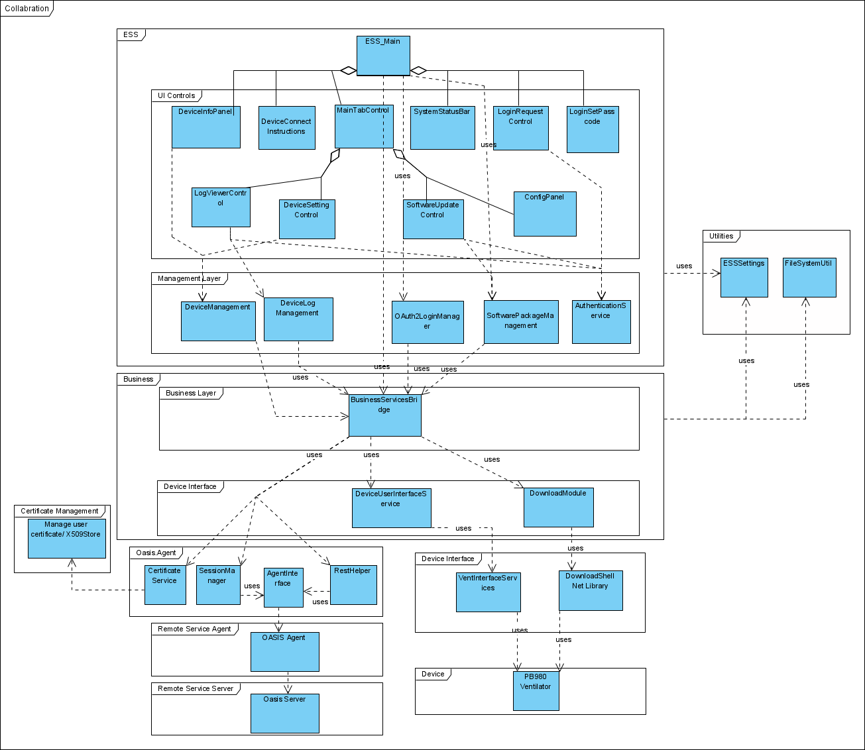

# Sequence Diagrams:

## Create Session

Follow Diagram shows the Establishing session sequence diagram

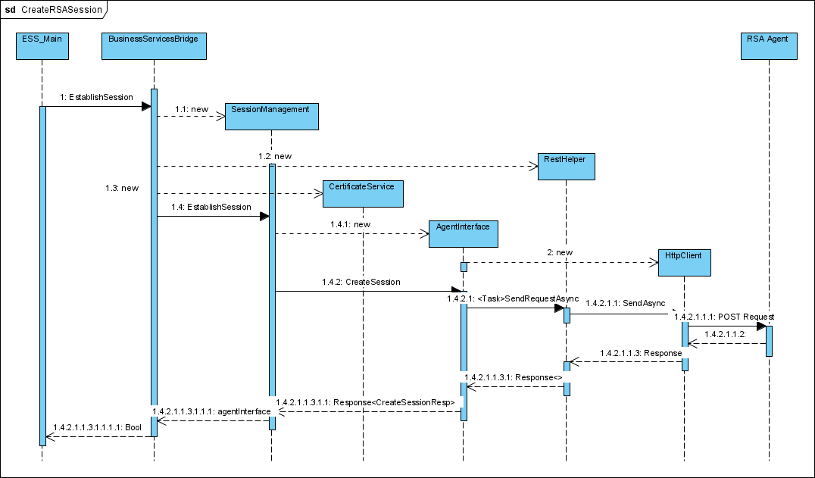

## Certificate Handling

Follow Diagram shows the Certificate fetching from OASIS server and storing in Windows Store sequence. All OASIS agent allows these (i.e., CreateSession, Login, GetServerStatus, GetSessionStatus, GetClientCertificate, RenewClientCertificate, LogOff, CloseSession) requests without certificate and all other requests must contain client certificate.

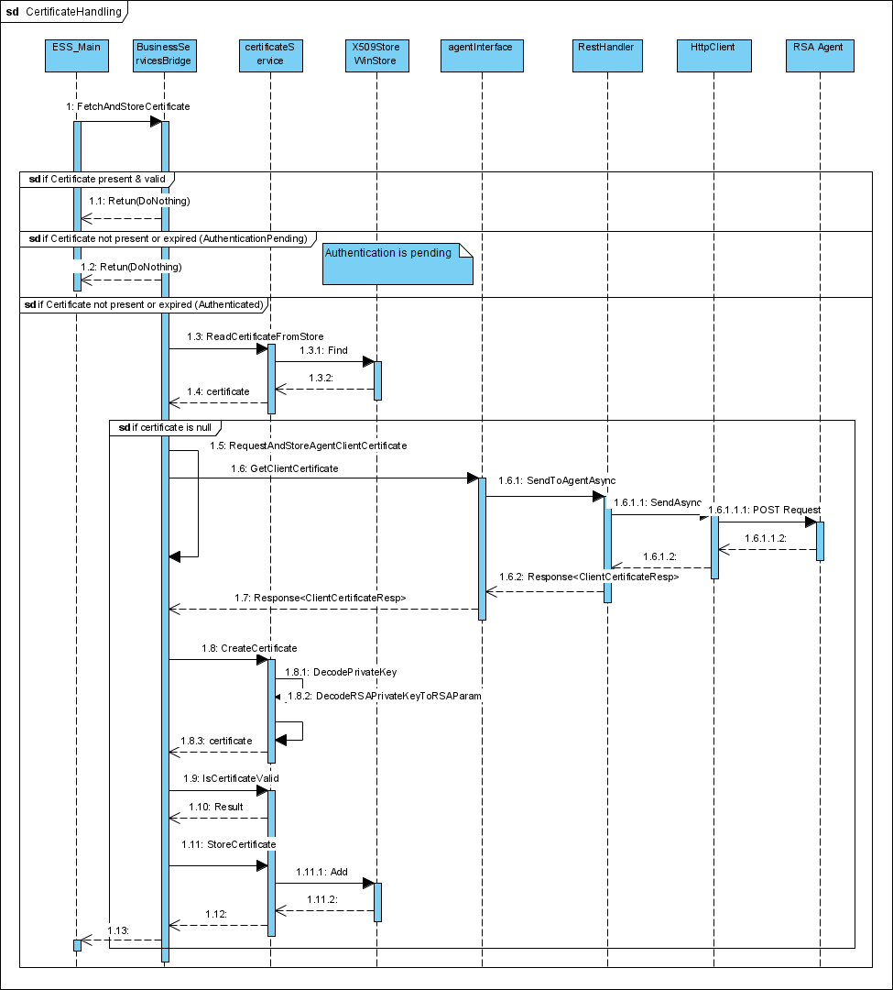

## Online Login

Follow Diagram shows the Online Authentication sequence diagram. Fetches the OIDC Authentication server information from above Create Session response. Based on Employee, Non-Employee uses appropriate information.

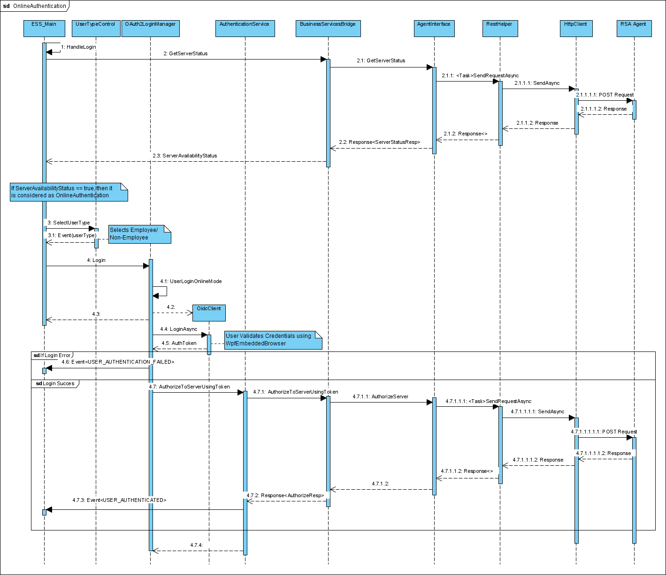

## Offline Login

Follow Diagram shows the Online Authentication sequence diagram. Fetches GetServer status, if Server is not available, then authenticates using following Offline Authentication sequence.

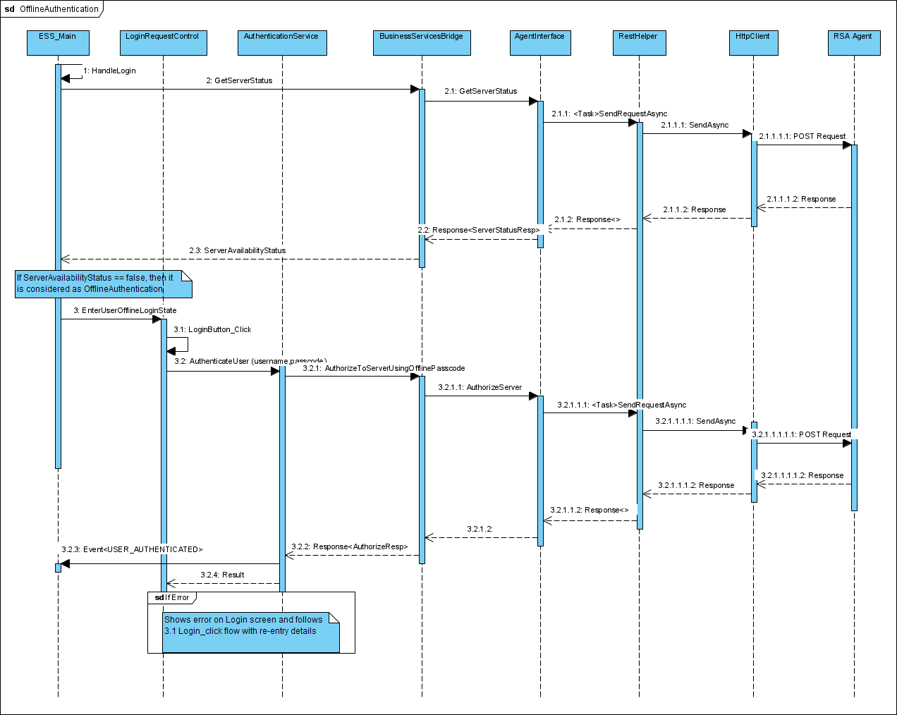

## Connecting to Device

Follow Sequence Diagram shows PB980 Device Connect Sequence.

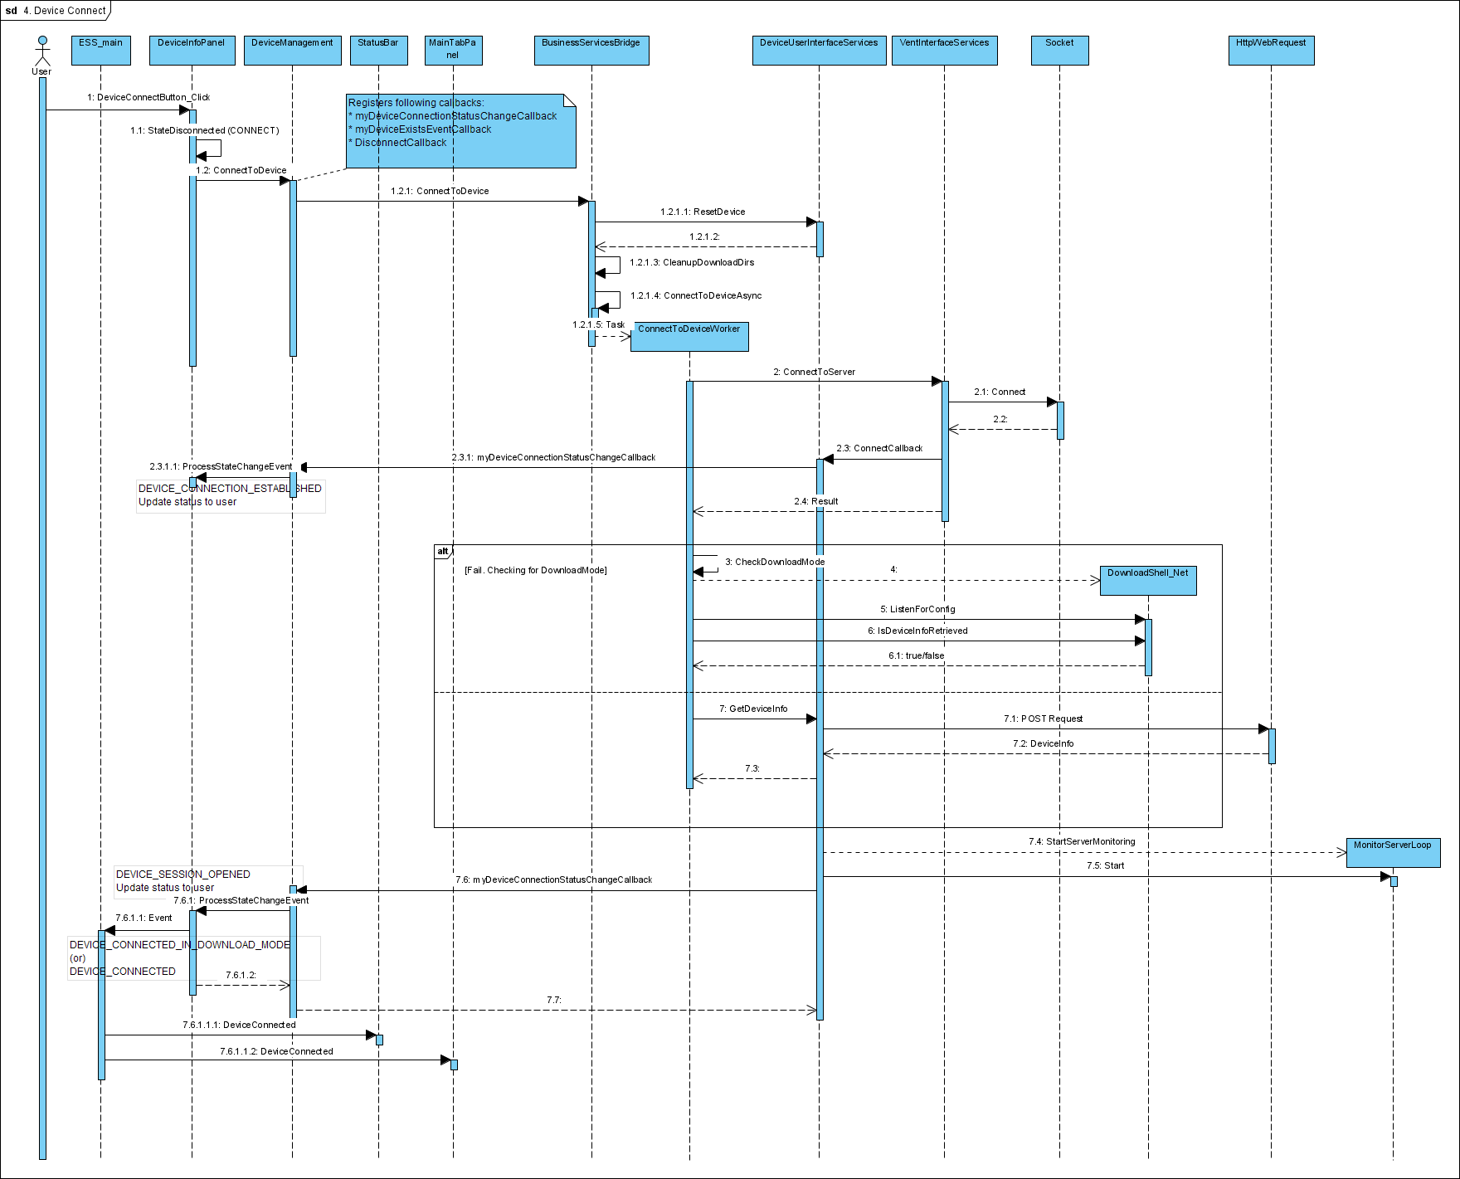

## Get Device Logs

Follow Sequence Diagram shows the Fetching Device logs from PB980.

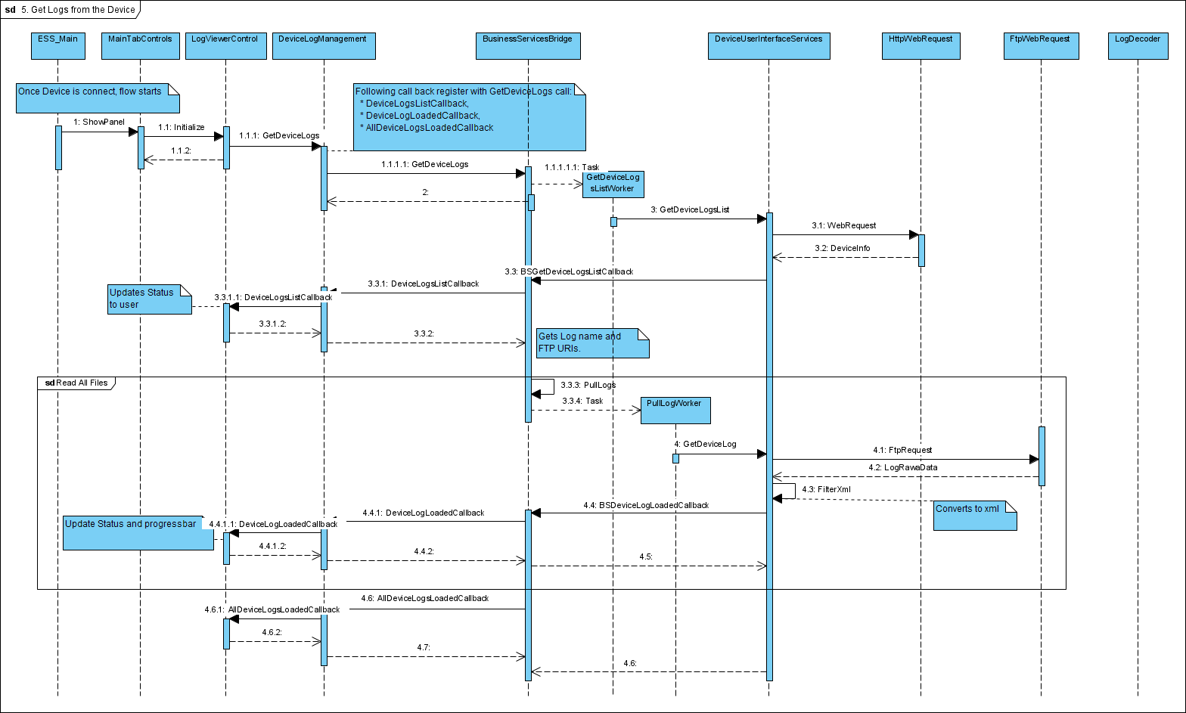

## Upload Logs to Server

Follow Sequence Diagram shows the logs upload to OASIS Agent.

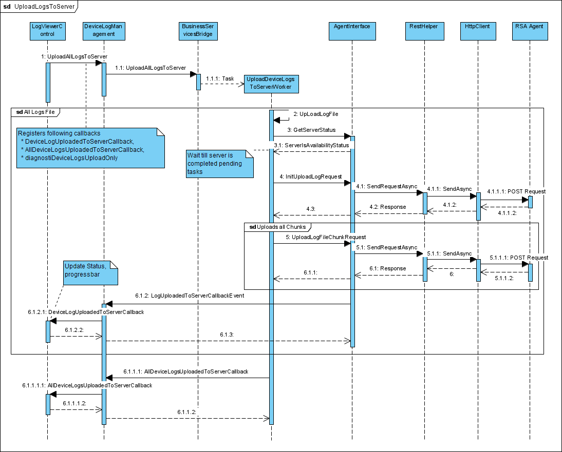

## Disconnect Device

Follow Sequence Diagram shows the PB980 Device disconnect sequence.

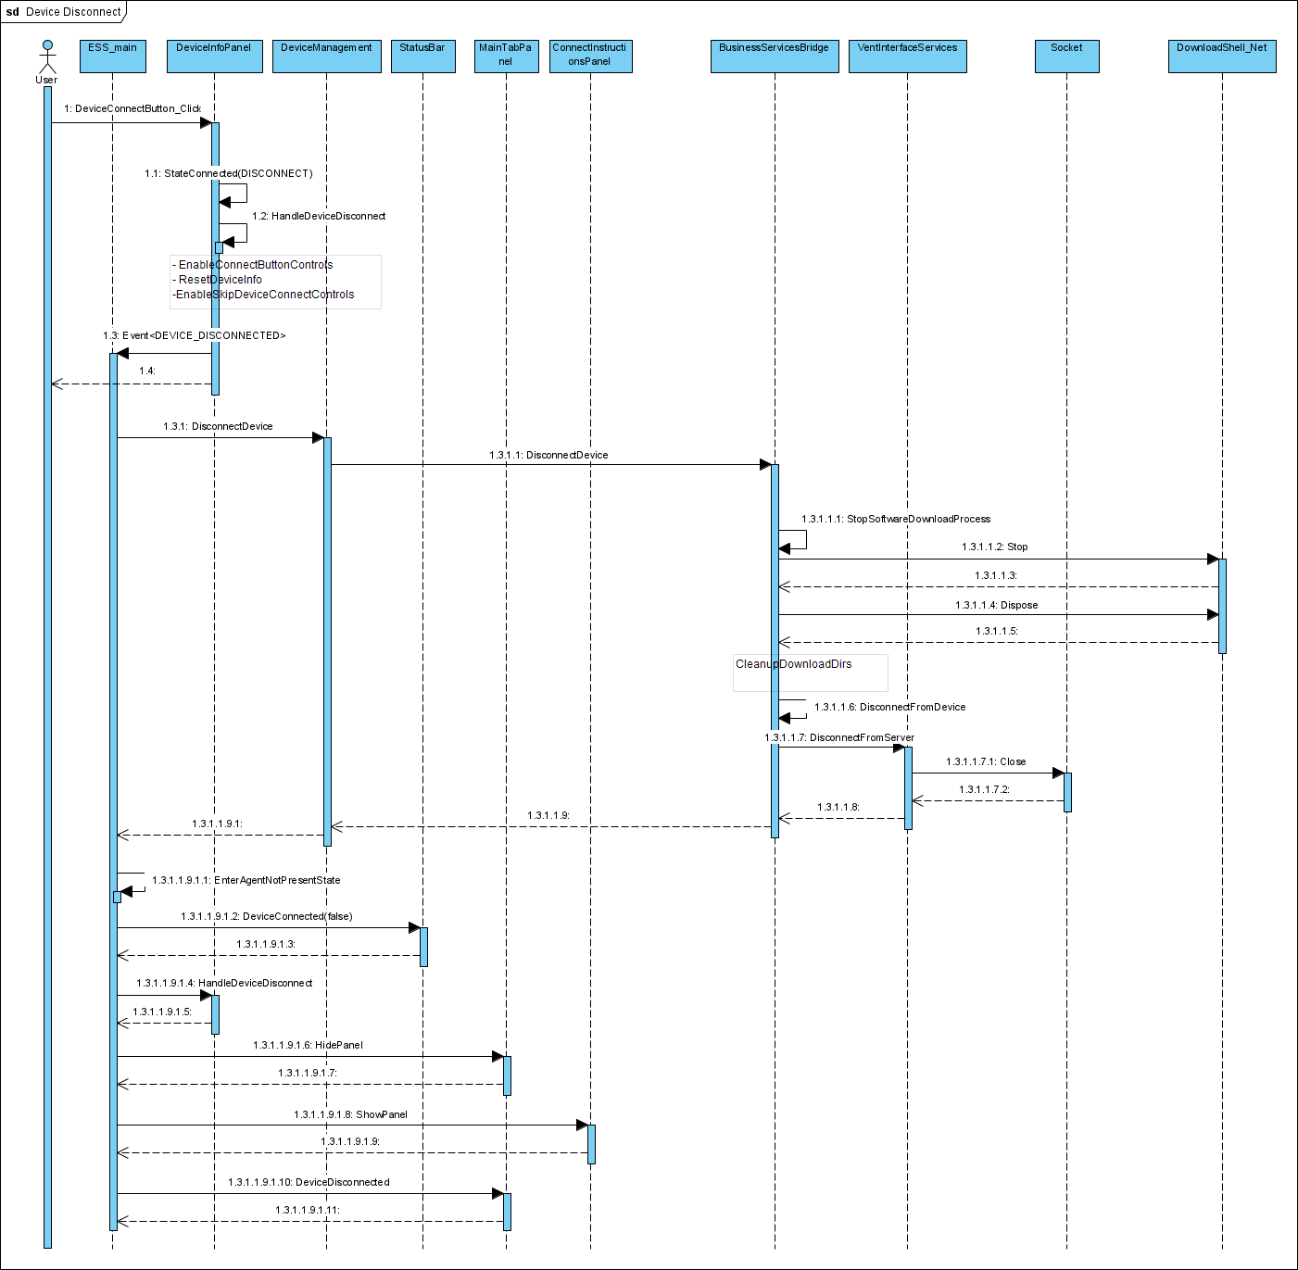

## Skip Device Connection

Follow Sequence Diagram shows the Skip actual device connection flow. This functionality enables to change Offline password (i.e., using ConfigPanel controls) and view available Software packages information(i.e., using SoftwareUpdateControls).

In Skip Device flow, actual device functionalities (e.g., Logs fetching, logs uploading, SW upgrade operations and device OpHours related settings) are disabled.

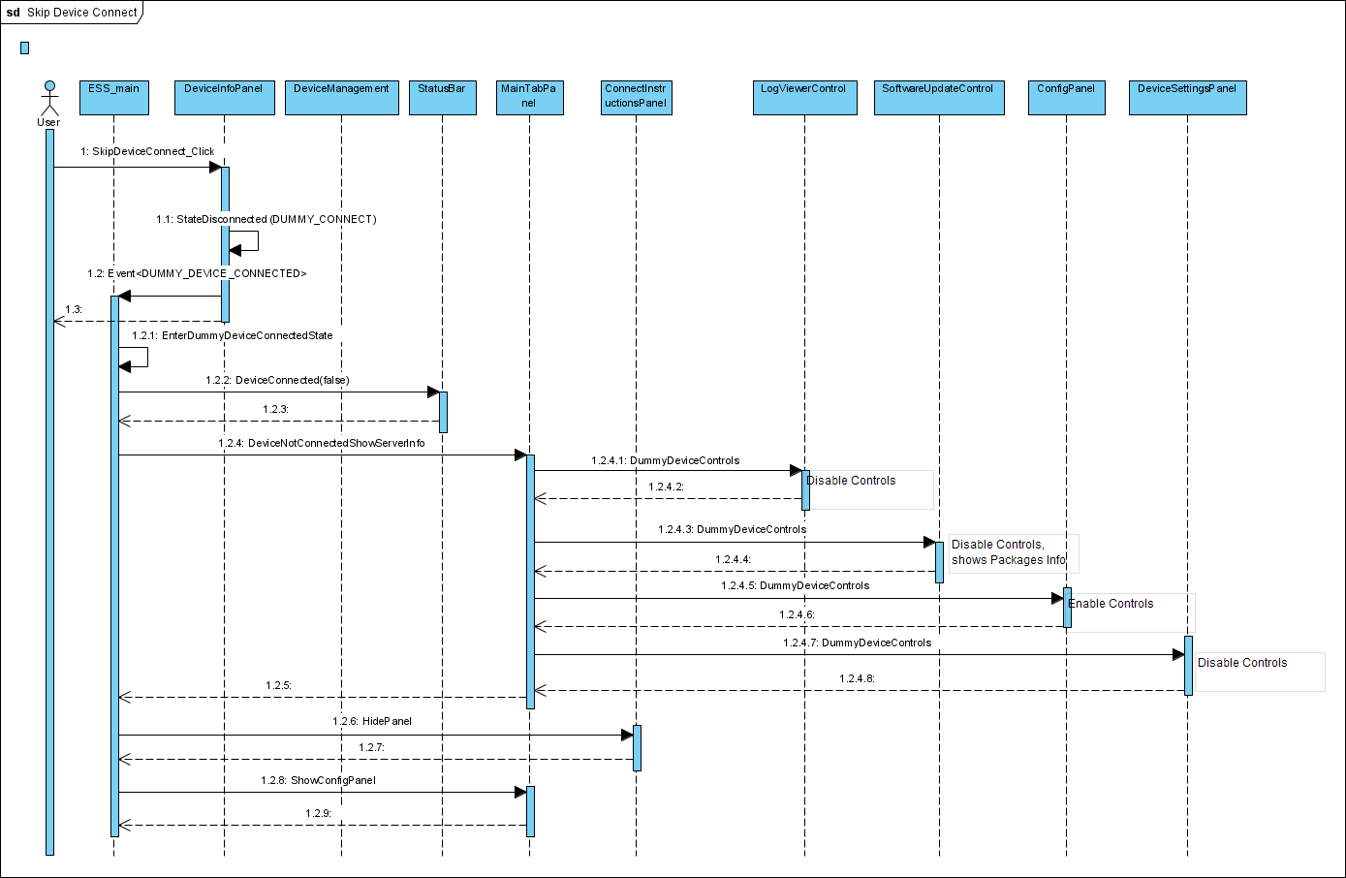

## Fetch Software Packages

Follow Sequence Diagram shows the Fetching Software Packages Catalog from OASIS Server.

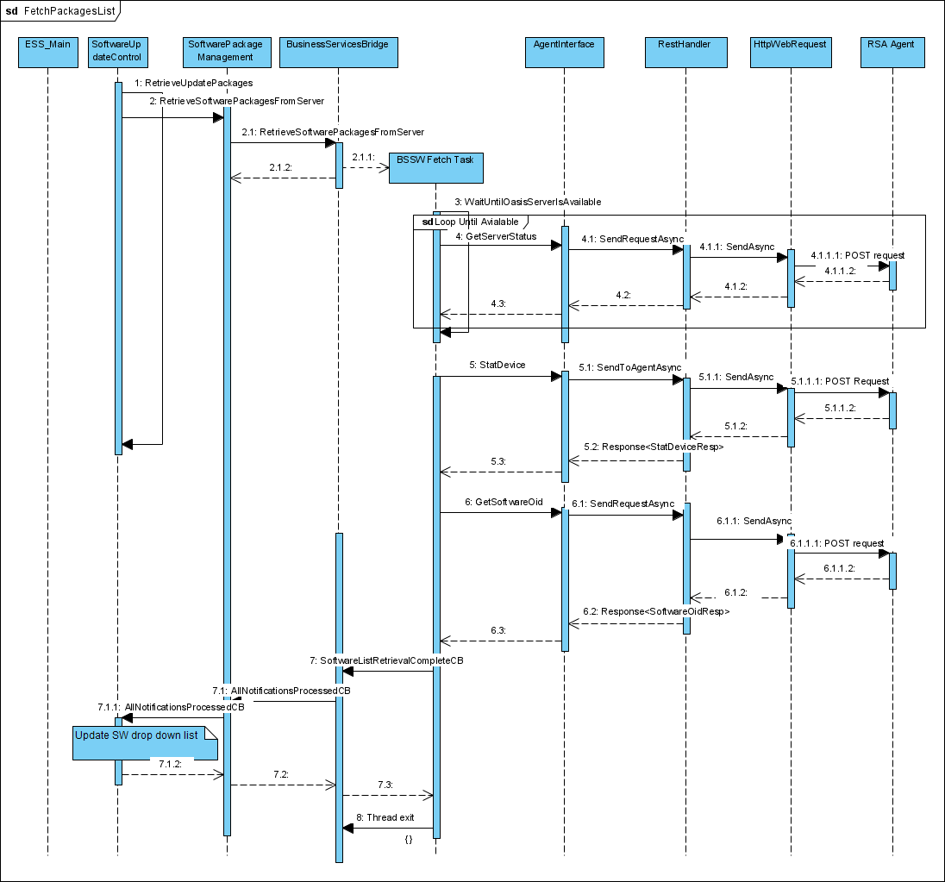

## Software Upgrade

Follow Sequence Diagram shows the Software Update on PB980 Device.

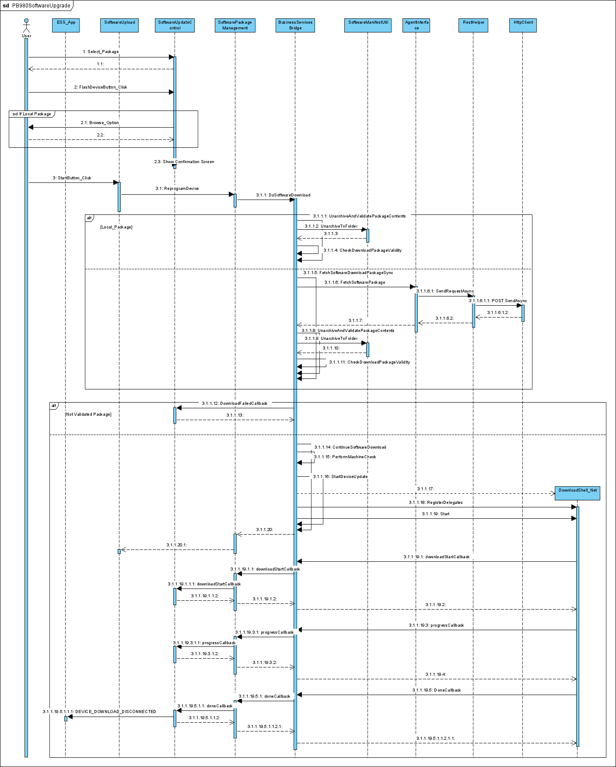

# Flowchart Diagrams:

## Other Software Package Download

ESS downloads other Packages (i.e., other than PB980 SW, FPGA packages) to local PC, as shown below.

