Remote Service Agent
Interface Specification
Table of Contents

1. Introduction 4
1.1. Purpose and Scope 4
1.2. Background System Description 4
1.3. Background Model 5
1.4. Remote Service Agent 5
2. Publish / Subscribe Communications 5
2.1. Notification Types 5
2.2. Notification Actions 5
3. XML Messages 6
3.1. Request Message 6
3.2. Response Message 6
3.3. Message Header 6
3.4. Message Body 7
3.5. Overview of Key Message Parts 7
3.5.1. Message Parts 7
4. GUIDs 7
4.1. Session GUID 7
4.2. Transaction GUID 7
4.3. Mailbox Classifications 8
4.4. Device Classifications 8
4.5. Message/Object Type Classifications 8
5. Pertinent Types 9
6. Device URIs 9
7. Object IDs 9
8. Specific Commands 9
9. Message Part Constructs 10
Params 10
9.1. Components 10
9.2. Rights 11
9.3. Logs ?? 12
10. Connection and Communications Flows 12
10.1. Basic Connectivity and Session Management 12
10.2. Connectivity and Extended Session Management 13
10.3. Getting Headers and Associated Notifications 14
10.4. Posting Notifications 15
11. Sample Messages and Responses 16
11.1. Session Management 16
11.1.1. Create Session 16
11.1.2. Open Session 17
11.1.3. Close Session 18
11.2. Authentication 19
11.2.1. Login 19
11.2.2. Logoff 19
11.3. Device Management 21
11.3.1. Create Device – NOT CURRENTLY IMPLEMENTED 21
11.3.2. Delete Device – NOT CURRENTLY IMPLEMENTED 21
11.3.3. Get Device List 23
11.3.4. Stat Device 23
11.4. Notification Management 24
11.4.1. Get (Notification) Headers 24
11.4.2. Get Notification 26
11.4.3. Post Notification 27
11.4.4. Delete Notification 28
11.4.5. Update Notification 29
11.4.6. Expunge (Notification) 30
12. Sample Messages / Notifications 31
12.1. Software Download (Notification) 31
12.2. Software Download Acknowledgement (Notification) 32
12.3. Log Info (Notification) 32
12.4. Device Info (Notification) 33
13. Sample Log File 33
13.1. Raw Log File 33
13.2. Decoded Log File 35

Introduction
The Covidien Gateway Remote Service capability is intended to enable “remote” interaction to medical devices performing such service oriented tasks as getting log files from devices or loading new software onto the device. This document describes one aspect of the system’s communications – between the service application and the remote service agent.

Purpose and Scope
The purpose of this document is to describe the messaging interface between the Device Manager (e.g., Vent Test System (VTS)) and the Remote Service Agent (RSA).
This document describes the “as built” communications interface. The interface between the RSA and Device Manager clients is managed by this communications contract.

Background System Description
The complete system is composed of:
- Hardware device (e.g., Ventilator, Pulse Oximeter, etc.)
- Service Application (e.g., Vent Test System)
- Remote Service Agent (RSA)
- Service Management Server
- Data feeds (e.g., manufacturing information, service contracts, etc.)
The hardware device is, of course, the object to which we intend to interact with, from which to get device revisions, details, or logs or onto which to download software.
The device manager is intended (ultimately) to support multiple devices, which means communicating in a device specific way to gather desired information or to perform software downloads onto the device. As much as possible, devices will conform to the specifications herein.
The remote service agent is a service, serving as a proxy to the service manager server. It isolates the device manager from the potential connectivity issues which exist with the server itself. E.g., a typical laptop will only have a single network card, but the current ventilator is not truly network enabled, and must be connected directly – essentially forcing the laptop to be disconnected from all other networks, hence being disconnected from the server. Due to this situation, the RSA must become connected to the server (connected state, get populated with information that will be needed, become disconnected from the server (disconnected state), so that the device manager may then be connected to the device and desired operations ensue.
The service manager server is populated with information and business rules to execute so that a device manager can be provided with the proper information to service each device to which it is connected, based on the logged-in user’s rights.
The data feeds are I.T. and Manufacturing feeds to the server providing knowledge about initial device configurations by device type and serial number, service contracts, software release information, etc. These provide the basis for activity at the device management level, but are not significant to the remainder of this document.

Background Model
Communications are asynchronous, with messages being sent from one system to another without expectation of an immediate response. This is, in part, to account for the expectation that the RSA, may, from time to time, act only as a forwarding agent, passing (re-cast) messages on to the backend service manager server.
As such, a publish / subscribe (pub/sub) model has been chosen as the base communications style. At any given time, either system may act as publisher or subscriber, with the roles changing based upon the current activity.
For the message store and forward, the iMAP communication mailbox approach is used by the RSA.
Communications are XML based, with all the rights and restrictions thereof. Where appropriate, binary data will likely be base64 encoded (and appropriately identified as such).

Remote Service Agent
An objective for the Remote Service Agent was for it to be “invisible”, such that the Device Manager would act as if it was connected to the server itself, but without having to know that. To an extent, that objective is met. However, due to the very nature of the connectivity, the Device Manager does sometimes need to interact with the RSA knowing that it does exist.

Publish / Subscribe Communications
The original intent of the communications system was to follow a basic publish / subscribe model where messages would contain, in their header content, a high-level description of what the message is intended to accomplish. Two key pieces of information are provided: notification type and notification action.

Notification Types
There are three notification types:
- Event – a “one-time” occurrence being reported
- Command – a command / demand / instruction to a partnering component
- Response – the response to a prior command

Notification Actions
There are six notification actions:
- Create – the purpose of the notification is to create something.
- Delete – the purpose of the notification is to delete something.
- Modify – the purpose of the notification is to modify something.
- Replace – the purpose of the notification is to replace something.
- Get – the purpose of the notification is to make a request to get something.
- Set – the purpose of the notification is to set something.
The ”something” referred to above is clearly indicated by the specific message. At this point, not all actions are in use.

XML Messages
The basic message structure is composed of the standard XML header tag, followed by a message tag and the “schema_version” attribute which it encodes.
<?xml version="1.0" encoding="utf-8"?>
<message schema_version="3644767c-2632-411a-9416-44f8a7dee08e">
--- content ---
</message>
The message may be composed of XML elements of head, body or neither, which vary with need and content. Further detail is provided in the subsections below.

Request Message
Most specific commands from the device manager to the RSA are identified as requests. The general structure is an xml element request followed by a transaction GUID and, once known, a session GUID. The following shows an example.
<?xml version="1.0" encoding="utf-8"?>
<message schema_version="3644767c-2632-411a-9416-44f8a7dee08e">
<request type='createsession' xaction_guid='0f16a851-a043-498d-a857-77ee5c59499c' />
</message>

Response Message
Requests made are expected to receive a response, usually indicating that the request was ok or bad and often receiving associated parameters / results. The general structure is an xml element response followed by a transaction GUID to indicate to which request the response is associated. The following shows an example (the response to the createsession request above).
<?xml version="1.0" encoding="utf-8"?>
<message schema_version="3644767c-2632-411a-9416-44f8a7dee08e" session_guid='bd86a4a2-a894-4be5-b0e4-8b9b24ba6ed3'>
<response type='param' xaction_guid='0f16a851-a043-498d-a857-77ee5c59499c' >
<params>
<param name='session'>bd86a4a2-a894-4be5-b0e4-8b9b24ba6ed3</param>
</params>
</response>
</message>

Message Header
When used, this might read
<header>
<session>bd86a4a2-a894-4be5-b0e4-8b9b24ba6ed3</session>
<example>sample content</example>
</header>

Message Body
When used, this might read
<body>
<is_accessible>true</is_accessible>
<last_update>08/17/2012 12:00:00</last_update>
<components>
-- component list here --
</components>
</body>

GUIDs
To provide a level of flexibility and obscurity, GUIDs (global unique identifiers) are used to provide key tags used when identifying message types, destinations, etc. The GUIDs defined below were created by the development team and are considered “well known” (as they are documented here). Currently these are used for transactions and session ids as well as grouped to “define” specific object instances, such as mailbox classifications, device classifications, and message type classifications. As the need for additional common identifiers are recognized, the development team will create such and extend this document accordingly.

Schema GUID
To manage message revisions, a “schema_version” GUID is defined and passed in every message element as an attribute, as follows:
<?xml version="1.0" encoding="utf-8"?>
<message schema_version="3644767c-2632-411a-9416-44f8a7dee08e" session_guid='bd86a4a2-a894-4be5-b0e4-8b9b24ba6ed3' >
--- content ---
</message>

In the future, this GUID will serve as a guide to interpreting a message whose format may have evolved over time.

Session GUID
To manage connections and authentication, a session GUID will be created (as a result of a createsession message) which will always be passed with the messages thereafter. Once the session has been created or opened, the message element will contain the “session_guid” attribute, as follows:
<?xml version="1.0" encoding="utf-8"?>
<message schema_version="3644767c-2632-411a-9416-44f8a7dee08e" session_guid='bd86a4a2-a894-4be5-b0e4-8b9b24ba6ed3' >
--- content ---
</message>
Creation of the session GUID is the responsibility of the RSA. It persists for the duration of the session.

Transaction GUID
Because the system follows the pub / sub asynchronous communication model, there is no inherent mechanism by which to associate a reply with the originating message. To solve this, a transaction GUID, “xaction_guid” attribute will be supplied with each request or response message (element). This should be, but is not required to be, unique. It might appear as follows:
<?xml version="1.0" encoding="utf-8"?>
<message schema_version="3644767c-2632-411a-9416-44f8a7dee08e">
<request type='createsession' xaction_guid='0f16a851-a043-498d-a857-77ee5c59499c' />
</message>
Because the message originator creates this GUID, the originator has the ability to recognize which response goes with which request.
Transaction GUID is generated by the originator of the message.

Mailbox Classifications
These GUIDs are used to represent different mailboxes (making it more difficult for someone snooping on the line to understand what is actually happening). These GUIDS remain static for the life of the system.
Description (debug string) | GUID
DEVICE_INBOX | 34caa93b-6ed3-4a93-9be7-4e31eb4b22d5
DEVICE_OUTBOX | 3bd775ad-7250-42ff-adf4-188e0b691bff
SYSTEM_INBOX | b20af193-6353-4cf5-95cc-e79b84d88907
SYSTEM_OUTBOX | 5b5fd529-4244-46be-88cd-1a1304c179df

The system outbox is included for completeness, but is not expected to be used.

Device Classifications
Each device is associated with a GUID. These GUIDS remain static for the life of the system.
Description (debug string) | GUID
PB980_VENTILATOR | 7a85f0c9-531e-4754-ad68-04c77ed63657
PB840_VENTILATOR | a7a65225-ef2d-48e9-89c8-6975dd7dc054

GUIDs for other devices to be added as implemented.

Message/Object Type Classifications
Each actionable message or message content descriptor has its own GUID.
Description (debug string) | GUID
DEVICE_INFO | 532ffdda-6f38-41da-9a40-cb0801e6695f
DEVICE_SOFTWARE_UPGRADE_PACKAGE / DEVICE_SOFTWARE | 24637560-edb3-4961-b17d-14e74f74457c
DEVICE_SOFTWARE_DOWNLOAD_ACK | 91dec715-f256-421a-8560-e6b015dae5f9
DEVICE_FIRMWARE_UPGRADE_PACKAGE / DEVICE_FIRMWARE | a582e8a9-282a-4f49-93d1-f11547826a9
DEVICE_FIRMWARE_DOWNLOAD_ACK | 2c0d006f-2282-4417-bf20-2096b56a9ff6
DEVICE_HARDWARE | fc1f3c2c-16df-4b52-a9ea-99409b131d31
DEVICE_LIST | 06949c6d-5893-4579-b587-736373685683
DEVICE_STAT | 4bee9772-adcb-4ec2-b944-3191492b3436
DEVICE_RAW_LOG | 2f62d564-a162-440a-a5f6-ed16e7e632d5
DEVICE_DECODED_LOG | 8e74db99-f0a3-4de4-aeed-f17afb6896fc
RELEASE_NOTES | 02d7aa7b-25e0-423f-8f98-c15612e6a7c0
SERVICE_MANUAL | c250c8db-b532-4d18-8956-420c3d637a41
SYSTEMWIDE_NOTIFICATION | 44972a33-8fc4-4742-a1fc-940f2cc1cc92

GUIDs for other specific identifiers to be added as implemented.

Pertinent Types
Pub / sub messages are conceptually at a high level and further detail is often necessary to provide context. The pertinent type is a composition of the device classification and the message classification, as follows (without the excess blank spaces):
device classification GUID / message classification GUID
For example: the device information for a PB980 would read:
7a85f0c9-531e-4754-ad68-04c77ed63657/532ffdda-6f38-41da-9a40-cb0801e6695f
And, within the XML structure of the message, would read:
<pertinent_type>7a85f0c9-531e-4754-ad68-04c77ed63657/532ffdda-6f38-41da-9a40-cb0801e6695f</pertinent_type>
As can be seen, the guids defined in the section above are used.

Device URIs
The specific device is referenced by its device classification GUID and relatively unique serial number. Because we cannot control the serial number, a choice was made to wrap each part of the data in curly braces (i.e., { and }). The construct is as follows (without the excess blank spaces):
{ device classification GUID } / { device serial number }
For example: the device URI for a PB980 might read:
{7a85f0c9-531e-4754-ad68-04c77ed63657}/{980 abc1234567}

Object IDs
Communication objects, notifications specifically, are managed by an “object id” (OID). This identifier is provided by the RSA to the Device Manager enabling the device manager the ability to uniquely reference any object (e.g., message notification) of which it has knowledge.

Specific Commands
Despite the original intent to follow the publish / subscribe model and use the pertinent type for further define the content of a message, several specific commands were specifically identified as follows:
Description | Purpose
Createsession | Create a new session
Opensession | Open an existing session (session id handed off from an authenticated process)
Closesession | Close a session
Login | Login a given user (with password) for authentication
Logout | Logout the user
GetDeviceList | Get the list of devices of which the current user (representing a current facility) is allowed to have knowledge.
DeviceStat | Get the device status / statistics of a specific device
GetHeaders | Get the message headers that are available for the given user
GetNotification | Get the notification associated with a given header
PostNotification | Post the notification to the RSA
DeleteNotification | Delete the notification from the RSA
UpdateNotification | Update the notification at the RSA
ExpungeNotification | Remove completely the notification from the RSA

The messages in the above list would be created from the service application and sent to the RSA. Where appropriate, and if connected, the RSA will message the server (which discussion is out of scope of this document).

Message Part Constructs
Certain messages require meaningful construct(s) that may themselves be composed when appropriate. These are defined below.

Params
A “params” content provides a list of key-value-pairs, where the name attribute in the XML is the name of the param(eter) and is used as the key. The associate text of the XML is then used as the value.
<params>
<session>bd86a4a2-a894-4be5-b0e4-8b9b24ba6ed3</session>
<example>sample content</example>
</params>
The following types of messages return params
Description | Direction
Createsession | response
Opensession | response

Components
A “components” content provides a list of component details, where each component is defined as having a type and then a collection of internal elements further describing the component.
<component type=”HARDWARE”>
<name>INSPIRATORY</name>
<serial_number>sample content</serial_number>
<part_number>sample content</part_number>
<revision>sample content</revision>
<timestamp>time stamp</timestamp>
<status>installed</status>
<rights>
-- rights list here
</rights>
</component>
Naturally, the elements of a component may contain some, none, all, or more than exemplified above.
The following types of messages pass or return params.
Description | Purpose
CreateSession | The resulting “session” or else a “reason” for failure
OpenSession | The resulting “session” or else a “reason” for failure
CloseSession | A “reason” for failure
Login | Request: “username” and “password”  Response: a “reason” for failure
Logoff | A “reason” for failure
CreateDevice | Request: “device_uri”  Response: a “reason” for failure
DeleteDevice | Request: “device_uri”  Response: a “reason” for failure
StatDevice | Request: “device_uri”  Response: a “reason” for failure
GetHeaders | Request: “mailbox” and “device_uri”  Response: a “reason” for failure
GetNotification | A “reason” for failure
PostNotification | Request: “mailbox”
DeleteNotification | Request: “notification_oid”  Response: a “reason” for failure
UpdateNotification | Request: “notification_oid” (and the full notification?)  Response: a “reason” for failure
Expunge | Request: “notification_oid” (or none if expunging all)  Response: a “reason” for failure

Rights
A rights list may accompany a component, indicating that the user has, for example, the right to install software.
<rights>
<right>install</right>
<right>remove</right>
</rights>
The list of available rights is not well defined at this point, and ultimately is a contract between the backend service management server and a given device manager. However, here we need only detail the transport mechanism.

Logs
Log messages, whether for raw or decoded logs, require a meaningful construct for their body as defined below.
<logs>
<log name=’LogName’>
<transfer_encoding>gzip</transfer_encoding>
<uri_inc>full path</uri_inc>
</log>
</logs>

The “LogName” would be replaced with the actual name for the log.
The “gzip” example shows how to indicate any external file formatting.
The “full path” is a path to the file wherein the log is stored.

Connection and Communications Flows
The RSA is a service that will be running on the laptop, listening to socket port number 9999. The Device Manager will connect to the server at the designated port and initiate communications. The following communications flows indicate interaction between the Device Manager and the RSA.

Basic Connectivity and Session Management
The basic session setup and user login is shown below
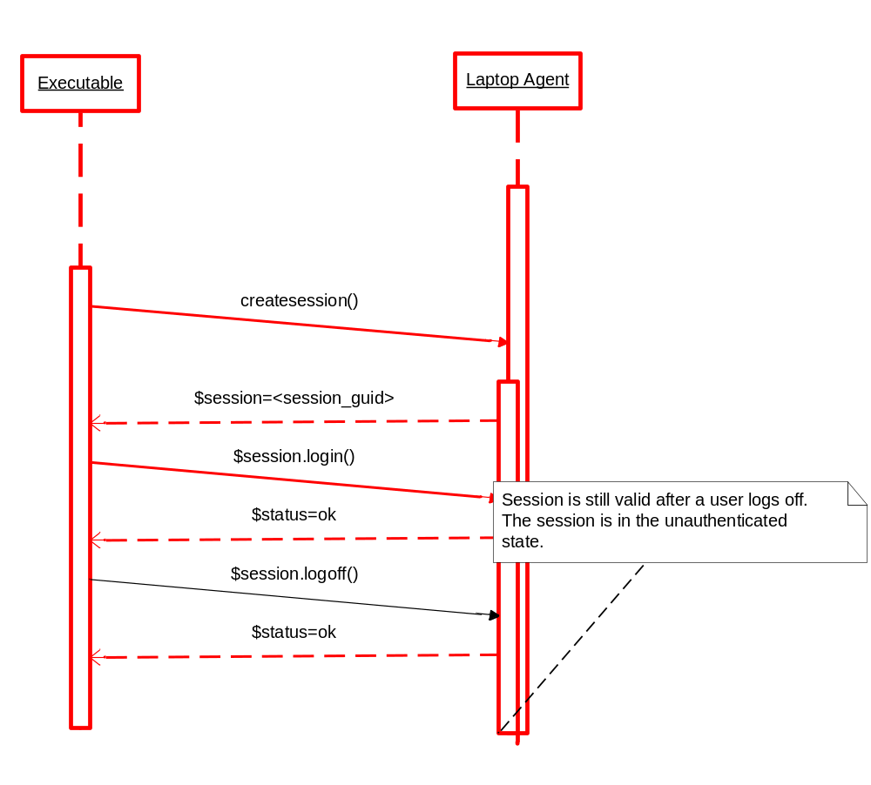

Connectivity and Extended Session Management
The basic session setup and user login is shown below
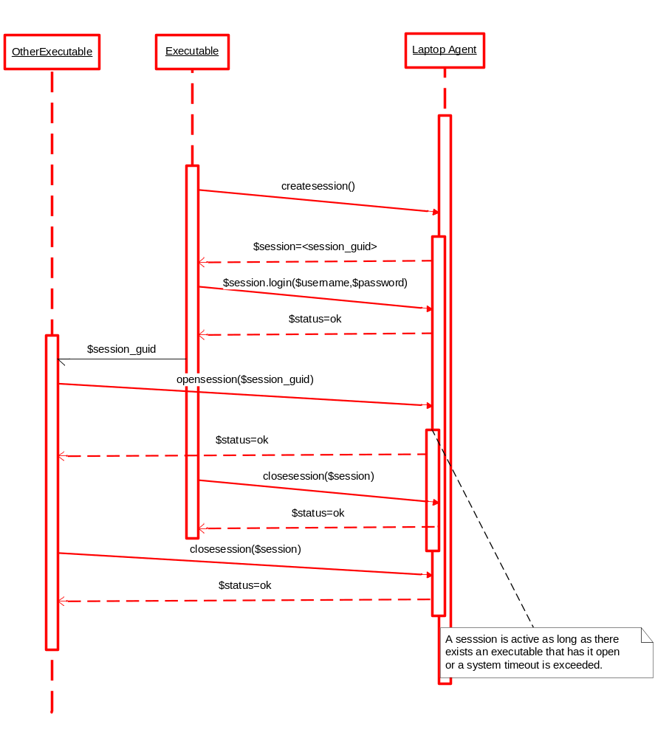

Getting Headers and Associated Notifications
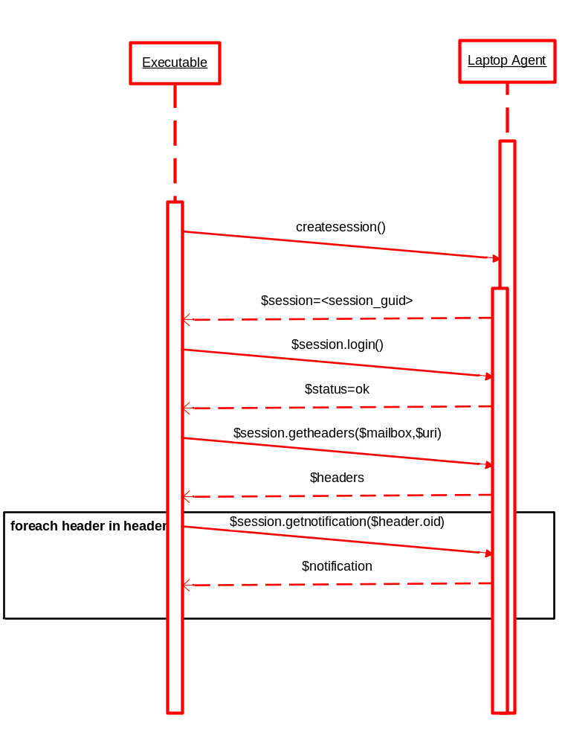

Posting Notifications
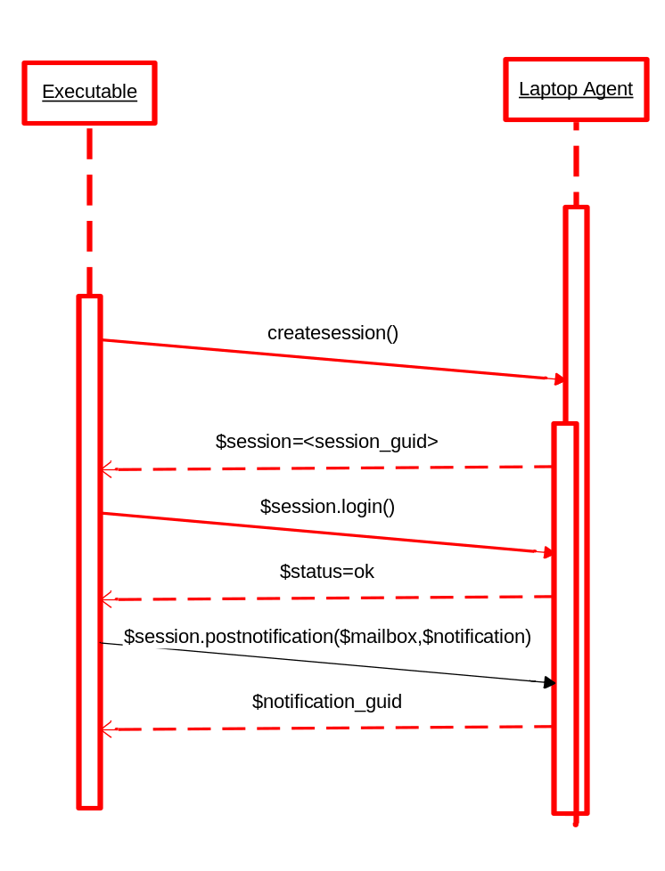

Sample Messages and Responses
Following are a series of samples of messages and their responses.

Session Management

Create Session
A session_guid id is generated by the laptop agent when the client requests a session. It is used by the laptop agent to distinguish between multiple application sessions and to assigns state to an application
Call:
<?xml version="1.0" encoding="utf-8"?>
<message schema_version="3644767c-2632-411a-9416-44f8a7dee08e">
<request type='createsession' xaction_guid='0f16a851-a043-498d-a857-77ee5c59499c' />
</message>
Response:
On success, a new session GUID is returned.
<?xml version="1.0" encoding="utf-8"?>
<message schema_version="3644767c-2632-411a-9416-44f8a7dee08e" session_guid='bd86a4a2-a894-4be5-b0e4-8b9b24ba6ed3'>
<response type='param' xaction_guid='0f16a851-a043-498d-a857-77ee5c59499c' >
<params>
<param name='session'>bd86a4a2-a894-4be5-b0e4-8b9b24ba6ed3</param>
</params>
</response>
</message>
On failure, an error response is returned with an indication of reason.
<?xml version="1.0" encoding="utf-8"?>
<message schema_version="3644767c-2632-411a-9416-44f8a7dee08e" session_guid='bd86a4a2-a894-4be5-b0e4-8b9b24ba6ed3' >
<response type='bad' xaction_guid='0f16a851-a043-498d-a857-77ee5c59499c'>
<params>
<param name='reason'>Error:???????</param>
</params>
</response>
</message>

Open Session
Call:
<?xml version="1.0" encoding="utf-8"?>
<message schema_version="3644767c-2632-411a-9416-44f8a7dee08e">
<request type='opensession' xaction_guid='9650e555-810d-487b-94bf-da8d2f0e334e'>
<params>
<param name='session'>bd86a4a2-a894-4be5-b0e4-8b9b24ba6ed3</param>
</params>
</request>
</message>
Response:
On success, a confirmation message indicating that a session has been opened.
<?xml version="1.0" encoding="utf-8"?>
<message schema_version="3644767c-2632-411a-9416-44f8a7dee08e" session_guid='bd86a4a2-a894-4be5-b0e4-8b9b24ba6ed3' >
<response type='ok' xaction_guid='9650e555-810d-487b-94bf-da8d2f0e334e'/>
</message>

On failure, an error response is returned with an indication of reason.
<?xml version="1.0" encoding="utf-8"?>
<message schema_version="3644767c-2632-411a-9416-44f8a7dee08e" session_guid='bd86a4a2-a894-4be5-b0e4-8b9b24ba6ed3' >
<response type='bad' xaction_guid='0f16a851-a043-498d-a857-77ee5c59499c'>
<params>
<param name='reason'>Error:???????</param>
</params>
</response>
</message>

Close Session

Call:
<?xml version="1.0" encoding="utf-8"?>
<message schema_version="3644767c-2632-411a-9416-44f8a7dee08e" session_guid='bd86a4a2-a894-4be5-b0e4-8b9b24ba6ed3'>
<request type='closesession' xaction_guid='9650e555-810d-487b-94bf-da8d2f0e334e'/>
</message>
Response:
On success, a confirmation message indicating that the session is closed.
<?xml version="1.0" encoding="utf-8"?>
<message schema_version="3644767c-2632-411a-9416-44f8a7dee08e">
<response type='ok' xaction_guid='9650e555-810d-487b-94bf-da8d2f0e334e'/>
</message>

On failure, an error response is returned with an indication of reason.
<?xml version="1.0" encoding="utf-8"?>
<message schema_version="3644767c-2632-411a-9416-44f8a7dee08e" session_guid='bd86a4a2-a894-4be5-b0e4-8b9b24ba6ed3' >
<response type='bad' xaction_guid='0f16a851-a043-498d-a857-77ee5c59499c'>
<params>
<param name='reason'>Error:???????</param>
</params>
</response>
</message>

Authentication

Login
The Login command is used to identify and authenticate a user, associating him/her to a session.
Call:
<?xml version="1.0" encoding="utf-8"?>
<message schema_version="3644767c-2632-411a-9416-44f8a7dee08e" session_guid='bd86a4a2-a894-4be5-b0e4-8b9b24ba6ed3'>
<request type='login' xaction_guid='e1c38f30-50a0-4ccf-a74a-c7ec11b54544'>
<params>
<param name='username'>michael.ekaireb</param>
<param name='password'>P@ssw0rd1</param>
</params>
</request>
</message>

Response:
On success, a confirmation message indicating that the user has successfully logged in and is in the authenticated state.
<?xml version="1.0" encoding="utf-8"?>
<message schema_version="3644767c-2632-411a-9416-44f8a7dee08e" session_guid='bd86a4a2-a894-4be5-b0e4-8b9b24ba6ed3'>
<response type='ok' xaction_guid='e1c38f30-50a0-4ccf-a74a-c7ec11b54544'/>
</message>

On failure, an error response is returned with an indication of reason.
<?xml version="1.0" encoding="utf-8"?>
<message schema_version="3644767c-2632-411a-9416-44f8a7dee08e" session_guid='bd86a4a2-a894-4be5-b0e4-8b9b24ba6ed3' >
<response type='bad' xaction_guid='0f16a851-a043-498d-a857-77ee5c59499c'>
<params>
<param name='reason'>Error:???????</param>
</params>
</response>
</message>

Logoff
The Logoff command informs the server that a user is no longer associated with a given session.

Call:
<?xml version="1.0" encoding="utf-8"?>
<message schema_version="3644767c-2632-411a-9416-44f8a7dee08e" session_guid='bd86a4a2-a894-4be5-b0e4-8b9b24ba6ed3'>
<request type='logoff' xaction_guid='23b2320b-6378-4013-80fb-a05ffe199e9c'/>
</message>

Response:
On success, a confirmation that logoff completed, user is no longer associated.
<?xml version="1.0" encoding="utf-8"?>
<message schema_version="3644767c-2632-411a-9416-44f8a7dee08e" session_guid='bd86a4a2-a894-4be5-b0e4-8b9b24ba6ed3'>
<response type='ok' xaction_guid='23b2320b-6378-4013-80fb-a05ffe199e9c'/>
</message>
On failure, an error response is returned with an indication of reason.
<?xml version="1.0" encoding="utf-8"?>
<message schema_version="3644767c-2632-411a-9416-44f8a7dee08e" session_guid='bd86a4a2-a894-4be5-b0e4-8b9b24ba6ed3' >
<response type='bad' xaction_guid='0f16a851-a043-498d-a857-77ee5c59499c'>
<params>
<param name='reason'>Error:???????</param>
</params>
</response>
</message>

Device Management

Create Device
The Create Device command is used to create a device node, allowing the agent to know about the existence of a given device. It is used when a device is connected to the Service Application but the RSA does not recognize the device. When invoked the RSA

Call:
<?xml version="1.0" encoding="utf-8"?>
<message schema_version="3644767c-2632-411a-9416-44f8a7dee08e" session_guid='bd86a4a2-a894-4be5-b0e4-8b9b24ba6ed3'>
<request type='createdevice' xaction_guid='55c26878-90fb-4a4a-aa1f-3a689310771e'>
<params>
<param name='device_uri'>{7a85f0c9-531e-4754-ad68-04c77ed63657}/{840 34567453}</param>
</params>
</request>
</message>

Response:
On success, a confirmation that the device was created.
<?xml version="1.0" encoding="utf-8"?>
<message schema_version="3644767c-2632-411a-9416-44f8a7dee08e" session_guid='bd86a4a2-a894-4be5-b0e4-8b9b24ba6ed3'>
<response type='ok' xaction_guid='55c26878-90fb-4a4a-aa1f-3a689310771e'/>
</message>

On failure, an error response is returned with an indication of reason.
<?xml version="1.0" encoding="utf-8"?>
<message schema_version="3644767c-2632-411a-9416-44f8a7dee08e" session_guid='bd86a4a2-a894-4be5-b0e4-8b9b24ba6ed3' >
<response type='bad' xaction_guid='0f16a851-a043-498d-a857-77ee5c59499c'>
<params>
<param name='reason'>Error:???????</param>
</params>
</response>
</message>

Delete Device – NOT CURRENTLY IMPLEMENTED
The Delete Device command is used to remove a device node, allowing the agent to forget about the existence of a given device. This only causes the Agent to forget about the device, it doesn’t go to the server. Device will still be a registered device on the Agent

Call:
<?xml version="1.0" encoding="utf-8"?>
<message schema_version="3644767c-2632-411a-9416-44f8a7dee08e" session_guid='bd86a4a2-a894-4be5-b0e4-8b9b24ba6ed3'>
<request type='deletedevice' xaction_guid='55c26878-90fb-4a4a-aa1f-3a689310771e'>
<params>
<param name='device_uri'>{7a85f0c9-531e-4754-ad68-04c77ed63657}/{840 34567453}</param>
</params>
</request>
</message>
Response:
On success, a confirmation that the device was deleted.
<?xml version="1.0" encoding="utf-8"?>
<message schema_version="3644767c-2632-411a-9416-44f8a7dee08e" session_guid='bd86a4a2-a894-4be5-b0e4-8b9b24ba6ed3'>
<response type='ok' xaction_guid='55c26878-90fb-4a4a-aa1f-3a689310771e'/>
</message>
On failure, an error response is returned with an indication of reason.
<?xml version="1.0" encoding="utf-8"?>
<message schema_version="3644767c-2632-411a-9416-44f8a7dee08e" session_guid='bd86a4a2-a894-4be5-b0e4-8b9b24ba6ed3' >
<response type='bad' xaction_guid='55c26878-90fb-4a4a-aa1f-3a689310771e'>
<params>
<param name='reason'>Error:???????</param>
</params>
</response>
</message>

Get Device List – not implemented
The intent of this message is to get the list of all devices that the agent knows about that are relevant for the logged-in user.

Stat Device
The Stat Device command is used to test the assertion that a device is known by the server. If that fails it goes to the RSA. Although known configuration details are returned, perhaps the most critical information provided are the rights for the logged-in user.

Call:
<?xml version="1.0" encoding="utf-8"?>
<message schema_version="3644767c-2632-411a-9416-44f8a7dee08e" session_guid='bd86a4a2-a894-4be5-b0e4-8b9b24ba6ed3'>
<request type='statdevice' xaction_guid='55c26878-90fb-4a4a-aa1f-3a689310771e'>
<params>
<param name='device_uri'>{7a85f0c9-531e-4754-ad68-04c77ed63657}/{840 34567453}</param>
</params>
</request>
</message>

Response:
On success, confirmation that a device is known to system, the last known configuration, and user access rights.

<?xml version=“1.0” encoding=“utf-8”?>
<message schema_version=“3644767c-2632-411a-9416-44f8a7dee08e” session_guid='SESSION_ID'>
<response type='statdevice' xaction_guid='55c26878-90fb-4a4a-aa1f-3a689310771e'>
<params>
<device_uri>{7a85f0c9-531e-4754-ad68-04c77ed63657}/{980 112358}</device_uri>
</params>
<body>
<is_accessible>true</is_accessible>
<last_update>08/17/2012 12:00:00</last_update>
<components>
<component type=“software”>
<name>fedora</name>
<revision>15</revision>
<part_number>097531</part_number>
<rights>
<right>install</right>
<right>remove</right>
</rights>
</component>
<component type=“software”>
<name>bluetoothdvr</name>
<revision>2.4.5</revision>
<part_number>097235</part_number>
<rights>
<right>install</right>
<right>remove</right>
</rights>
</component>
</components>
</body>
</response>
</message>

On failure, an error response is returned with an indication of reason.
<?xml version="1.0" encoding="utf-8"?>
<message schema_version="3644767c-2632-411a-9416-44f8a7dee08e" session_guid='bd86a4a2-a894-4be5-b0e4-8b9b24ba6ed3' >
<response type='bad' xaction_guid='0f16a851-a043-498d-a857-77ee5c59499c'>
<params>
<param name='reason'>Device Not Found!!!</param>
</params>
</response>
</message>

Notification Management

Get (Notification) Headers
Call:
<?xml version="1.0" encoding="utf-8"?>
<message schema_version="3644767c-2632-411a-9416-44f8a7dee08e" session_guid='bd86a4a2-a894-4be5-b0e4-8b9b24ba6ed3'>
<request type='getheaders'
xaction_guid='55c26878-90fb-4a4a-aa1f-3a689310771e' >
<params>
<param name='mailbox'>34caa93b-6ed3-4a93-9be7-4e31eb4b22d5</param>
<param name='device_uri'>{bc108d24-1cd7-403f-8dd4-e8e0ad816a20}/{840 34567453}</param>
</params>
</request>
</message>

Response:
On success, a list of notifications that is available for a given device_uri.

<?xml version="1.0" encoding="utf-8"?>
<message schema_version="3644767c-2632-411a-9416-44f8a7dee08e" session_guid='bd86a4a2-a894-4be5-b0e4-8b9b24ba6ed3'>
<response type='headers'
xaction_guid='55c26878-90fb-4a4a-aa1f-3a689310771e'>
<headers>
<notification oid='344aa359-f0ba-4f5a-b6d2-790bfd1ad95e'>
<header notification_type='command' notification_action='set'>
<pertinent_type>7a85f0c9-531e-4754-ad68-04c77ed63657/86fd6b83-219a-4482-8813-191c477ccd7e</pertinent_type>
<pertinent_identifier>840 351545678</pertinent_identifier>
<notification_id>344aa359-f0ba-4f5a-b6d2-790bfd1ad95e</notification_id>
</header>
</notification>
<notification oid='344aa359-f0ba-4f5a-b6d2-790bfd1ad95e'>
<header notification_type='command' notification_action='get'>
<pertinent_type>7a85f0c9-531e-4754-ad68-04c77ed63657/ac2b174e-f6f7-45ed-997c-35c71f74ef5b</pertinent_type>
<pertinent_identifier>840 351545678</pertinent_identifier>
<notification_id>344aa359-f0ba-4f5a-b6d2-790bfd1ad95e</notification_id>
</header>
</notification>
</headers>
</response></message>

On failure, an error response is returned with an indication of reason.
<?xml version="1.0" encoding="utf-8"?>
<message schema_version="3644767c-2632-411a-9416-44f8a7dee08e" session_guid='bd86a4a2-a894-4be5-b0e4-8b9b24ba6ed3' >
<response type='bad' xaction_guid='0f16a851-a043-498d-a857-77ee5c59499c'>
<params>
<param name='reason'>Error:???????</param>
</params>
</response>
</message>

Get Notification
Call:
<?xml version="1.0" encoding="utf-8"?>
<message schema_version="3644767c-2632-411a-9416-44f8a7dee08e" session_guid='bd86a4a2-a894-4be5-b0e4-8b9b24ba6ed3'>
<request type='getnotification' xaction_guid='55c26878-90fb-4a4a-aa1f-3a689310771e' >
<params>
<param name='notification_oid'>bc108d24-1cd7-403f-8dd4-e8e0ad816a20</param>
</params>
</request>
</message>

Response:
On success, a notification with both body and header. The body element is base64 encoded.
<?xml version="1.0" encoding="utf-8"?>
<message schema_version="3644767c-2632-411a-9416-44f8a7dee08e" session_guid='bd86a4a2-a894-4be5-b0e4-8b9b24ba6ed3' >
<response type='notifications'
xaction_guid='55c26878-90fb-4a4a-aa1f-3a689310771e'>
<notifications>
<notification oid='344aa359-f0ba-4f5a-b6d2-790bfd1ad95e'>
<header notification_type='command' notification_action='set'>
<pertinent_type>ddf96625-cb25-49c2-a59b-07da0f48d46c/86fd6b83-219a-4482-8813-191c477ccd7e</pertinent_type>
<pertinent_identifier>840 351545678</pertinent_identifier>
<notification_id>344aa359-f0ba-4f5a-b6d2-790bfd1ad95e</notification_id>
</header>
<body />
</notification>
</notifications>
</response>
</message>

On failure, an error response is returned with an indication of reason.
<?xml version="1.0" encoding="utf-8"?>
<message schema_version="3644767c-2632-411a-9416-44f8a7dee08e" session_guid='bd86a4a2-a894-4be5-b0e4-8b9b24ba6ed3' >
<response type='bad' xaction_guid='0f16a851-a043-498d-a857-77ee5c59499c'>
<params>
<param name='reason'>Error:???????</param>
</params>
</response>
</message>

Post Notification
Call:
The body element is base64 encoded.

<?xml version="1.0" encoding="utf-8"?>
<message schema_version="3644767c-2632-411a-9416-44f8a7dee08e" session_guid='bd86a4a2-a894-4be5-b0e4-8b9b24ba6ed3' >
<request type='postnotification'
xaction_guid='55c26878-90fb-4a4a-aa1f-3a689310771e'>
<params>
<param name='mailbox'>34caa93b-6ed3-4a93-9be7-4e31eb4b22d5</param>
<notification>
<header notification_type='command' notification_action='set'>
<pertinent_type>7a85f0c9-531e-4754-ad68-04c77ed63657/86fd6b83-219a-4482-8813-191c477ccd7e</pertinent_type>
<pertinent_identifier>840 351545678</pertinent_identifier>
<notification_id>344aa359-f0ba-4f5a-b6d2-790bfd1ad95e</notification_id>
</header>
<body />
</notification>
</params>
</request>
</message>

Response:
On success, the OID of the notification is returned.
<?xml version="1.0" encoding="utf-8"?>
<message schema_version="3644767c-2632-411a-9416-44f8a7dee08e" session_guid='bd86a4a2-a894-4be5-b0e4-8b9b24ba6ed3'>
<response type='param' xaction_guid='0f16a851-a043-498d-a857-77ee5c59499c' >
<params>
<param name='notification_oid'>bd86a4a2-a894-4be5-b0e4-8b9b24ba6ed3</param>
</params>
</response>
</message>

On failure, an error response is returned with an indication of reason.
<?xml version="1.0" encoding="utf-8"?>
<message schema_version="3644767c-2632-411a-9416-44f8a7dee08e" session_guid='bd86a4a2-a894-4be5-b0e4-8b9b24ba6ed3' >
<response type='bad' xaction_guid='0f16a851-a043-498d-a857-77ee5c59499c'>
<params>
<param name='reason'>Error:???????</param>
</params>
</response>
</message>

Delete Notification
Mark a notification deleted.

Call:
<?xml version="1.0" encoding="utf-8"?>
<message schema_version="3644767c-2632-411a-9416-44f8a7dee08e" session_guid='bd86a4a2-a894-4be5-b0e4-8b9b24ba6ed3'>
<request type='deletenotification' xaction_guid='55c26878-90fb-4a4a-aa1f-3a689310771e' >
<params>
<param name='notification_oid'>bc108d24-1cd7-403f-8dd4-e8e0ad816a20</param>
</params>
</request>
</message>

Response:
On success, a confirmation that the notification was deleted.
<?xml version="1.0" encoding="utf-8"?>
<message schema_version="3644767c-2632-411a-9416-44f8a7dee08e" session_guid='bd86a4a2-a894-4be5-b0e4-8b9b24ba6ed3'>
<response type='ok' xaction_guid='55c26878-90fb-4a4a-aa1f-3a689310771e'/>
</message>

On failure, an error response is returned with an indication of reason.
<?xml version="1.0" encoding="utf-8"?>
<message schema_version="3644767c-2632-411a-9416-44f8a7dee08e" session_guid='bd86a4a2-a894-4be5-b0e4-8b9b24ba6ed3' >
<response type='bad' xaction_guid='0f16a851-a043-498d-a857-77ee5c59499c'>
<params>
<param name='reason'>Error:???????</param>
</params>
</response>
</message>

Update Notification
Call:

<?xml version="1.0" encoding="utf-8"?>
<message schema_version="3644767c-2632-411a-9416-44f8a7dee08e" session_guid='bd86a4a2-a894-4be5-b0e4-8b9b24ba6ed3' >
<request type='updatenotification'
xaction_guid='55c26878-90fb-4a4a-aa1f-3a689310771e'>
<params>
<notification oid='344aa359-f0ba-4f5a-b6d2-790bfd1ad95e'>
<header notification_type='command' notification_action='set'>
<pertinent_type>ddf96625-cb25-49c2-a59b-07da0f48d46c/86fd6b83-219a-4482-8813-191c477ccd7e</pertinent_type>
<pertinent_identifier>840 351545678</pertinent_identifier>
<notification_id>344aa359-f0ba-4f5a-b6d2-790bfd1ad95e</notification_id>
</header>
<body />
</notification>
</params>
</request>
</message>

Response:
On success, confirmation that a notification has been updated.
<?xml version="1.0" encoding="utf-8"?>
<message schema_version="3644767c-2632-411a-9416-44f8a7dee08e" session_guid='bd86a4a2-a894-4be5-b0e4-8b9b24ba6ed3'>
<response type='ok' xaction_guid='55c26878-90fb-4a4a-aa1f-3a689310771e'/>
</message>

On failure, an error response is returned with an indication of reason.
<?xml version="1.0" encoding="utf-8"?>
<message schema_version="3644767c-2632-411a-9416-44f8a7dee08e" session_guid='bd86a4a2-a894-4be5-b0e4-8b9b24ba6ed3' >
<response type='bad' xaction_guid='0f16a851-a043-498d-a857-77ee5c59499c'>
<params>
<param name='reason'>Error:???????</param>
</params>
</response>
</message>

Expunge (Notification)
Call:
Remove a single notification marked for deletion.
<?xml version="1.0" encoding="utf-8"?>
<message schema_version="3644767c-2632-411a-9416-44f8a7dee08e" session_guid='bd86a4a2-a894-4be5-b0e4-8b9b24ba6ed3'>
<request type='expunge' xaction_guid='55c26878-90fb-4a4a-aa1f-3a689310771e' >
<params>
<param name='notification_oid'>bc108d24-1cd7-403f-8dd4-e8e0ad816a20</param>
</params>
</request>
</message>

Remove notifications marked deletion from system.
<?xml version="1.0" encoding="utf-8"?>
<message schema_version="3644767c-2632-411a-9416-44f8a7dee08e" session_guid='bd86a4a2-a894-4be5-b0e4-8b9b24ba6ed3'>
<request type='expunge' xaction_guid='55c26878-90fb-4a4a-aa1f-3a689310771e' />
</message>

Response:
On success, a confirmation that the notification was undeleted is returned.
<?xml version="1.0" encoding="utf-8"?>
<message schema_version="3644767c-2632-411a-9416-44f8a7dee08e" session_guid='bd86a4a2-a894-4be5-b0e4-8b9b24ba6ed3'>
<response type='ok' xaction_guid='55c26878-90fb-4a4a-aa1f-3a689310771e'/>
</message>

On failure, an error response is returned with an indication of reason.
<?xml version="1.0" encoding="utf-8"?>
<message schema_version="3644767c-2632-411a-9416-44f8a7dee08e" session_guid='bd86a4a2-a894-4be5-b0e4-8b9b24ba6ed3' >
<response type='bad' xaction_guid='0f16a851-a043-498d-a857-77ee5c59499c'>
<params>
<param name='reason'>Error:???????</param>
</params>
</response>
</message>

Sample Messages / Notifications
Following are a variety of samples using

Software Download (Notification)
<?xml version=“1.0” encoding=“UTF-8” standalone=“yes”?>
<message schema_version=“3644767c-2632-411a-9416-44f8a7dee08e” session_guid="123">
<response type=“notifications” xaction_guid="456">
<notifications><notification oid=“1”>
<header notification_action=“get” notification_type=“response”>
<notification_id>3644767c-2632-411a-9416-44f8a7d11235</notification_id>
<pertinent_identifier>980 112358</pertinent_identifier>
<pertinent_type>7a85f0c9-531e-4754-ad68-04c77ed63657/24637560-edb3-4961-b17d-14e74f74457c</pertinent_type>
</header>
<body>
<components>
<component type=“software”>
<location>file:///C:/LaptopAgent/Downloads/Output.pre.gz</location>
<length>14976866</length>
<md5sum>29f896d8ff7c6eb3dcf1dd89d7b30a62</md5sum>
<name>PB980_10090951X00</name>
<part_number>10090951</part_number>
<revision>X00</revision>
</component>
<component type=“document”>
<location>file:///C:/LaptopAgent/Downloads/4_075609_00_rev g_ops_840_useng.pdf</location>
<md5sum>29f896d8ff7c6eb3dcf1dd89d7b30a62</md5sum>
<part_number>075609</part_number>
<name>user manual</name>
<revision>00-g</revision>
</component>
</components>
</body>
</notification>
</notifications>
</response></message>

Software Download Acknowledgement (Notification)
<?xml version='1.0' encoding='utf-8'?>
<message schema_version='3644767c-2632-411a-9416-44f8a7dee08e' session_guid='7242ff7a-fbec-44d8-8c50-2b1fc0780617'>
<request type='postnotification' xaction_guid='6d21cdca-bbd3-4e38-aa9e-bb83d2b8b68f'>
<params>
<mailbox>3bd775ad-7250-42ff-adf4-188e0b691bff</mailbox>
</params>
<notification oid='378534e1-2ec5-410f-a6e3-fcf238d77efb'>
<header notification_type='event' notification_action='create'>
<pertinent_type>a7a65225-ef2d-48e9-89c8-6975dd7dc054/91dec715-f256-421a-8560-e6b015dae5f9</pertinent_type>
<pertinent_identifier>980 112358</pertinent_identifier>
</header>
<body>
<components>
<component type='software'>
<part_number>10090951</part_number>
<revision>X00</revision>
<timestamp>8/21/2012 1:37:36 PM</timestamp>
<status>installed</status>
</component>
</components></body></notification></request></message>

Log Info (Notification)
<?xml version='1.0' encoding='utf-8'?>
<message schema_version='3644767c-2632-411a-9416-44f8a7dee08e' session_guid=''>
<request type='postnotification' xaction_guid='1d65b46d-d14d-4bcd-9c50-083102cc043c'>
<params>
<mailbox>3bd775ad-7250-42ff-adf4-188e0b691bff</mailbox>
</params>
<notification oid='95db4769-701b-4aa4-8f6f-f47e124459bf'>
<header notification_type='event' notification_action='create'>
<pertinent_type>7a85f0c9-531e-4754-ad68-04c77ed63657/2f62d564-a162-440a-a5f6-ed16e7e632d5</pertinent_type>
<pertinent_identifier>980 112358</pertinent_identifier>
</header>
<body>
<logs>
<log name='sysdiag'>
<meta http-equiv="transfer-encoding" content="gzip"/>
<uri_inc> C:/Logs/PB980_VENTILATOR-980 112358-sysdiag-raw-2_21_53 PM.log.xml.gz </uri_inc>
</log>
</logs>
</body>
</notification>
</request>
</message>

Device Info (Notification)
<?xml version='1.0' encoding='utf-8'?>
<message schema_version='3644767c-2632-411a-9416-44f8a7dee08e' session_guid='740306bb-a7e4-4a1c-be40-ffa0b720e284'>
<request type='postnotification' xaction_guid='c67a7a12-f291-4f02-a2ea-63f5bc83b7e9'>
<params>
<mailbox>3bd775ad-7250-42ff-adf4-188e0b691bff</mailbox>
</params>
<notification oid='dc308fde-bf9a-4c6f-9ef0-f41cb499c8e1'>
<header notification_type='event' notification_action='create'>
<pertinent_type>7a85f0c9-531e-4754-ad68-04c77ed63657/532ffdda-6f38-41da-9a40-cb0801e6695f</pertinent_type>
<pertinent_identifier>980 112358</pertinent_identifier>
</header>
<body>
<component type='HARDWARE' >
<name>VENTILATOR</name>
<part_number></part_number>
<revision_number></revision_number>
<serial_number>35B1203041</serial_number>
</component><component type='HARDWARE' >
<name>INSP_FLOW_SENSOR</name>
<part_number></part_number>
<revision_number></revision_number>
<serial_number>123456</serial_number>
</component>
<component type='HARDWARE' >
<name>EXH_FLOW_SENSOR</name>
<part_number></part_number>
<revision_number></revision_number>
<serial_number></serial_number>
</component><component type='HARDWARE' >
<name>GUI_PCBA</name>
<part_number></part_number>
<revision_number></revision_number>
<serial_number>XXXXXXXXXXXXX</serial_number>
</component><component>
<name>OPTIONAL_ACCESSORIES</name>
<part_number></part_number>
<revision_number>Not Installed</revision_number>
<serial_number></serial_number>
</component><component type='HARDWARE' >
<name>PROX</name>
<part_number></part_number>
<revision_number></revision_number>
<serial_number>4294967295</serial_number>
</component>
</components>
</body>
</notification>
</request>
</message>

Sample Log Files
Following are samples of raw and decoded log files.

Raw Log File

The following is a sample raw log file,

<LogFiles>
<LogFile name="estsstdiag" >
<head>
<meta http-equiv="Content-Type" content="application/pbVentLog-diag;ver=1.0" />
<meta http-equiv="Transfer-Encoding" content="base64" />
</head>
<body>
AAAABBEGEwEAAABRAAAAAAAAADEAAAAAAAAAAAAACZ0AAABwAAAAIAAAAQEAACCQAAAA5gAAAOYAAAEAAAAAAAAAAAAAAAAwAAAAMQAAAAAAAAAxAAAAAAwFFAglEQFbDAUUCggDA28AAAAAAAAGYwwFEAwSJgE7AAAAAAAAAKGOBg
AEAAAAAAAAAAAAAAHaDAUQDBMkAhcAAAAAAAAAfY4EAA4AAAAAAAAAAAAAAZoMBRAMFDcAmQAAAAAAAAERjgAAAQAAAAAAAAAAAAABsgwFEAwbGgMQAAAAAAAAAHWOBAAOAAAAAAAAAAAAAAGKDAUQDBs5ACkAAAAAAAAAqo4EAA4A
AAAAAAAAAAAAAfQMBRAMHB4BlAAAAAAAAAD8jgQADgAAAAAAAAAAAAACmAwFEAwdAgPGAAAAAAAAARWOBAAOAAAAAAAAAAAAAAHLDAUQDB0wAigAAAAAAAAApI4GAAQAAAAAAAAAAAAAAeAMBRAMIi8AawAAAAAAAADpjgQADgAAAA
AAAAAAAAACcgwFEAwjCgD8AAAAAAAAAVaOBAAOAAAAAAAAAAAAAAJNDAUQDCMfA64AAAAAAAABII4EAA4AAAAAAAAAAAAAAeEMBRAMJAADgQAAAAAAAADVjgYABAAAAAAAAAAAAAACQgwFEAwkOgL0AAAAAAAAAYGOBAAOAAAAAAAA
AAAAAAKjDAUQDCUWAMoAAAAAAAABMo4GAAQAAAAAAAAAAAAAAf0MBRAMJR0CuAAAAAAAAAEpjgAAAQAAAAAAAAAAAAAB4gwFEAwlMwFRAAAAAAAAANeOAQACAAAAAAAAAAAAAAI/DAUQDCYPA1UAAAAAAAAAuo4EAA4AAAAAAAAAAA
AAAhQMBRAMLA4DQQAAAAAAAACrjgQADgAAAAAAAAAAAAAB9gwFEAwsJgNlAAAAAAAAAOeOBAAOAAAAAAAAAAAAAAJuDAUQDCw6AgMAAAAAAAAAmI4EAA4AAAAAAAAAAAAAAdAMBRAMLRcBkwAAAAAAAAEFjgYABAAAAAAAAAAAAAAB
owwFEAwuAANpAAAAAAAAAMeOBAAOAAAAAAAAAAAAAAIuDAUQEDIeAqMAAAAAAAABJhQBAAAAAAAAAAAAAAAAAWIMBRAQODsB9gAAAAAAAAGbFAEAAAAAAAAAAAAAAAACTAwFEBEADgH7AAAAAAAAATwUAQAAAAAAAAAAAAAAAAGODA
UQEiYmAfAAAAAAAAABcBQBAAAAAAAAAAAAAAAAAfYMBRATIhIBRAAAAAAAAACtFAEAAAAAAAAAAAAAAAABbwwFEBQDFQCMAAAAAAAAANkUAQAAAAAAAAAAAAAAAAHHDAUTCSMkATIAAAAAAAAAp3wBAAMAAAAAAAAAAAAAAc4MBRMJ
IyUDMgAAAAAAAACqfAEAAwAAAAAAAAAAAAAB1AwFEwkjJwM2AAAAAAAAALB+AQACAAAAAAAAAAAAAAHhDAUTDQ8jAq8AAAAAAAABFBQBAAAAAAAAAAAAAAAAAT4MBRMNDyMCsAAAAAAAAAEVFAEAAAAAAAAAAAAAAAABQAwFFAgmHw
BJAAAAAAAAALsUAQAAAAAAAAAAAAAAAAGLDAUUCCYfAEoAAAAAAAAAvBQBAAAAAAAAAAAAAAAAAY0MBRQIOiwCyQAAAAAAAAFeFAEAAAAAAAAAAAAAAAAB0gwFFAkDNAH2AAAAAAAAAVyCHQEZAAAAAAAAAAAAAAJyDAUUCQgPAecA
AAAAAAABLRQBAAAAAAAAAAAAAAAAAXAMBRQJCSgDpwAAAAAAAAEJih0AAQAAAAAAAAAAAAABuwwFFAkJKAPDAAAAAAAAASWKHQABAAAAAAAAAAAAAAHzDAUUCQsLAs8AAAAAAAABFXoIAAEAAAAAAAAAAAAAAa4MBRQJCwsC2gAAAA
AAAAEgeggAAQAAAAAAAAAAAAABxAwFFAkNLwICAAAAAAAAAG5+AAAEAAAAAAAAAAAAAAFeDAUUCREeAqsAAAAAAAABCn4AAAQAAAAAAAAAAAAAAZcMBRQJEzoDTAAAAAAAAADKfgAABAAAAAAAAAAAAAACFgwFFAk1GAAcAAAAAAAA
AJd8AQADAAAAAAAAAAAAAAGuDAUUCTUZAB4AAAAAAAAAmnwBAAMAAAAAAAAAAAAAAbQMBRQJNRoCWwAAAAAAAADafAEAAwAAAAAAAAAAAAACNAwFFAk1HABNAAAAAAAAAMx8AQADAAAAAAAAAAAAAAIY
</body>
</LogFile>
</LogFiles>

Decoded Log File
The following is a sample decoded log file,

<LogFiles><LogFile name='sysdiag'><head><meta http-equiv='content-type' content='application/pbVentLog-diag-json' /><renderHeaderHead><thead><tr><th>Meta Data Item</th><th>Value</th></tr></thead></renderHeaderHead><renderHeaderBody><headRows><row><tr><td>File Id</td><td>%1%</td></tr></row><row><tr><td>File Revision</td><td>%2%</td></tr></row><row><tr><td>Status</td><td>%3%</td></tr></row><row><tr><td>File Created</td><td>%23%-%24%-%25% %26%:%27%:%28%</td></tr></row><row><tr><td>Last Updated</td><td>%30%-%31%-%32% %33%:%34%:%35%</td></tr></row></headRows></renderHeaderBody><renderBodyHead><thead><tr><th>#</th><th>Date</th><th>Time</th><th>Patient Id</th><th>Diag Code</th></tr></thead></renderBodyHead><renderBodyBody><bodyRows><row><tr><td align="right">%0%</td><td>%2%-%3%-%1%</td><td align="right">%4%:%5%:%6%.%7%</td><td>%8%</td><td>%10%</td></tr></row></bodyRows></renderBodyBody></head><body><head>[ 0,2,285610753,81,0,52,0,0,1331,112,32,257,8336,230,230,256,0,0,51,52,0,52,0,'12','05','20','08','37','17','225','12','05','20','10','08','03','868',0,1657 ]</head><body>[ [ 0,'12','05','19','09','40','59','559',0,193,[ 'ZB0000',4,2,0,71,256,0,0 ],530 ],
[ 1,'12','05','19','09','40','59','559',0,193,[ 'ZB0000',4,2,0,71,256,0,0 ],530 ],
[ 2,'12','05','19','11','30','06','151',0,234,[ 'LB0000',4,1,6,52,256,0,0 ],592 ],
[ 3,'12','05','19','11','32','23','463',0,310,[ 'LB0000',4,1,0,54,256,0,0 ],488 ],
[ 4,'12','05','19','11','34','01','292',0,119,[ 'LB0000',4,1,6,52,256,0,0 ],362 ],
[ 5,'12','05','19','11','36','17','609',0,199,[ 'LB0000',4,1,0,54,256,0,0 ],521 ],
[ 6,'12','05','19','11','42','21','134',0,244,[ 'LB0000',4,1,6,52,256,0,0 ],612 ],
[ 7,'12','05','19','11','44','25','722',0,328,[ 'LB0000',4,1,0,54,256,0,0 ],524 ],
[ 8,'12','05','19','11','46','30','503',0,371,[ 'LB0000',4,1,6,52,256,0,0 ],611 ],
[ 9,'12','05','19','11','53','37','910',0,282,[ 'LB0000',4,1,0,54,256,0,0 ],432 ],
[ 10,'12','05','19','12','09','31','503',0,336,[ 'LB0000',4,1,6,52,256,0,0 ],541 ],
[ 11,'12','05','19','12','13','22','439',0,267,[ 'LB0000',4,1,0,54,256,0,0 ],402 ],
[ 12,'12','05','19','12','14','54','711',0,317,[ 'LB0000',4,1,6,52,256,0,0 ],503 ],
[ 13,'12','05','19','12','22','35','641',0,236,[ 'LB0000',4,1,0,54,256,0,0 ],595 ],
[ 14,'12','05','19','12','23','01','027',0,99,[ 'LB0000',4,1,6,52,256,0,0 ],322 ],
[ 15,'12','05','19','12','23','32','365',0,213,[ 'LB0000',4,1,0,54,256,0,0 ],549 ],
[ 16,'12','05','19','12','26','25','912',0,246,[ 'LB0000',4,1,6,52,256,0,0 ],616 ],
[ 17,'12','05','19','12','29','07','274',0,103,[ 'LB0000',4,1,0,54,256,0,0 ],329 ],
[ 18,'12','05','19','12','29','46','732',0,345,[ 'LB0000',4,1,6,52,256,0,0 ],559 ],
<snip>
[ 42,'12','05','20','09','05','52','160',0,263,[ 'LB0000',4,1,6,52,256,0,0 ],395 ],
[ 43,'12','05','20','09','08','15','486',0,300,[ 'LB0000',4,1,0,54,256,0,0 ],468 ],
[ 44,'12','05','20','09','08','15','487',0,301,[ 'E00000',1,1,1,0,0,0 ],368 ],
[ 45,'12','05','20','09','54','07','740',0,337,[ 'LB0000',4,1,6,52,256,0,0 ],543 ],
[ 46,'12','05','20','09','55','17','286',0,149,[ 'LB0000',4,1,0,54,256,0,0 ],421 ],
[ 47,'12','05','20','09','55','18','173',0,292,[ 'ZB0000',4,2,6,53,256,0,0 ],458 ],
[ 48,'12','05','20','09','55','18','217',0,336,[ 'ZB0000',4,2,0,55,256,0,0 ],545 ],
[ 49,'12','05','20','09','58','41','226',0,371,[ 'LB0000',4,1,6,52,256,0,0 ],611 ],
[ 50,'12','05','20','10','01','14','568',0,120,[ 'LB0000',4,1,0,54,256,0,0 ],363 ],
[ 51,'12','05','20','10','03','37','650',0,227,[ 'LB0000',4,1,6,79,256,0,0 ],605 ] ]</body></LogFile></LogFiles>

