Software Architecture
And
Design

Revision History

Author | Date | Version | Description
John Dougherty | May 26 2012 | 0.9 | Initial revision

Table of Contents

1. Introduction 5
1.1.1 Business and technology goals 5
1.1.2 Goals 5
1.1.3 Definitions, Acronyms and Abbreviations 5
1.1.4 References 5
2. Document 5
3. Status 5
1.1.5 Development Principles 6
4. Key Scenarios 7
1.1.6 Expected Growth of the System 8
1.1.7 Safety Requirements (planning for future requirements) 8
5. Logical Architecture 9
1.1.8 Interfaces 9
Users and Roles 10
16
1.1.9 Components 16
5.1. Architectural Stack 17
5.2. Overview 18
1.1.10 Communication Model 21
1.1.11 Data Strategy 21
1.1.12 Software Integration 22
6. Third Party Products (including versions) 22
Pugh Decision Matrix O/S 23
7. Deployment Views 24
1.1.13 Primary Physical Topology 24
8. Cross-Cutting Concerns 27
1.1.14 Internationalization 27
1.1.15 Error Handling Strategy 33
1.1.16 Logging Strategy 33
9. Attributes 34
1.1.17 Availability 34
1.1.18 Security 34
1.1.19 Scalability 35
1.1.20 Maintainability 36
1.1.21 Testability 36
1.1.22 Reusability 36
1.1.23 Supportability 36
PHI, PII and HIPAA 36
10. Security and HIPPA compliance requirements 36
11. Security and PII 37
12. Mechanisms of ensuring compliance with Healthcare, HIPAA PHI, and PII security requirements 38
1.1.24 Policy and Procedure Creation 38
1.1.25 Awareness, Training, and Education 38
1.1.26 Minimizing the Use, Collection, and Retention of PII 38
1.1.27 De-Identifying Information 38
1.1.28 Client and Server IT Related Security Controls 38
13. Managing Open Source Licensing 40

Introduction
Describe key attributes of design for development and the product team.

The technology goals are to enable device management of medical data in multiple formats including logs through a PHI secure web environment. Typically the information will be shared within Covidien to manage, monitor, upgrade, and repair devices in the field. Handheld devices and other edge devices are currently in scope for Covidien and will be a key integration point for the server architecture of future releases. The initial design will use laptop devices to secure connection to the medical devices like the PB840 Ventilator, ForceTriad, and SpO2 Monitor.

Business and technology goals
Recommendations for the database management system (DBMS), the messaging service bus (ESB) or similar technology, and a review of extraction translation and loading(ETL) software and its applicability to the Covidien problem domain as well as web application tools for functions like dashboards, view, parse, trend, graph, etc... We will also provide for 3rd party tools with a particular focus on solutions with low costs to entry that can grow with the needs of Covidien. The following is the constellation of major user and administrator use cases.

Goals
Provide architectural to develop the next generation of Covidien’s server-side and client connectivity gateway. This project focuses on the functionality necessary for supporting the deployment of data center facing functionality like – the data model, messaging, data visualization and reporting, bi-directional content management, external 3rd party interfaces, user account management, and administration management.

Definitions, Acronyms and Abbreviations

References

Document | Status
User Requirements Document (URD) version information | in process
Systems Requirement Specification v1.3 | approved
Build Process Automation Setup 1.0 | in process

Development Principles
Use open source code to write less code, test less code, and get to market with solid solutions. Use the large development community to get fast answers and support for new projects. Build to accommodate future change – design with standards allowing the integration of new applications via the standard based infrastructure.

Don’t repeat yourself (DRY) – Every piece of knowledge must have a single unambiguous authoritative representation within a system. Specifically there should be no copy/paste activities related to source code.

You ain’t going to need it (YAGNI) argue against the temptation to write code that is not necessary at the moment but may be in the future. But if you over develop the code it will have the following impact:

The time spent is taken from adding, testing or improving necessary functionality.
The new features must be debugged, documented, and supported.
Any new feature imposes constraints on what can be done in the future, so an unnecessary feature now may prevent implementing a necessary feature later.
Until the feature is actually needed, it is difficult to fully define what it should do and to test it. If the new feature is not properly defined and tested, it may not work correctly, even if it eventually is needed.

In combination the over-development of the solutions will delay time to market. These sections are likely to require rework because the features were not well understood at the time of their development adding dubious value to the overall system. For these reasons any development will be focused on delivering the specific services and features. The framework and technologies provided a growth path for future development.

Key Scenarios
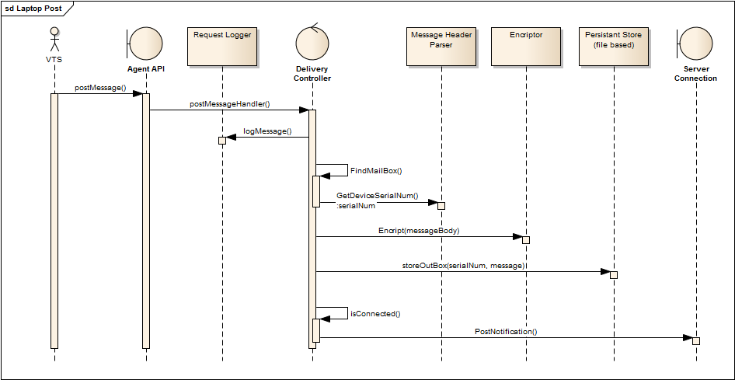Examples of how a few key scenarios will work in the system.

Here is the system Post Notification. The laptop agent design is based on iMAP communication mailboxes. We add a message logger the intent of the logger is to be able to completely reproduce the calls to the application so that they can be run in as a mock object to exercise the service.

The messages will be stored in a ‘mailbox’ for the device. The name of the mailbox is the device+serial number of the device. Here outgoing posts are placed in the out box, while any incoming messages will be placed into the inbox. Conceptually the mail boxes will be set up like this:
..\PB480-321324d1
\InBox\
\OutBox\

The body of the message will be encrypted using public-private key encryption.
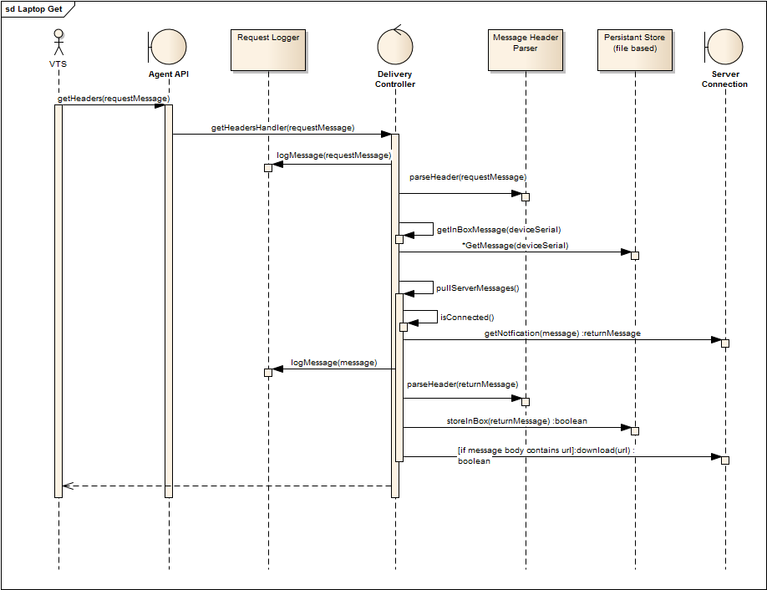

Expected Growth of the System
Future releases shall have these requirements.
The laptop agent shall be designed to running on the following operating systems:
Windows XP, Windows 7, iOS, and Embedded Linux

A single instance of an agent shall be able to communicate with and update software on several devices simultaneously.

The system shall operate correctly through the network infrastructure of any Covidien customer including firewalls and proxy servers without modifications to the customer network infrastructure.

Safety Requirements (planning for future requirements)

Safety Requirements
The system shall safe guard PHI information at all times.
The system shall encrypt PHI in transient.
The system shall encrypt PHI in storage.
The system shall encrypt PII in transient.
The system shall encrypt PII in storage.
The system shall abide by the HIPPA security instruction.

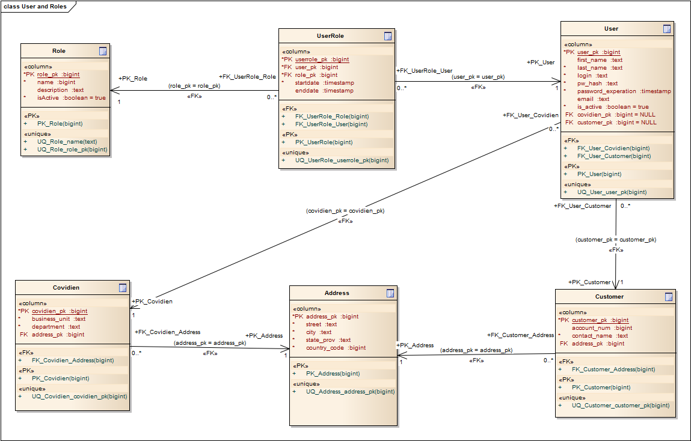
Logical Architecture

Interfaces

Software Interfaces
See the CDMP-Messages document for the lates on the integration API for the agent.

Data Design

Users and Roles
Managing users their roles and the associated management data.

- Role- The role defined for a user.
- User - system users.
- UserRole - Association between user and roles. A user may only be in one role at a time, but may be in multiple roles over time.
- Address – generic entity for capturing the location information. Initially here used to capture Covidien user address or customer address.
- Covidien – Entity for tracking Covidien departmental information.
- Customer – Captures customer contact information

These tables will augment the existing user, role tables used by Drupal 6 to capture additional information about the users.

Additional Data domains are in work for Sprints 3 and 4.

Communication Interfaces
The software will support communication over http port 80, https port 443, transport layer protocols. Communications will run over SSH-2 for file transfers using SFTP or FTP over SSH.

User Interfaces
Stakeholders and their concerns include:

Application Users
Title | Decision Authority | Role in Use Case
Respiratory Equipment Technician (if present) | Impacted Party | Set up/prep ventilator equipment  First echelon of problem diagnosis
Biomedical Technician | Champion  Influencer  Impacted Party | Installs, updates, and maintains system  Manages user permissions on system  Maintain/service medical equipment in the hospital  Track & report ventilator service/performance statistics  Maintain hospital service agreements  Accept equipment into institution
Covidien CSE | Impacted Party | Maintain/service medical equipment in the hospital  Track & report ventilator service/performance statistics  Maintain hospital service agreements  Troubleshoot by remote access to ventilator
Covidien TSE | Champion  Impacted Party | Troubleshoot by remote access to ventilator  Track & report ventilator service/performance statistics  Remote Service Application System administrator
Sustaining Engineering | Impacted Party | Retrieving Device error logs for fault analysis
Product Monitoring | Impacted Party | Will use legacy systems for their complaint file processing.
Failure Investigations | Impacted Party | Will use legacy systems for their complaint file processing.
Covidien Service Manager | - Impacted Party | - Track & report ventilator service/performance statistics  - Monitor hospital service agreements

The following is an overview of initially communicated basic concerns and areas of functionality for the stakeholders. This list will grow with further analysis.

Wire frame models of the UI work flow are being developed as part of the UxD design. Here are the major use cases constellations are outlined based on an exemplar role.

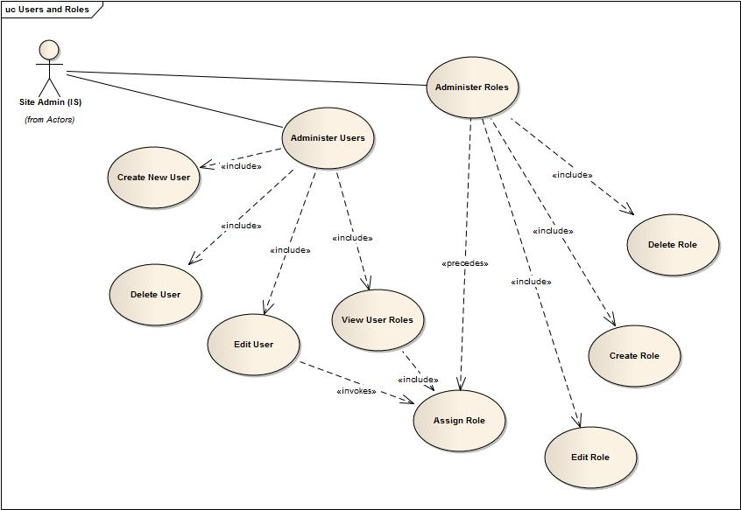
Figure 1 User and Role

Site administrators will manage create, update, and delete functions for users and roles. They will also manage the assignment of roles to uses. They will also be able to view the list of users or roles.
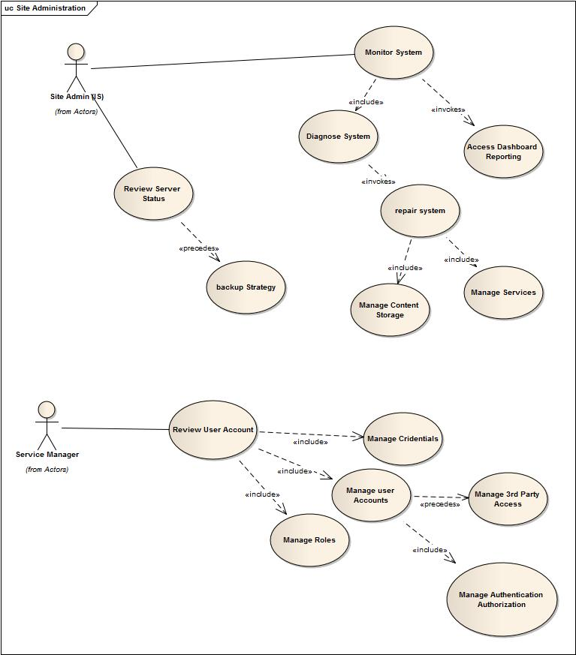
Figure 2 Site Administration

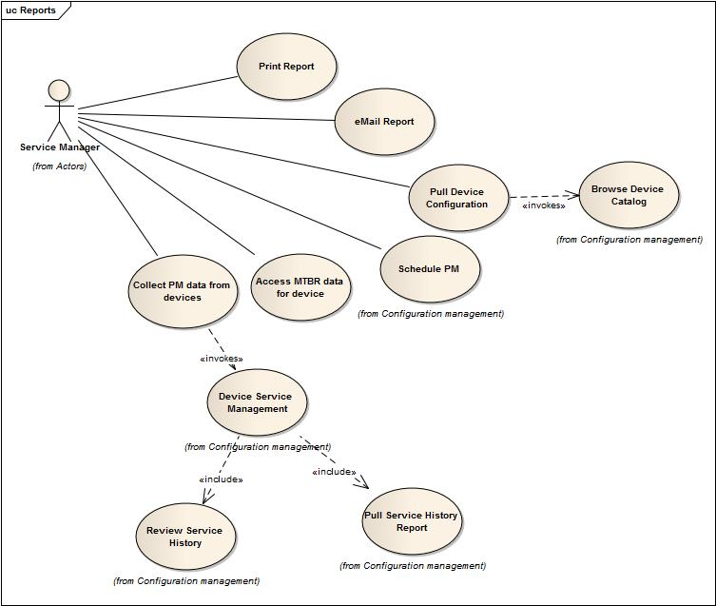
Figure 3 Reports
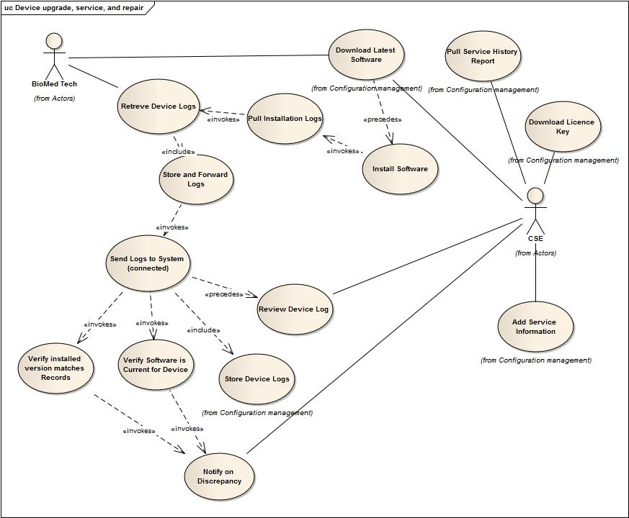
Figure 4 Device Upgrade and Repair

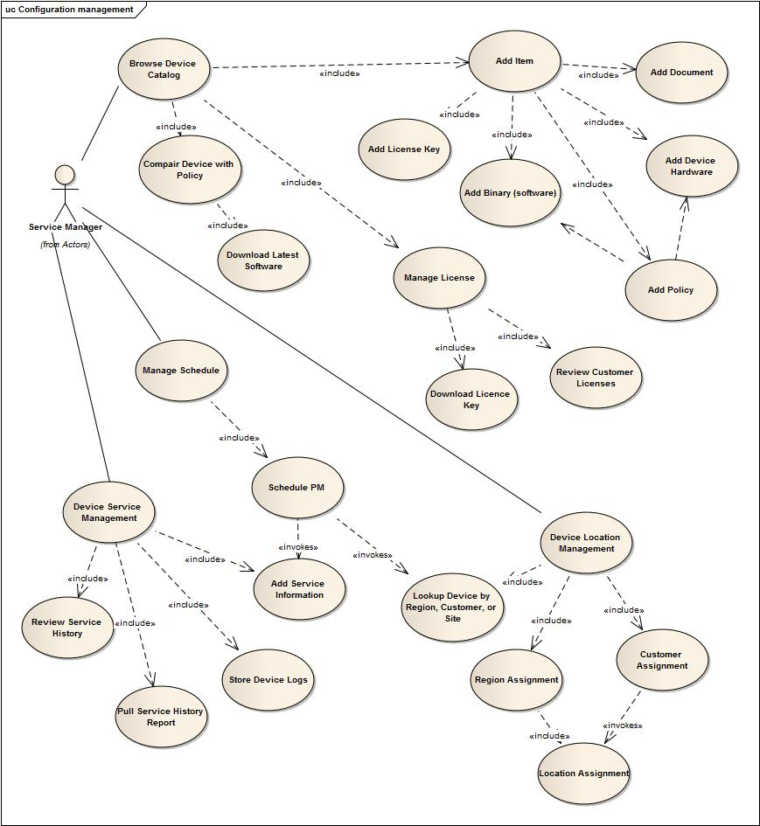
Figure 5 Configuration management

Components

The architecture approach is based on enterprise systems architecture. The focus is on the deployment of enterprise scale web application and backend infrastructure. The architecture tenants are based on IEEE software design methodology and the Software Engineering Institutes best practices in systems architecture.
Separation of Concerns, in general makes it easier to understand, design and manage the architecture. Each service should focus on doing one thing very well and integrate into the overall architecture through well documented interfaces. The design of each service can be optimized independently of others. Any failure of one service does not cause other services or systems to fail. This supports our robust fault tolerant development strategy.

Architecture Views
Each of the following views provides a different perspective of the system and software architecture, the views included here are the traditional architecture stack, communication (because that is so important to this particular application), operations view, and the deployment architecture. In the architecture stack the specific technologies that are part of the final solution are included. It focuses on each layer of the architecture and how they will interact with one another to meet the specific needs of the use cases and stakeholders. An inventory of the tools and the systems needed to develop follow.

Architectural Stack
Several coordinated technologies come together into an integrated enterprise architecture. As outlined below in the architecture stack below. At the top are the user web clients and it moves down the logical architecture stack from there to the database services at the bottom of the stack. This is strictly a logic view of the technologies and design.
These technologies make up our component library and will be reusable for other projects.

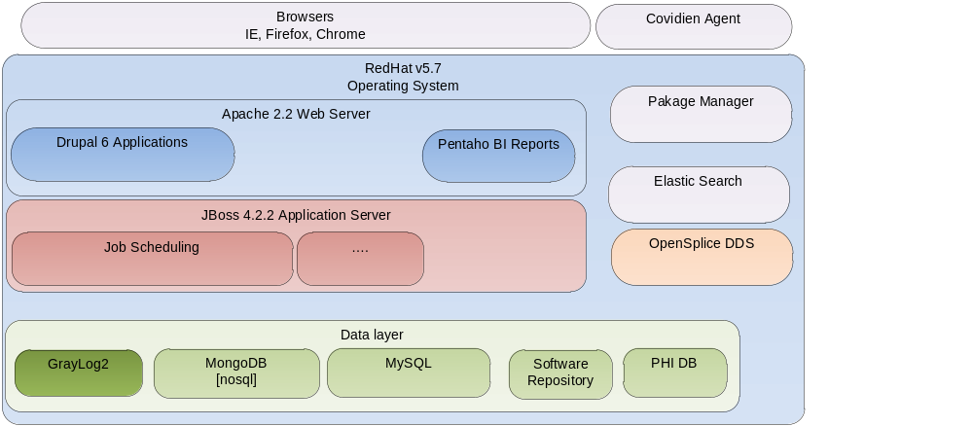

Overview

Working from the outside in and from the top down through the architecture stack, first the users are expected to come into the hosted site through typical browsers including Microsoft Internet Explorer v8.x or v9.x, Mozilla Firefox 3.x or 4.x, Google Chrome v10.x, 11.x, 12.x, and Apple Safari 4.x and 5.x. This covers the preponderance of user browsers and allows for a ubiquitous web end user experience.

It is recommended that a Drupal Theme be used if it meets the needs of the client applications.
External systems are expected to adhere to standard base interfaces and will be addressed through those standards only. The architecture support s XML based messaging, SOAP, and JAX-WS interfaces with third party systems. The architecture uses an ESB and can therefore support a preponderance of data and message types.

For development the operating system is CentOS v5.7. CentOS is a Linux operating system that is binary compatible with RedHat Linux. CentOS is an Enterprise-class Linux Distribution derived from sources freely provided to the public. It does not have any direct costs associated with it. The run-time environment is RedHat Enterprise Linux Server v5.7.

The web Server is Apache 2.2. Apache provides a proxying service allowing the web applications to be load balanced from the beginning. It supports production level caching which will help meet the performance needs of the site. Apache supports HTML5 see appendix E for installation instructions. Apache supports server-side scripting via PHP. Since April 1996 Apache has been the most popular HTTP server software in use. As of February 2011 Apache served over 59.13% of all websites and more than 66.62% of the million busiest.

Application Server JBoss 4.2.2 JBoss, a free certified application server, is the most widely used open source application server on the market. The highly flexible and easy-to-use server architecture has made JBoss the ideal choice a customizable middleware platform. The server binary and source code distributions are available from the SourceForge repository. For our purposes this will provide container services only.
Data Services include the database management system, configuration Meta data (registries), the file system, data replication services, and disaster recovery.

OpenSplice DDS Overview
Multiple Architectures, unique configurable Federated or Non-Federated deployment options allow you to match performance, scalability and fault tolerance characteristics to evolving system needs; reducing both initial and lifetime development costs. 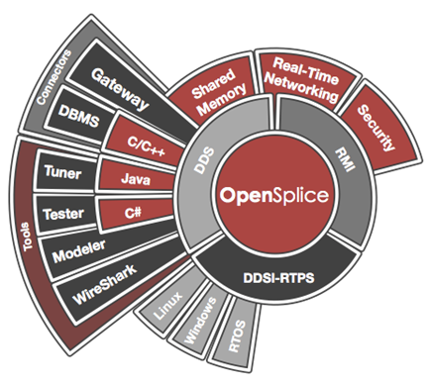
Scalable & Real-Time federated deployment option (maximum scalability & minimal latencies) and Real-time Networking option combine to deliver support ultra large scale real-time systems. OpenSplice Gateway delivers integration support for over 80 connectors to other messaging technologies (e.g. JMS & AMQP), and proprietary Web Technologies (e.g. W3C Web Services & RESTful). And OpenSplice DDS is the strictest implementation of the DDS OMG Open Standard guaranteeing portability and interoperability across competing DDS implementations.

Apache Camel
Camel uses a Java based Routing Domain Specific Language (DSL) or an Xml Configuration to configure routing and mediation rules which are added to a CamelContext to implement the various Enterprise Integration Patterns.

At a high level Camel consists of a CamelContext which contains a collection of Component instances. A Component is essentially a factory of Endpoint instances. You can explicitly configure Component instances in Java code or an IoC container like Spring or Guice, or they can be auto-discovered using URIs.

An Endpoint acts rather like a URI or URL in a web application or a Destination in a JMS system; you can communicate with an endpoint; either sending messages to it or consuming messages from it. You can then create a Producer or Consumer on an Endpoint to exchange messages with it.

The DSL makes heavy use of pluggable Languages to create an Expression or Predicate to make a truly powerful DSL which is extensible to the most suitable language depending on your needs.
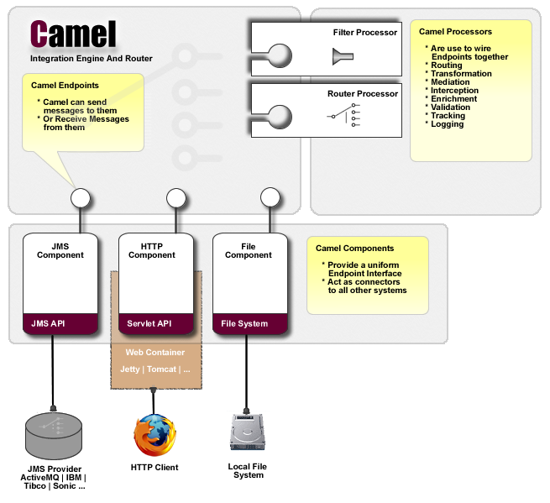

Drupal 6.0 is a web based content management system (CMS). A CMS is uses to manage a large number of people contributing to and sharing stored data. It controls access to the data base on user roles and permissions. This system will use the principle of least privilege to manage user roles and permissions. It is known to support over 50 million page views per month, over 2 million page views in a single day, over 30,000 registrations in a single day, and over 9,000 concurrent users and 6.5 million visitors per month. (source: Acquia scaling Drupal). Given a proxy and replication strategy Drupal will scale with the needs of the business. Drupal is a free, open source content management framework (CMF) written in PHP and distributed under the GNU GPL. The architecture adds the Webmail Plus plug-in for Drupal for email services. It's designed to provide email for any or all members of a Drupal site. It relies on a standard IMAP (Dovecot, Courier-IMAP) server for mail storage and localhost or SMTP (Postfix, Exim) server for mail delivery.

ElasticSearch
ElasticSearch is a JSON based search engine for enterprise computing. It is an Open Source (Apache 2), Distributed, RESTful, Search Engine built on top of Apache Lucene. Issuing queries is a simple call hiding away the sophisticated distributed based search support elasticsearch provides. Search can be executed either using a simple, lucene based query string or using an extensive JSON based search query DSL. Search though does not end with just queries, facets, highlighting, custom scripts, and more are all there to be used when needed.

MongoDB
MongoDB is a nosql, flexible, and scalable data store. It combines the ability to scale out with many of the most useful features of relational databases, such as secondary indexes, range queries, and sorting. MongoDB has features such as built-in support for MapReduce-style aggregation and geospatial indexes. MongoDB is a document-oriented database, not a relational one. The primary reason for moving away from the relational model is to make scaling out easier, but there are some other advantages as well. The basic idea is to replace the concept of a “row” with a more flexible model, the “document.” By allowing embedded documents and arrays, the document-oriented approach makes it possible to represent complex hierarchical relationships with a single record. This fits very naturally into the way developers in modern object-oriented languages think about their data.

MySQL enables high performance, scalable Online Transaction Processing (OLTP) database applications. It is a fully integrated transaction-safe, ACID compliant database. It includes full commit, rollback, and crash recovery and row level locking capabilities. Database Partitioning allows improved performance and management of very large database environments. This is the primary database requested by both Pentaho and Drupal environments. It is expected that there will be little integration issues given the wide distribution and applications running on this database. The enterprise edition includes a monitoring dashboard that continuously monitors the databases and alerts administrators to potential problems before they impact the system.

Communication Model
Continue with the use of OpenSplice Data Distribution Services (DDS) as a key approach for the Gateway Backbone project for hard real-time (microsecond resolution) data transmission. DDS provides a sophisticated communication interface that is used in safety-critical and performance sensitive industries like defense, avionics, and nuclear. DDS also supports real-time deterministic data distribution where Quality of Service (QoS) is built-in and is dynamically scalable.
DDS provides real-time protocols that allow for flexibility in deployment environments, being applicable to be used inside devices, in the cloud, and on servers. Providing a Data Centric QoS approach rather than a Message centric approach, DDS allows for guaranteed message delivery, lightweight binary payloads, and strong typing providing for optimal performance and proper data validation. In addition to DDS, standard REST and SOAP as well as other “enterprise IT” friendly data communications protocols will be supported for data types that do not require hard real-time low latency packet transfers.

Data Strategy
How and where is the system data stored?
What reliability and recovery mechanism are provided?
How does the data model relate to the business domain model?

Software Integration
For software and hardware integrations:
What functionality needs to be support?
What information needs to be communicated?
What means of communication and/or integration will be used (including interfaces and protocols)?

Third Party Products (including versions)

Attached below is the COTS list. Please keep in mind that for all the GPL type licenses, we will only be using the environment, not making any code modifications. Regarding Netspective license agreement for any of our software, which will not be necessary as we are not using those environments in this project.

Software | Alternative | Type of license | License doc
CentOS 5.7 | Redhat Linux Server v5.7, Ubuntu LTS | GPL | http://www.gnu.org/copyleft/gpl.html
Apache 2.2 |  | Apache | http://www.apache.org/licenses/
OpenSplice DDS 5.4 | OpenSplice 6 (commercial) | LGPL | http://www.gnu.org/copyleft/lesser.html
Drupal 6.0 | Drupal 7 | GPL | http://api.drupal.org/api/drupal/LICENSE.txt/6
Boost Library |  | Boost Software License | http://www.boost.org/users/license.html
Log4cpp |  | LGPL | http://www.gnu.org/copyleft/lesser.html
Websocket++ |  | BSD | http://www.linfo.org/bsdlicense.html
Elasticsearch |  | Apache | https://github.com/elasticsearch/elasticsearch/blob/master/LICENSE.txt
Graylog2 |  | GPLv3 | http://www.gnu.org/copyleft/gpl.html
MongoDB |  | GNU AGPL v3.0 | http://www.gnu.org/licenses/agpl-3.0.html
Ruby on Rails |  | MIT | http://dev.rubyonrails.org/browser/trunk/railties/MIT-LICENSE
Pentaho Reports |  | MPL
PostgreSQL
Apache Camel
MySQL |  |  | Bundled with Drupal 6.0
JBoss 4.22 |  | LGPL | http://docs.jboss.org/jbossas/admindevel326/html/apa.html
Redhat Enterprise v5.7 |  | GPL | http://www.redhat.com/licenses/us.html

Tools and Components (including versions)

Tools
Java JDK v1.7.04

Eclipse
Apache Ant 1.8.3
Subversion SVN
Checkstyle
Jenkins plug-in
EMMA Jenkins plug-in
Jenkins v1.146

Operating System (including version)
The operating system will be CentOS v5.7or development and debugging of the software that running on the server. CentOS v5.7 is binary compatible with the deployment environment which will be Red Hat Linux Enterprise Server v5.7.

The Agent software will run on Win-Tel architectures. Specifically, Microsoft 7 and Microsoft XP are targeted for the client.

Pugh Decision Matrix O/S
Given the constraints of time and cost and the goal of a large scale SaaS environment the choices were not difficult. The one place where the evaluation tool provided some support is in the O/S selection.

Pugh Concept Selection
Operating System
 | Note: The Baseline Concept is Windows Server
Criteria | Rating | CentOS | Windows Server | RedHat
PHI /PII management | 5 | s | s | s
Security | 5 | + | s | +
Performance | 5 | + | s | +
Installation | 3 | s | s | s
Cost | 3 | + | s | +
Appropriate for Technology | 4 | + | s | +
Server Market Share | 3 | + | s | +
Control over pre-installed software | 3 | + | s | +
Stability of environment (Crashes) | 5 | + | s | +
Downtime | 3 | s | s | +
Recovery | 4 | + | s | +
Support | 4 | - | s | s
Bug Response Speed | 4 | + | s | +
Sum of Positives |  | 9 | 0 | 10
Sum of Negatives |  | 1 | 0 | 0
Sum of Sames |  | 3 | 13 | 3
Weighted Sum of Positives |  | 36 | 0 | 39
Weighted Sum of Negatives |  | 4 | 0 | 0

Deployment Views

Primary Physical Topology
Diagram(s) and a description of the main deployment.

The proxy server will manage load balancing for the array of web and application servers. The Database servers will only be available to machines with particular IPs through the data fire wall. The Collector Services will provide the Covidien services through a separate fire wall portal which is connected to the Messaging services provided by OpenSplice. This is also the pathway for 3rd party data. All of this will be done through a secure communication infrastructure which may vary be the type of client and the data sent.

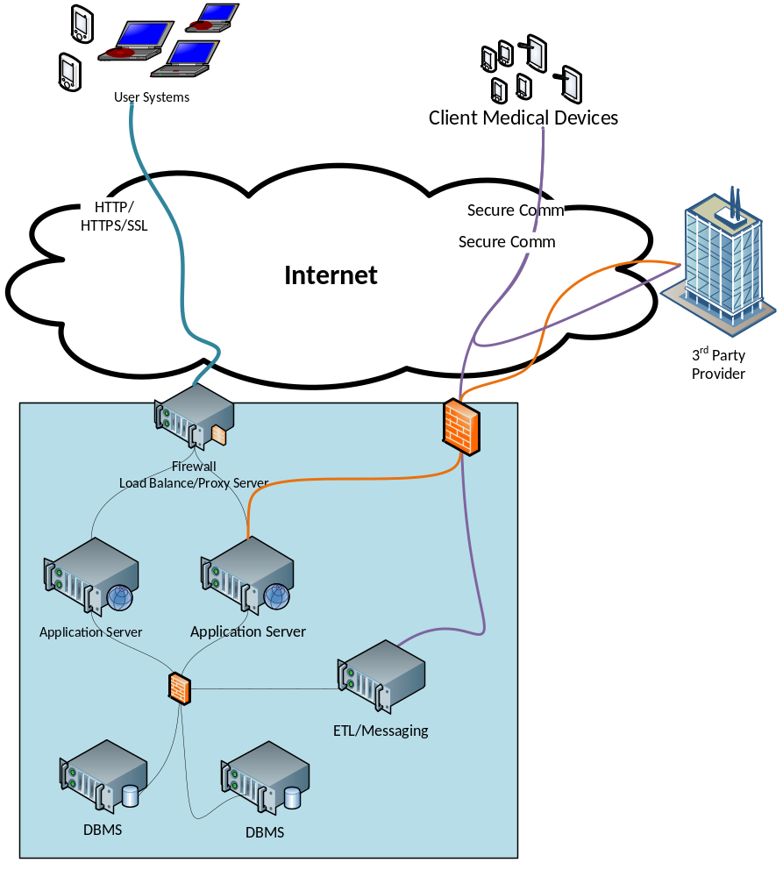
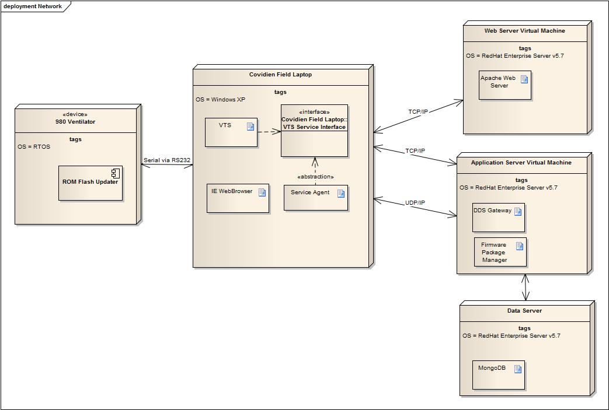
Figure 6 Network Topology

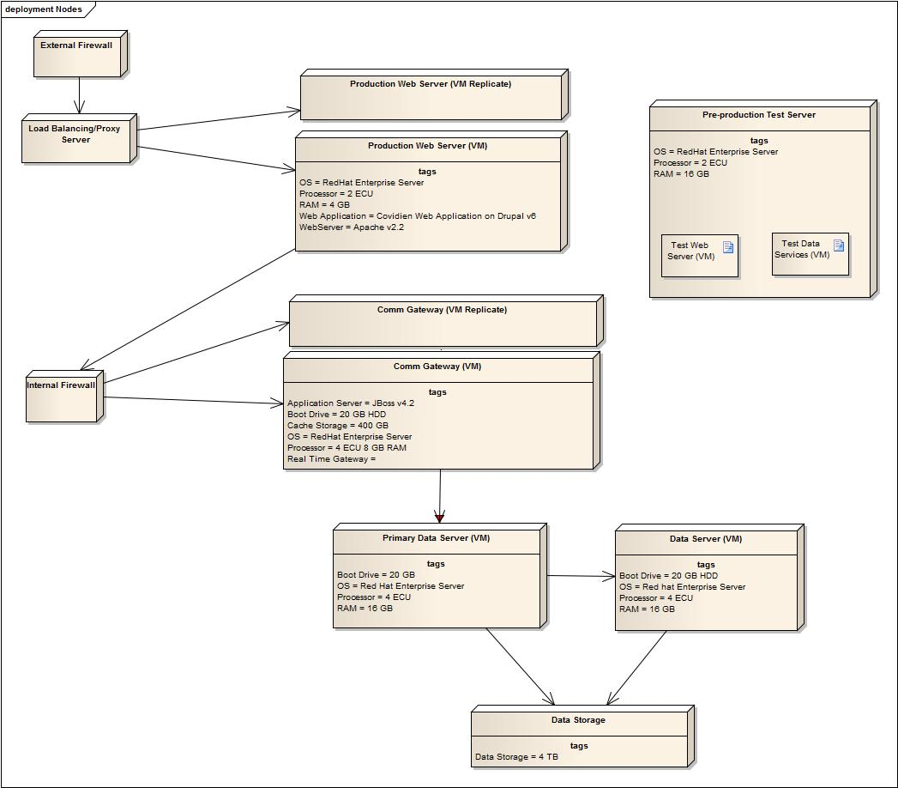
Figure 7 Cloud Server Topology

Cross-Cutting Concerns

Internationalization
Covidien is targeting a multitude of countries and languages. This is a significant requirement on the build process. Outlined here is the design architecture for managing these constraints.

RESOURCE MANAGEMENT
Resources are considered any culturally dependent data that should be localized. These include GUI component labels, titles, messages, descriptions, images, database data, or any other data that may need to be translated or modified to be suitable for a culture. The resource management system will be driven from a single culture, as selected by the user for their session, or selected by the system for a specific object or feature.

Resource FILES
Resource (resource) files will be used to store culture-specific UI values. This is a file consisting of XML tags as part of key-value pairs. All UI specific strings (display strings, widget properties such as height/width) should be extracted into these files. The unique key will correspond to a particular localized string value. In this way, each supported culture can have its own Resource file containing culture-specific values, and all values will be read from these files.

IMAGE RESOURCES
Image resources, which contain localizable text, must be avoided since these may be expensive to create, localize and maintain. If these are absolutely needed, they must also be extracted for the purpose of localization. The paths to the images will be defined in the Resource files. The path or the name of the image will either be modified by the localization vendor for each culture specific image.

DATABASE TABLES
Database tables containing translatable data should be designed in a manner as to allow the storage of that data in multiple cultures. This might include adding a culture column to the table as part of the primary key. Any data access of this table would specify the culture desired.

HTML
Resources contained within HTML cannot be easily extracted into resource only locations because there is no resource management mechanism built into HTML. Thus the directory structure containing the HTML files must be duplicated for each culture. Any paths within the HTML file must be relative to the file. The entry point to the HTML structure will provide a culture so that the system is aware of which directory structure to load files from. Again, like Image Resources, embedding culture-specific values in HTML must be avoided.

ASPX PAGES
Localizable resources within ASPX pages will be extracted into Resource files.

NON-LOCALIZABLE RESOURCES
Some resources may not be localizable. Examples include assembly resources, or configuration resources. These resources are not localizable, however, may need to be configured/modified by an Administrator or Technician speaking a language other than English, therefore unreadable. To resolve this, three approaches may be taken. A wrapper application which is localizable may be used to modify the resource instead of having them modified directly. Comments describing the configuration parameters may be put in the resource files, which are localized. Finally, these comments may be put in System Documentation, which is itself localized. This documentation should describe the configuration files, how to modify them, and what the possible values are for each property.]

DATA FORMAT
All cultural-sensitive data will be stored either in database data types that match the corresponding data, or in strings formatted to the standards as described in the appendices. Examples: Numeric data will be stored in the associated type in the database. This data will be retrieved into the corresponding numeric object (Integer, Float, Double, etc). For some cases or database engines, dates may need to be stored as strings. In this case, the format of those dates will be in a standard format as described in the appendices.

DATABASE ENCODING
The encoding of the database is typically defined at database creation time. For most database vendors, this encoding cannot easily be changed, usually requiring one to create a separate database in the desired encoding and porting the data over from the old database. Therefore, it is crucially important that the database encoding for a specific installed system meet the internationalization needs of that system. For example, if it is absolutely known that a system will operate in no other than Western European languages, then a code page such as 1252 will suffice. If a system will operate in Japanese, and no other language, then code page 932 would suffice. However, if the Japanese system later needed to support Chinese, the code page 932 is not sufficient to store this information. An encompassing code page, such as Unicode, must be used instead.

STRING MANIPULATION
All string manipulation routines, such as to_string(date/number) used within stored procedures or embedded SQL should be avoided if possible. Most of these types of routines are vendor specific and should be avoided anyway. If they cannot be avoided, they should be aware of the culture of the accessing client.

COLLATION
Collation, the culture specific comparison of encoded character data (mainly for sorting), is a responsibility of the database. This takes place when one wants to query the database for a set of data, and have it returned in an ordered fashion using the ORDER BY clause. Another case is when one wants to query a database for values less than, equal to, or greater than another value.
However, for most database vendors, the collation is specified at database creation time. Some vendors allow a connecting client to specify in their environment settings, which may determine how collation occurs for that particular client. However, this functionality is vendor specific and not provided by all database versions or vendors.

RESOURCE EXTERNALIZATION INTO RESOURCE AND DBRESOURCE FILES
The main goal in internationalizing a UI is to prepare it so that its resources (text, images, etc) and layout may be easily adapted to another language without having to change the code.
The strategy chosen for Web Site UI internationalization is highly dependent on the content of the web site. For example, if the content is relatively static, it may be easiest to duplicate the entire site (including directory structure, web pages, and all other resources) per language. The user is directed to the directory structure matching their preferred language/culture. This is considered a language separated site or page structure. However, if the content is very dynamic and changes often, it will become cumbersome to maintain all the pages in each language. Also, when using technologies such as ASP, the web pages may contain code, and it would not be desirable to maintain the same code in multiple web pages.
Therefore, the chosen strategy is to externalize the static resources (to a resource file) so that the ASP engine loads the appropriate language resources when the page is being rendered. The local resources folder is for resource files that are associated with a specific UI. These resource files have the same name as the UI component they are associated with and can only be accessed by that UI component.

NON-UI COMPONENT EXTERNALIZATION
There may be several categories of application data that need to be represented to the user as human readable text. This includes data such as error messages, information messages, warning messages, and static selectable data such as that in combo-box or list-box items. The resources for this data will be maintained outside of the UI. These resources may either be maintained in the database, or in separate resource files.

STRING CONCATENATION
For localizable messages, string concatenation should be avoided at all cost. The main reason for this is that linguistically, the structure of sentences and strings differs largely from language to language. It should never be assumed that two strings could be concatenated together to make a structured meaningful string.
Example 1: In English, we may concatenate the string “Ninety” with “Three” to produce “Ninety-Three”, a meaningful number in English. If, however, one were to localize the two strings into French separately, we would produce “quatre-vingt-dix” and “30ouri”. The concatenation, “quatre-vingt-dix-trois”, is a meaningless number in French. The real translation is actually, “quatre-vingt-treize” (meaning four twenties and a thirteen).
Example 2: In English, we may want to concatenate a string such as “Please turn” with strings “on the service” and “off the service”. However, in Chinese the term “to turn on” is represented by one ideogram, while another represents “to turn off”. Thus, the English strings could not be correctly localized.
String concatenation is commonly used when a programmer wants to reuse a string in multiple parts of a program. Code reuse is an excellent idea and encouraged; however String reuse is absolutely not. A localizable string should have one and only one purpose within an application.

PAGE LAYOUT
Web UI components should also be designed to allow for dynamic layout so that other languages will be accommodated automatically. This means adhering to the following guidelines:
Avoid using absolute positioning
Avoid specifying widths for controls such as input buttons. Browsers will automatically adjust the widths of these controls based on the control caption
Avoid using absolute widths for table columns or other layout mechanisms. Instead, use percentages.
Leave plenty of space for translated text. Don’t place too many controls in one area.

FONTS
There are two types of fonts, physical and logical. Physical fonts are the actual fonts installed on an operating system, for example, Times New Roman or Helvetica. Because different language scripts require different fonts, hard-coded physical fonts should never be used to display character data.

LOCALIZATION TECHNIQUES, SUGGESTIONS AND PITFALLS
The following contains information regarding internationalization suggestions, techniques, and pitfalls to watch out for. It summarizes the information presented in this document.
Collation: If your GUI is displaying a sorted list of strings, make sure you use the proper locale specific collator.
Avoid relying on converting to upper or lower case for strings that are to be displayed to the user. In some languages characters don’t have an upper or lower case equivalent (Asian scripts for example).
Do not re-use the same string in different GUI contexts. For example, the string “None” may be used in many different combo-boxes. In French, this may be “Aucun” (feminine) or “Aucune” (masculine) depending on what object it is referring to. Therefore, you would want to create a separate string for each combo box.
Hot keys are used to activate buttons and menu items, or put focus in text fields using an Alt+<key> combination. The general rules of thumb for choosing a hot key for your component are: Avoid duplicates on the same screen; avoid putting hot keys on “thin” characters such as I, I, l; avoid putting hot keys on hanging characters such as q, y, p, g, j; avoid putting hot keys on accented characters such as é.
Extract all text from your GUI into a resource file. This includes label text, button text, tooltip text, menu text, button hot keys, or any other text which may be displayed to a user. Also, locale specific images, sound, or other media should be extracted into resources files as well. The media should be stored in a file.
Avoid text in images. Images that contain text must be re-created during localization. This not only costs more money, but is a tedious and time-consuming process as well. Therefore, it should be avoided where possible. An example of this is a button with a question mark on it “?”. The question mark doesn’t always refer to questions in all languages throughout the world.
Avoid using wordplay images. These are images that only have meaning in the language they are created for. Thus, these are even more difficult to re-create during localization. An example is an image with a check mark (“√”) next to an envelope. In English, this may mean “Check Mail”. However, we are assuming that the word describing the symbol is the same one used to look at your mail. In French, the symbol is called “Marque de coche”, while the translation of “Check Mail” is “Vérifier le nouveau ourier”.
Other images to watch out for: The Red Cross is not known throughout the world to mean first aid, if anything at all. Images depicting hands or skin are considered offensive in some cultures.
Avoid making formatting assumptions about punctuation. For example, in English, we commonly have no space between a word and a colon, “User ID:” However, many other languages have a space both before and after the colon, “User ID : “.
An important issue is locale specific data entry and data display. If your GUI contains locale specific fields (such as numeric, date, time, currency) the format you display and parse should adhere to the current locale.
Avoid string concatenations whenever possible. If unavoidable, use message formatting (string.Format), or restructure messages so that they are more easily translated.
Examples:
The number 93 is written in English “Ninety-Three”, 94 is written “Ninety-Four”. So, we may cleverly write a piece of code that concatenates “Ninety” and “Three” or “Four”. However, in French, 93 is written “quatre-vingt-treize” which roughly translates into “four twenties and thirteen”. 98 is written “quatre-vingt-dix-huit”, “four twenties, ten, and eight”. Obviously, our piece of code will not work in French.
Message formatting consists of determining what the variables are in a sentence, and extracting them so that you have one string pattern with many pluggable strings or variables. “Your password will expire in 3 days”. Obviously, the variable is the number 3, so your string pattern would look like “Your password will expire in {0} days” and your variable would be 3.
Avoid gender and number generalizations. Putting a plural generalization at the end of a word (Ex: “car(s)”) may become quite complex to translate. This is because in many languages, adjectives and articles of nouns often carry the same pluralization.
Example:
In English, “The green car(s)”. The singular in French translates as “verte la voiture” while the plural is “vertes les voitures”. A suggestion is to always keep the articles and adjectives with their appropriate nouns.
Lastly, whenever checking character properties such as testing if it is an integer vs. an alphabetic character, always use the System.Char methods (IsNumber, IsLetter, IsWhiteSpace, etc).

Error Handling Strategy
What is the mechanism for handling errors? Include detection, recovery and diagnoses.

Logging Strategy
What system activities are logged? How are system activities logged? For what purposes are they logged? Ex: Field diagnosis of problems, auditing, creating scalability models, etc.? Who will use the logs?

Attributes

Availability
The web servers will be redundantly deployed with routing managed through a load balancing proxy server. The database and server will be redundantly deployed using mirrors in a master –slave configuration through MongoDB. The data sent to the servers will be kept locally on the laptop machines for 24 hours before being removed. The local system will ask permission of the server before the delete occurs (Server up time check).This allows the server to recover any data that had not been backed-up in case of the loss of an entire data array.

Security
This section provides security guidance that applies across the system. Module designs cover many detailed security issues. All module designs will be evaluated against and contribute to the system threat model. The key security principle is defense in depth.
The trust boundary of the system is defined as the area where data and commands are trusted. Outside of this boundary data may be corrupt, either maliciously or inadvertently. Any data crossing the trust boundary will be validated and, where possible authenticated. A means to encrypt sensitive data traveling outside of the trust boundary is provided. Service calls that originate from outside of the data center are authenticated. Where appropriate authorization rules are applied to information from outside the trust boundary. PHI and PII data will be encrypted either during transport or before transport. The data will be stored on encrypted HDDs.

Security Threats include the following:
• Denial of Service (DoS) against the authentication service.
• Network packet snooping between the browser and Web Server to capture client data and credentials.
• Identity spoofing through the capture of an authentication cookie or cookie replay.
• DNS redirect through a directory service cache attack.
• SQL injection attach on exposed application interfaces, Web, Web Services, and messaging. Allowing attacker to exploit data input to execute commands in the database.
• Cross-site scripting occurring through successful injection of script code.
Addressing the Vulnerabilities through:
• Single Sign- On (SSO) and LDAP authentication and authorization
• Ensure strong input validation at the server accounting for the Trust boundary.
• Do not return exception information to end users.
• System shall use of x.509 certification for 3rd party partners.
• To protect PHI encrypt the data stream where risk exists.

The server file system will be configured so that the web server, Apache (v2.2), does not have permission to edit or write the files which it then executes. That is, all of files will be 'read-only' for the Apache process, and owned with write permissions by a separate user.
HTTPS is typically used in situations where a user would send sensitive information to a website and interception of that information would be a problem. Commonly this means:
Especially in situations where administrators are sending passwords or the FTP password for your server to third parties, the site will use HTTPS whenever possible to reduce the risk of compromising the web site.
HTTPS also prevents eavesdroppers from obtaining the authenticated session key, which is a cookie sent from the client browser with each request to the web site, and using it to impersonate the user.
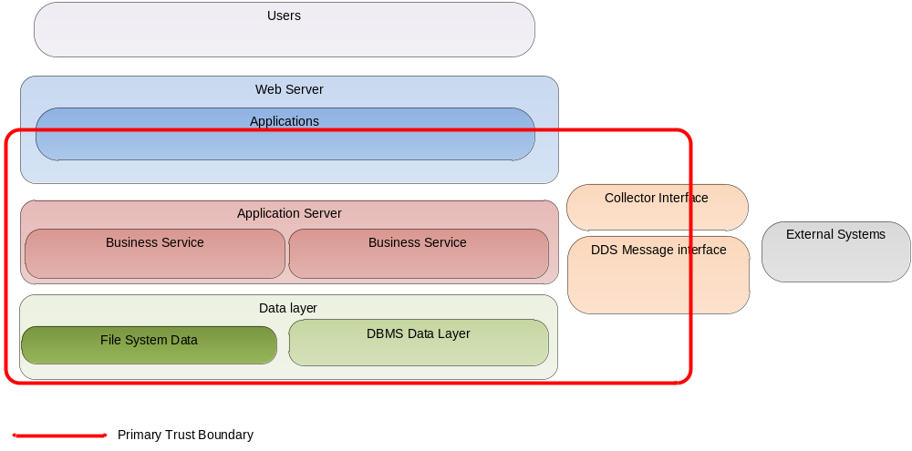
All requests, communication, and related data that cross the primary trust boundary must be accessed based on the threat model.
As port of the security framework the solution will run on a linux operating system (o/s). They have an outstanding reputation as a server O/S and remain highly secure.
The application stack of integrated services will be patched on regular bases. These reviews shall occur monthly providing a review and patch as appropriate. Why? The most common issue for web based sites is a failure to appropriately apply a security patch mitigating a known issue.

Scalability
The choice of a web structure aids performance and scalability by limiting the volume of data flowing and, the number of locations it must flow. This shortens the latency of receiving information updates. It lowers the amount of network traffic to achieve timely information.
We will us a scale out versus a scale up approach allows for a highly scalable system at a low cost. Each of the solutions will run in a virtualized environment in a hosted deployment. We will use a load balancing proxy managing multiple web servers which can be dynamically deployed as the load requires. The management of this mechanism will be the responsibility of the cloud service environment.

Maintainability
The key architecture pattern for maintainability is the Enterprise Service Bus and related communication patterns. The code will be documented and tested using JUnit for component verification.

Testability
Please see the testing design in the SRD. It is a Man in the Middle pattern for logging and rerunning error paths that are discovered during system execution.

Reusability
What components can be reused from other projects including the common components library?
This project is expecting to provide business level service reuse. That is that the business services will be developed as modules that may be reused as new applications are developed on the framework outlined in this document. The following common services are reusable:
The Laptop Agent
The Web Services
The Software Repository
The Communication infrastructure

This allows for continued growth without rewriting the services. Of course the features will also be added to the services extending their functionality. But that will be then only reason to touch the services.

Supportability
The web shall have dash boarding and reporting capabilities to manage the use of the site. The middle layer services will have multiple level logging (off, errors, warnings, verbose). Critical services will send messages (SMS, e-mail) to the administrator warning of site problems. The VTS and the Agent will use a Man-In-The-Middle approach to managing logs allowing the system to track issues and reproduce them in the software lab.

PHI, PII and HIPAA

Security and HIPPA compliance requirements
Companies engaged with PHI and PII are required to manage the following specific data:
1. Names;
2. All geographical subdivisions smaller than a State, including street address, city, county, precinct, zip code, and their equivalent geocodes, except for the initial three digits of a zip code, if according to the current publicly available data from the Bureau of the Census: (1) The geographic unit formed by combining all zip codes with the same three initial digits contains more than 20,000 people; and (2) The initial three digits of a zip code for all such geographic units containing 20,000 or fewer people is changed to 000.
3. All elements of dates (except year) for dates directly related to an individual, including birth date, admission date, discharge date, date of death; and all ages over 89 and all elements of dates (including year) indicative of such age, except that such ages and elements may be aggregated into a single category of age 90 or older;
4. Phone numbers;
5. Fax numbers;
6. Electronic mail addresses;
7. Social Security numbers;
8. Medical record numbers;
9. Health plan beneficiary numbers;
10. Account numbers;
11. Certificate/license numbers;
12. Vehicle identifiers and serial numbers, including license plate numbers;
13. Device identifiers and serial numbers;
14. Web Universal Resource Locators (URLs);
15. Internet Protocol (IP) address numbers;
16. Biometric identifiers, including finger and voice prints;
17. Full face photographic images and any comparable images; and
18. Any other unique identifying number, characteristic, or code (note this does not mean the unique code assigned by the investigator to code the data)

Security and PII
The following data, often used for the express purpose of distinguishing individual identity, clearly class as PII under the definition used by the U.S. Office of Management and Budget:
- Full name (if not common)
- National identification number
- IP address (in some cases)
- Vehicle registration plate number
- Driver's license number
- Face, fingerprints, or handwriting
- Credit card numbers
- Digital identity
- Birthday
- Birthplace
- Genetic information
The following are less often used to distinguish individual identity, because they are traits shared by many people. However, they are potentially PII, because they may be combined with other personal information to identify an individual.
- First or last name, if common
- Country, state, or city of residence
- Age, especially if non-specific
- Gender or race
- Name of the school they attend or workplace
- Grades, salary, or job position
- Criminal record

Mechanisms of ensuring compliance with Healthcare, HIPAA PHI, and PII security requirements

Policy and Procedure Creation
Establish policy and procedures regarding privacy rules. Provide guidance on the proper handling of PII, as well as the consequences for failure to comply with the policy. Consider developing privacy policies and associated procedures for the following topics:
- Access rules for PII within a system
- PII retention schedules and procedures
- PII incident response and data breach notification
- Privacy in the system development life cycle process
- Limitation of collection, disclosure, sharing, and use of PII
- Consequences for failure to follow privacy rules of behavior.

Awareness, Training, and Education
Awareness efforts designed to change behavior or reinforce desired PII practices. The purpose of awareness is to focus attention on the protection of PII. Awareness relies on using attention-grabbing techniques to reach all different types of staff across an organization.

Minimizing the Use, Collection, and Retention of PII
The practice of minimizing the use, collection, and retention of PII is a basic privacy principle. By limiting PII collections to the least amount necessary to conduct its mission, Covidien may limit potential negative consequences in the event of a data breach involving PII.

De-Identifying Information
Full data records are not always necessary, such as for some forms of research, resource planning, and examinations of correlations and trends. The term de-identified information is used to describe records that have had enough PII removed or obscured, also referred to as masked or obfuscated, such that the remaining information does not identify an individual and there is no reasonable basis to believe that the information can be used to identify an individual.

Client and Server IT Related Security Controls

Access Enforcement (AC-3) Control access to PII through access control policies and access enforcement mechanisms (e.g., access control lists through Drupal, and user privilege management in Linux, and role security in MySQL). Covidien is implementing a role-based access control and configuring it so that each user can access only the pieces of data necessary for the user‘s role.
End User access to PHI and PII is only through applications that tightly restrict their access to the PII, instead of permitting users to directly access the databases or files containing PII.
Hard drives will encrypt stored information.
Least Privilege (AC-6) the system will enforce the most restrictive set of rights/privileges or accesses needed by users (or processes acting on behalf of users) for the performance of specified tasks. This is a continuation of role based access and ensures that users who must access records containing PII only have access to the minimum amount of PII, along with only those privileges (e.g., read, write, execute) that are necessary to perform their job duties.
Auditable Events (AU-2) Covidien monitor events that affect the confidentiality of PII, such as unauthorized access to PII. This is done through the audit logging infrastructure.
Audit Review, Analysis, and Reporting (AU-6) Covidien will regularly review and analyze information system audit records for indications of inappropriate or unusual activity affecting PII, investigate suspicious activity or suspected violations, report findings to appropriate officials, and take necessary actions. This will be supported through the Pentaho Dashboard system.
Identification and Authentication (Organizational Users) (IA-2) Users will be uniquely identified and authenticated before accessing PHI/PII. This is part of the authentication and authorization service. A logged in user will timeout in 30 minutes of inactivity.
Media Marking (MP-3) Covidien can label information system media and output containing PII to indicate how it should be distributed and handled. Examples of labeling are cover sheets on reports and paper labels on digital media.
Media Sanitization (MP-6) Organizations can sanitize digital and non-digital media containing PII before it is disposed or released for reuse. An example is degaussing a hard drive—applying a magnetic field to the drive to render it unusable.
Transmission Confidentiality (SC-9) Covidien can protect the confidentiality of transmitted PII. This is most often accomplished by encrypting the communications HTTPS/SSL or by encrypting the information before it is transmitted.
Protection of Information at Rest (SC-28) Covidien can protect the confidentiality of PII at rest, which refers to information stored on a secondary storage device, such as a hard drive or backup tape. This is accomplished by encrypting the stored information.
Information System Monitoring (SI-4) Covidien can employ automated tools to monitor PII internally or at network boundaries for unusual or suspicious transfers or events. An example is the use of data loss prevention technologies. This can be monitored though our security framework.
Please read the Security and Section 7 of the Architecture Covidien SAD Document. There is security support in Drupal, Pentaho, Apache, JBoss, MySQL, and CentOS.

Managing Open Source Licensing
Most commercial software developers consider the General Public License 2.0 as belonging to the unapproved list, e.g. unacceptable to use within commercial software. Developers need to know that more than 50% of the open source available is licensed through the GPL 2.0 license, since it is the license used by Linux. It is important to just use Linux rather than adding code to it particularly for a private venture like Covidien because any code written to add to Linux becomes open source and we definitely do not wish to link Covidien private software to Linux in that way.
As contrasted with a CopyRight, CopyLeft licenses are licenses which have viral provisions, that under certain conditions can infect your own proprietary source code, and force you to distribute your proprietary source code as open source (without royalties) under the same license. The most popular CopyLeft licenses are the General Public 2.0 License and the Lesser General Public 2.1 License.
The Lesser General Public License is considered less onerous because the CopyLeft provisions only apply to your own proprietary intellectual property (files) if they are linked through static linking to the LGPL licensed packages, if they are not linked or if they are linked dynamically, the provisions do not apply. It is relatively easy to remove this static linkage and to still use and distribute the LGPL open source package along with your own software.
If you find GPL 2.0 licensed open source inside your software you have a number of choices as to how to precede, but you have to know it is there to do something about your legal risks:
- Remove the open source licensed by GPL and replace it with your own proprietary software
- Remove the open source licensed by GPL and replace it with a similar open source package with a less onerous license
- Remove all linkages between your other software and the GPL licensed open source
- Ask your customers to get their own copy of the GPL licensed open source
- Accept the provisions of the GPL license and make your own files that are linked to it available under open source
Most open source licenses and all of the systems in this document are safe to use in a production environment. Here is a short list of the open source licenses and where they are safe to use.
Berkeley Software Distribution (BSD)
- All BSD software are safe to integrate or link into proprietary software – they really mean that it is free to use.
- Old BSD - requires discloser in advertising – you must disclose that you are using their software typically in documentation and the ‘about box’.
- New BSD - removes the requirement – no need to add that your using open source in your software
- FreeBSD - removes the non-endorsement clause
Massachusetts Institute of Technology (MIT)
- Safe to integrate or link into proprietary software – this license also means that it is free to you.
GNU Lesser General Public License (LGPL)
- You may dynamically link to these libraries without fear starting with v2.1 and v3.
- Do not create a derived work or in any way comingle your code unless you intend to give away the source code.
GNU General Public License (GPL)
- For tools and O/S Only- Do not create a derived work nothing here should ever be statically linked with the product unless you are okay with giving away the related source code.

