**Assignment: Multi-Agent System**

**Submitted By: Rajesh Kumar Sharma**

**Date: 27-Dec-24**

**Assignment:** **Develop a multi-agent system that incorporates a minimum of two agents and exposes it as a Fast API**

Creating a multi-agent Financial Analyst which when provided with stock symbol provides the analyst recommendations and the latest news on it.

**Code Link:** [**https://github.com/rajeshksharmasls/GenAI/blob/master/GenAI/Multi_Agent_Phidata_Groq/main.py**](https://github.com/rajeshksharmasls/GenAI/blob/master/GenAI/Multi_Agent_Phidata_Groq/main.py)

**Process:**

1. Setup:
   * Imports necessary libraries like FastAPI for API creation, and phi components for AI agent functionality.
   * Loads environment variables using dotenv for secure configuration management.
2. Agent Creation:
   * Creates two specialized AI agents:
     + Web Agent: Uses DuckDuckGo for web searches and includes sources in its output.
     + Finance Agent: Uses YFinanceTools to fetch stock prices, analyst recommendations, and company information, formatted in tables.
   * Combines the agents into an Agent Team to collaborate on tasks.
3. API Endpoint:
   * Defines a POST endpoint /summarize that accepts a stock symbol as input.
   * Uses the Agent Team to generate a summary of analyst recommendations and the latest news for the given stock symbol.
   * Handles errors gracefully, returning success or error status in a JSON response.

This setup allows users to query financial and web data through a simple API endpoint backed by AI agents.

**Dataset:** *None*

**Snapshots of the conversations with the Chatbot:**

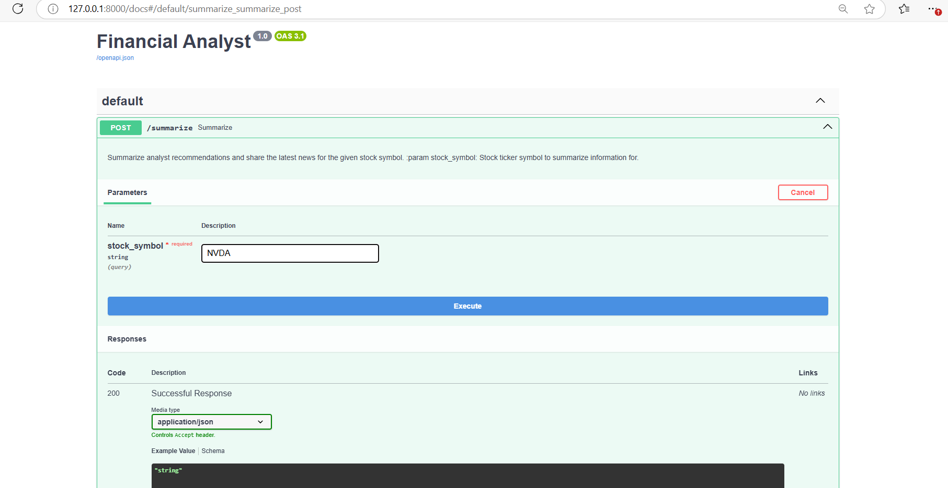

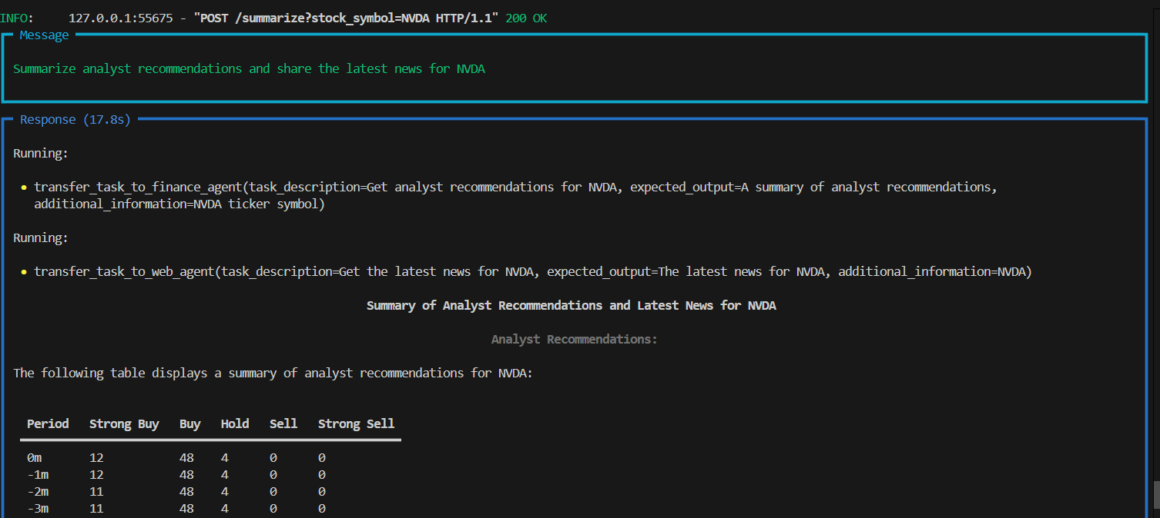

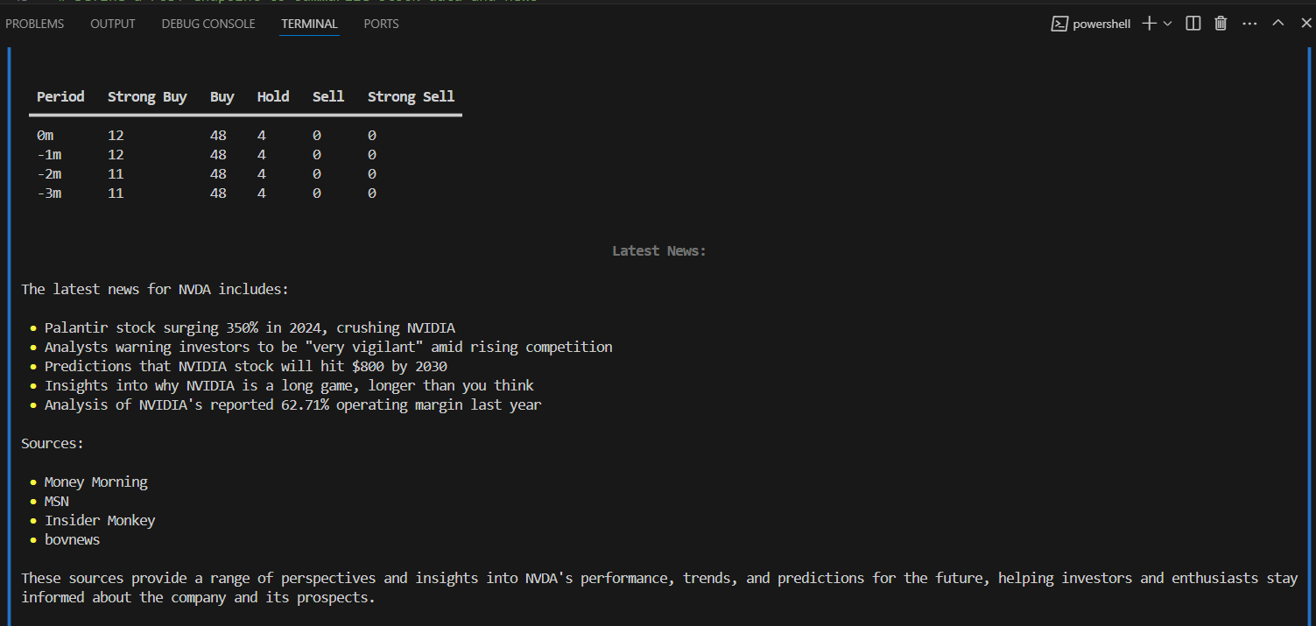

**Conclusion:** Hence, we can see that the multi-agent is performing as per the expectations for the provided stock symbol.