**ABSTRACT:**

The Smart Garbage Segregation and Bin Level Indication System improves waste management by integrating advanced technology.

It uses Arduino Uno and ESP32 microcontrollers, sensors, and actuators to automate waste segregation and monitor bin fill levels.

With a moisture sensor, it categorizes waste as wet or dry, aiding recycling and composting. Ultrasonic sensors precisely measure bin fill levels for efficient resource allocation.

Through Wi-Fi and the Blynk IoT platform, users can monitor bin levels remotely, making data-driven decisions for effective waste management. This system is a significant advancement in waste management technology, offering a sustainable solution to environmental concerns

**COMPONENTS USED:**

**1.** **Arduino Uno**: Functions as the central control unit, coordinating sensor inputs, actuator outputs, and communication with the ESP32. Its versatile platform enables seamless integration with the overall system architecture, ensuring efficient operation.

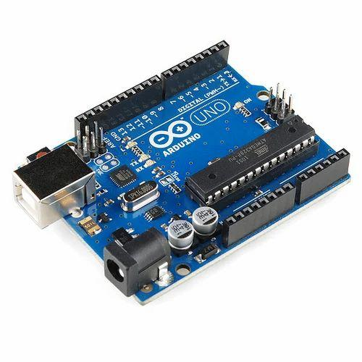

**2.ESP32**: Handles data collection from sensors, manages Wi-Fi connectivity, and facilitates data transmission to the Blynk server for remote access. Its powerful processing capabilities and built-in Wi-Fi module make it an ideal choice for real-time IoT applications.

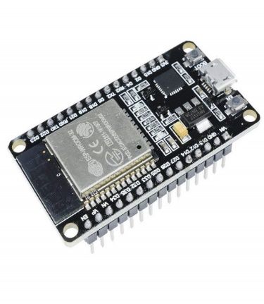

**3..Moisture Sensor**: Classifies waste as wet or dry by analyzing moisture content, optimizing segregation for recycling and composting. Its inclusion enhances the system's efficiency and effectiveness in waste management.

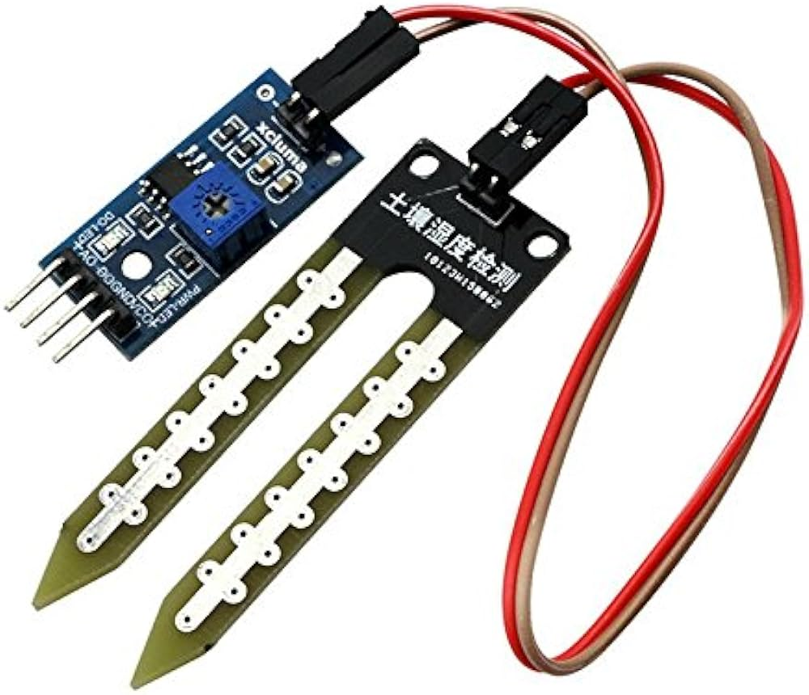

**4.Ultrasonic Sensors**: Accurately measure bin fill levels, providing critical data for proactive waste management strategies and resource optimization. Their non-contact operation and high accuracy make them essential for precise distance measurements.

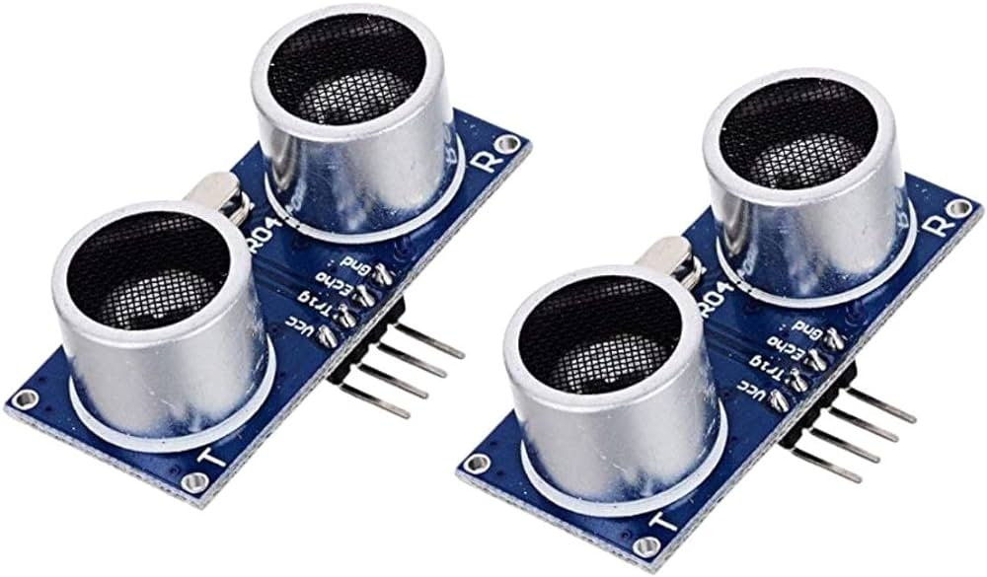

**5**.**Servo Motor**: Actuates bin lids based on sensor inputs, automating waste segregation processes and enhancing system efficiency. Its precise control over angular motion ensures reliable operation and efficient waste disposal.

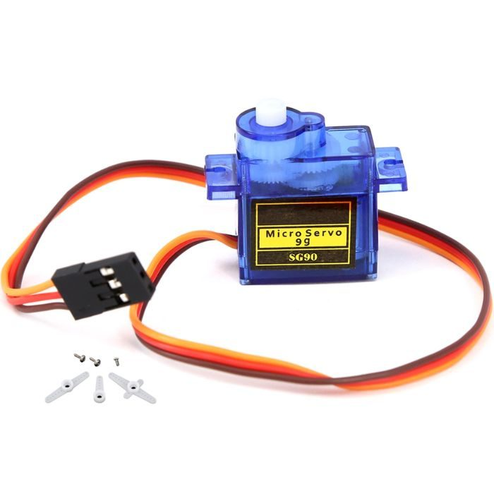

**6.IR Sensors**: Detect the presence of objects near garbage bins, triggering data acquisition and actuator operation. These sensors contribute to the system's reliability and responsiveness, enhancing its overall functionality.

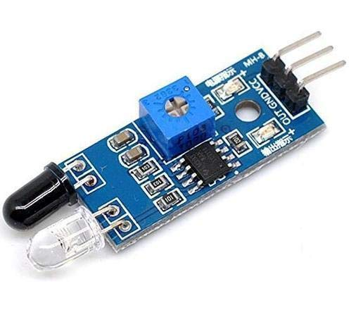

**METHODOLOGY**

1. **Hardware Setup**: Assembled and connected all hardware components meticulously, ensuring proper functionality and integration between microcontrollers, sensors, and actuators. Verified power supply requirements and physically mounted components for robust deployment.
2. **Software Development**: Developed and deployed firmware for Arduino Uno and ESP32 microcontrollers, implementing algorithms for sensor data processing, actuator control, Wi-Fi communication, and Blynk integration. Debugged and optimized code for efficient performance and compatibility.
3. **Testing and Integration**: Conducted comprehensive testing of individual components and system integration, verifying sensor accuracy, actuator responsiveness, data transmission reliability, and user interface functionality through the Blynk app. Fine-tuned sensor thresholds and actuator behavior for optimal operation.
4. **Deployment and Optimization**: Deployed the Smart Garbage Segregation and Bin Level Indication System in real-world environments and monitored its performance. Gathered user feedback for further optimization and customization. Continuously refined algorithms, adjusted sensor thresholds, and enhanced user experience to ensure maximum efficiency and effectiveness.

**CIRCUIT DIAGRAM:ARDUINO UNO**

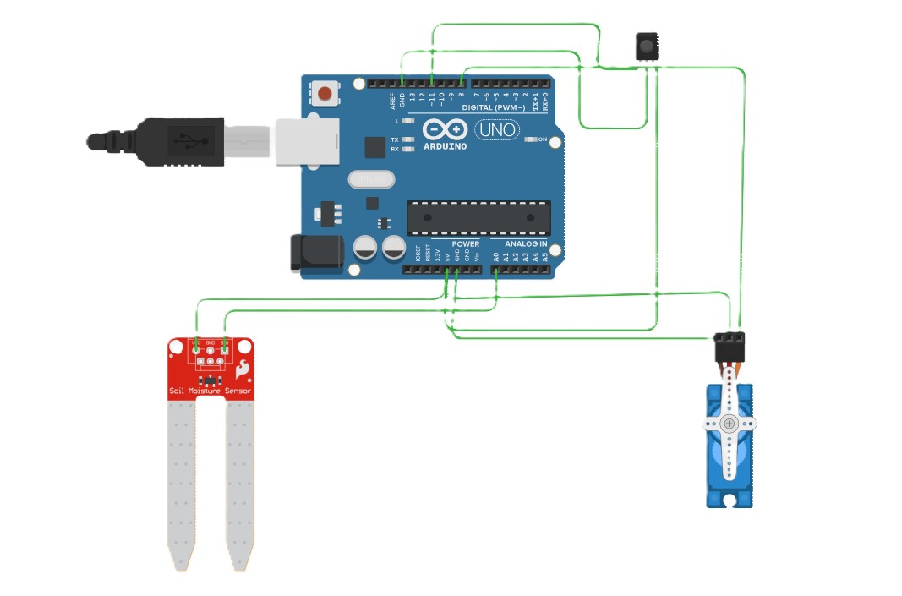

**CIRCUIT DIAGRAM:ESP32**

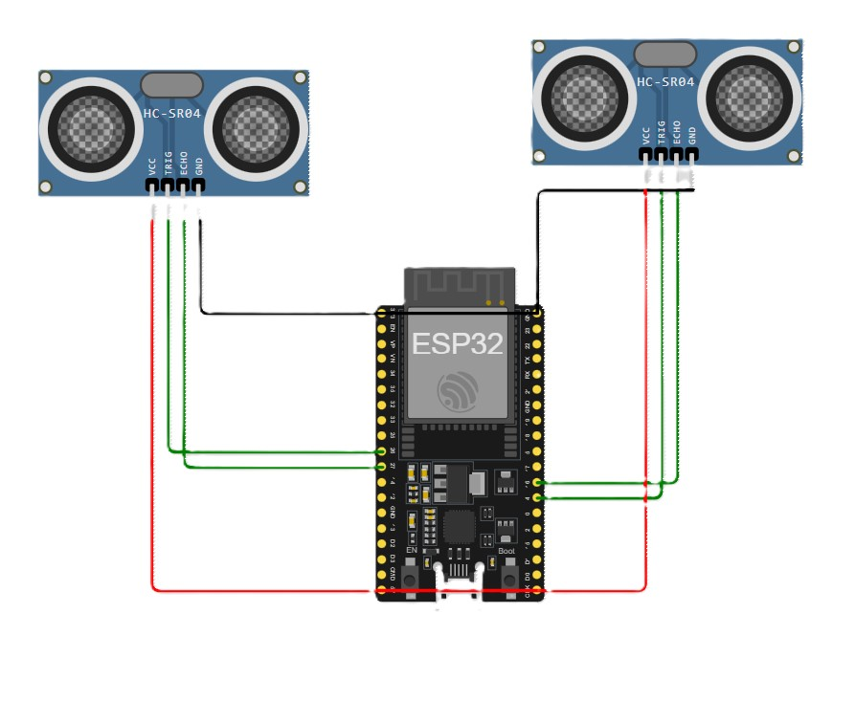

**WORKING:**

1. **Mounted Sensors**: Installed IR sensors near garbage bins and ultrasonic sensors to measure bin fill levels at appropriate locations.
2. **Connected Components**: Wired the sensors, actuators (such as servo motor), and microcontrollers (Arduino Uno and ESP32) following the circuit diagram.
3. **Uploaded Firmware**: Uploaded firmware to Arduino Uno to read data from IR sensors, control the servo motor, and read data from the moisture sensor.
4. **Programmed ESP32 Firmware**: Programmed ESP32 to read data from ultrasonic sensors and transmit it to the Blynk server using Wi-Fi connectivity.
5. **Set up Blynk**: Set up the Blynk mobile application and created a project with virtual pins to receive and display sensor data.
6. **Configured Virtual Pins**: Assigned virtual pins in the Blynk app to receive data from ESP32 and display it on the mobile interface.
7. **Tested Individual Components**: Tested each sensor, actuator, and microcontroller individually to ensure they were functioning properly.

**8.Integrated Components**: Integrated all componentand tested the systems functionality as a whole.

**9.Optimized Performance**: Fine-tuned sensor thresholds, actuator behavior, and communication protocols to optimize system performance.

**10.Deployed the System**: Deployed the system in a real-world environment, monitored its performance, and made adjustments as necessary for efficient waste management.

**CONCLUSION:**

The Smart Garbage Segregation and Bin Level Indication System represents a significant advancement in waste management technology, offering a comprehensive and efficient solution to address the pressing environmental concerns associated with waste management. By automating waste segregation tasks and providing real-time feedback on bin fill levels, the system empowers users to make informed decisions and implement targeted interventions to optimize waste management practices effectively.

With its innovative design and seamless integration of hardware and software components, the system holds great promise for enhancing sustainability and promoting environmental stewardship in communities worldwide.