

Master Document Location

Kitting Design

Owner

Document Version

0.1

Date Published

01/27/2020

Key Contacts
Role | Name | Employee Number | Approver/Reviewer
Manager | Lorraine Lucero | 288047 | Approver
Architect | Joey Cline | 190014 | Approver

Reference Documents
Document Name | Owner | Location
Cloud Dojo Reference | Dojo | https://www.dojo.fedex.com/resources/
Manhattan AIM Document | Manhattan
Teams Site | CIL
Kubernetes |  | https://kubernetes.io/

Table of Contents

Key Contacts 2
Reference Documents 2
Kitting Overview 4
Design Approach 4
High Level Flow 5
Order Flow 6
High-level Interaction Diagram 6
Manhattan Dependencies 6
CIL Edge Dependencies 7
EIBCE (CILMsg) 7
McFly 7
Gozer 7
Master Blaster 7
8
Zoltar 8
EIBCE (ManhMsg) 8
MPlus 8
Design Focus Items 9
Assumptions 9
Risks 9
Technologies 9
System Monitoring and Alerting 10
Logging 10
Testing 10
Messages Services 10
JMS Queues 10
Oracle Kubernetes Configuration 11
Deployment 11
Build Pipeline 11
Deploy Pipeline 11
Image Versioning 12
Tbd 12
Docker Repository 12
HELM Chart 12
Docker Container Requirements 12
Base Image 12
Entry Point 12
Directory Structure 12
Oracle Database 13
XSD Message Definitions 13
Revision History 13

Kitting Overview
To ensure that Critical Inventory Logistics (CIL) can implement kitting based upon our customer needs, we will enhance the current Distribution Order processing logic to create and post workorder to Manhattan. This will allow CIL to maintain unique Billing of Material (BOM) attributes outside of Manhattan. Manhattan processing of workorders will be supported via a Manhattan Mod. This mod allows for maintaining serial numbers of individual kit items and trigger printing of kitting documents.

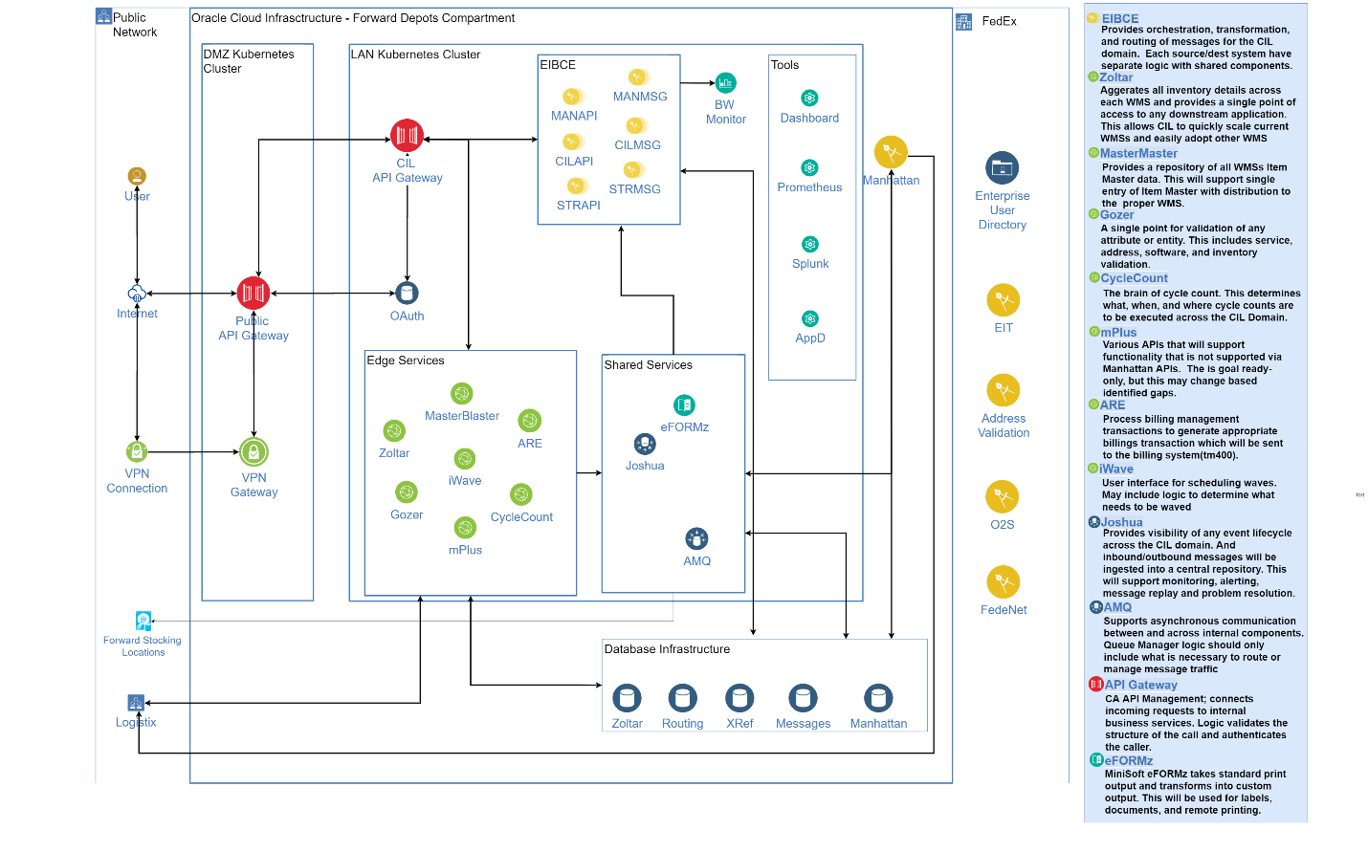

Figure 1: High Level Interfaces

Design Approach
Since Manhattan kitting does not support some of the CIL unique kitting requirements, CIL will maintain the Bill of Material (BOM) outside of Manhattan and generate workorders to build the kit. As part of the normal Distribution Order flow, we will check each item and determine if that item is a kit. If the item is a kit, we will call and retrieve the BOM, which includes all the items that used to make that kit. These details will be added to the Order LMD in the appropriate reference fields. A workorder will be generated for each Kit and sent to Manhattan. Once in Manhattan a Workorder wave will be executed and RF task will be generated to pick the items needed to complete the workorder. Once the kit is completed the finish good will be put away and made available to fulfill distribution orders.

High Level Flow

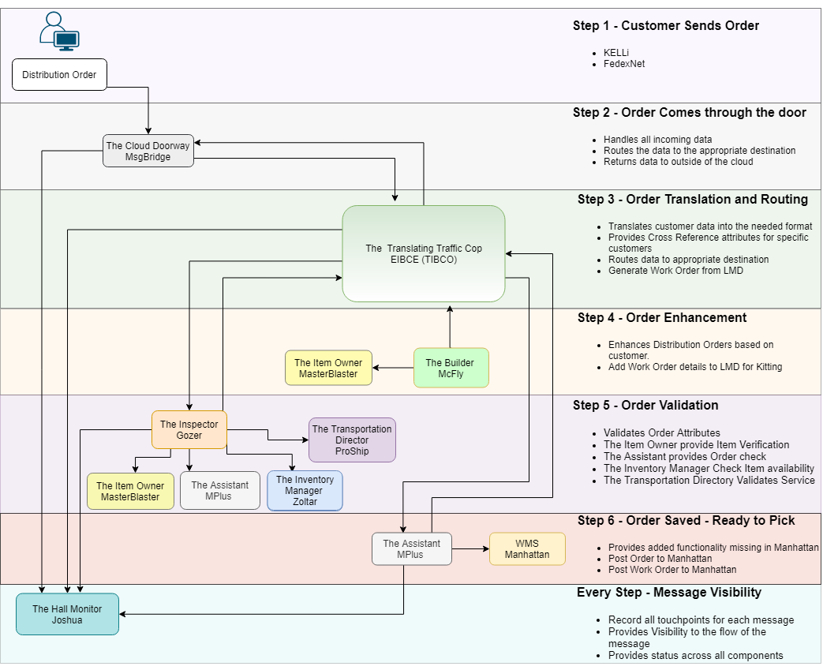

Figure 2: High Level Architecture

Order Flow
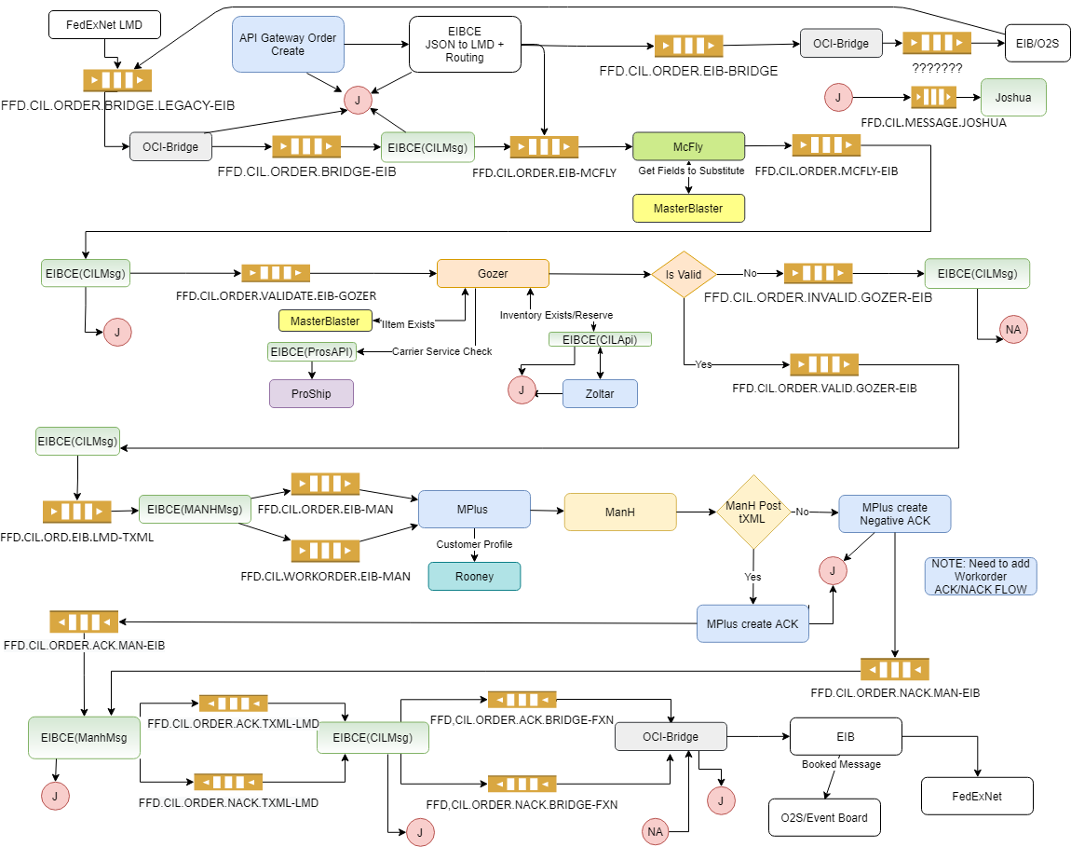

Manhattan Dependencies
- Post SOAP Request API

CIL Edge Dependencies
- EIBCE
- McFly
- Gozer
- Zoltar (This may not be needed)
- MasterBlaster
- AMQ
- Mplus

EIBCE (CILMsg)
CILMsg routing order will need to be changed to put McFly in the beginning of the flow. This will allow us to build out the BOM in the LMD before is flows to other components and validation in Gozer.

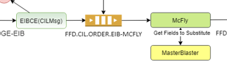

McFly
For each Distribution Order McFly will consume the order LMD message. For each item in the order McFly will call Master Blaster for to determine if the item is a kit. If it is a kit McFly will add each item that makes up the kit to LMD reference fields and publish the Order LMD.
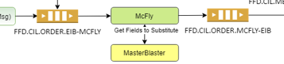

Gozer
Gozer still needs some analysis. We know that the kit inventory will not exist, but we could check each item inventory and validate that there is enough inventory to build the kits. We may not have Zoltar in place. Do we call Manhattan for this? Do we let the Workorder wave fail and handle the wave failures?

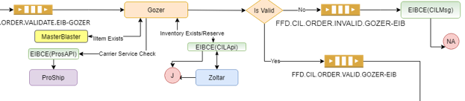

Master Blaster
MasterBlaster will be called to validate the item for each item of the kit and order. MasterBlaster will need to be enabled and the Item Master data including BOM will need to be stored in the Database. The Item Master API to retrieve the Item details will need to be updated to include the BOM.

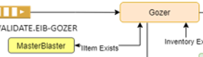



Zoltar
This may not be in place. Would need to call mplus to check for inventory. Mplus does not have this available now.



EIBCE (ManhMsg)
Manhmsg will consume the Order LMD and map the LMD reference to a Workorder tXML and publish the tXML to Mplus. There are no dependencies between the Workorder and Order.
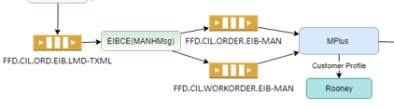

MPlus
Mplus will consume the tXML and use the PostSoapRequest service to the post the Workorder tXML to Manhattan. Mplus will publish a ACK or Negative ACK based upon results from Manhattan PostSoapReqeust call. Results of the PostatSoapRequest need to be published to Joshua. Still need to determine what to do with the ACK and Negative ACK for processing of the WorkOrder. We may need to update EIBCE to throw away the ACK and NACK.

AMQ
ACK and NACK queues will need to be defined.
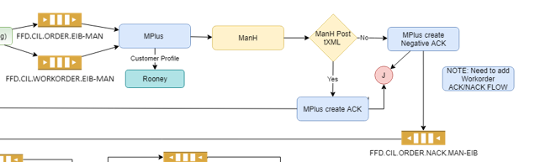

Design Focus Items
The development is focused on delivering the following:
- Implement MasterBlaster to maintain Item Master details including BOM
- McFly will explode BOM and update LMD reference fields with Kit details
- Gozer will validate Kitting items, Order, and Inventory (if needed)
- Enhance current Distribution Order flow to implement Kitting
- Apply Kitting Mod in Manhattan
- Manhattan configurations for Kitting, including Waving, Kit Picking, Finished goods(Kit) Putaway
- Process kitting completed PIX to generate ARE kitting transaction.
- Change current Order Flow to have McFly explode the BOM before Gozer Validation. This will make the validation easier.

Assumptions
- All development will use Java Spring Boot and Tibco BWCE when appropriate. Any exception to this will have to be approved by the development team.
- Kubernetes will be the Container Managed Platform for deployments
- AMQ will be used for inner process communication
- AMQ will be used within OCI
- MAAS, if needed, will be used in FDX Datacenters

Risks
- TBD

Technologies
The development technologies used for this application will be guided by the recommendations of the Cloud Dojo Team. Deviations from the recommendations will be considered and approval required when necessary.
- The Twelve-Factor App Patterns should be followed
- Adhere to Cloud Agnostic Development Principals
- Java
- REST Webservices
- Gradle Build
- Spring Boot
- Spring JPA
- Spring Config
- Spring Lombok
- Spring logback
- JIB Container Creation
- Docker Containers
- Helm Charts
- Kubernetes
- Jenkins

System Monitoring and Alerting
AppDynamics, Prometheus, and Splunk will be used to monitor the system. As we rollout the application, we anticipate defining alert rules based upon issues.

Logging
All components will utilize the logging best practices guidelines provided by the Cloud Dojo team.
- Spring Boot Default Logger “Logback” will be used
- All application logs must output to either STDOUT or STDERR
- logback-spring.xml will setup
- Do not use specific logging implementations
- SLF4J needs to be used to determine the logging implementation

Testing
Developers are expected to create unit and integration test cases. The system team will provide automated tests that will be executed after each deployment. Automated test results should be archived and made available to everyone.

Messages Services
All messaging within the OCI infrastructure will be supported with Active AMQ. The support team will create queues and topics. While monitoring is provided by the team. CIL development will need to determine that appropriate threshold for alerts.

EIT will support any messaging with a FedEx Datacenter.

JMS Queues

Oracle Kubernetes Configuration
All components will utilize Oracles Kubernetes Cluster (OKE) to deploy the application components, OKE is a container managed environment running in the Oracle Could. All client traffic is directed through a ingress load balancer and routed to the discovered application pods. This ensures that the client can point to a single IP and the load balancer can manage where the traffic is routed by availability.

At this point, we have not confirmed where and how many of each engine will be deployed on each server. We plan to update this section once a we have determined the configuration via performance testing.

Deployment
All components will be deployed using Jenkins shared libraries developed for OCI. The will be multibranch Jenkins pipeline, which can build and deploy the application. The build step builds the image and pushes it to OCR, The deploy pipeline deploys a given to the desired cluster.

Build Pipeline
This pipeline will execute the JIB Build gradle task which generates a docker image and pushes it to the OCR registry.
Jenkins Build Pipeline Steps
- Check out Git repository
- Compile source with application jar output
- Call Gradle build
  - Copy jar and other required files into the image
  - Add Build Details to Image
  - Build image
  - Push image to OCR
- Publish Build details to Teams site

Deploy Pipeline
This pipeline will execute the Deploy Script to apply the yaml files to the cluster.
Jenkins Deploy Pipeline Steps
- Checkout out Git repository
- Call Deploy script
  - Set the inputs
    - Namespace
    - Image tag
    - Level
    - Number of replicas
  - Run Helm chart to create yaml files
  - Run Kubectl to deploy each yaml
  - Check each deployed output
- Run Required Test
- Publish test artifacts
- Add tag to image with deploy level and date/time
- Publish deploy details to Teams site

Image Versioning
The image must have a tag for the docker image.
The format will follow this:

Tbd

Docker Repository
All component docker images will be stored in the Oracle Cloud Registry(OCR).
Repository: iad.ocir.io/fedexoraclecloud/ffd/cil/tbf

HELM Chart
All components will use the base application chart for CIL Spring. This can easily be extended to support each specific deployment needs.

Docker Container Requirements

Base Image
All components will be built using the custom base image that contains all the needed utilities to support Java Spring boot application. The base image is built from Alpine OpenJDK. This base image may change as we move forward.
Base image: iad.ocir.io/fedexoraclecloud/ffd/cil/cilspring

Entry Point
You must of an entry point script for container to start. The script must be defined the Docker image build.
The start scripts must have an environment variable defined for setting the java options. The java options are used for JVM settings and AppD.

Example:
#!/bin/sh

echo $JAVA_OPTS

# Start Machine Agent
cmd="java ${JAVA_OPTS} -jar /opt/app/app.jar"
echo $cmd
$cmd

Directory Structure
We anticipate the following directory structures for the application there may be modifications to this list as we learn more.
app | Application top-level directory
app/bin | Local jars, ears and binaries
app/certs | HTTPS certificates
app/config | Application config files will be stored here.
app/lib | External jars and libraries
app/scripts | scripts, etc.
startApp.sh | Entry point start script

Oracle Database

XSD Message Definitions
We have included the following XML Schema Definitions for reference only. Please refer to Symphony project documentation for the latest version.

Revision History

Version | Date | Description of Change | Revision Made By
1.0 |  | Initial Publication - draft

******** End Of Document ********

