# **CohortDetails.module.css**

.box {

width: 300px;

display: inline-block;

margin: 10px;

padding-top: 10px;

padding-bottom: 10px;

padding-left: 20px;

padding-right: 20px;

border: 1px solid #000;

border-radius: 10px;

}

.h3Green {

color: green;

}

.h3Blue {

color: blue;

}

dt {

font-weight: bold;

font-weight: 500;

}

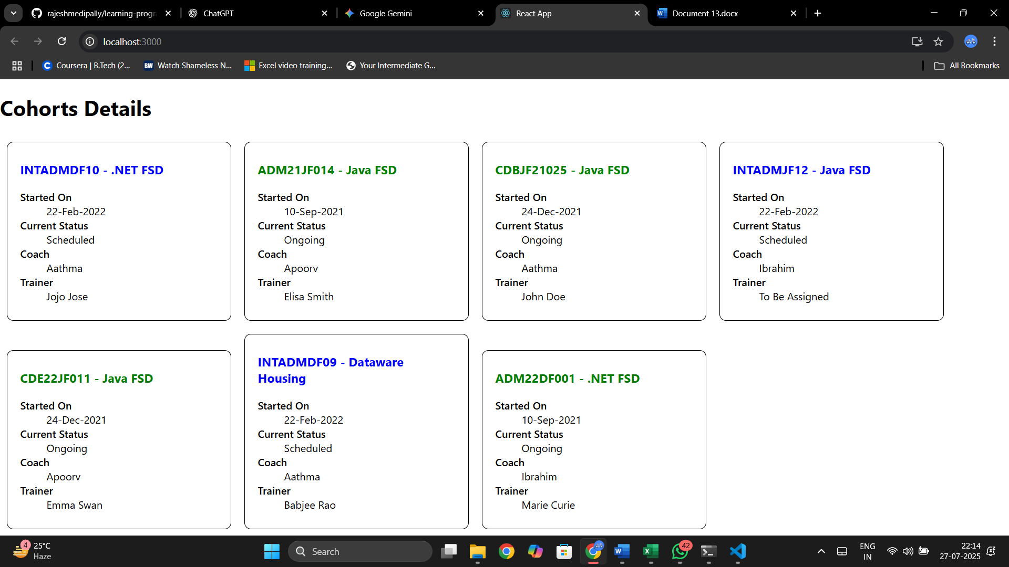

# **CohortDetails.js**

import styles from './CohortDetails.module.css';

function CohortDetails(props) {

const h3ColorClassName =

props.cohort.currentStatus === 'Ongoing'

? styles.h3Green

: styles.h3Blue;

return (

<div className={styles.box}>

<h3 className={h3ColorClassName}>

{props.cohort.cohortCode} - <span>{props.cohort.technology}</span>

</h3>

<dl>

<dt>Started On</dt>

<dd>{props.cohort.startDate}</dd>

<dt>Current Status</dt>

<dd>{props.cohort.currentStatus}</dd>

<dt>Coach</dt>

<dd>{props.cohort.coachName}</dd>

<dt>Trainer</dt>

<dd>{props.cohort.trainerName}</dd>

</dl>

</div>

);

}

export default CohortDetails;