# **ListofPlayers.js**

import React from 'react';

function ListofPlayers({ players }) {

return (

<div>

{players.map((item, index) => (

<li key={index}>

Mr. {item.name} <span>- {item.score}</span>

</li>

))}

</div>

);

}

export default ListofPlayers;

# **Scorebelow70.js**

import React from 'react';

function Scorebelow70({ players }) {

const players70 = [];

players.map((item) => {

if (item.score < 70) {

players70.push(item);

}

});

return (

<div>

{players70.map((item, index) => (

<li key={index}>Mr. {item.name} {item.score}</li>

))}

</div>

);

}

export default Scorebelow70;

# **OddPlayers.js**

import React from 'react';

function OddPlayers({ IndianTeam }) {

const [first, , third, , fifth] = IndianTeam;

return (

<div>

<p>First : {first}</p>

<p>Third : {third}</p>

<p>Fifth : {fifth}</p>

</div>

);

}

export default OddPlayers;

# **EvenPlayers.js**

import React from 'react';

function EvenPlayers({ IndianTeam }) {

const [, second, , fourth, , sixth] = IndianTeam;

return (

<div>

<p>Second : {second}</p>

<p>Fourth : {fourth}</p>

<p>Sixth : {sixth}</p>

</div>

);

}

export default EvenPlayers;

# **App.js**

import React from 'react';

import ListofPlayers from './components/ListofPlayers';

import Scorebelow70 from './components/Scorebelow70';

import OddPlayers from './components/OddPlayers';

import EvenPlayers from './components/EvenPlayers';

import ListofIndianPlayers from './components/ListofIndianPlayers';

function App() {

const flag = true;

const players = [

{ name: "Jack", score: 50 },

{ name: "Michael", score: 70 },

{ name: "John", score: 40 },

{ name: "Amin", score: 61 },

{ name: "Elizabeth", score: 61 },

{ name: "Dhoni", score: 100 },

{ name: "Virat", score: 90 },

{ name: "Jadeja", score: 64 },

{ name: "Raina", score: 85 },

{ name: "Rohit", score: 70 }

];

const IndianTeam = ["Sachin", "Dhoni2", "Virat3", "Rohit4", "Yuvraj5", "Raina6"];

const T20Players = ["First Player", "Second Player", "Third Player"];

const RanjiTrophyPlayers = ["Fourth Player", "Fifth Player", "Sixth Player"];

const IndianPlayers = [...T20Players, ...RanjiTrophyPlayers];

if (flag === false) {

return (

<div>

<h1>List of Players</h1>

<ListofPlayers players={players} />

<hr />

<h1>List of Players having Scores Less than 70</h1>

<Scorebelow70 players={players} />

</div>

);

} else {

return (

<div>

<h1>Indian Team</h1>

<h1>Odd Players</h1>

<OddPlayers IndianTeam={IndianTeam} />

<hr />

<h1>Even Players</h1>

<EvenPlayers IndianTeam={IndianTeam} />

<hr />

<h1>List of Indian Players Merged:</h1>

<ListofIndianPlayers IndianPlayers={IndianPlayers} />

</div>

);

}

}

export default App;

# **ListofIndianPlayers.js**

import React from 'react';

function ListofIndianPlayers({ IndianPlayers }) {

return (

<div>

{IndianPlayers.map((item, index) => (

<li key={index}>Mr. {item}</li>

))}

</div>

);

}

export default ListofIndianPlayers;

**When flag = false:**

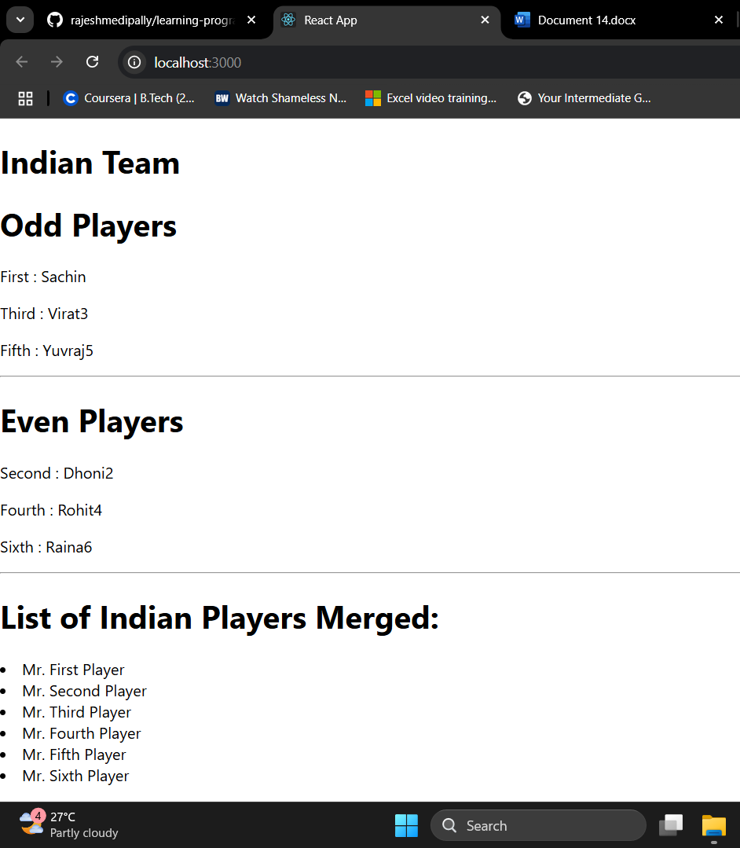

**When flag = true:**

