* Navigating to the working directory

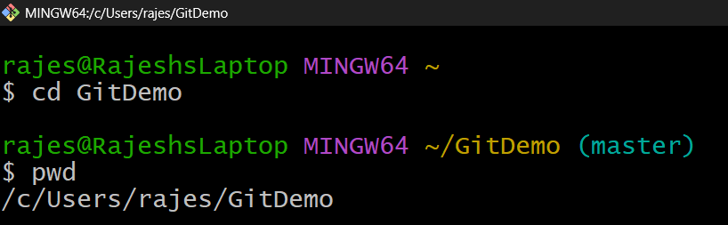

* Creating the files and the folder

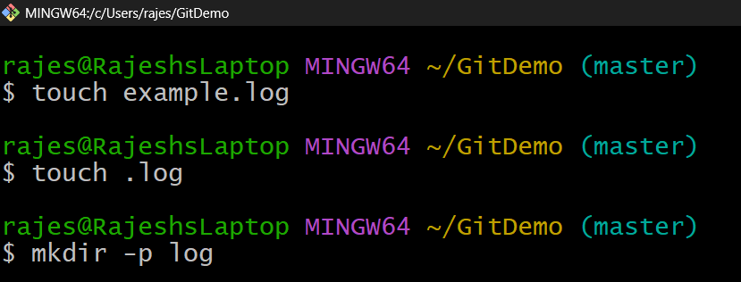

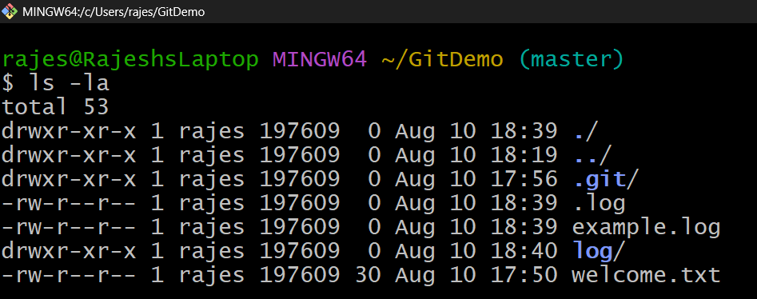

* Making changes such that the log folders and .log extension files are ignored

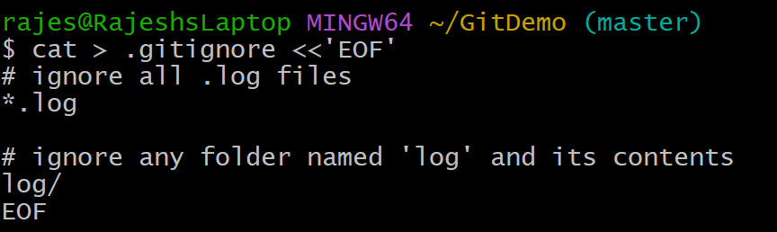

* Verifying the status and committing changes

